INT301: OPEN-SOURCE TECHNOLOGIES

SUBMITTED BY:

NAME: Ala Sai Harsha Vinay

REG NO: 11909635

ROLL NO: 22

GitHub:

1.INTRODUCTION

1.1 OBJECTIVE OF THE PROJECT

Use any open-source software to find and repair partly erased or damaged multimedia files from your system from last 3 months.

1.2 DESCRIPTION OF THE PROJECT:

One open-source tool that can be used to find and repair partly erased or damaged multimedia files from your system from last 3 months is “PhotoRec”. PhotoRec is a free and open-source data recovery software that can recover lost or deleted files including multimedia files from a wide range of devices, including hard drives, USB drives, memory cards, and more.

To use PhotoRec, follow these steps:

* Download and install PhotoRec on your system. It is available for Windows, Mac, and Linux operating systems.
* Launch PhotoRec and select the drive or storage device from which you want to recover multimedia files.
* Choose the file type that you want to recover. PhotoRec supports a wide range of multimedia file types, including photos, videos, and audio files.
* Select the location where you want to save the recovered files.
* Click on the “Search” button to start the scanning process.
* Once the scanning process is complete, PhotoRec will display a list of recovered files.
* Select the files that you want to recover and Click “Recover” button to save them to the selected location.
* Click “Quit” button after the scanning process is complete to exit from the PhotoRec software tool.

1.3 SCOPE OF THE PROJECT

PhotoRec is an open-source software to find and repair partly erased or damaged multimedia files from your system including photos, videos, and audios. The main purpose of this data recovery tool is: Sometimes, data present in the physical drives (Internal/External Hard disk, Pen Drive, etc.) gets lost, deleted, and formatted due to circumstances like virus attack, accidental deletion, or accidental use of SHIFT+DELETE. In these cases, data recovery software like PhotoRec is used to recover/restore the data files.

2. SYSTEM DESCRIPTION

A type of software called data recovery software makes it possible to retrieve lost, damaged, or inaccessible data from a storage device. Review, scan, identify, extract, and copy data from deleted, corrupted, and formatted sectors as well as from a user-specified place on the storage device with this software.

3.ANALYSIS REPORT

3.1 SYSTEM SNAPSHOTS AND FULL ANALYSIS REPORT

I have downloaded the PhotoRec data recovery software tool from the website called “cgsecurity.org”.

This is the interface of the PhotoRec tool, and there is a dropdown where we must select the disk/drive from which we want to recover the files.

Below the disk dropdown there is a list of drives available from which we must select our system disk to get the damaged or deleted files we want.

After selecting the drive, we must select a destination file to save the recovered files.

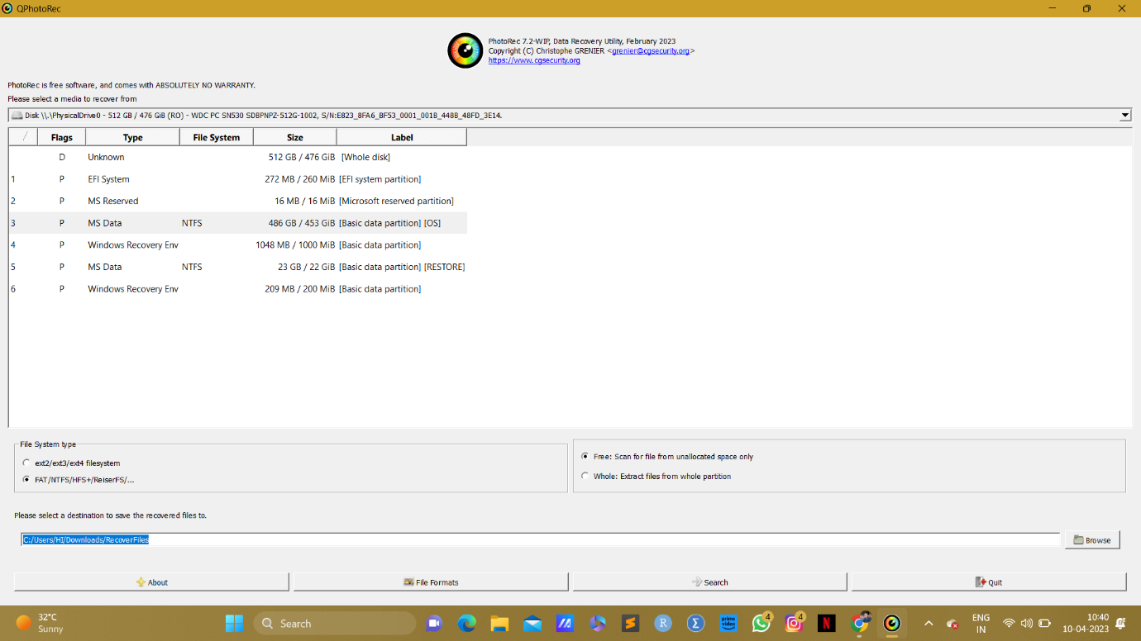

At the bottom there is an option called “File Formats”.

Click “File Formats” and select the multimedia file extensions including jpg, mkv, mov, mp3, etc. And then click “Search”.

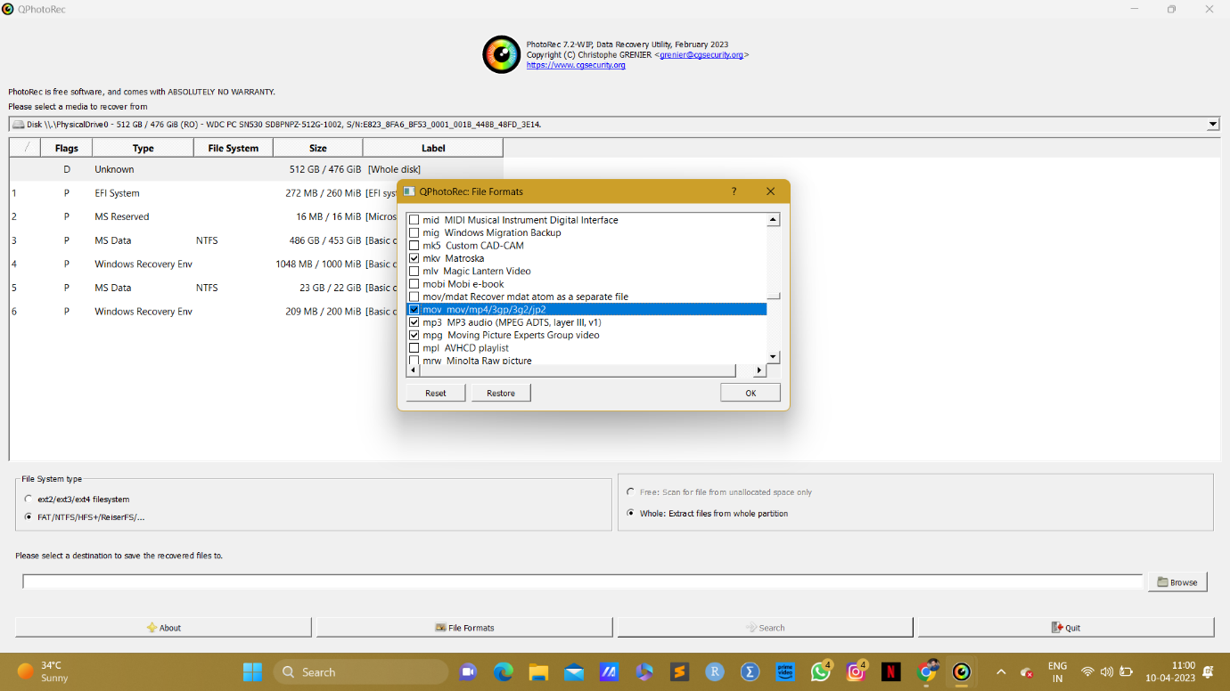

After Click “Search” it will start scanning the files to recover our selected multimedia files.

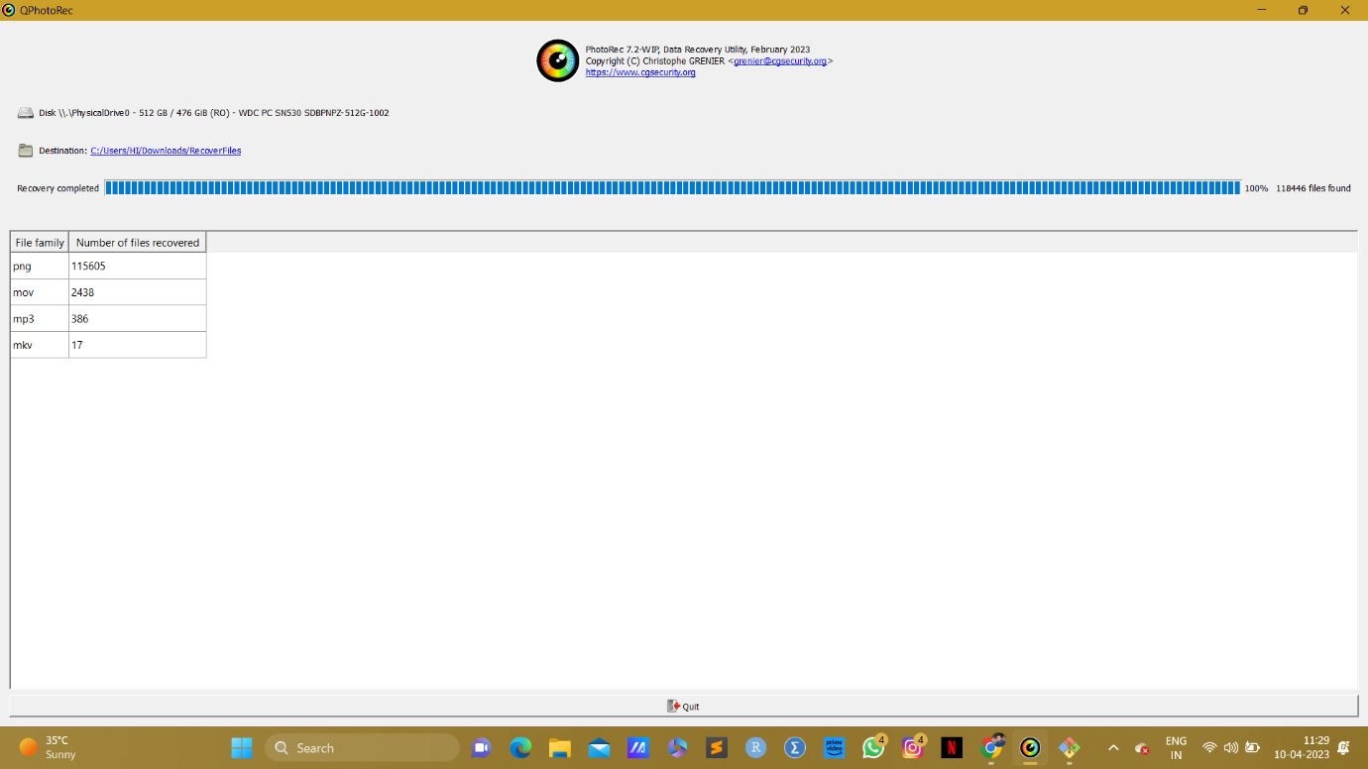

All the multimedia files including jpg, png, mkv, mov, mp3 extension files are recovered and saved in our destination file.

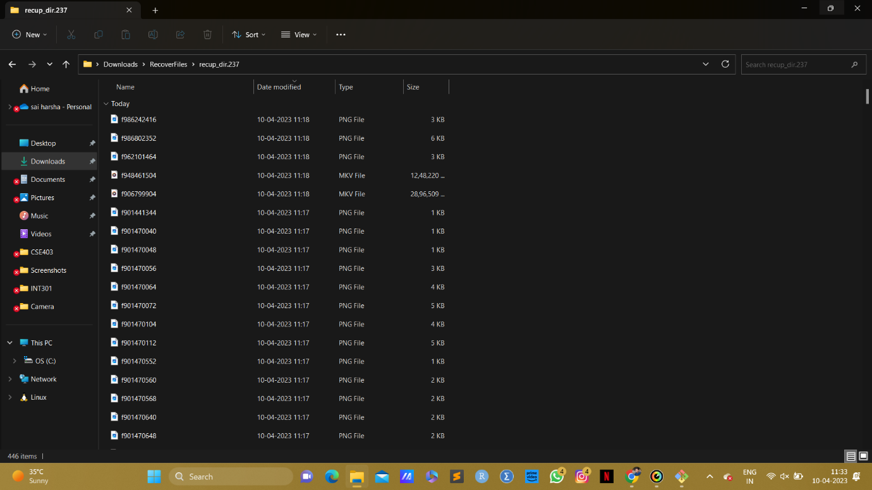

4. Reference/Bibliography

PhotoRec Software - <https://www.cgsecurity.org/wiki/PhotoRec>