**PERSONAL EXPENSESTRACKE**

**APPLICATION**

*Abstract— The Personal Finance Tracking Application is designed to help individuals take control of their finances through a user-friendly platform. It offers a seamless registration and login process, allowing users to securely manage their financial data. The application enables users to easily add, categorize, and track their income and expenses, providing clear insights into their spending habits and financial status. Comprehensive visualizations, such as graphs and charts, offer users a better understanding of their financial patterns. Additionally, the application allows for the deletion of individual transaction entries, ensuring accurate record-keeping. Ultimately, this application promotes financial awareness and empowers users to make informed decisions, fostering better financial management and budgeting. Keywords: 1. Expense Tracker 2. Personal Finance 3. Budget Management 4. Transaction Tracking 5. Financial Visualization*

# **Introduction**

Take control of your financial future with our Personal Finance Tracker. Say goodbye to financial stress and hello to financial freedom as you effortlessly manage your expenses and income in one convenient platform. Whether you're saving for a dream vacation or planning for retirement, our tracker empowers you to make informed decisions, track your progress, and achieve your financial goals with confidence. Start your journey toward financial success today!

**PROBLEM STATEMENT**

Many people struggle to manage their finances effectively, and traditional methods such as spreadsheets or pen-and-paper notebooks can be cumbersome and time-consuming. This lack of a user-friendly system often leads to poor financial awareness, difficulty with budgeting, and ultimately, overspending. A comprehensive personal finance tracker is essential to address these challenges. This application provides a streamlined platform for tracking expenses and income, offering clear visualizations and insights into spending habits. By simplifying financial record-keeping and analysis, this tool empowers users to take control of their finances and make informed financial decisions.

**OBJECTIVE OF THE PROJECT**

The objective of the Personal Finance Tracker project is to create a user-friendly and efficient platform that allows individuals to effectively manage their expenses and income. By offering comprehensive tracking and analysis features, users can gain valuable insights into their financial habits, identify areas for improvement, and make informed decisions to achieve their financial goals. Through intuitive interfaces and customizable tools, this application aims to empower users to take control of their finances, enhance their financial literacy, and promote responsible money management practices.

# **SCOPE**

This Personal Finance Tracker application is designed to empower users to take control of their financial well-being. It provides a user-friendly platform for registration and login, ensuring secure access to financial data. Users can easily add both income and expense entries, which are categorized for clear and efficient tracking. The application generates detailed visualizations that offer valuable insights into spending and income patterns, helping users understand where their money is going and identify potential savings opportunities. Additionally, the app allows users to delete individual expense entries, ensuring the accuracy of their financial records. Overall, this application acts as a comprehensive tool to promote financial awareness and help users make informed financial decisions.

# **MOTIVATION**

Managing personal finances can be overwhelming, especially without a clear system to track and analyze income and expenses. Traditional methods such as spreadsheets or paper notebooks can be time-consuming and often lead to errors or disorganization. This lack of organization can cause poor financial decisions, missed opportunities for saving, and unnecessary stress. With the increasing complexity of financial responsibilities, there is a growing need for a more accessible and user-friendly tool that helps individuals take control of their finances.

**Literature Survey**

# **Related Work:**

**[1] Author: Bell, G. (2012)**

**Title**: Messy Futures: Culture, Technology, and Research.

**Outcome**: This paper discusses the interconnections between culture, technology, and research, highlighting how these factors influence each other. It emphasizes the complexity of predicting future technological advancements and societal impacts, noting that the future is often "messy" due to these intertwined dynamics.

**Disadvantages**: The paper suggests that the uncertainty in predicting the future can make long-term planning and technological foresight challenging.

**[2] Author: Blythe, M., Monk, A., & Park, J. (2002)**

**Title** Technology Biographies: Field Study Techniques for Home Use Product Development.

**Outcome**: This study presents field study techniques for developing products for home use, offering valuable insights into understanding user needs and behaviors in domestic contexts. It underscores the importance of ethnographic research methods in product development.

**Disadvantages**: The study highlights that user needs can be highly subjective and may differ across cultural or personal contexts, which complicates the development process.

**[3] Author: Collins, D., Morduch, J., Rutherford, S., & Ruthven, O. (2010)**

**Title** Portfolios of the Poor: How the World's Poor Live on $2 a Day.

**Outcome**: This book provides deep insights into the financial practices and challenges faced by individuals living in poverty, emphasizing the importance of designing financial tools and services that meet the needs of the economically disadvantaged.

**Disadvantages**: The book suggests that financial tools may not always be accessible or appropriate for the poorest segments of society, leaving gaps in financial inclusion.

**[4] Author: Gaver, B., Dunne, T., & Pacenti, E. (1999)**

**Title**: Cultural Probes.

**Outcome** This paper introduces cultural probes as a design research method, focusing on eliciting insights into users' daily lives, behaviors, and attitudes. It advocates for a user-centered and empathetic approach to design that considers cultural contexts.

**Disadvantages**: The method's subjective nature can lead to challenges in interpreting and generalizing findings across diverse user groups.

**[5] Author: Kaye, J. ‘J.’ (2014)**

**Title**: The Financial Tour.

**Outcome**: This chapter examines research methods for studying financial practices within households, emphasizing the socio-economic and cultural dynamics that shape individuals' financial behaviors. It offers insights into designing tools for effective financial management. **Disadvantages**: The study acknowledges that financial behaviors can vary significantly between households, making it challenging to create universally applicable tools​.

**[6] Author: Kiyosaki, R.T. (2004)**

**Title**: Rich Dad, Poor Dad.

**Outcome**: This book shares personal finance lessons based on the author's experiences with his "rich dad" and "poor dad." It highlights financial literacy, investment strategies, and mindset shifts necessary for achieving financial success.

**Disadvantages**: The book's focus on individual success may not address systemic financial challenges faced by lower-income individuals or communities.​.

**[7] Author: Lampe, C., Ellison, N., & Steinfield, C. (2006)**

**Title**: A Face(book) in the Crowd: Social Searching vs. Social Browsing. **Outcome**: This paper explores the difference between social searching and browsing on online platforms, providing insights into how users seek information actively or passively. It offers guidance on designing online platforms that cater to diverse user behaviors.

**Disadvantages**: The study does not delve deeply into the ethical concerns surrounding user privacy and data collection on social media platforms.

**Implementation:**

**Register Module:** The Register module enables users to create an account by providing basic information such as name, email, and password. The system ensures that emails are unique and passwords meet security requirements. Upon successful registration, users receive a confirmation message or email. This module is designed to provide a seamless user onboarding experience while ensuring the security of user data.

**Login Module:** The Login module allows registered users to access their accounts using email and password. It incorporates authentication mechanisms to verify credentials, ensuring that only authorized users can access their accounts. The system gracefully handles failed login attempts by displaying appropriate error messages, such as "Invalid email or password." This module also ensures secure and reliable access control.

**Expense Management Module:** The Expense Management module enables authenticated users to add, view, and manage their expenses. Users can enter details such as the amount, category, date, and description. They can also upload receipts or attach notes for each expense entry. The module allows users to categorize their expenses (e.g., groceries, rent, entertainment ) and provides a comprehensive summary of their spending habits. Users can filter and sort their expenses by different criteria such as date, amount, and category.

**Visualization and Reporting Module:** This module provides users with a graphical representation of their expenses using charts and graphs. It offers a clear and intuitive overview of their spending patterns, helping users to make better financial decisions. The system supports visualizations such as pie charts, bar graphs, and line charts to display categorized expenses and trends over time.

**Delete Expense Module:** Users can delete individual expense entries through the Delete Expense module. If an expense was added in error or is no longer relevant, users can delete it from their records. The module includes confirmation prompts to prevent accidental deletions. Additionally, deleted expenses are temporarily moved to a trash bin for a set period before being permanently removed, ensuring users have time to reconsider any deletions.

**Proposed Method:** The proposed system is a comprehensive expense tracking platform built using the Flask framework for the backend, with a user-friendly interface for seamless interaction. The system offers users the ability to manage their expenses efficiently by adding new expenses, categorizing them, and visualizing them through charts and graphs. It integrates secure user authentication and ensures data integrity by validating user input and protecting sensitive information. The platform also supports expense deletion with an optional trash bin for recovery. By offering various modules for registration, login, expense tracking, and reporting, the system aims to enhance user financial management and improve decision-making by providing detailed insights into spending patterns.

**Work Flow of Proposed System:**

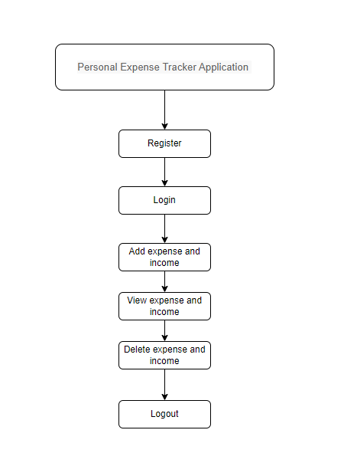

Fig-1

**Register Module:**

In the above fig-1

• The system ensures that each email address is unique, preventing duplicate registrations.

• Passwords must meet the required strength criteria, including:

* Minimum length (e.g., 8 characters).
* Inclusion of both uppercase and lowercase letters.
* Inclusion of numbers and special characters.

• Users receive a confirmation email or message with a link to verify their account upon successful registration.

• This email confirmation ensures the legitimacy of the registration process, preventing fake accounts.

• Once the user confirms the email, their account is activated and they can access the platform.

**Login Module:**

In the above fig-1

• Users can log in securely to the system using their registered email and password.

• The system verifies the entered credentials against the stored user data for authentication.

• If the login credentials are incorrect, the system displays an error message such as "Invalid email or password."

• Users are provided with an option to reset their password in case they forget it, with instructions sent to their registered email.

• Successful login grants users access to their account, where they can manage their expenses and view their data.

• The system maintains user sessions, allowing users to stay logged in until they explicitly log out or the session expires.

**Add Expense and Income:**

In the above fig-1

• Users can add their expenses and income by providing details such as amount, category, date, and description.

• The system supports different categories for expenses, such as groceries, rent, utilities, entertainment, and others.

• For income, users can specify the source (e.g., salary, freelance work, etc.) along with the amount and date.

• Users may upload receipts for expenses or attach notes for both expenses and income entries to maintain detailed records.

• The system allows users to track the source of income and categorize expenses to gain better insights into their financial management.

• The data entered by users is stored securely and can be viewed in the "View Expenses" and "View Income" sections for later analysis.

# **System Design and Architecture**

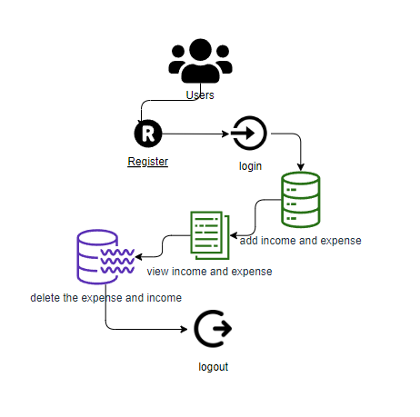

Fig-2

**Introduction of Input Design:**

In the above **fig-2** information system, input refers to the raw data that is processed to produce the output. During the input design phase, developers need to consider which input devices, such as PC, MICR, OMR, and others, will be used to collect data.

The quality of the system input directly affects the quality of the output produced by the system. Well-designed input forms and screens possess the following characteristics:

* **Purpose Effectiveness:** The input design must serve specific functions effectively, such as storing, recording, and retrieving information to meet the system’s objectives.
* **Accuracy and Completion:** The design should ensure that all data is completed accurately, minimizing errors and ensuring data integrity.
* **Simplicity and Usability:** It should be easy to fill out and straightforward, providing a user-friendly experience.
* **User Focus and Consistency:** The design should prioritize maintaining the user’s attention, while ensuring consistency and simplicity throughout the system.

These objectives are achieved by applying basic design principles, which include:

* **Identifying Necessary Inputs:** What data does the system require? Developers need to define and understand the inputs needed for effective processing.
* **Understanding User Interaction:** How do end users respond to different components of the forms and screens? This knowledge helps create designs that are intuitive and easy for users to navigate.

1. **Objectives for Input Design:**

The primary goals of designing input processes include:

* **Development of Data Entry Systems and Procedures:** The main goal of this process is to design efficient data entry systems along with related procedures that streamline the process of data input while ensuring accuracy and minimizing user effort.
* **Creation of Data Capture Tools:** This involves planning source documents and developing alternative data capture strategies, which serve as tools for accurate and efficient data collection.
* **Modelling Input Forms, Data Entry Screens, and User Interface Elements:** A key responsibility in input design is to model the layout of input forms, data entry screens, and user interface elements to ensure a user-friendly and intuitive experience, aiding in easy data entry.
* **Development of Effective Input Control Systems and Validation Checks:** This objective focuses on developing robust input control systems and implementing validation checks to ensure that only valid, complete, and accurate data is entered into the system, preserving data integrity.

**Output Design:**

The success of any system largely depends on designing effective output features. During the development phase, system developers determine the necessary output types and establish appropriate output controls, along with prototype reporting layouts to ensure proper presentation and delivery of results.

**Objectives of Output Design:** The objectives of output design include:

* **Purposeful Output Creation:** The development of output design should follow a clear, purposeful path that ensures only relevant and necessary output is generated, eliminating the production of unwanted or redundant data.
* **Meeting End User Requirements:** Output designs should be developed with the end user’s needs in mind, ensuring that the generated outputs align with what the user requires to make informed decisions.
* **Correct Output Quantity:** The organization must ensure the correct quantity of output is delivered, avoiding both overproduction and underproduction of data, which can impact efficiency.
* **Appropriate Format and Delivery:** The output should be formatted correctly and directed to the appropriate person or system, ensuring that it is accessible and usable by the intended recipient.
* **Timeliness of Output:** Ensuring that outputs are delivered on time is critical to facilitate timely decision-making. The availability of up-to-date information is essential for making well-informed choices.

# **results**

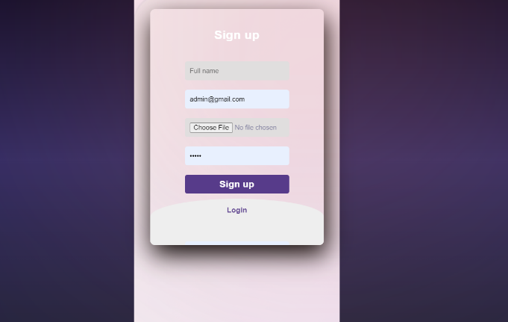

Fig.1

**Landing Page:** The **fig.1** represents the Sign Up page. When the execution starts, this is the page where new users can register by providing their personal details such as name, email, and password

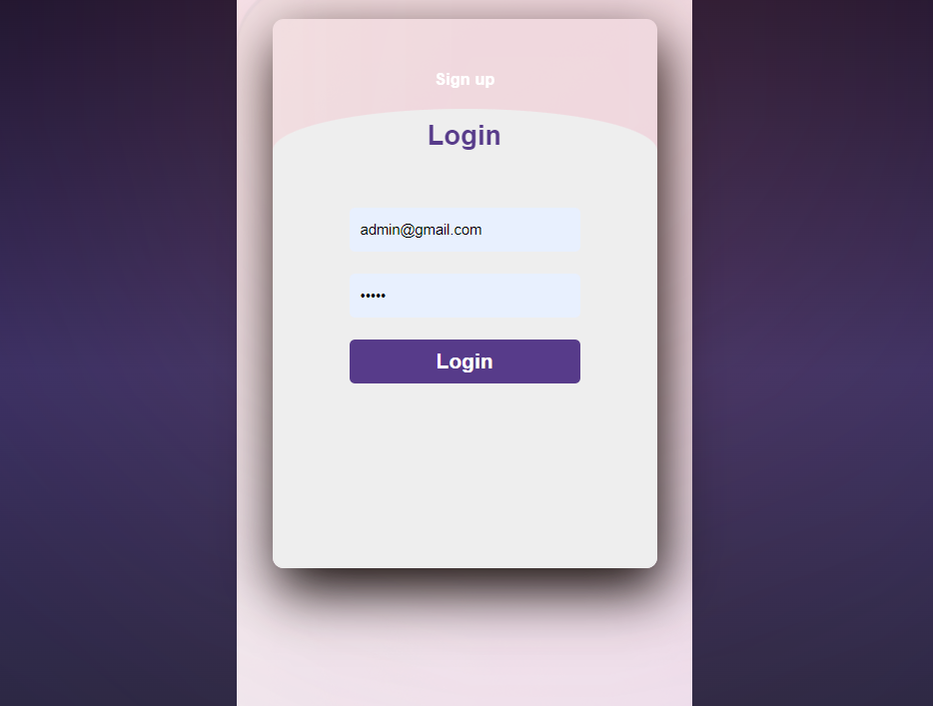

Fig.2

**User login page :**The fig.2This is the user login page the registered user can login.

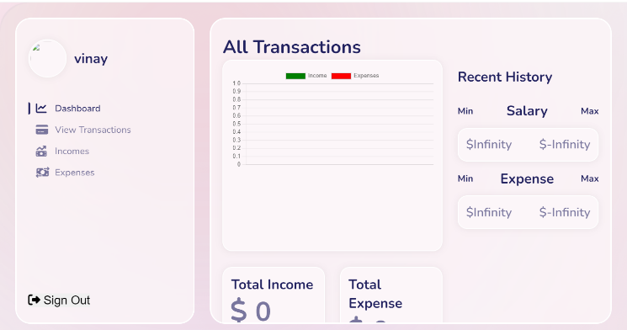

Fig.3

**Dash Board:** The **fig.3** represents the Dashboard. Once the user has logged in, this is the main page that provides an overview of the user’s activity, including recent expenses, income, and summary statistics.

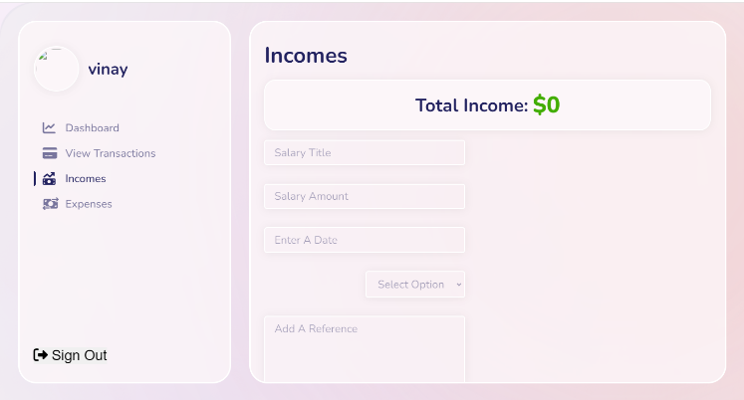

Fig.4

**Add Income:** The **fig.4** represents the Add Income page. This page allows users to enter their income details, including the amount, source, date, and any additional notes..

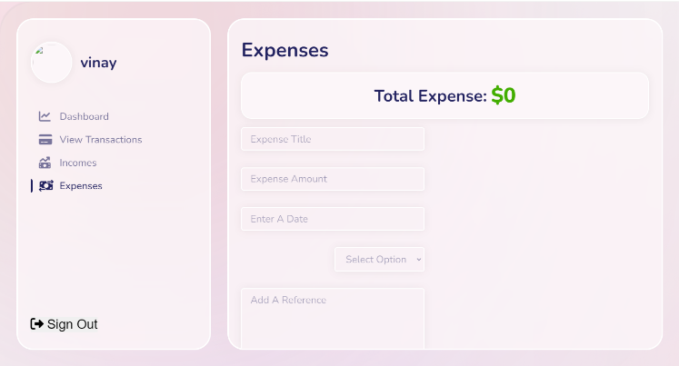

Fig.5

**Add Expense:** The **fig.5** represents the Add Expense page. This page allows users to input details of their expenses, such as the amount, category, date, and description.

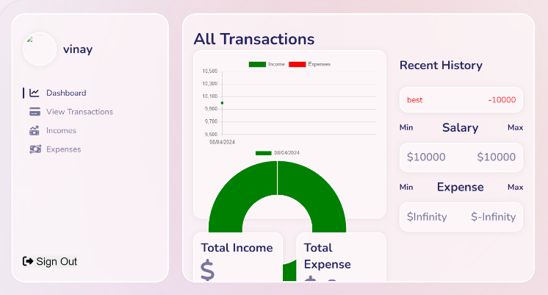

Fig.6

**View Page:** The **fig.6** represents the View page. This page allows users to view a summary of their expenses and income. It provides detailed information, including total expenditure, categorized expenses, and income records. Users can filter, sort, and visualize their data, helping them analyze their financial situation effectively.

# **Conclusion**

The **Personal Finance Tracker** empowers users to take control of their finances by providing an intuitive platform to manage both expenses and income. With seamless transaction recording and clear categorization for easy tracking, the system allows users to identify spending patterns and make informed financial decisions. The ability to delete individual expenses ensures accurate record-keeping, allowing users to maintain up-to-date financial records. By offering insightful visualizations, this application enhances financial awareness, helping users build a healthier relationship with their money. Ultimately, the **Personal Finance Tracker** serves as a valuable tool in achieving financial goals and promoting financial well-being.

# **Future enhancement**

In future iterations, the **Personal Finance Tracker** could integrate advanced machine learning algorithms to offer predictive insights into spending patterns, helping users anticipate future expenses and identify potential areas for saving. Integration with banking APIs would allow for real-time transaction categorization and analysis, providing users with an effortless way to track their financial habits. Additionally, features such as goal setting and progress tracking could be introduced, empowering users to work towards their financial objectives with greater focus and efficiency. Expanding compatibility to support cryptocurrency portfolios and investment tracking would cater to a wider range of users, including those with diverse financial interests and investment strategies, further enhancing the platform's functionality.

**Reference**

1. Bell, G. (2012): *In Messy Futures: Culture, Technology, and Research*, the author discusses the intertwining relationships between culture, technology, and research, highlighting the challenges of predicting technological advancements and their societal impacts. The study emphasizes that the future is often "messy" due to the complexity of these factors and explores how technology and culture influence one another.
2. Blythe, M., Monk, A., & Park, J. (2002): *Technology Biographies: Field Study Techniques for Home Use Product Development*, the authors present ethnographic research methods for developing home-use products. They discuss how field studies and understanding user behaviors in domestic contexts can aid in designing products that meet user needs.
3. Collins, D., Morduch, J., Rutherford, S., & Ruthven, O. (2010): *Portfolios of the Poor: How the World's Poor Live on $2 a Day* provides a deep analysis of the financial practices of individuals living in poverty. The authors explore the daily struggles and coping mechanisms of the poor and the importance of designing financial tools that cater to their specific needs.
4. Gaver, B., Dunne, T., & Pacenti, E. (1999): *Design: Cultural Probes*, the authors introduce cultural probes as a method of design research. The paper advocates for understanding cultural contexts and user experiences in the design process and proposes a more empathetic, user-centered approach to designing products and systems.
5. Kaye, J. ‘J.’ (2014): *The Financial Tour* focuses on research methods used to study financial practices within households. The paper examines the socio-economic factors that shape financial behaviors and provides insights into designing financial management tools for domestic life.
6. Kiyosaki, R.T. (2004): *Rich Dad, Poor Dad* presents personal finance lessons learned from the author's experiences with two father figures, emphasizing the importance of financial literacy, investment strategies, and mindset shifts required for financial success.
7. Lampe, C., Ellison, N., & Steinfield, C. (2006): *A Face(book) in the Crowd: Social Searching vs. Social Browsing*, the authors explore social behaviors on platforms like Facebook. They distinguish between social searching, where users actively seek information, and social browsing, where users passively discover information. The paper offers insights into designing social platforms that cater to both active and passive user behaviors.
8. Rosen, L.D., Carrier, L.M., & Cheever, N.A. (2013): *Facebook and Texting Made Me Do It: Media-Induced Task-Switching While Studying* investigates how social media use influences multitasking and productivity. The study helps to understand distractions that could affect financial management apps or tools, offering insights into how to optimize the user experience.
9. Thaler, R.H., & Sunstein, C.R. (2008): *Nudge: Improving Decisions About Health, Wealth, and Happiness* examines behavioral economics and how small, subtle interventions can guide individuals toward making better financial decisions. It provides valuable lessons for designing personal expense trackers that subtly guide users toward better spending habits.
10. Shiller, R.J. (2015): *Irrational Exuberance* explores the behavioral factors influencing financial decision-making and market trends. This work provides insights into how users perceive financial data, which is useful for designing expense tracking tools that provide clear and actionable financial insights.