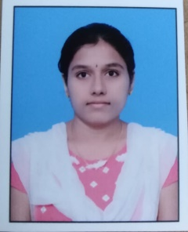**GUMMARAJU NAGA BHAVANA**

**EMAIL ID:** gnbhavana1997@gmail.com

**MOBILE NO: +91**9963097716

# CAREER OBJECTIVE:

# A highly organized and hard-working individual looking for a responsible position to gain practical experience.

# EDUCATIONAL QUALIFICATIONS:

|  |  |  |  |  |
| --- | --- | --- | --- | --- |
| **Course** | **Board/University** | **Name of The College/School** | **Year Of** | **Percentage/CGPA** |
| **completion** |
| **B.TECH(CSE)** | Jawaharlal Nehru Technological University,  Anantapuramu | Srinivasa Institute of Technology Anantapur | 2019 | 65% |
|  |  |
| **Intermediate(M.P.C)** | Board of Intermediate | Narayana Junior | 2015 | 94.3% |
| Education-AP | College, Anantapur |
| **S.S.C** | Board of Secondary Education, Andhra Pradesh | Prasad Concept School | 2013 | 9.7(CGPA) |

# TECHNICAL EXPOSURE:

MS Office (Word, Power point)

**PERSONAL SKILLS:**

* **STRENGTHS:**
  + - Eager to learn
    - Hard Working
    - Disciplined
    - Punctual
* **HOBBIES:**
* Shopping
* Listening music
* Reading books

**PERSONAL DETAILS:**

**Name :** G. Naga Bhavana

**Father Name :** G. Nageswararao

**Mother Name :** D. Uma Devi

**DOB :** 22-06-1997

**Gender :** Female

**Nationality :** Indian

**Address :** D.No: 4-1197, Ganesh Nagar, Kalyandurgam Bypass Road, Anantapur,

Andhra Pradesh

**Languages :** English, Hindi, Telugu

**Declaration:**

I hereby declare that the above furnished information is true and correct to the best of my knowledge.

Place: Anantapur

Date:

(G. Naga Bhavana)