**Name: B.Sai Hithesh**

**USN: 1BM17CS021**

**Program Number :**

**Program Title : Fire alarm using temp sensor**

**AIM: Alarm when temperature rises above 35**

**Hardware Required:**

* **Arduino Board**
* **Temperature sensor**
* **Piezo**
* **Led**

**Circuit Diagram:**

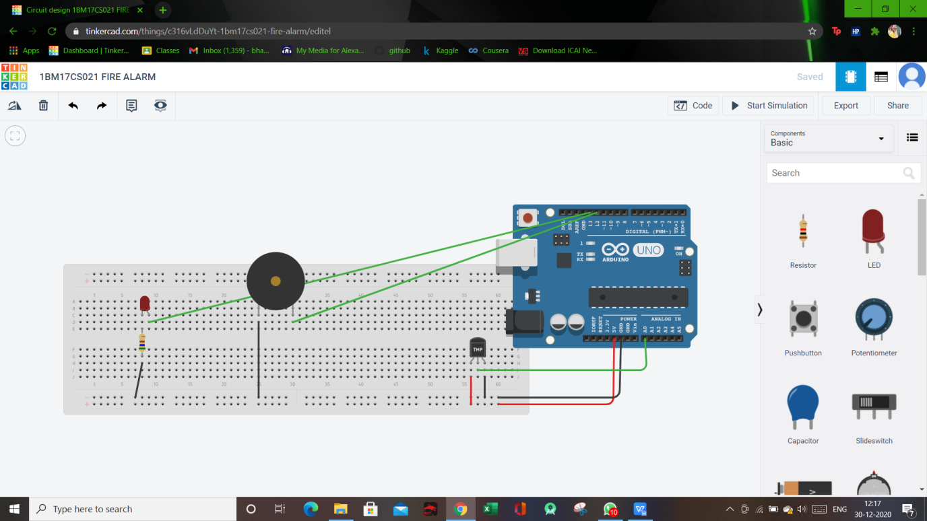

**Circuit diagram along with code:**

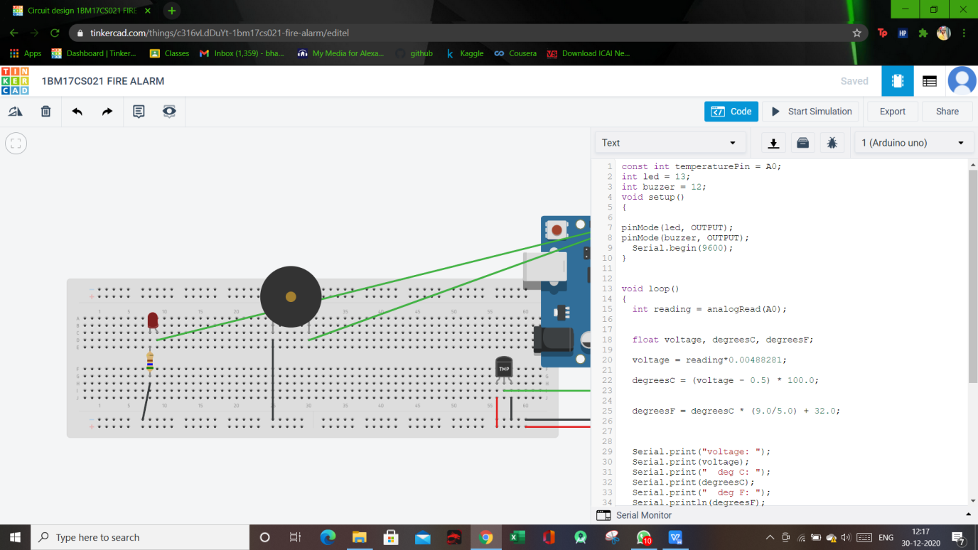

**Simulation:**

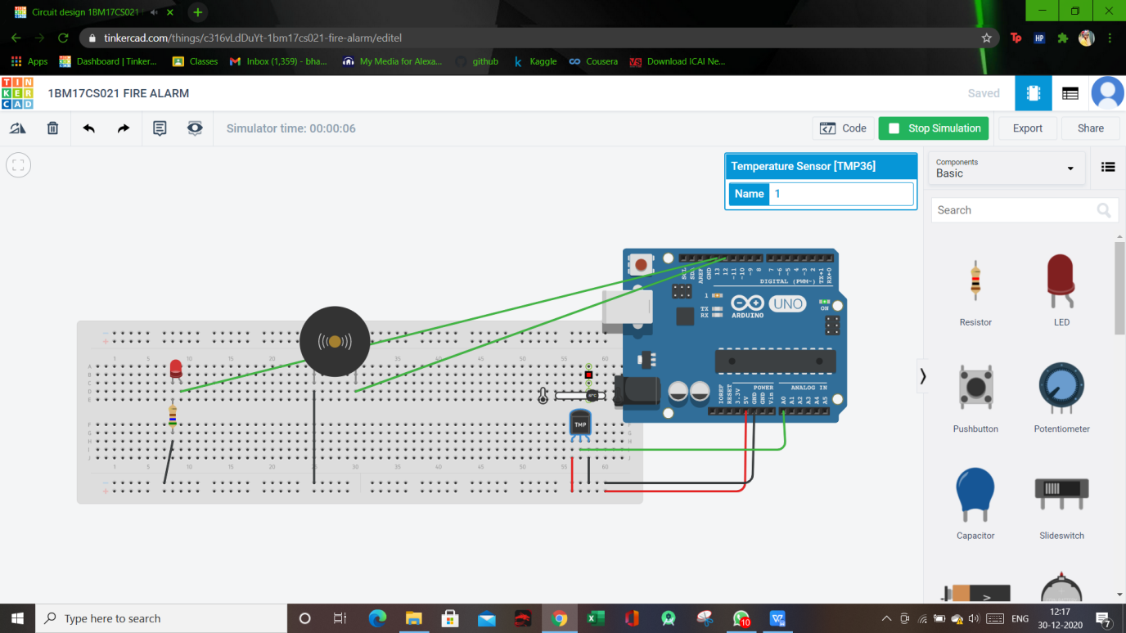

**Code:**

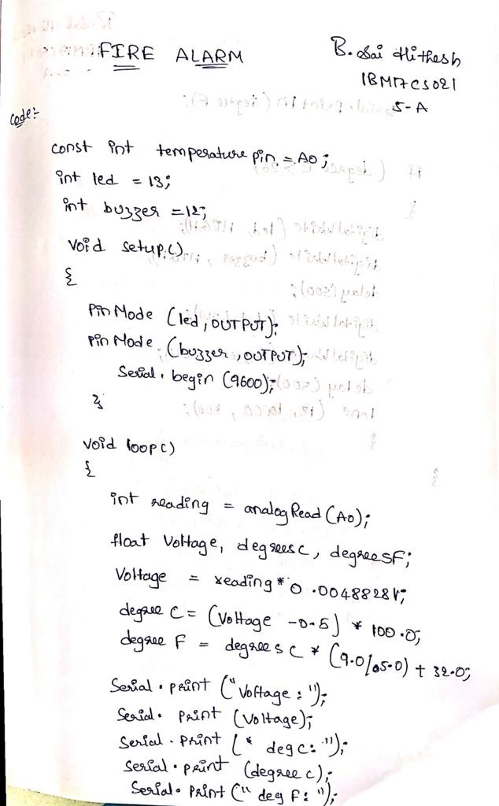

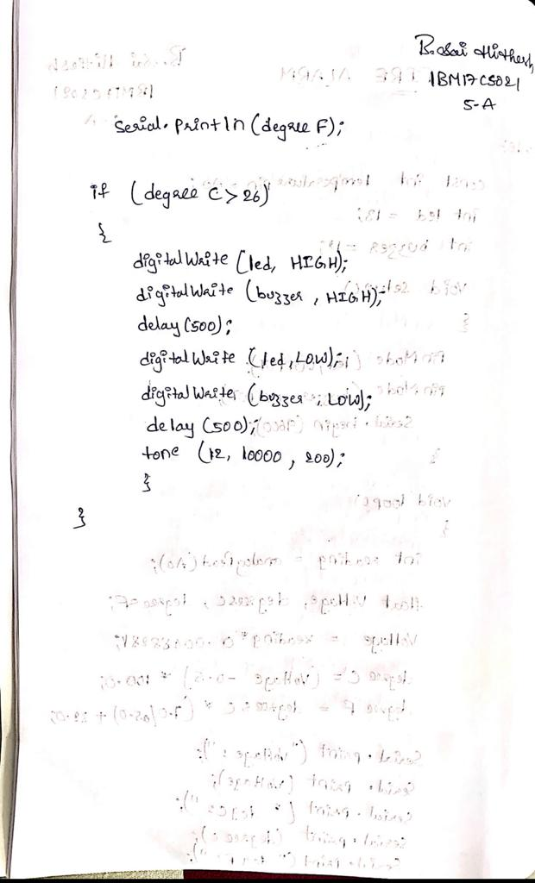

**Observation/output:**

Alarm when temperature rises above 26c