**Name: B.Sai Hithesh**

**USN: 1BM17CS021**

**Program Number :**

**Program Title : LCD**

**AIM: Displaying the colour of the LCD glown.**

**Hardware Required:**

* **Arduino Board**
* **LED rgb**
* **LCD**
* **Breadboard**

**Circuit Diagram:**

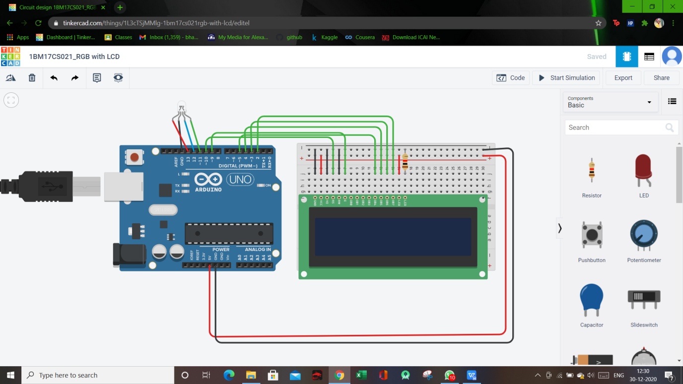

**Circuit diagram along with code:**

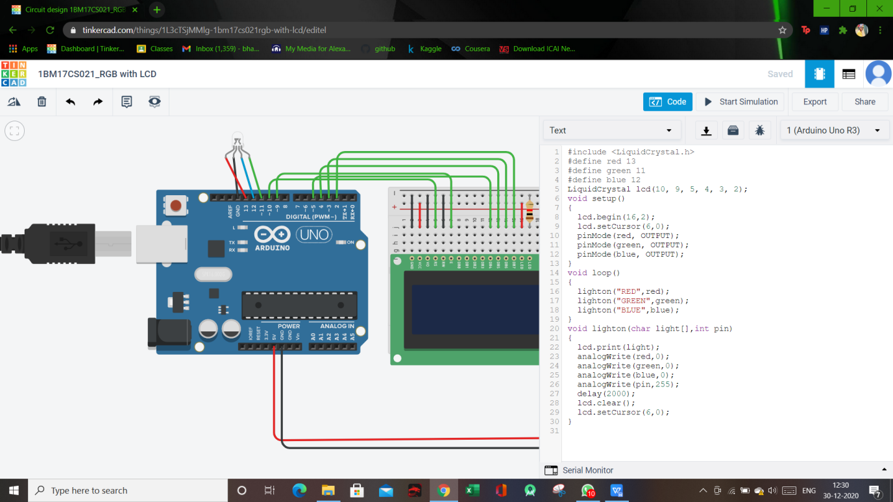

**Simulation:**

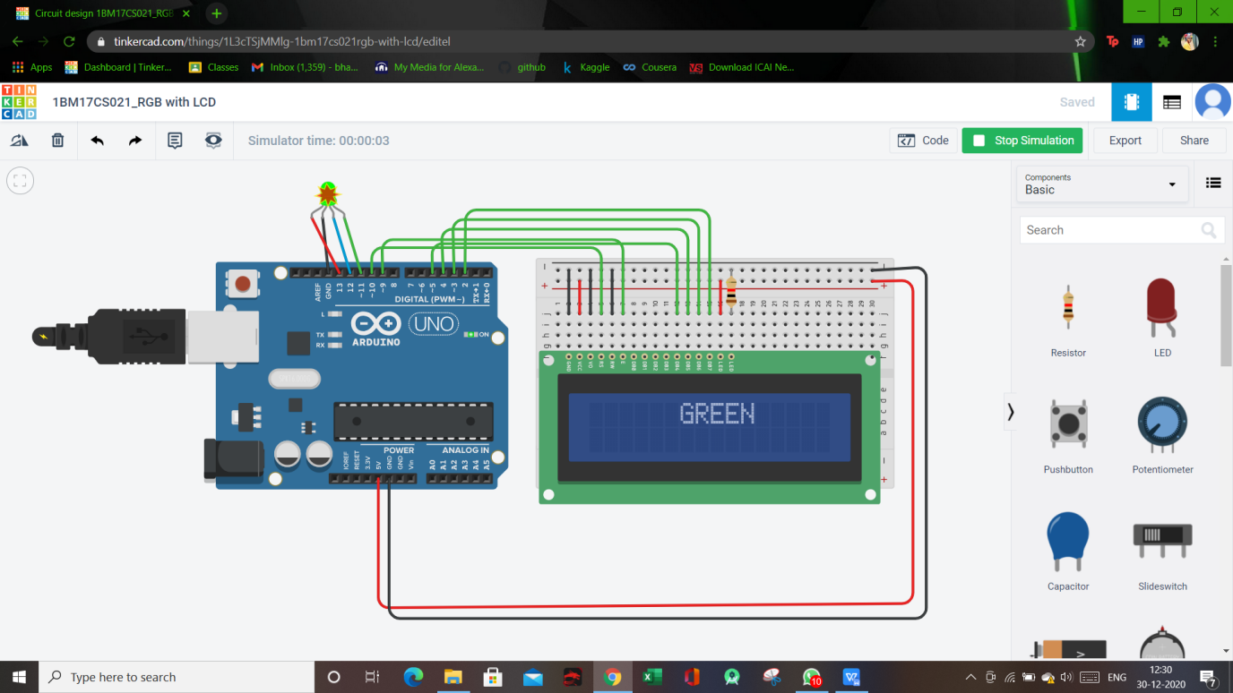

**CODE :**

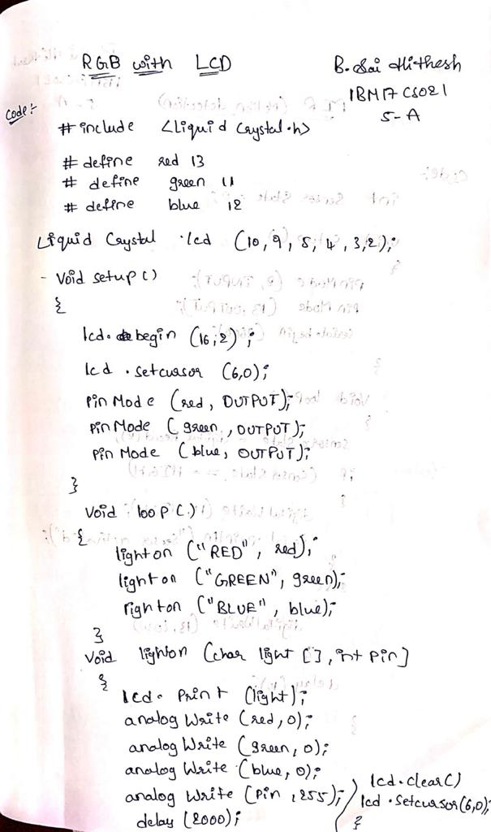

**Observation/output:**

Corresponding colour was displayed on LCD.