**Name: B.Sai Hithesh**

**USN: 1BM17CS021**

**Program Number :**

**Program Title : Photo resistor**

**AIM: To turn on the led in absence of sunlight.**

**Hardware Required:**

* **Arduino Board**
* **Photo resistor**
* **Led**
* **Resistor**

**Circuit Diagram:**

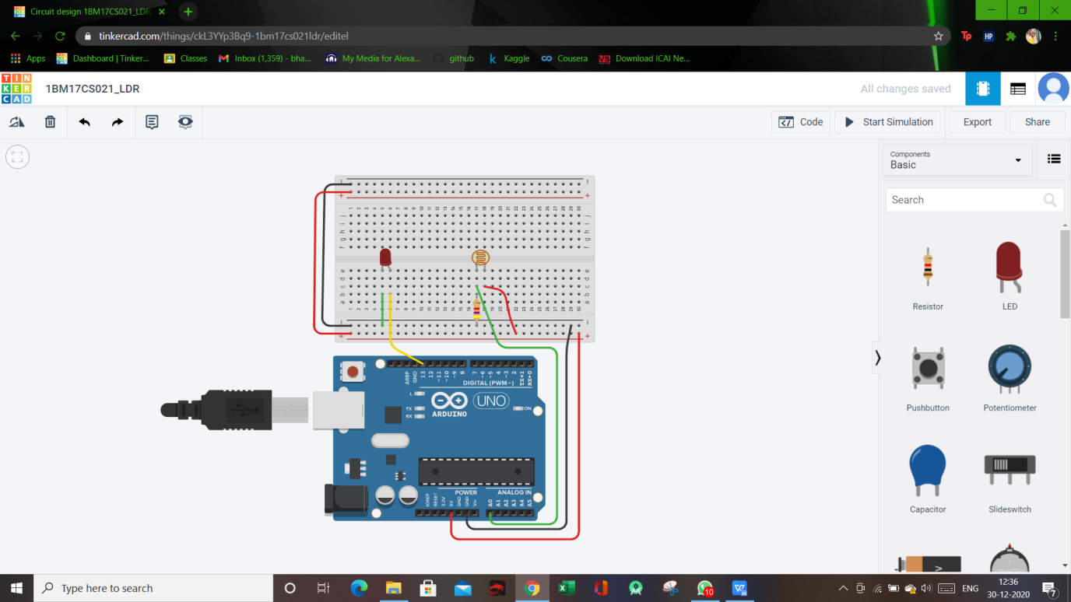

**Circuit diagram along with code:**

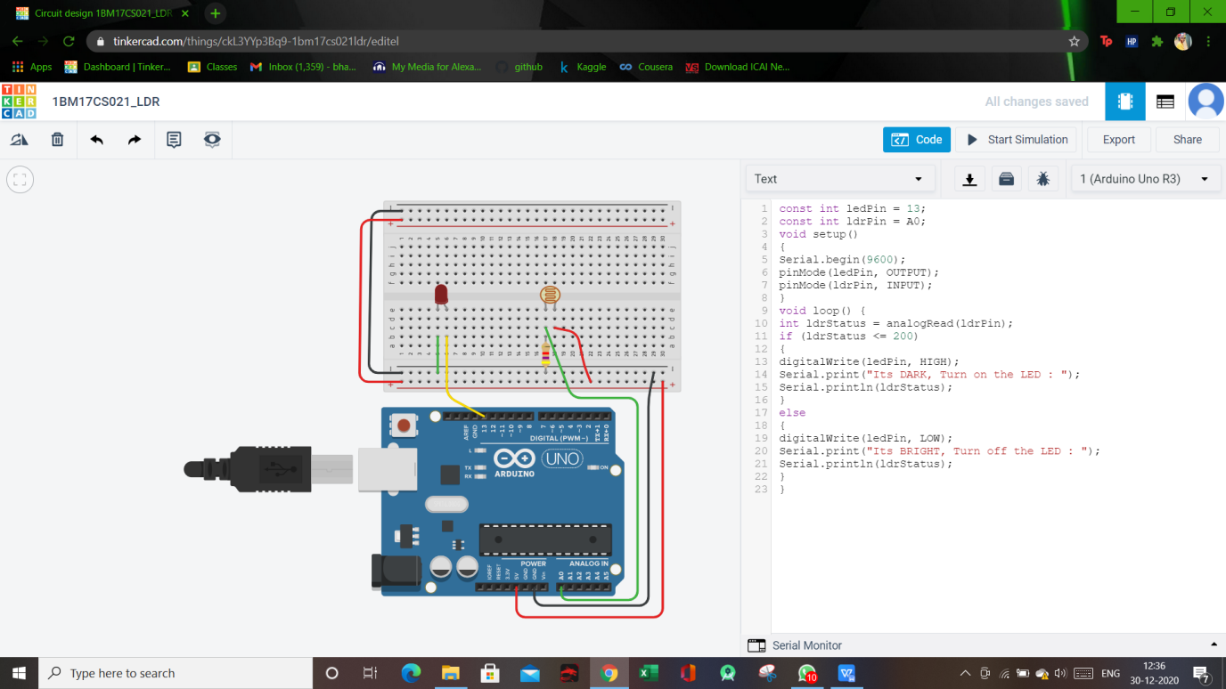

**Simulation:**

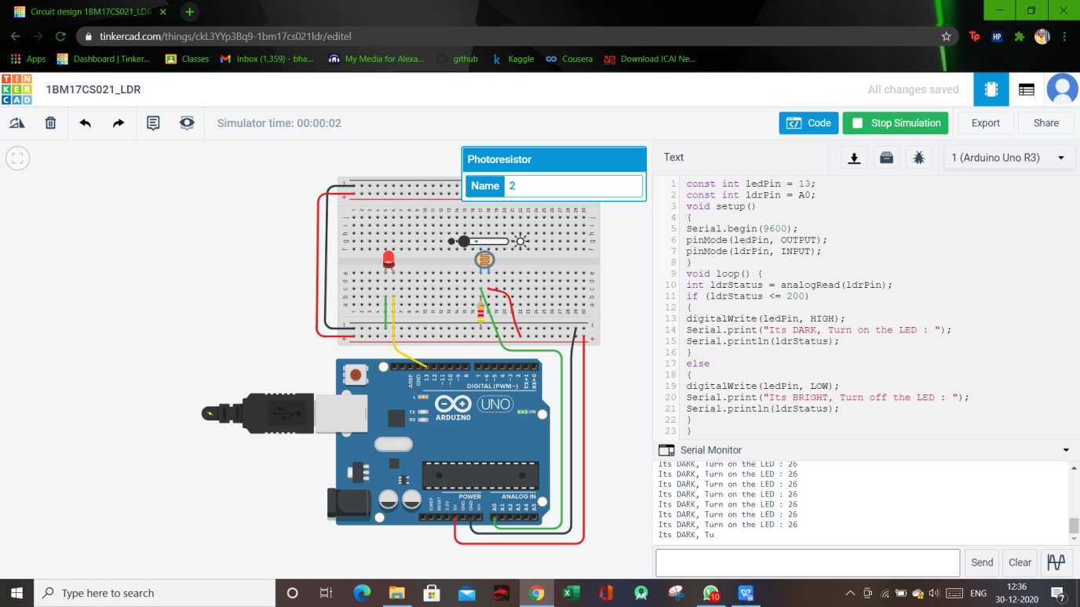

**Code:**

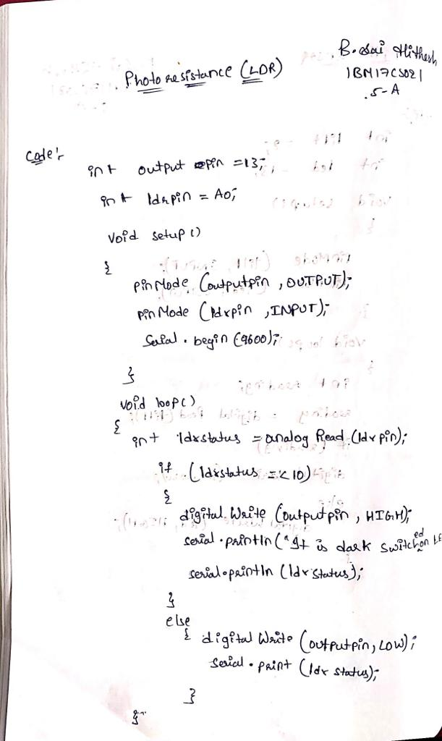

**Observation/output:**

Led light was glown in absence of sunlight.