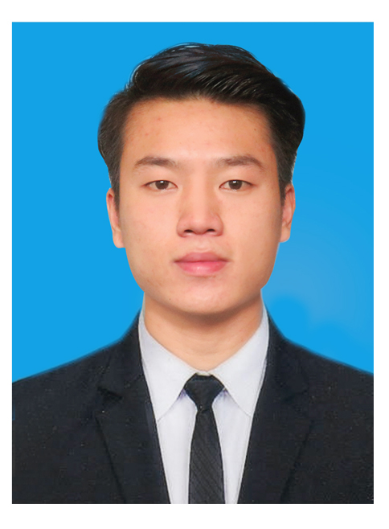**CURRICULUM VITAE**

Name: Sai Htun Lu

Address: Hlaing, Yangon.

Mobile: 09-264018885

Email: [saihtunlu14996@gmail.com](mailto:saihtunlu14996@gmail.com)

Date of Birth: 14 September 1996

Gender: Male

NRC No.: 13/LaYaNa(N)149120

Father Name: U Maung Thin

Religion: Buddhist

Github: [Sai Htun Lu](https://github.com/saihtunlu)

**EDUCATION**

**Bachelor of Technology (B-Tech) 2013-2017**

Major - Electronic Engineering (EC)

University - Technologies University, Lashio

**Bachelor of Engineering (BE) 2017-2019**

Major - Electronic Engineering (EC)

University - Technologies University, Lashio

**COURSES AND TRAINING**

* English 4 Skills
* Japanese (N5)
* Computer Basic, A+(Hardware, Software & Network), Multimedia (Ps)
* Arduino Programming (Basic of C/C++)
* PHP Bootcamp
* Python 3 + Django (Udemy)
* React + Redux (Udemy)
* Java (Udemy - Processing)

**TECHNICAL SKILLS**

Languages Arduino Programming(C/C++), JavaScript, TypeScript, PHP, Python, Java(core), HTML, Css.

Frameworks & Plugins Vue, React/React Native, Angular 2, JQuery, Laravel, Wordpress, Django, Express, Vuex, Redux, NgRx.

Databases & Servers MySQL, PostgreSQL, Nginx, Apache.

OS & Tools Microsoft Window Operating Systems, Ubuntu(Linux), XD, Photoshop, VSCode, Xampp.

Other Technical Woocommerce Facebook Integration, Messenger Chatbot, Google Analytics, Git, SVN.

Other Skills Troubleshooting PC and Mobile Problems, Software Installation, Testing, Strong in Self-study ++.

**EMPLOYMENT HISTORY**

**Mobile Service (Hardware & Software) 1 Year**

**Achievements:**

* Experienced in searching error and how to fix error or problem.
* Successfully fix all errors in time.

**360Digital (Software Developer) 1 Year**

**Achievements:**

* Experienced in writing code as a fullstack developer.
* Experienced in mobile development (both android and ios).

**PROJECTS**

**University Projects**

1. **Smart Greenhouse**
   * Automatic and manual (android application) control, informing and monitoring system via GSM Module.
2. **Gas Sensing System in factory**
3. **Smart Home**
   * Automatic or manual turn on/off devices.
4. **Alcohol Sensing System for safely driving**

**Web Development**

**- Personal Projects (for improving skill)**

1. **ZHOP (Ecommerce)**
   * This project was developed with Vue.js, Laravel and React Native.
   * For other small and testing projects, you can visit [my github account](https://github.com/saihtunlu).

**- Freelance Projects**

1. **Htun Lynn Online Store**
   * This project was developed with Wordpress using woocommerce.
2. **မွၵ်ႇငိုၼ်းၶဝ်ႈ(POS Software)**
   * This project was developed with Vue.js, Django and React Native.

**- Projects at Work**

1. **SMS (Student Management System)**
   * This project was developed with Vue.js, Laravel.
2. **Use your voice 2020**
   * This project was developed with Vue.js, django.
   * Actually, this project was developed for mobile first, it’s website is [Here](https://www.useyourvoice2020.org/)
3. **Mgou Myanmar**
   * This project was developed with Wordpress.
   * The project’s website is [Here](https://www.mgoumyanmar.com/)**.**
4. **Buymore**
   * This project was developed with Wordpress and React Native was used for mobile development.
   * The project’s website is [Here](https://www.buymore.com.mm/)**.**
5. **PMG Myanmar**
   * This project was developed with Wordpress (still developing).
   * The project’s website is [Here](https://pmg.com.mm/update/)
6. **POS (Company’s product)**
   * This project was developed with Vue.js, Django and React Native.