

YES OR NO?

WAREHOUSE / STOCKROOM 1

WAREHOUSE / STOCKROOM 2

WAREHOUSE / STOCKROOM 3

Customer Service

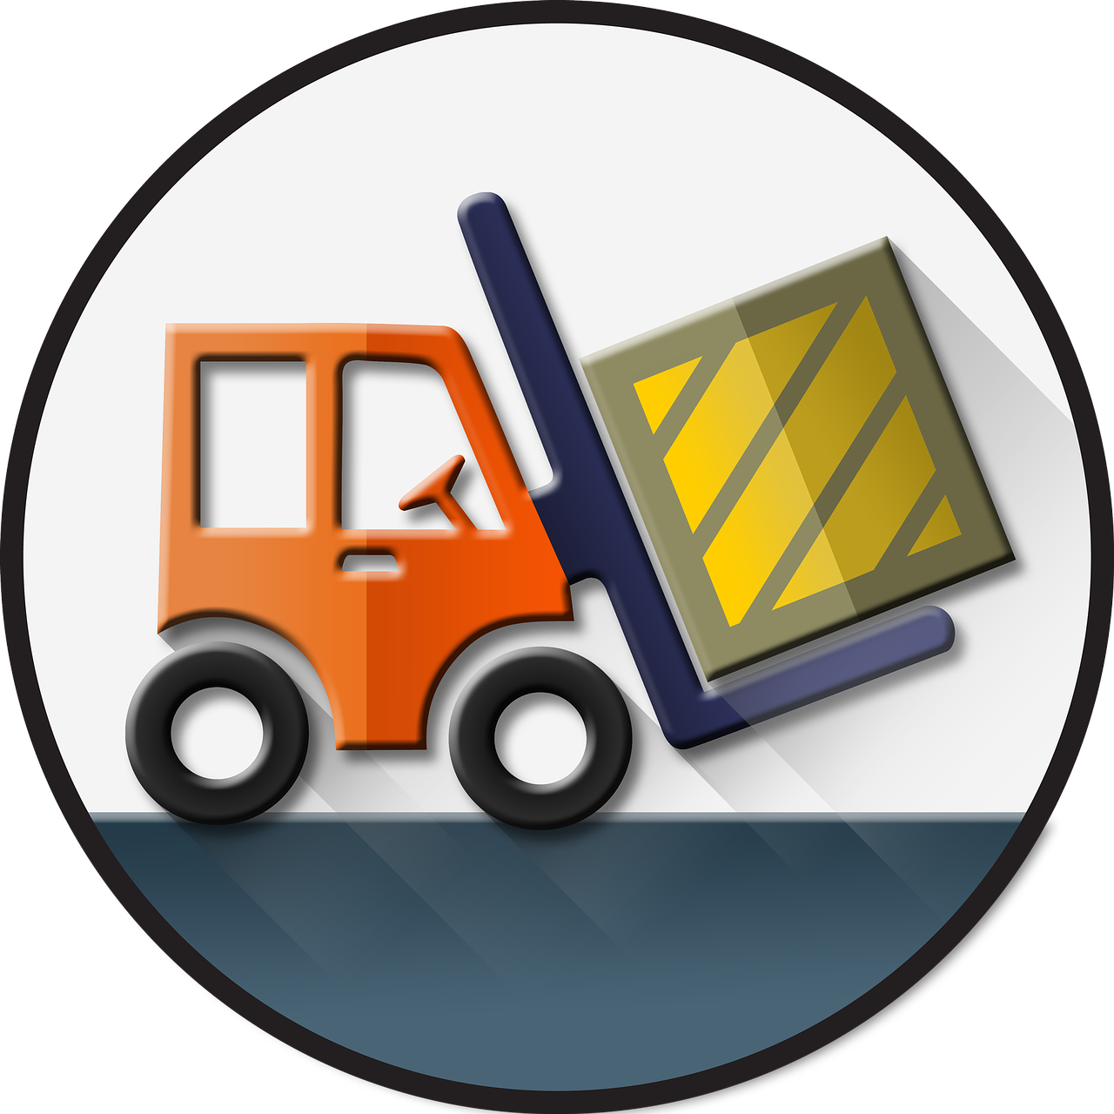

NO

YES

YES OR NO?

NO

YES

BRANCH

Customer

PURCHASE ORDER

CASHIER

SUPPLIER