|  |
| --- |
|  |
| BUSINESS REQUIREMENTS  DOCUMENT FOR  ROMBE PHILIPPINES INCORPORATED |
| **2023** |

**TABLE OF CONTENTS**

**REVISION HISTORY** 3

**APPROVALS** 4

**1.0 APPROACH** 5

**1.1 PROJECT INFORMATION** 5

**1.2 PURPOSE** 5

**2.0 PROJECT OVERVIEW** 6

**2.1 BUSINESS NEED** 6

**2.2 CURRENT STATE CONTEXT** 7

**2.3 PROPOSED SOLUTION** 8

**2.4 PROPOSED SYSTEM ARCHITECTURE** 8

**3.0 PROJECT INFORMATION** 9

**3.1 PROJECT GOAL AND OBJECTIVES** 9

**3.2 PROJECT SCOPE** 9

**3.3 PROJECT LIMITATION** 10

**3.4 ASSUMPTIONS AND CONSTRAINTS** 10

**3.5 ROLES AND RESPONSIBILITIES** 11

**4.0 TECHNICAL FEASIBILITY** 12

**4.1 PROGRAM ENVIRONMENT** 12

**4.2 SOFTWARE (Recommended)** 12

**5. HARDWARE (Recommended)** 12

#### **REVISION HISTORY**

|  |  |  |  |  |
| --- | --- | --- | --- | --- |
| **Revision Date** | **Revision No.** | **Revision Details** | **Updated By** | **Approved By** |
|  |  | Start the BRD |  |  |
|  |  |  |  |  |
|  |  |  |  |  |

### 

### 

### 

### 

### 

### 

### 

### 

### 

### **APPROVALS**

CLIENT <CLIENT NAME>

|  |  |  |  |
| --- | --- | --- | --- |
| Name | Title | Date | Signature |
|  |  |  |  |
|  |  |  |  |
|  |  |  |  |

SYSTEM PROVIDER <SLASH TECHNOLOGY SOLUTIONS>

|  |  |  |  |
| --- | --- | --- | --- |
| Name | Title | Date | Signature |
| Gen Borja | Chief Solutions Architect | 10/26/2022 |  |
|  |  |  |  |

|  |
| --- |
| **1.0 APPROACH** |

### **1.1 PROJECT INFORMATION**

This document describes the anticipated business procedure for the Client. The details outlined here determine how the ERP System will be configured to fulfill both functional and non-functional requirements of the Client. It is also designed to assist with project management and execution throughout the project's lifecycle. It focuses mostly on what should be the outcome and what should be provided in order to obtain value from the project.

### **1.2 PURPOSE**

The purpose of this document is to summarize functional and procedural requirements gathered by Slash Technology Solutions Inc. throughout the implementation's business requirements collecting phase.

This document contains information obtained during meetings with the {Rombe Philippines Team}, allowing the team to visualize the business needs to an efficient flow in the proposed system. There are no limits that have prevented us from attaining all the criteria that we need. Working remotely did not affect requirements. Lack of physical observation, inspection did not limit our understanding of the Client’s processes. Once complete, this document will serve as a blueprint for the team to configure the application.

As a starting point for this project, a set of process mapping questionnaires concentrating on the core areas of the business were utilized. This document follows the same format as the surveys, categorizing the findings into the same major process categories. This documentation contains all of the Customer's business needs.

### 

|  |
| --- |
| **2.0 PROJECT OVERVIEW** |

### **2.1 BUSINESS NEED**

Computer technology has now become an essential part of everyday life. Many opportunities are emerging on the internet as a result of the massive increase in internet and technology knowledge. Several new businesses and companies may now be established with relative ease through the use of the internet. Technology has made some of the biggest contributions to the business field. The utilization of computer technology has greatly benefited several firms, particularly in the business industry.

Slash ERP System is a type of software system that supports businesses in automating and controlling basic company operations with the goal of achieving high performance at Rombe Philippines Incorporated. Typically, the company's warehouses are not integrated, so the supplies and inventories that enter their warehouses cannot be tracked. The other branches of the Rombe Company struggle to monitor and track supplies, inventories, and P.O. Even though they have an existing Sales and inventory management system that their main branch currently employs to conduct their business, it is incapable of interfacing with external systems and other branches of company. The system utilized to operate and execute transactions at Rombe PH Inc. is in desperate need of improvement.

The use of an IT-based solution is the most effective method to address the aforementioned problem. Slash Tech Solutions Corp. develops an automated monitoring system for civic usage. The technology will eliminate all of the difficulties and errors that occurred during the manual procedure.

### **2.2 CURRENT STATE CONTEXT**

FIGURE 2.2.1

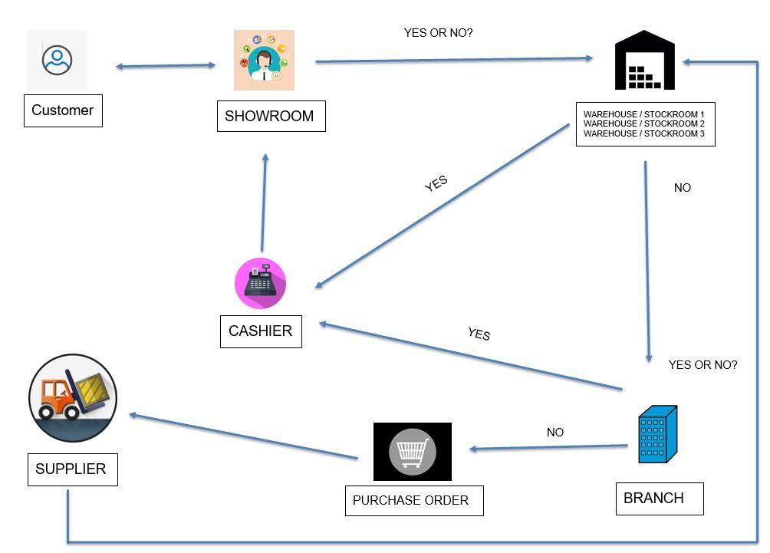

### **2.3 PROPOSED SOLUTION**

Provide a full-scale ERP system capable of integrating into future branches and warehouses with user access creation and admin privileges, as well as tracking and monitoring inventory, sales, and PO management for all the company's branches. The aforementioned system will solve all the problems and errors. It offers a simple method for monitoring the inventory of all branches. The ERP system implementation will enhance overall services. This ERP system provides better planning, decision-making and reporting. STSC developed a system for the purpose to track the operations of all branches. It was designed to guarantee information flow inside the company.

### **2.4 PROPOSED SYSTEM ARCHITECTURE**

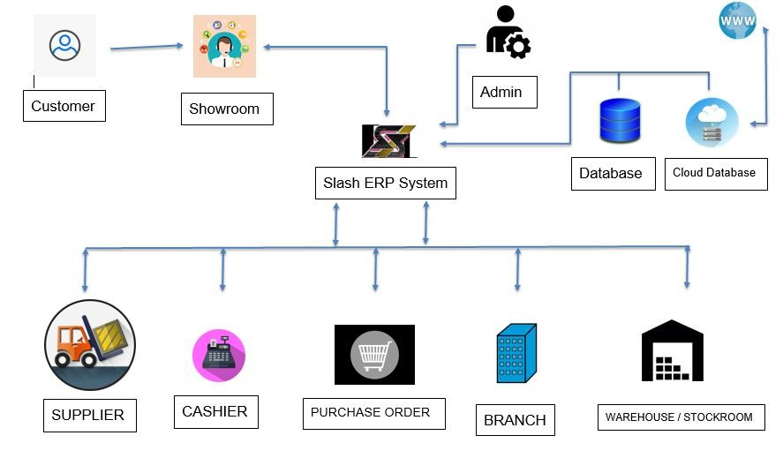

|  |
| --- |
| **3.0 PROJECT INFORMATION** |

### **3.1 PROJECT GOAL AND OBJECTIVES**

The main objective of the project is to develop an ERP system that will perform convenient process with real-time monitoring in every stock from their warehouses. This system is integrated into a company to conduct efficient, effectively manage and coordinate all company goals.

Furthermore, the identified goals are:

* To maintain accuracy inventory levels
* To reduce the workload and make easier to keep tracking the company's product information
* To forecast the company insufficient, overstock, sufficient and no longer maintained through analytic dashboard
* Ease of use when it comes to updating inventory levels
* To monitor and manage supply chain and business processes with higher efficiency
* To increase organizational productivity in a company by controlling and enhancing how business resources are utilized
* To assist with several elements of a business

### **3.2 PROJECT SCOPE**

* **Analytic Dashboard Module** - The analytic dashboard will assist the user in forecasting the company's requirement to replenish inventories. A forecasting dashboard allows users to immediately assess if a product is insufficient, overstocked, sufficient, or no longer maintained.
* **History Module** - The activity log contains a historical review of the user's actions, events, and activity. It includes the date, time, and the name of the person who operates the system.
* **User Module** - The user was divided into two roles: admin and superadmin. The admin role is for viewing and uploading files, while the superadmin role provides overall system control, including the ability to edit, delete, and add new users.
* **Inventory Module** - The inventory module can help the user maintain control of the company’s stock at all times. It can maximize the availability of product information.
* **Monitoring Module -** The user may simply keep monitoring the list of categories by product and status.
* **Admin Interface** - It contains employee master data, which allows user to view a list of employees, as well as product settings, where you can change the categories, brands, variations, pricing, and payment methods for products. also Inventory and warehouse type can relate to each company's warehouse inventory.
* **Purchase Order Interface** - The user may view the types of transactions in the purchasing of order in this interface, whether it is a single transaction or a bulk transaction. The good receipt is used to document and monitor the transportation of products from one seller to another into a warehouse. Accounts payable (AP) invoicing is the process of receiving, documenting, routing, and executing payments on invoices.
* **Sales Order Interface** - This interface may assist users in tracking sales at business warehouses. It certifies the sale of products or services and specifies the terms of the transaction, such as the amount, price, and quality of goods or services given.

### **3.3 PROJECT LIMITATION**

* The API connection to their current system or any other system the client have
* Product content management system (CMS)
* Chat functionality within the Client’s Organization
* Text Blast
* Banking finance
* Email Notification
* Product barcode tagging

### **3.4 ASSUMPTIONS AND CONSTRAINTS**

The following assumptions are made by the Implementation team. This will apply to processes, requirements, and/or other information unless otherwise stated in this documentation.

* Standard process means as-is system feature or functionality.
* The Clients will maximize the use of standard system functionality.
* The Client will use standard system forms including fields and layout.
* Additional fields, list, and forms indicated in this document will be configured into the system by Slash Tech functional consultant / project manager.
* The Client will use System Documentation pages as a supplement reference.
* Any setup and or configuration that will be done in the system, which was not thoroughly discussed during Business Process Interviews, but nevertheless stated in the requirements, based on the established best practices of Slash Tech, are deemed accepted by the Client upon signing of this document.

### **3.5 ROLES AND RESPONSIBILITIES**

**Slash Technology Solutions Inc.**

|  |  |
| --- | --- |
| **Project Sponsor** | Gen Borja |
| **Project Manager** |  |
| **Functional Consultants** | Cyrus Machete / Regin Legaspi |
| **Technical Consultants** | Mark Camu |
| **Account Manager** | Gen Borja |

**The Client**

|  |  |
| --- | --- |
| **Project Sponsor** |  |
| **Project Manager** |  |
| **Technical Manager** |  |
| **Business Process Owners** *(by Business Cycle)* |  |

|  |
| --- |
| **4.0 TECHNICAL FEASIBILITY** |

#### **4.1 PROGRAM ENVIRONMENT**

Front End

* HTML
* CSS
* JavaScript
* JSP

Back End

* HTML
* CSS
* JavaScript
* JSP

#### **4.2 SOFTWARE (Recommended)**

* + JAVA
  + Apache Strut 2
  + MSSQL R2 2008
  + IntelliJ
  + Cloud Database

#### **5. HARDWARE (Recommended)**

* Windows 10 64x
* Hard Disk: At Least 1TB
* SSD 250GB
* Memory: 8GB or Higher
* Processor: i5 10th GEN 4.3 GHz or faster 64-bit processor
* Monitor
* Mouse
* Physical Database Server (optional)