Date:2/09/2024

1.Hello World!

Print ("Hello, World!")

2.Comment

#This is a comment

3.Variable

x = 5  
y = "John"  
print(x)  
print(y)

Number

X=1 #int

Y=2.8 #float

Z=1j #Complex

4.Datatype

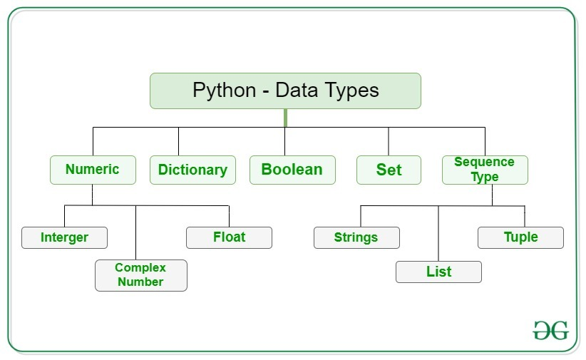

* List

List can be modified. their element can be changed, Added, Remove.

They Used More Memory & their size is Dynamic.

Lists are created using square brackets



* Tuple

Tuple Cannot be Modify. Their element cannot be changed, added or remove.

They used less memory and their size is fix.

Tuples are written with round brackets.



* Sets

Sets are used multiple items in a single variable.

Sets is a collection which is unorder, unchangeable and unindexed.

Sets are written with curly brackets.



5.Operator

* Arithmetic operators
* Assignment operators
* Comparison operators
* Logical operators
* Identity operators
* Membership operators
* Bitwise operators

6.Python Conditions and If statements

Python supports the usual logical conditions from mathematics:

* Equals: a == b
* Not Equals: a != b
* Less than: a < b
* Less than or equal to: a <= b
* Greater than: a > b
* Greater than or equal to: a >= b

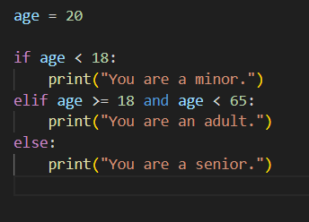

7.Loops

Python has two primitive loop commands:

* while loops: Check Boolean condition then execute a code is called while Loop.
* for loop: For Loops Means execute a Loop in n Specific Time.

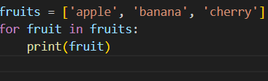

8.Function

A function is a block of code which only runs when it is called.You can pass data, known as parameters, into a function.A function can return data as a result.

Example:

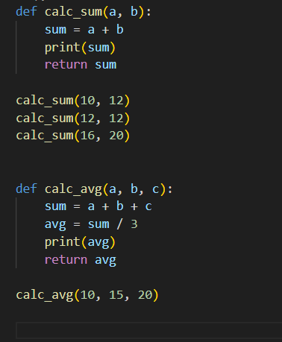

9.Lambda Function

A lambda function is a small anonymous function.

Example:

