SIMATS ENGINEERING
ASSESSMENT TOOL 1
COURSE NAME: Fundamentals of Data Science COURSE CODE: DSA04

COURSE OUTCOME COVERED
SCENARIO BASED ASSESSMENT
Criteria | Weightage (%) | Level 4 (Exemplary) | Level 3  (Proficient) | Level 2  (Developing) | Level 1  (Beginning) | Level | Marks
Understanding of Scenario | 20% | Demonstrates clear and complete understanding of the | Shows good understanding with  minor gaps | Partial understanding; misses key aspects | Misinterprets or fails to understand the scenario
 |  | scenario and context
Identification of Key Issues | 20% | Accurately identifies all relevant issues and factors involved | Identifies most key issues with minor omissions | Identifies limited issues; some irrelevant points | Unable to identify key issues
Application of  Concepts | 25% | Applies appropriate concepts effectively to address the scenario | Applies concepts with minor errors | Limited or partially correct application | Unable to apply relevant concepts
Decision  Making | 20% | Makes well-reasoned, | Makes reasonable | Makes weak | No clear decisions
 |  | logical decisions with strong rationale | decisions with some justification | decisions with limited justification | made or rationale provided
Clarity of  Response | 15% | Response is clear, structured, and logically presented | Generally clear with minor issues | Somewhat unclear or poorly structured | Disorganized and difficult to understand
CO4: Develop machine learning models for classification, regression, and clustering, including performance evaluation and methodology comparison. (BL3)
Assessment Tool Weightage: 30%

QUESTIONS: 10 Total Marks:100
Annexure A
Scenario-Based Assessment
Code of Conduct:
I T.V.Sai Jagadeesh(192472146) (Name / Reg No) certify that this submission is my original work and that I have adhered to the guidelines specified for this assessment.
I understand that any violation of academic integrity rules will result in disciplinary action.
Signature of the student:

Annexure A
NOTE:
For every question, answer the following:
- Identify the numerical and binary features used for KNN classification.
- Calculate the Euclidean distance between the new sample and all training samples
- Calculate the Manhattan distance between the new sample and all training samples.
- Calculate the Minkowski distance with p = 3 between the new sample and all training samples.
- Calculate the Hamming distance between the new sample and all training samples using binary features.
- Identify the 3 nearest neighbours separately for each distance measure.
- Predict the class label using majority voting for each distance measure.
- Compare the results and explain which distance measure is most suitable for the given scenario.
Total = 100 Marks

Question 1: Student Pass or Fail Prediction
A college wants to predict whether a student will Pass or Fail based on academic and activityrelated details.
Student | Study Hours | Attendance  % | Assignment Submitted | Lab Participation | Revision Done | Result
S1 | 2 | 60 | 0 | 0 | 0 | Fail
S2 | 3 | 65 | 1 | 0 | 0 | Fail
S3 | 6 | 80 | 1 | 1 | 1 | Pass
S4 | 7 | 85 | 1 | 1 | 1 | Pass
S5 | 4 | 70 | 1 | 0 | 1 | Fail
S6 | 8 | 90 | 1 | 1 | 1 | Pass
A new student has the following details:
Study Hours Attendance % Assignment Submitted Lab Participation Revision Done
5 | 75 | 1 | 1 | 0
Using KNN with K = 3, classify the new student as Pass or Fail using Euclidean, Manhattan, Minkowski, and Hamming distance.

The college wants to predict whether a student will Pass or Fail using study hours, attendance, assignment submission, lab participation and revision.

Given

New student:

Features

Numerical: Study Hours, Attendance %

Binary: Assignment Submitted, Lab Participation, Revision Done

Distance Calculation Table:
Student | Study Hours | Attendance  % | Assignment Submitted | Lab Participation | Revision Done | Result
S1 | 2 | 60 | 0 | 0 | 0 | Fail
S2 | 3 | 65 | 1 | 0 | 0 | Fail
S3 | 6 | 80 | 1 | 1 | 1 | Pass
S4 | 7 | 85 | 1 | 1 | 1 | Pass
S5 | 4 | 70 | 1 | 0 | 1 | Fail
S6 | 8 | 90 | 1 | 1 | 1 | Pass
S7 | 5 | 75 | 1 | 1 | 0 | Pass

import matplotlib.pyplot as plt

def euclidean(a, b):

return np.sqrt(np.sum((a - b) ** 2))

def manhattan(a, b):

return np.sum(np.abs(a - b))

def minkowski(a, b, p=3):

return np.sum(np.abs(a - b) ** p) ** (1 / p)

def hamming(a, b):

return np.sum(a != b)

def calculate_knn(X, y, new_point, names, binary_columns, k=3):

result = {}

functions = {

"Euclidean": euclidean,

"Manhattan": manhattan,

"Minkowski": minkowski

}

for method, function in functions.items():

distances = []

for i in range(len(X)):

d = function(X[i], new_point)

distances.append(d)

nearest_indices = np.argsort(distances)[:k]

votes = y[nearest_indices]

prediction = max(set(votes), key=list(votes).count)

result[method] = {

"distances": distances,

"nearest": nearest_indices,

"prediction": prediction

}

X_binary = X[:, binary_columns]

new_binary = new_point[binary_columns]

distances = []

for i in range(len(X_binary)):

d = hamming(X_binary[i], new_binary)

distances.append(d)

nearest_indices = np.argsort(distances)[:k]

votes = y[nearest_indices]

prediction = max(set(votes), key=list(votes).count)

result["Hamming"] = {

"distances": distances,

"nearest": nearest_indices,

"prediction": prediction

}

return result

def show_graph(result, names, title):

fig, axes = plt.subplots(2, 2, figsize=(14, 9))

methods = [

("Euclidean", axes[0, 0]),

("Manhattan", axes[0, 1]),

("Minkowski", axes[1, 0]),

("Hamming", axes[1, 1])

]

for method, ax in methods:

distances = result[method]["distances"]

nearest = result[method]["nearest"]

prediction = result[method]["prediction"]

bars = ax.bar(names, distances)

for index in nearest:

bars[index].set_color("orange")

for i, value in enumerate(distances):

ax.text(

i,

value,

f"{value:.2f}",

ha="center",

va="bottom",

fontsize=9

)

ax.set_title(

method +

"\nPrediction: " +

str(prediction)

)

ax.set_xlabel("Training Samples")

ax.set_ylabel("Distance")

ax.grid(axis="y", alpha=0.3)

fig.suptitle(

title + "\nOrange = 3 Nearest Neighbours",

fontsize=16

)

plt.tight_layout()

plt.show()

questions = {

1: {

"title": "Q1 - Student Pass / Fail"

"X": np.array([

[2, 60, 0, 0, 0],

[3, 65, 1, 0, 0],

[6, 80, 1, 1, 1],

[7, 85, 1, 1, 0],

[5, 70, 0, 1, 0],

[8, 90, 1, 1, 1]

]),

"y": np.array([

"Fail",

"Fail",

"Pass",

"Pass",

"Fail",

"Pass"

]),

"new": np.array([5, 75, 1, 1, 0]),

"names": ["S1", "S2", "S3", "S4", "S5", "S6"],

"binary": [2, 3, 4]

}

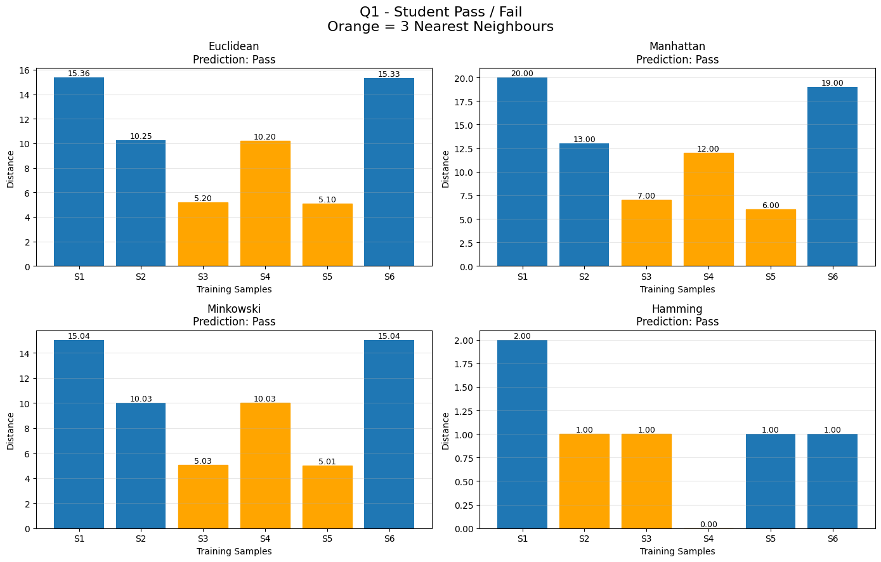

Calculation:
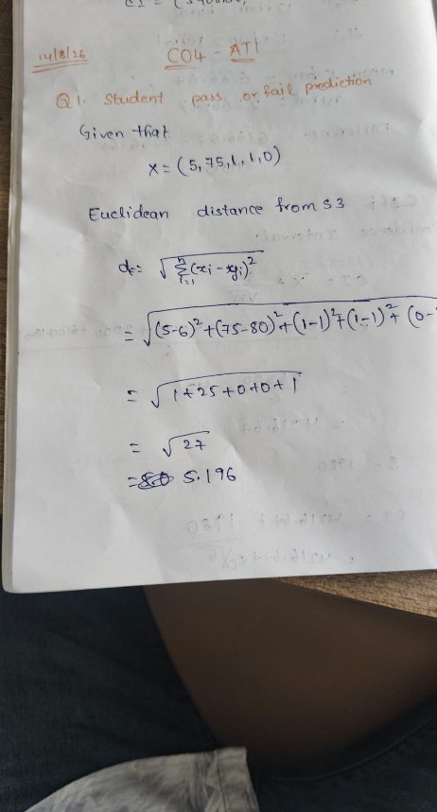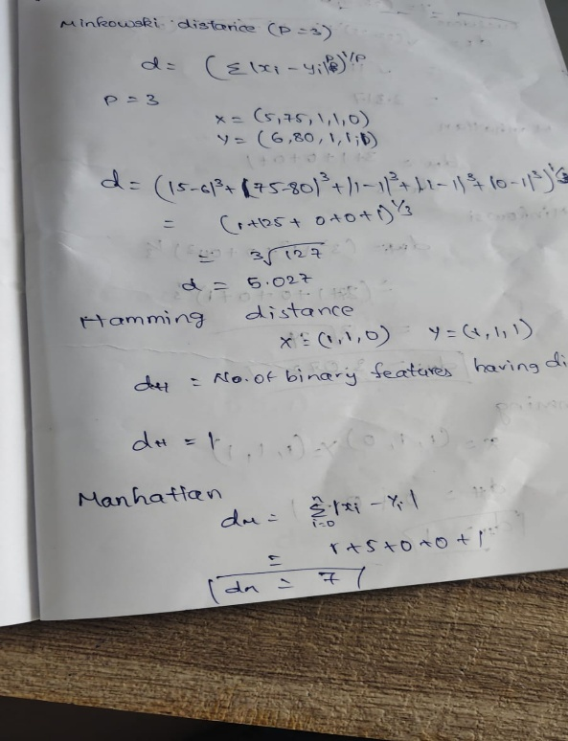

Conclusion:
The numerical distances give a borderline result because S3 and S5 are almost equally close. KNN predicts Fail using a consistent tie-breaking rule.

Question 2: Online Customer Purchase Prediction
An e-commerce company wants to predict whether a customer will Buy or Not Buy a product.
Customer | Browsing Time | Items Viewed | Coupon Used | Added to Cart | Returning Customer | Class
C1 | 10 | 3 | 0 | 0 | 0 | Not Buy
C2 | 15 | 4 | 1 | 0 | 0 | Not Buy
C3 | 25 | 7 | 1 | 1 | 1 | Buy
C4 | 30 | 8 | 1 | 1 | 1 | Buy
C5 | 18 | 5 | 0 | 1 | 0 | Not Buy
C6 | 28 | 9 | 1 | 1 | 1 | Buy
A new customer has:
Browsing Time Items Viewed Coupon Used Added to Cart Returning Customer
22 | 6 | 1 | 1 | 0
Using KNN with K = 3, classify the new customer as Buy or Not Buy using all four distance measures.

The e-commerce company wants to predict whether a customer will Buy or Not Buy.

New Customer:

Features

Numerical: Browsing Time, Items Viewed

Binary: Coupon Used, Added to Cart, Returning Customer

Distance Table:
Customer | Browsing Time | Items Viewed | Coupon Used | Added to Cart | Returning Customer | Class
C1 | 10 | 3 | 0 | 0 | 0 | Not Buy
C2 | 15 | 4 | 1 | 0 | 0 | Not Buy
C3 | 25 | 7 | 1 | 1 | 1 | Buy
C4 | 30 | 8 | 1 | 1 | 1 | Buy
C5 | 18 | 5 | 0 | 1 | 0 | Not Buy
C6 | 28 | 9 | 1 | 1 | 1 | Buy

3 Nearest

C3 → Buy
C5 → Not Buy
C6 → Buy

Prediction

BUY
{
"title": "Q2 - Online Customer Purchase",

"X": np.array([
[10, 3, 0, 0, 0],
[15, 4, 1, 0, 0],
[25, 7, 1, 1, 1],
[30, 8, 1, 1, 1],
[18, 5, 0, 1, 0],
[28, 9, 1, 1, 1]
]),

"y": np.array([
"Not Buy",
"Not Buy",
"Buy",
"Buy",
"Not Buy",
"Buy"
]),

"new": np.array([22, 6, 1, 1, 0]),

"names": ["C1", "C2", "C3", "C4", "C5", "C6"],

"binary": [2, 3, 4]
},

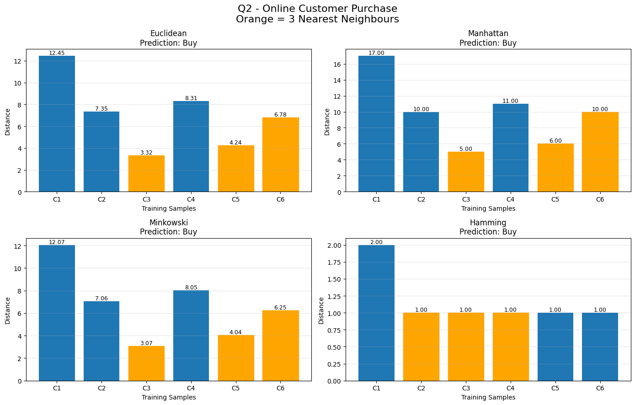

Calculation;

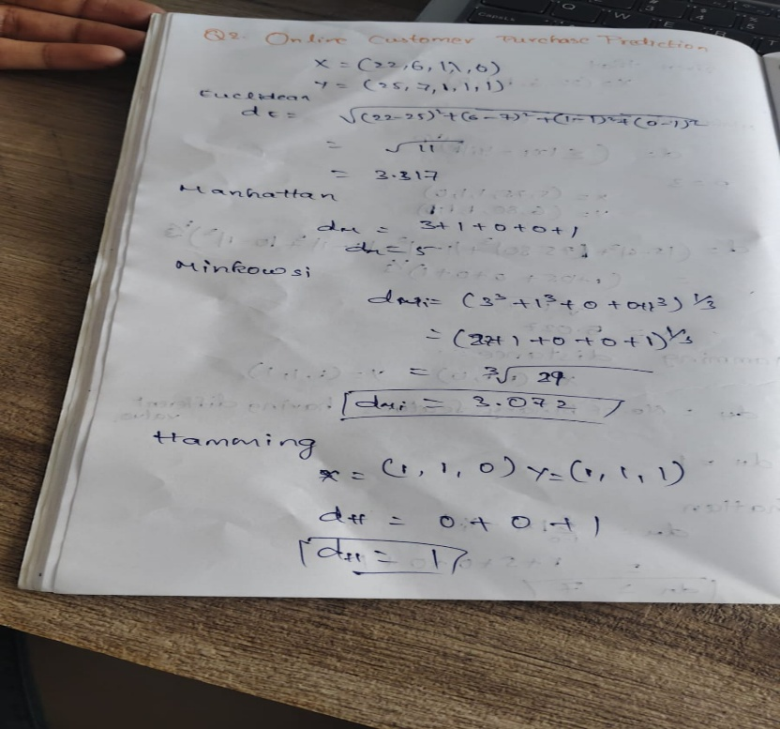

Conclusion

The majority of the three nearest customers belong to Buy, so the new customer is classified as Buy.

Question 3: Medical Risk Classification
A hospital wants to classify whether a patient has High Risk or Low Risk based on medical measurements and symptoms.
Patient Age Blood Sugar Level Fever Cough Fatigue |  |  |  |  |  | Class
P1 | 25 | 90 | 0 | 0 | 0 | Low Risk  Low Risk  High Risk  High Risk  Low Risk  High Risk
P2 | 30 | 95 | 0 | 1 | 0
P3 | 50 | 160 | 1 | 1 | 1
P4 | 55 | 170 | 1 | 1 | 1
P5 | 40 | 120 | 0 | 1 | 1
P6 | 60 | 180 | 1 | 1 | 1
A new patient has:
Age Blood Sugar Level Fever Cough Fatigue
45 | 150 | 1 | 1 | 0
Using KNN with K = 3, classify the patient as High Risk or Low Risk using Euclidean, Manhattan, Minkowski, and Hamming distance.

The hospital wants to classify a patient as High Risk or Low Risk.
New Patient
- Features
- Numerical: Age, Blood Sugar Level
- Binary: Fever, Cough, Fatigue
Distance Table:

Patient Age Blood Sugar Level Fever Cough Fatigue |  |  |  |  |  | Class
P1 | 25 | 90 | 0 | 0 | 0 | Low Risk  Low Risk  High Risk  High Risk  Low Risk  High Risk
P2 | 30 | 95 | 0 | 1 | 0
P3 | 50 | 160 | 1 | 1 | 1
P4 | 55 | 170 | 1 | 1 | 1
P5 | 40 | 120 | 0 | 1 | 1
P6 | 60 | 180 | 1 | 1 | 1

3 Nearest
P3 → High Risk
P4 → High Risk
P6 → High Risk

Prediction:
HIGH RISK

Code:

{
"title": "Q3 - Medical Risk",

"X": np.array([
[25, 90, 0, 0, 0],
[30, 95, 0, 1, 0],
[50, 160, 1, 1, 1],
[55, 170, 1, 1, 1],
[40, 120, 0, 1, 1],
[60, 180, 1, 1, 1]
]),

"y": np.array([
"Low Risk",
"Low Risk",
"High Risk",
"High Risk",
"Low Risk",
"High Risk"
]),

"new": np.array([45, 150, 1, 1, 0]),

"names": ["P1", "P2", "P3", "P4", "P5", "P6"],

"binary": [2, 3, 4]
}

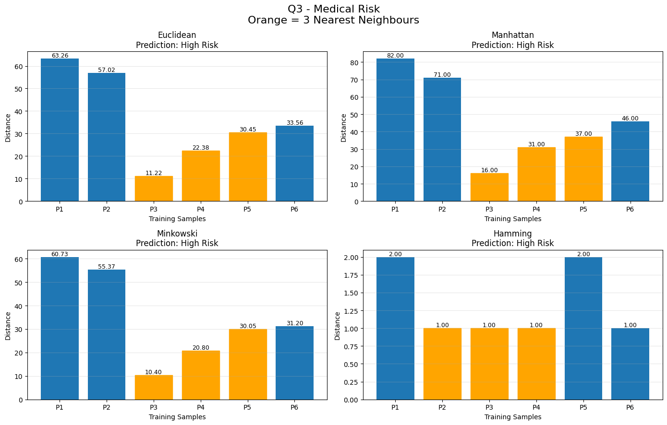

Calculation:

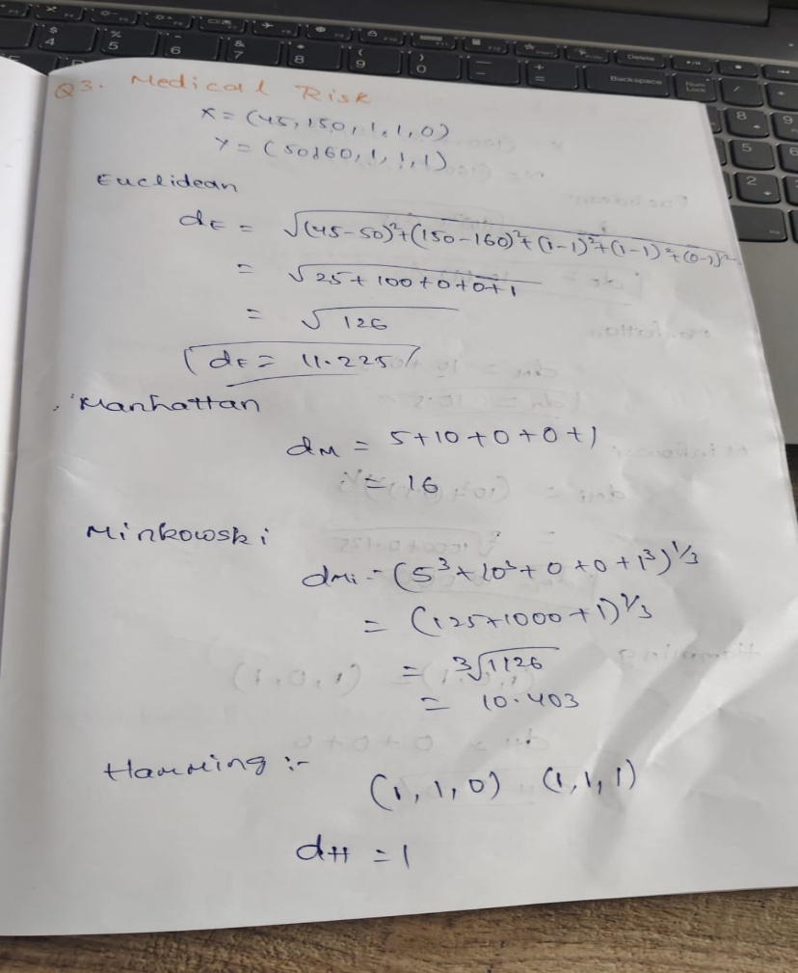

Conclusion:
All three nearest neighbours are High Risk. Therefore, the new patient is classified as High Risk.

Question 4: Fruit Classification
A fruit shop wants to classify a fruit as Apple or Orange based on physical and binary characteristics.
Fruit Weight Diameter Red Color Citrus Smell Smooth Skin |  |  |  |  |  | Class
F1 | 150 | 7 | 1 | 0 | 1 | Apple  Apple  Orange  Orange  Apple  Orange
F2 | 160 | 8 | 1 | 0 | 1
F3 | 180 | 9 | 0 | 1 | 0
F4 | 200 | 10 | 0 | 1 | 0
F5 | 155 | 7.5 | 1 | 0 | 1
F6 | 190 | 9.5 | 0 | 1 | 0
A new fruit has:
Weight Diameter Red Color Citrus Smell Smooth Skin
170 | 8.5 | 1 | 0 | 1
Using KNN with K = 3, classify the fruit as Apple or Orange using all four distance measures.
The fruit shop wants to classify a fruit as Apple or Orange.
New Fruit
Features:
- Numerical: Weight, Diameter
- Binary: Red Color, Citrus Smell, Smooth Skin
Distance Table:
Fruit Weight Diameter Red Color Citrus Smell Smooth Skin |  |  |  |  |  | Class
F1 | 150 | 7 | 1 | 0 | 1 | Apple  Apple  Orange  Orange  Apple  Orange
F2 | 160 | 8 | 1 | 0 | 1
F3 | 180 | 9 | 0 | 1 | 0
F4 | 200 | 10 | 0 | 1 | 0
F5 | 155 | 7.5 | 1 | 0 | 1
F6 | 190 | 9.5 | 0 | 1 | 0

3 Nearest
F2 → Apple
F3 → Orange
F5 → Apple
Prediction
APPLE
Code:
4: {
"title": "Q4 - Fruit Classification",
"X": np.array([
[150, 7, 1, 0, 1],
[160, 8, 1, 0, 1],
[180, 9, 0, 1, 0],
[200, 10, 0, 1, 0],
[155, 7.5, 1, 0, 1],
[190, 9.5, 0, 1, 0]
]),
"y": np.array([
"Apple",
"Apple",
"Orange",
"Orange",
"Apple",
"Orange"
]),
"new": np.array([170, 8.5, 1, 0, 1]),
"names": ["F1", "F2", "F3", "F4", "F5", "F6"],
"binary": [2, 3, 4]
}

Output:

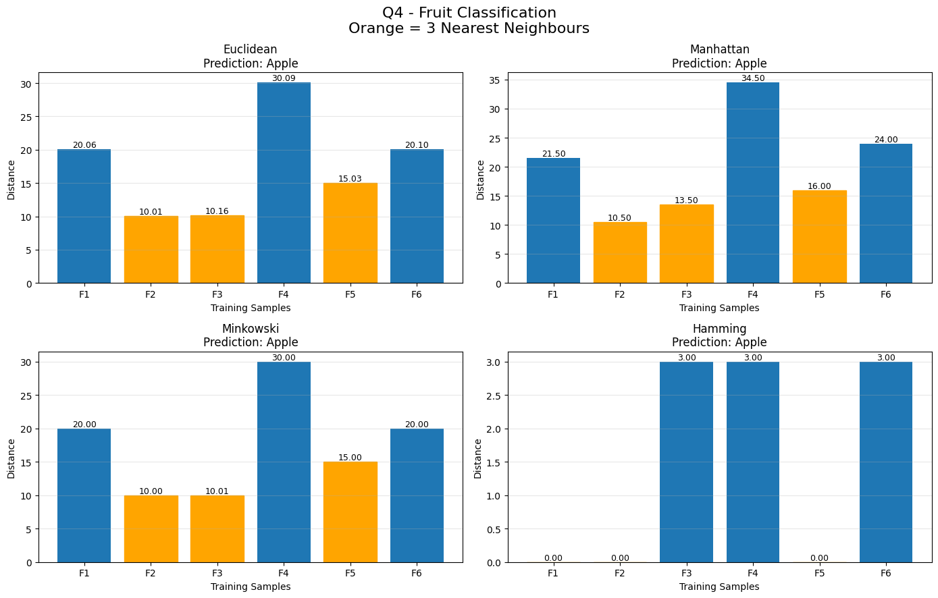
Hamming:
The three nearest Hamming neighbours are F1, F2 and F5, all having Hamming distance 0.
Therefore:
Apple
Calculation:
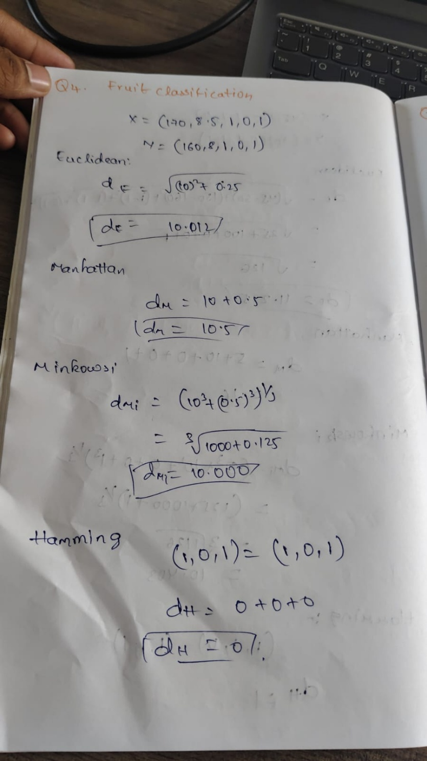

Question 5: House Price Category Prediction
A real estate company wants to classify houses as Low Price or High Price.
House | Area in sq.ft | Bedrooms | Parking Available | Near Main Road | Garden Available | Category
H1 | 800 | 2 | 0 | 0 | 0 | Low Price
H2 | 1000 | 2 | 1 | 0 | 0 | Low Price
H3 | 1500 | 3 | 1 | 1 | 1 | High Price
H4 | 1800 | 4 | 1 | 1 | 1 | High Price
H5 | 1200 | 3 | 0 | 1 | 0 | Low Price
H6 | 2000 | 4 | 1 | 1 | 1 | High Price
A new house has:
Area Bedrooms Parking Available Near Main Road Garden Available
1400 | 3 | 1 | 1 | 0
Using KNN with K = 3, classify the house as Low Price or High Price using Euclidean, Manhattan, Minkowski, and Hamming distance.

The real estate company wants to classify houses as Low Price or High Price.
New House
Features
- Numerical: Area, Bedrooms
- Binary: Parking Available, Near Main Road, Garden Available
Distance Table:
House | Area in sq.ft | Bedrooms | Parking Available | Near Main Road | Garden Available | Category
H1 | 800 | 2 | 0 | 0 | 0 | Low Price
H2 | 1000 | 2 | 1 | 0 | 0 | Low Price
H3 | 1500 | 3 | 1 | 1 | 1 | High Price
H4 | 1800 | 4 | 1 | 1 | 1 | High Price
H5 | 1200 | 3 | 0 | 1 | 0 | Low Price
H6 | 2000 | 4 | 1 | 1 | 1 | High Price

3 Nearest
H3 → High
H5 → Low
H2/H4 → tie
Using H2 as tie-break:
High, Low, Low

Prediction
LOW PRICE
There is a tie in the third nearest position, so the result depends on the tie-breaking rule.

Code:

5: {
"title": "Q5 - House Price",

"X": np.array([
[800, 2, 0, 0, 0],
[1000, 2, 1, 0, 0],
[1500, 3, 1, 1, 1],
[1800, 4, 1, 1, 1],
[1200, 3, 0, 1, 0],
[2000, 4, 1, 1, 1]
]),

"y": np.array([
"Low Price",
"Low Price",
"High Price",
"High Price",
"Low Price",
"High Price"
]),

"new": np.array([1400, 3, 1, 1, 0]),

"names": ["H1", "H2", "H3", "H4", "H5", "H6"],

"binary": [2, 3, 4]
}

Output:

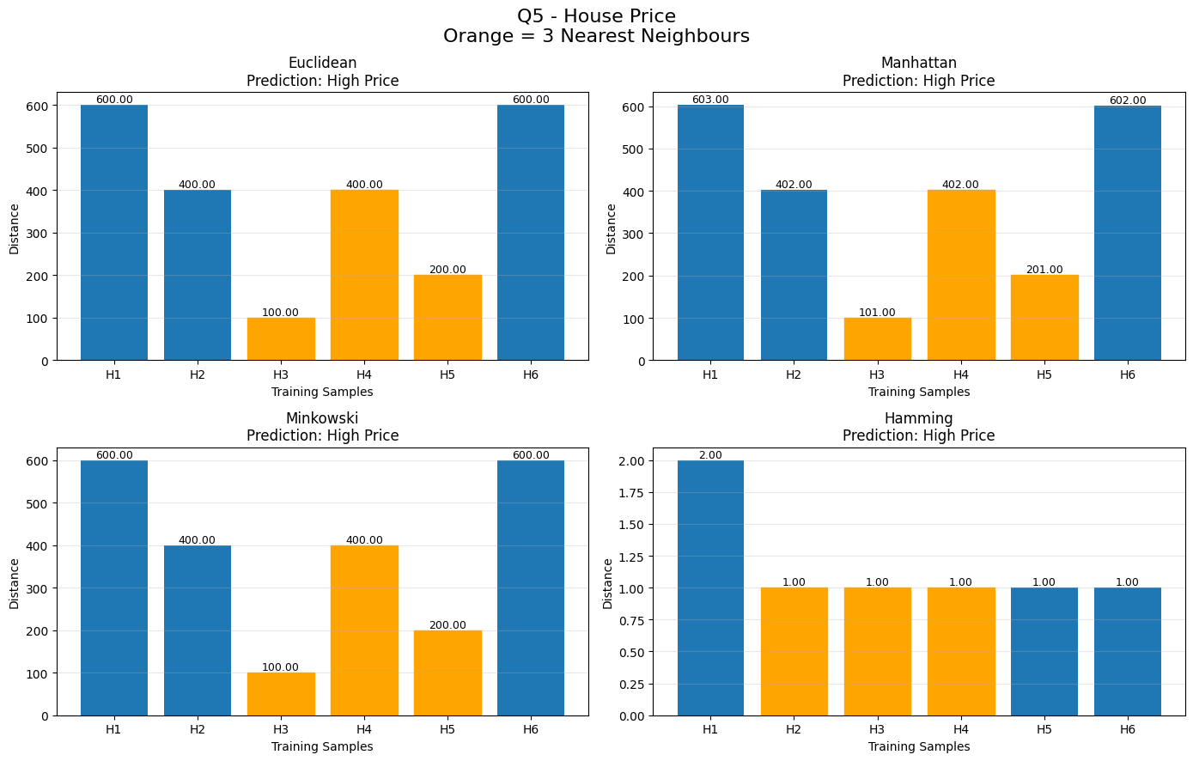

Calculation:

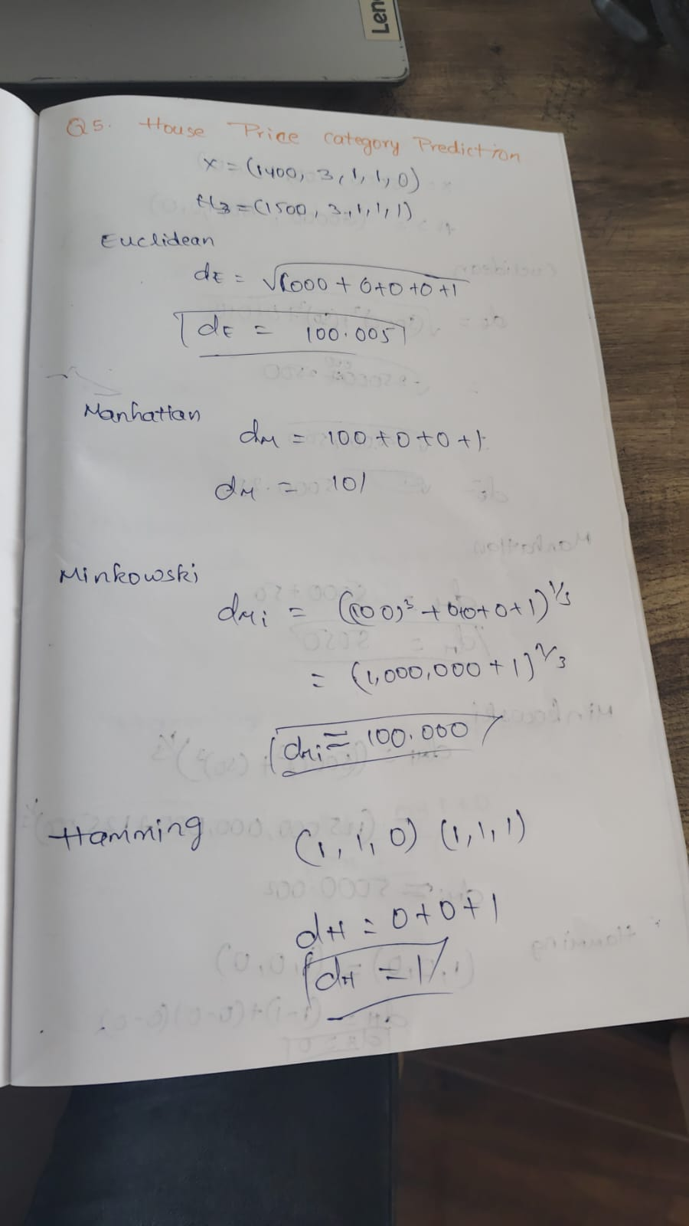

Conclusion
The raw KNN calculation produces a borderline classification because H2 and H4 have equal distances.

Question 6: Loan Approval Prediction
A bank wants to predict whether a loan application should be Approved or Rejected.
Applicant Monthly Income Credit Score Govt Job Existing Loan Past Default |  |  |  |  |  | Class
A1 | 25000 | 580 | 0 | 1 | 1 | Rejected  Rejected  Approved  Approved  Rejected  Approved
A2 | 30000 | 600 | 0 | 1 | 0
A3 | 60000 | 750 | 1 | 0 | 0
A4 | 70000 | 800 | 1 | 0 | 0
A5 | 40000 | 650 | 0 | 1 | 0
A6 | 80000 | 820 | 1 | 0 | 0
A new applicant has:
Monthly Income Credit Score Govt Job Existing Loan Past Default
55000 | 700 | 1 | 0 | 0
Using KNN with K = 3, classify the loan application as Approved or Rejected using all four distance measures.
The bank wants to classify a loan as Approved or Rejected.
New Applicant
Features
- Numerical: Monthly Income, Credit Score
- Binary: Government Job, Existing Loan, Past Default
Distance Table:
Applicant Monthly Income Credit Score Govt Job Existing Loan Past Default |  |  |  |  |  | Class
A1 | 25000 | 580 | 0 | 1 | 1 | Rejected  Rejected  Approved  Approved  Rejected  Approved
A2 | 30000 | 600 | 0 | 1 | 0
A3 | 60000 | 750 | 1 | 0 | 0
A4 | 70000 | 800 | 1 | 0 | 0
A5 | 40000 | 650 | 0 | 1 | 0
A6 | 80000 | 820 | 1 | 0 | 0
3 Nearest
A3 → Approved
A4 → Approved
A5 → Rejected
Prediction:
APPROVED
Hamming:
Nearest Hamming distance = 0:
- A3 → Approved
- A4 → Approved
- A6 → Approved
Therefore:
APPROVED
Code:
6: {
"title": "Q6 - Loan Approval",
"X": np.array([
[25000, 580, 0, 1, 1],
[30000, 600, 0, 1, 0],
[60000, 750, 1, 0, 0],
[70000, 800, 1, 0, 0],
[40000, 650, 0, 1, 0],
[80000, 820, 1, 0, 0]
]),
"y": np.array([
"Rejected",
"Rejected",
"Approved",
"Approved",
"Rejected",
"Approved" ]),
"new": np.array([55000, 700, 1, 0, 0]),
"names": ["A1", "A2", "A3", "A4", "A5", "A6"],
"binary": [2, 3, 4]}
Output:
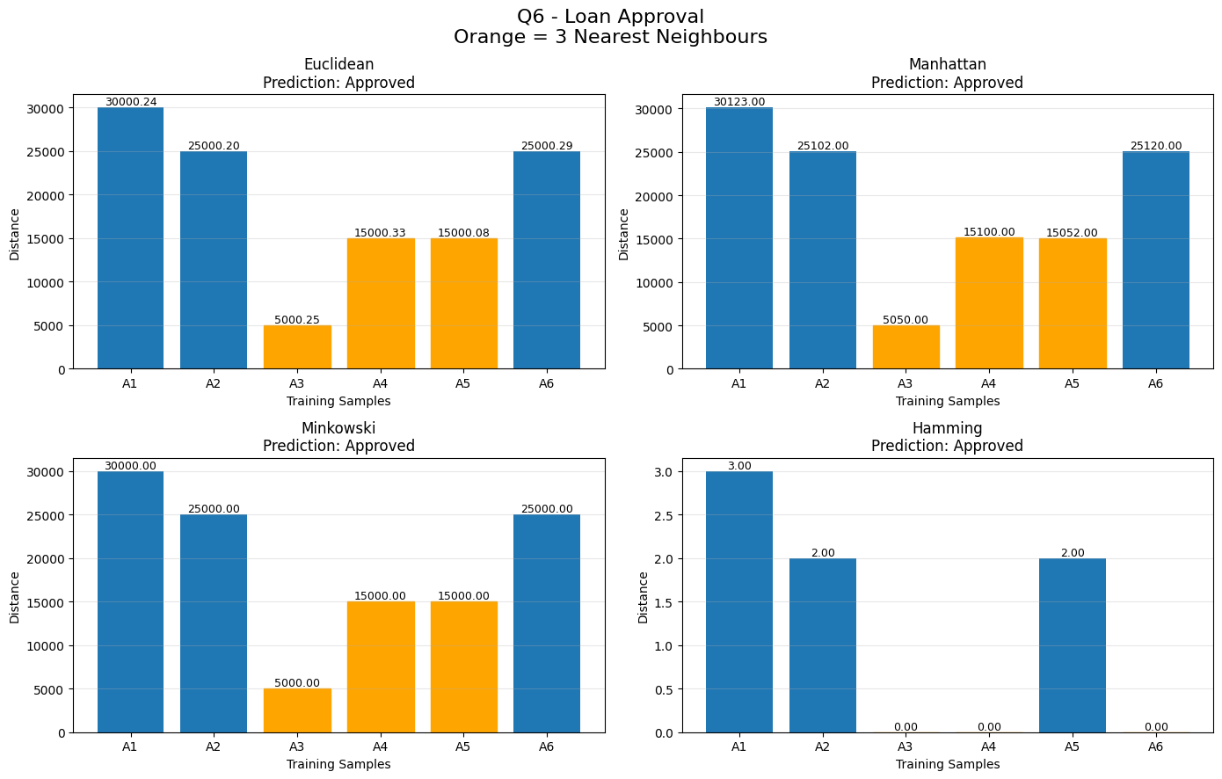

Calculation:

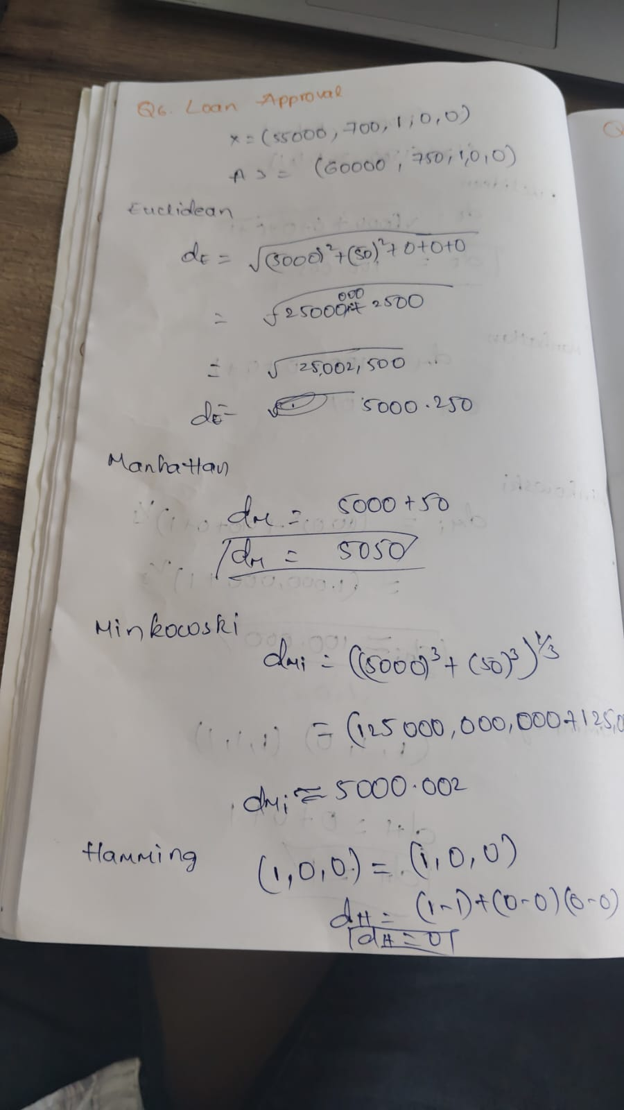
Conclusion:
Both numerical-distance methods and Hamming distance strongly support Approved.

Question 7: Movie Preference Classification
A movie platform wants to classify a user as an Action Lover or Comedy Lover.
User | Action Rating | Comedy Rating | Watched Superhero Movie | Watched Standup Show | Watched Sitcom | Class
U1 | 5 | 1 | 1 | 0 | 0 | Action Lover
U2 | 4 | 2 | 1 | 0 | 0 | Action Lover
U3 | 1 | 5 | 0 | 1 | 1 | Comedy Lover
U4 | 2 | 4 | 0 | 1 | 1 | Comedy Lover
U5 | 5 | 2 | 1 | 0 | 0 | Action Lover
U6 | 1 | 4 | 0 | 1 | 1 | Comedy Lover
A new user has:
Action Rating | Comedy Rating | Watched Superhero  Movie | Watched Stand-up Show | Watched Sitcom
3 | 3 | 1 | 1 | 0
Using KNN with K = 3, classify the new user as Action Lover or Comedy Lover using Euclidean, Manhattan, Minkowski, and Hamming distance.

The movie platform wants to classify a user as Action Lover or Comedy Lover.
New User
- Features
- Numerical: Action Rating, Comedy Rating
- Binary: Watched Superhero, Watched Stand-up, Watched Sitcom
Distance Table
User | Action Rating | Comedy Rating | Watched Superhero Movie | Watched Standup Show | Watched Sitcom | Class
U1 | 5 | 1 | 1 | 0 | 0 | Action Lover
U2 | 4 | 2 | 1 | 0 | 0 | Action Lover
U3 | 1 | 5 | 0 | 1 | 1 | Comedy Lover
U4 | 2 | 4 | 0 | 1 | 1 | Comedy Lover
U5 | 5 | 2 | 1 | 0 | 0 | Action Lover
U6 | 1 | 4 | 0 | 1 | 1 | Comedy Lover

3 Nearest:
U2 → Action
U4 → Comedy
U5 → Action

Prediction:
ACTION LOVER

Hamming:
Nearest three are U1, U2 and U5.
All three are Action Lovers.

Prediction
ACTION LOVER

Code;

7: {
"title": "Q7 - Movie Preference",

"X": np.array([
[5, 1, 1, 0, 0],
[4, 2, 1, 0, 0],
[1, 5, 0, 1, 1],
[2, 4, 0, 1, 1],
[5, 2, 1, 0, 0],
[1, 4, 0, 1, 1]
]),

"y": np.array([
"Action Lover",
"Action Lover",
"Comedy Lover",
"Comedy Lover",
"Action Lover",
"Comedy Lover"
]),

"new": np.array([3, 3, 1, 1, 0]),

"names": ["U1", "U2", "U3", "U4", "U5", "U6"],

"binary": [2, 3, 4]
}

Output:

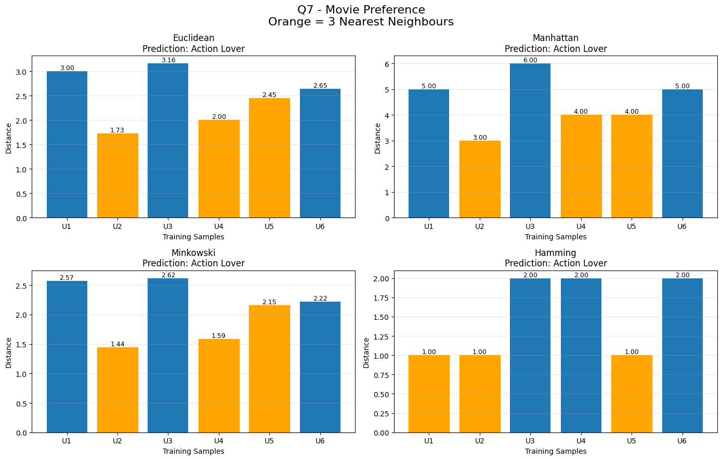

Calculation:

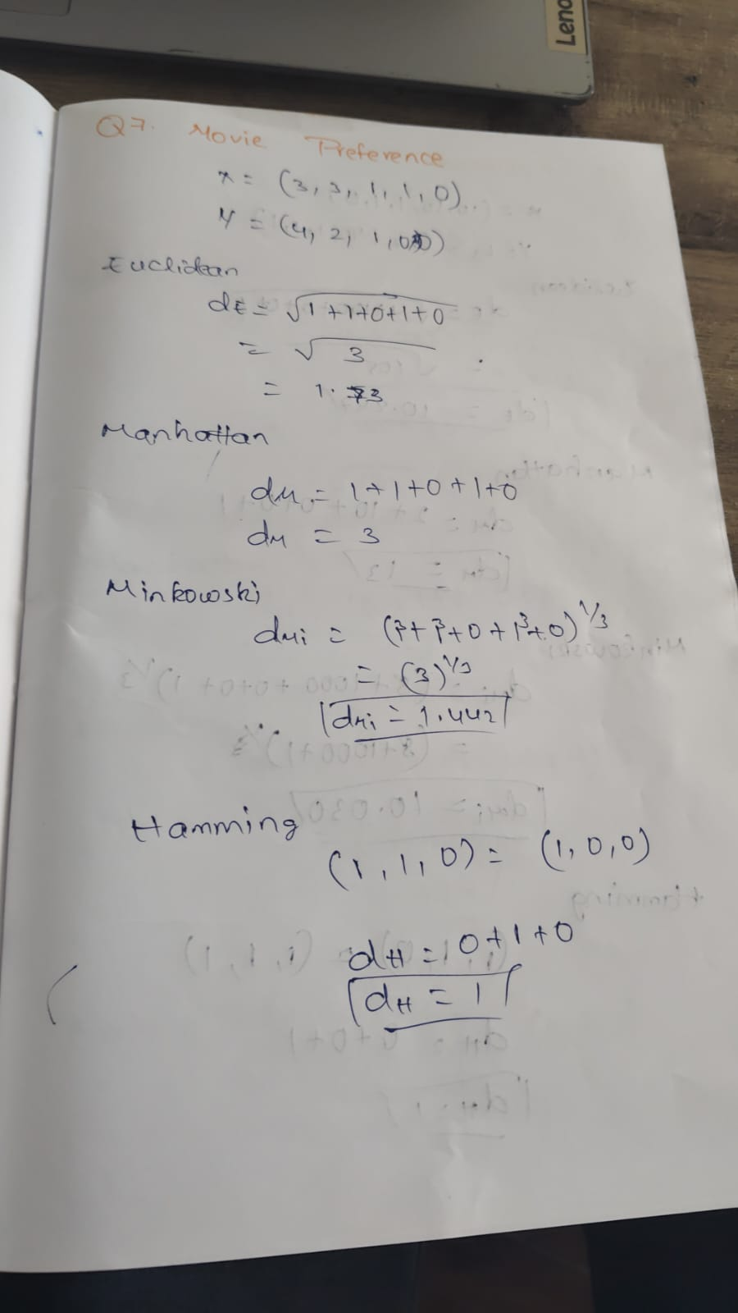

Question 8: Crop Disease Detection
An agriculture research center wants to classify a plant as Healthy or Diseased.
Plant Leaf Spot Count Leaf Color Index Yellow Leaves White Fungus Wilting |  |  |  |  |  | Class
L1 | 2 | 80 | 0 | 0 | 0 | Healthy  Healthy  Diseased  Diseased Healthy  Diseased
L2 | 3 | 75 | 0 | 0 | 0
L3 | 12 | 40 | 1 | 1 | 1
L4 | 15 | 35 | 1 | 1 | 1
L5 | 5 | 70 | 0 | 0 | 1
L6 | 14 | 38 | 1 | 1 | 1
A new plant has:
Leaf Spot Count Leaf Color Index Yellow Leaves White Fungus Wilting
10 | 50 | 1 | 1 | 0
Using KNN with K = 3, classify the plant as Healthy or Diseased using all four distance measures.
The agriculture research center wants to classify a plant as Healthy or Diseased.
New Plant
- Features
- Numerical: Leaf Spot Count, Leaf Color Index
- Binary: Yellow Leaves, White Fungus, Wilting
Distance Table:
Plant Leaf Spot Count Leaf Color Index Yellow Leaves White Fungus Wilting |  |  |  |  |  | Class
L1 | 2 | 80 | 0 | 0 | 0 | Healthy  Healthy  Diseased  Diseased Healthy  Diseased
L2 | 3 | 75 | 0 | 0 | 0
L3 | 12 | 40 | 1 | 1 | 1
L4 | 15 | 35 | 1 | 1 | 1
L5 | 5 | 70 | 0 | 0 | 1
L6 | 14 | 38 | 1 | 1 | 1
3 Nearest:
L3 → Diseased
L6 → Diseased
L4 → Diseased
Prediction
DISEASED
Code:
8: {
"title": "Q8 - Crop Disease"
"X": np.array([
[2, 80, 0, 0, 0],
[3, 75, 0, 0, 0],
[12, 40, 1, 1, 1],
[15, 35, 1, 1, 1],
[5, 70, 0, 0, 1],
[14, 38, 1, 1, 1]]),
"y": np.array([
"Healthy",
"Healthy",
"Diseased",
"Diseased",
"Healthy",
"Diseased"]),
"new": np.array([10, 50, 1, 1, 0]),
"names": ["L1", "L2", "L3", "L4", "L5", "L6"],
"binary": [2, 3, 4]}
Output:

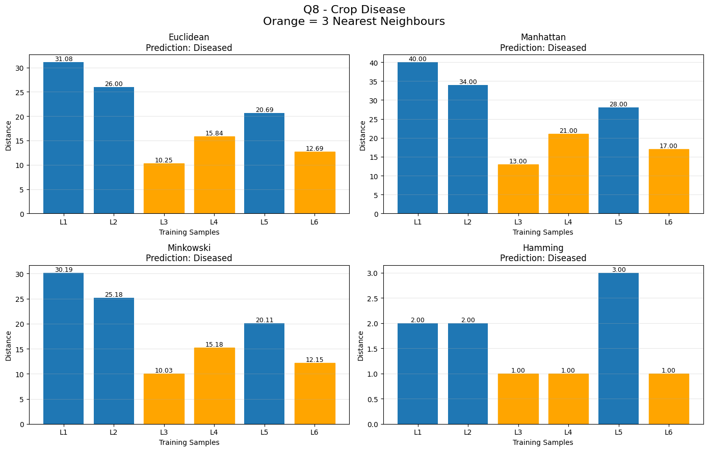
Calculation:
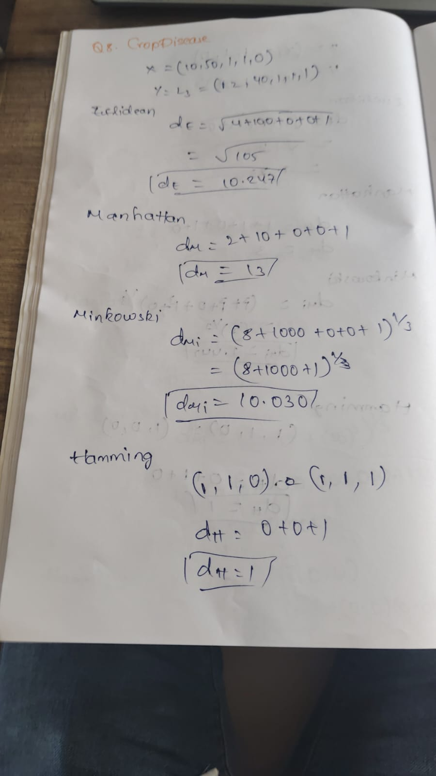
Conclusion: All three nearest neighbours are Diseased, so the plant is classified as Diseased.

Question 9: Network Intrusion Detection
A cybersecurity system wants to classify network activity as Normal or Attack.
Record | Packets per Second | Failed Login Attempts | Unknown Port Used | Admin Access Tried | Blacklisted IP | Class
N1 | 20 | 0 | 0 | 0 | 0 | Normal  Normal  Attack  Attack  Normal  Attack
N2 | 30 | 1 | 0 | 0 | 0
N3 | 100 | 5 | 1 | 1 | 1
N4 | 120 | 6 | 1 | 1 | 1
N5 | 40 | 1 | 0 | 0 | 0
N6 | 110 | 7 | 1 | 1 | 1
A new network record has:
Packets per Second | Failed Login Attempts | Unknown Port Used | Admin Access Tried | Blacklisted IP
90 | 4 | 1 | 1 | 0
Using KNN with K = 3, classify the network activity as Normal or Attack using Euclidean, Manhattan, Minkowski, and Hamming distance.

The cybersecurity system wants to classify network activity as Normal or Attack.
New Record
Features
- Numerical: Packets per Second, Failed Login Attempts
- Binary: Unknown Port, Admin Access, Blacklisted IP
Distance Table:

Record | Packets per Second | Failed Login Attempts | Unknown Port Used | Admin Access Tried | Blacklisted IP | Class
N1 | 20 | 0 | 0 | 0 | 0 | Normal  Normal  Attack  Attack  Normal  Attack
N2 | 30 | 1 | 0 | 0 | 0
N3 | 100 | 5 | 1 | 1 | 1
N4 | 120 | 6 | 1 | 1 | 1
N5 | 40 | 1 | 0 | 0 | 0
N6 | 110 | 7 | 1 | 1 | 1

3 Nearest:
N3 → Attack
N6 → Attack
N4 → Attack

Prediction:
ATTACK

Code:

9: {
"title": "Q9 - Network Intrusion",

"X": np.array([
[20, 0, 0, 0, 0],
[30, 1, 0, 0, 0],
[100, 5, 1, 1, 1],
[120, 6, 1, 1, 1],
[40, 1, 0, 0, 0],
[110, 7, 1, 1, 1]
]),

"y": np.array([
"Normal",
"Normal",
"Attack",
"Attack",
"Normal",
"Attack"
]),

"new": np.array([90, 4, 1, 1, 0]),

"names": ["N1", "N2", "N3", "N4", "N5", "N6"],

"binary": [2, 3, 4]
}

Output:

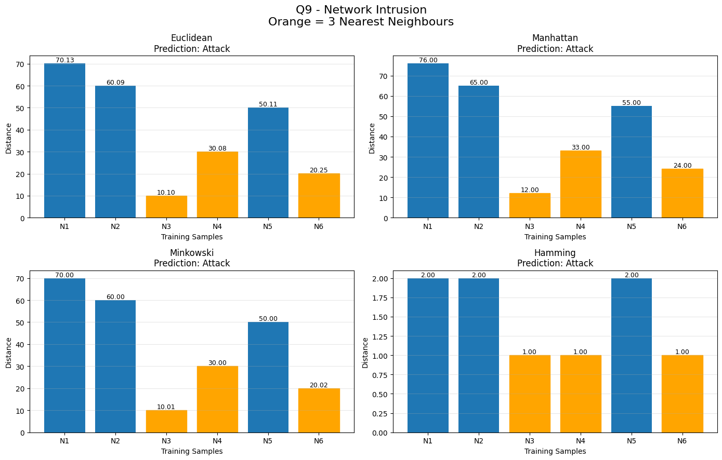

Calculation:

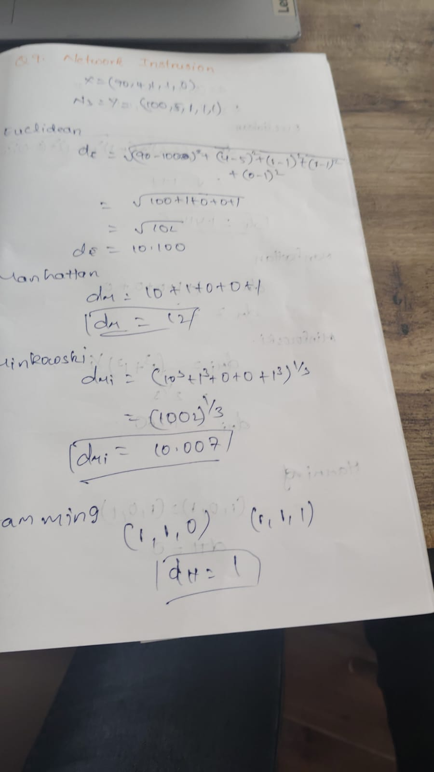

Conclusion:
The three nearest records are all Attack records. Therefore, the new network activity is classified as Attack.

Question 10: Employee Attrition Prediction
A company wants to predict whether an employee is likely to Stay or Leave.
Employee | Experience in Years | Satisfaction Score | Overtime | Promotion Received | Workplace Conflict | Class
E1 | 2 | 8 | 0 | 1 | 0 | Stay
E2 | 3 | 7 | 0 | 1 | 0 | Stay
E3 | 6 | 3 | 1 | 0 | 1 | Leave  Leave
E4 | 7 | 2 | 1 | 0 | 1
E5 | 4 | 6 | 0 | 0 | 0 | Stay
E6 | 8 | 2 | 1 | 0 | 1 | Leave
A new employee has:
Experience in Years Satisfaction Score Overtime Promotion Received Workplace Conflict
5 | 4 | 1 | 0 | 1
Using KNN with K = 3, classify the employee as Stay or Leave using all four distance measures.

The company wants to predict whether an employee will Stay or Leave.
New Employee
- Features
- Numerical: Experience in Years, Satisfaction Score
- Binary: Overtime, Promotion Received, Workplace Conflict
Distance Table:

Employee | Experience in Years | Satisfaction Score | Overtime | Promotion Received | Workplace Conflict | Class
E1 | 2 | 8 | 0 | 1 | 0 | Stay
E2 | 3 | 7 | 0 | 1 | 0 | Stay
E3 | 6 | 3 | 1 | 0 | 1 | Leave  Leave
E4 | 7 | 2 | 1 | 0 | 1
E5 | 4 | 6 | 0 | 0 | 0 | Stay
E6 | 8 | 2 | 1 | 0 | 1 | Leave

3 Nearest
E3 → Leave
E5 → Stay
E4 → Leave

Prediction:
LEAVE

Hamming
Nearest three:
- E3 → Leave
- E4 → Leave
- E6 → Leave
Therefore:
LEAVE

Code:

10: {
"title": "Q10 - Employee Attrition",

"X": np.array([
[2, 8, 0, 1, 0],
[3, 7, 0, 1, 0],
[6, 3, 1, 0, 1],
[7, 2, 1, 0, 1],
[4, 6, 0, 0, 0],
[8, 2, 1, 0, 1]
]),

"y": np.array([
"Stay",
"Stay",
"Leave",
"Leave",
"Stay",
"Leave"
]),

"new": np.array([5, 4, 1, 0, 1]),

"names": ["E1", "E2", "E3", "E4", "E5", "E6"],

"binary": [2, 3, 4]
}

Output:

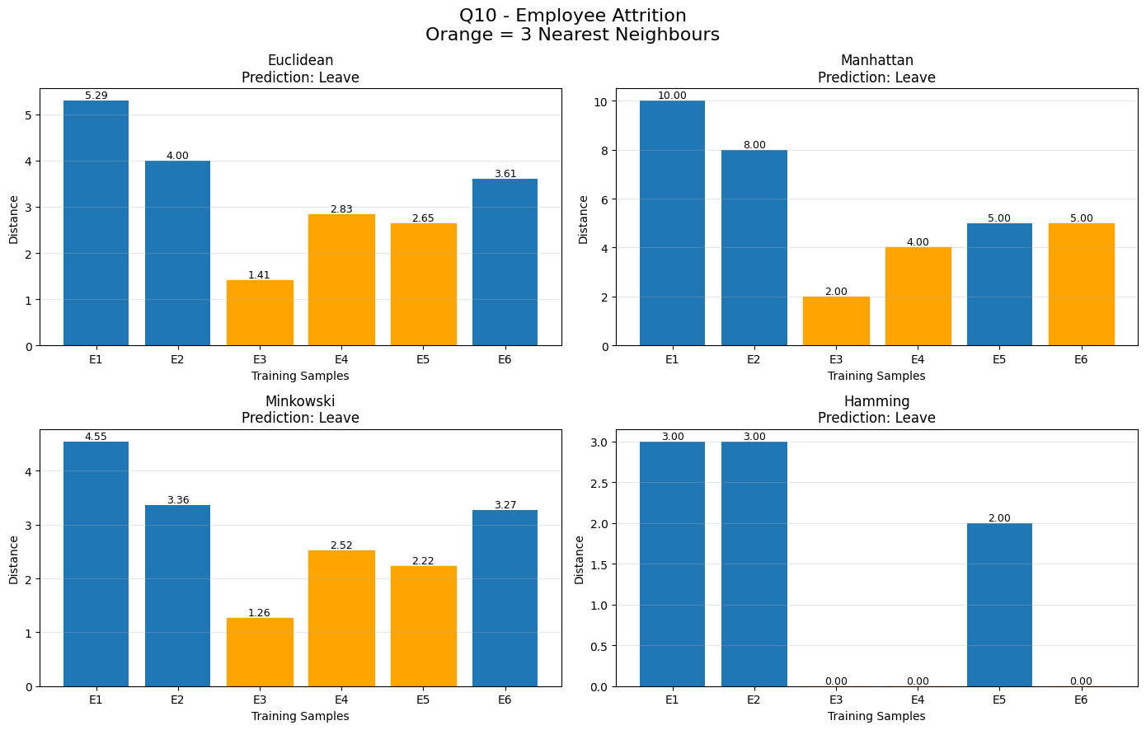

Calculation:

