NAME:T.V.Sai Jagadeesh
REG.NO:192472146

Case Study 7: Retail Sales Performance Analysis:
Scenario:
A retail chain has collected sales data from different branches, including daily sales amount,
number of customers, discount percentage, product category, and customer feedback score.
The company wants to evaluate branch performance and improve sales planning.
Questions:
A. How can descriptive statistics and distribution analysis be used to summarize daily sales
and customer count?
B. Discuss how abnormal sales values, such as festival-season sales or very low sales days,
can affect the analysis. Explain suitable outlier detection methods.
C. How can confidence intervals and hypothesis testing be used to determine whether the
average sales of urban branches are significantly higher than rural branches?

INTRODUCTION:
In this case study, a retail chain analyzes sales data from multiple branches to evaluate performance and improve planning. The dataset includes variables such as daily sales, number of customers, discounts, product category, and feedback score. Data Science techniques like descriptive statistics, outlier detection, and hypothesis testing help in making better business decisions.
Problem Statement:
A retail chain has collected large amounts of data from different branches, including daily sales, number of customers, discount percentages, product categories, and customer feedback scores. However, the company is unable to effectively analyze this data to understand branch performance and sales patterns.

Procedure:
Step 1: Data Collection
- Collect sales data from different retail branches.
- Data includes sales amount, number of customers, discounts, category, and feedback.

Step 2: Data Preparation
- Load the dataset using tools like Pandas.
- Clean the data by handling missing values and errors.
- Remove duplicate records and format columns properly.

Step 3: Descriptive Statistics
- Calculate mean, median, and standard deviation of sales and customers.
- Summarize overall performance of branches.
- Understand general trends in the dataset.

Step 4: Distribution Analysis
- Use graphs like histograms or box plots.
- Analyze how sales data is distributed.
- Identify patterns such as skewness or spread.
Step 5: Outlier Detection
- Detect abnormal values (very high or low sales).
- Apply methods like IQR or Z-score.
- Remove or treat outliers for better accuracy.
Step 6: Hypothesis Testing
- Compare urban and rural branch sales.
- Use t-test to check significance.
- Decide whether differences are meaningful.
Step 7: Confidence Interval
- Calculate range for average sales.
- Estimate reliability of results.
Step 8: Interpretation & Conclusion
- Analyze results and draw insights.
- Identify high-performing branches.
- Suggest improvements for sales planning.

Dataset:
 | Type | Sales | Customers | Discount (%) | Category | Feedback
B1 | Urban | 5000 | 200 | 10 | Food | 4.5
B2 | Rural | 3000 | 120 | 5 | Clothes | 4.0
B3 | Urban | 7000 | 250 | 15 | Food | 4.8
B4 | Rural | 2000 | 90 | 8 | Grocery | 3.8
B5 | Urban | 6500 | 230 | 12 | Clothes | 4.6
B6 | Rural | 1800 | 80 | 5 | Food | 3.5

Code:
import pandas as pd
import numpy as np
from scipy import stats
data = {
"Type": ["Urban","Rural","Urban","Rural","Urban","Rural"],
"Sales": [5000,3000,7000,2000,6500,1800],
"Customers": [200,120,250,90,230,80]
}

df = pd.DataFrame(data)

print(df.describe())
Q1 = df["Sales"].quantile(0.25)
Q3 = df["Sales"].quantile(0.75)
IQR = Q3 - Q1
outliers = df[(df["Sales"] < (Q1 - 1.5*IQR)) | (df["Sales"] > (Q3 + 1.5*IQR))]
print("Outliers:\n", outliers)
urban = df[df["Type"]=="Urban"]["Sales"]
rural = df[df["Type"]=="Rural"]["Sales"]
t_stat, p_value = stats.ttest_ind(urban, rural)
print("t-stat:", t_stat, "p-value:", p_value)

Output:
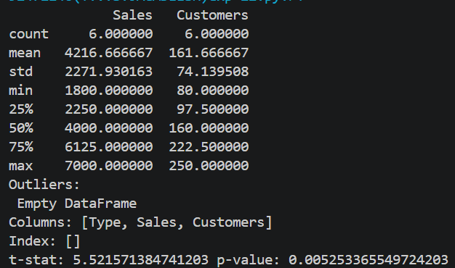

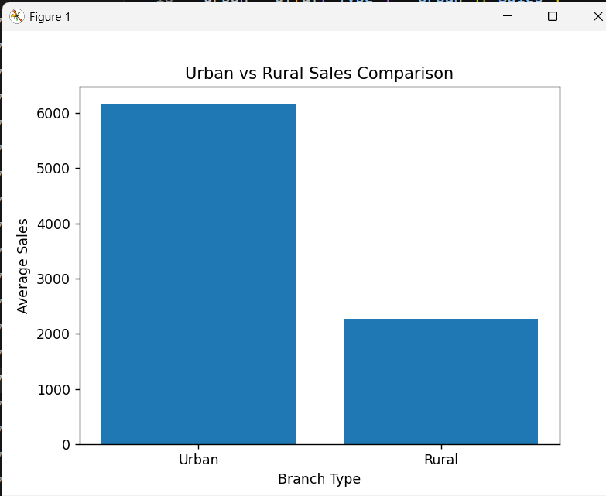

Manual Calculation:
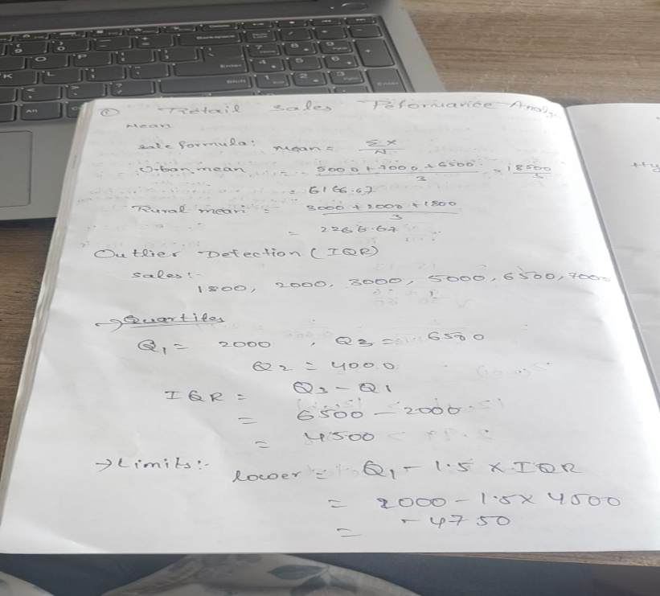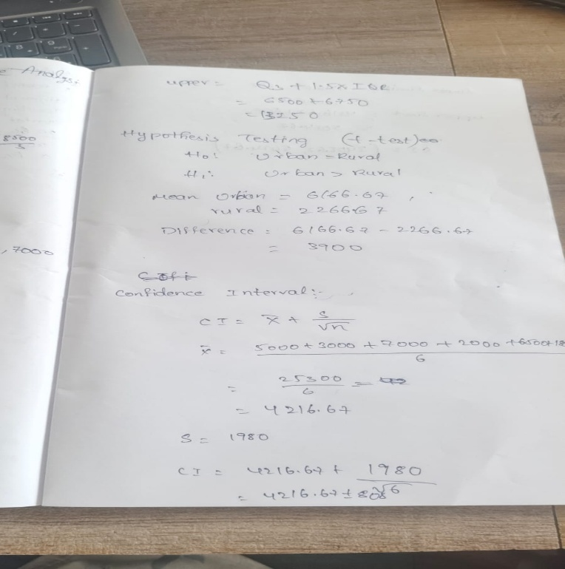


Conclusion:
Using Data Science techniques:
- Descriptive statistics summarize performance
- Outlier detection improves accuracy
- Hypothesis testing validates business assumptions
👉 This helps the company make data-driven decisions for sales improvement.

