SIMATS ENGINEERING ASSESSMENT TOOL 2
COURSE NAME: Fundamentals of Data Science COURSE CODE: DSA04
COURSE OUTCOME COVERED
SCENARIO BASED ASSESSMENT
Criteria | Weightage  (%) | Level 4  (Exemplary) | Level 3  (Proficient) | Level 2  (Developing) | Level 1  (Beginning) | Level | Marks
Understandin g of Scenario | 20% | Demonstrates clear and complete understanding of | Shows good understanding with minor gaps | Partial understanding; misses key | Misinterprets or fails to understand the
 |  | the scenario and context |  | aspects | scenario
Identification of Key Issues | 20% | Accurately  identifies all relevant issues and factors involved | Identifies most key issues with minor omissions | Identifies limited issues; some irrelevant points | Unable to identify key issues
Application of  Concepts | 25%
 |  | Applies appropriate concepts effectively to address the scenario | Applies concepts with minor errors | Limited or partially correct application | Unable to apply  relevant concepts
Decision  Making | 20% | Makes wellreasoned, logical decisions with strong rationale | Makes reasonable  decisions with some  justification | Makes weak decisions with limited justification | No clear decisions made  or rationale provided
Clarity of  Response | 15% | Response is clear, structured, and logically presented | Generally clear with minor issues | Somewhat  unclear or poorly structured | Disorganized and difficult to understand
CO4: Develop machine learning models for classification, regression, and clustering, ncluding performance evaluation and methodology comparison. (BL3)
Assessment Tool Weightage: 30%
QUESTIONS: 10 Total Marks:100
Annexure A Industry Problem Solving
Code of Conduct:
I T.V.Sai Jagadeesh(192472146) (Name / Reg No) certify that this submission is my original work and that I have adhered to the guidelines specified for this assessment.
I understand that any violation of academic integrity rules will result in disciplinary action.
Signature of the student:t.sai
RUBRICS FOR CALCULATION
Annexure A
Question 1: Real Estate Price Prediction Using Linear Regression
A real estate company wants to predict the selling price of houses based on house-related features.
House Area sq.ft Bedrooms Age Distance from City km Price Lakhs
H1 | 900 | 2 | 12 | 10 | 45
H2 | 1100 | 2 | 10 | 8 | 55
H3 | 1300 | 3 | 8 | 6 | 68
H4 | 1500 | 3 | 5 | 5 | 82
H5 | 1800 | 4 | 3 | 3 | 115
H6 | 2000 | 4 | 2 | 2 | 135
H7 | 1000 | 2 | 15 | 12 | 40
H8 | 1600 | 3 | 6 | 4 | 90
Tasks
- Create the dataset using Python.
- Identify independent and dependent variables.
- Split the dataset into training and testing data.
- Implement Linear Regression.
- Predict house price for test data.
- Predict the price of a new house with:
Area Bedrooms Age Distance
1700 | 3 | 4 | 4
- Evaluate the model using MAE, MSE, RMSE, and R² score.
- Interpret the result and explain whether the model is useful for real estate price prediction.
Sol:
Linear Regression is a supervised machine learning algorithm used to predict a continuous numerical value from one or more input variables.
In this problem:
- Independent variables: House Area, Bedrooms, Age, Distance from City
- Dependent variable: House Price
- Algorithm: Multiple Linear Regression
The model tries to find a relationship between house features and price using an equation:
where is the predicted house price.
The dataset is divided into training data and testing data. The training data is used to learn the relationship, while testing data is used to evaluate the model.
Evaluation metrics:
- MAE: Average absolute prediction error.
- MSE: Average squared prediction error.
- RMSE: Square root of MSE.
- R²: Measures how well the model explains the variation in house prices.
A high R² and low MAE/RMSE indicate a useful model.
House Area sq.ft Bedrooms Age Distance from City km Price Lakhs
H1 | 900 | 2 | 12 | 10 | 45
H2 | 1100 | 2 | 10 | 8 | 55
H3 | 1300 | 3 | 8 | 6 | 68
H4 | 1500 | 3 | 5 | 5 | 82
H5 | 1800 | 4 | 3 | 3 | 115
H6 | 2000 | 4 | 2 | 2 | 135
H7 | 1000 | 2 | 15 | 12 | 40
H8 | 1600 | 3 | 6 | 4 | 90

Code:
import pandas as pd
import matplotlib.pyplot as plt
from sklearn.model_selection import train_test_split
from sklearn.linear_model import LinearRegression
from sklearn.metrics import mean_absolute_error, mean_squared_error, r2_score
import numpy as np
data = {
"Area": [900, 1100, 1300, 1500, 1800, 2000, 1000, 1600],
"Bedrooms": [2, 2, 3, 3, 4, 4, 2, 3],
"Age": [12, 10, 8, 5, 3, 2, 15, 6],
"Distance": [10, 8, 6, 5, 3, 2, 12, 4],
"Price": [45, 55, 68, 82, 115, 135, 40, 90]}
df = pd.DataFrame(data)
print("Dataset:")
print(df)
X = df[["Area", "Bedrooms", "Age", "Distance"]]
y = df["Price"]
X_train, X_test, y_train, y_test = train_test_split(
X, y, test_size=0.25, random_state=42
)
model = LinearRegression()
model.fit(X_train, y_train)
y_pred = model.predict(X_test)
print("\nActual vs Predicted:")
print(pd.DataFrame({
"Actual Price": y_test.values,
"Predicted Price": y_pred
}))
new_house = [[1700, 3, 4, 4]]
new_price = model.predict(new_house)
print("\nPredicted price for new house:", new_price[0], "Lakhs")
mae = mean_absolute_error(y_test, y_pred)
mse = mean_squared_error(y_test, y_pred)
rmse = np.sqrt(mse)
r2 = r2_score(y_test, y_pred)
print("\nModel Evaluation:")
print("MAE :", mae)
print("MSE :", mse)
print("RMSE:", rmse)
print("R2 :", r2)
plt.scatter(y_test, y_pred)
plt.plot(
[y_test.min(), y_test.max()],
[y_test.min(), y_test.max()],
'r--)

plt.xlabel("Actual Price (Lakhs)")
plt.ylabel("Predicted Price (Lakhs)")
plt.title("Actual vs Predicted House Prices")
plt.show()
Calculation:

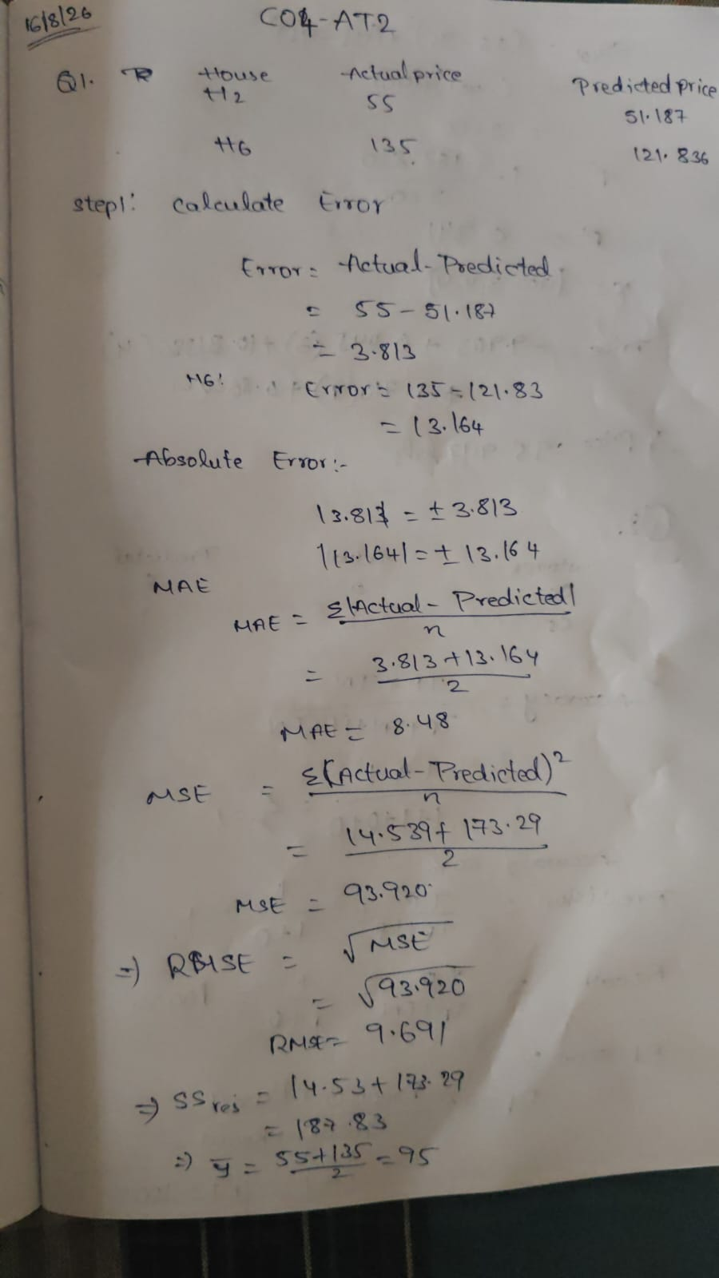
Output:
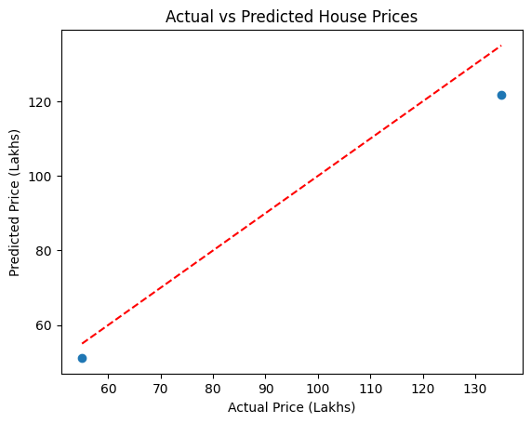

Question 2: Customer Churn Prediction Using Logistic Regression
A telecom company wants to predict whether a customer will churn or not churn.
Customer Monthly Bill Complaints Data Usage GB Tenure Months Churn
C1 | 500 | 0 | 25 | 36 | 0
C2 | 900 | 3 | 10 | 8 | 1
C3 | 750 | 2 | 15 | 12 | 1
C4 | 400 | 0 | 30 | 48 | 0
C5 | 1000 | 4 | 8 | 6 | 1
C6 | 550 | 1 | 22 | 30 | 0
C7 | 850 | 3 | 12 | 10 | 1
C8 | 450 | 0 | 28 | 40 | 0
Here,
Churn = 1 means customer leaves the company.
Churn = 0 means customer stays.
Tasks
- Create the dataset using Python.
- Identify the input features and target variable.
- Perform train-test split.
- Implement Logistic Regression.
- Predict churn status for test customers.
- Predict churn for a new customer:
Monthly Bill Complaints Data Usage GB Tenure Months
800 | 2 | 14 | 10
- Evaluate the model using accuracy, confusion matrix, precision, recall, and F1-score.
- Explain why Logistic Regression is suitable for churn prediction.
Sol:
Logistic Regression is a supervised classification algorithm used when the target variable has two or more classes.
Here:
- Input features: Monthly Bill, Complaints, Data Usage, Tenure
- Target: Churn
- Churn = 1: Customer leaves
- Churn = 0: Customer stays
Logistic Regression calculates the probability of a customer leaving:
where:
If the probability is greater than 0.5, the customer is generally classified as Churn = 1.
Evaluation metrics:
- Accuracy: Overall percentage of correct predictions.
- Precision: How many predicted churn customers actually churned.
- Recall: How many actual churn customers were correctly identified.
- F1-score: Balance between precision and recall.
- Confusion Matrix: Shows TP, TN, FP and FN.
Logistic Regression is suitable because churn is a binary classification problem.
Customer Monthly Bill Complaints Data Usage GB Tenure Months Churn
C1 | 500 | 0 | 25 | 36 | 0
C2 | 900 | 3 | 10 | 8 | 1
C3 | 750 | 2 | 15 | 12 | 1
C4 | 400 | 0 | 30 | 48 | 0
C5 | 1000 | 4 | 8 | 6 | 1
C6 | 550 | 1 | 22 | 30 | 0
C7 | 850 | 3 | 12 | 10 | 1
C8 | 450 | 0 | 28 | 40 | 0

Code:
import pandas as pd
import matplotlib.pyplot as plt
from sklearn.model_selection import train_test_split
from sklearn.linear_model import LogisticRegression
from sklearn.metrics import (
accuracy_score,
confusion_matrix,
precision_score,
recall_score,
f1_score,
ConfusionMatrixDisplay
)
data = {
"Monthly_Bill": [500, 900, 750, 400, 1000, 550, 850, 450],
"Complaints": [0, 3, 2, 0, 4, 1, 3, 0],
"Data_Usage": [25, 10, 15, 30, 8, 22, 12, 28],
"Tenure": [36, 8, 12, 48, 6, 30, 10, 40],
"Churn": [0, 1, 1, 0, 1, 0, 1, 0]
}
df = pd.DataFrame(data)
print("Dataset:")
print(df)
X = df[["Monthly_Bill", "Complaints", "Data_Usage", "Tenure"]]
y = df["Churn"]
X_train, X_test, y_train, y_test = train_test_split(
X, y, test_size=0.25, random_state=42, stratify=y
)
model = LogisticRegression(max_iter=1000)
model.fit(X_train, y_train)
y_pred = model.predict(X_test)
print("\nActual vs Predicted:")
print(pd.DataFrame({
"Actual": y_test.values,
"Predicted": y_pred
}))
new_customer = [[800, 2, 14, 10]]
prediction = model.predict(new_customer)
if prediction[0] == 1:
print("\nNew customer prediction: CHURN")
else:
print("\nNew customer prediction: NOT CHURN")
accuracy = accuracy_score(y_test, y_pred)
cm = confusion_matrix(y_test, y_pred)
precision = precision_score(y_test, y_pred, zero_division=0)
recall = recall_score(y_test, y_pred, zero_division=0)
f1 = f1_score(y_test, y_pred, zero_division=0)

print("\nModel Evaluation:")
print("Accuracy :", accuracy)
print("Confusion Matrix:\n", cm)
print("Precision:", precision)
print("Recall :", recall)
print("F1 Score :", f1)
plt.bar(
["Not Churn", "Churn"],
[(y_pred == 0).sum(), (y_pred == 1).sum()])
plt.xlabel("Churn Status")
plt.ylabel("Number of Customers")
plt.title("Customer Churn Prediction")
plt.show()
ConfusionMatrixDisplay.from_predictions(y_test, y_pred)
plt.title("Customer Churn Confusion Matrix")
plt.show()

Calculation:

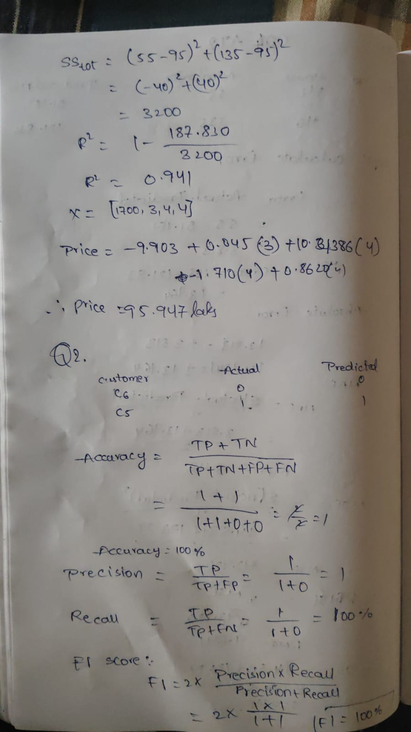
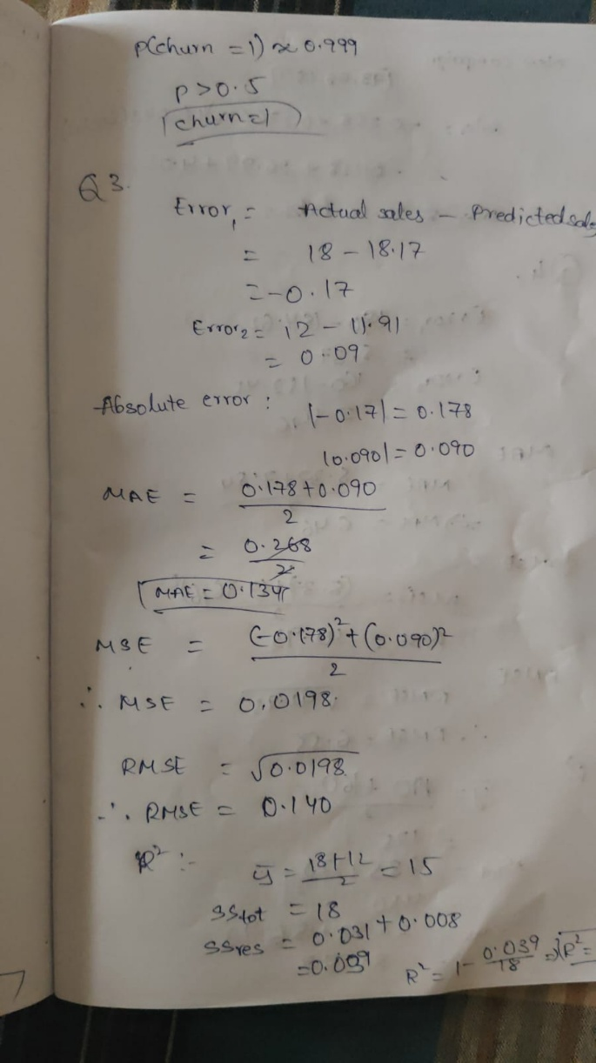
Output:
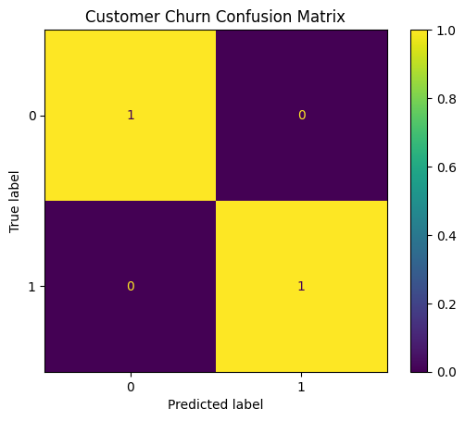
Question 3: Marketing Sales Prediction Using Lasso Regression
A retail company wants to predict monthly sales based on advertisement spending across different platforms. The company wants to know which marketing channels are most important.
Month TV Ads Social Media Ads Newspaper Ads Email Campaigns Sales Lakhs
M1 | 50 | 20 | 10 | 5 | 15
M2 | 60 | 25 | 12 | 6 | 18
M3 | 80 | 40 | 15 | 8 | 25
M4 | 100 | 60 | 20 | 10 | 32
M5 | 120 | 70 | 22 | 12 | 38
M6 | 40 | 15 | 8 | 4 | 12
M7 | 90 | 50 | 18 | 9 | 28
M8 | 110 | 65 | 21 | 11 | 35
Tasks
- Create the dataset using Python.
- Identify features and target variable.
- Apply train-test split.
- Implement Lasso Regression.
- Use an alpha value such as 0.1 or 1.0.
- Predict sales for test data.
- Predict sales for a new campaign:
TV Ads Social Media Ads Newspaper Ads Email Campaigns
95 | 55 | 18 | 9
- Evaluate using MAE, MSE, RMSE, and R² score.
- Display the coefficients and identify which features are reduced or selected by Lasso.
- Explain how Lasso helps in feature selection.
Sol:
Lasso Regression is a regularized version of Linear Regression.
It is useful when a company has several input features and wants to identify the most important ones.
Here:
- Features: TV Ads, Social Media Ads, Newspaper Ads, Email Campaigns
- Target: Sales
- Algorithm: Lasso Regression
Lasso adds a penalty based on the absolute value of coefficients:
where:
- = Residual Sum of Squares
- = regularization parameter
- = model coefficients
The important advantage of Lasso is that it can make some coefficients exactly zero.
For example:
means that the feature has been removed from the model.
Therefore, Lasso performs both:
- Prediction
- Feature selection
A larger alpha produces stronger regularization.
Month TV Ads Social Media Ads Newspaper Ads Email Campaigns Sales Lakhs
M1 | 50 | 20 | 10 | 5 | 15
M2 | 60 | 25 | 12 | 6 | 18
M3 | 80 | 40 | 15 | 8 | 25
M4 | 100 | 60 | 20 | 10 | 32
M5 | 120 | 70 | 22 | 12 | 38
M6 | 40 | 15 | 8 | 4 | 12
M7 | 90 | 50 | 18 | 9 | 28
M8 | 110 | 65 | 21 | 11 | 35

Code:
import pandas as pd
import matplotlib.pyplot as plt
from sklearn.model_selection import train_test_split
from sklearn.linear_model import Lasso
from sklearn.metrics import mean_absolute_error, mean_squared_error, r2_score
import numpy as np
data = {
"TV_Ads": [50, 60, 80, 100, 120, 40, 90, 110],
"Social_Media_Ads": [20, 25, 40, 60, 70, 15, 50, 65],
"Newspaper_Ads": [10, 12, 15, 20, 22, 8, 18, 21],
"Email_Campaigns": [5, 6, 8, 10, 12, 4, 9, 11],
"Sales": [15, 18, 25, 32, 38, 12, 28, 35]
}
df = pd.DataFrame(data)
print("Dataset:")
print(df)
X = df[
["TV_Ads", "Social_Media_Ads",
"Newspaper_Ads", "Email_Campaigns"]
]
y = df["Sales"]
X_train, X_test, y_train, y_test = train_test_split(
X, y, test_size=0.25, random_state=42
)
lasso = Lasso(alpha=0.1)
lasso.fit(X_train, y_train)
y_pred = lasso.predict(X_test)
print("\nActual vs Predicted:")
print(pd.DataFrame({
"Actual Sales": y_test.values,
"Predicted Sales": y_pred
}))
new_campaign = [[95, 55, 18, 9]]
new_sales = lasso.predict(new_campaign)
print("\nPredicted sales for new campaign:",
new_sales[0], "Lakhs")
mae = mean_absolute_error(y_test, y_pred)
mse = mean_squared_error(y_test, y_pred)
rmse = np.sqrt(mse)
r2 = r2_score(y_test, y_pred)
print("\nModel Evaluation:")
print("MAE :", mae)
print("MSE :", mse)
print("RMSE:", rmse)
print("R2 :", r2)
print("\nLasso Coefficients:")
for feature, coefficient in zip(X.columns, lasso.coef_):
print(feature, ":", coefficient)
plt.scatter(y_test, y_pred)
plt.plot(
[y_test.min(), y_test.max()],
[y_test.min(), y_test.max()],
'r--'
)
plt.xlabel("Actual Sales")
plt.ylabel("Predicted Sales")
plt.title("Actual vs Predicted Sales")
plt.show()
plt.bar(X.columns, lasso.coef_)
plt.xlabel("Marketing Features")
plt.ylabel("Coefficient")
plt.title("Lasso Regression Coefficients")
plt.xticks(rotation=45)
plt.show()
Calculation:
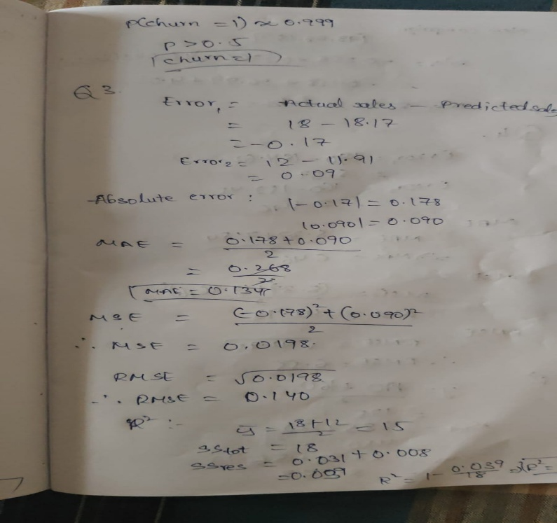

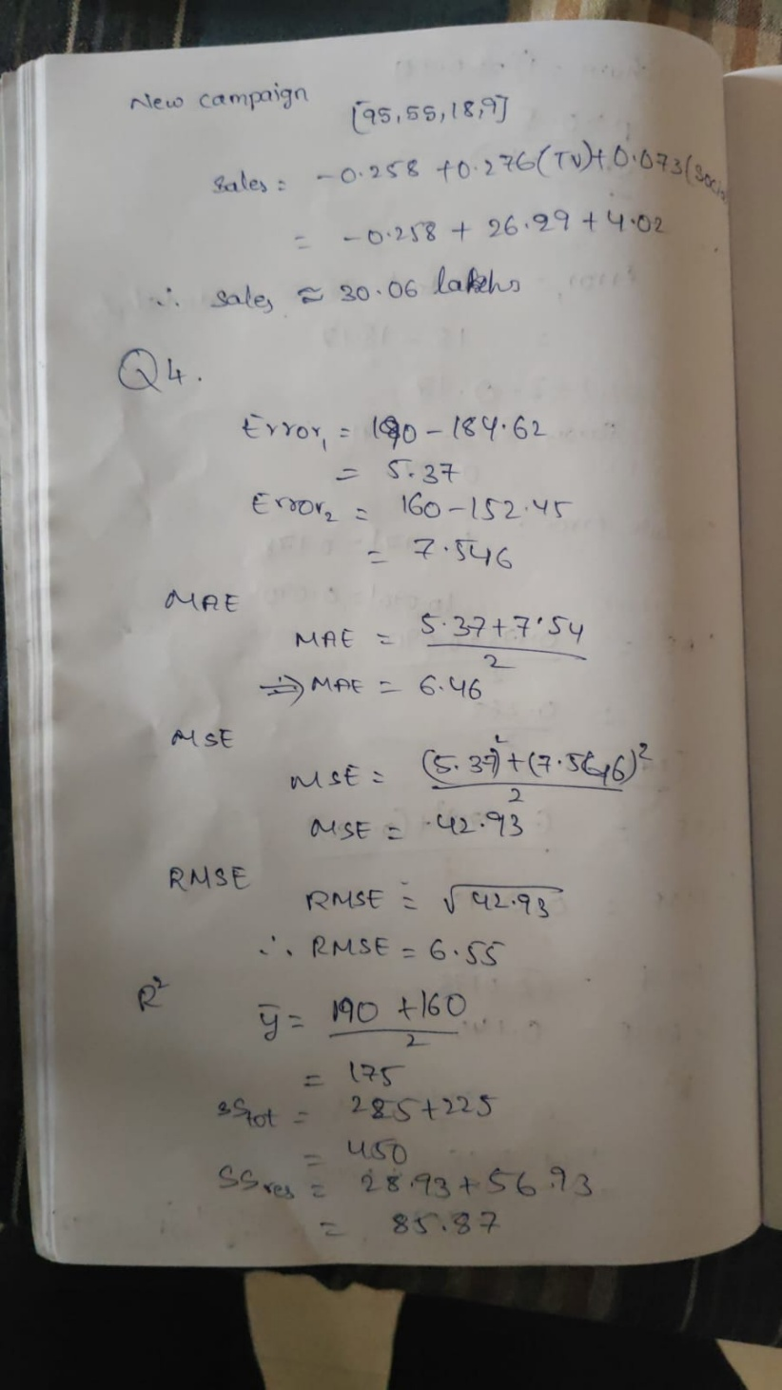
Output:
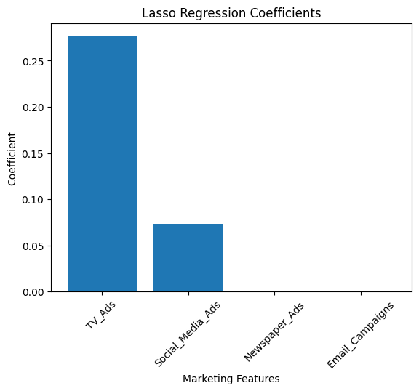
Question 4: Electricity Consumption Prediction Using Ridge Regression
A smart energy company wants to predict household electricity consumption. Some features may be highly correlated, such as number of appliances and daily usage hours. Therefore, Ridge Regression is used.
House Appliances Usage Hours House Size sq.ft Occupants Consumption Units
H1 | 5 | 4 | 800 | 3 | 120
H2 | 7 | 6 | 1000 | 4 | 190
H3 | 8 | 7 | 1200 | 4 | 240
H4 | 10 | 8 | 1500 | 5 | 320
H5 | 4 | 3 | 700 | 2 | 90
H6 | 6 | 5 | 900 | 3 | 160
H7 | 9 | 7 | 1300 | 5 | 280
H8 | 11 | 9 | 1600 | 6 | 350
Tasks
- Create the dataset using Python.
- Identify the independent and dependent variables.
- Split the data into training and testing sets.
- Implement Ridge Regression.
- Use an alpha value such as 1.0.
- Predict electricity consumption for test data.
- Predict consumption for a new house:
Appliances Usage Hours House Size Occupants
8 | 6 | 1100 | 4
- Evaluate using MAE, MSE, RMSE, and R² score.
- Display the Ridge coefficients.
- Explain how Ridge Regression reduces overfitting.
Sol:
Ridge Regression is a regularized form of Linear Regression that is particularly useful when input variables are highly correlated.
Here:
- Features: Appliances, Usage Hours, House Size, Occupants
- Target: Electricity Consumption
- Algorithm: Ridge Regression
Ridge adds an L2 penalty:
The penalty prevents coefficients from becoming excessively large.
Unlike Lasso, Ridge normally does not make coefficients exactly zero.
Purpose of Ridge
Ridge helps to:
- Reduce overfitting.
- Handle multicollinearity.
- Stabilize regression coefficients.
- Improve model generalization.
For this problem, features such as number of appliances and usage hours may be related, so Ridge is appropriate.
House Appliances Usage Hours House Size sq.ft Occupants Consumption Units
H1 | 5 | 4 | 800 | 3 | 120
H2 | 7 | 6 | 1000 | 4 | 190
H3 | 8 | 7 | 1200 | 4 | 240
H4 | 10 | 8 | 1500 | 5 | 320
H5 | 4 | 3 | 700 | 2 | 90
H6 | 6 | 5 | 900 | 3 | 160
H7 | 9 | 7 | 1300 | 5 | 280
H8 | 11 | 9 | 1600 | 6 | 350

Code:
import pandas as pd
import matplotlib.pyplot as plt

from sklearn.model_selection import train_test_split
from sklearn.linear_model import Ridge
from sklearn.metrics import mean_absolute_error, mean_squared_error, r2_score
import numpy as n
data = {
"Appliances": [5, 7, 8, 10, 4, 6, 9, 11],
"Usage_Hours": [4, 6, 7, 8, 3, 5, 7, 9],
"House_Size": [800, 1000, 1200, 1500, 700, 900, 1300, 1600],
"Occupants": [3, 4, 4, 5, 2, 3, 5, 6],
"Consumption": [120, 190, 240, 320, 90, 160, 280, 350]
}
df = pd.DataFrame(data)
print("Dataset:")
print(df)
X = df[
["Appliances", "Usage_Hours",
"House_Size", "Occupants"]
]
y = df["Consumption"]
X_train, X_test, y_train, y_test = train_test_split(
X, y, test_size=0.25, random_state=42
)
ridge = Ridge(alpha=1.0)
ridge.fit(X_train, y_train)
y_pred = ridge.predict(X_test)
print("\nActual vs Predicted:")
print(pd.DataFrame({
"Actual Consumption": y_test.values,
"Predicted Consumption": y_pred
}))
new_house = [[8, 6, 1100, 4]]
new_consumption = ridge.predict(new_house)
print("\nPredicted consumption:",
new_consumption[0], "Units")
mae = mean_absolute_error(y_test, y_pred)
mse = mean_squared_error(y_test, y_pred)
rmse = np.sqrt(mse)
r2 = r2_score(y_test, y_pred)
print("\nModel Evaluation:")
print("MAE :", mae)
print("MSE :", mse)
print("RMSE:", rmse)
print("R2 :", r2)
print("\nRidge Coefficients:")
for feature, coefficient in zip(X.columns, ridge.coef_):
print(feature, ":", coefficient)
plt.scatter(y_test, y_pred)
plt.plot(
[y_test.min(), y_test.max()],
[y_test.min(), y_test.max()],
'r--'
)
plt.xlabel("Actual Consumption")
plt.ylabel("Predicted Consumption")
plt.title("Actual vs Predicted Electricity Consumption")
plt.show()
plt.bar(X.columns, ridge.coef_)
plt.xlabel("Features")
plt.ylabel("Ridge Coefficient")
plt.title("Ridge Regression Coefficients")
plt.xticks(rotation=45)
plt.show()
Calculation:
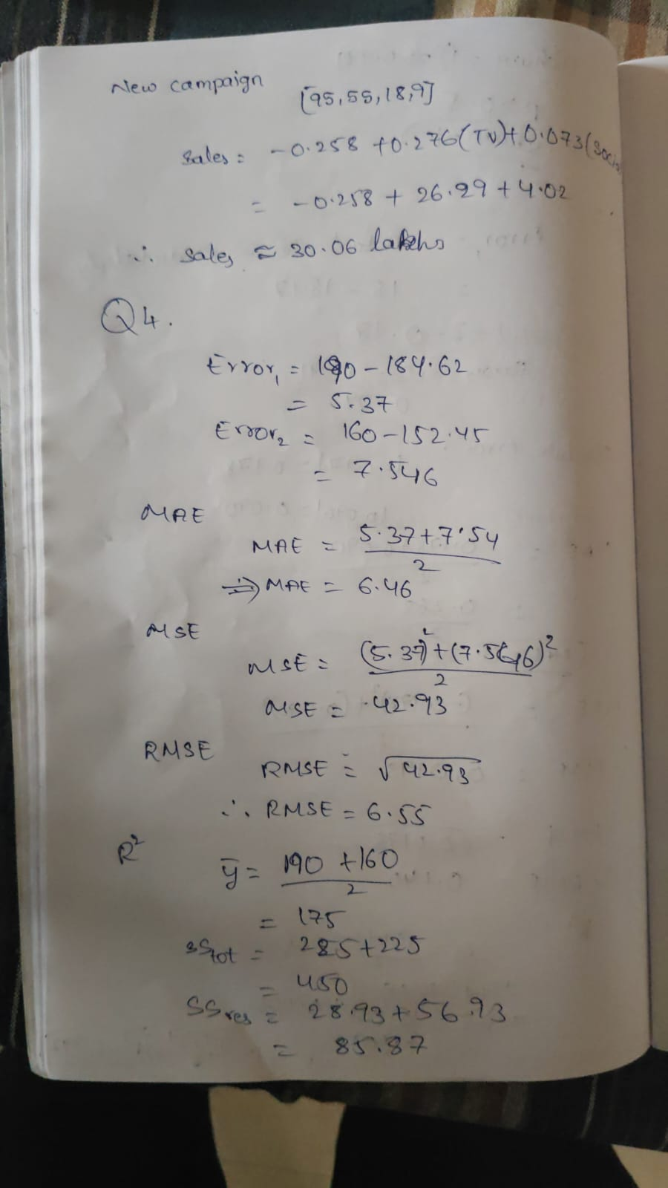
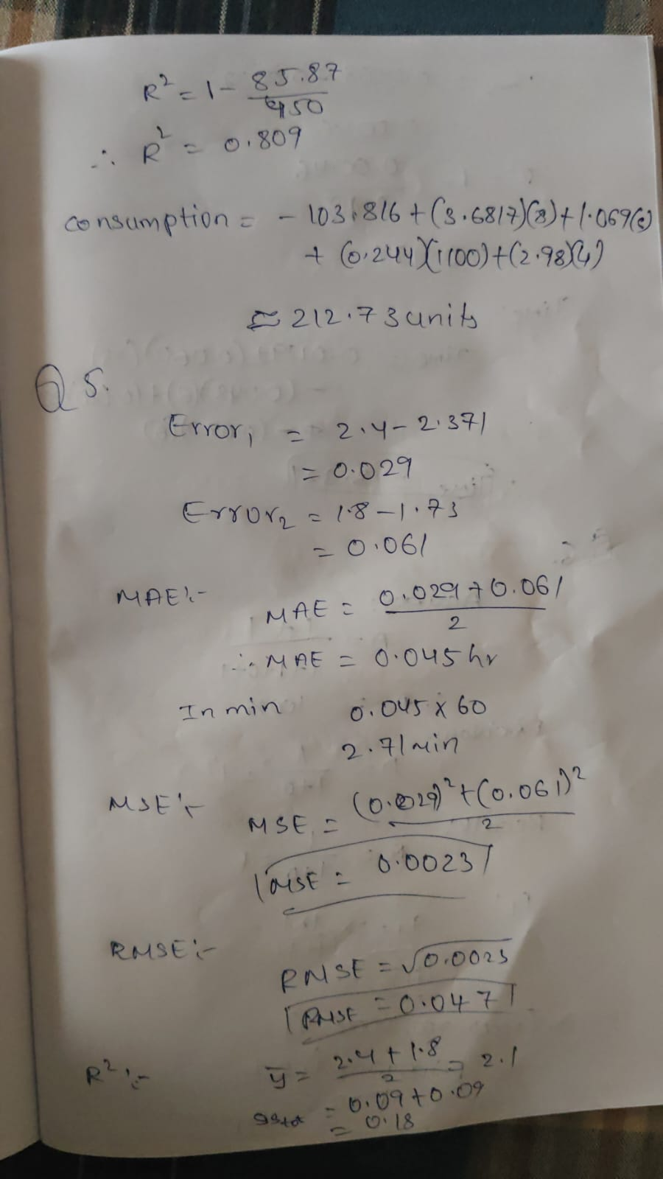
Output:
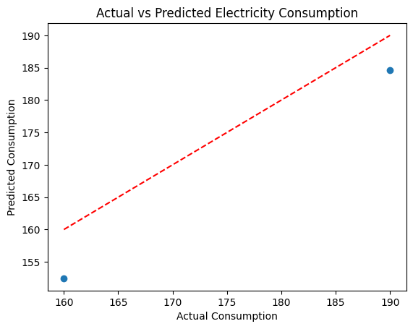

Question 5: Delivery Time Prediction Using Linear Regression
A logistics company wants to predict delivery time based on distance, traffic level, number of packages, and weather score.
Delivery Distance km Traffic Level Packages Weather Score Time Hours
D1 | 10 | 2 | 20 | 8 | 1.2
D2 | 20 | 4 | 30 | 7 | 2.4
D3 | 30 | 6 | 40 | 6 | 3.5
D4 | 40 | 8 | 50 | 5 | 4.8
D5 | 50 | 9 | 60 | 4 | 6.0
D6 | 15 | 3 | 25 | 8 | 1.8
D7 | 35 | 7 | 45 | 5 | 4.2
D8 | 25 | 5 | 35 | 6 | 3.0
Tasks
- Create the dataset.
- Identify input and output variables.
- Split the data into train and test sets.
- Implement Linear Regression.
- Predict delivery time for test records.
- Predict delivery time for:
Distance Traffic Level Packages Weather Score
28 | 6 | 38 | 6
- Evaluate using MAE, MSE, RMSE, and R² score.
- Explain how this model can help a logistics company plan delivery schedules.
Sol:
Linear Regression can be used to predict the delivery time of an order based on logistics-related factors.
Input features
- Distance
- Traffic Level
- Number of Packages
- Weather Score
Target
- Delivery Time in hours
The model learns the relationship between these variables and delivery time.
The general equation is:
The model is trained using historical delivery records.
After training, it can predict the expected delivery time for a new delivery.
Business use
The company can use predictions to:
- Estimate delivery times.
- Plan delivery schedules.
- Assign vehicles and drivers.
- Inform customers about expected delivery times.
- Identify delays caused by traffic or weather.
Delivery Distance km Traffic Level Packages Weather Score Time Hours
D1 | 10 | 2 | 20 | 8 | 1.2
D2 | 20 | 4 | 30 | 7 | 2.4
D3 | 30 | 6 | 40 | 6 | 3.5
D4 | 40 | 8 | 50 | 5 | 4.8
D5 | 50 | 9 | 60 | 4 | 6.0
D6 | 15 | 3 | 25 | 8 | 1.8
D7 | 35 | 7 | 45 | 5 | 4.2
D8 | 25 | 5 | 35 | 6 | 3.0

Code:
import pandas as pd
import matplotlib.pyplot as plt
from sklearn.model_selection import train_test_split
from sklearn.linear_model import LinearRegression
from sklearn.metrics import mean_absolute_error, mean_squared_error, r2_score
import numpy as np
data = {
"Distance": [10, 20, 30, 40, 50, 15, 35, 25],
"Traffic_Level": [2, 4, 6, 8, 9, 3, 7, 5],
"Packages": [20, 30, 40, 50, 60, 25, 45, 35],
"Weather_Score": [8, 7, 6, 5, 4, 8, 5, 6],
"Time": [1.2, 2.4, 3.5, 4.8, 6.0, 1.8, 4.2, 3.0]
}
df = pd.DataFrame(data)
print("Dataset:")
print(df)
X = df[
["Distance", "Traffic_Level",
"Packages", "Weather_Score"]
]
y = df["Time"]
X_train, X_test, y_train, y_test = train_test_split(
X, y, test_size=0.25, random_state=42
)
model = LinearRegression()
model.fit(X_train, y_train)
y_pred = model.predict(X_test)
print("\nActual vs Predicted:")
print(pd.DataFrame({
"Actual Time": y_test.values,
"Predicted Time": y_pred
}))
new_delivery = [[28, 6, 38, 6]]
new_time = model.predict(new_delivery)
print("\nPredicted delivery time:",
new_time[0], "Hours")
mae = mean_absolute_error(y_test, y_pred)
mse = mean_squared_error(y_test, y_pred)
rmse = np.sqrt(mse)
r2 = r2_score(y_test, y_pred)
print("\nModel Evaluation:")
print("MAE :", mae)
print("MSE :", mse)
print("RMSE:", rmse)
print("R2 :", r2)
plt.scatter(y_test, y_pred)
plt.plot(
[y_test.min(), y_test.max()],
[y_test.min(), y_test.max()],
'r--'
)
plt.xlabel("Actual Delivery Time")
plt.ylabel("Predicted Delivery Time")
plt.title("Actual vs Predicted Delivery Time")
plt.show()
Calculation:

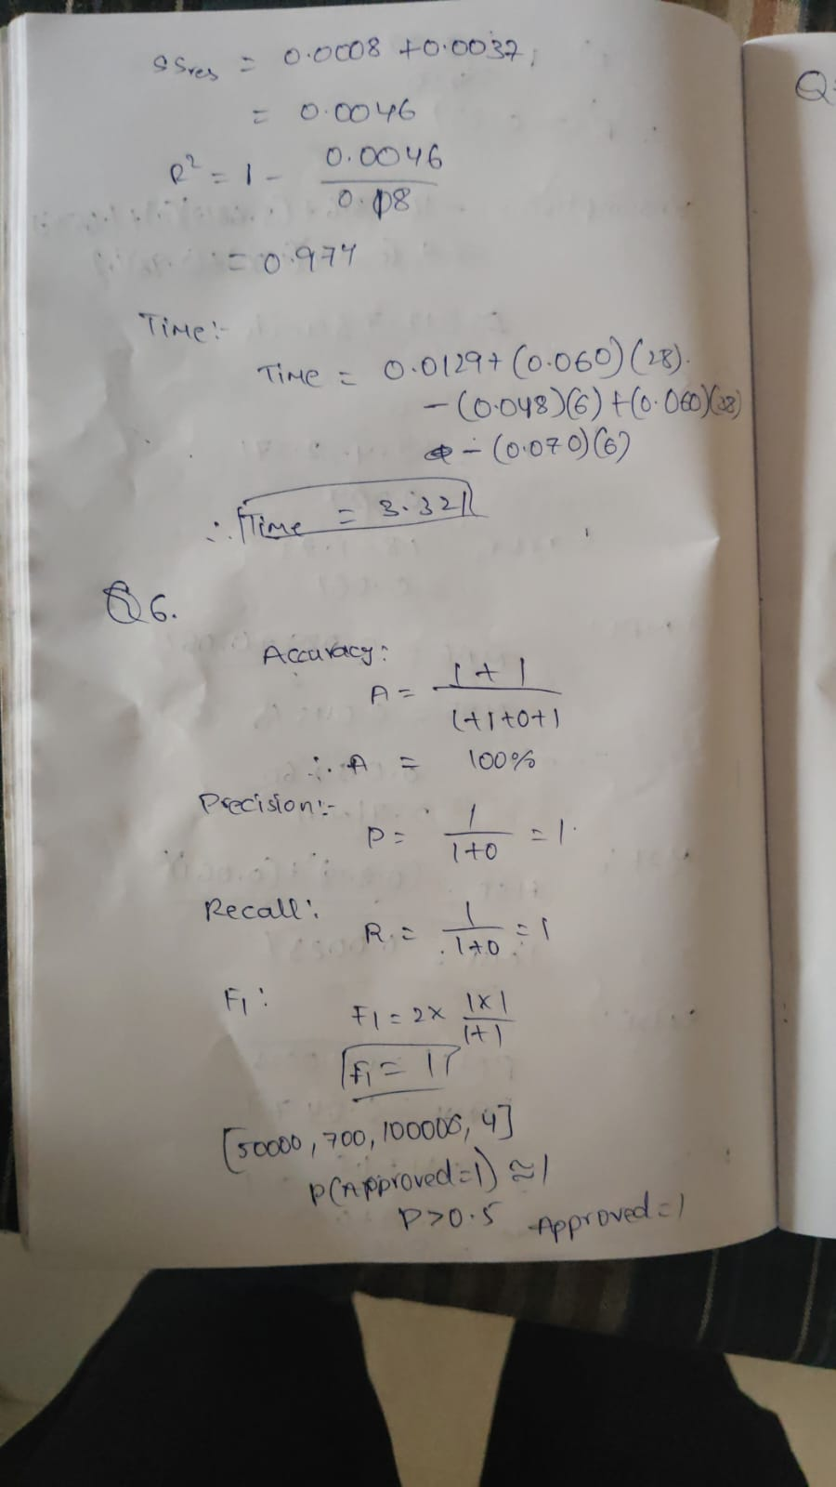
Output:
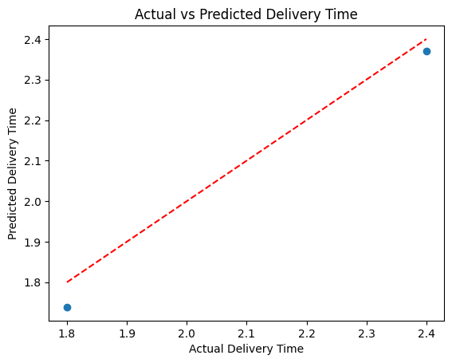

Question 6: Loan Approval Prediction Using Logistic Regression
A bank wants to predict whether a loan application should be approved or rejected.
Applicant Income Credit Score Existing Loan Employment Years Approved
A1 | 25000 | 580 | 200000 | 1 | 0
A2 | 30000 | 600 | 180000 | 2 | 0
A3 | 45000 | 680 | 120000 | 3 | 1
A4 | 60000 | 750 | 80000 | 5 | 1
A5 | 70000 | 800 | 50000 | 6 | 1
A6 | 28000 | 590 | 220000 | 1 | 0
A7 | 55000 | 720 | 100000 | 4 | 1
A8 | 35000 | 620 | 160000 | 2 | 0
Here,
Approved = 1 means loan approved.
Approved = 0 means loan rejected.
Tasks
- Create the dataset in Python.
- Identify independent and dependent variables.
- Split the dataset.
- Implement Logistic Regression.
- Predict approval status for test data.
- Predict loan approval for a new applicant:
Income Credit Score Existing Loan Employment Years
50000 | 700 | 100000 | 4
- Evaluate using accuracy, confusion matrix, precision, recall, and F1-score.
- Explain why Logistic Regression is suitable for loan approval prediction.
Sol:
Logistic Regression can be used by a bank to classify loan applications into:
- Approved = 1
- Rejected = 0
Input features
- Applicant Income
- Credit Score
- Existing Loan
- Employment Years
Target
The model calculates the probability that an applicant should be approved.
For example:
Since:
the model predicts:
Evaluation
The model is evaluated using:
- Accuracy
- Confusion Matrix
- Precision
- Recall
- F1-score
Logistic Regression is suitable because the output consists of two classes.
Applicant Income Credit Score Existing Loan Employment Years Approved
A1 | 25000 | 580 | 200000 | 1 | 0
A2 | 30000 | 600 | 180000 | 2 | 0
A3 | 45000 | 680 | 120000 | 3 | 1
A4 | 60000 | 750 | 80000 | 5 | 1
A5 | 70000 | 800 | 50000 | 6 | 1
A6 | 28000 | 590 | 220000 | 1 | 0
A7 | 55000 | 720 | 100000 | 4 | 1
A8 | 35000 | 620 | 160000 | 2 | 0

Code:
import pandas as pd
import matplotlib.pyplot as plt
from sklearn.model_selection import train_test_split
from sklearn.linear_model import LogisticRegression
from sklearn.metrics import (
accuracy_score,
confusion_matrix,
precision_score,
recall_score,
f1_score,
ConfusionMatrixDisplay
)
data = {
"Income": [25000, 30000, 45000, 60000, 70000, 28000, 55000, 35000],
"Credit_Score": [580, 600, 680, 750, 800, 590, 720, 620],
"Existing_Loan": [200000, 180000, 120000, 80000,
50000, 220000, 100000, 160000],
"Employment_Years": [1, 2, 3, 5, 6, 1, 4, 2],
"Approved": [0, 0, 1, 1, 1, 0, 1, 0]
}
df = pd.DataFrame(data)
print("Dataset:")
print(df)
X = df[
["Income", "Credit_Score",
"Existing_Loan", "Employment_Years"]
]
y = df["Approved"]
X_train, X_test, y_train, y_test = train_test_split(
X, y, test_size=0.25,
random_state=42,
stratify=y
)
model = LogisticRegression(max_iter=1000)
model.fit(X_train, y_train)
y_pred = model.predict(X_test)
print("\nActual vs Predicted:")
print(pd.DataFrame({
"Actual": y_test.values,
"Predicted": y_pred
}))
new_applicant = [[50000, 700, 100000, 4]]
prediction = model.predict(new_applicant)
if prediction[0] == 1:
print("\nNew applicant: LOAN APPROVED")
else:
print("\nNew applicant: LOAN REJECTED")
accuracy = accuracy_score(y_test, y_pred)
cm = confusion_matrix(y_test, y_pred)
precision = precision_score(y_test, y_pred, zero_division=0)
recall = recall_score(y_test, y_pred, zero_division=0)
f1 = f1_score(y_test, y_pred, zero_division=0)
print("\nModel Evaluation:")
print("Accuracy :", accuracy)
print("Confusion Matrix:\n", cm)
print("Precision:", precision)
print("Recall :", recall)
print("F1 Score :", f1)
plt.bar(
["Rejected", "Approved"],
[(y_pred == 0).sum(), (y_pred == 1).sum()]
)
plt.xlabel("Loan Status")
plt.ylabel("Number of Applicants")
plt.title("Loan Approval Prediction")
plt.show()
ConfusionMatrixDisplay.from_predictions(y_test, y_pred)
plt.title("Loan Approval Confusion Matrix")
plt.show()
Calculation:


Output:
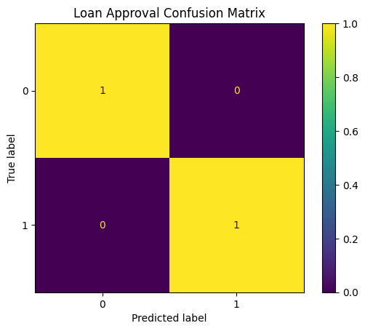

Question 7: Healthcare Treatment Cost Prediction Using Lasso Regression
A hospital wants to predict treatment cost based on patient health parameters. Since many medical features are available, the hospital wants to use Lasso Regression to identify important predictors.
Patient Age BP Sugar Level BMI Previous Visits Treatment Cost
P1 | 25 | 115  125  140  155  165  120  150  135 | 90 | 22 | 1 | 5000
P2 | 35 |  | 110 | 25 | 2 | 8000
P3 | 45 |  | 150 | 29 | 3 | 15000
P4 | 55 |  | 180 | 32 | 5 | 25000
P5 | 60 |  | 200 | 35 | 6 | 32000
P6 | 30 |  | 100 | 24 | 1 | 7000
P7 | 50 |  | 170 | 31 | 4 | 22000
P8 | 40 |  | 130 | 27 | 2 | 12000
Tasks
- Create the dataset using Python.
- Identify features and target variable.
- Split into training and testing sets.
- Implement Lasso Regression.
- Try alpha values such as 0.1, 1.0, and 10.0.
- Predict treatment cost for test patients.
- Predict treatment cost for a new patient:
Age BP Sugar Level BMI Previous Visits
48 | 145 | 160 | 30 | 4
- Evaluate using MAE, MSE, RMSE, and R² score.
- Print the model coefficients.
- Explain which medical features are important based on Lasso coefficients.
Sol:
Lasso Regression can be used to predict healthcare treatment costs when many patient-related variables are available.
Features
- Age
- Blood Pressure
- Sugar Level
- BMI
- Previous Visits
Target
- Treatment Cost
Lasso applies an L1 regularization penalty:
This penalty reduces unnecessary coefficients.
If a coefficient becomes:
the corresponding feature is effectively removed.
Importance
The hospital can use Lasso to:
- Predict treatment expenses.
- Identify important health parameters.
- Remove less useful variables.
- Build a simpler prediction model.
The coefficient magnitude can be used to understand the relative influence of a feature, while the sign indicates whether its relationship with predicted cost is positive or negative.
Patient Age BP Sugar Level BMI Previous Visits Treatment Cost
P1 | 25 | 115  125  140  155  165  120  150  135 | 90 | 22 | 1 | 5000
P2 | 35 |  | 110 | 25 | 2 | 8000
P3 | 45 |  | 150 | 29 | 3 | 15000
P4 | 55 |  | 180 | 32 | 5 | 25000
P5 | 60 |  | 200 | 35 | 6 | 32000
P6 | 30 |  | 100 | 24 | 1 | 7000
P7 | 50 |  | 170 | 31 | 4 | 22000
P8 | 40 |  | 130 | 27 | 2 | 12000

Code:
import pandas as pd
import matplotlib.pyplot as plt
from sklearn.model_selection import train_test_split
from sklearn.linear_model import Lasso
from sklearn.metrics import mean_absolute_error, mean_squared_error, r2_score
import numpy as np
data = {
"Age": [25, 35, 45, 55, 60, 30, 50, 40],
"BP": [115, 125, 140, 155, 165, 120, 150, 135],
"Sugar_Level": [90, 110, 150, 180, 200, 100, 170, 130],
"BMI": [22, 25, 29, 32, 35, 24, 31, 27],
"Previous_Visits": [1, 2, 3, 5, 6, 1, 4, 2],
"Treatment_Cost": [5000, 8000, 15000, 25000,
32000, 7000, 22000, 12000]
}
df = pd.DataFrame(data)
print("Dataset:")
print(df)
X = df[
["Age", "BP", "Sugar_Level",
"BMI", "Previous_Visits"]
]
y = df["Treatment_Cost"]
X_train, X_test, y_train, y_test = train_test_split(
X, y, test_size=0.25, random_state=42
)
lasso = Lasso(alpha=0.1)
lasso.fit(X_train, y_train)
y_pred = lasso.predict(X_test)
print("\nActual vs Predicted:")
print(pd.DataFrame({
"Actual Cost": y_test.values,
"Predicted Cost": y_pred
}))
new_patient = [[48, 145, 160, 30, 4]]
new_cost = lasso.predict(new_patient)

print("\nPredicted treatment cost:",
new_cost[0])
mae = mean_absolute_error(y_test, y_pred)
mse = mean_squared_error(y_test, y_pred)
rmse = np.sqrt(mse)
r2 = r2_score(y_test, y_pred)
print("\nModel Evaluation:")
print("MAE :", mae)
print("MSE :", mse)
print("RMSE:", rmse)
print("R2 :", r2)
print("\nAlpha Comparison:")
for alpha in [0.1, 1.0, 10.0]:
temp_model = Lasso(alpha=alpha)
temp_model.fit(X_train, y_train)
temp_pred = temp_model.predict(X_test)
temp_r2 = r2_score(y_test, temp_pred)
print("Alpha:", alpha,
"R2:", temp_r2)
print("\nLasso Coefficients:")
for feature, coefficient in zip(X.columns, lasso.coef_):
print(feature, ":", coefficient)

plt.scatter(y_test, y_pred)
plt.plot(
[y_test.min(), y_test.max()],
[y_test.min(), y_test.max()],
'r--'
)
plt.xlabel("Actual Treatment Cost")
plt.ylabel("Predicted Treatment Cost")
plt.title("Actual vs Predicted Treatment Cost")
plt.show()
plt.bar(X.columns, lasso.coef_)
plt.xlabel("Medical Features")
plt.ylabel("Lasso Coefficient")
plt.title("Lasso Feature Coefficients")
plt.xticks(rotation=45)
plt.show()

Calculation:
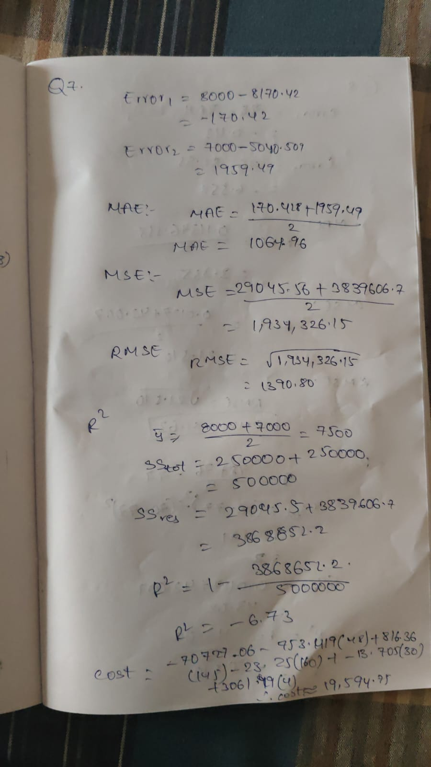
Output:
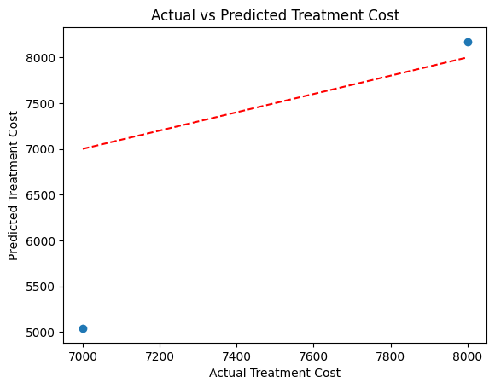
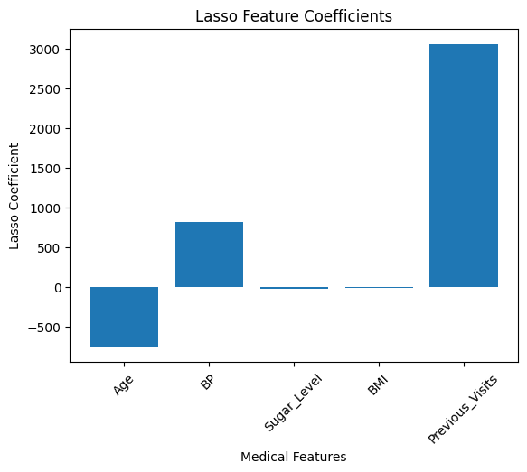
Question 8: Manufacturing Defect Strength Prediction Using Ridge Regression
A manufacturing company wants to predict the strength score of a product based on machine parameters. Since temperature, pressure, and machine speed may be correlated, Ridge Regression is used.
Product Temperature Pressure Machine Speed Material Quality Strength Score
P1 |  | 70 |  | 30 |  | 100 |  | 8 |  | 75
P2 |  | 75 |  | 35 |  | 110 |  | 7 |  | 78
P3 |  | 80 |  | 38 |  | 120 |  | 6 |  | 80
P4 |  | 85 |  | 42 |  | 125 |  | 6 |  | 82
 | P5 |  | 90 |  | 45 |  | 130 |  | 5 |  | 79
 | P6 |  | 95 |  | 50 |  | 140 |  | 4 |  | 76
 | P7 |  | 78 |  | 36 |  | 115 |  | 7 |  | 81
 | P8 |  | 88 |  | 44 |  | 128 |  | 5 |  | 80
Tasks
- Create the dataset.
- Identify the independent variables and dependent variable.
- Split into training and testing data.
- Implement Ridge Regression.
- Use alpha values such as 0.1, 1.0, and 10.0.
- Predict strength score for test products.
- Predict strength score for a new product:
Temperature Pressure Machine Speed Material Quality
82 | 40 | 122 | 6
- Evaluate using MAE, MSE, RMSE, and R² score.
- Display Ridge coefficients.
- Explain how Ridge handles multicollinearity in manufacturing data.
Sol:
Ridge Regression is used to predict product strength based on manufacturing parameters.
Features
- Temperature
- Pressure
- Machine Speed
- Material Quality
Target
- Strength Score
Some manufacturing parameters may be correlated. For example, changes in temperature may be associated with changes in pressure or machine speed.
This is called multicollinearity.
Ridge handles this by adding an L2 penalty:
This shrinks large coefficients and makes the model more stable.
Benefits
Ridge can:
- Handle correlated features.
- Reduce overfitting.
- Stabilize coefficients.
- Improve prediction performance.
The model can then predict the strength score of a new product before manufacturing or quality testing.
Product Temperature Pressure Machine Speed Material Quality Strength Score
P1 |  | 70 |  | 30 |  | 100 |  | 8 |  | 75
P2 |  | 75 |  | 35 |  | 110 |  | 7 |  | 78
P3 |  | 80 |  | 38 |  | 120 |  | 6 |  | 80
P4 |  | 85 |  | 42 |  | 125 |  | 6 |  | 82
 | P5 |  | 90 |  | 45 |  | 130 |  | 5 |  | 79
 | P6 |  | 95 |  | 50 |  | 140 |  | 4 |  | 76
 | P7 |  | 78 |  | 36 |  | 115 |  | 7 |  | 81
 | P8 |  | 88 |  | 44 |  | 128 |  | 5 |  | 80

Code:
import pandas as pd
import matplotlib.pyplot as plt
from sklearn.model_selection import train_test_split
from sklearn.linear_model import Ridge
from sklearn.metrics import mean_absolute_error, mean_squared_error, r2_score
import numpy as np
data = {
"Temperature": [70, 75, 80, 85, 90, 95, 78, 88],
"Pressure": [30, 35, 38, 42, 45, 50, 36, 44],
"Machine_Speed": [100, 110, 120, 125, 130, 140, 115, 128],
"Material_Quality": [8, 7, 6, 6, 5, 4, 7, 5],
"Strength_Score": [75, 78, 80, 82, 79, 76, 81, 80]
}

df = pd.DataFrame(data)
print("Dataset:")
print(df)
X = df[
["Temperature", "Pressure",
"Machine_Speed", "Material_Quality"]
]
y = df["Strength_Score"]
X_train, X_test, y_train, y_test = train_test_split(
X, y, test_size=0.25, random_state=42
)
ridge = Ridge(alpha=1.0)
y_pred = ridge.predict(X_test)
print("\nActual vs Predicted:")
print(pd.DataFrame({
"Actual Strength": y_test.values,
"Predicted Strength": y_pred
}))
new_product = [[82, 40, 122, 6]]
new_strength = ridge.predict(new_product)
print("\nPredicted strength score:",
new_strength[0])
mae = mean_absolute_error(y_test, y_pred)
mse = mean_squared_error(y_test, y_pred)
rmse = np.sqrt(mse)
r2 = r2_score(y_test, y_pred)
print("\nModel Evaluation:")
print("MAE :", mae)
print("MSE :", mse)
print("RMSE:", rmse)
print("R2 :", r2)
print("\nAlpha Comparison:")
for alpha in [0.1, 1.0, 10.0]:
temp_model = Ridge(alpha=alpha)
temp_model.fit(X_train, y_train)
temp_pred = temp_model.predict(X_test)
temp_r2 = r2_score(y_test, temp_pred)
print("Alpha:", alpha,
"R2:", temp_r2)
print("\nRidge Coefficients:")
for feature, coefficient in zip(X.columns, ridge.coef_):
print(feature, ":", coefficient)
plt.scatter(y_test, y_pred)
plt.plot(
[y_test.min(), y_test.max()],
[y_test.min(), y_test.max()],
'r--'
)
plt.xlabel("Actual Strength Score")
plt.ylabel("Predicted Strength Score")
plt.title("Actual vs Predicted Strength Score")
plt.show()
plt.bar(X.columns, ridge.coef_)
plt.xlabel("Manufacturing Features")
plt.ylabel("Ridge Coefficient")
plt.title("Ridge Regression Coefficients")
plt.xticks(rotation=45)
plt.show()
Calculation:
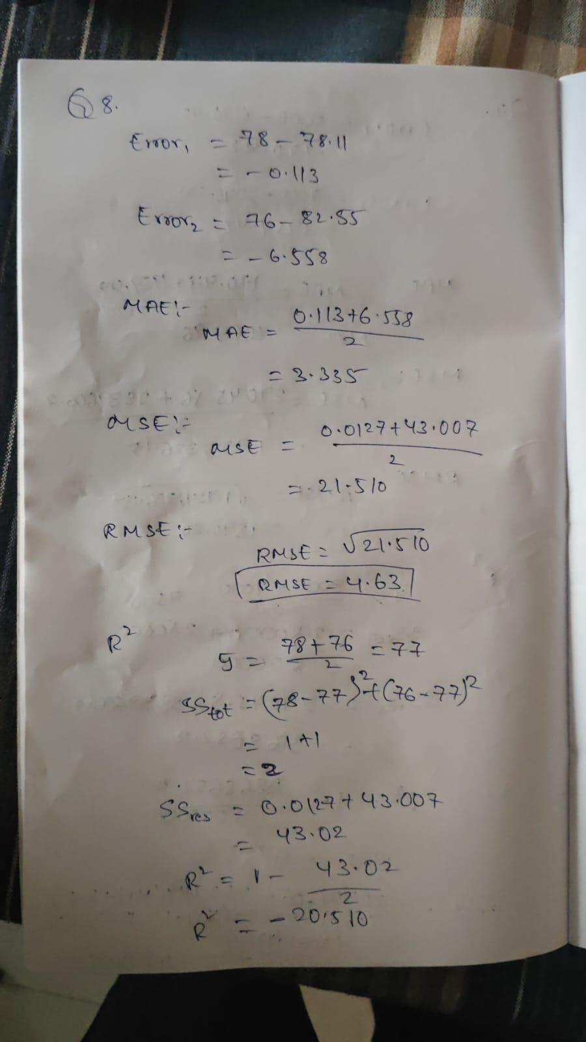
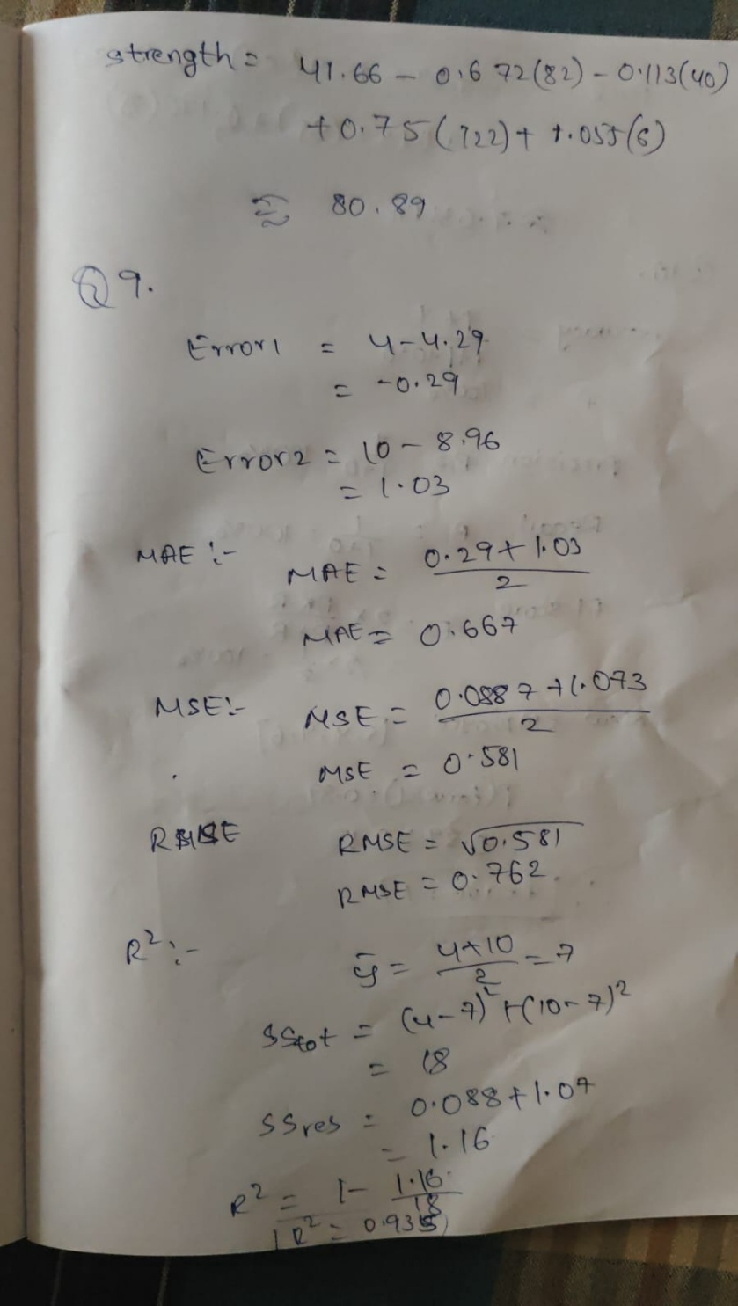
Output:
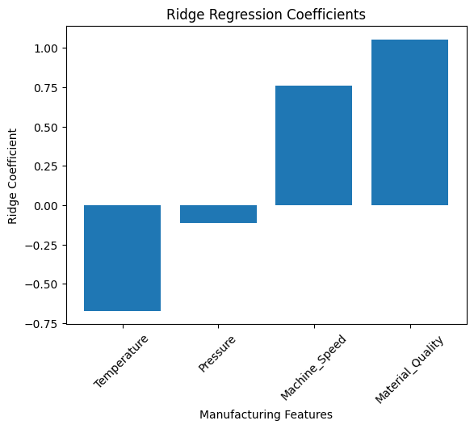

Question 9: Student Salary Package Prediction Using Linear Regression
A university placement cell wants to predict the expected salary package of students.
Student CGPA Aptitude Score Coding Score Communication Score Package LPA
S1 | 6.5 | 60 | 55 | 65 | 3.2
S2 | 7.0 | 65 | 60 | 70 | 4.0
S3 | 7.5 | 70 | 68 | 72 | 5.0
S4 | 8.0 | 78 | 80 | 75 | 6.5
S5 | 8.5 | 85 | 88 | 80 | 8.0
S6 | 9.0 | 90 | 92 | 85 | 10.0
S7 | 6.8 | 62 | 58 | 68 | 3.8
S8 | 8.2 | 80 | 82 | 78 | 7.0
Tasks
- Create the dataset using Python.
- Identify input and output variables.
- Split the dataset.
- Implement Linear Regression.
- Predict package for test students.
- Predict package for a new student:
CGPA Aptitude Score Coding Score Communication Score
8.1 | 82 | 85 | 78
- Evaluate using MAE, MSE, RMSE, and R² score.
- Interpret the result from the placement cell perspective.
Sol:
Linear Regression can be used by a university placement cell to predict the expected salary package of students.
Input features
- CGPA
- Aptitude Score
- Coding Score
- Communication Score
Target
- Salary Package in LPA
The model learns the relationship:
A general equation is:
Evaluation
The model can be evaluated using:
- MAE
- MSE
- RMSE
- R²
A high R² indicates that student performance variables explain a large part of the variation in salary packages.
Placement-cell use
The placement cell can use the model to:
- Estimate expected salary.
- Identify students who may need additional training.
- Understand important performance factors.
- Support placement planning.

Student CGPA Aptitude Score Coding Score Communication Score Package LPA
S1 | 6.5 | 60 | 55 | 65 | 3.2
S2 | 7.0 | 65 | 60 | 70 | 4.0
S3 | 7.5 | 70 | 68 | 72 | 5.0
S4 | 8.0 | 78 | 80 | 75 | 6.5
S5 | 8.5 | 85 | 88 | 80 | 8.0
S6 | 9.0 | 90 | 92 | 85 | 10.0
S7 | 6.8 | 62 | 58 | 68 | 3.8
S8 | 8.2 | 80 | 82 | 78 | 7.0

Code:
import pandas as pd
import matplotlib.pyplot as plt
from sklearn.model_selection import train_test_split
from sklearn.linear_model import LinearRegression
from sklearn.metrics import mean_absolute_error, mean_squared_error, r2_score
import numpy as np
data = {
"CGPA": [6.5, 7.0, 7.5, 8.0, 8.5, 9.0, 6.8, 8.2],
"Aptitude_Score": [60, 65, 70, 78, 85, 90, 62, 80],
"Coding_Score": [55, 60, 68, 80, 88, 92, 58, 82],
"Communication_Score": [65, 70, 72, 75, 80, 85, 68, 78],
"Package": [3.2, 4.0, 5.0, 6.5, 8.0, 10.0, 3.8, 7.0]
}
df = pd.DataFrame(data)
print("Dataset:")
print(df)
X = df[
["CGPA", "Aptitude_Score",
"Coding_Score", "Communication_Score"]
]
y = df["Package"]
X_train, X_test, y_train, y_test = train_test_split(
X, y, test_size=0.25, random_state=42
)
model = LinearRegression()
model.fit(X_train, y_train)
y_pred = model.predict(X_test)
print("\nActual vs Predicted:")
print(pd.DataFrame({
"Actual Package": y_test.values,
"Predicted Package": y_pred
}))
new_student = [[8.1, 82, 85, 78]]
new_package = model.predict(new_student)
print("\nPredicted package:",
new_package[0], "LPA")
mae = mean_absolute_error(y_test, y_pred)
mse = mean_squared_error(y_test, y_pred)
rmse = np.sqrt(mse)
r2 = r2_score(y_test, y_pred)
print("\nModel Evaluation:")
print("MAE :", mae)
print("MSE :", mse)
print("RMSE:", rmse)
print("R2 :", r2)
plt.scatter(y_test, y_pred)
plt.plot(
[y_test.min(), y_test.max()],
[y_test.min(), y_test.max()],
'r--'
)
plt.xlabel("Actual Package (LPA)")
plt.ylabel("Predicted Package (LPA)")
plt.title("Actual vs Predicted Student Salary Package")
plt.show()
Calculation:
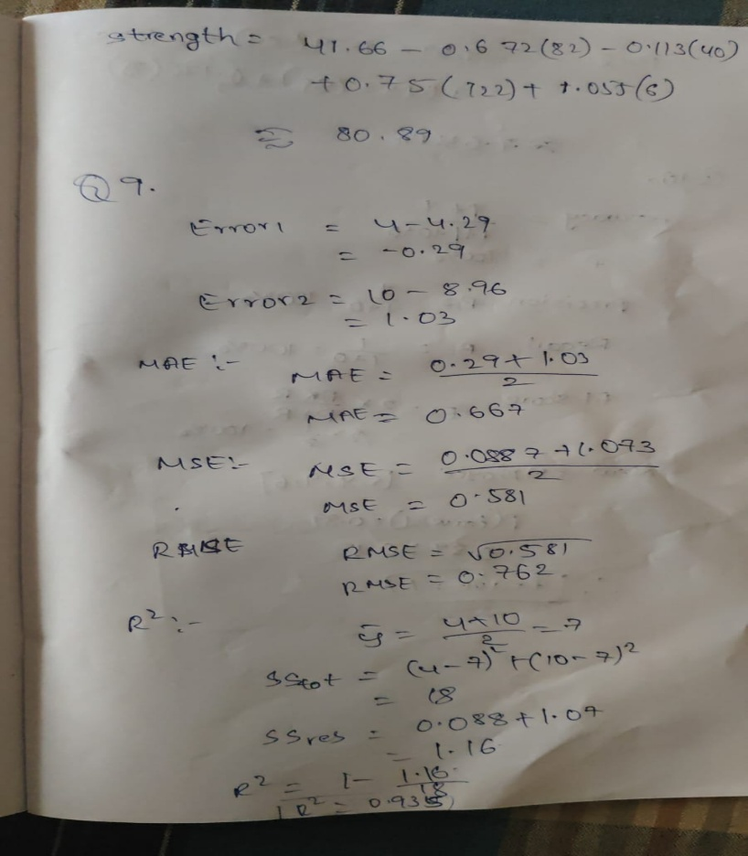
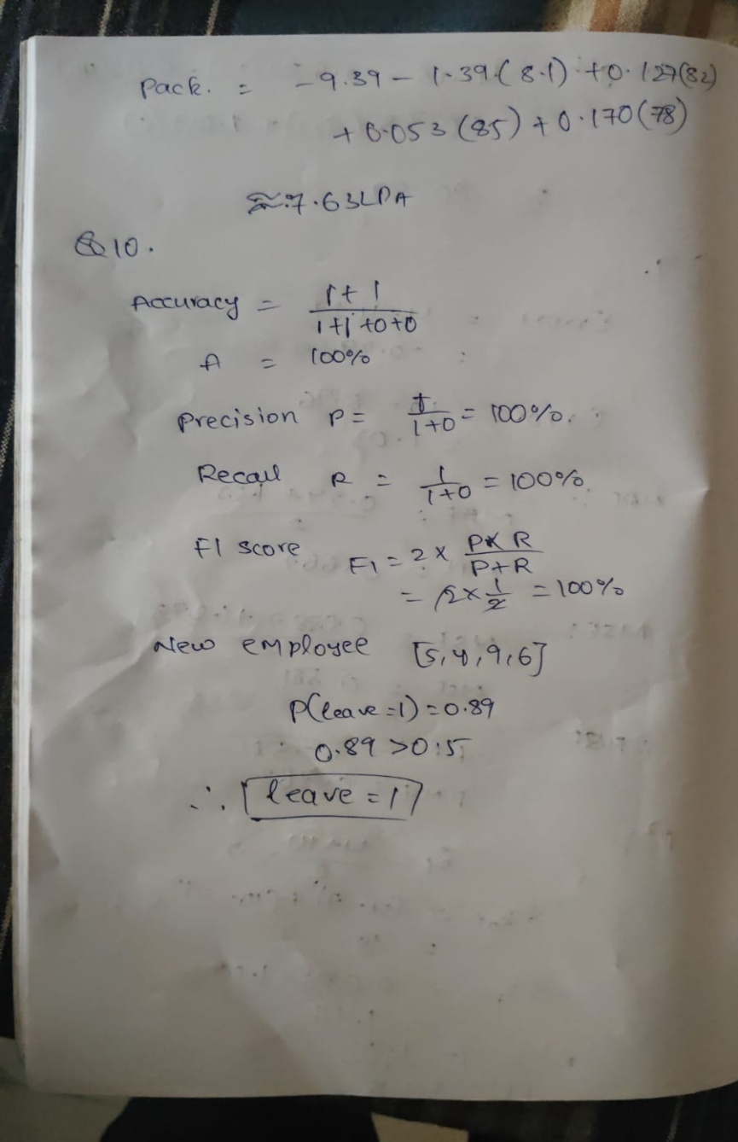
Output:
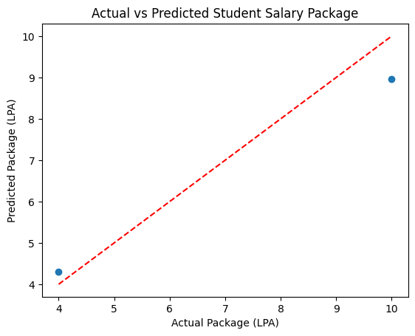

Question 10: Employee Attrition Prediction Using Logistic Regression
An HR department wants to predict whether an employee will leave the company or stay.
Employee Experience Satisfaction Score Overtime Hours Salary Increment % Leave
E1 | 2 | 8 | 2 | 12 | 0
E2 | 3 | 7 | 4 | 10 | 0
E3 | 1 | 4 | 10 | 5 | 1
E4 | 5 | 6 | 6 | 8 | 0
E5 | 6 | 3 | 12 | 4 | 1
E6 | 8 | 2 | 14 | 3 | 1
E7 | 4 | 7 | 3 | 11 | 0
E8 | 7 | 4 | 11 | 5 | 1
Here,
Leave = 1 means employee may leave.
Leave = 0 means employee may stay.
Tasks
- Create the dataset using Python.
- Identify features and target variable.
- Split into training and testing data.
- Implement Logistic Regression.
- Predict attrition for test employees.
- Predict attrition for a new employee:
Experience Satisfaction Score Overtime Hours Salary Increment %
5 | 4 | 9 | 6
- Evaluate using accuracy, confusion matrix, precision, recall, and F1-score.
- Explain how the HR team can use this prediction to reduce employee attrition.

Sol:

Logistic Regression can be used by HR departments to predict whether an employee may leave the company.
Features
- Experience
- Satisfaction Score
- Overtime Hours
- Salary Increment %
Target
where:
The model calculates:
If the probability is greater than the classification threshold, the employee is classified as likely to leave.
Evaluation
The model can be evaluated using:
- Accuracy
- Confusion Matrix
- Precision
- Recall
- F1-score
HR application
HR can use the prediction to identify employees with a high probability of leaving and take appropriate retention actions such as:
- Improving employee satisfaction.
- Managing excessive overtime.
- Reviewing compensation.
- Providing career development opportunities.

Employee Experience Satisfaction Score Overtime Hours Salary Increment % Leave
E1 | 2 | 8 | 2 | 12 | 0
E2 | 3 | 7 | 4 | 10 | 0
E3 | 1 | 4 | 10 | 5 | 1
E4 | 5 | 6 | 6 | 8 | 0
E5 | 6 | 3 | 12 | 4 | 1
E6 | 8 | 2 | 14 | 3 | 1
E7 | 4 | 7 | 3 | 11 | 0
E8 | 7 | 4 | 11 | 5 | 1

Code:
import pandas as pd
import matplotlib.pyplot as plt
from sklearn.model_selection import train_test_split
from sklearn.linear_model import LogisticRegression

from sklearn.metrics import (
accuracy_score,
confusion_matrix,
precision_score,
recall_score,
f1_score,
ConfusionMatrixDisplay
)

data = {
"Experience": [2, 3, 1, 5, 6, 8, 4, 7],
"Satisfaction_Score": [8, 7, 4, 6, 3, 2, 7, 4],
"Overtime_Hours": [2, 4, 10, 6, 12, 14, 3, 11],
"Salary_Increment": [12, 10, 5, 8, 4, 3, 11, 5],
"Leave": [0, 0, 1, 0, 1, 1, 0, 1]
}
df = pd.DataFrame(data)
print("Dataset:")
print(df)
X = df[
["Experience", "Satisfaction_Score",
"Overtime_Hours", "Salary_Increment"]
]
y = df["Leave"]
X_train, X_test, y_train, y_test = train_test_split(
X, y, test_size=0.25,
random_state=42,
stratify=y
)
model = LogisticRegression(max_iter=1000)
model.fit(X_train, y_train)
y_pred = model.predict(X_test)

print("\nActual vs Predicted:")
print(pd.DataFrame({
"Actual": y_test.values,
"Predicted": y_pred
}))
new_employee = [[5, 4, 9, 6]]
prediction = model.predict(new_employee)
if prediction[0] == 1:
print("\nNew employee prediction: MAY LEAVE")
else:
print("\nNew employee prediction: MAY STAY")
accuracy = accuracy_score(y_test, y_pred)
cm = confusion_matrix(y_test, y_pred)
precision = precision_score(y_test, y_pred, zero_division=0)
recall = recall_score(y_test, y_pred, zero_division=0)
f1 = f1_score(y_test, y_pred, zero_division=0)
print("\nModel Evaluation:")
print("Accuracy :", accuracy)
print("Confusion Matrix:\n", cm)
print("Precision:", precision)
print("Recall :", recall)
print("F1 Score :", f1)

plt.bar(
["Stay", "Leave"],
[(y_pred == 0).sum(), (y_pred == 1).sum()]
)
plt.xlabel("Employee Status")
plt.ylabel("Number of Employees")
plt.title("Employee Attrition Prediction")
plt.show()
ConfusionMatrixDisplay.from_predictions(y_test, y_pred)
plt.title("Employee Attrition Confusion Matrix")
plt.show()

Calculation:

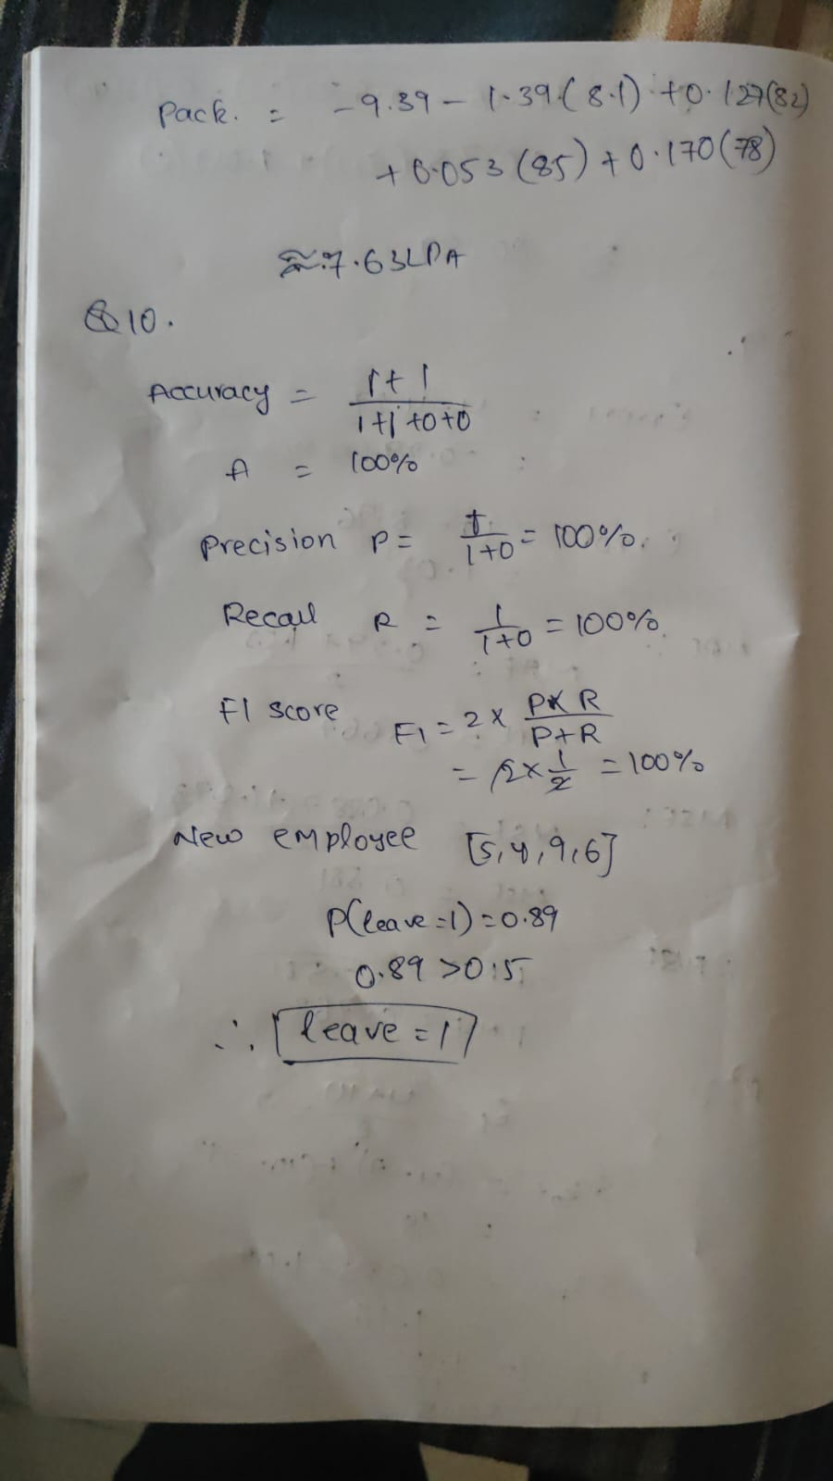

Output:
