NAME:T.V.SAI JAGADEESH
REG.NO:192472146
Q3. Sales Forecasting Dashboard
A retail company wants to analyze monthly sales data and predict future sales trends. Explain
how:
A. Pandas is used for reading and cleaning sales data
B. SciPy and Scikit-Learn are used for analysis and prediction
C. Matplotlib and Seaborn are used to create business visualizations
CODE:
import pandas as pd
import numpy as np
import matplotlib.pyplot as plt
from sklearn.linear_model import LinearRegression
data = {
"Month": [1, 2, 3, 4, 5],
"Sales": [200, 250, 300, 350, 400]
}
df = pd.DataFrame(data)
X = df[["Month"]]
y = df["Sales"]
model = LinearRegression()
model.fit(X, y)
future_months = np.array([[6], [7]])
predictions = model.predict(future_months)
print("Future Sales:", predictions)
plt.plot(df["Month"], df["Sales"], marker='o')
plt.title("Sales Trend")
plt.show()

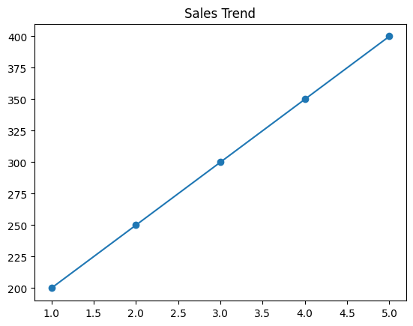

PROBLEM:
The retail company wants to analyze past sales data and predict future sales.
They need better decision-making for inventory, marketing, and revenue growth.
METHODOLOGY:
- Data Collection
Gather historical sales data from databases or files.
- Data Preprocessing
Clean the data using Pandas (handle missing values, remove errors).
- Data Analysis
Analyze trends, seasonality, and patterns using statistical methods.
- Model Building
Use machine learning models (like Linear Regression) for forecasting.
- Evaluation
Check model accuracy using performance metrics.
- Visualization
Present results using charts.
SOLUTION:
The solution is to build a Sales Forecasting Dashboard.
- Use Pandas for data handling
- Use Scikit-Learn for prediction models
- Use visualization tools for insights
- Deploy as a dashboard for business users

