SIMATS ENGINEERING (SAVEETHA SCHOOL OF ENGINEERING)
Section / Topic | Focus | Q Nos Marks
Feature Detection and Matching | Preprocessing, Edge Detection,  Harris Corner Detection, Hough  Transform, SIFT | 1 | 10
Feature Detection and Matching | PCA, Image Representation, Feature  Matching, Image Processing  Applications | 2 | 10
 | GRAND TOTAL: | 20 Marks
Department of Computer Science and Engineering
ASSESSMENT TOOL 2– Case Study (2 QUESTIONS)

Course Code: | ITA05 | Course Title: | COMPUTER VISION
CO Assessed: | CO3 – Precision (BL4) | Assessment: | Assessment Tool 1 – Case Study
Weightage: | 40% of CIA | Total Marks: | 20 (2 Questions × 10Marks)
CO1 Statement: | Analyze and extract image features using detection and matching techniques for effective image representation and comparison..(BL4)
Student Name: |  | Reg. No.:
Section / Batch: |  | Date:

Code of Conduct
I __________________________ (Name / Reg No) certify that this submission is my original work and that I have adhered to the guidelines specified for this assessment. I understand that any violation of academic integrity rules will result in disciplinary action.
Signature of the Student: _________________________
Instructions
- This test contains 2 questions, each carrying 10 marks. Total: 20 Marks.
- No negative marking. Unanswered questions carry zero marks.
- No calculators or electronic devices permitted.
- Duration: 60 minutes.
Annexure A –Case Study

1.A remote sensing application is used to align satellite images of the same geographical region captured at different times for monitoring environmental changes. The system initially relies on edge detection to identify matching regions between the images; however, due to differences in illumination, image orientation, and background details, the matching process becomes unreliable and produces inaccurate alignment results. The development team decides to replace the edge-based approach with Harris Corner Detection to identify stable and distinctive feature points. Analyze the limitations of edge detection in this application and explain how Harris Corner Detection improves feature localization, matching accuracy, and robustness for image registration under varying imaging conditions.
Solution:
Case Interpretation:
The given scenario describes a remote sensing system that aligns satellite images of the same region captured at different times. Initially, the system relies on edge detection to identify matching regions. However, due to variations such as illumination changes, orientation differences, and complex backgrounds, the system fails to produce accurate alignment.
This indicates a real-world limitation of edge-based feature extraction, where environmental variability affects consistency. To overcome this issue, the system replaces edge detection with Harris Corner Detection, aiming to improve feature stability and matching reliability.
Analysis of Edge Detection Limitations:
Edge detection methods (like Canny) focus only on identifying intensity discontinuities. While edges highlight object boundaries, they are not reliable for matching in this case due to:
- Sensitivity to Illumination:
Satellite images captured at different times may have varying lighting conditions. Edges depend heavily on intensity gradients, which change with lighting, leading to inconsistent detection.
- Orientation Variability:
Changes in satellite angle or rotation alter edge structures, making correspondence difficult.
- Lack of Distinctiveness:
Edges are continuous and repetitive in nature. Many regions may have similar edge patterns, resulting in false matches.
- Background Complexity:
Natural landscapes contain textures like vegetation, water bodies, and urban patterns, which introduce noise in edge maps.
These limitations reduce the accuracy of image registration, making edge detection unsuitable for robust alignment.

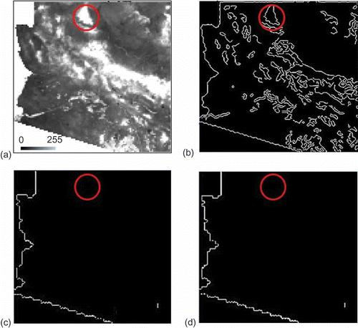
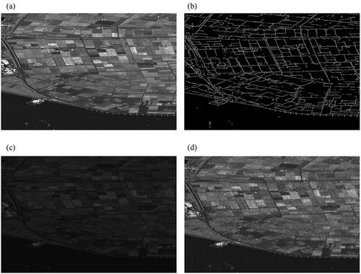

Role of Harris Corner Detection:
Harris Corner Detection addresses these issues by focusing on corner features, which are points where intensity changes significantly in multiple directions.

🔹 Improvement in Feature Localization:
Corners represent precise intersection points of edges. Unlike edges, they provide exact pixel-level locations, improving alignment accuracy.
🔹 Enhanced Matching Accuracy:
Corner points are unique and highly distinctive, reducing ambiguity during matching between images.
🔹 Robustness to Illumination Changes:
Harris detector uses local intensity variation patterns, making it less sensitive to overall brightness differences.
🔹 Rotation Invariance:
Corner features remain stable even when the image is rotated, ensuring reliable detection across different orientations.

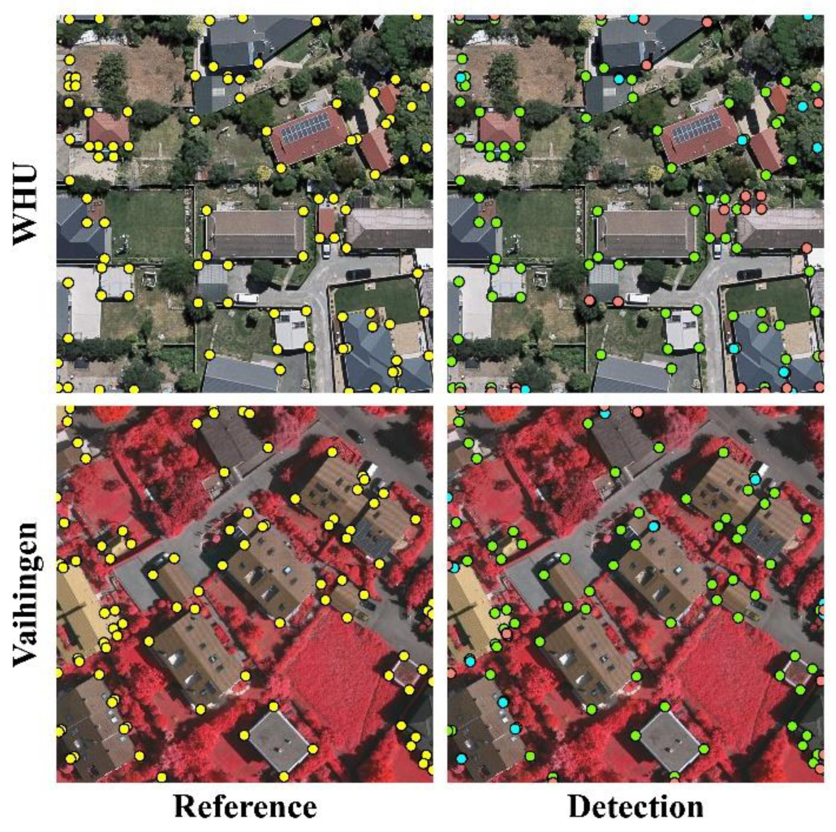
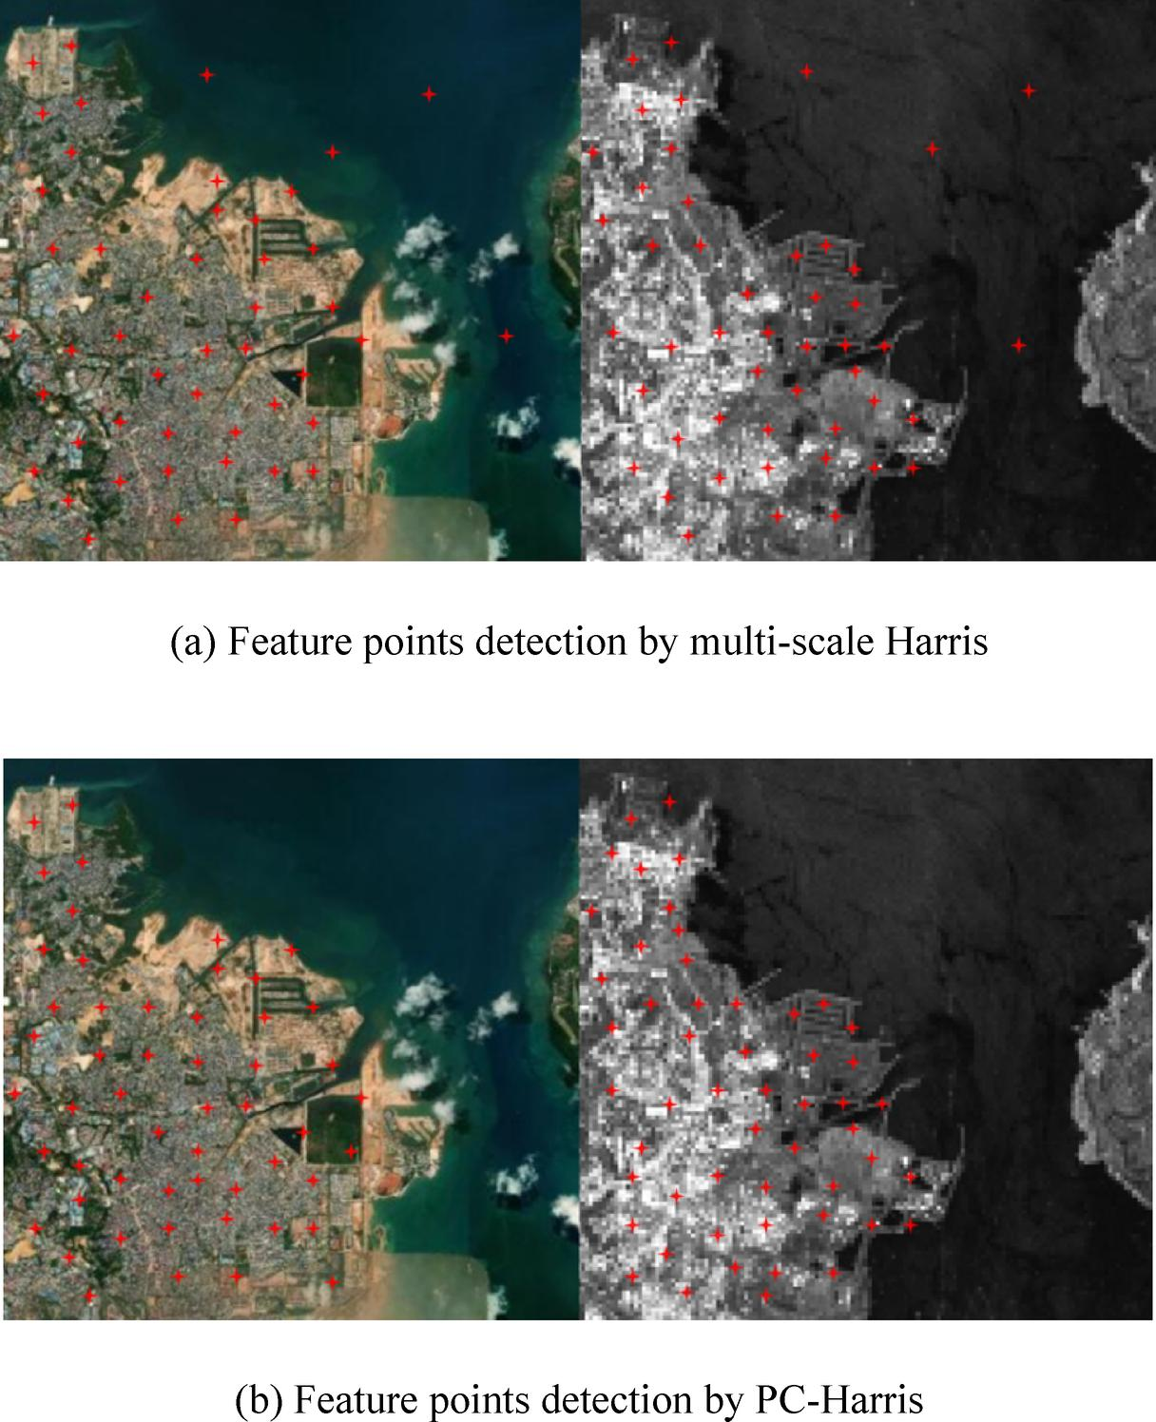

Analytical Insight:
The shift from edge detection to Harris Corner Detection reflects a transition from low-level features (edges) to more stable feature points (corners). This improves:
- Feature repeatability
- Matching precision
- System robustness
Thus, the system becomes more suitable for multi-temporal satellite image registration, where environmental conditions are not constant.

2.An autonomous surveillance system continuously captures high-resolution color images to detect vehicles and pedestrians in real time. Processing the original color images directly increases computational complexity and slows down feature extraction, making it difficult to achieve the required processing speed. To improve system performance, the engineers consider converting the images into grayscale or binary representations before applying feature detection algorithms. Analyze the impact of different image representations on computational efficiency, edge detection, and feature extraction performance, and justify the most appropriate image representation for achieving accurate and reliable object detection in real-time computer vision applications.

Solution:

Case Interpretation:
The scenario presents an autonomous surveillance system that processes high-resolution color images for detecting vehicles and pedestrians in real time. However, handling full-color images increases computational complexity, slowing down processing speed.
To improve efficiency, engineers consider converting images into grayscale or binary formats before applying feature detection techniques.

This introduces a key challenge:
Balancing computational efficiency with detection accuracy

Analysis of Image Representations:
Color Images (RGB):
- Provide detailed visual information
- Require processing of three channels (R, G, B)
- Increase memory usage and computation time
Result: Accurate but not suitable for real-time systems

Grayscale Images:
- Reduce data from 3 channels to 1
- Preserve intensity and structural information
- Maintain edges and object boundaries
Result: Balanced performance (speed + accuracy)
Binary Images:
- Simplify image into 0s and 1s
- Extremely fast processing
- Lose significant detail and texture
Result: Fast but poor detection accuracy
Grayscale representation emerges as the most appropriate solution because:
- It significantly reduces computational load
- Preserves essential features like edges and shapes
- Supports efficient feature extraction algorithms
- Enables faster processing required for real-time detection

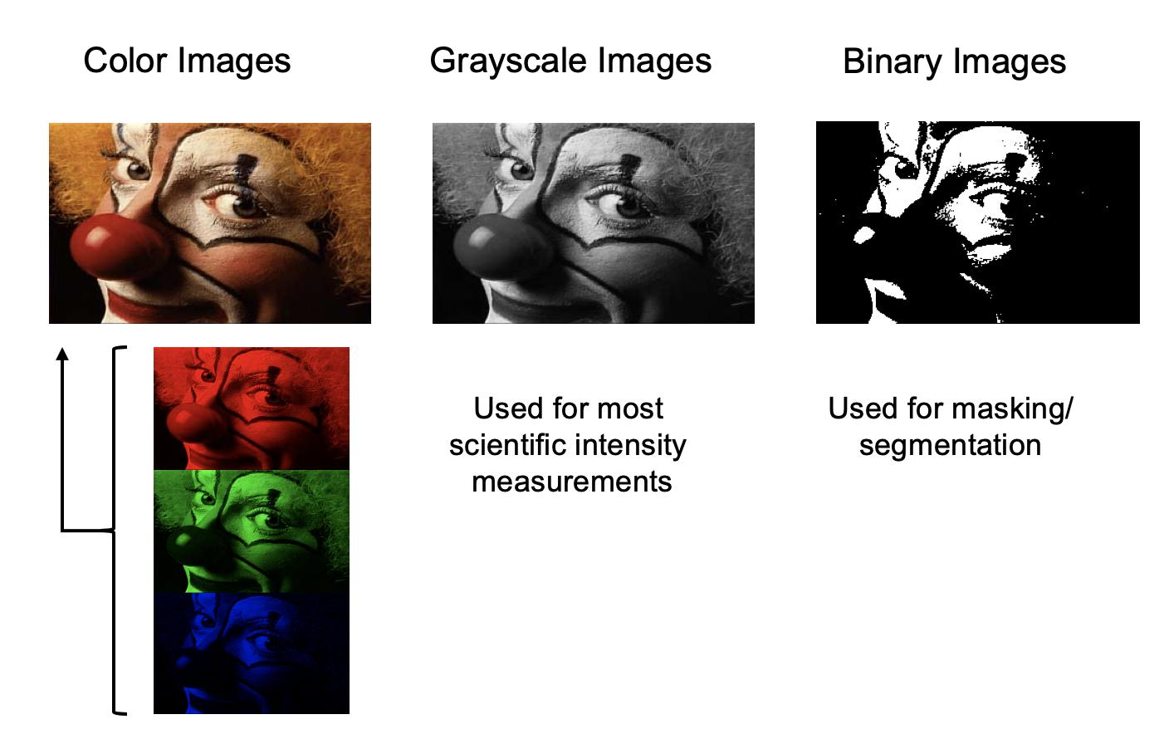

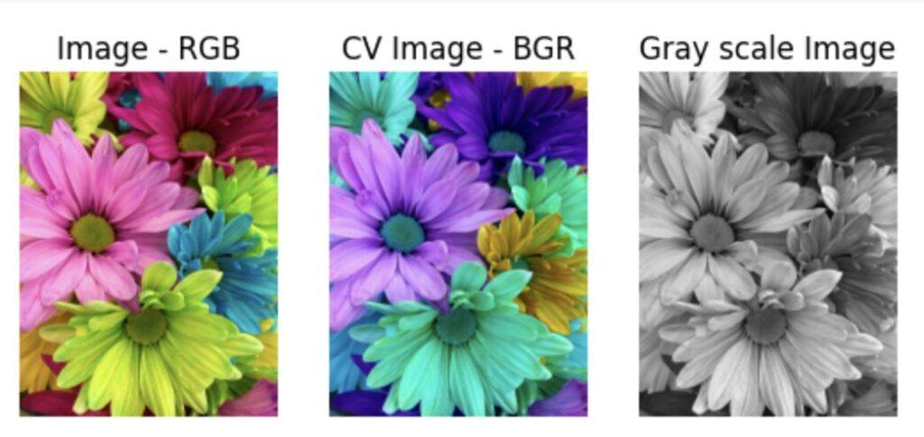

Analytical Insight:
The decision reflects a fundamental principle in computer vision:
“Efficient representation should reduce complexity without losing critical information.”
Grayscale images achieve this by eliminating redundant color data while retaining structural features necessary for detection tasks.

Case Conclusion:
The case highlights that processing full-color images is inefficient for real-time systems. Among the alternatives:
- Binary images lose critical information
- Grayscale images provide the best trade-off
Thus, grayscale representation ensures:
- Faster computation
- Reliable feature extraction
- Accurate object detection
making it the optimal choice for autonomous surveillance systems.

Rubrics
Faculty In-charge
Signature: _______________
Date: ___________________

For Calculation

Criteria | Weig Level 4 – htage Exemplary |  | Level 3 – Proficient | Level 2 –  Developing | Level 1 –  Beginning | Marks
Understanding of Case | 25 | Thorough understanding; clearly identifies all key issues | Good understandin g with most issues identified | Basic understanding ; some issues missed | Poor understanding; problem not identified correctly
Application of  Concepts | 25 | Effectively applies relevant concepts to analyze the case  deeply | Applies appropriate concepts with minor gaps | Limited application of concepts | Fails to apply relevant concepts
Analysis | 20 | In-depth analysis with strong reasoning and insights | Good  analysis with logical reasoning | Basic analysis  with limited depth | Weak or no analysis; lacks reasoning
Solution  Design | 20 | Innovative, feasible solutions with strong justification | Logical solutions with  adequate  justification | Basic solutions with weak  justification | Incorrect or no solution provided
Clarity | 10 | Clear, wellstructured, and easy to understand | Organized and understanda ble presentation | Limited clarity and structure | Poor clarity; difficult to understand

