CO5_ASSESSMENTS 2
PSEUDOCODE WRITING TASK
1. Real-Time Face Detection and Recognition
Scenario: A security system processes a live camera stream, detects multiple faces, recognizes registered persons using a trained dataset, and displays bounding boxes with identity labels.
Tools / Technologies
• Python programming language
• OpenCV for image acquisition, preprocessing, face detection, visualization, and camera control
• Haar Cascade or another OpenCV-compatible face detector
• LBPH / trained face-recognition model for registered-person identification
• NumPy for image and feature-array handling
• Webcam or CCTV stream as the live input
Constraints
• The system must operate in real time.
• Processing delay should be minimized.
• Multiple faces must be handled simultaneously.
Detailed Pseudocode
BEGIN

1. Load the face detection model.

2. Load the trained face recognition model
and registered person's dataset.

3. Initialize the camera / live video stream.

4. IF camera cannot be opened THEN
Display "Camera not available"
STOP
END IF

5. WHILE exit key is not pressed DO

5.1 Capture one frame from the camera.

5.2 IF frame is not captured THEN
Continue to next frame
END IF

5.3 Resize the frame to reduce processing time.

5.4 Convert the frame from RGB/BGR
to grayscale.

5.5 Apply preprocessing such as
contrast enhancement if required.

5.6 Detect all faces in the frame.

5.7 FOR each detected face DO

a. Extract the face region (ROI).

b. Resize the face ROI to the
required recognition size.

c. Extract facial features
from the face ROI.

d. Compare the extracted features
with the registered dataset.

e. Calculate the matching
confidence/distance.

f. IF confidence satisfies
the recognition threshold THEN
Assign the registered person's name.
ELSE
Assign "Unknown".
END IF

g. Draw a bounding box around the face.

h. Display the person's identity
and confidence value.

END FOR

5.8 Display the processed frame.

5.9 Use a small delay to maintain
real-time performance.

5.10 IF user presses 'q' THEN
EXIT the loop.
END IF

END WHILE

6. Release the camera.

7. Close all OpenCV windows.

END
Output Example:
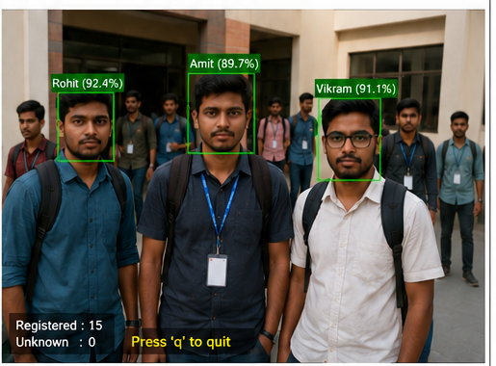
Expected output: Multiple detected faces are enclosed by bounding boxes, registered identities are displayed with confidence values, and unknown faces are labelled as Unknown. The same frame can contain several recognized persons simultaneously.

2. Vehicle Detection, Tracking and Counting
Scenario: A traffic monitoring system analyzes a live video stream, detects vehicles inside a predefined region of interest, tracks multiple vehicles across frames, counts vehicles crossing a virtual line, and displays tracking IDs and the total vehicle count.
Tools / Technologies
• Python programming language
• OpenCV for video acquisition, preprocessing, detection support, tracking, drawing, and display
• Background subtraction, contour detection, or an OpenCV-compatible object detector
• Centroid/IoU-based tracking logic or an OpenCV tracker for maintaining vehicle identities
• NumPy for image-array operations
• Roadside camera or traffic video as the input source
Constraints
• Avoid double counting of the same vehicle.
• Handle multiple vehicles simultaneously.
• Maintain near real-time performance.
Detailed Pseudocode
BEGIN

1. Open the live traffic video stream.

2. IF video source cannot be opened THEN
Display "Video source not available"
STOP
END IF

3. Define the Region of Interest (ROI).

4. Define the virtual counting line.

5. Initialize vehicle_count = 0.

6. Initialize tracking data structure.

7. Initialize counted_vehicle_IDs.

8. WHILE exit key is not pressed DO

8.1 Capture the next video frame.

8.2 IF frame is not captured THEN
Continue or terminate if video has ended.
END IF

8.3 Resize the frame to improve
processing speed.

8.4 Apply preprocessing to reduce
camera noise.

8.5 Extract the predefined ROI.

8.6 Detect vehicles inside the ROI
using background subtraction,
contours, or an object detector.

8.7 Apply thresholding and
morphological operations to
remove small unwanted objects.

8.8 FOR each detected vehicle DO

a. Find the bounding box.

b. Calculate the center point
of the vehicle.

c. Compare the current center
with previously tracked vehicles.

d. IF a matching vehicle is found THEN
Keep its existing tracking ID.
ELSE
Create a new tracking ID.
END IF

e. Update the vehicle's
current position.

END FOR

8.9 FOR each tracked vehicle DO

a. Compare its previous position
with its current position.

b. Check whether the vehicle
crossed the virtual line.

c. IF the vehicle crossed the line
AND its ID is not in the
counted_vehicle_IDs THEN

vehicle_count =
vehicle_count + 1

Add vehicle ID to
counted_vehicle_IDs.

END IF

END FOR

8.10 Remove tracking information for
vehicles that have disappeared
for several frames.

8.11 Draw bounding boxes around vehicles.

8.12 Display tracking ID for each vehicle.

8.13 Draw the ROI and virtual
counting line.

8.14 Display the total vehicle count.

8.15 Display the processed frame.

8.16 Use a small delay to maintain
near real-time performance.

8.17 IF user presses 'q' THEN
EXIT the loop.
END IF
END WHILE
9. Release the video source.
10. Close all OpenCV windows.
END
Output Example:
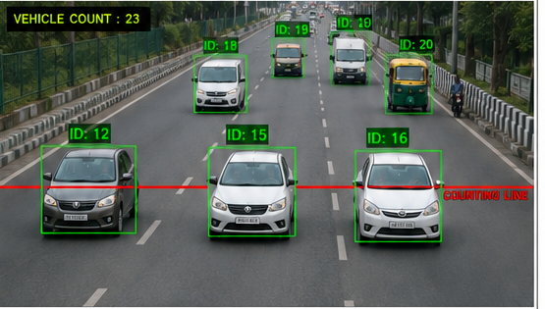
Expected output: Vehicles are enclosed by bounding boxes, each active vehicle receives a tracking ID, a red virtual counting line is shown, and the vehicle count increases only when a new tracking ID crosses the line. This prevents the same vehicle from being counted repeatedly.

