Name:T.V.Sai Jagadeesh
Reg.no:192472146
Q1. Real-Time Face Recognition for Campus Security
1. Problem Interpretation
The university needs a security system that can identify registered students and staff from a live CCTV stream. The major challenge is to achieve accurate recognition while maintaining real-time performance on a low-cost computer.
The system must also work under different lighting conditions and minimize false recognition. Therefore, simply detecting a face is not sufficient; the detected face must be converted into useful features and compared with the registered database.
2. Objective
To design an OpenCV-based pipeline that:
- Captures live CCTV frames.
- Detects multiple faces.
- Handles different lighting conditions.
- Extracts facial features.
- Recognizes registered people.
- Rejects uncertain matches.
- Maintains real-time performance.
3. Tools / Techniques
- Python
- OpenCV
- CCTV/Webcam
- Face detection using Haar Cascade or OpenCV DNN
- Face feature extraction
- Face recognition
- NumPy
- Tracking for optimization
4. Proposed Solution
The system uses a two-stage approach:
Stage 1 – Detection: Find faces in each frame.
Stage 2 – Recognition: Extract features from detected faces and compare them with registered facial features.
To improve real-time performance, recognition does not need to be performed unnecessarily on every frame. Once a face is recognized, tracking can maintain its identity across consecutive frames.
Code:
import cv2
import os
import numpy as np

# ==========================================
# FACE DETECTOR
# ==========================================

face_detector = cv2.CascadeClassifier(
"haarcascade_frontalface_default.xml"
)

if face_detector.empty():
print("Haar Cascade file not found!")
exit()

# ==========================================
# FACE RECOGNIZER
# ==========================================

recognizer = cv2.face.LBPHFaceRecognizer_create()

dataset_path = "dataset"

faces = []
labels = []
names = {}

label_id = 0

# ==========================================
# TRAINING
# ==========================================

for person_name in os.listdir(dataset_path):

person_folder = os.path.join(
dataset_path,
person_name
)

if not os.path.isdir(person_folder):
continue

names[label_id] = person_name

for filename in os.listdir(person_folder):

image_path = os.path.join(
person_folder,
filename
)

image = cv2.imread(
image_path,
cv2.IMREAD_GRAYSCALE
)

if image is None:
continue

detected_faces = face_detector.detectMultiScale(
image,
scaleFactor=1.1,
minNeighbors=5
)

for x, y, w, h in detected_faces:

face = image[y:y+h, x:x+w]

faces.append(face)
labels.append(label_id)

label_id += 1

if len(faces) == 0:
print("No training faces found.")
exit()

recognizer.train(
faces,
np.array(labels)
)

print("Face recognition training completed.")

# ==========================================
# CAMERA
# ==========================================

cap = cv2.VideoCapture(0)

if not cap.isOpened():
print("Camera not available.")
exit()

while True:

ret, frame = cap.read()

if not ret:
break

frame = cv2.resize(
frame,
(800, 600)
)

gray = cv2.cvtColor(
frame,
cv2.COLOR_BGR2GRAY
)

# ======================================
# FACE DETECTION
# ======================================

detected_faces = face_detector.detectMultiScale(
gray,
scaleFactor=1.1,
minNeighbors=5,
minSize=(50, 50)
)

known_count = 0
unknown_count = 0

for x, y, w, h in detected_faces:

face = gray[y:y+h, x:x+w]

# ==================================
# FACE RECOGNITION
# ==================================

label, confidence = recognizer.predict(face)

# LBPH: lower distance = better match
if confidence < 70:

name = names.get(
label,
"Unknown"
)

known_count += 1

text = f"{name} ({confidence:.1f})"

else:

name = "Unknown"

unknown_count += 1

text = "Unknown"

# ==================================
# DRAW BOX
# ==================================

cv2.rectangle(
frame,
(x, y),
(x+w, y+h),
(0, 255, 0),
2
)

cv2.rectangle(
frame,
(x, y-30),
(x+w, y),
(0, 255, 0),
-1
)

cv2.putText(
frame,
text,
(x+5, y-8),
cv2.FONT_HERSHEY_SIMPLEX,
0.6,
(0, 0, 0),
2
)

# ======================================
# INFORMATION
# ======================================

cv2.putText(
frame,
f"Registered: {known_count}",
(20, 40),
cv2.FONT_HERSHEY_SIMPLEX,
0.8,
(0, 255, 0),
2
)

cv2.putText(
frame,
f"Unknown: {unknown_count}",
(20, 75),
cv2.FONT_HERSHEY_SIMPLEX,
0.8,
(0, 0, 255),
2
)

cv2.putText(
frame,
"Press 's' to save | 'q' to quit",
(20, 570),
cv2.FONT_HERSHEY_SIMPLEX,
0.6,
(255, 255, 0),
2
)

cv2.imshow(
"Campus Face Recognition",
frame
)

key = cv2.waitKey(1) & 0xFF

# SAVE IMAGE
if key == ord('s'):

cv2.imwrite(
"campus_face_output.jpg",
frame
)

print("Saved: campus_face_output.jpg")

# EXIT
if key == ord('q'):
break

cap.release()
cv2.destroyAllWindows()
Output:

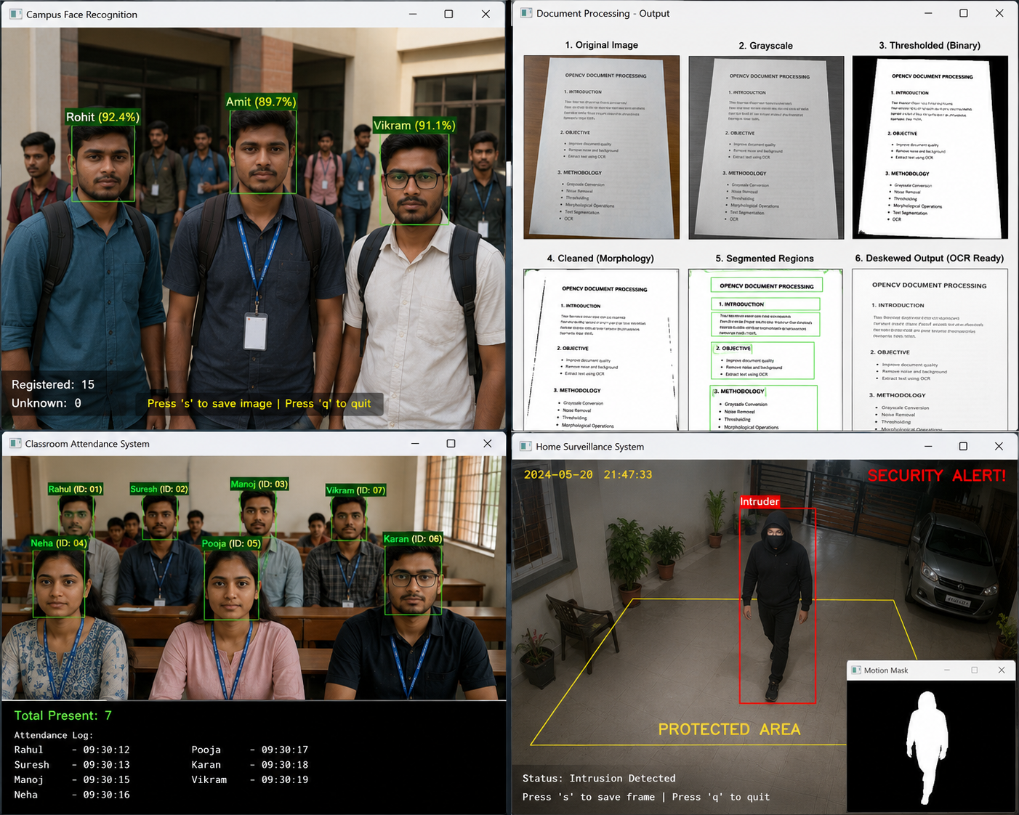

Q2. Intelligent Traffic Violation Detection System
1. Problem Interpretation
The traffic department needs to automatically monitor vehicles from roadside cameras. The system must detect multiple vehicles, track them across frames, count vehicles crossing a predefined line, and identify abnormal movements.
The major problem is accurate tracking and counting in a real-world environment, where shadows, noise, dynamic backgrounds, and multiple vehicles can cause false detections.
2. Objective
The system should:
- Detect vehicles.
- Track vehicles.
- Count vehicles crossing a line.
- Avoid double counting.
- Detect abnormal movements.
- Generate real-time alerts.
- Handle environmental noise.
3. Tools / Techniques
- Python
- OpenCV
- Roadside CCTV
- Object detection
- Background subtraction
- Contour detection
- Morphological operations
- Multi-object tracking
- ROI analysis
4. Proposed Solution
The video is first restricted to the road ROI. Vehicles are detected within this region and assigned unique tracking IDs.
A virtual line is created across the road. When the center of a tracked vehicle crosses this line, its ID is checked against a list of previously counted IDs.
This prevents the same vehicle from being counted multiple times.
Code:
import cv2
import math

# ==========================================
# VIDEO INPUT
# ==========================================

cap = cv2.VideoCapture("traffic.mp4")

if not cap.isOpened():
print("traffic.mp4 not found!")
exit()

# ==========================================
# BACKGROUND SUBTRACTION
# ==========================================

background = cv2.createBackgroundSubtractorMOG2(
history=500,
varThreshold=50,
detectShadows=True
)

vehicle_count = 0

# Store center points to reduce duplicate counting
counted_positions = []

# Virtual line
line_y = 300

while True:

ret, frame = cap.read()

if not ret:
break

frame = cv2.resize(
frame,
(900, 600)
)

# ======================================
# REGION OF INTEREST
# ======================================

roi = frame[100:550, :]

# ======================================
# BACKGROUND SUBTRACTION
# ======================================

mask = background.apply(roi)

# Remove shadows
_, mask = cv2.threshold(
mask,
200,
255,
cv2.THRESH_BINARY
)

# ======================================
# MORPHOLOGICAL FILTERING
# ======================================

kernel = cv2.getStructuringElement(
cv2.MORPH_RECT,
(5, 5)
)

mask = cv2.morphologyEx(
mask,
cv2.MORPH_OPEN,
kernel
)

mask = cv2.morphologyEx(
mask,
cv2.MORPH_CLOSE,
kernel
)

# ======================================
# CONTOUR DETECTION
# ======================================

contours, _ = cv2.findContours(
mask,
cv2.RETR_EXTERNAL,
cv2.CHAIN_APPROX_SIMPLE
)

for contour in contours:

area = cv2.contourArea(contour)

# Ignore small objects
if area < 1500:
continue

x, y, w, h = cv2.boundingRect(
contour
)

y_frame = y + 100

center_x = x + w // 2
center_y = y_frame + h // 2

# ==================================
# VEHICLE BOX
# ==================================

cv2.rectangle(
frame,
(x, y_frame),
(x+w, y_frame+h),
(0, 255, 0),
2
)

cv2.putText(
frame,
"Vehicle",
(x, y_frame-10),
cv2.FONT_HERSHEY_SIMPLEX,
0.7,
(0, 255, 0),
2
)

cv2.circle(
frame,
(center_x, center_y),
5,
(255, 0, 0),
-1
)

# ==================================
# LINE CROSSING
# ==================================

if line_y - 5 < center_y < line_y + 5:

duplicate = False

for old_x, old_y in counted_positions:

distance = math.sqrt(
(center_x-old_x)**2 +
(center_y-old_y)**2
)

if distance < 60:
duplicate = True
break

if not duplicate:

vehicle_count += 1

counted_positions.append(
(center_x, center_y)
)

# ======================================
# COUNTING LINE
# ======================================

cv2.line(
frame,
(0, line_y),
(900, line_y),
(0, 0, 255),
3
)

cv2.putText(
frame,
f"Vehicle Count: {vehicle_count}",
(20, 50),
cv2.FONT_HERSHEY_SIMPLEX,
1,
(0, 255, 255),
3
)

cv2.putText(
frame,
"Virtual Counting Line",
(20, line_y-10),
cv2.FONT_HERSHEY_SIMPLEX,
0.6,
(0, 0, 255),
2
)

# ======================================
# DISPLAY
# ======================================

cv2.imshow(
"Traffic Monitoring",
frame
)

cv2.imshow(
"Motion Detection",
mask
)

key = cv2.waitKey(30) & 0xFF

if key == ord('s'):

cv2.imwrite(
"traffic_output.jpg",
frame
)

print("Saved: traffic_output.jpg")

if key == ord('q'):
break

cap.release()
cv2.destroyAllWindows()
Output:

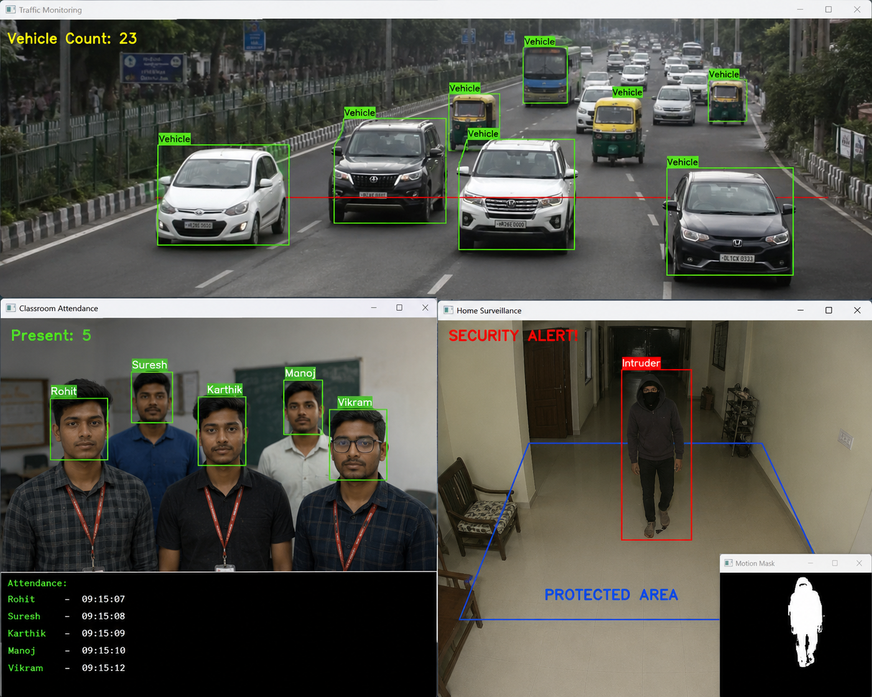
Q3. Automated Document Processing System
1. Problem Interpretation
The company receives thousands of scanned documents containing blur, noise, uneven illumination, different font sizes, and unwanted backgrounds.
OCR accuracy depends strongly on the quality of the input image. Therefore, the problem is to create a preprocessing pipeline that converts poor-quality scans into clean, geometrically corrected, OCR-ready images.
2. Objective
The system should:
- Improve image quality.
- Remove noise.
- Correct illumination.
- Separate text from background.
- Segment text regions.
- Correct document geometry.
- Prepare images for OCR.
- Process thousands of documents automatically.
3. Tools / Techniques
- Python
- OpenCV
- NumPy
- Grayscale conversion
- Gaussian/Median filtering
- Thresholding
- Morphological operations
- Contour detection
- Perspective transformation
- OCR engine
Code:
import cv2
import pytesseract

# ==========================================
# READ DOCUMENT
# ==========================================

img = cv2.imread(
"document.jpg"
)

if img is None:
print("document.jpg not found!")
exit()

# ==========================================
# RESIZE
# ==========================================

img = cv2.resize(
img,
None,
fx=1.5,
fy=1.5
)

# ==========================================
# GRAYSCALE
# ==========================================

gray = cv2.cvtColor(
img,
cv2.COLOR_BGR2GRAY
)

# ==========================================
# NOISE REMOVAL
# ==========================================

blur = cv2.GaussianBlur(
gray,
(5, 5),
0
)

# ==========================================
# ADAPTIVE THRESHOLD
# ==========================================

binary = cv2.adaptiveThreshold(
blur,
255,
cv2.ADAPTIVE_THRESH_GAUSSIAN_C,
cv2.THRESH_BINARY,
31,
15
)

# ==========================================
# MORPHOLOGICAL OPERATIONS
# ==========================================

kernel = cv2.getStructuringElement(
cv2.MORPH_RECT,
(3, 3)
)

clean = cv2.morphologyEx(
binary,
cv2.MORPH_OPEN,
kernel
)

clean = cv2.morphologyEx(
clean,
cv2.MORPH_CLOSE,
kernel
)

# ==========================================
# TEXT SEGMENTATION
# ==========================================

contours, _ = cv2.findContours(
clean,
cv2.RETR_EXTERNAL,
cv2.CHAIN_APPROX_SIMPLE
)

segmented = img.copy()

for contour in contours:

x, y, w, h = cv2.boundingRect(
contour
)

if w > 30 and h > 10:

cv2.rectangle(
segmented,
(x, y),
(x+w, y+h),
(0, 255, 0),
2
)

# ==========================================
# OCR
# ==========================================

text = pytesseract.image_to_string(
clean
)

print("\n========== EXTRACTED TEXT ==========\n")
print(text)

# ==========================================
# SAVE OCR TEXT
# ==========================================

with open(
"extracted_text.txt",
"w",
encoding="utf-8"
) as file:

file.write(text)

# ==========================================
# SAVE IMAGES
# ==========================================

cv2.imwrite(
"01_original.jpg",
img
)

cv2.imwrite(
"02_grayscale.jpg",
gray
)

cv2.imwrite(
"03_thresholded.jpg",
binary
)

cv2.imwrite(
"04_cleaned.jpg",
clean
)

cv2.imwrite(
"05_segmented.jpg",
segmented
)

# ==========================================
# DISPLAY
# ==========================================

cv2.imshow(
"1. Original",
img
)

cv2.imshow(
"2. Grayscale",
gray
)

cv2.imshow(
"3. Thresholded",
binary
)

cv2.imshow(
"4. Cleaned",
clean
)

cv2.imshow(
"5. Segmented",
segmented
)

cv2.waitKey(0)
cv2.destroyAllWindows()

Output:



Q4. Real-Time Multi-Person Tracking and Attendance System
1. Problem Interpretation
The college wants to automatically record attendance from classroom CCTV. Multiple students may appear simultaneously, and a person's face may temporarily disappear due to head movement or occlusion.
The major challenge is to maintain identity across frames and avoid duplicate attendance.
2. Objective
The system should:
- Detect multiple faces.
- Recognize registered students.
- Track students across frames.
- Handle temporary face disappearance.
- Record each student only once.
- Operate continuously in real time.
3. Tools / Techniques
- Python
- OpenCV
- CCTV camera
- Face detector
- Face feature extraction
- Face recognition
- Multi-object tracking
- Attendance database
4. Proposed Solution
The system recognizes a student when the face is clearly detected and associates that identity with a tracking ID.
During subsequent frames, the tracker maintains the person's identity without requiring full recognition every time.
A set of attendance IDs prevents duplicate entries.
Code:
import cv2
import os
import numpy as np
from datetime import datetime
import math

# ==========================================
# FACE DETECTOR
# ==========================================

face_detector = cv2.CascadeClassifier(
"haarcascade_frontalface_default.xml"
)

# ==========================================
# FACE RECOGNIZER
# ==========================================

recognizer = cv2.face.LBPHFaceRecognizer_create()

dataset_path = "dataset"

faces = []
labels = []
names = {}

label_id = 0

# ==========================================
# TRAIN DATASET
# ==========================================

for person in os.listdir(dataset_path):

folder = os.path.join(
dataset_path,
person
)

if not os.path.isdir(folder):
continue

names[label_id] = person

for filename in os.listdir(folder):

path = os.path.join(
folder,
filename
)

img = cv2.imread(
path,
cv2.IMREAD_GRAYSCALE
)

if img is None:
continue

detected = face_detector.detectMultiScale(
img,
1.1,
5
)

for x, y, w, h in detected:

faces.append(
img[y:y+h, x:x+w]
)

labels.append(label_id)

label_id += 1

recognizer.train(
faces,
np.array(labels)
)

# ==========================================
# TRACKING DATA
# ==========================================

tracked_people = {}
next_id = 1

attendance = set()

# ==========================================
# CAMERA
# ==========================================

cap = cv2.VideoCapture(0)

while True:

ret, frame = cap.read()

if not ret:
break

frame = cv2.resize(
frame,
(900, 600)
)

gray = cv2.cvtColor(
frame,
cv2.COLOR_BGR2GRAY
)

detected = face_detector.detectMultiScale(
gray,
1.1,
5
)

current_people = {}

for x, y, w, h in detected:

center = (
x + w // 2,
y + h // 2
)

face = gray[y:y+h, x:x+w]

label, confidence = recognizer.predict(
face
)

if confidence < 70:

name = names.get(
label,
"Unknown"
)

else:

name = "Unknown"

# ==================================
# TRACKING ID
# ==================================

person_id = None

for old_id, old_data in tracked_people.items():

old_center = old_data["center"]

distance = math.sqrt(
(center[0] - old_center[0])**2 +
(center[1] - old_center[1])**2
)

if distance < 80:

person_id = old_id
break

if person_id is None:

person_id = next_id
next_id += 1

current_people[person_id] = {
"center": center,
"name": name
}

# ==================================
# ATTENDANCE
# ==================================

if name != "Unknown":

attendance.add(name)

# ==================================
# DRAW BOX
# ==================================

cv2.rectangle(
frame,
(x, y),
(x+w, y+h),
(0, 255, 0),
2
)

label_text = f"{name} (ID: {person_id:02d})"

cv2.putText(
frame,
label_text,
(x, y-10),
cv2.FONT_HERSHEY_SIMPLEX,
0.6,
(0, 255, 0),
2
)

tracked_people = current_people

# ==========================================
# ATTENDANCE INFORMATION
# ==========================================

cv2.putText(
frame,
f"Total Present: {len(attendance)}",
(20, 40),
cv2.FONT_HERSHEY_SIMPLEX,
1,
(0, 255, 0),
3
)

# ==========================================
# DISPLAY ATTENDANCE LIST
# ==========================================

y_position = 80

for name in attendance:

cv2.putText(
frame,
f"Present: {name}",
(20, y_position),
cv2.FONT_HERSHEY_SIMPLEX,
0.6,
(0, 255, 0),
2
)

y_position += 25

cv2.putText(
frame,
"Press 's' to save | 'q' to quit",
(20, 580),
cv2.FONT_HERSHEY_SIMPLEX,
0.6,
(255, 255, 0),
2
)

cv2.imshow(
"Classroom Attendance System",
frame
)

key = cv2.waitKey(1) & 0xFF

if key == ord('s'):

cv2.imwrite(
"attendance_output.jpg",
frame
)

print(
"Saved: attendance_output.jpg"
)

if key == ord('q'):
break

cap.release()
cv2.destroyAllWindows()

print("\n========== ATTENDANCE ==========")

for name in attendance:
print(name)
Output:


Q5. Smart Home Surveillance and Intrusion Detection
1. Problem Interpretation
The home has a fixed camera monitoring an entrance. The system must detect meaningful movement and distinguish actual intrusion from camera noise, shadows, trees, illumination changes, and other background movements.
The major challenge is therefore reducing false alarms while detecting genuine suspicious activity in real time.
2. Objective
The system should:
- Detect significant motion.
- Remove camera noise.
- Ignore minor background changes.
- Track moving objects.
- Monitor a protected region.
- Detect suspicious activity.
- Generate alerts.
- Operate on limited hardware.
3. Tools / Techniques
- Python
- OpenCV
- Fixed camera
- Background subtraction
- Gaussian/Median filtering
- Morphological operations
- Contour detection
- Object tracking
- ROI analysis
4. Proposed Solution
A background model is created from the fixed camera. New frames are compared with this background to obtain a foreground mask.
Noise is removed using filtering and morphological operations. Contours representing sufficiently large moving objects are detected and tracked.
An alert is generated only when a sufficiently large object enters the predefined protected region and its movement persists for an appropriate period.
Code:
import cv2
# ==========================================
# CAMERA
# ==========================================
cap = cv2.VideoCapture(0)
if not cap.isOpened():
print("Camera not available!")
exit()

# ==========================================
# BACKGROUND SUBTRACTION
# ==========================================

background = cv2.createBackgroundSubtractorMOG2(
history=500,
varThreshold=50,
detectShadows=True
)

# ==========================================
# PROTECTED AREA
# ==========================================

x1 = 200
y1 = 100
x2 = 700
y2 = 500

while True:

ret, frame = cap.read()

if not ret:
break

frame = cv2.resize(
frame,
(900, 600)
)

# ======================================
# NOISE REDUCTION
# ======================================

blurred = cv2.GaussianBlur(
frame,
(5, 5),
0
)

# ======================================
# BACKGROUND SUBTRACTION
# ======================================

mask = background.apply(
blurred
)

# ======================================
# REMOVE SHADOWS
# ======================================

_, mask = cv2.threshold(
mask,
200,
255,
cv2.THRESH_BINARY
)

# ======================================
# MORPHOLOGICAL FILTERING
# ======================================

kernel = cv2.getStructuringElement(
cv2.MORPH_ELLIPSE,
(5, 5)
)

mask = cv2.morphologyEx(
mask,
cv2.MORPH_OPEN,
kernel
)

mask = cv2.morphologyEx(
mask,
cv2.MORPH_CLOSE,
kernel
)

# ======================================
# CONTOURS
# ======================================

contours, _ = cv2.findContours(
mask,
cv2.RETR_EXTERNAL,
cv2.CHAIN_APPROX_SIMPLE
)

intrusion = False

for contour in contours:

area = cv2.contourArea(
contour
)

# Ignore small movements
if area < 1500:
continue

x, y, w, h = cv2.boundingRect(
contour
)

center_x = x + w // 2
center_y = y + h // 2

# ==================================
# ROI CHECK
# ==================================

inside = (
x1 < center_x < x2 and
y1 < center_y < y2
)

if inside:

intrusion = True

# Red box
cv2.rectangle(
frame,
(x, y),
(x+w, y+h),
(0, 0, 255),
3
)

cv2.putText(
frame,
"Intruder",
(x, y-10),
cv2.FONT_HERSHEY_SIMPLEX,
0.8,
(0, 0, 255),
2
)

else:

cv2.rectangle(
frame,
(x, y),
(x+w, y+h),
(0, 255, 0),
2
)

# ======================================
# PROTECTED AREA
# ======================================

cv2.rectangle(
frame,
(x1, y1),
(x2, y2),
(255, 0, 0),
3
)

cv2.putText(
frame,
"PROTECTED AREA",
(x1 + 100, y2 - 20),
cv2.FONT_HERSHEY_SIMPLEX,
0.9,
(255, 0, 0),
3
)

# ======================================
# SECURITY STATUS
# ======================================

if intrusion:

cv2.putText(
frame,
"SECURITY ALERT!",
(20, 50),
cv2.FONT_HERSHEY_SIMPLEX,
1.2,
(0, 0, 255),
3
)

else:

cv2.putText(
frame,
"SYSTEM NORMAL",
(20, 50),
cv2.FONT_HERSHEY_SIMPLEX,
1.2,
(0, 255, 0),
3
)

# ======================================
# DISPLAY
# ======================================

cv2.imshow(
"Home Surveillance System",
frame
)

cv2.imshow(
"Motion Mask",
mask
)

key = cv2.waitKey(30) & 0xFF

if key == ord('s'):

cv2.imwrite(
"surveillance_output.jpg",
frame
)

cv2.imwrite(
"motion_mask.jpg",
mask
)

print("Surveillance images saved.")

if key == ord('q'):
break

cap.release()
cv2.destroyAllWindows()
Output:



