Name:T.V.Sai Jagadeesh
Reg.no:192472146
Q1.Computer Vision Case Study
These questions are analytical case studies, so code is not required. The answers should focus on comparison, evaluation, justification, and practical deployment decisions.
- Real-Time Detection System
Case
A surveillance system has three possible detection techniques:
Method | Accuracy | Speed
Viola-Jones | 78% | Fast
YOLO | 92% | Moderate
Deep Learning | 95% | Slow

The system operates under strict latency constraints, so both detection accuracy and processing speed must be considered.
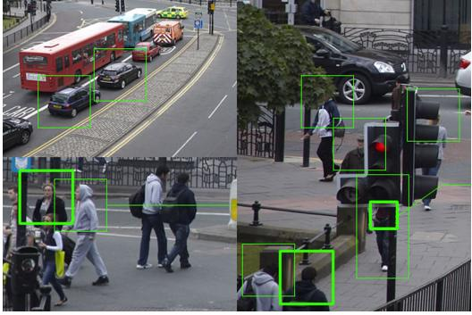
Fig.1
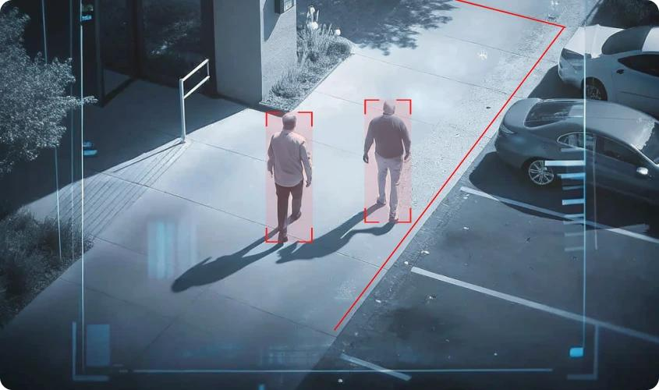
Fig.2
Comparison
1. Viola-Jones
Viola-Jones provides 78% accuracy and has fast processing speed. Its main advantage is low computational cost, making it suitable for systems with very limited processing resources.
However, its accuracy is considerably lower than YOLO and Deep Learning. In a surveillance environment, this may result in missed objects or incorrect detections.
2. YOLO
YOLO provides 92% accuracy with moderate speed. It offers a strong balance between detection accuracy and processing time.
It is capable of detecting multiple objects in a single frame and is well suited to real-time computer vision applications.
3. Deep Learning
The Deep Learning method gives the highest accuracy of 95%, but it is classified as slow in the given case.
Although it provides better detection performance, its higher computational requirement may violate the strict latency requirements of the surveillance system.
Evaluation:
The important trade-off is:
- Viola-Jones → fastest but lowest accuracy
- YOLO → high accuracy with moderate speed
- Deep Learning → highest accuracy but slowest
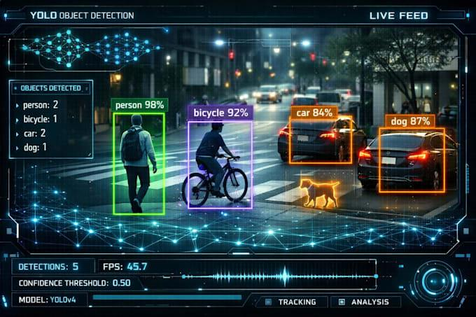
Fig.3
Recommended Method: YOLO
- YOLO should be selected because it provides 92% accuracy with moderate processing speed.
- The difference in accuracy between YOLO and Deep Learning is:
- Thus, the system sacrifices only 3 percentage points of accuracy compared with Deep Learning while gaining better suitability for real-time operation.
Deployment Justification:
For a surveillance system with strict latency constraints:
- Very fast detection is essential.
- Some accuracy loss can be accepted if it significantly improves response time.
- YOLO provides a practical balance between speed and accuracy.
- It is more accurate than Viola-Jones while being faster than the given Deep Learning method.
Final Decision:
YOLO is the most appropriate choice because it provides high accuracy while maintaining moderate speed, making it a practical compromise for real-time surveillance under latency constraints.

Q2. Robust Object Detection:
The performance of the three methods under different environmental conditions is:
Method | Normal | Occlusion | Low Light
Viola-Jones | 80% | 60% | 55%
YOLO | 90% | 75% | 70%
Deep Learning | 95% | 85% | 80%

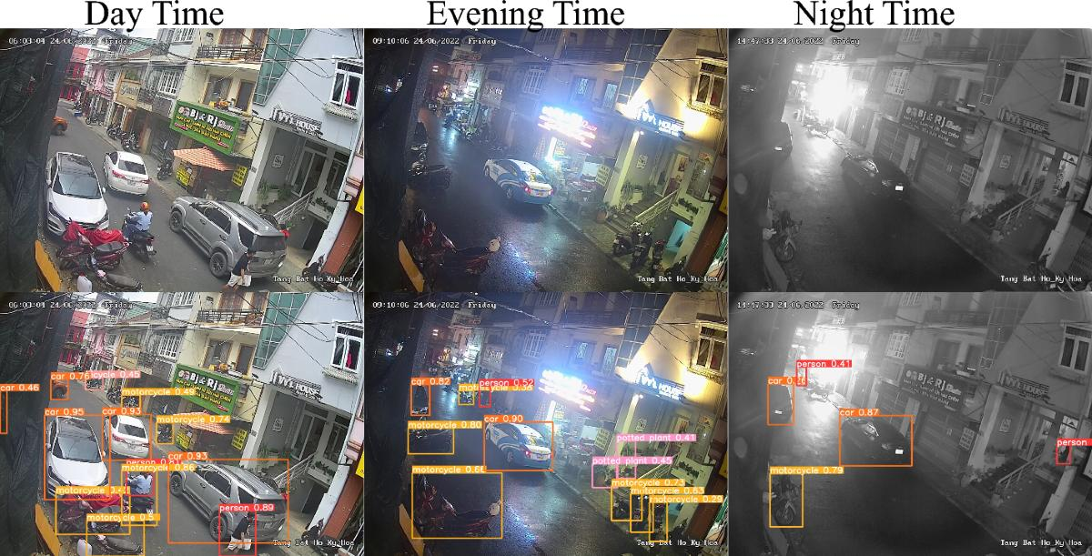
Fig.1
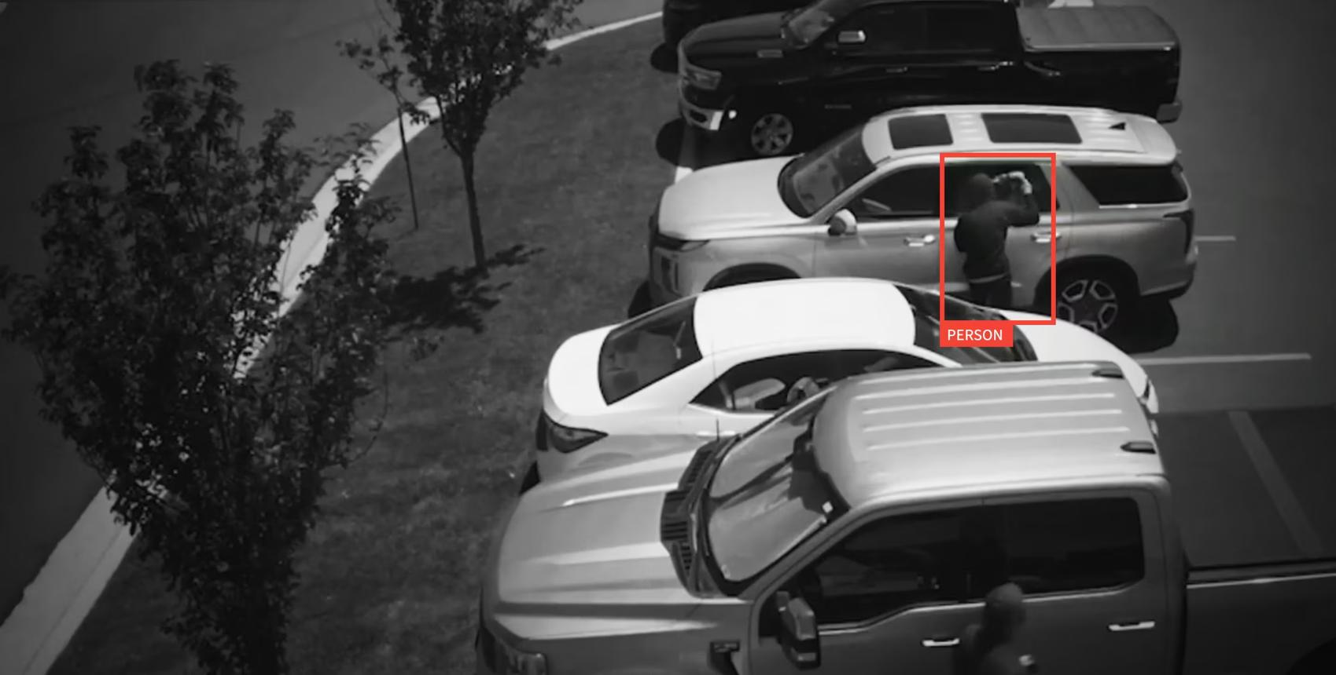
Fig.2
1. Performance under Normal Conditions:
Under normal conditions:
- Viola-Jones = 80%
- YOLO = 90%
- Deep Learning = 95%
- Deep Learning provides the highest accuracy.
- The difference between Deep Learning and Viola-Jones is:
- Therefore, Deep Learning is considerably more accurate under normal conditions.
2. Performance under Occlusion:
When objects are partially hidden:
- Viola-Jones = 60%
- YOLO = 75%
- Deep Learning = 85%
Deep Learning performs best.
Compared with Viola-Jones:
- Therefore, Deep Learning provides 25 percentage points higher accuracy than Viola-Jones under occlusion.
- This indicates better robustness when parts of an object are hidden.

3. Performance under Low-Light Conditions:
Under low-light conditions:
- Viola-Jones = 55%
- YOLO = 70%
- Deep Learning = 80%
Again, Deep Learning performs best.
Improvement over Viola-Jones:
- Therefore, Deep Learning is considerably more robust under poor lighting.
Overall Performance:
We can calculate the average performance.
- Viola-Jones
- YOLO
- Deep Learning
Comparison
Method | Average Accuracy
Viola-Jones | 65%
YOLO | 78.33%
Deep Learning | 86.67%
Recommended Method: Deep Learning:
Deep Learning provides the best overall performance, with an average accuracy of 86.67%.
Trade-offs
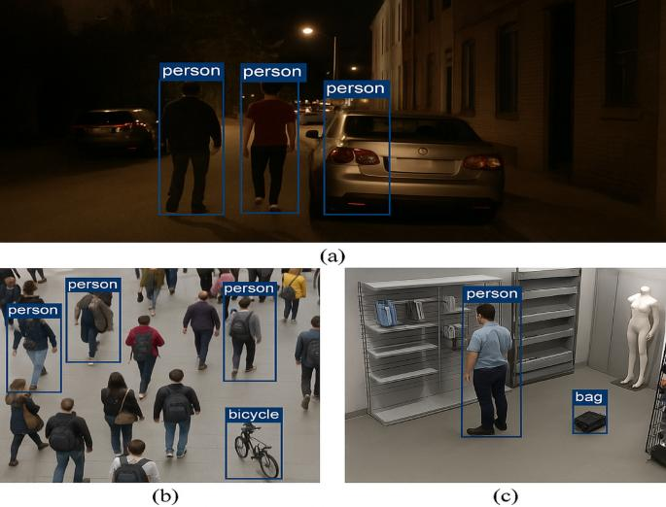
Fig.3
Advantages:
- Highest normal-condition accuracy
- Best performance with occlusion
- Best performance in low light
- Most robust overall
Disadvantages:
- Generally requires greater computational resources
- May require more processing time
- Deployment can be more expensive
Final Decision:
Deep Learning is the best method when robustness and detection accuracy are the primary requirements. YOLO is a suitable alternative when computational resources or real-time speed are more important. Viola-Jones is appropriate mainly when simplicity and low computational requirements are the priorities.

Q3.Optical Flow Analysis:
Two optical flow methods are available:
- Method A: Stable motion vectors but misses small motions.
- Method B: Detects fine motion but produces noisy vectors.
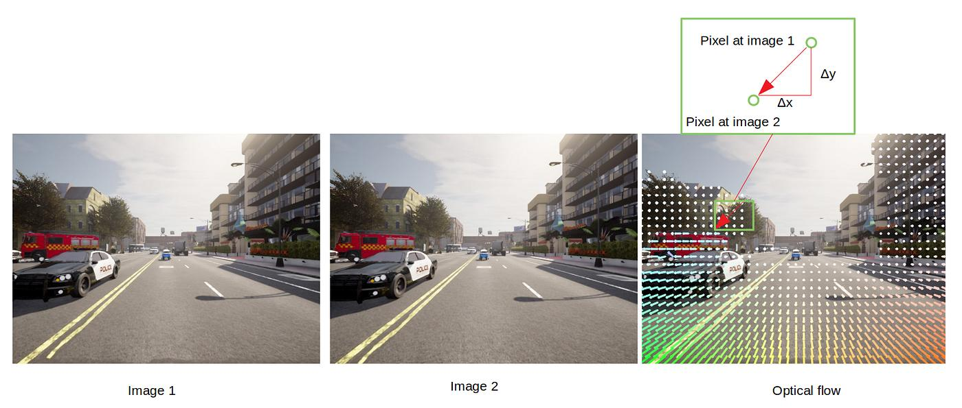

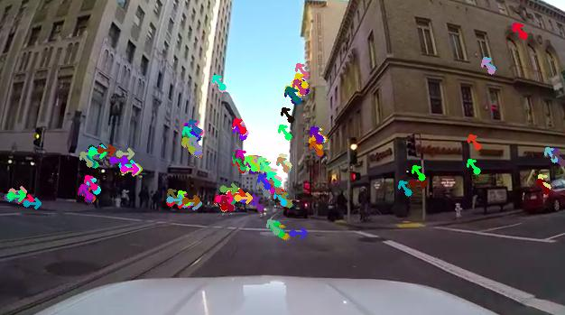
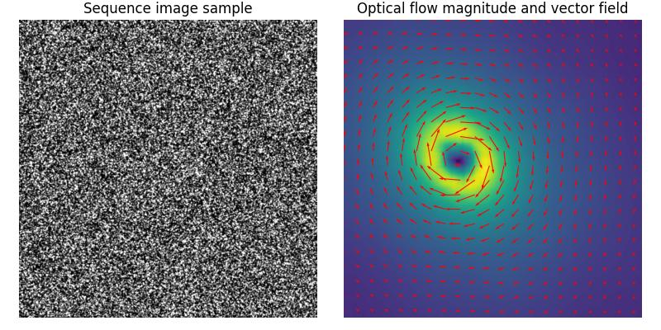
Case Interpretation
Optical flow estimates the apparent movement of pixels between consecutive frames. It is useful for:
- Motion tracking
- Vehicle tracking
- Human activity analysis
- Robot navigation
- Video surveillance
The two methods have different strengths.
Method A – Stable Motion Vectors
Method A produces stable and consistent motion vectors.
Advantages
- Low noise
- Consistent motion estimation
- Reliable tracking
- Suitable for long-term motion tracking
Limitation
Its major disadvantage is that it misses small movements.
For example, small movements of a person's hand or a small object may not be detected correctly.
Method B – Fine Motion Detection
Method B can detect small and detailed movements.
Advantages:
- Detects fine motion
- Sensitive to small changes
- Useful when small movements are important
Limitation:
It produces noisy motion vectors.
This can result in:
- Incorrect motion directions
- Unstable tracking
- False motion detection
- Difficulty in interpreting movement
Comparison
Factor | Method A | Method B
Motion stability | High | Low
Small-motion detection | Low | High
Noise sensitivity | Low | High
Tracking reliability | High | Moderate
Fine-motion analysis | Limited | Excellent

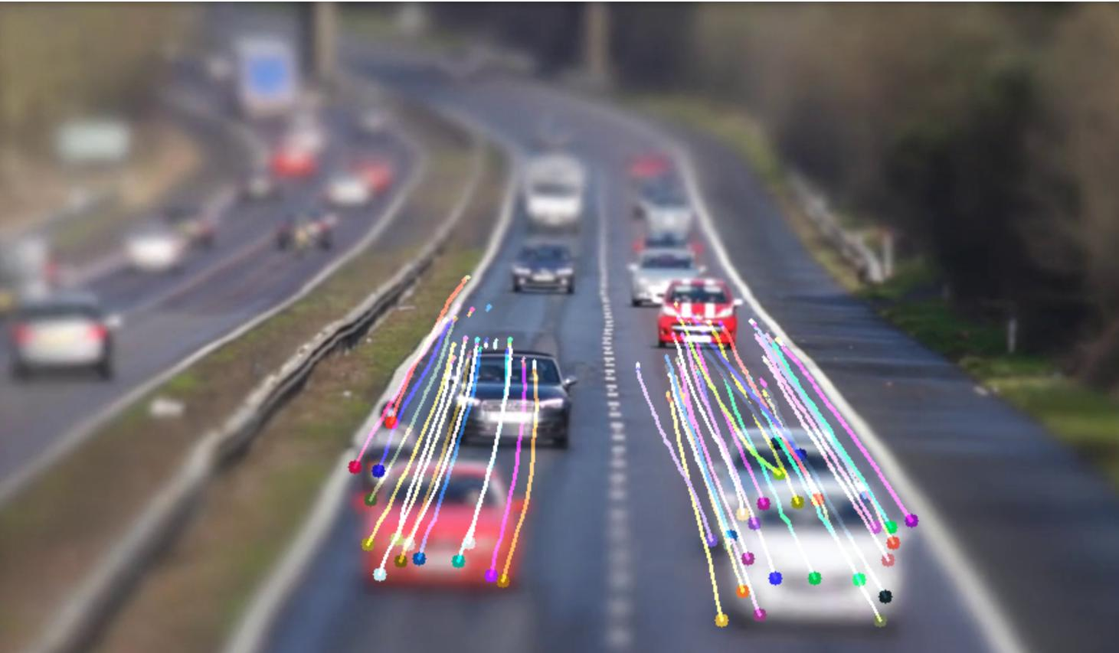
Evaluation:
For dynamic scenes, such as traffic surveillance or moving vehicles, stable motion estimation is generally important.
If the objective is to track the overall movement of:
- Vehicles
- People
- Large objects
then Method A is preferable because stable vectors provide reliable tracking.
- However, if the application specifically requires detection of small and subtle movements, Method B may be preferable.
- Recommended Method: Method A for general dynamic-scene tracking
- Method A is recommended when the main requirement is stable and reliable motion tracking.
- The reason is that noisy motion vectors can cause incorrect tracking even though Method B detects smaller movements.

Final Decision:
Method A is more suitable for general-purpose motion tracking in dynamic scenes because its stable motion vectors provide reliable tracking and are less affected by noise. Method B should be selected when detecting fine or small movements is more important than vector stability.

Q4. Model Generalization and Overfitting
The two models have the following performance:
Model | Training Accuracy | Testing Accuracy
A | 98% | 70%
B | 90% | 88%
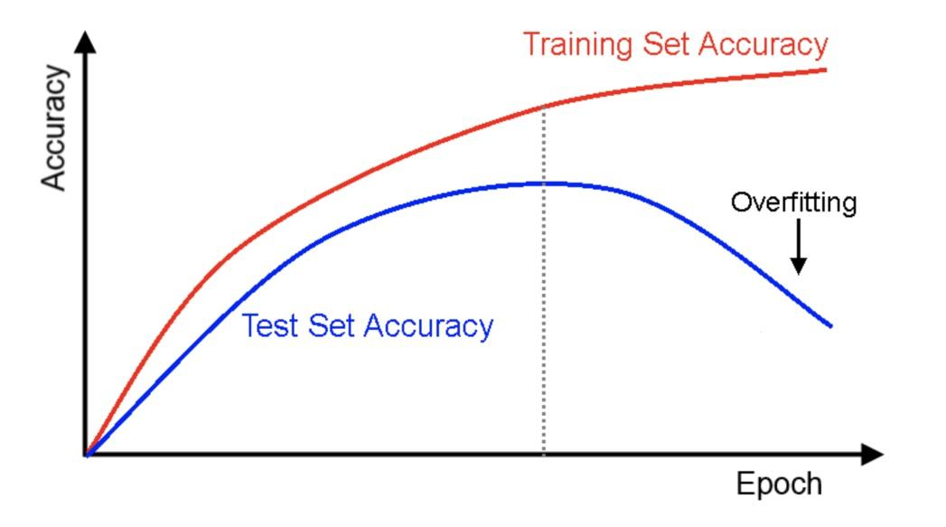
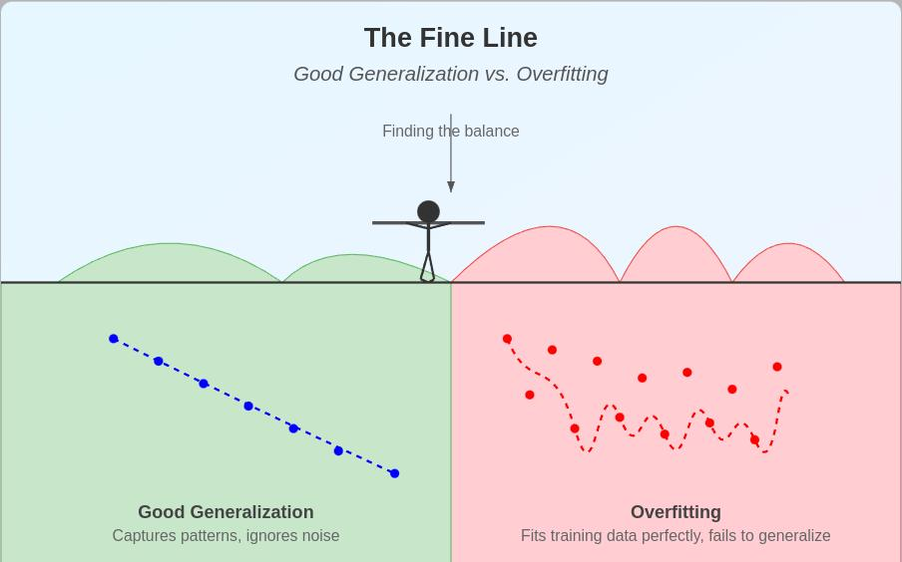
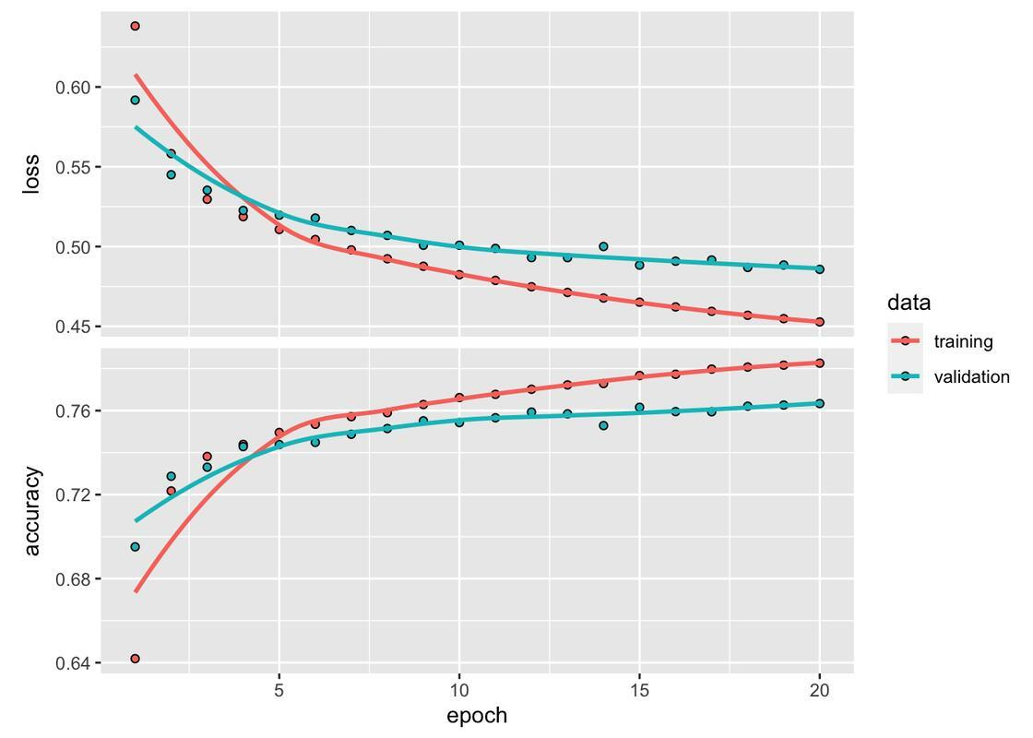
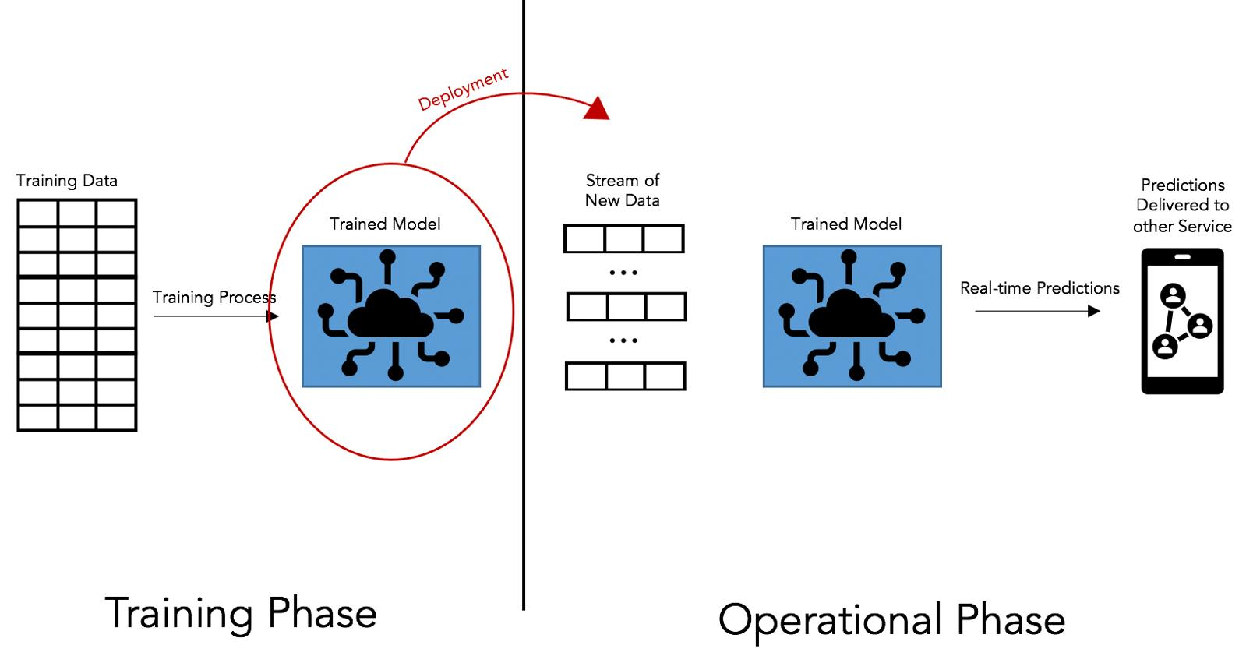
Model A Analysis:
There is a 28 percentage-point gap between training and testing accuracy.
This indicates that the model performs extremely well on the training data but its performance decreases significantly on unseen data.
Interpretation:
Model A is likely suffering from overfitting.
Overfitting occurs when a model learns the training data too closely, including patterns that do not generalize well to new data.
Risk:
If deployed in the real world, Model A may produce unreliable predictions on new images or situations.
Model B Analysis:
The difference is:
The training-testing gap is only 2 percentage points.
This indicates that Model B generalizes much better to unseen data.
Interpretation:
Model B has:
- Good training performance
- High testing performance
- Small generalization gap
- Lower overfitting risk
Comparison
Factor | Model A | Model B
Training accuracy | 98% | 90%
Testing accuracy | 70% | 88%
Accuracy gap | 28% | 2%
Overfitting risk | High | Low
Generalization | Poor | Good
Real-world reliability | Lower | Higher
Recommended Model: Model B
- Although Model A has a higher training accuracy, its testing accuracy is only 70%.
- Model B has a lower training accuracy but achieves 88% testing accuracy.
- Difference in testing accuracy:
- Therefore, Model B performs 18 percentage points better on testing data.

Final Decision:
Model B should be selected for real-world deployment because it has strong generalization ability, a small training-testing gap, high testing accuracy, and lower overfitting risk.

Q5. System Performance under Constraints
Three models are available:
Model | Accuracy | Latency | Cost
A | 88% | 50 ms | Low
B | 92% | 80 ms | Moderate
C | 95% | 120 ms | High

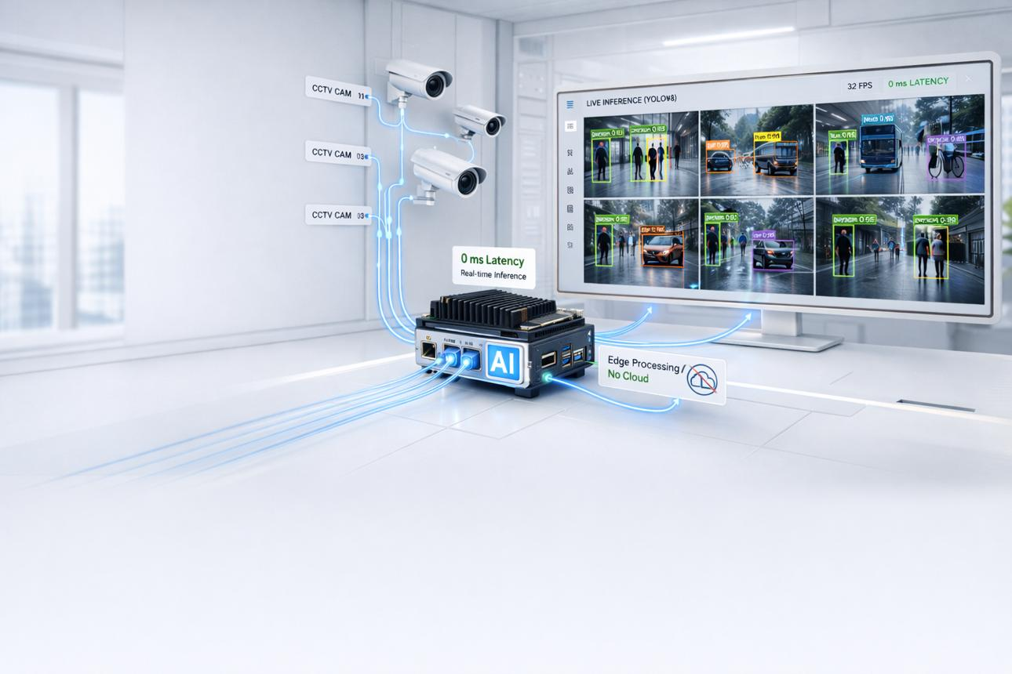
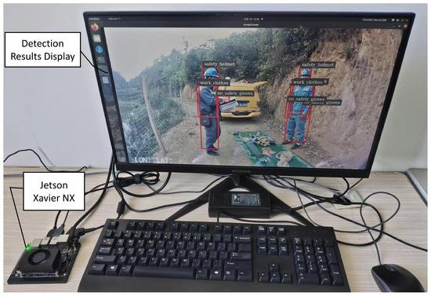
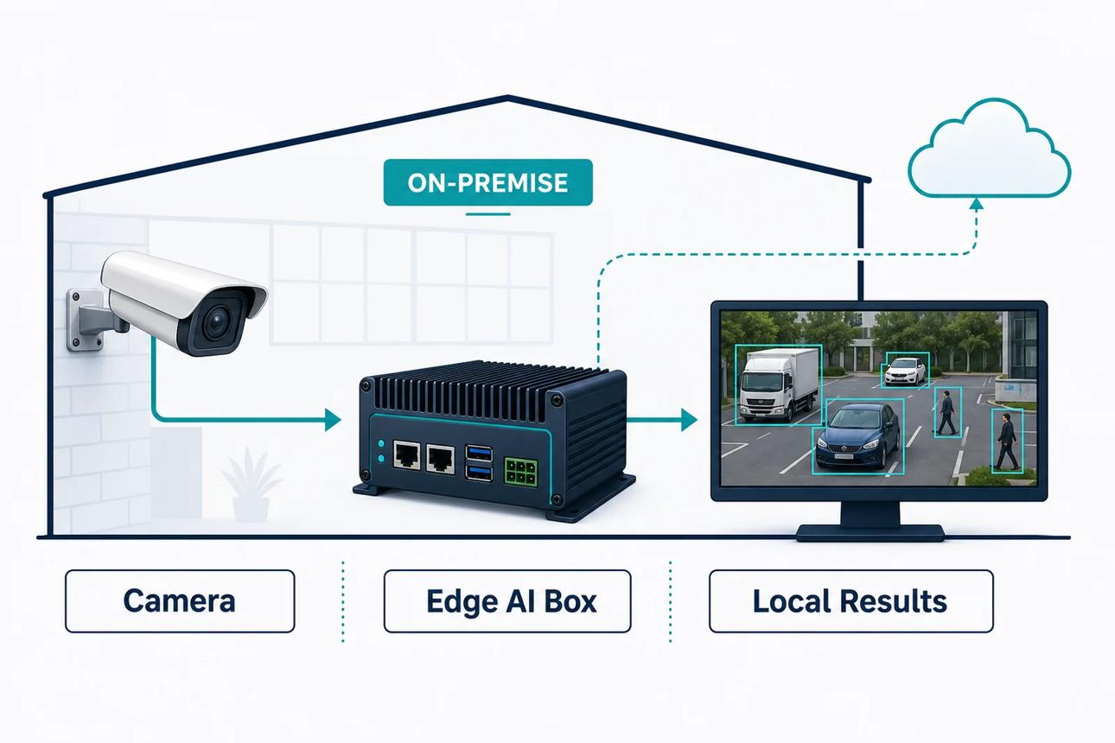
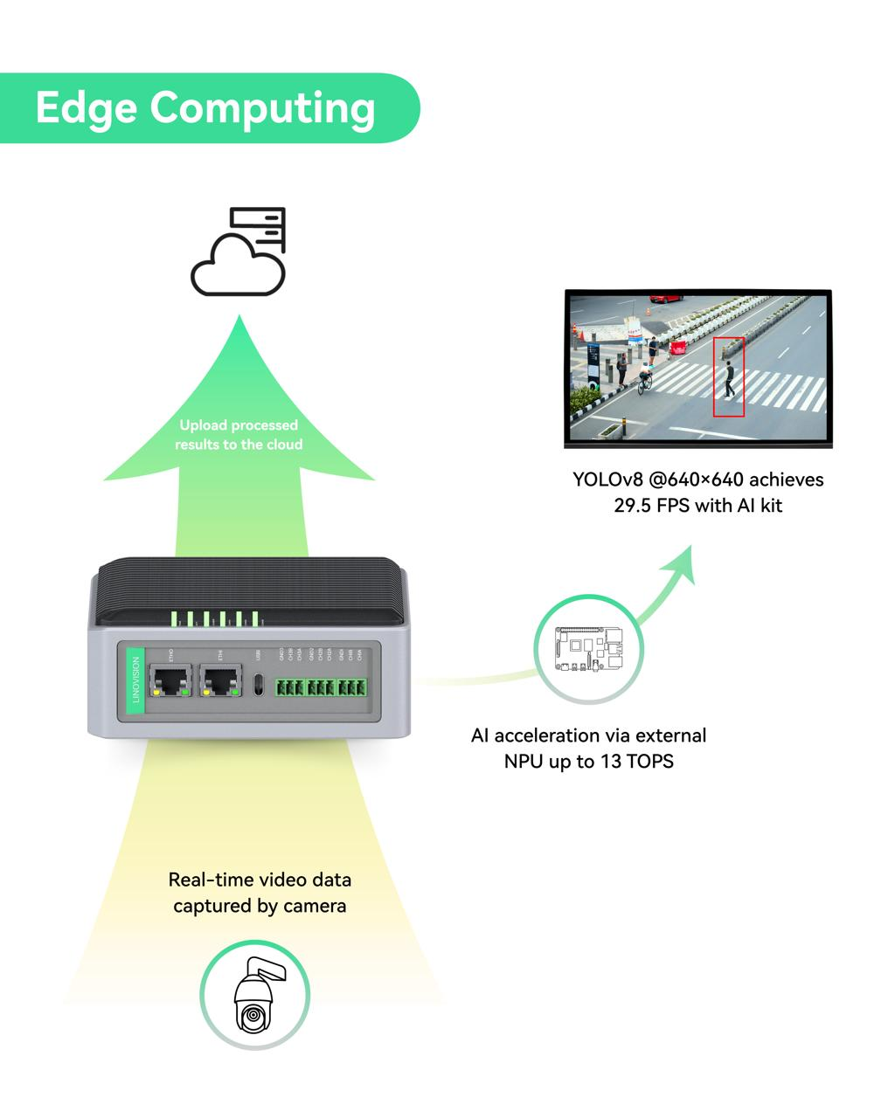
Model A
- Accuracy = 88%
- Latency = 50 ms
- Cost = Low
Advantages
- Fastest model
- Lowest cost
- Suitable for strict real-time applications
- Requires fewer computational resources
Disadvantage:
Its accuracy is the lowest among the three models.
Model B
- Accuracy = 92%
- Latency = 80 ms
- Cost = Moderate
It provides a good compromise between accuracy, latency, and cost.
Compared with Model A:
So Model B improves accuracy by 4 percentage points.
However, latency increases by:
Model C
- Accuracy = 95%
- Latency = 120 ms
- Cost = High
It provides the highest accuracy but also has the highest latency and cost.
Compared with Model B:
Model C provides only 3 percentage points additional accuracy, but latency increases by:
and the cost also increases from moderate to high.

Overall Comparison
Factor | Model A | Model B | Model C
Accuracy | 88% | 92% | 95%
Latency | 50 ms | 80 ms | 120 ms
Cost | Low | Moderate | High
Speed | Excellent | Good | Low
Accuracy | Good | Very Good | Excellent
Overall balance | Good | Best | Lower

Recommended Model: Model B
For a real-time application, Model B provides the best overall balance.
Why not Model A?
Model A is faster and cheaper, but its accuracy is only 88%.
If the application requires better detection reliability, the additional 4% accuracy provided by Model B can justify the moderate increase in latency and cost.
Why not Model C?
Model C provides the highest accuracy, but:
- Latency is 120 ms
- Cost is High
- It provides only 3% more accuracy than Model B
Therefore, the additional accuracy may not justify the additional latency and deployment cost in a real-time system.

Practical Deployment Decision
The choice depends on application requirements:
If latency is extremely strict:
Model A
If balanced performance is required:
Model B
If accuracy is the highest priority and latency/cost are acceptable:
Model C
For the given real-time application, the best overall choice is:
Model B provides 92% accuracy, 80 ms latency, and moderate cost, making it the most practical balance between accuracy, response time, and deployment cost.

