Name:T.V.Sai Jagadeesh
Reg.no:192472146

Q1. Autonomous Vehicle Vision System Selection
The automobile company requires a vision system that satisfies all three conditions:
- Accuracy must be at least 90%
- Latency must not exceed 70 ms
- Computation must be moderate, because the vehicle supports moderate computational resources.
Comparison:
Method | Accuracy | Latency | Computation | Meets Accuracy | Meets Latency | Meets Computation
Viola-Jones | 82% | 30 ms | Low | No | Yes | Yes
YOLO | 93% | 60 ms | Moderate | Yes | Yes | Yes
Deep Learning | 97% | 90 ms | High | Yes | No | No
1. Viola-Jones:
- Viola-Jones has an accuracy of 82%, which is below the required minimum of 90%.
- Therefore, the system would fail the accuracy requirement even though its latency and computational requirements are acceptable.
Decision: Not suitable.

2. YOLO:
- Computational requirement is also satisfied because the vehicle supports moderate computation.
- Therefore, YOLO satisfies all three constraints.
Decision: Suitable.
3. Deep Learning:
- Deep Learning provides the highest accuracy:
- Therefore, it violates the latency constraint. It also requires high computation, while the vehicle only supports moderate computational resources.
Decision: Not suitable.
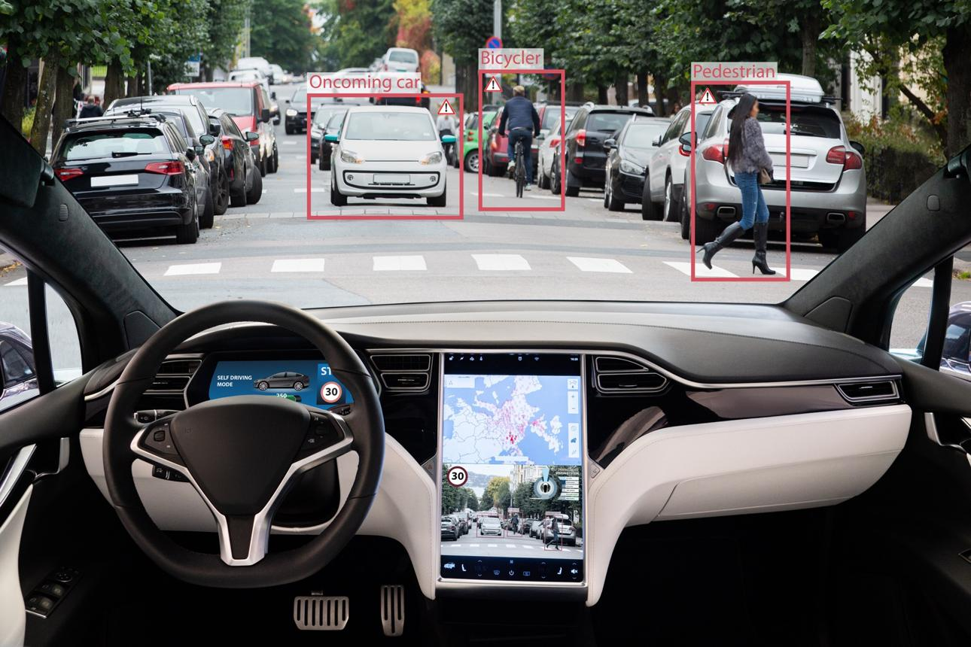
Final Decision:
YOLO is the only method that satisfies all the specified constraints.
It provides:
- 93% accuracy → above the 90% minimum
- 60 ms latency → below the 70 ms maximum
- Moderate computation → matches available hardware
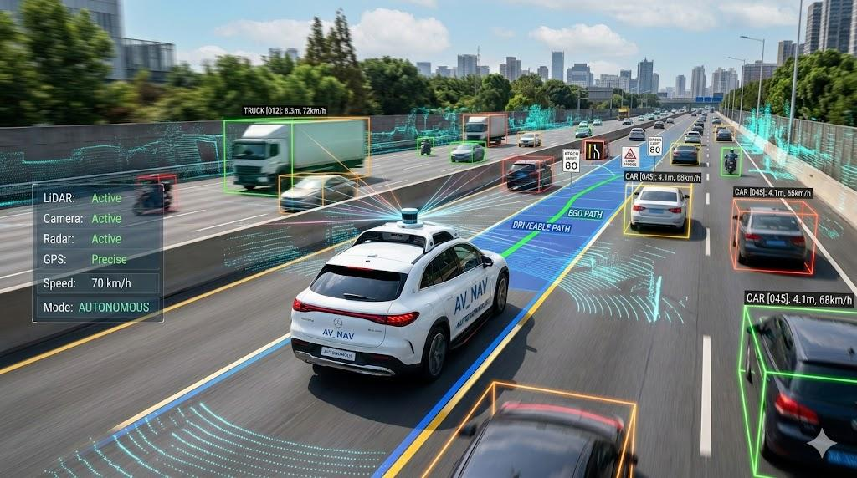
Conclusion:
For the autonomous vehicle, YOLO should be selected. Viola-Jones is fast and computationally inexpensive but fails the accuracy requirement. Deep Learning provides higher accuracy but fails both latency and computational constraints. YOLO provides the best practical balance and meets every requirement.

Q2. Smart Factory Product Inspection Selection
The manufacturing system has three strict requirements:
- Accuracy must be at least 95%
- Processing time must not exceed 50 ms
- Hardware supports moderate computation
Comparison
Method | Accuracy | Processing Time | Computation | Meets Accuracy? | Meets Time? | Meets Computation?
Traditional Image Analysis | 91% | 25 ms | Low | No | Yes | Yes
YOLO | 96% | 45 ms | Moderate | Yes | Yes | Yes
Deep Learning | 98% | 75 ms | High | Yes | No | No

1. Traditional Image Analysis:
- The required accuracy is 95%.
- Although its processing time is only 25 ms and its computation requirement is low, it fails the accuracy condition.
- This could result in defective products being missed during inspection.
Decision: Not suitable.
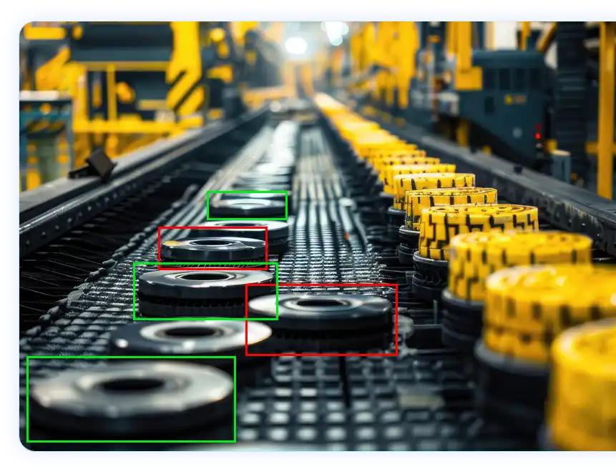
2. YOLO:
- The computation requirement is moderate, which matches the available hardware.
- Therefore, YOLO satisfies all three conditions.
Decision: Suitable.
3. Deep Learning:
- Its accuracy is excellent. However, its processing time is:
- This exceeds the maximum permitted processing time.
- It also requires high computation, whereas the factory hardware supports only moderate computation.
- Therefore, it cannot satisfy the deployment requirements despite having the highest accuracy.
Decision: Not suitable.
Final Decision:
YOLO is the only method satisfying all the factory's constraints.
It provides:
- 96% accuracy → above the required 95%
- 45 ms processing time → below the 50 ms limit
- Moderate computation → compatible with available hardware
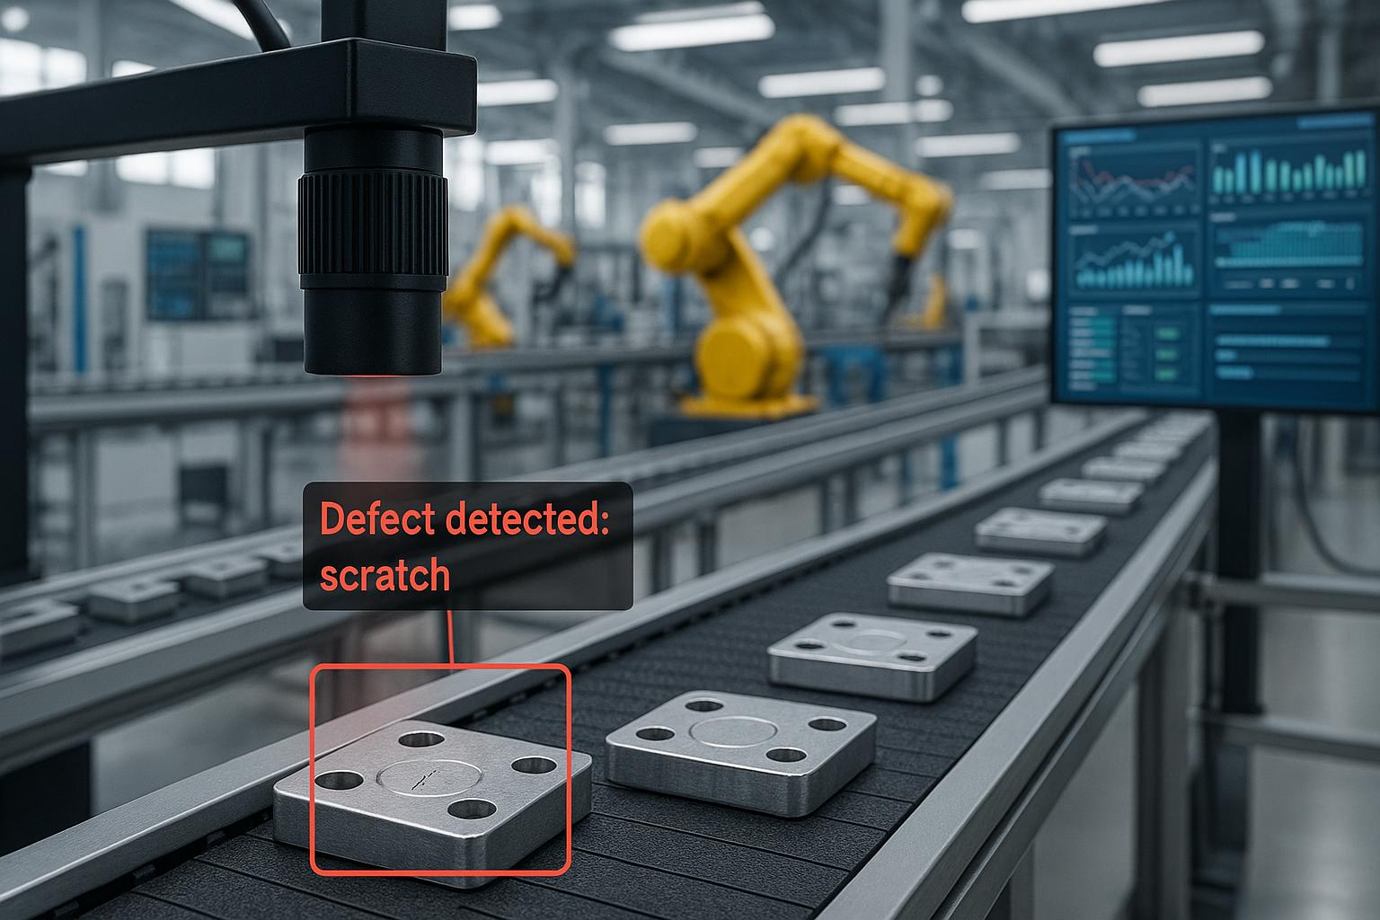

Conclusion:
For the smart factory, YOLO is the most appropriate method. Traditional Image Analysis is fast and inexpensive but its 91% accuracy is insufficient for reliable defect detection. Deep Learning achieves 98% accuracy but its 75 ms processing time would slow the production line and its high computational requirement exceeds the available hardware. YOLO provides the required accuracy while remaining fast enough for real-time production-line inspection.

