Name:T.V.Sai Jagadeesh
Reg.no:192472146

1. Object Detection Performance Comparison:
Given: Model A has TP = 80, FP = 20, FN = 30. Model B has TP = 90, FP = 15, FN = 20.

(a) Calculate Precision and Recall:

Model A
Precision = TP / (TP + FP)
= 80 / (80 + 20) = 80 / 100 = 0.80
Therefore, Precision = 80%
Recall = TP / (TP + FN)
= 80 / (80 + 30) = 80 / 110 = 0.7273
Therefore, Recall = 72.73%

Model B
Precision = TP / (TP + FP)
= 90 / (90 + 15) = 90 / 105 = 0.8571
Therefore, Precision = 85.71%
Recall = TP / (TP + FN)
= 90 / (90 + 20) = 90 / 110 = 0.8182
Therefore, Recall = 81.82%

(b) Comparison and Justification
Model | TP | FP | FN | Precision | Recall
Model A | 80 | 20 | 30 | 80% | 72.73%
Model B | 90 | 15 | 20 | 85.71% | 81.82%

Precision improvement of Model B = 85.71% − 80% = 5.71 percentage points.
Recall improvement of Model B = 81.82% − 72.73% = 9.09 percentage points.
Conclusion: Model B provides better overall object detection performance because it has higher precision and recall, with fewer false positives and false negatives.
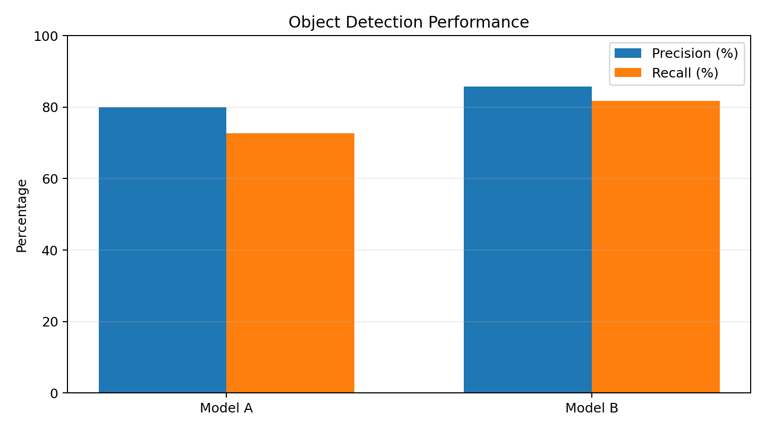
Figure 1. Precision and recall comparison.
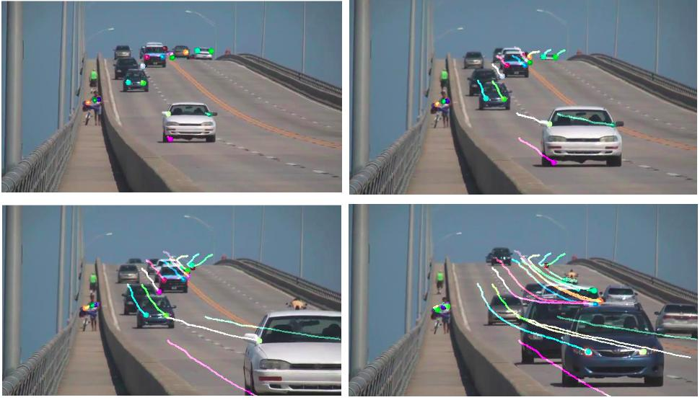

Q2. Motion Estimation Error Analysis:
Given: Method A errors = 2, 3, 2 pixels. Method B errors = 3, 5, 4 pixels.

(a) Calculate Average Displacement Error

Method A
Average Error = (2 + 3 + 2) / 3 = 7 / 3 = 2.33 pixels.

Method B
Average Error = (3 + 5 + 4) / 3 = 12 / 3 = 4.00 pixels.

(b) Compare the Two Methods
Method | Frame 1 (px) | Frame 2 (px) | Frame 3 (px) | Average (px)
Method A | 2 | 3 | 2 | 2.33
Method B | 3 | 5 | 4 | 4.00

Difference in average error = 4.00 − 2.33 = 1.67 pixels.

(c) Justification:
A lower displacement error indicates that estimated motion is closer to the actual motion. Method A has the lower average error and smaller errors in every frame.
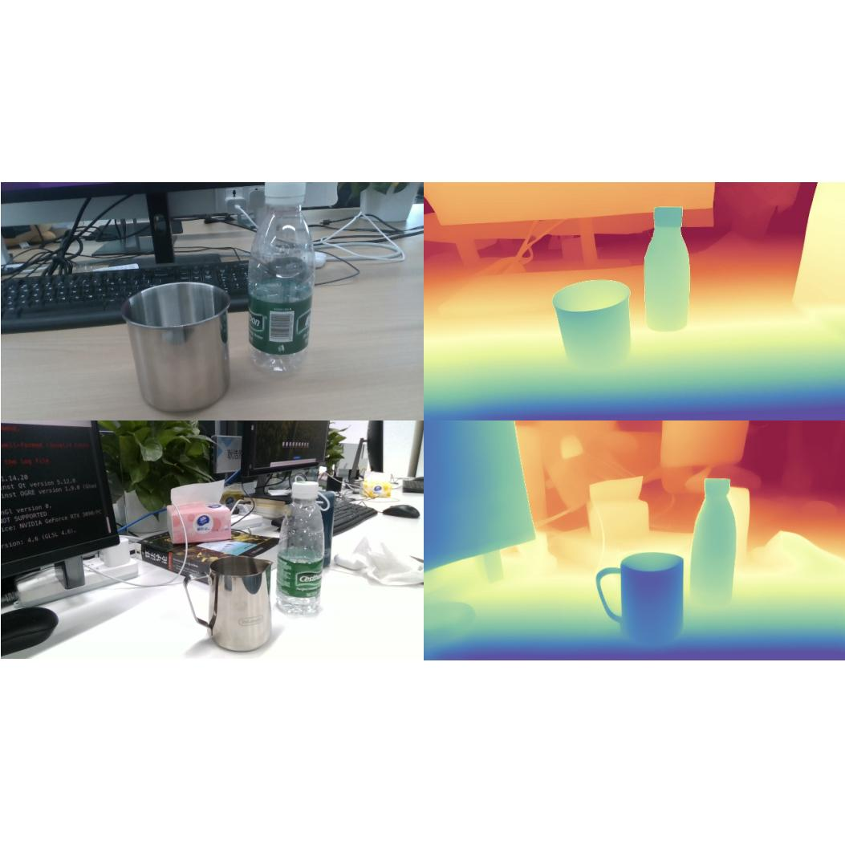
Conclusion: Method A provides more accurate motion estimation.
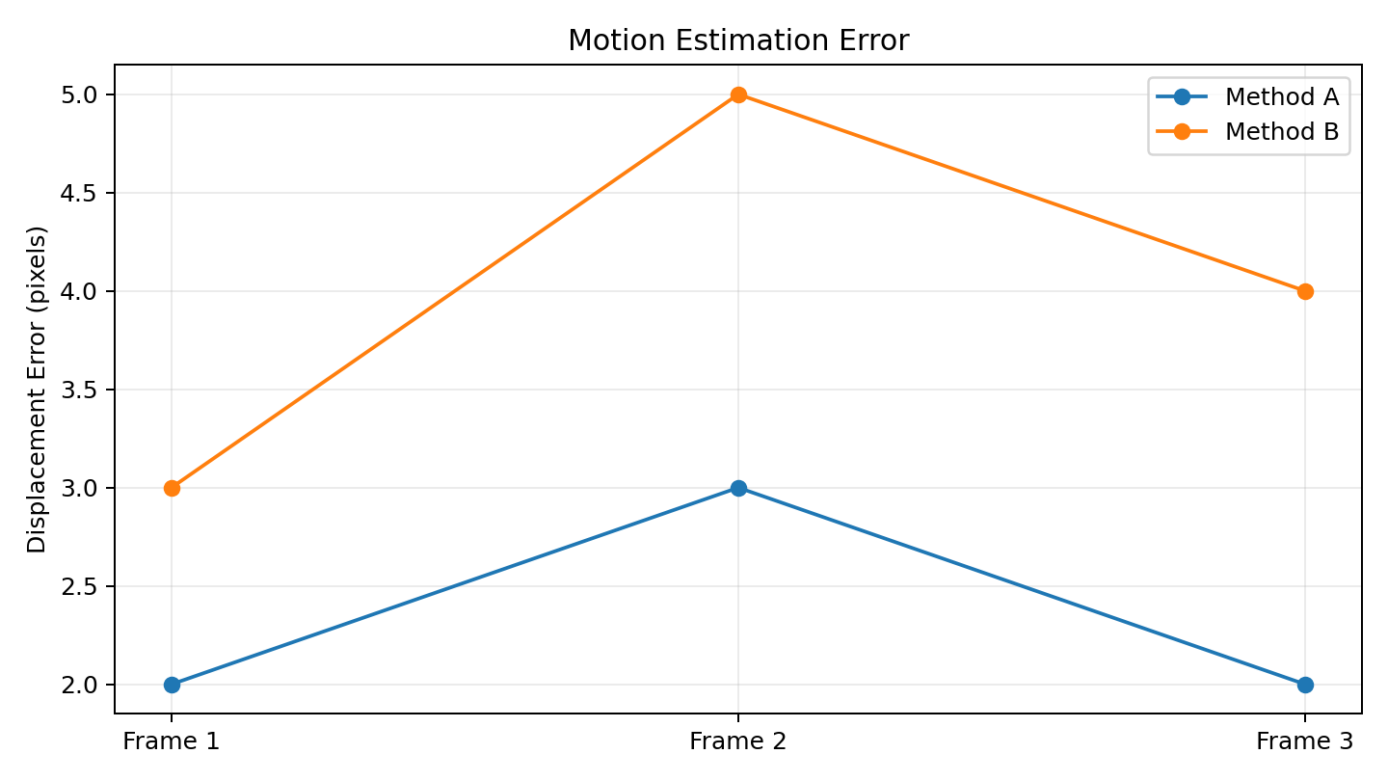
Figure 2. Displacement error across three consecutive frames.

3. Depth Estimation Comparison
Given: Actual depths = 2 m, 3 m, 4 m. Stereo Vision estimates = 2.0 m, 3.0 m, 4.0 m. SfM estimates = 2.5 m, 3.8 m, 5.0 m.

(a) Absolute Error for Each Object
Formula: Absolute Error = |Estimated Depth − Actual Depth|
Object | Actual (m) | Stereo Estimate | Stereo Error | SfM Estimate | SfM Error
1 | 2.0 | 2.0 | 0.0 | 2.5 | 0.5
2 | 3.0 | 3.0 | 0.0 | 3.8 | 0.8
3 | 4.0 | 4.0 | 0.0 | 5.0 | 1.0

Object 1: Stereo = |2.0 − 2.0| = 0 m; SfM = |2.5 − 2.0| = 0.5 m.
Object 2: Stereo = |3.0 − 3.0| = 0 m; SfM = |3.8 − 3.0| = 0.8 m.
Object 3: Stereo = |4.0 − 4.0| = 0 m; SfM = |5.0 − 4.0| = 1.0 m.

(b) Average Absolute Error
Stereo Vision = (0 + 0 + 0) / 3 = 0 m.
SfM = (0.5 + 0.8 + 1.0) / 3 = 2.3 / 3 = 0.767 m (approximately).

(c) Comparison and Conclusion
Method | Average Absolute Error
Stereo Vision | 0 m
SfM | 0.767 m

Stereo Vision exactly matches the actual depths for all three objects, while SfM overestimates all three.
Conclusion: Stereo Vision provides more accurate depth estimation because its average absolute error is 0 m.
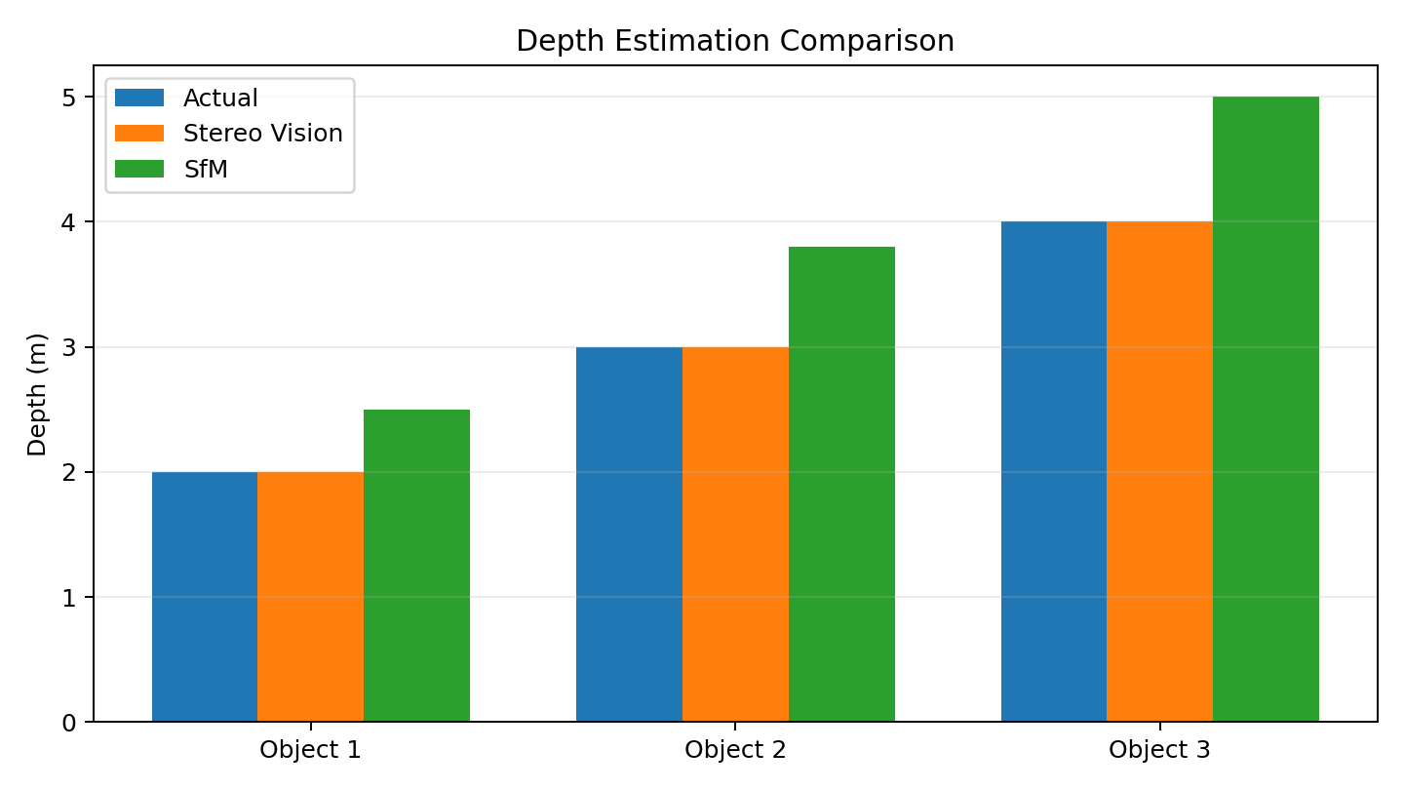
Figure 3. Actual depth compared with Stereo Vision and SfM estimates.

Final Summary
Question | Better Method | Key Result
1. Object Detection | Model B (YOLO) | Precision 85.71%, Recall 81.82%
2. Motion Estimation | Method A | Average error 2.33 pixels
3. Depth Estimation | Stereo Vision | Average absolute error 0 m

Overall conclusion: Model B performs better for object detection, Method A provides lower motion estimation error, and Stereo Vision provides the most accurate depth estimates for the given data.

