Game Design Document

Fill up the Following document

1. Write the title of your project.

Jurasic world

1. What is the goal of the game?

In this game the hero will destroy the dangerous animals and go to the next level after all levels hero will be win

1. Write a brief story of your game?

The game will be in the forest and the hero enters the forest and the people in the forest were suffering with these animals and they tells it to the hero and hero wants to kill the animals by levels in the game

1. Which are the playing characters of this game?

* Playing characters are the ones which respond to the user based on the input from the user
* Cars, monkeys, dinos, wizards etc, are the playing characters in the game.

|  |  |  |
| --- | --- | --- |
| Number | Character Name | What can this character do? |
| 1 | Hero | He can destroy all animals |
| 2 | Enemy 1 | He destroys all things in the society |
| 3 | Enemy 2 | He destroys all things in the society |
| 4 | Enemy3 | He destroys all things in the society |
| 5 | Enemy 4 | He destroys all things in the society |
| 6 | Enemy5 | He destroys all things in the society |
| 7 |  |  |
| 8 |  |  |

1. Which are the Non Playing Characters of this game?

* Non Playing characters are the ones which don't have an action or a behaviour when the user interacts with the game.
* Hurdles, stones, bananas, coins, etc are non playing characters in the game.

|  |  |  |
| --- | --- | --- |
| Number | Character Name | What can this character do? |
| 1 |  |  |
| 2 |  |  |
| 3 |  |  |
| 4 |  |  |
| 5 |  |  |
| 6 |  |  |
| 7 |  |  |
| 8 |  |  |

Draw your imagination of this game. What does this game look like?

* Draw the game either on your computer or on paper,
* Add images of scenes of the game to show each of the playing and non-playing characters at least once.

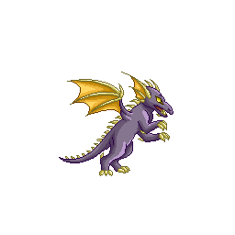 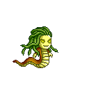 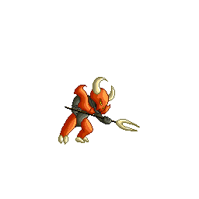 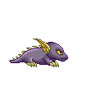

How do you plan to make your game engaging?

After every level player get some points after all point the leader board will

shown