

REPORT
Advanced Physics Lab

Wi-Fi radiation pattern analysis using smartphones and graphical mapping of the same.
Project Report Submitted to Department of Physics,
School of Science and Humanities, Shiv Nadar University Chennai

BY
K. Sai Jyothirmayi – 24011103021
Jenita Rachel.C –24011103019
Lakshana Baskaran – 24011103026
Vaarshini.R – 24011103065
Vandana Padman - 24011103067

Acknowledgements
We express our heartfelt gratitude to Dr. N.P. Rajesh and Dr. Sudipta Som for their invaluable guidance and suggestions throughout the course of this project. Their expertise and encouragement have been crucial in shaping our ideas and ensuring the successful completion of this work.
We extend our sincere thanks to the laboratory staff for their unwavering assistance and to the college management for their continued support. The facilities provided by the institution played a significant role in enabling us to carry out our experiments and achieve meaningful results.
We are thankful to our parents for their constant support and encouragement, which motivated us to successfully complete this project.

Index

S. No. | Title | Page Number
1 | Introduction | 3
2 | Why this topic | 4
3 | Objective | 5
4 | Novelty | 5
5 | Methodology | 6
6 | Future Work | 11
7 | Design | 12
8 | Conclusion | 19

Introduction

Wi-Fi is a vital part of our daily lives, keeping devices connected at home, work, and in public spaces. The strength and coverage of Wi-Fi signals can change based on distance, obstacles like walls, or interference from other devices. Understanding these changes helps improve network performance, fix weak spots, and optimize coverage.

This project looks at Wi-Fi signal patterns using smartphones. Instead of expensive tools, it uses the built-in sensors in smartphones to measure signal strength and other details. The data collected is used to create visual maps, like heatmaps, showing how Wi-Fi performs in different areas.

We also explore how things like crowded spaces or building materials impact signals. By using smartphones, this project makes it easier and cheaper to analyze Wi-Fi, with the added potential for real-time monitoring and crowdsourced data collection. This new method could help improve Wi-Fi networks on a much larger scale.

Why this topic

Wi-Fi is a key part of modern communication, allowing devices to connect wirelessly through electromagnetic signals. These signals are affected by how they travel (wave behavior), lose strength over distance, and face interference from other objects or devices. Studying these patterns helps us improve Wi-Fi coverage, speed, and reliability.

How Wi-Fi Works
Wi-Fi signals are electromagnetic waves in the 2.4 GHz and 5 GHz frequency bands. These waves move through the air and are affected by things like walls, furniture, and other barriers. As they interact with the environment, they can bounce, bend, or get absorbed, which changes how strong and far they go.

Signal Strength and RSSI
Signal strength shows how strong the Wi-Fi is at a specific spot. It's measured as RSSI (Received Signal Strength Indicator). RSSI helps figure out how close a device is to the router and how good the connection is. Signals weaken with distance and get worse when blocked by materials like concrete or wood.

Smartphones and Wi-Fi Analysis
Modern smartphones can measure Wi-Fi signals using built-in tools. They collect data like signal strength and internet speed. Other sensors, like accelerometers, can help map these signals across an area. This makes smartphones a cheaper and easier option compared to special tools like spectrum analyzers.

By understanding these basics, we can use simple tools like smartphones to analyze and improve Wi-Fi networks in homes, offices, or public spaces.

Objective
The objective of this project is to analyze the radiation patterns of Wi-Fi signals using smartphones equipped with suitable sensors and software. Wi-Fi signals, generate electromagnetic radiation that varies in strength and direction based on factors such as distance from the source, environmental conditions, and interference from other devices.
The project aims to:
- Measure and map Wi-Fi signal strength across different areas
- Evaluate the effectiveness of smartphones in detecting and mapping Wi-Fi radiation using built-in sensors like Wi-Fi signal strength indicators, accelerometers, and gyroscopes.
- Develop visual representations of the Wi-Fi signal strength and radiation patterns using graphical mapping techniques, such as heat maps or contour plots, to provide clear insights into signal distribution.

Novelty
This project introduces a novel approach by utilizing the built-in capabilities of smartphones to conduct Wi-Fi radiation analysis, traditionally performed with expensive, specialized equipment such as spectrum analyzers and directional antennas. The key innovative aspects of the project include:
- Smartphone-Based Measurements: Leveraging commercially available smartphones, the project provides a cost-effective and accessible alternative to traditional measurement techniques.
- Real-Time Data Collection: The analysis allows for real-time monitoring and mapping of Wi-Fi signal strength as the user moves through different environments, offering dynamic insights into signal distribution and strength.
- Integration of Environmental Factors: The project explores how environmental variables, such as building materials, layout, and interference from other devices, influence Wi-Fi radiation patterns, a feature not easily observable with conventional methods.
- Crowdsourcing Potential: The mobile application developed for this project could be used in a crowdsourced manner, allowing users to contribute data and create a comprehensive, large-scale database of Wi-Fi performance across various regions.

Methodology

1. Purpose of the Experiment:
- Investigate the impact of environmental factors (population density) on Wi-Fi signal parameters.
- Generate and analyse heatmaps to visualize the spatial distribution of parameters like internet speed and RSSI.
2. Tools:
- Smartphones
- Apps – Fast.com, NetSpot
- Environment – AB-1 Ground Floor
- Visualisation using python – matplotlib, seaborn, SciPy
3. Method:
- Data Collection
- Map out the area for data collection
- Baseline Measuring - Record Wi-Fi parameters in an empty space at each grid point.
- Populated Measuring - Introduce people into the space and record the same parameters. Ensure consistent population density and placement.
- Data Points – Parameters like Signal strength (RSSI),upload speed, internet speed
- Data Analysis - Organize the data into a csv file with columns for each parameter, linking grid coordinates with recorded values. Use heatmap generation tools to visualize each parameter under both conditions (populated and empty).
- Comparative Analysis - Compare heatmaps of the empty and populated space for Internet speed

Source Code
import pandas as pd
import seaborn as sns
import matplotlib.pyplot as plt
import cv2
from scipy.ndimage import gaussian_filter, zoom
class Colors:
RESET = "\033[0m"
YELLOW = "\033[33m"
GREEN = "\033[32m"
# Function to create heatmap
def create_heatmap(csv_path, image_path, output_dir, value_column, x_col='x', y_col='y',vminimum = 0,vmaximum = 30):
# Load the data into a pandas data frame
data = pd.read_csv(csv_path)
# Create a pivot table from the dataframe data
raw_heatmap_data = data.pivot_table(index=y_col, columns=x_col, values=value_column)
# Fill missing values and upscale the data grid
raw_heatmap_data = raw_heatmap_data.fillna(0)
up_sample_factor = 5 # Factor to increase resolution
smoothed_data = zoom(raw_heatmap_data, up_sample_factor)
# Apply Gaussian smoothing to the up-sampled data
smoothed_data = gaussian_filter(smoothed_data, sigma=1.5)

# Create and save the heatmap with a color bar
plt.figure(figsize=(10, 10))
sns.heatmap(smoothed_data, cmap="Spectral", vmin=vminimum, vmax=vmaximum, cbar=True, xticklabels=False, yticklabels=False)
plt.axis('off')
plt.tight_layout()
heatmap_cb_path = f"{output_dir}/heatmap_cb_{value_column}.png"
plt.savefig(heatmap_cb_path, bbox_inches='tight', pad_inches=0, dpi=96)
plt.close()

# Create and save the heatmap without a color bar
plt.figure(figsize=(10, 10))
sns.heatmap(smoothed_data, cmap="Spectral", cbar=False, vmin=vminimum, vmax=vmaximum, xticklabels=False, yticklabels=False)
plt.axis('off')
plt.tight_layout()
heatmap_path = f"{output_dir}/heatmap_{value_column}.png"
plt.savefig(heatmap_path, bbox_inches='tight', pad_inches=0, dpi=96)
plt.close()

# Load the saved heatmap and the map image
map_image = cv2.imread(image_path)
heatmap = cv2.imread(heatmap_path)
# Resize the heatmap to match the map dimensions
heatmap = cv2.resize(heatmap, (map_image.shape[1], map_image.shape[0]))
# Overlay the heatmap onto the map
blended_image = cv2.addWeighted(map_image, 0.3, heatmap, 0.5, 0)
# Save the overlaid heatmap
output_path = f"{output_dir}/final_heatmap_{value_column}.png"
cv2.imwrite(output_path, blended_image)
print(f"{Colors.GREEN}Overlay heatmap saved to {output_path}{Colors.RESET}")
# Main script
csv_file = r"C:\SNU\PhyProject\PhysicsProjectData.csv" # Path to CSV file
floor_map = r"C:\SNU\PhyProject\map.jpeg" # Path to map image
output_directory = r"C:\SNU\PhyProject\heatmaps" # Output directory for the heatmaps
# List of columns to generate heatmaps for
columns_to_visualize = ['InternetSpeedClean', 'InternetSpeedNoise', 'UploadSpeed']
# Loop through each column and generate the heatmap
for column in columns_to_visualize:
print(f"{Colors.YELLOW}Generating heatmap for {column}...{Colors.RESET}")
create_heatmap(csv_file, floor_map, output_directory, column, "xcoordinate", "ycoordinate")
# Generate heatmap for RSSI with custom parameters
print(f"\n{Colors.YELLOW}Generating heatmap for RSSI...{Colors.RESET}")
create_heatmap(csv_file,floor_map,output_directory, "RSSI","xcoordinate", "ycoordinate",vminimum= -100, vmaximum= -60)

Output

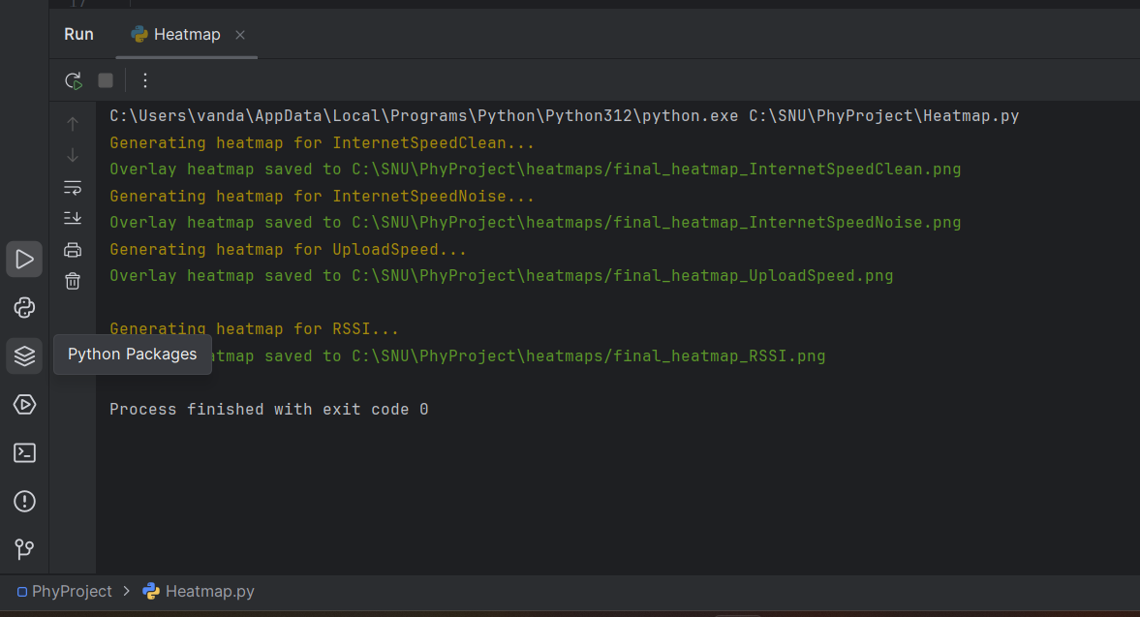

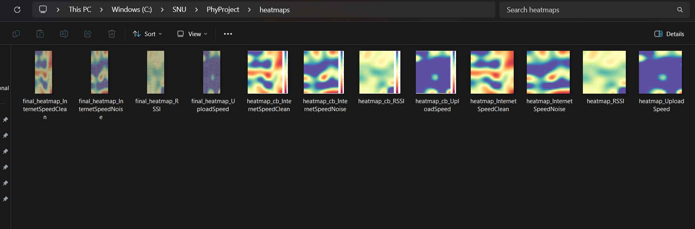

Future Work

Building on the current project, there are several avenues for future development and research:
- Improved Signal Mapping Algorithms: Future efforts could focus on enhancing mapping algorithms using machine learning to more accurately predict Wi-Fi signal strength and propagation, incorporating additional environmental variables.
- Application to 5G and Future Networks: This methodology could be adapted to analyze higher frequency bands such as those used in 5G networks, offering insights into their propagation characteristics and interference patterns.
- Integration with IoT Devices: The project could expand to include data from IoT devices, allowing for a more comprehensive analysis of Wi-Fi performance in smart home or office environments.
- Advanced Visualization Tools: Future work could include the development of advanced visualization tools, such as 3D mapping of Wi-Fi signals, which would provide clearer and more intuitive insights into the signal interactions with the environment.
- Health and Safety Analysis: Given the increasing concerns regarding electromagnetic radiation, future studies could explore the correlation between Wi-Fi signal exposure and potential health impacts, focusing on the safe exposure thresholds for users.

Design

1. Floor plan map:
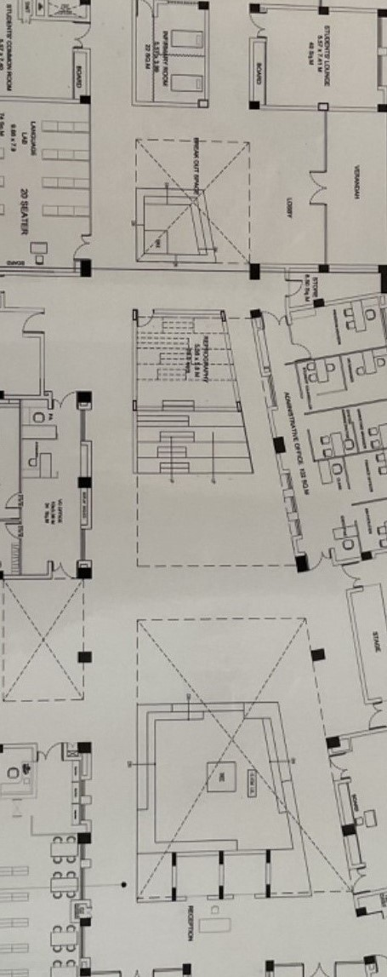
2. Data Points Map:
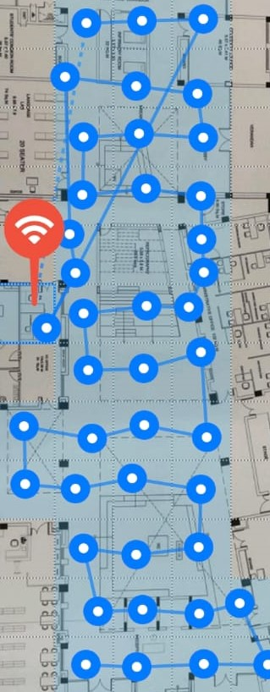

3. Heatmaps:
- Heatmap – Internet speeds ( clean and noise )
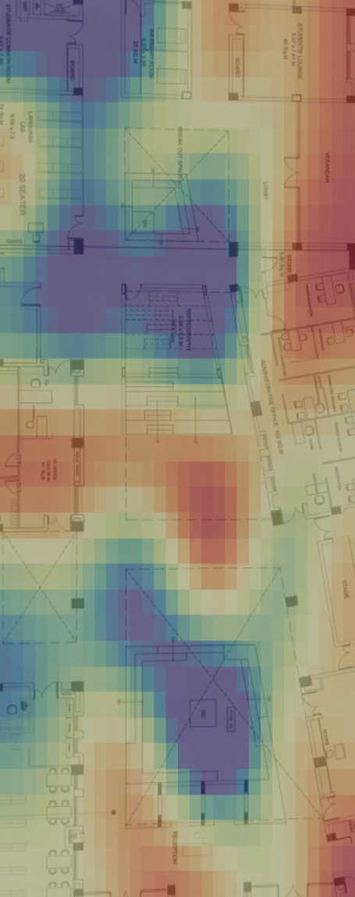
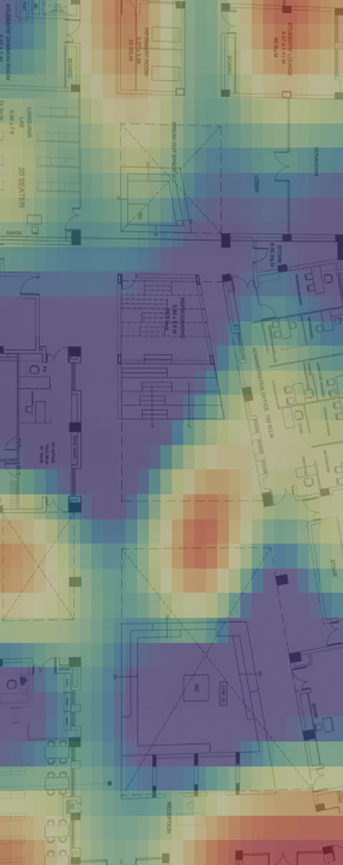
- Heatmap – Upload speeds

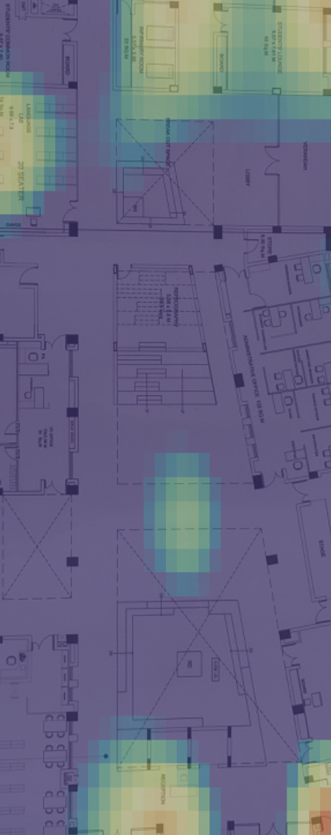
- Heatmap – RSSI

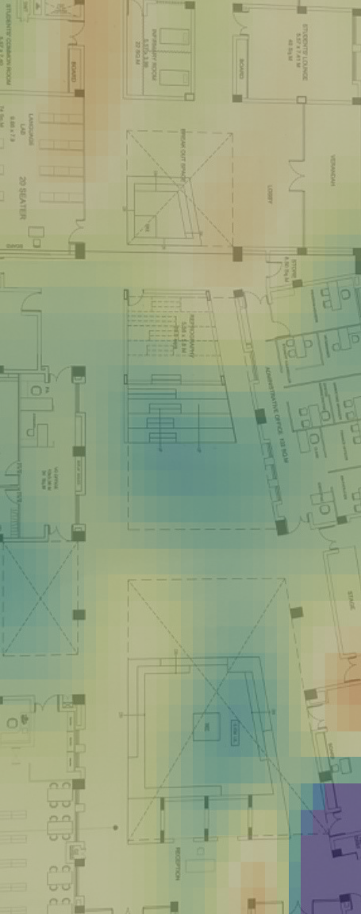

- Heatmap – Scale for speed and signal strength parameters

Fig1: Speed Scale 0 to 30
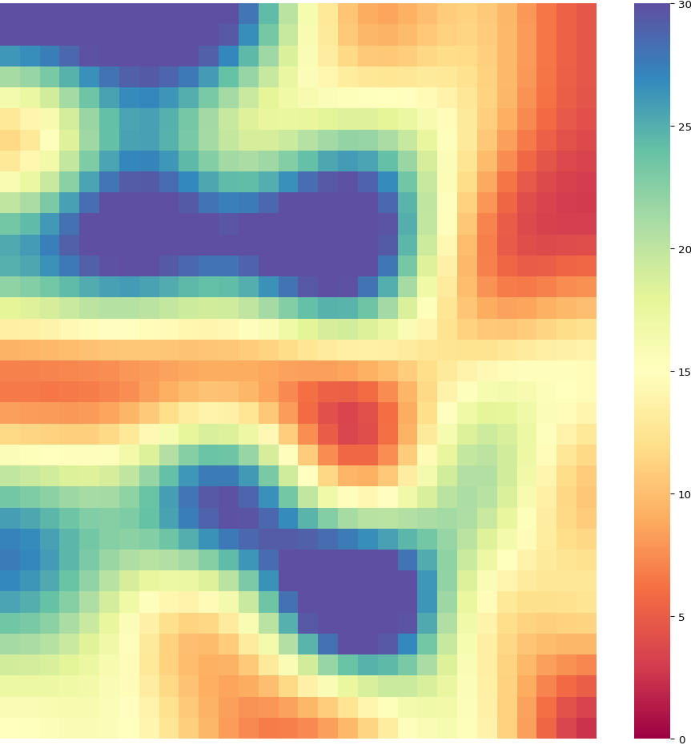

Fig2: RSSI scale -100 to -60
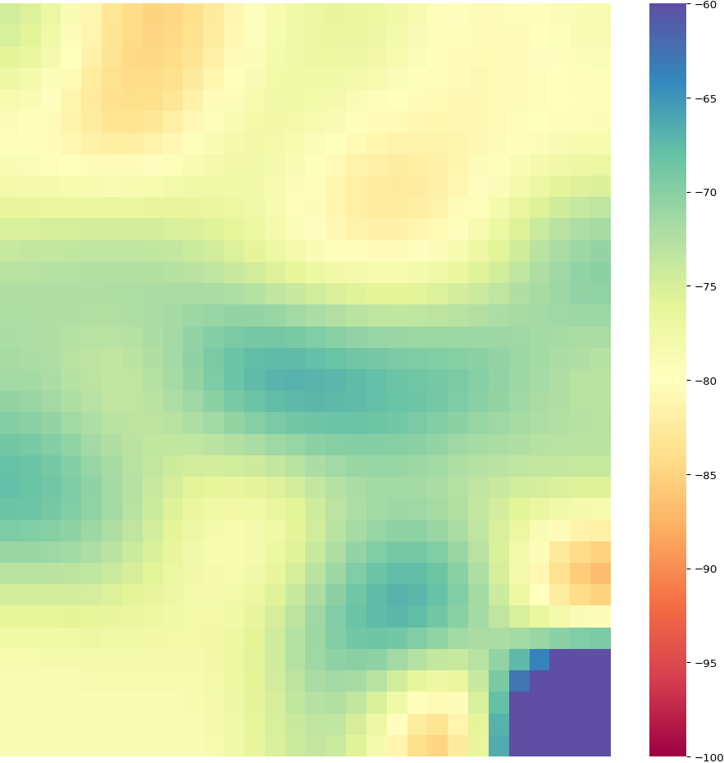

Conclusion

This project demonstrates the feasibility and effectiveness of using smartphones to measure and map Wi-Fi radiation patterns, providing a cost-effective alternative to traditional methods. By leveraging the built-in capabilities of smartphones, the project allows for real-time collection and graphical mapping of Wi-Fi signal strength, offering valuable insights into how Wi-Fi signals propagate and interact with the environment. These insights can help optimize the design and placement of Wi-Fi networks, improving performance and coverage.

Additionally, this methodology opens the door to new possibilities, including crowdsourced data collection, machine learning-based signal prediction, and even health-related studies of Wi-Fi radiation. As wireless technologies continue to evolve, the techniques developed in this project can be adapted for use with 5G and future networks, further enhancing our understanding of wireless signal propagation and optimization.

