**Question 1: Implement JWT Authentication in ASP.NET**

**Project:**

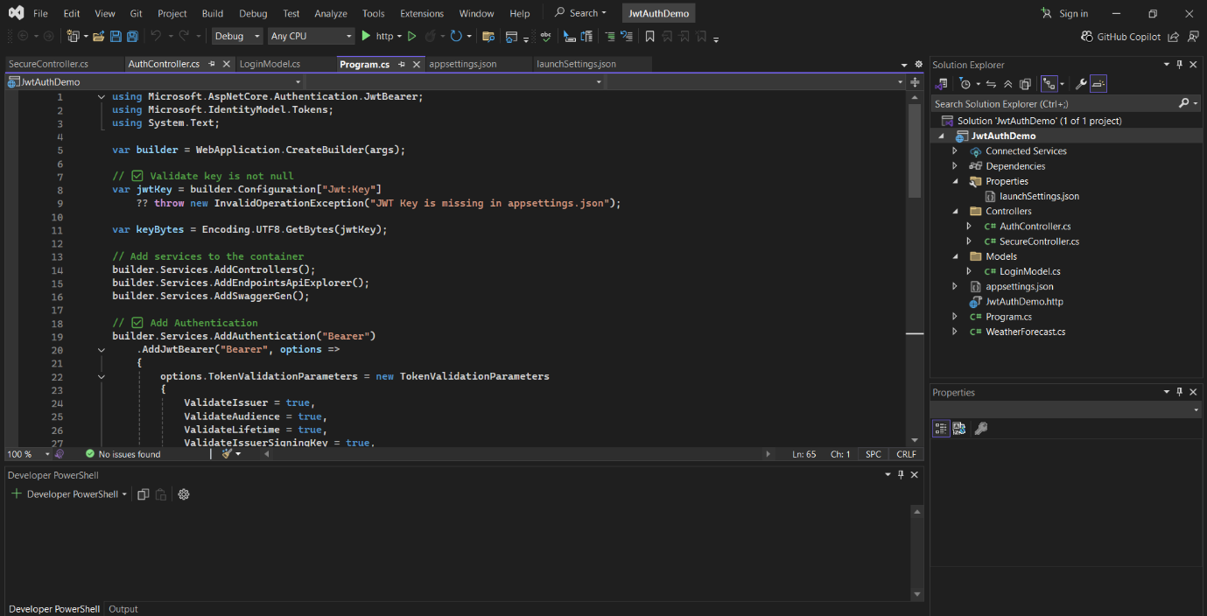

**OUTPUT:**

