1) Delivery_time -> Predict delivery time using sorting time

2) Salary_hike -> Build a prediction model for Salary_hike

------------------------------------------------------------

Build a simple linear regression model by performing EDA and do necessary transformations and select the best model using R or Python.

==================================================================================

1)Q

**Ans: delivery_time_csv (file)**

**# Import necessary librarie**

import pandas as pd

import matplotlib.pyplot as plt

from sklearn.model_selection import train_test_split

from sklearn.linear_model import LinearRegression

from sklearn.metrics import mean_squared_error

**# Load the dataset**

file_path = ('F:\delivery_time.csv') # Update with your actual file path

data = pd.read_csv(file_path)

# Display the first few rows of the dataset

print(data.head())

**# Visualize the data if applicable**

**# For example, if you have columns 'Sorting Time' and 'Delivery Time'**

plt.scatter(data['Sorting Time'], data['Delivery Time'])

plt.xlabel('Sorting Time')

plt.ylabel('Delivery Time')

plt.title('Sorting Time vs Delivery Time')

plt.show()

**# Prepare the data for modeling**

X = data[['Sorting Time']]

y = data['Delivery Time']

**# Split the data into training and testing sets**

X_train, X_test, y_train, y_test = train_test_split(X, y, test_size=0.2, random_state=42)

**# Train a linear regression model**

model = LinearRegression()

model.fit(X_train, y_train)

# Make predictions on the test set

y_pred = model.predict(X_test)

**# Evaluate the model**

mse = mean_squared_error(y_test, y_pred)

print(f'Mean Squared Error: {mse}')

**# Plot the regression line**

plt.scatter(X_test, y_test, label='Actual')

plt.plot(X_test, y_pred, color='red', linewidth=2, label='Predicted')

plt.xlabel('Sorting Time')

plt.ylabel('Delivery Time')

plt.title('Linear Regression Model')

plt.legend()

plt.show()

**OUTPUT:**

**1)** 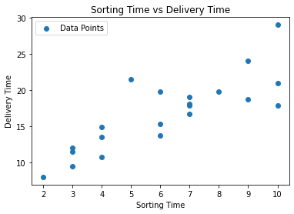

**2) Intercept: [4.68229796]**

**Coefficient: [2.02424455]**

**3)** **Mean Squared Error: 14.046738956635016**

**4)**

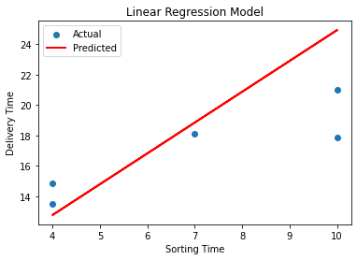

**-------------------------------**

**2) Q.**

**Ans: Salary_data.csv(file).**

import pandas as pd

import matplotlib.pyplot as plt

from sklearn.model_selection import train_test_split

from sklearn.linear_model import LinearRegression

from sklearn.metrics import mean_squared_error, r2_score

**# Load the dataset**

file_path = r'F:\Salary_data.csv'

data = pd.read_csv(file_path)

# Display the first few rows of the dataset

print(data.head())

**# EDA and Data Visualization**

plt.scatter(data['YearsExperience'], data['Salary'])

plt.xlabel('Years of Experience')

plt.ylabel('Salary')

plt.title('Scatter Plot of Years of Experience vs. Salary')

plt.show()

# Split the data into training and testing sets

X = data[['YearsExperience']]

y = data['Salary']

X_train, X_test, y_train, y_test = train_test_split(X, y, test_size=0.2, random_state=42)

**# Train a simple linear regression model**

model = LinearRegression()

model.fit(X_train, y_train)

# Make predictions on the test set

y_pred = model.predict(X_test)

**# Evaluate the model**

mse = mean_squared_error(y_test, y_pred)

r2 = r2_score(y_test, y_pred)

print(f'Mean Squared Error: {mse}')

print(f'R-squared: {r2}')

**# Plot the regression line**

plt.scatter(X_test, y_test, label='Actual')

plt.plot(X_test, y_pred, color='red', linewidth=2, label='Predicted')

plt.xlabel('Years of Experience')

plt.ylabel('Salary')

plt.title('Simple Linear Regression Model')

plt.legend()

plt.show()

**OUTPUT**

1)

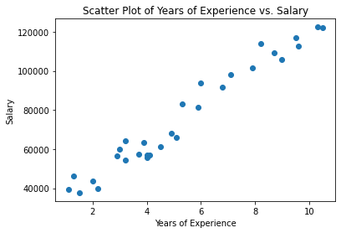

2) Mean Squared Error: 49830096.85590839

R-squared: 0.9024461774180497

3)



