1.Whoami



2. hostname



3. nano



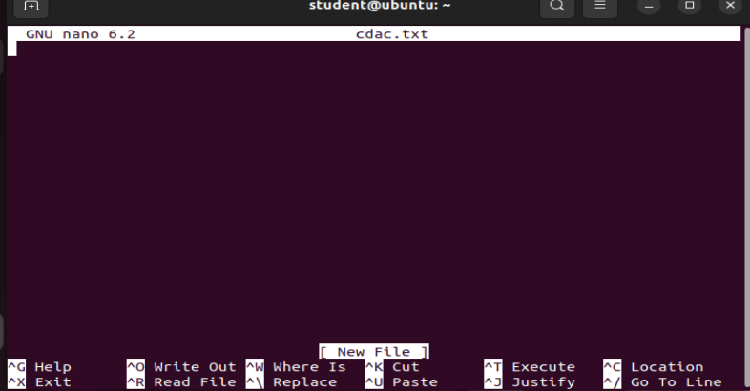

4.Cat cdac.txt



5. History

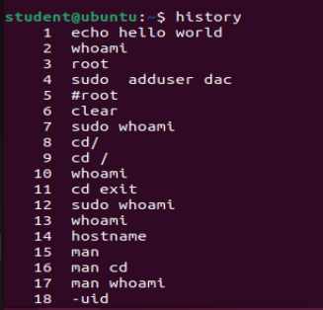

7. mkdir

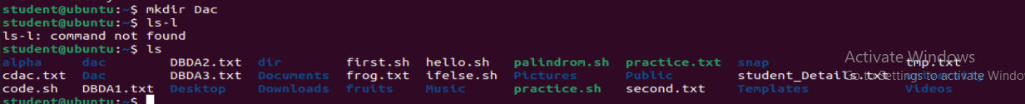

8. pwd



9. ls



10. ls –l

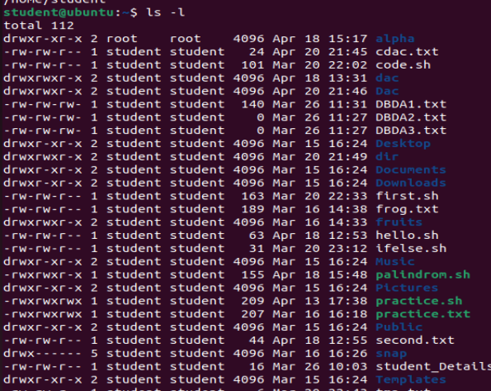

11. touch

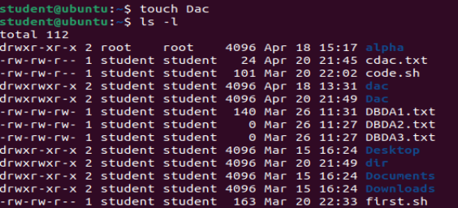

12. man man

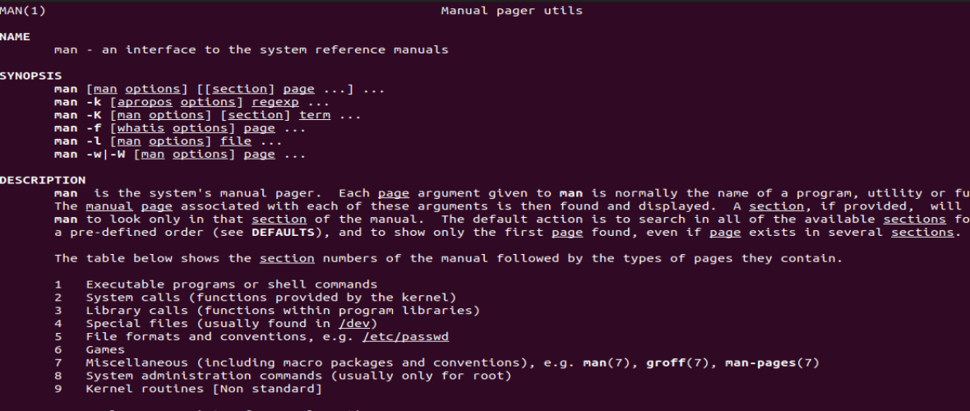

13. what is



14. echo “Hello”



15. echo –e “Hello\nWorld”



16. echo –n “Welcome to Iacsd”



17. which nano



18. rm Dac

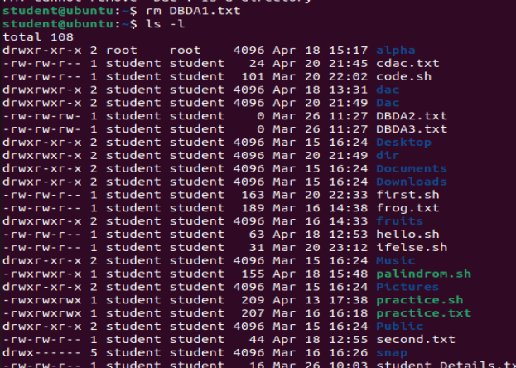

19. cd Dac



20. ls –a



21. rmdir Dac

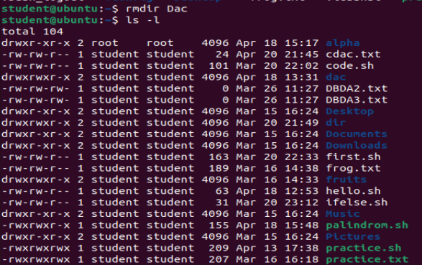

22. mkdir apple mango orange

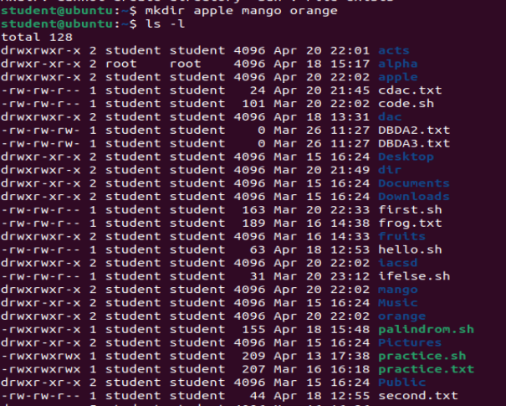

23. wc frog.txt



24. Wc –l frog.txt



25.wc –c frog.txt



26. wc –w frog.txt



27. chmod frog.txt





28. Shell scripting for pyramid structure

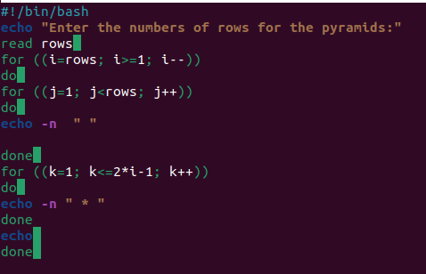

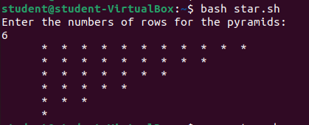

29. Shell scripting for greater number.

