1. Checking the current and existing branch.

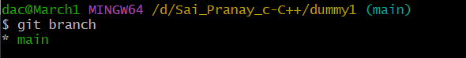

1. Checkout/switching and creation of branch on the same time

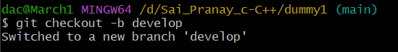

1. Switched to new branch ‘develop’

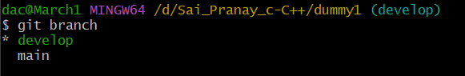

1. Checking the status on new branch

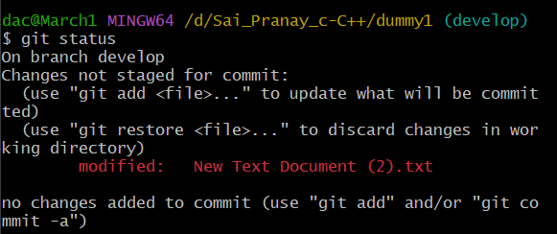

1. Staging all the changes and commiting them

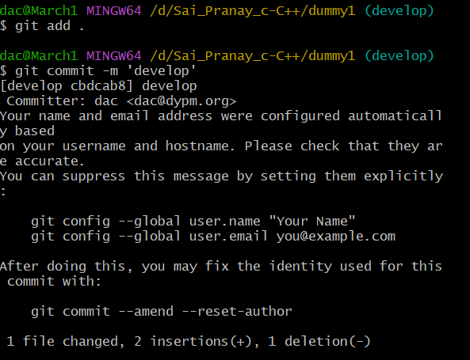

1. Pushing the changes in the branch named ‘develop’

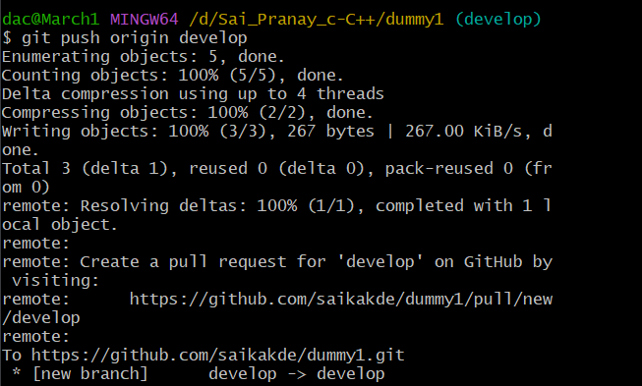

1. Switching back to ‘main’ branch

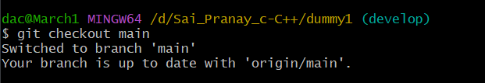

1. Merging the changes from ‘develop’ in ‘main’ branch

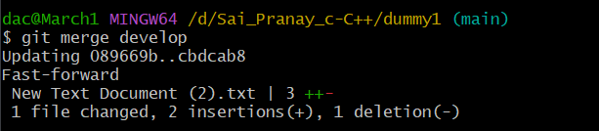

1. Checking the merged changes on ‘main’ branch

