#include<stdio.h>
#include<stdlib.h>
#define max 3
int q[max];
int rear = -1;
int front = -1;

void enqueue(int item){
if(rear == max-1){
printf("Queue is full\n");
}
else if(front == -1){
front = 0;
rear = 0;
q[rear] = item;
}
else{
rear++;
q[rear] = item;
}
}
int dequeue(){
int item;
if(front == -1){
printf("Queue is empty\n");
}
else if(front == rear){
front = -1;
rear = -1;
item = q[rear];
return item;
}
else{
item = q[front];
front++;
return item;
}
}

void display(){
printf("Queue:");
if(front == -1){
printf("queue is empty");
}
else{
for(int i=front;i<=rear;i++)
printf("%d ",q[i]);
}
}

int main() {
int choice;
while (1) {
printf("\nStack Operations:\n");
printf("1. Enqueue\n");
printf("2. Dequeue\n");
printf("3. Display\n");
printf("4. Exit\n");
printf("Enter your choice: ");
scanf("%d", &choice);

switch (choice) {
case 1:
printf("Enter the element you want to insert : ");
int item;
scanf("%d",&item);
enqueue(item);
break;
case 2:
dequeue();
break;
case 3:
display();
break;
case 4:
break;
default:
printf("Invalid choice. Please try again.\n");
}
}
return 0;
}
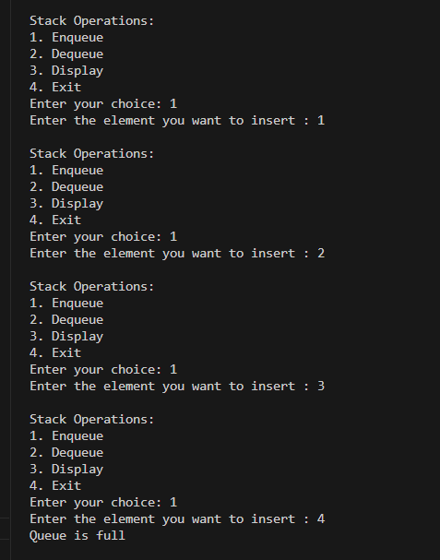
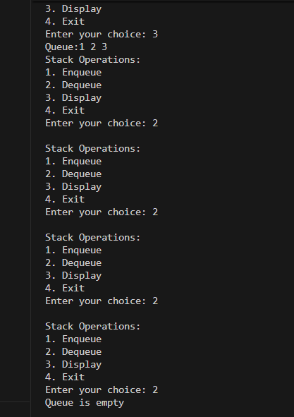

#include <stdio.h>
#define SIZE 3

int queue[SIZE];
int front = -1, rear = -1;

void insert(int item) {
if ((front == 0 && rear == SIZE - 1) || (rear + 1) % SIZE == front) {
printf("Queue Overflow\n");
} else if (front == -1) {
front = rear = 0;
queue[rear] = item;
} else {
rear = (rear + 1) % SIZE;
queue[rear] = item;
}
}

void deleteItem() {
if (front == -1) {
printf("Queue Empty\n");
} else if (front == rear) {
printf("Deleted: %d\n", queue[front]);
front = rear = -1;
} else {
printf("Deleted: %d\n", queue[front]);
front = (front + 1) % SIZE;
}
}

void display() {
if (front == -1) {
printf("Queue Empty\n");
} else {
int i = front;
while (1) {
printf("%d ", queue[i]);
if (i == rear) break;
i = (i + 1) % SIZE;
}
printf("\n");
}
}

int main() {
int choice, item;
while (1) {
printf("\nCircular Queue Operations:\n");
printf("1. Insert\n");
printf("2. Delete\n");
printf("3. Display\n");
printf("4. Exit\n");
printf("Enter your choice: ");
scanf("%d", &choice);
switch (choice) {
case 1:
printf("Enter the element you want to insert: ");
scanf("%d", &item);
insert(item);
break;
case 2:
deleteItem();
break;
case 3:
display();
break;
case 4:
return 0;
default:
printf("Invalid choice. Please try again.\n");
}
}
}

