#include <stdio.h>
#include <stdlib.h>

struct node {
int info;
struct node *next;
};

struct node *stack_top = NULL;
struct node *q_front = NULL, *q_rear = NULL;

void push(int v) {
struct node *n = malloc(sizeof(struct node));
if (!n) return printf("Memory Error\n");
n->info = v;
n->next = stack_top;
stack_top = n;
printf("Pushed: %d\n", v);
}

void pop() {
if (!stack_top) return printf("Stack Empty\n");
struct node *t = stack_top;
printf("Popped: %d\n", t->info);
stack_top = t->next;
free(t);
}

void display_stack() {
if (!stack_top) return printf("Stack Empty\n");
struct node *t = stack_top;
printf("Stack: ");
while (t) { printf("%d ", t->info); t = t->next; }
printf("\n");
}

void enqueue(int v) {
struct node *n = malloc(sizeof(struct node));
if (!n) return printf("Memory Error\n");
n->info = v;
n->next = NULL;

if (!q_front)
q_front = q_rear = n;
else
q_rear->next = n, q_rear = n;

printf("Enqueued: %d\n", v);
}

void dequeue() {
if (!q_front) return printf("Queue Empty\n");
struct node *t = q_front;
printf("Dequeued: %d\n", t->info);
q_front = q_front->next;
if (!q_front) q_rear = NULL;
free(t);
}

void display_queue() {
if (!q_front) return printf("Queue Empty\n");
struct node *t = q_front;
printf("Queue: ");
while (t) { printf("%d ", t->info); t = t->next; }
printf("\n");
}

int main() {
int choice, sub, val;

while (1) {
printf("\n1.Stack 2.Queue 3.Exit\nChoice: ");
scanf("%d", &choice);

if (choice == 1) {
printf("\n1.Push 2.Pop 3.Show 4.Back\nChoice: ");
scanf("%d", &sub);
if (sub == 1) { printf("Value: "); scanf("%d", &val); push(val); }
else if (sub == 2) pop();
else if (sub == 3) display_stack();
}
else if (choice == 2) {
printf("\n1.Enqueue 2.Dequeue 3.Show 4.Back\nChoice: ");
scanf("%d", &sub);
if (sub == 1) { printf("Value: "); scanf("%d", &val); enqueue(val); }
else if (sub == 2) dequeue();
else if (sub == 3) display_queue();
}
else if (choice == 3) return 0;
else printf("Invalid\n");
}
}

OUTPUT:
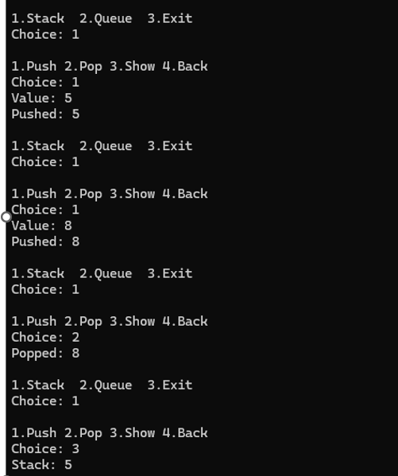
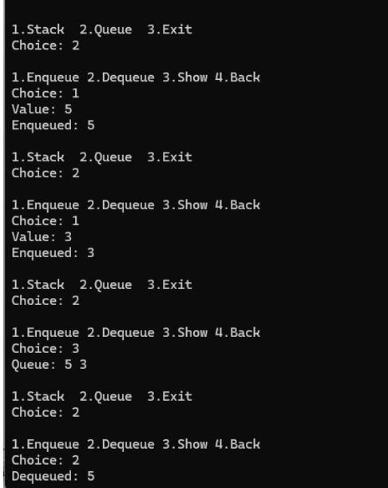
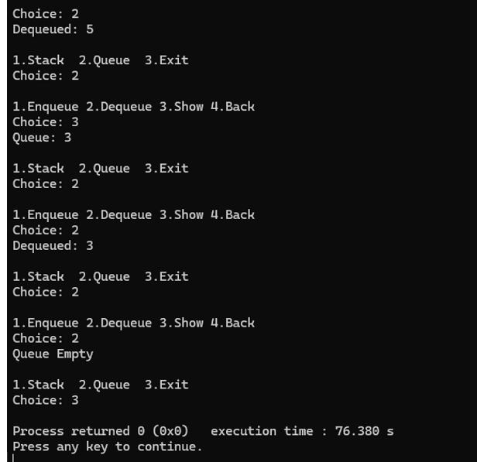

#include <stdio.h>
#include <stdlib.h>

struct node {
int info;
struct node *next;
};

struct node *start1 = NULL;
struct node *start2 = NULL;

void create_list1(int value) {
struct node *newnode = (struct node*)malloc(sizeof(struct node));
newnode->info = value;
newnode->next = NULL;
if (start1 == NULL)
start1 = newnode;
else {
struct node *temp = start1;
while (temp->next != NULL)
temp = temp->next;
temp->next = newnode;
}
}

void create_list2(int value) {
struct node *newnode = (struct node*)malloc(sizeof(struct node));
newnode->info = value;
newnode->next = NULL;
if (start2 == NULL)
start2 = newnode;
else {
struct node *temp = start2;
while (temp->next != NULL)
temp = temp->next;
temp->next = newnode;
}
}

void display(struct node *start) {
if (start == NULL) {
printf("List is empty\n");
return;
}
struct node *temp = start;
while (temp != NULL) {
printf("%d ", temp->info);
temp = temp->next;
}
printf("\n");
}

void sort_list(struct node **s) {
if (*s == NULL || (*s)->next == NULL) return;
int swapped;
do {
swapped = 0;
struct node *ptr = *s;
while (ptr->next != NULL) {
if (ptr->info > ptr->next->info) {
int t = ptr->info;
ptr->info = ptr->next->info;
ptr->next->info = t;
swapped = 1;
}
ptr = ptr->next;
}
} while (swapped);
}

void reverse_list(struct node **s) {
struct node *prev = NULL;
struct node *curr = *s;
struct node *next = NULL;
while (curr != NULL) {
next = curr->next;
curr->next = prev;
prev = curr;
curr = next;
}
*s = prev;
}

void concatenate() {
if (start2 == NULL) {
printf("Second list is empty — nothing to concatenate\n");
return;
}
if (start1 == NULL) {
start1 = start2;
} else {
struct node *temp = start1;
while (temp->next != NULL)
temp = temp->next;
temp->next = start2;
}
start2 = NULL;
printf("Lists concatenated: list2 appended to list1\n");
}

int main() {
int choice, value, n, i;

while (1) {
printf("\n--- SINGLY LINKED LIST MENU ---\n");
printf("1. Create list1 (append n elements)\n");
printf("2. Create list2 (append n elements)\n");
printf("3. Display list1\n");
printf("4. Display list2\n");
printf("5. Sort list1\n");
printf("6. Sort list2\n");
printf("7. Reverse list1\n");
printf("8. Reverse list2\n");
printf("9. Concatenate list2 to list1\n");
printf("10. Display concatenated list (list1)\n");
printf("11. Exit\n");
printf("Enter your choice: ");
if (scanf("%d", &choice) != 1) return 0;

switch (choice) {
case 1:
printf("How many elements to append to list1? ");
scanf("%d", &n);
for (i = 0; i < n; i++) {
printf("Enter element %d: ", i+1);
scanf("%d", &value);
create_list1(value);
}
break;

case 2:
printf("How many elements to append to list2? ");
scanf("%d", &n);
for (i = 0; i < n; i++) {
printf("Enter element %d: ", i+1);
scanf("%d", &value);
create_list2(value);
}
break;

case 3:
printf("List1: ");
display(start1);
break;

case 4:
printf("List2: ");
display(start2);
break;

case 5:
sort_list(&start1);
printf("List1 sorted\n");
break;

case 6:
sort_list(&start2);
printf("List2 sorted\n");
break;

case 7:
reverse_list(&start1);
printf("List1 reversed\n");
break;

case 8:
reverse_list(&start2);
printf("List2 reversed\n");
break;

case 9:
concatenate();
break;

case 10:
printf("Concatenated list (list1): ");
display(start1);
break;

case 11:
return 0;

default:
printf("Invalid choice\n");
}
}
return 0;
}

OUTPUT:
