Build a Secure Authentication System for a Role-Based Platform

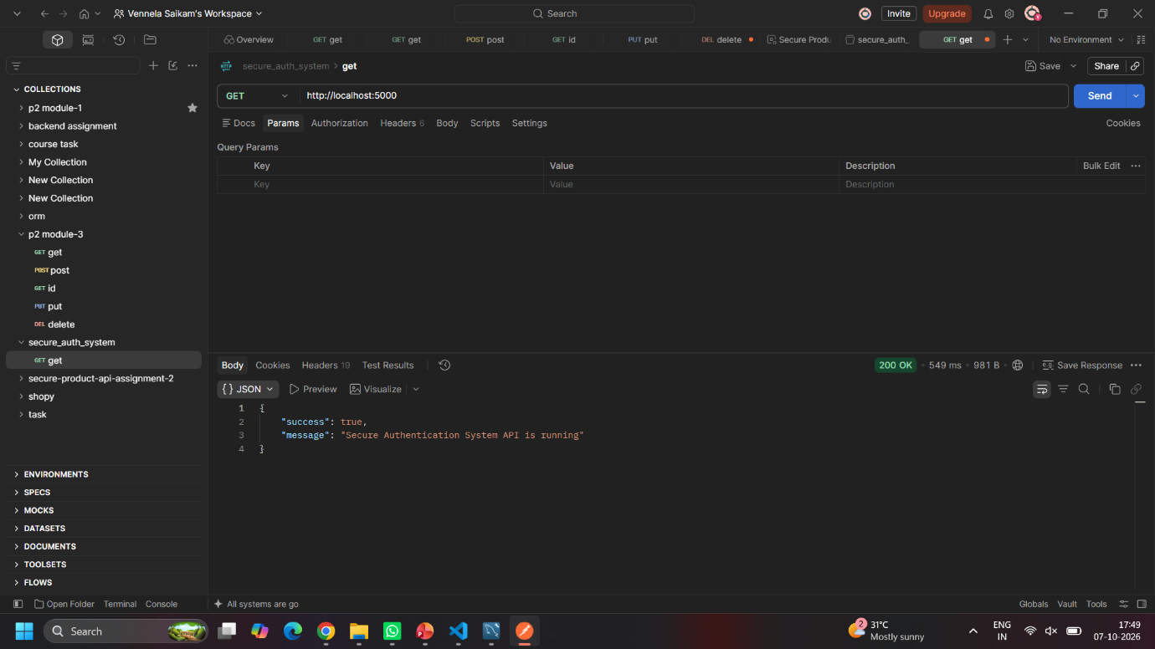

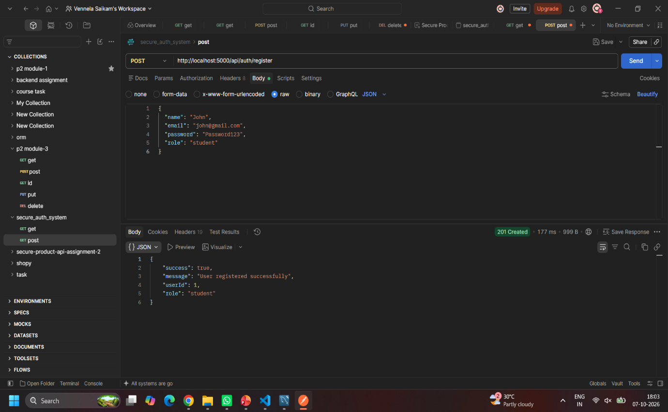
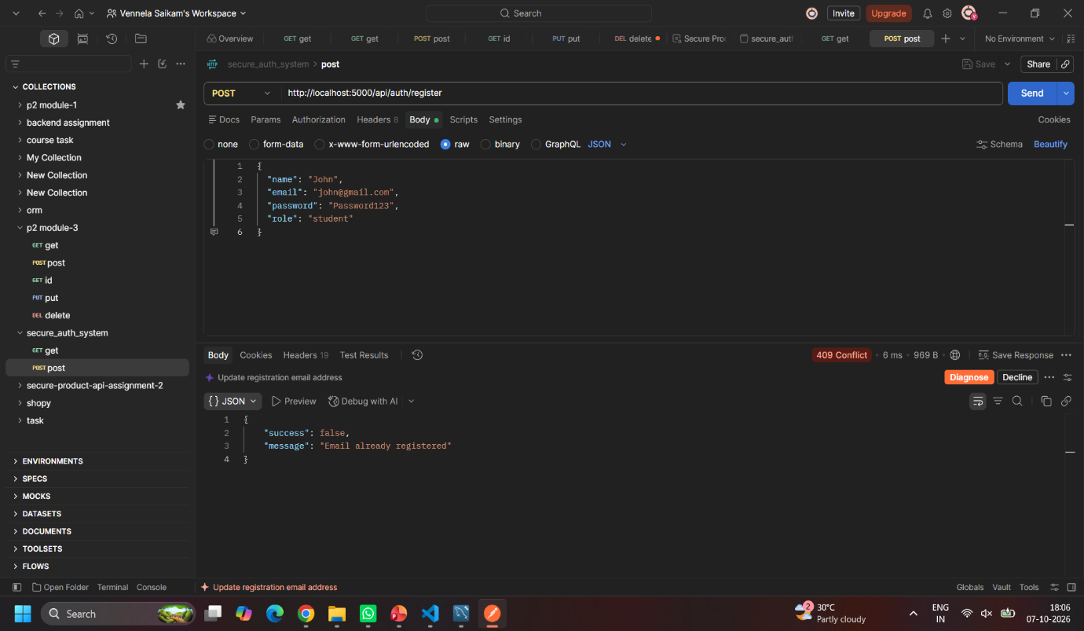

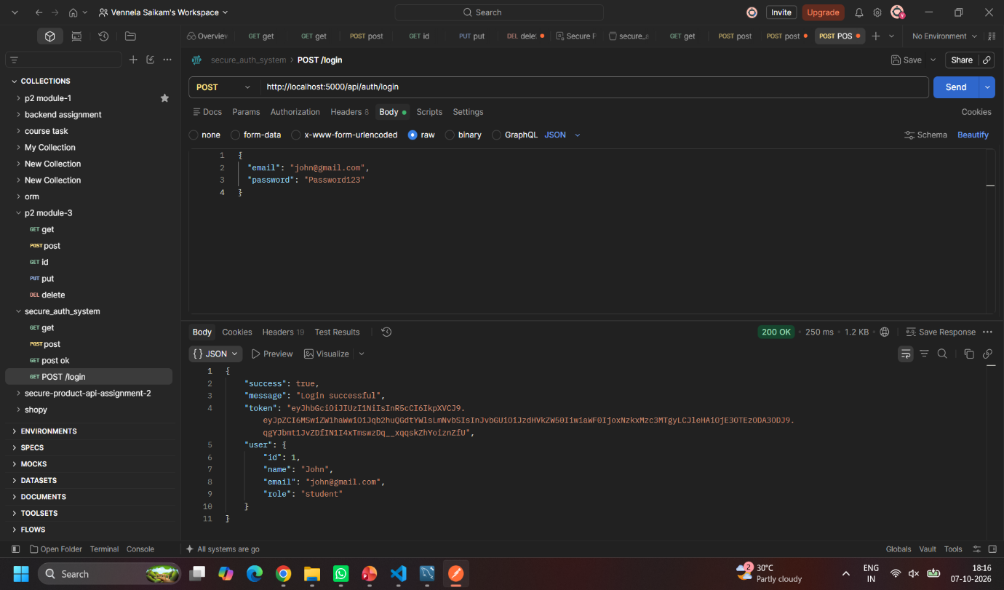

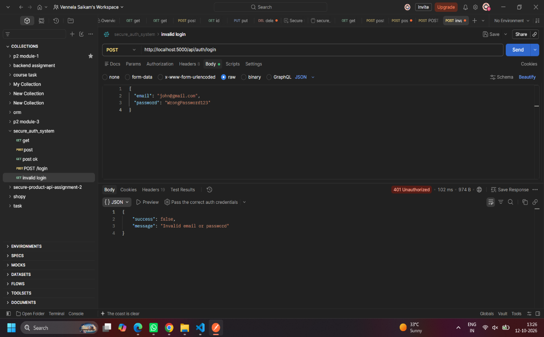

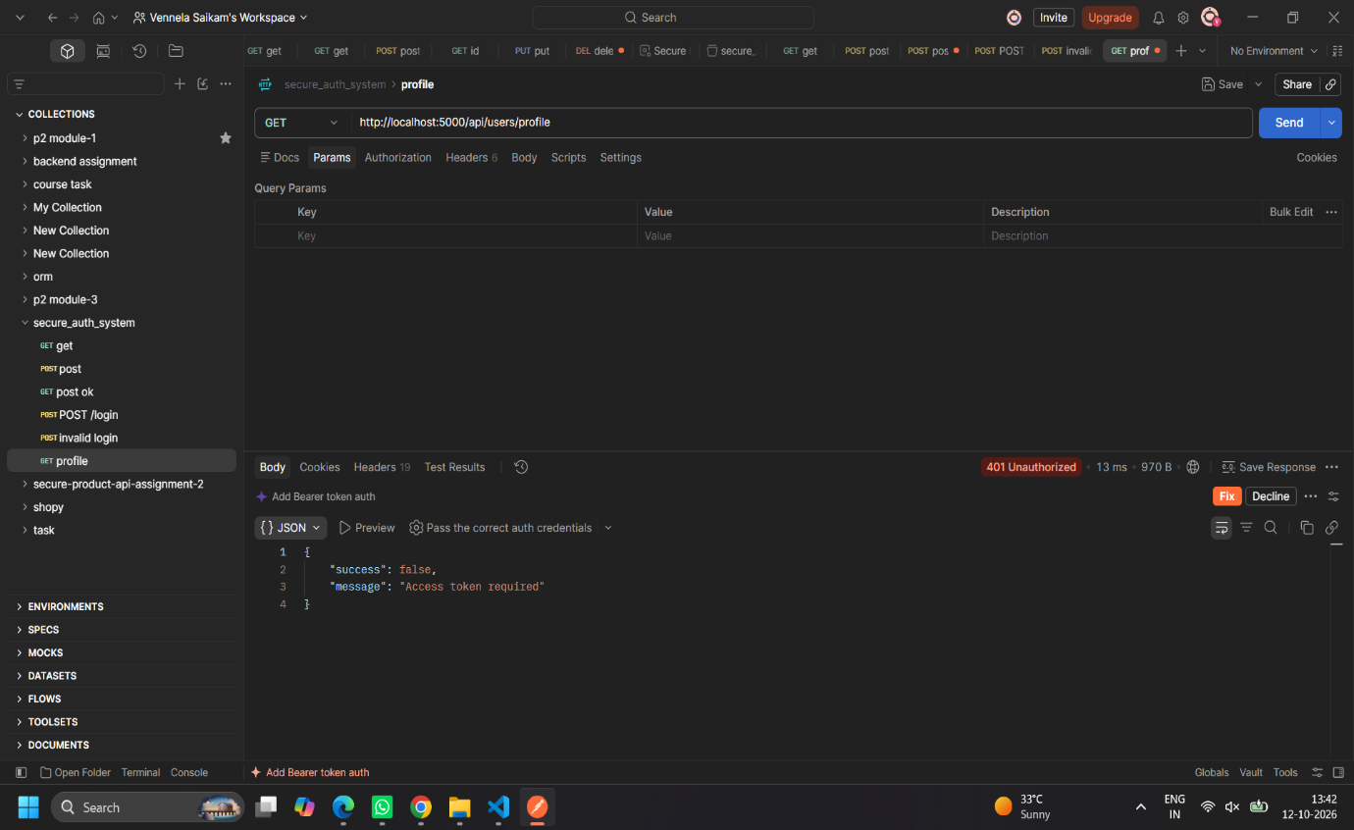

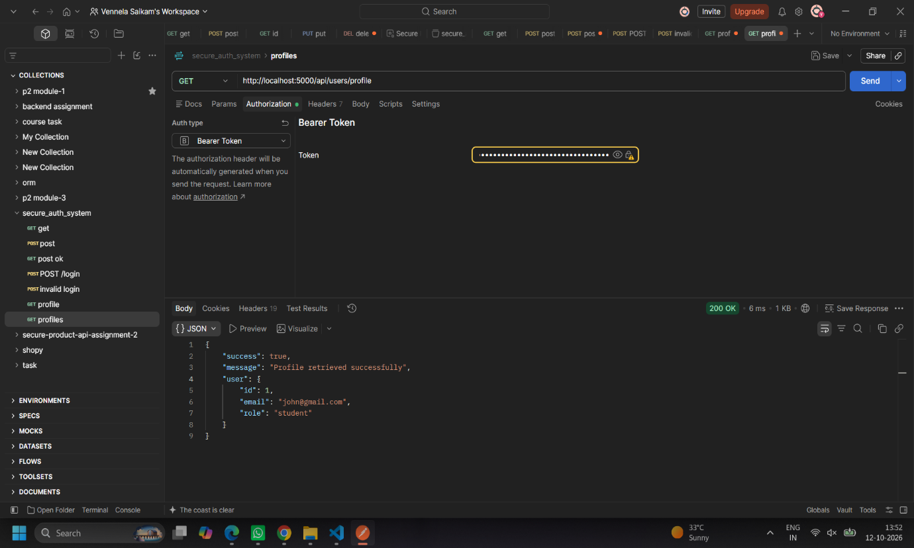

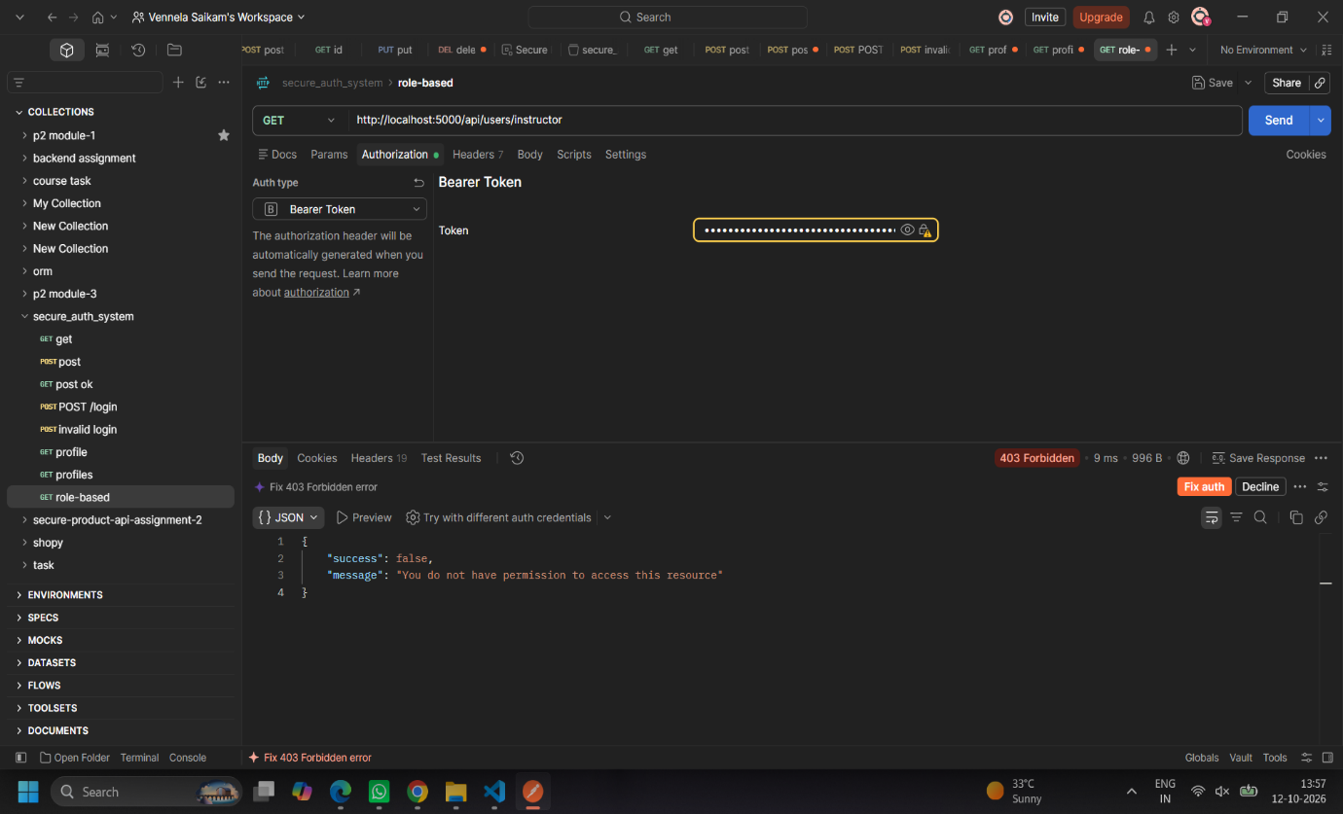

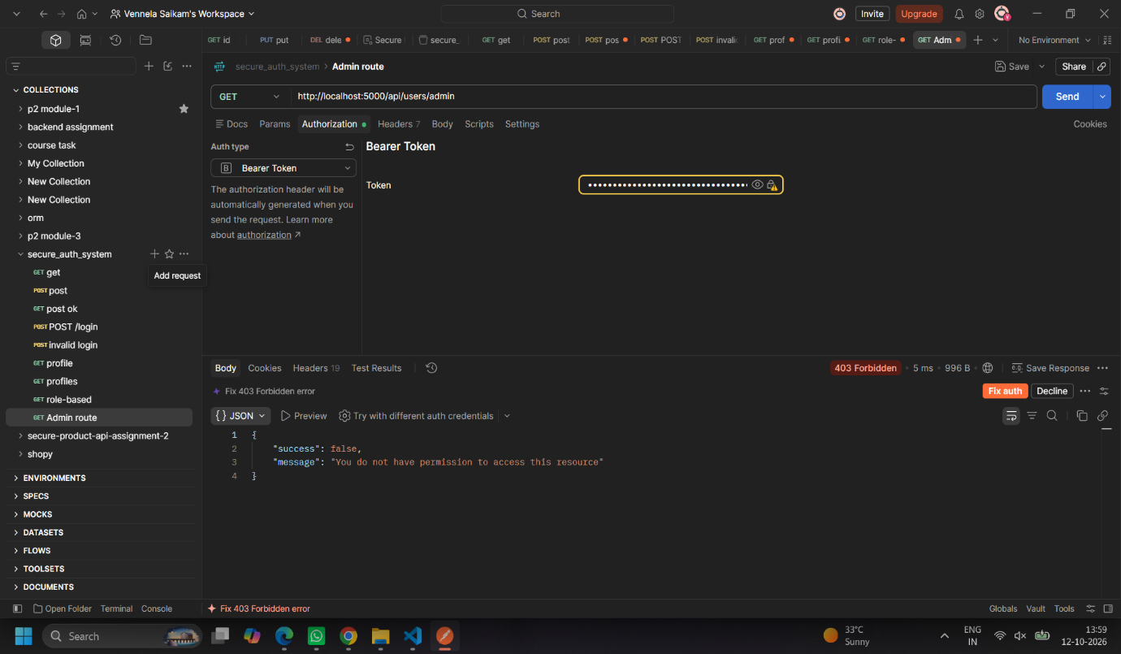

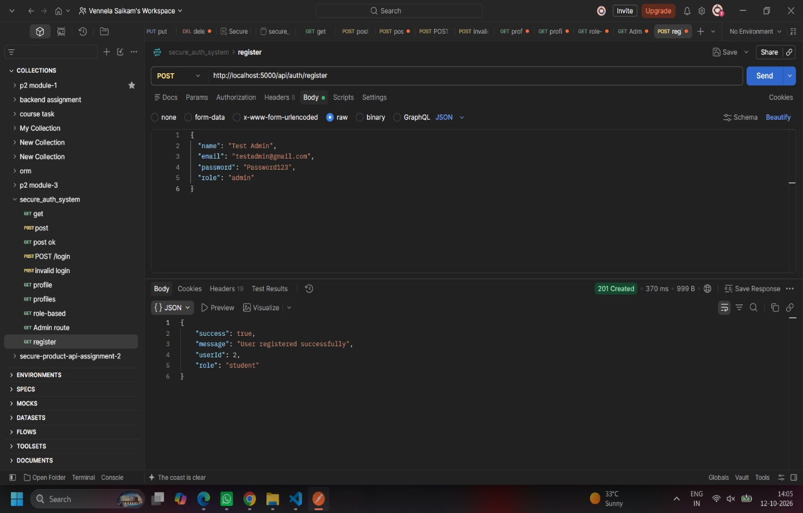

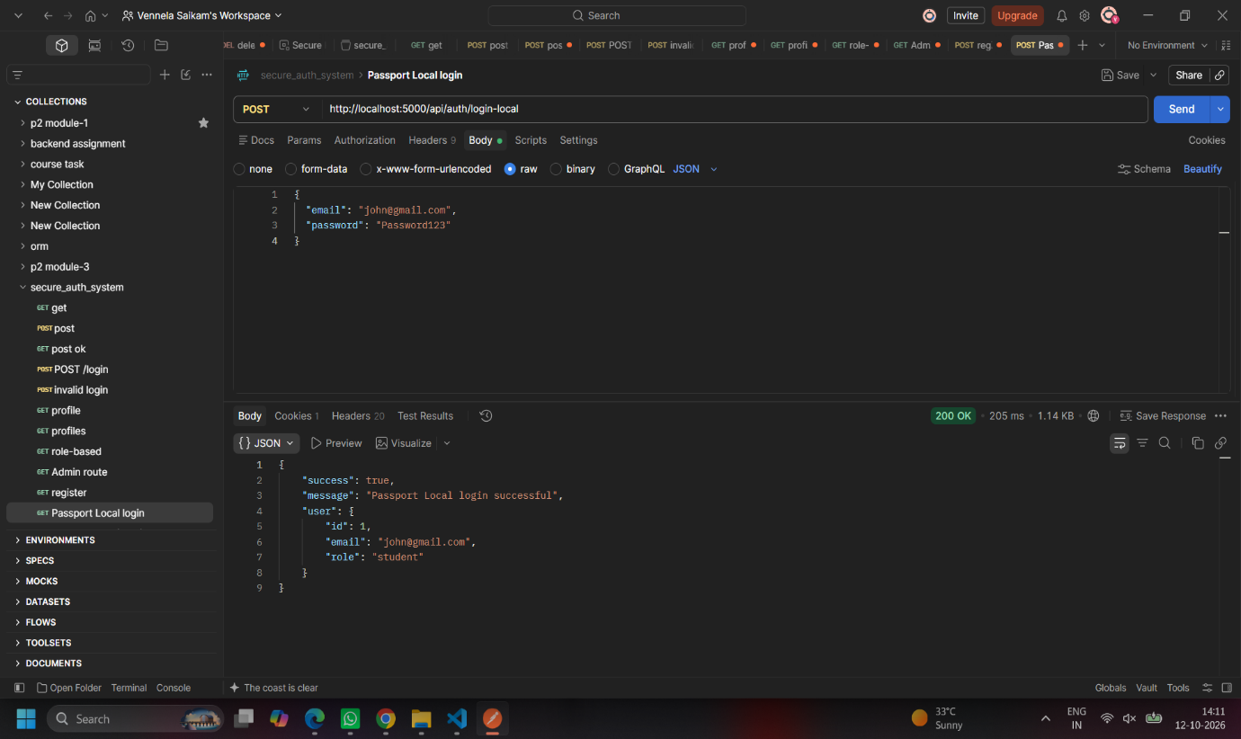

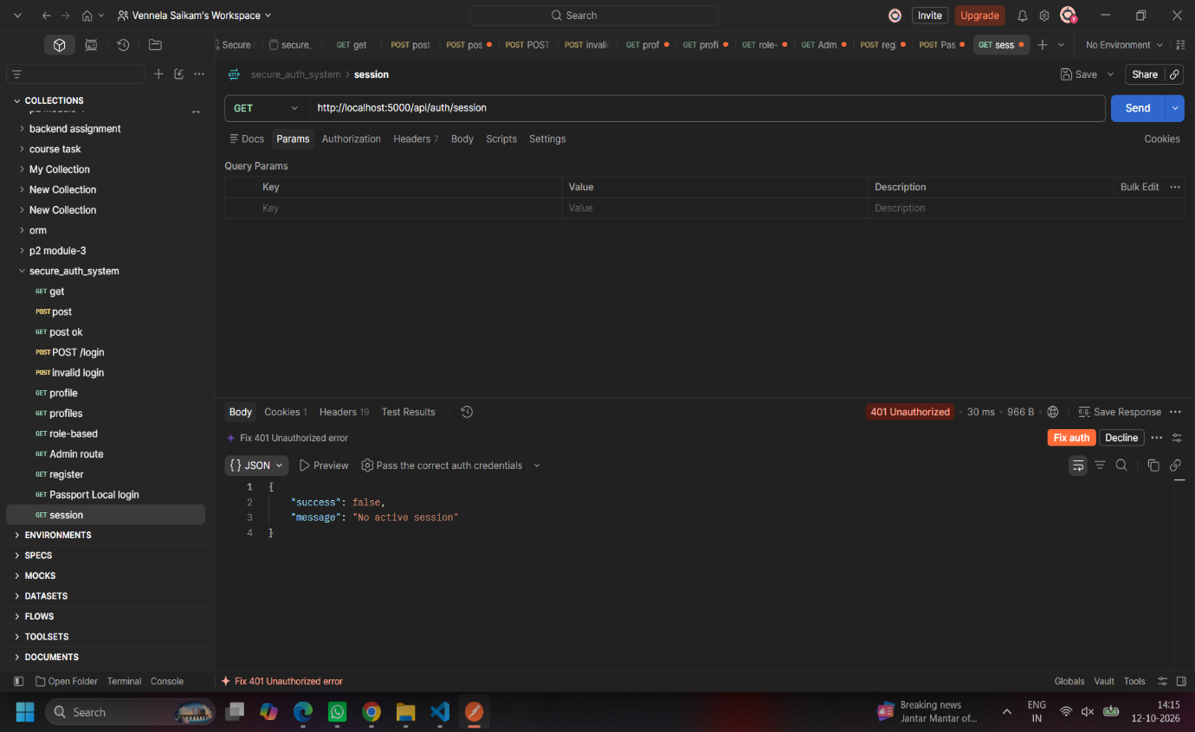

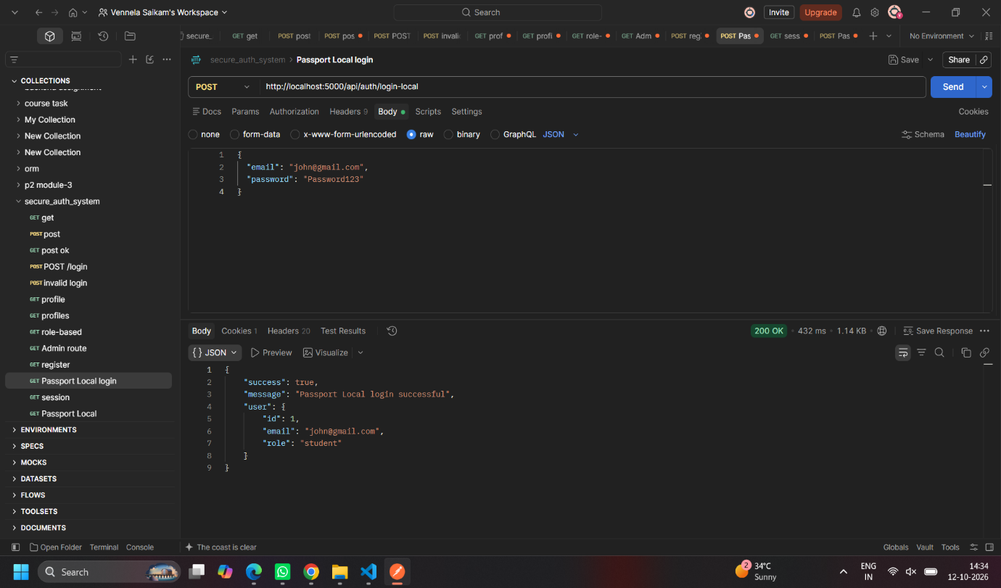

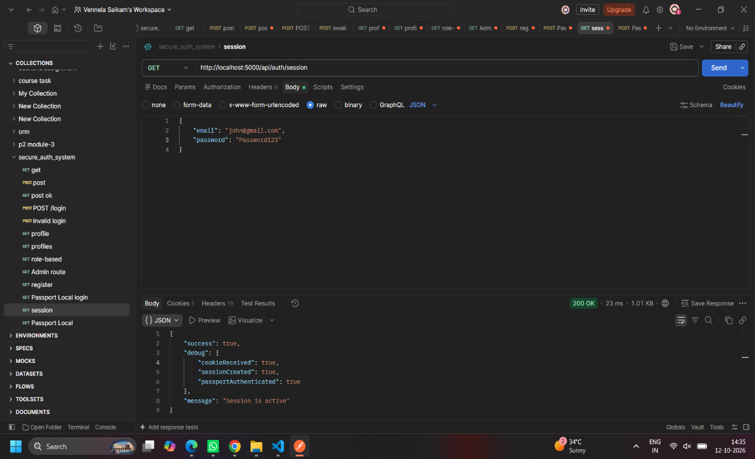

Github Repository:
https://github.com/saikamvennela/secure-auth-system

LMS Platform:
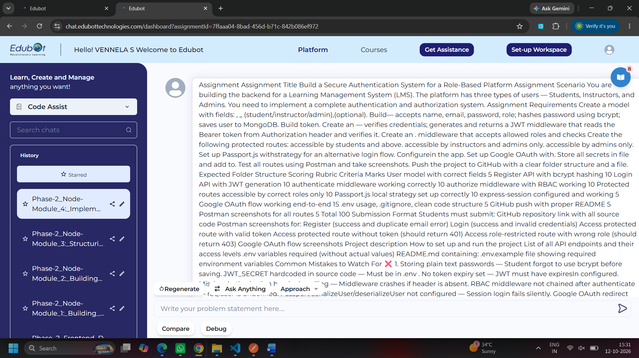

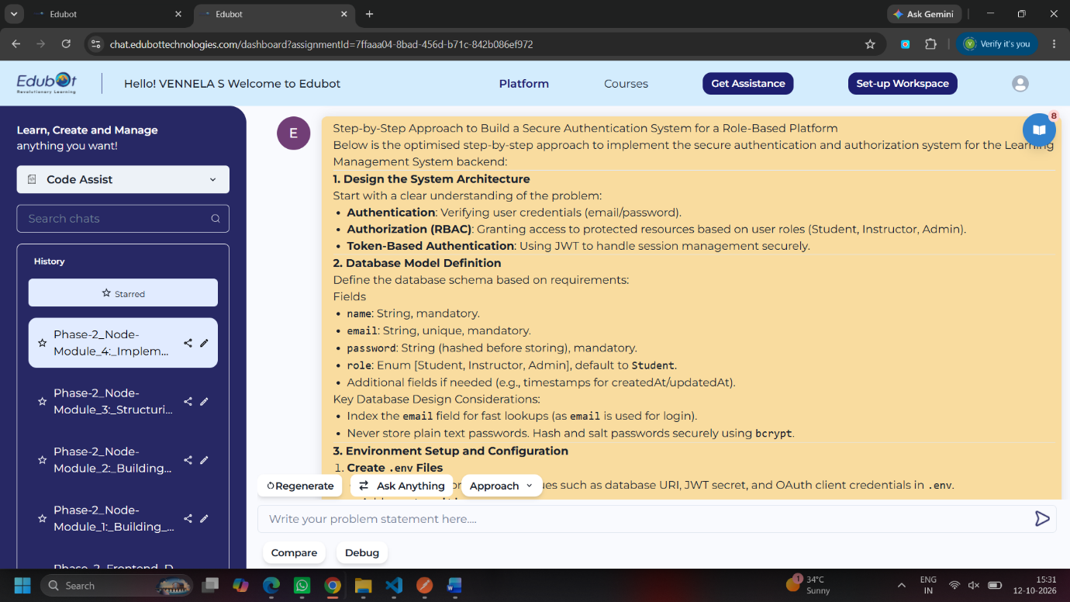

Assignment Title: Build a Secure Authentication System for a Role-Based Platform
Description
The Secure Authentication System is a backend application developed using Node.js, Express.js, TypeScript, and MySQL. The main purpose of this project is to provide secure user registration and login, authenticate users, and control access to protected resources based on user roles.
The system uses bcrypt to hash user passwords before storing them in the database. JSON Web Tokens (JWT) are used to authenticate users when accessing protected API endpoints. Passport Local and Express Session are also implemented to support session-based authentication.
The platform supports three user roles: Student, Instructor, and Admin. Role-based authorization ensures that users can access only the resources permitted for their assigned roles.

Key Points
- User Registration: Allows new users to register with their name, email, and password.
- Secure Password Storage: Uses bcrypt to hash passwords before storing them in the MySQL database.
- User Login: Verifies user credentials and generates a JWT after successful authentication.
- JWT Authentication: Validates access tokens before allowing users to access protected endpoints.
- Role-Based Authorization: Restricts access to specific routes according to the user's role.
- Passport Local Authentication: Supports email and password authentication through Passport.js.
- Session Management: Uses Express Session to maintain Passport authentication sessions.
- MySQL Database: Stores user details, password hashes, and role information.
- Protected API Routes: Provides profile, instructor, and admin endpoints with authentication and permission checks.
- Security Middleware: Uses Helmet, CORS, and Morgan for security headers, cross-origin configuration, and request logging.

Advantages
- Protects user passwords by storing hashed passwords instead of plain-text passwords.
- Prevents unauthorized users from accessing protected API resources.
- Provides separate access permissions for students, instructors, and administrators.
- Uses JWT authentication to verify users making requests to protected endpoints.
- Supports both token-based authentication and Passport Local session-based authentication.
- Uses MySQL to store and manage user information in a structured database.
- Uses TypeScript to improve code quality through static type checking.
- Separates routes, controllers, models, and middleware, making the project easier to maintain and extend.

Disadvantages
- The project requires a properly configured MySQL database and environment variables to run.
- JWT-based authentication requires careful token handling, expiration management, and secure storage.
- Session-based authentication needs an appropriate persistent session store for production use.
- User roles and permissions must be managed carefully to prevent unauthorized privilege changes.
- Google OAuth is not yet configured in the current implementation and requires additional development and valid Google OAuth credentials.
- The application requires additional production hardening, monitoring, and security testing before deployment for real-world use.

Conclusion
The Secure Authentication System demonstrates the implementation of user authentication and role-based authorization using Node.js, Express.js, TypeScript, and MySQL. It combines bcrypt password hashing, JWT verification, Passport Local authentication, and session management to protect user accounts and API resources.
The project also demonstrates the importance of middleware, database integration, and access control in backend development. The implemented features were tested using Postman, including registration, login, protected profile access, and role-based permission checks.
Overall, this assignment provides practical experience in developing a structured and security-focused backend application. Additional features, including Google OAuth and production-level session management, can be implemented to further improve the system.

