SECURE PRODUCT CATALOG API

Project Structure:
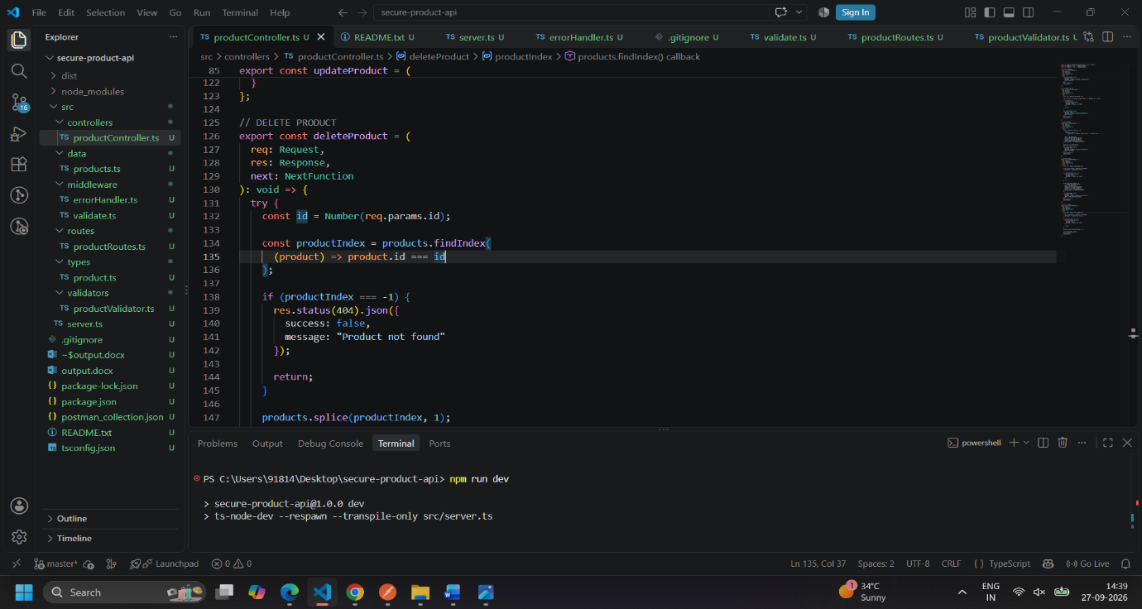

GET all products
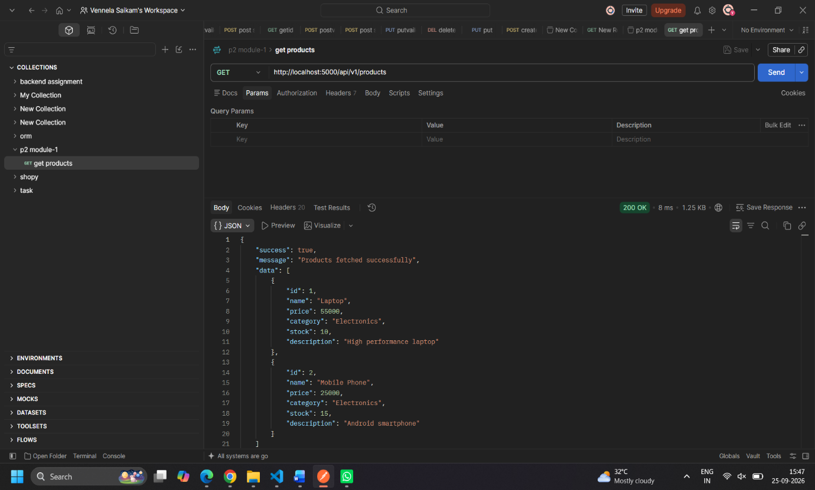
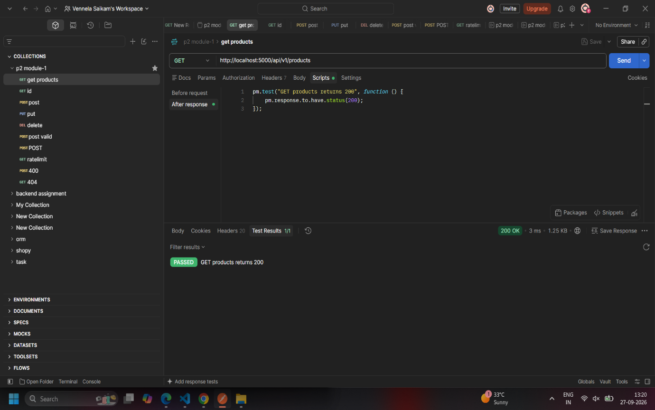

GET product by ID
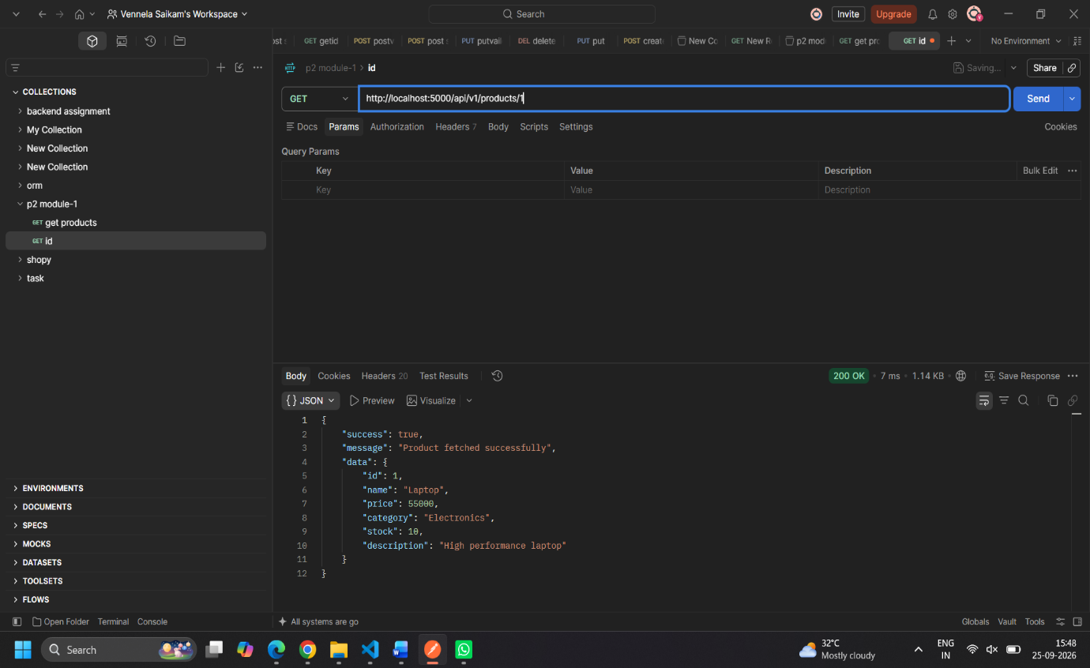

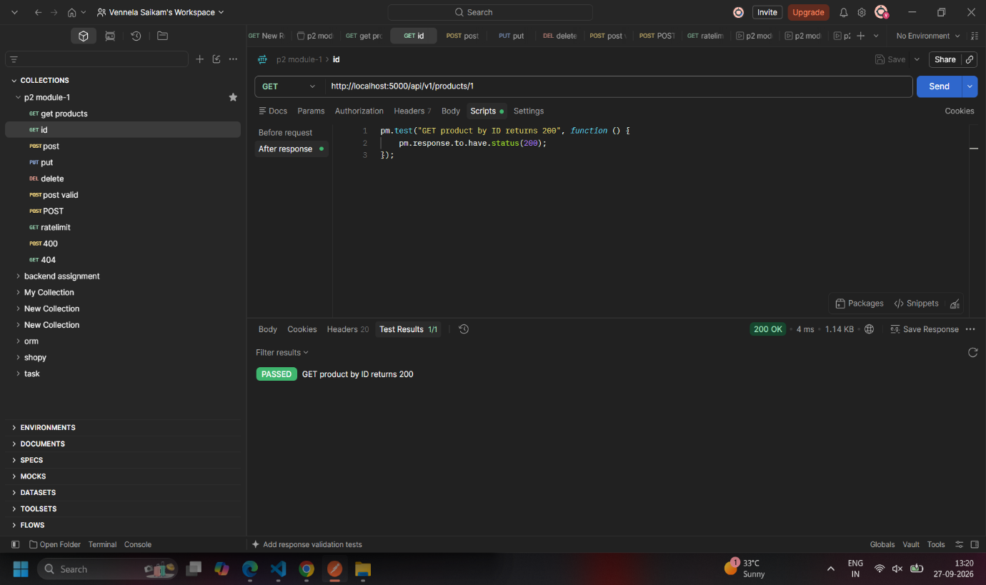

POST Product
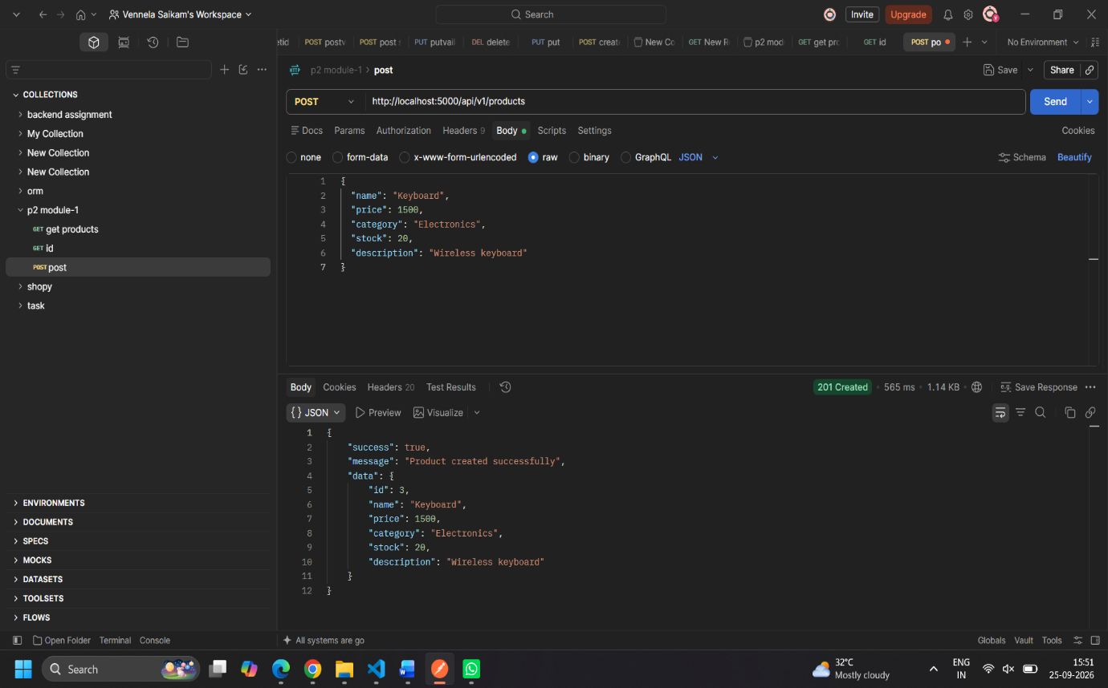
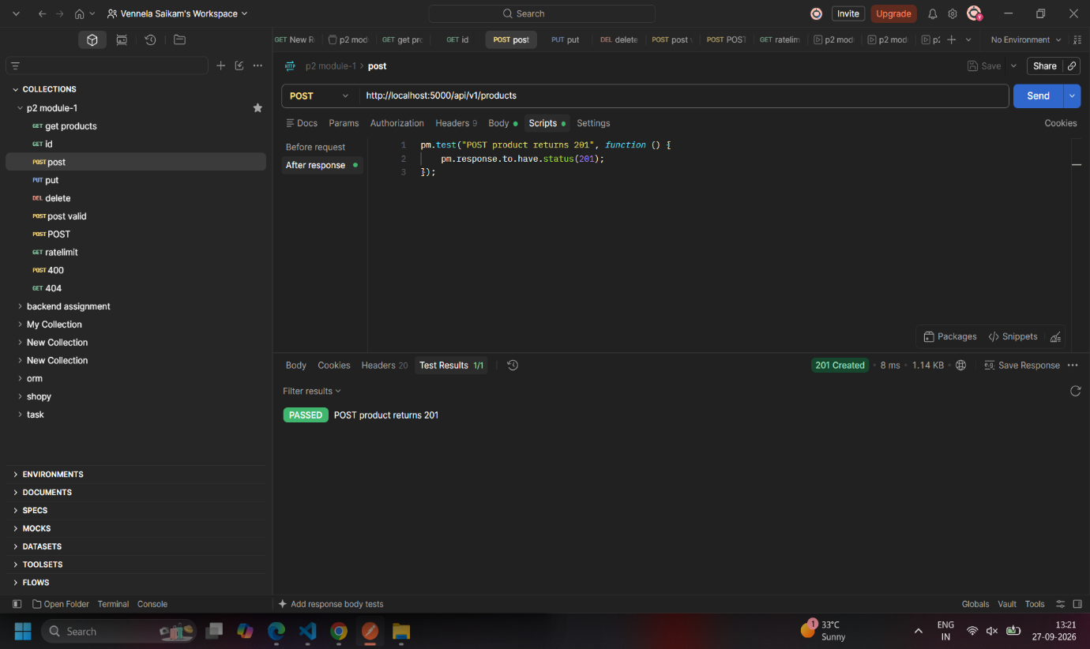

PUT Product
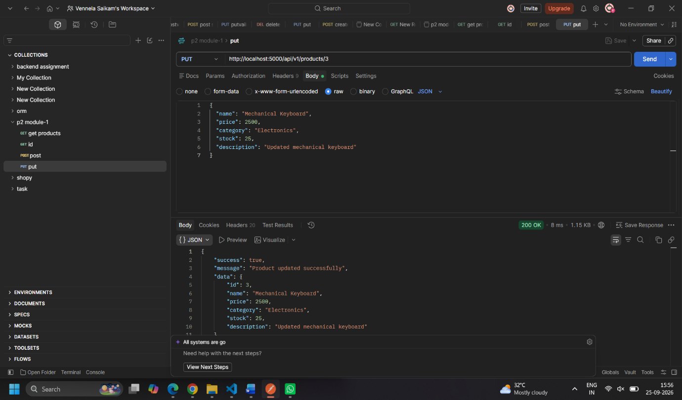

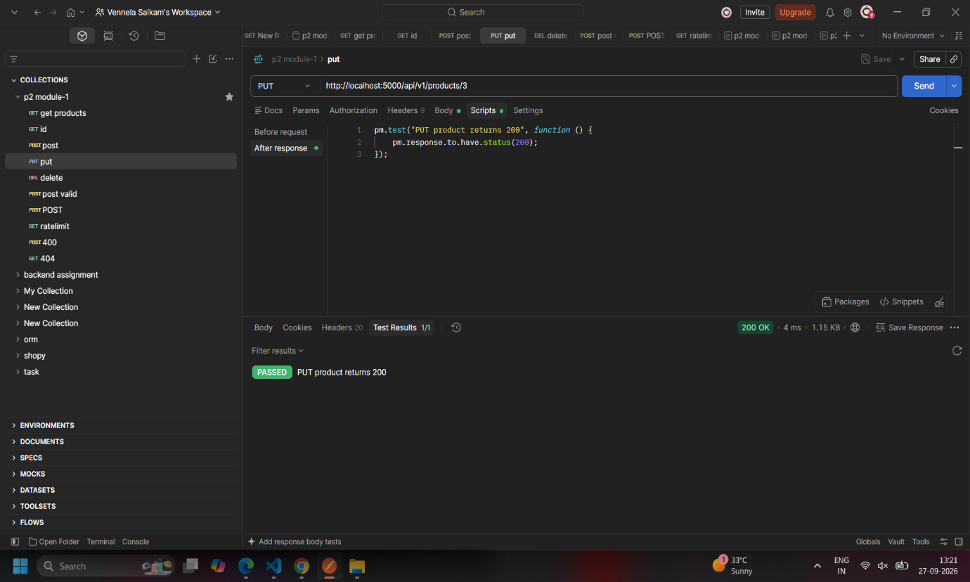

DELETE Product

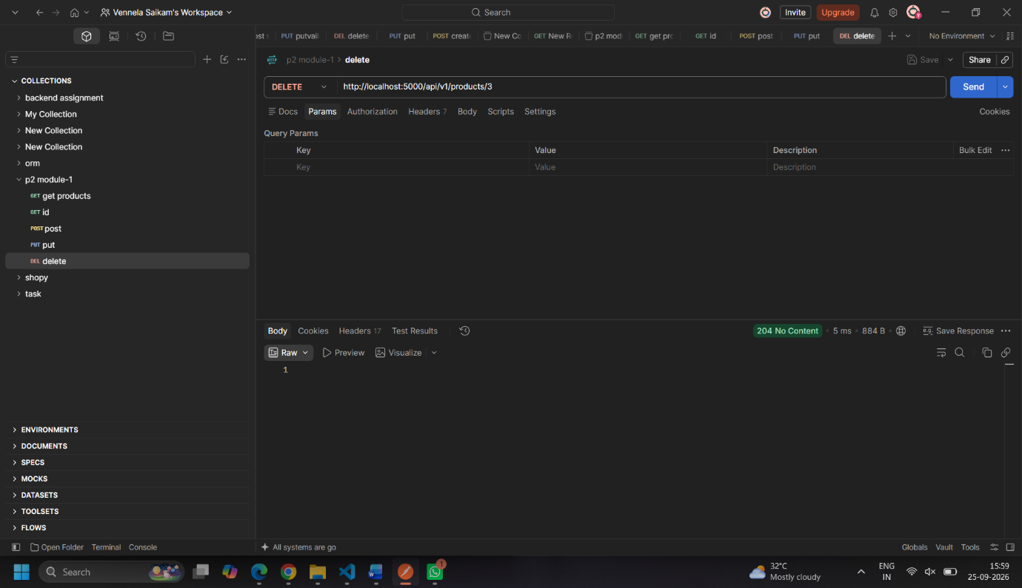

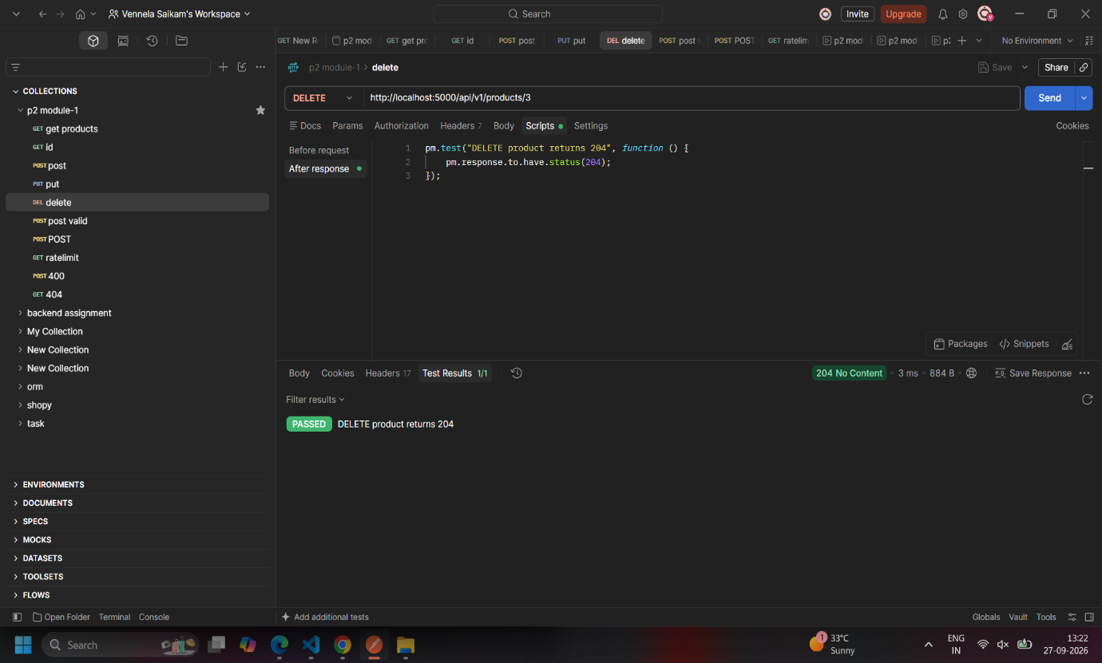

Validation error
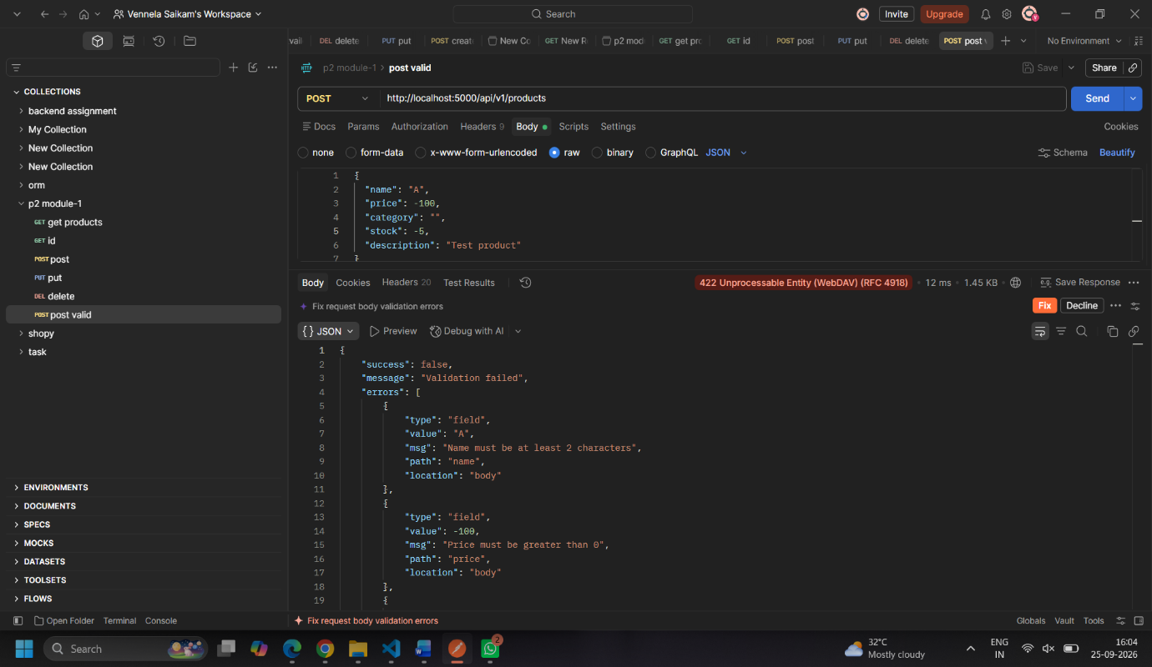

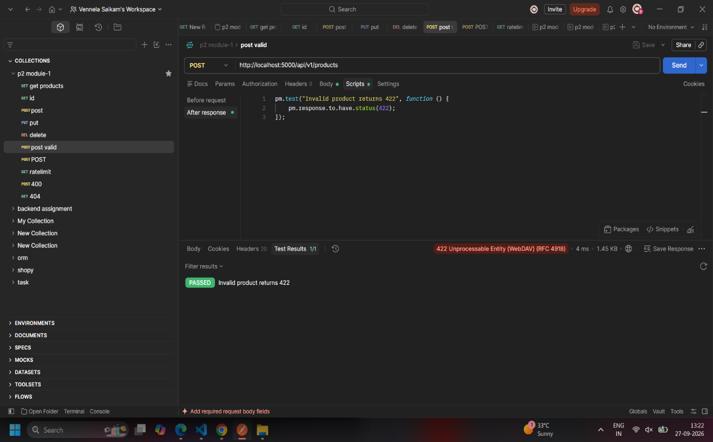
Sanitization
Use data containing spaces and HTML/script characters:
Show the resulting sanitized response.

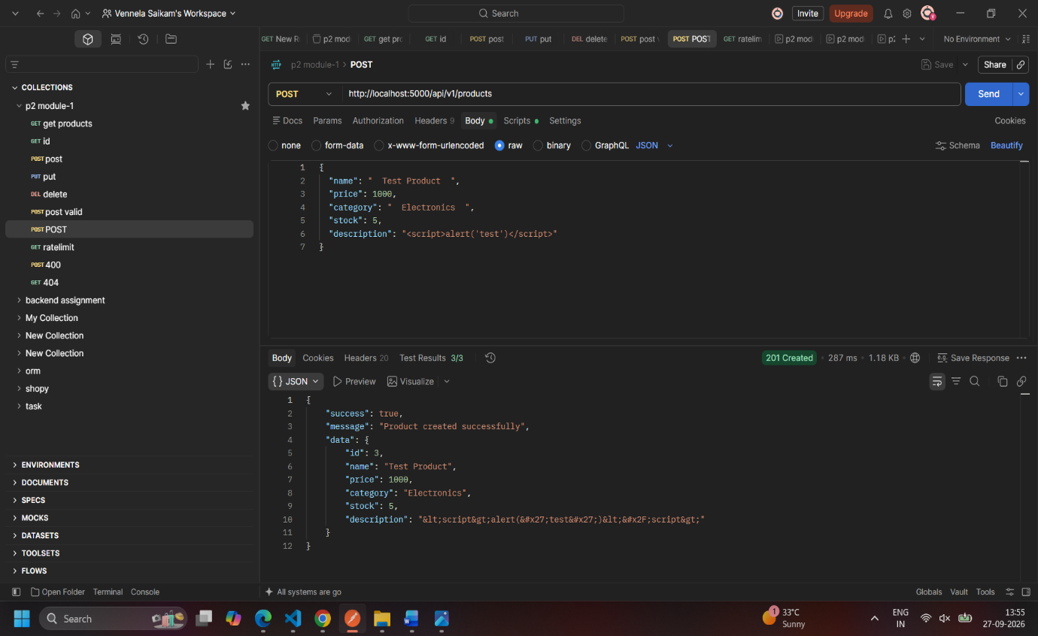
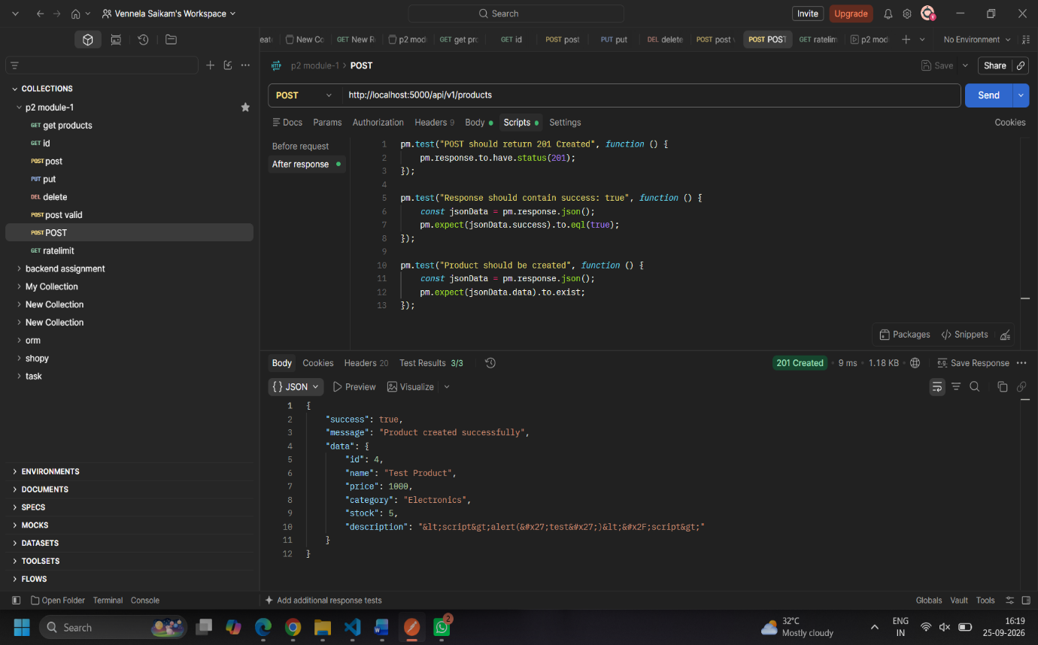

Rate limit
This is very important because the assignment specifically requires rate limiting and a 429 response.
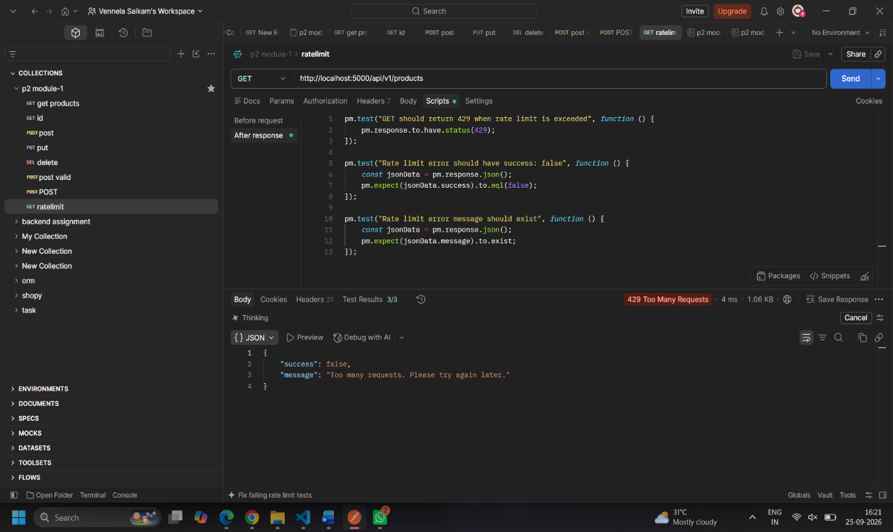

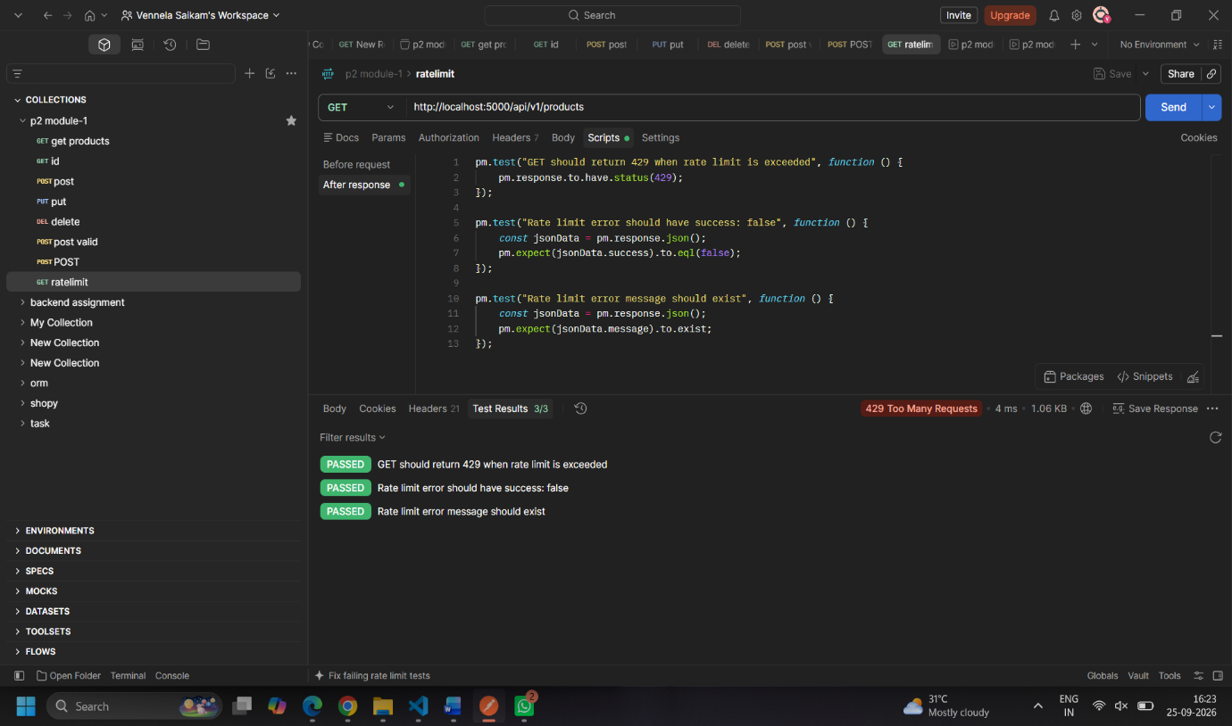

400 Bad Request
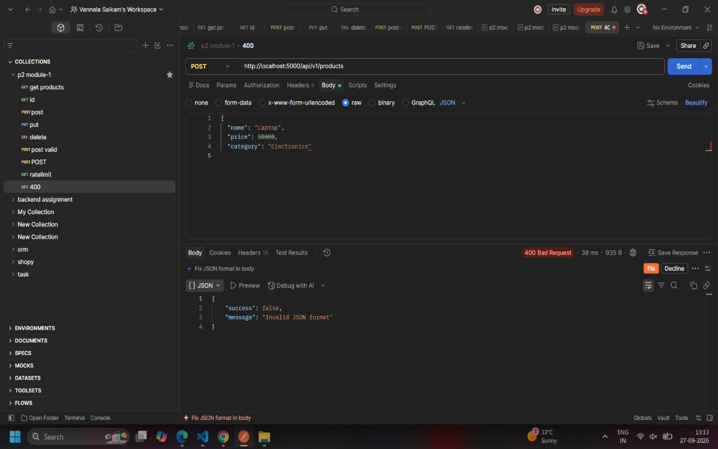
404 Not Found
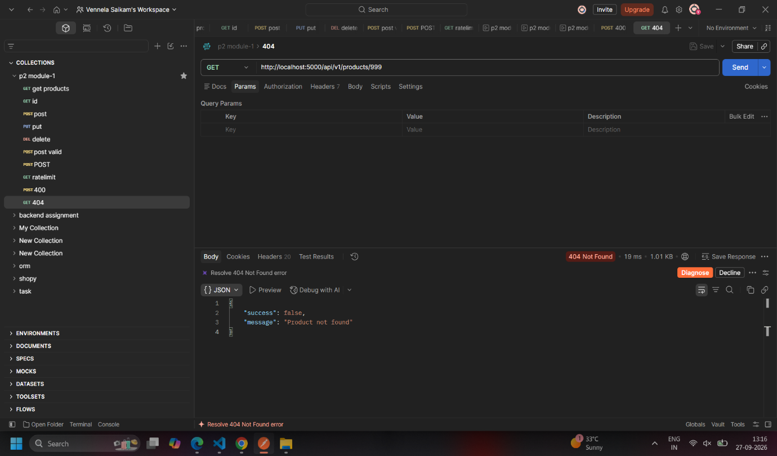

LMS Platform:

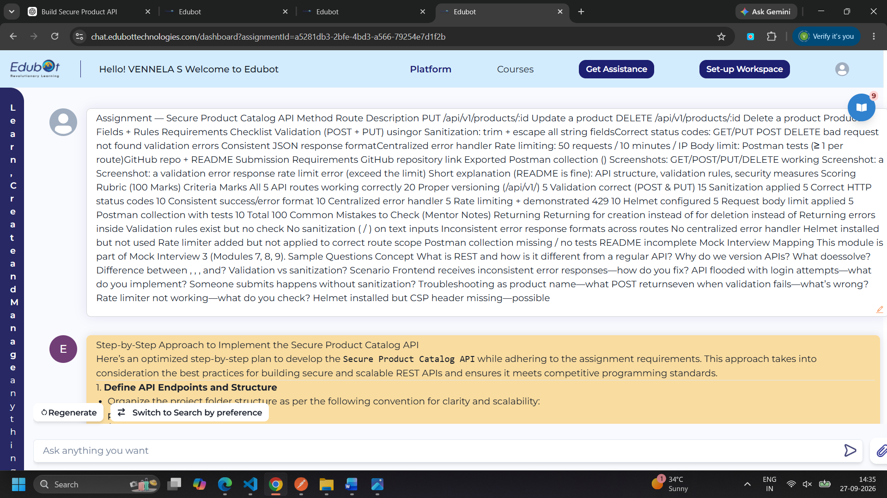
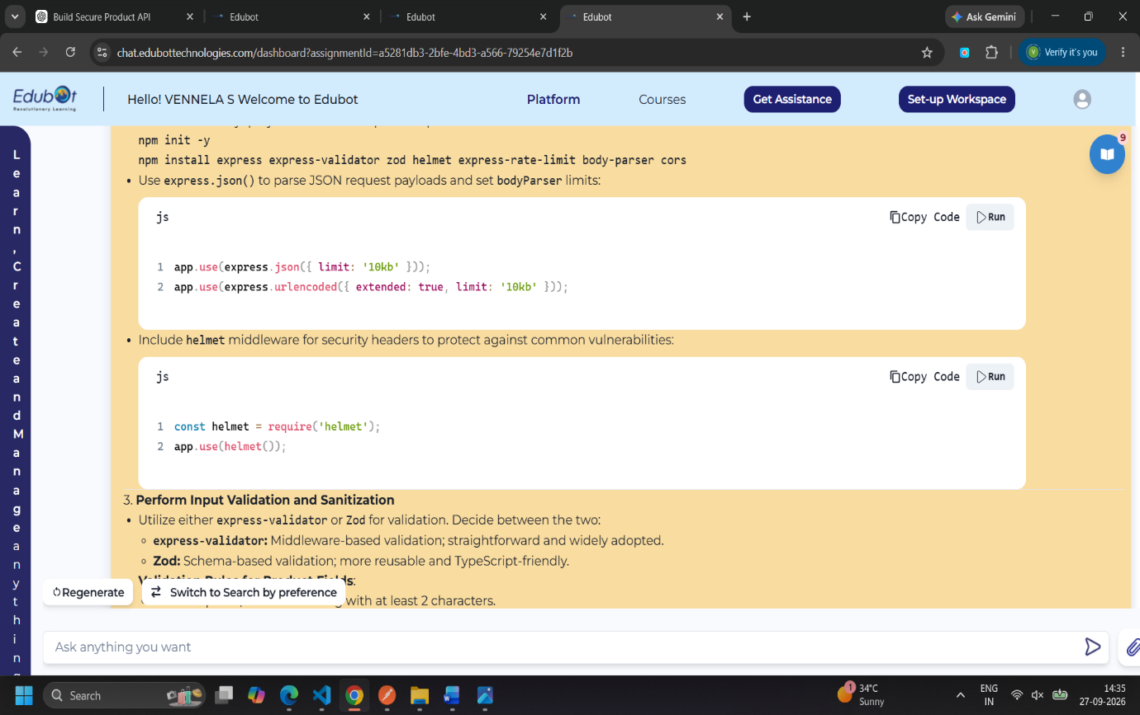

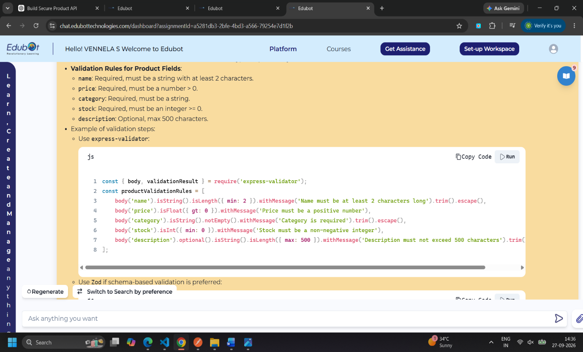

Description
Secure Product Catalog API is a RESTful API developed using Node.js, Express.js, and TypeScript. The API provides CRUD operations for managing product information.
The API supports creating, reading, updating, and deleting products through versioned routes under /api/v1/products. Each product contains fields such as name, price, category, stock, and description.
The project also implements input validation, input sanitization, centralized error handling, consistent JSON responses, rate limiting, request body size limitation, and Helmet security middleware. These features help make the API more secure, reliable, and easier to maintain

Main Features
- GET Products – Retrieves all products.
- GET Product by ID – Retrieves a specific product.
- POST Product – Creates a new product.
- PUT Product – Updates an existing product.
- DELETE Product – Deletes a product.
- Input Validation – Checks required fields and valid values.
- Input Sanitization – Uses trimming and escaping for string fields.
- Centralized Error Handling – Provides consistent error responses.
- Rate Limiting – Limits API requests to 50 requests per 10 minutes per IP.
- Request Body Limit – Restricts JSON request bodies to 10 KB.
Advantages
- Helmet and rate limiting provide additional protection for the API.
- Invalid product information can be rejected before it is processed.
- Trimming and escaping string fields helps prevent unsafe input from being stored or returned.
- Products can be created, viewed, updated, and deleted using standard HTTP methods.
- The API follows a consistent JSON response format for successful and error responses.
- Errors can be handled in one middleware instead of repeating error-handling logic throughout the application.
- /api/v1 makes it easier to introduce future API versions.
- Postman can be used to test the different API endpoints and error cases.

Disadvantages
- Product data is stored in an application array, so the data is not persistent when the server restarts.
- The current assignment does not implement user authentication or authorization.
- The application is designed as a simple API and does not use a production database.
- The project provides centralized error handling, but more detailed production-level logging could be added.
- Clients making many legitimate requests may also receive a 429 response after reaching the configured limit.

Conclusion
The Secure Product Catalog API demonstrates how to develop a secure and structured REST API using Node.js, Express.js, and TypeScript. The project implements complete CRUD operations along with API versioning, input validation, sanitization, appropriate HTTP status codes, consistent JSON responses, centralized error handling, rate limiting, Helmet security, and request body size restrictions.
The API was tested using Postman for successful requests as well as validation, error-handling, and rate-limit scenarios. Overall, the project provides practical experience in developing, securing, testing, and documenting a RESTful API.

