

Khulna University of Engineering & Technology

Department of Computer Science and Technology

**CSE 4110: Artificial Intelligence Laboratory**

Game Title: **Eat The Cake**

**Presented By:**

Sayed Raihan(1607039)

Naymul Ekram(1607033)

Suman Mia(1607045)

Department of Computer Science and Engineering

Khulna University of Engineering & Technology

Khulna-920

**Objectives:**

1. To know about Artificial Algorithm
2. To know about Min-Max Algorithm
3. To getting knowledge about how AI works
4. Learn about Game Theory

**Introduction:**

Artificial intelligence is a theory and development of computer systems that can perform tasks that normally require human intelligence. It seems computer-controlled robot to perform tasks commonly associated with intelligent beings. The term is frequently applied to the project of developing systems endowed with the intellectual processes characteristic of humans, such as the ability to reason, discover meaning, generalize, or learn from past experience.

**Min-Max Algorithm:**

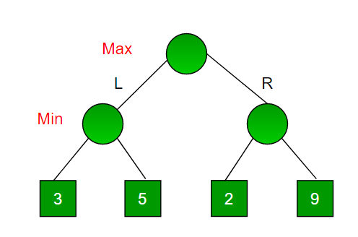The min max algorithm in AI, popularly known as the min-max, is a backtracking algorithm used in decision making, game theory and artificial intelligence (AI). It is used to find the optimal move for a player, assuming that the opponent is also playing optimally. Min-max generates a tree. If the depth is increased, The AI performs much more efficiently.

Fig: Min-Max Algorithm

**Methodology:**

**‘Eat The Cake’** is an AI based game where there will be a box of cake and each cake will have a random value. There will be a rotten cake in the box in any position and that’s have no value. There are two rules for the game-

1. The row or column of the rotten cake cannot be eaten

2. Only the boundary cakes in the cake box can be eaten

The winner of the game in between (Human vs Computer) is that one who can eat the maximum cake with maximum value. The sum of the values of the cakes will be higher, he will win.

**Game Movements when AI wins:**

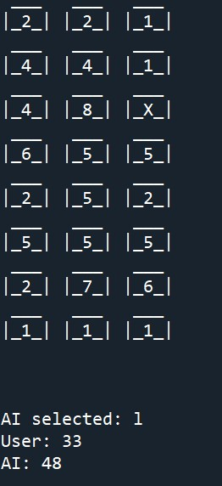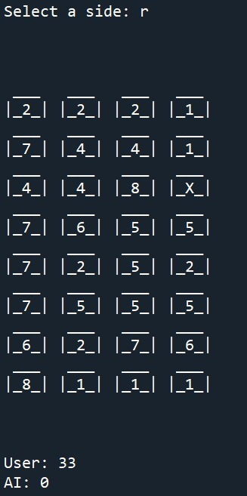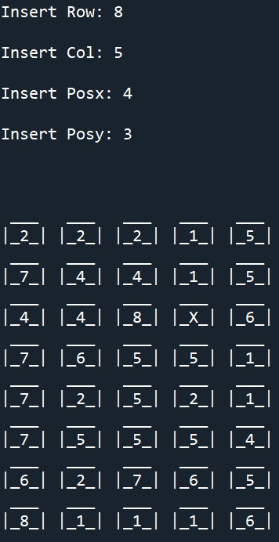Here, the cake box size is 8*5 matrix and the rotten cake(X) is in the position of 4*3. The user will get the first turn and AI will get the next .The process will continue recursively until the last cake becomes rot.

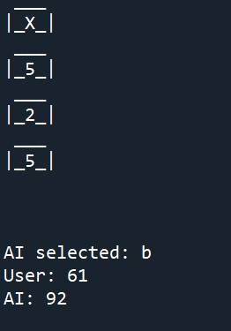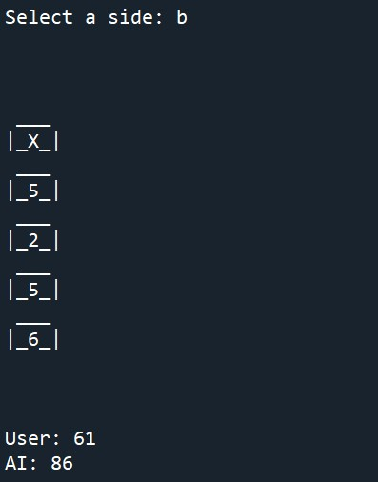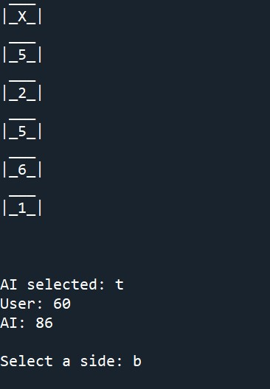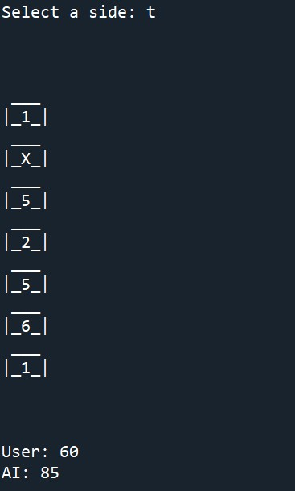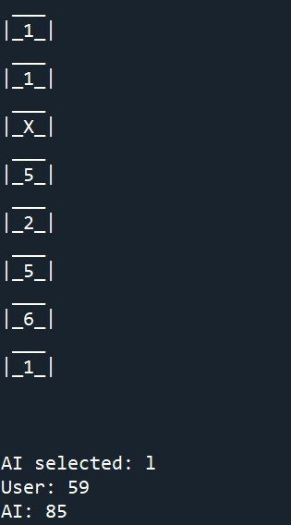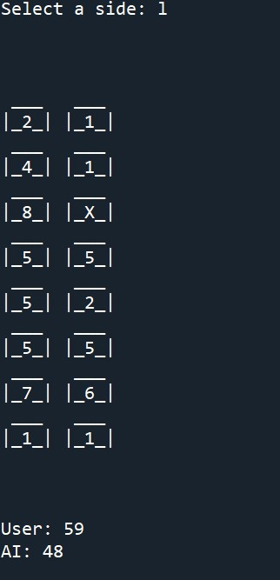

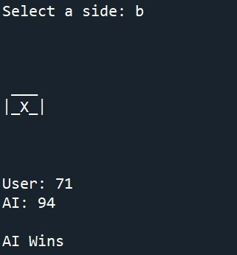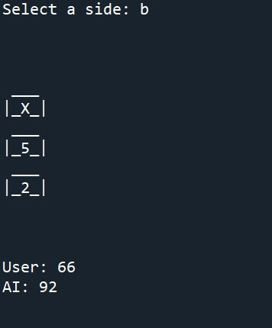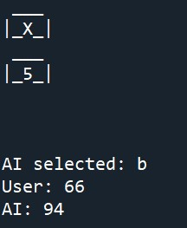 AI wins the game and it finds the best move by using min-max algorithm.

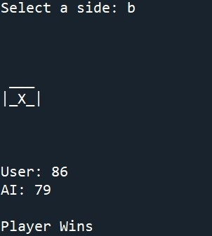**When Human Wins:**

In the below figure, player gets maximum points than AI and player wins the game.

**Discussion and Conclusion:**

By making this project, huge knowledge had been learnt. Also introduce the min-max algorithm, AI working principles and game theory. There were the important things in game theory and python algorithm. So finally applied all of the method, knowledge to make an AI based game. And the game had been running successfully after so many debugging.

**References:**

[1] <https://www.geeksforgeeks.org/minimax-algorithm-in-game-theory-set-1-introduction/>

[2] <https://towardsdatascience.com/an-introduction-to-game-theory-using-python-358c63e36e02>