1) how would you handle exception in your project specially when element is not found , not visible and when browser suddently closed?

When a method throws a checked exception, then the method must either handle the exception using try/catch block (or) it must specify the exception using throws keyword

For element is not found::NoSuchElementException

For element is not visiable::ElementNotVisibleException

when browser suddenly closed::WebDriverException.

Example:

try {

driver.findElement(By.name(nameValue)).clear();

driver.findElement(By.name(nameValue)).sendKeys(data);

System.out.println("The data: "+data+" entered successfully in field :");

bReturn = true;

}

catch (NoSuchElementException e) {

System.out.println("The Element not found");

}

catch (ElementNotVisibleException e) {

System.out.println("The Element not Visible");

}

catch (NoSuchSessionException e) {

System.out.println("The Browser is closed");

}

2) Explain the Exception hierarchy in Selenium.

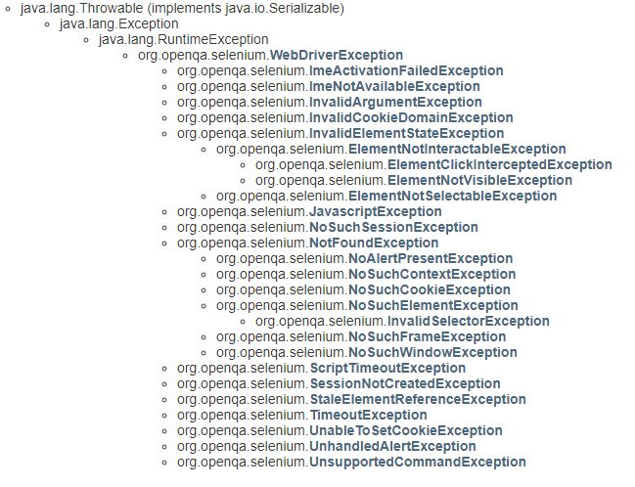

**Example:** Windows Execptions:

Nosuchwindowexception=Execptions hierarchy of NoSuchWindowException

java.lang.Object

java.lang.Throwable

java.lang.Exception

java.lang.RuntimeException

org.openqa.selenium.WebDriverException

org.openqa.selenium.NotFoundException

org.openqa.selenium.NoSuchWindowException