**Aws**

1. Cloud Computing Basics – IaaS, PaaS & SaaS Service Models

**IAAS:** Infrastructure As A Service (IAAS) is means of delivering computing infrastructure as on-demand services

**PAAS:** Platform As A Service (PAAS) is a cloud delivery model for applications composed of services managed by a third party

**SAAS,are:** Software As A Service (SAAS) allows users to run existing online applications and it is a model software that is deployed as a hosting service and is accessed

2. Cloud Computing Introduction

Cloud Computing is **the delivery of computing services such as servers, storage, databases, networking, software, analytics, intelligence, and more, over the Cloud (Internet)**.

3. Cloud Service Models

  Cloud computing is offered in three different service models which each satisfy a unique set of business requirements. These three models are known as **Software as a Service (SaaS), Platform as a Service (PaaS), and Infrastructure as a Service (IaaS)**

4. Cloud Deployment Models

Cloud service delivery models: The three basic types are **SaaS, IaaS, and PaaS**.

5. Aws Region

[[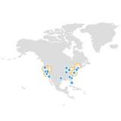](https://www.google.com/search?q=What+are+regions+in+AWS?&tbm=isch&source=iu&ictx=1&vet=1&fir=fDaVrqZb4wWtxM%252CquSMbFLq1U-gLM%252C_&usg=AI4_-kRKS775xc_CFiB72srjgSDkzpIHPA&sa=X&ved=2ahUKEwiEusG-rqj4AhWBw6ACHRwRBAUQ9QF6BAgZEAE#imgrc=fDaVrqZb4wWtxM)](https://www.google.com/search?q=What+are+regions+in+AWS?&tbm=isch&source=iu&ictx=1&vet=1&fir=fDaVrqZb4wWtxM%252CquSMbFLq1U-gLM%252C_&usg=AI4_-kRKS775xc_CFiB72srjgSDkzpIHPA&sa=X&ved=2ahUKEwiEusG-rqj4AhWBw6ACHRwRBAUQ9QF6BAgZEAE" \l "imgrc=fDaVrqZb4wWtxM)

AWS has the concept of a Region, which is **a physical location around the world where we cluster data centers**. We call each group of logical data centers an Availability Zone. Each AWS Region consists of multiple, isolated, and physically parate AZs within a geographic area.

6**.** Availability Zones

Availability zones (AZs) are **isolated locations within data center regions from which public cloud services originate and operate**. Regions are geographic locations in which public cloud service providers' data centers reside

7. Amazon EC2

Amazon Elastic Compute Cloud (Amazon EC2) **provides scalable computing capacity in the Amazon Web Services (AWS) Cloud**. Using Amazon EC2 eliminates your need to invest in hardware up front, so you can develop and deploy applications faster.

8. Create EC2 Instances

1. Select a region. ...
2. Navigate to the EC2 Console. ...
3. Create the EC2 instance. ...
4. Choose an instance type. ...
5. Configure storage. ...
6. Tag the instance. ...
7. Build in security. ...
8. Enable SSH access with a key.
9. EC2 Instance States

When your instance is **running (2)**, it's ready to use. This is also the stage where billing begins. As soon as an instance is running, you are then able to take other actions on the instance, such as reboot, terminate, stop, and stop-hibernate.

1. EC2 Instance Types

* Mac.
* T4g.
* T3.
* T3a.
* T2.
* M6g.
* M6i.
* M6a.

1. Elastic Load Balancing

Elastic Load Balancing (ELB) **automatically distributes incoming application traffic across multiple targets and virtual appliances in one or more Availability Zones (AZs)**. Application Load Balancer.

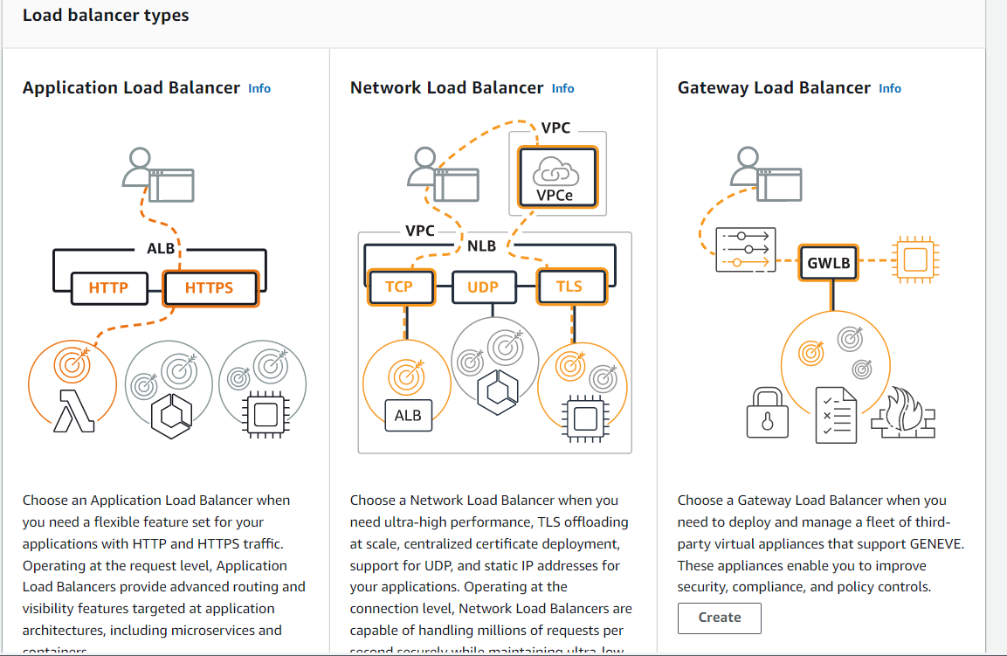

1. Auto Scaling Group

An Auto Scaling group **contains a collection of Amazon EC2 instances that are treated as a logical grouping for the purposes of automatic scaling and management**. An Auto Scaling group also enables you to use Amazon EC2 Auto Scaling features such as health check replacements and scaling policies.

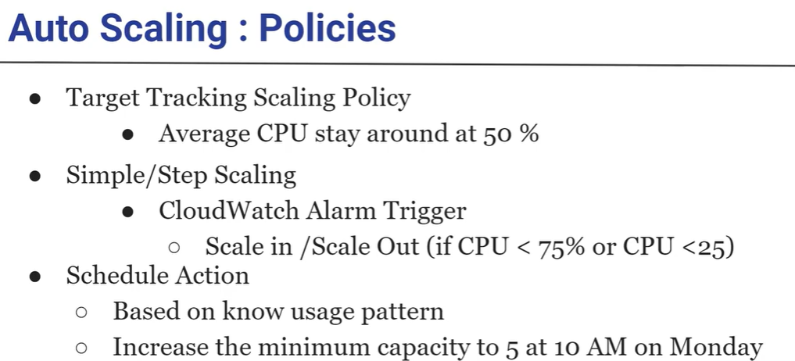

1. What is EBS volume & types?

An Amazon EBS volume is **a durable, block-level storage device that you can attach to your instances**. After you attach a volume to an instance, you can use it as you would use a physical hard drive. EBS volumes are flexible

All EBS volumes fall into two categories: **SSD-backed volumes and HDD-backed volumes**.

1. Route53 Hosted Zone

A hosted zone is an Amazon Route 53 concept. A hosted zone is **analogous to a traditional DNS zone file; it represents a collection of records that can be managed together, belonging to a single parent domain name**. All resource record sets within a hosted zone must have the hosted zone's domain name as a suffix

1. IAM Users & Roles

**An IAM user has permanent long-term credentials and is used to directly interact with AWS services.** **An IAM role does not have any credentials and cannot make direct requests to AWS services**.

1. IAM policy

IAM policies **define permissions for an action regardless of the method that you use to perform the operation**. For example, if a policy allows the GetUser action, then a user with that policy can get user information from the AWS Management Console, the AWS CLI, or the AWS API.

1. RDS Integration with Application
2. Open the Amazon EC2 console, and choose Launch instance.
3. Select an Amazon Machine Image (AMI).
4. Choose an instance type, and then choose Next: Configure Instance Details.
5. For Network, choose the VPC that the RDS DB instance uses.
6. For Subnet, select the subnet that has an internet gateway in its routing table.
7. Networking Basics

Referral Link:

<https://www.geeksforgeeks.org/basics-computer-networking/#:~:text=Computer%20networks%20can%20also%20include,different%20devices%20in%20a%20network>.

1. Create and Manage VPC

Referral Link: <https://docs.aws.amazon.com/directoryservice/latest/admin-guide/gsg_create_vpc.html>

20 Vpc peering

A VPC peering connection is **a networking connection between two VPCs that enables you to route traffic between them using private IPv4 addresses or IPv6 addresses**. Instances in either VPC can communicate with each other as if they are within the same network.

21 About lambda?

Referral Link: <https://docs.aws.amazon.com/lambda/latest/dg/welcome.html>

22. What is a CloudFront distribution?

Amazon CloudFront is **a web service that speeds up distribution of your static and dynamic web content, such as .** **html, .** **css, .** **js, and image files, to your users**. CloudFront delivers your content through a worldwide network of data centers called edge locations.

Aws interview question 2020 link :

<https://www.interviewbit.com/aws-interview-questions/>