**Program 1 :**

**Code –**

/*

* To change this license header, choose License Headers in Project Properties.

* To change this template file, choose Tools | Templates

* and open the template in the editor.

*/

package com.mycompany.myjavaproject;

import java.util.Scanner;

/**

*

* @author sai

*/

public class NumToWord {

public static void main(String[] args) {

Scanner sc = new Scanner(System.in);

System.out.println("Please enter a number from(0 to 1000):");

int number = sc.nextInt();

if (number > 0 && number < 1000) { /* If the user input lies between 0 and 1000, then if loop gets executed */

int numberToWord = number;

int ot = numberToWord % 100;

String onte = onesTens(ot);

if (number > 99) {

numberToWord = numberToWord / 100;

String onte_hun = hundreds(numberToWord);

System.out.println(onte_hun + " " + onte);

} else {

System.out.println(onte);

}

} else {

System.out.println("Please enter a number from 1 to 999");

}

}

public static String onesTens(int x) {

String[] ones = {" ", "one", "two", "three", "four", "five", "six", "seven", "eight", "nine"};

String[] teen = {"eleven", "twelve", "thirteen", "fourteen", "fifteen", "sixteen", "seventeen", "eighteen", "nineteen"};

String[] tens = {" ", "ten", "twenty", "thirty", "fourty", "fifty", "sixty", "seventy", "eighty", "ninety"};

int onte = x;

if (onte >= 11 && onte <= 19) {

int y = onte % 10;

return teen[y - 1];

} else if (onte > 19 || onte == 10) {

int on = onte % 10;

onte = onte / 10;

int on_on = onte % 10;

return (tens[on_on] + " " + ones[on]);

} else {

int on = onte % 10;

return ones[on];

}

}

public static String hundreds(int y) {

int n = y;

String[] hun = {" ", "one hundred", "two hundred", "three hundred", "four hundred", "five hundred", "six hundred", "seven hundred", "eight hundred", "nine hundred"};

return hun[n];

}

}

**Sample Output 1 –**

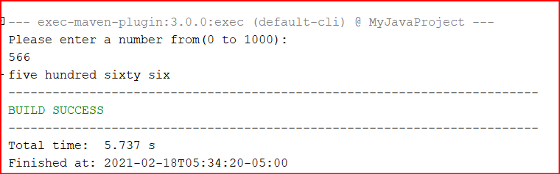

**Sample Output 2 –**

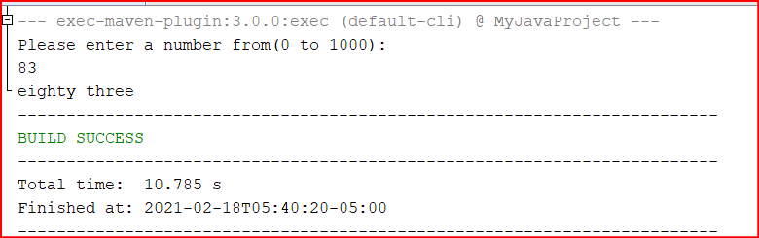

**Sample Output 3 –**

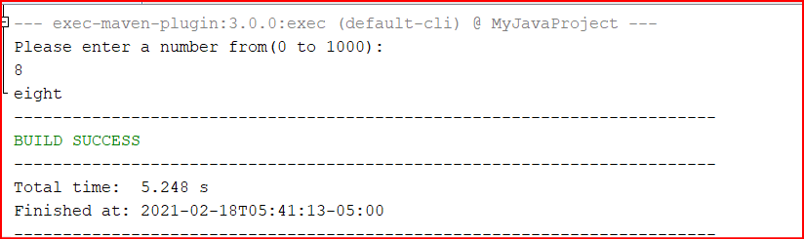

**Program 2 –**

**Code –**

/*

* To change this license header, choose License Headers in Project Properties.

* To change this template file, choose Tools | Templates

* and open the template in the editor.

*/

package com.mycompany.myjavaproject;

import java.util.Scanner;

/**

*

* @author sai

*/

public class RevPascalTriangle {

public static void main(String[] args) {

Scanner s = new Scanner(System.in);

System.out.println("Enter the number of rows");

int rows = s.nextInt();

int ncr = 1;

int i, j;

for (i = rows; i >= 0; i--) {

for (j = rows; j >= i; j--) {

System.out.print(" ");

}

for (j = 0; j <= i; j++) {

if (j == 0 || i == 0) {

ncr = 1;

} else {

ncr = ncr * (i - j + 1) / j;

}

System.out.printf("%4d \t", ncr);

}

System.out.println();

}

}

}

**Sample Output 1 –**

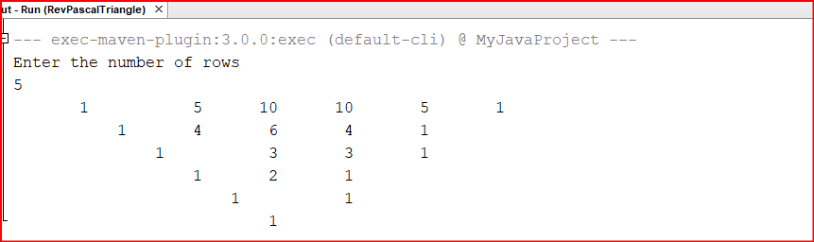

**Sample Output 2 –**

