**BATCH D 7**

**VEHICLE NUMBER PLATE DETECTION SYSTEM**

**OBJECTIVE:** This system will provide monitoring vehicles for law enforcement and security purposes, and keeping track of vehicles by successful recognition of plate number.

**FLOW CHART:**

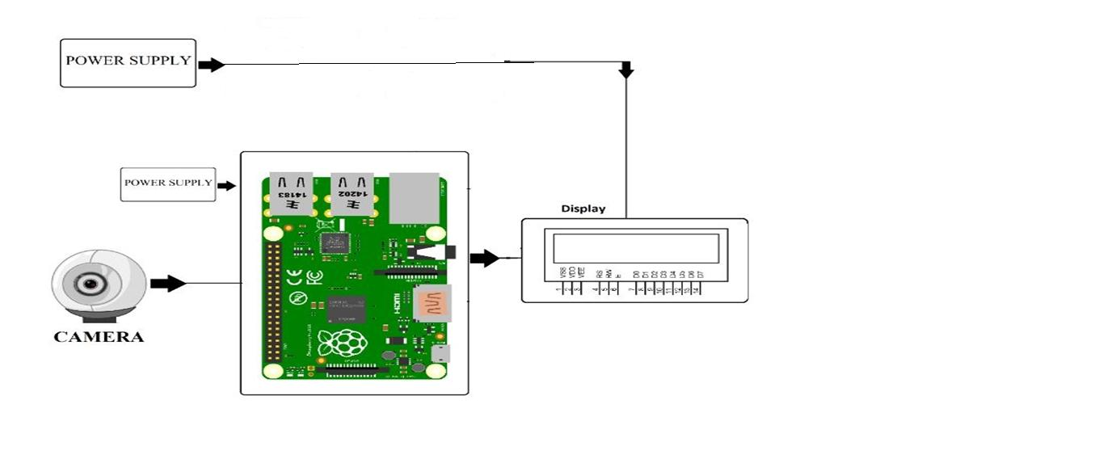

**METHODOLOGY:**

* Here we propose a Raspberry Pi based vehicle number plate recognition system that automatically recognizes vehicle number plates using image processing.
* The system uses a camera along with LCD display circuit interfaced to a Raspberry pi.
* The system constantly processes incoming camera footage to detect any trace of number plates.
* On sensing a number plate in front of the camera, it processes the camera input, extracts the number plate part from the image.
* Processes the extracted image using OCR and extracts the number plate number from it.
* The system then displays the extracted number on an LCD display.

**CHALLENGES:**

* Firstly, the images of the number plate or of any object which is taken by using the optical character reader technology may get blurred mainly due to the reason of motion blurring for which the picture seems to be hazy when uploaded in the database.
* Secondly, the technology often uses low-resolution images for which the images are not actually visible properly in every case.