**JAVA DATABASE UTILITY**

**Process Document**

Date Created: 20/04/2020

1. Execute below create scripts in respective database environments.



1. Execute or create below stored procedure in respective database environments.



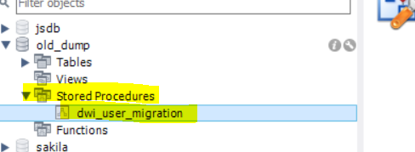

1. Create **mysql** folder in **C Drive** as shown below & copy below attached file.



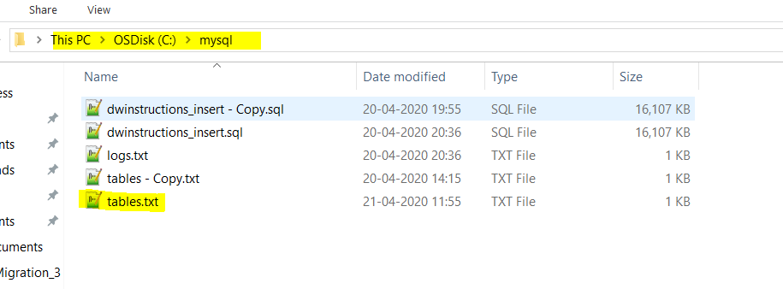

1. Once above 3 steps are completed, Run GenerateInsertScripts with database details as arguments as shown below,

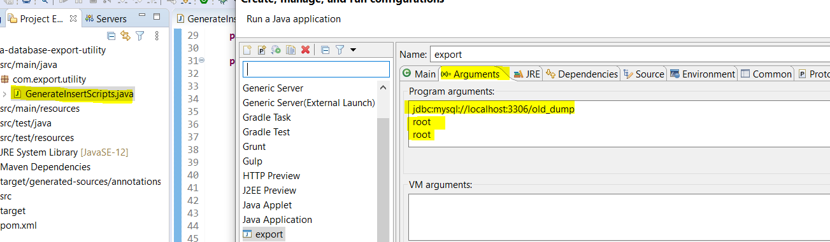

**Or**

Execute jar file with below commands

**Syntax:**

java -jar <<jar file>> <<db URL>> <<db Username>> <<db Password>>

**Example:**

java -jar java-database-export-utility-1.1.jar jdbc:mysql://localhost:3306/old_dump root root

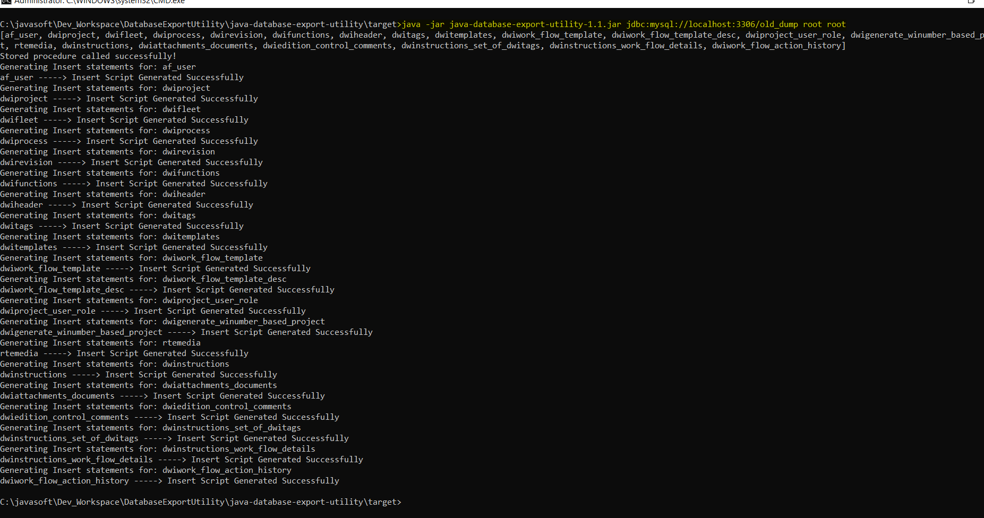

1. Once the job is done, you can find insert scripts sql file generated in “**C:\mysql**” directory.

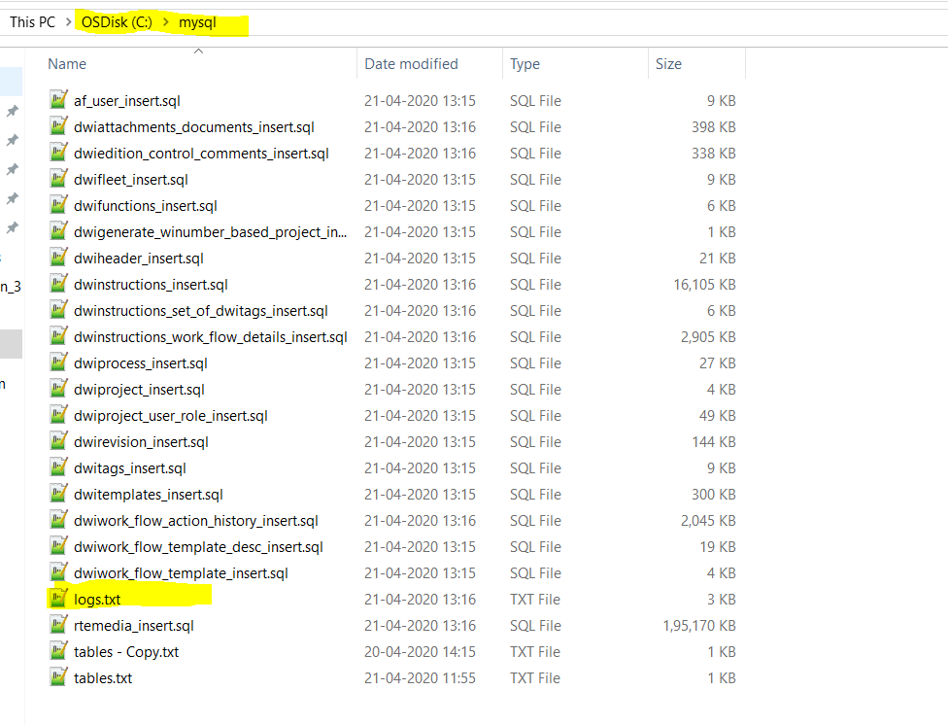

1. Export logs are stored in “**C:\mysql**” diretory

