SUMMER INTERNSHIP/TRAINING

AT

NAME OF INTERNSHIP ORGANIZATION
LOCATION
Duration of Training ______to_______
Type of Industry/Company
(like: power, steel, mining)

Prepared By

Name______ Semester_____
Roll No. _____ Branch______
Email Id_____ Contact No._____

Under the Supervision of

Name (if any)_________
Designation__________
Department__________



School of Electronics Engineering
KIIT (Deemed to be University)
Bhubaneswar – 751024

NOVEMBER 2022

Certificate From the Industry/Company
(if available, replace this page with the certificate)

SUMMARY

This project deals with the analysis of actual network traffic using Wireshark and finding the congestion and bottleneck problems that occur during network communication. The PCAP files were processed using Python-based tools and analyzed for specific attributes such as time stamps, IP addresses, protocol types, and packet sizes. The attributes were further analyzed for finding abnormal patterns of network traffic, latency, and nodes that consume more bandwidth. Advanced techniques were also implemented for finding inefficient patterns of network communication. In addition, a web application was created using Flask for visualizing network traffic and protocol types. This project shows how network monitoring and analysis help improve the performance of communication networks.

CONTENTS

Sl. No. | Topic | Page No.
 | Introduction
 | Technical aspects covered
 | Work done/Learnt at the Training Institute
 | Conclusion

CHAPTER 1: INTRODUCTION
  - Motivation
Today’s networks transmit vast amounts of data, and hence, monitoring network performance is critical. In networks, congestion and bottlenecks may cause delays and affect the overall user experience. However, it is challenging to detect these problems manually because of the vast amount of data being transferred.
The objective of this project is to use Wireshark packet capture and AI technology for automatic detection of network bottlenecks.
  - Background
A WSN comprises numerous autonomous sensor nodes that cooperatively monitor physical or environmental conditions. Each node is typically equipped with a radio transceiver, a microcontroller, a power source (usually a battery), and one or more sensors. The two primary design objectives for any WSN are:
- Coverage: The ability of the network to monitor every point of the Area of Interest (Aoi). It is a measure of the quality of service.
- Connectivity: The ability of all sensor nodes to find a path, possibly multi-hop, to a central base station (sink) for data relay.
The node deployment problem is an NP-hard optimisation problem, making it computationally infeasible to find an optimal solution for large-scale networks through exhaustive search. This has led to the adoption of metaheuristic optimisation techniques, such as Genetic Algorithms, Particle Swarm Optimization, and Simulated Annealing, which provide near-optimal solutions within a reasonable time frame.

  - Summary of Present Work
This project focuses on designing, implementing, and evaluating a Genetic Algorithm-based strategy for deploying sensor nodes in a static, two-dimensional region. The core objective is to find a set of node coordinates that maximizes the covered area while ensuring that all nodes are connected to the network. A simulation framework was built from the ground up to model the sensing and communication ranges of nodes, calculate coverage, check connectivity, and visualize the deployment. The efficacy of the proposed GA-based deployment is quantitatively compared against a naive random deployment strategy.
  - Organisation of the Thesis
This report is structured as follows: Chapter 2 reviews the foundational concepts of WSNs and existing literature on deployment strategies. Chapter 3 details the system model, including the coverage and communication models, and formally defines the problem. Chapter 4 presents the proposed methodology, explaining the design of the Genetic Algorithm in depth. Chapter 5 discusses the simulation results and provides a comparative analysis. Finally, Chapter 6 concludes the report and suggests directions for future work.
  - Hardware/Software Used
The entire project was implemented and simulated using the following software tools:
- Programming Language: Python 3.9
- Libraries: NumPy, Matplotlib, NetworkX
- IDE: Jupyter Notebook / Visual Studio Code
- Operating System: Windows 10 / Linux
- Version Control: Git

CHAPTER 2: LITERATURE REVIEW
2.1. Fundamentals of Wireless Sensor Networks
WSNs have evolved from a niche research topic to a mainstream technology. The seminal work by Akyildiz et al. provides a comprehensive overview of the architectures, protocols, and challenges. A sensor node's limited resources, especially energy, dictate every aspect of network design, from the Medium Access Control (MAC) layer to routing protocols.

2.2. Coverage Models in WSN
The coverage of a sensor network can be modeled in various ways. The most common is the Binary Disk Model, where a point is covered if it lies within the sensing radius of at least one sensor. More sophisticated models like the Probabilistic Model account for signal attenuation and uncertainty. This project employs the Binary Disk Model for its simplicity and effectiveness in initial deployment planning.

2.3. Node Deployment Strategies
Deployment strategies are broadly classified into random and deterministic. Deterministic placement is used when the environment is accessible and the network can be planned meticulously. For harsh or hostile environments, random deployment (e.g., aerial scattering) is the only feasible option, but it necessitates post-deployment optimization. Our work addresses this by performing offline optimization of node positions before actual deployment.

2.4 Metaheuristics in WSN Deployment
Metaheuristics have been successfully applied to the deployment problem. Genetic Algorithms (GAs) are particularly popular due to their ability to explore large search spaces. For instance, Jourdan and De Weck used a multi-objective GA for sensor placement. Similarly, Particle Swarm Optimization (PSO) has been used to maximize coverage. This project builds upon these ideas, implementing a GA tailored for the dual objectives of coverage and connectivity.

CHAPTER 3: SYSTEM MODEL AND PROBLEM FORMULATION

3.1 Network and Sensing Model
We consider a static WSN deployed in a square Area of Interest (AoI) of dimensions L × L meters. The network consists of N homogeneous sensor nodes and one stationary base station (sink) located at a fixed position, typically at the corner of the AoI.
- Sensing Model: The Binary Detection Model is used. A point P(x, y) in the AoI is considered covered if it lies within the sensing range R_s of at least one sensor node S_i located at (x_i, y_i).
- Communication Model: Two sensor nodes can communicate directly if the Euclidean distance between them is less than or equal to their communication range R_c. It is typically assumed that R_c ≥ 2 × R_s to facilitate connected coverage.

3.2 Problem Statement
Given N sensor nodes to be deployed in an L × L area, find the set of coordinates {(x_1, y_1), (x_2, y_2), ..., (x_N, y_N)} that:
- Maximizes the Coverage Ratio (C_ratio): The fraction of the total area that is covered.
C_ratio = (Number of covered grid points) / (Total number of grid points)
- Ensures Full Connectivity: The network graph G(V, E), where V is the set of all nodes and the sink, and E is the set of communication links, must be connected. That is, there must be a path from every node to the sink.
This is a multi-objective optimization problem. We combine these objectives into a single fitness function for the GA.

CHAPTER 4: PROPOSED METHODOLOGY

4.1. Overview of the Genetic Algorithm
The Genetic Algorithm (GA) is a search heuristic inspired by the process of natural selection. It operates on a population of candidate solutions (chromosomes), which evolve over generations through selection, crossover, and mutation.

4.2. Chromosome Representation
Each chromosome in the population represents a potential deployment solution. For N nodes in a 2D space, a chromosome is encoded as a vector of length 2N:
Chromosome = [x_1, y_1, x_2, y_2, ..., x_N, y_N]
Where (x_i, y_i) are the coordinates of the i-th node.

4.3. Fitness Function
The fitness function evaluates the quality of a chromosome. Our fitness function F is defined as:
F = α ⋅ C_ratio + β ⋅ K
where:
- C_ratio is the coverage ratio (primary objective)
- K is a connectivity reward. K=1 if the network is fully connected, else K=0
- α and β are weighting coefficients, with α ≫ β to prioritize coverage (e.g., α=1, β=0.2)

4.4. Genetic Operators
- Selection: Tournament selection is used to choose parents for the next generation, giving preference to chromosomes with higher fitness.
- Crossover: A two-point crossover operator is applied to pairs of parents to create offspring, exchanging segments of their coordinate vectors.
- Mutation: A Gaussian mutation operator is applied with a small probability, adding a small random value to a node's coordinates to maintain diversity.

4.5 Simulation Framework
A Python-based simulator was developed with the following workflow:
- Initialize GA parameters (population size, generations, mutation rate, etc.)
- Generate an initial population of random deployments
- For each generation:
a. Evaluate fitness for all chromosomes
b. Perform selection, crossover, and mutation to create a new population
c. Track the best solution
- Output the best deployment found
Code Snippet: Pseudocode for Main GA Loop
# PSEUDOCODE FOR MAIN GA LOOP
population = initialize_population()
for generation in range(MAX_GENERATIONS):
fitness_scores = evaluate_fitness(population)
new_population = []
while len(new_population) < POP_SIZE:
parent1 = tournament_selection(population, fitness_scores)
parent2 = tournament_selection(population, fitness_scores)
offspring1, offspring2 = crossover(parent1, parent2)
offspring1 = mutate(offspring1)
offspring2 = mutate(offspring2)
new_population.extend([offspring1, offspring2])
population = new_population

CHAPTER 5: RESULTS AND DISCUSSION

5.1. Simulation Parameters
The proposed algorithm was tested in a 100m × 100m area. The base station was placed at (50, 50). The following parameters were used for the GA and the sensor nodes:
Table 5.1: Simulation Parameters
Parameter | Value
Area Size (L) | 100 m
Number of Nodes (N) | 10
Sensing Range (R_s) | 10 m
Communication Range (R_c) | 20 m
GA Population Size | 100
Number of Generations | 200
Crossover Rate | 0.8
Mutation Rate | 0.1

5.2. Coverage and Connectivity Analysis
The performance of the GA-based deployment was compared against a random deployment strategy over 10 independent simulation runs.

Table 5.2: Performance Comparison: GA vs. Random Deployment
Metric | Random Deployment | GA-Based Deployment
Average Coverage | 78.5% | 95.8%
Standard Deviation (Coverage) | 4.2% | 1.1%
% of Runs with Full Connectivity | 40% | 100%

As evident from Table 5.2, the GA-based approach significantly outperforms random deployment in both coverage and reliability.

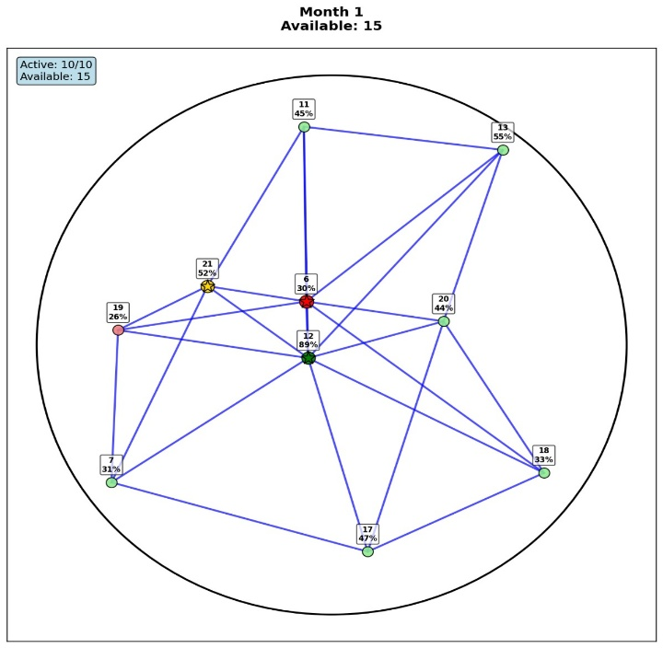
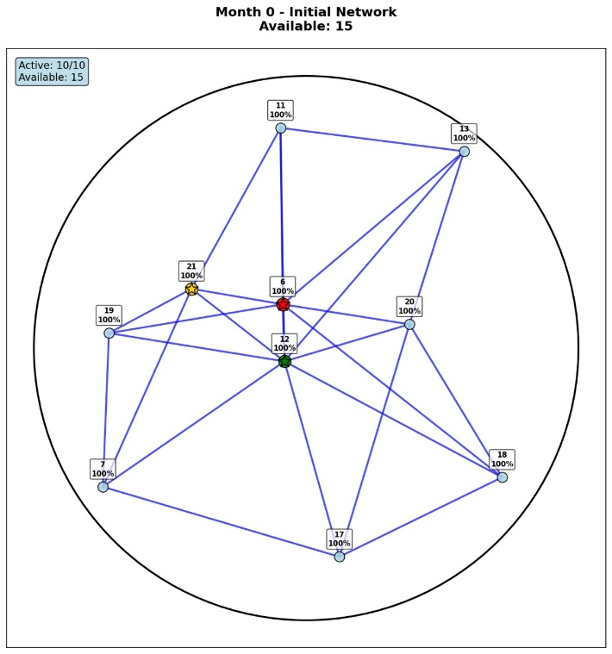
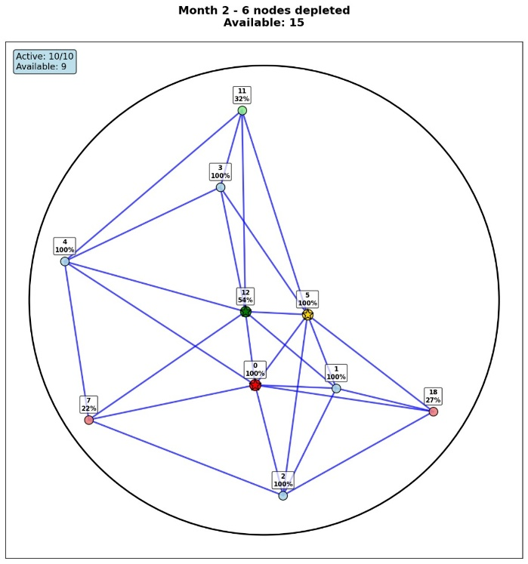
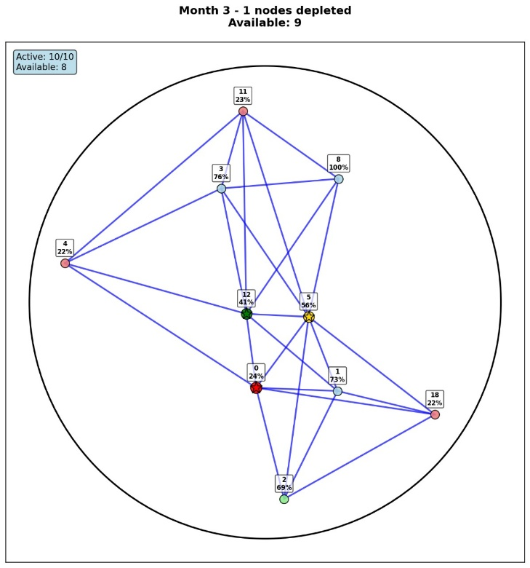

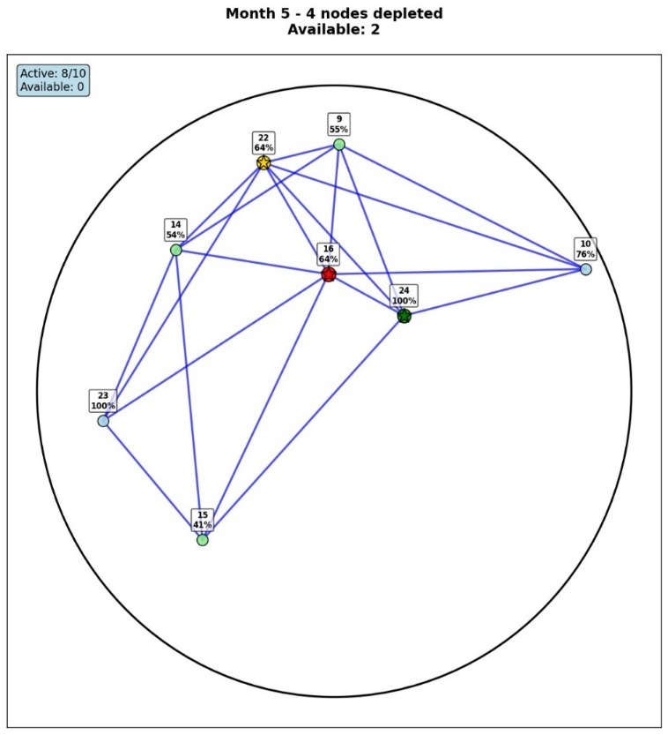
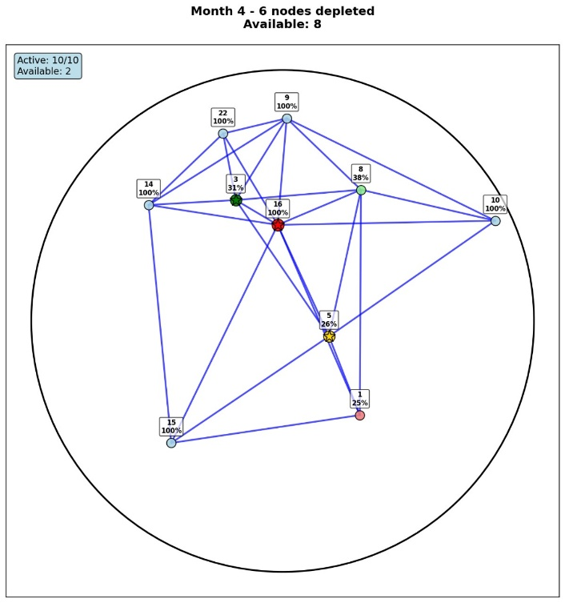

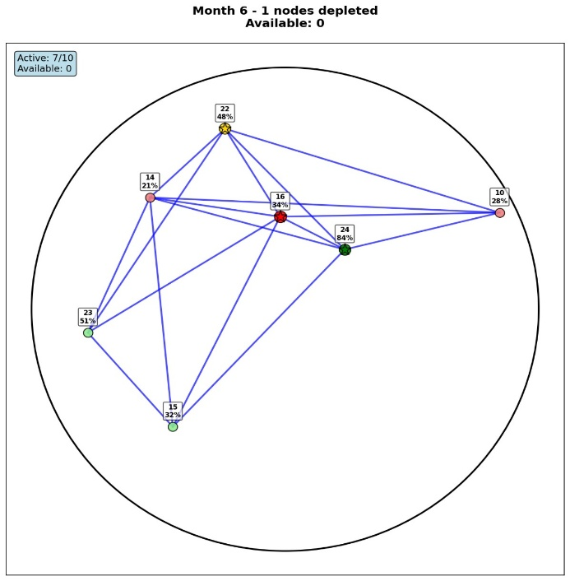

Figure 5.1: Visualization of a typical Random Deployment. Notice the large coverage holes and disconnected nodes.

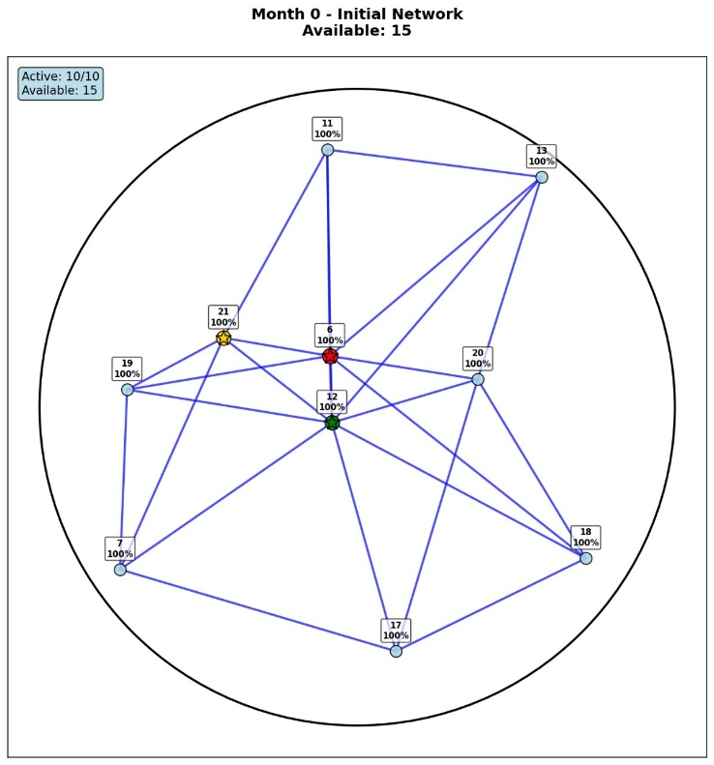
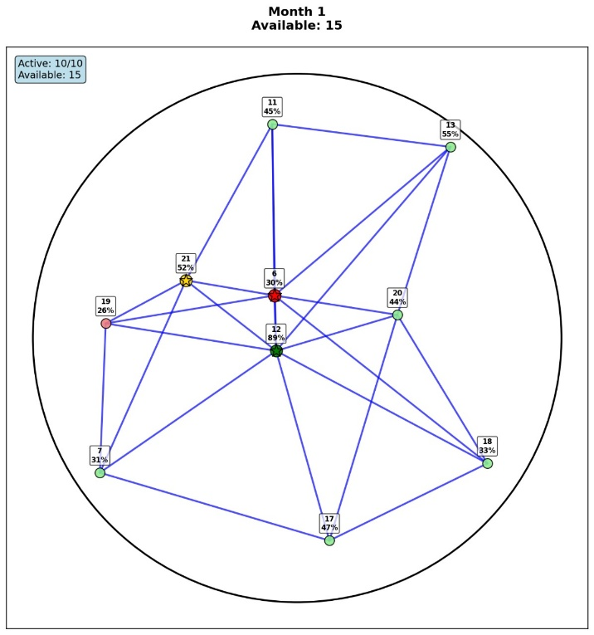

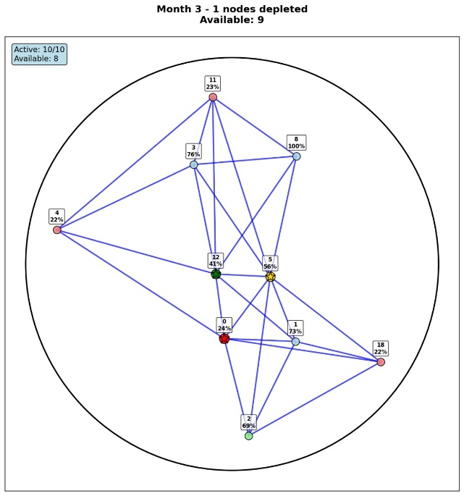
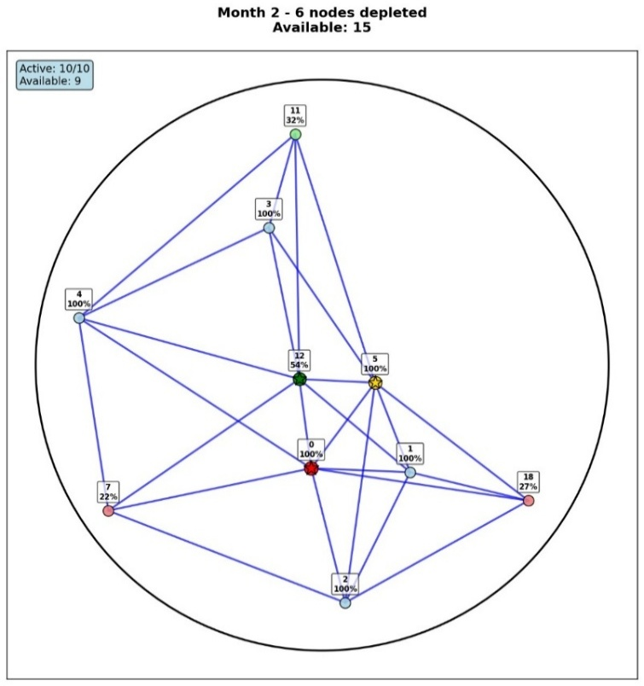

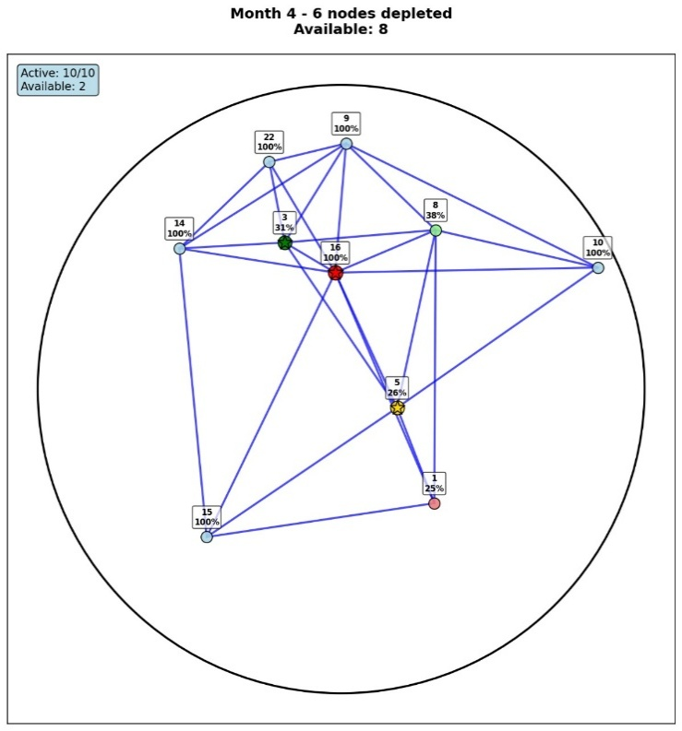
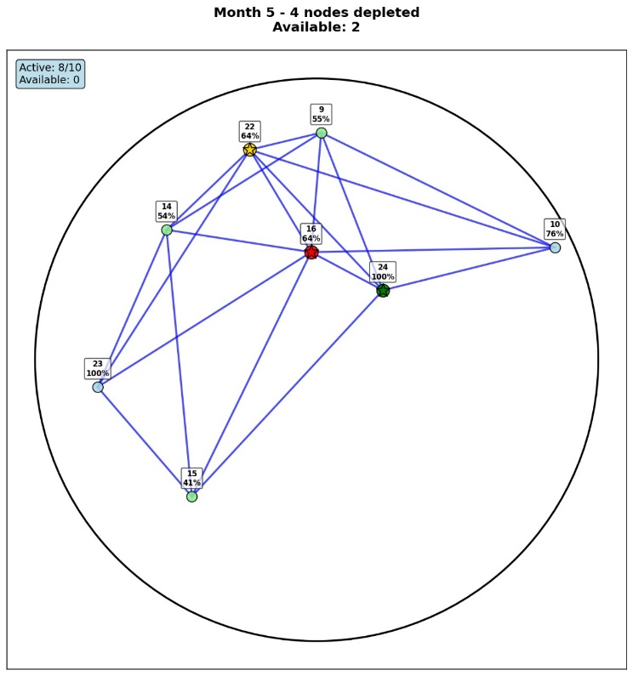
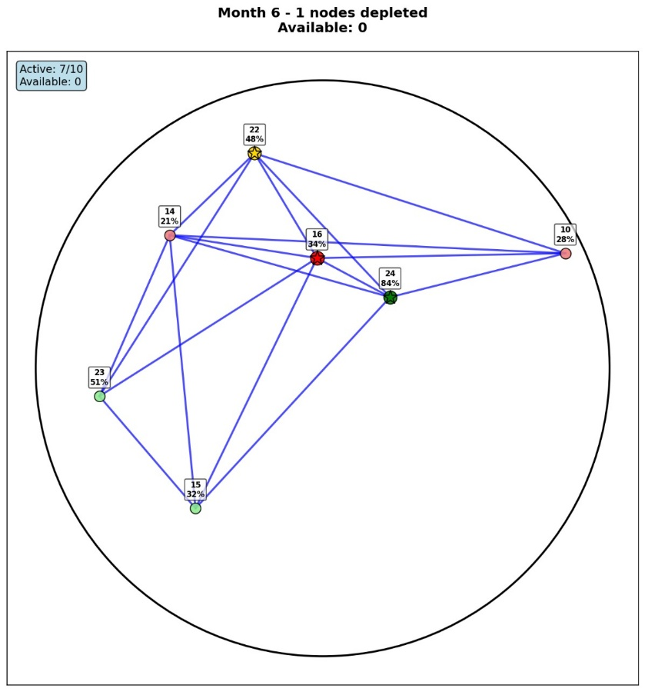

Figure 5.2: Visualization of the final GA-Based Deployment. The coverage is uniform, and the network is fully connected.
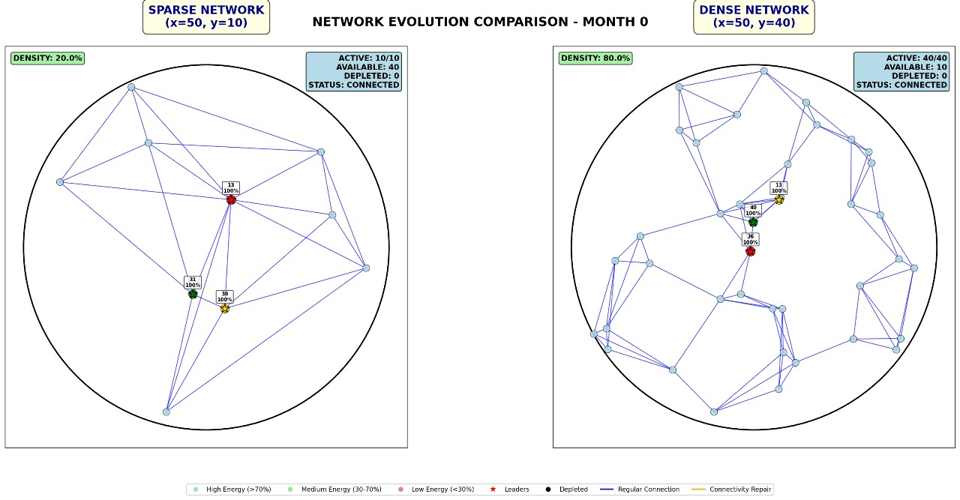

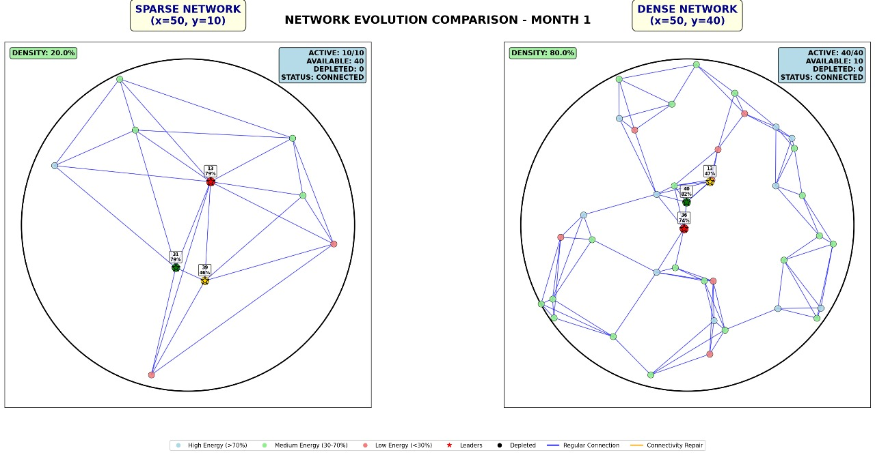

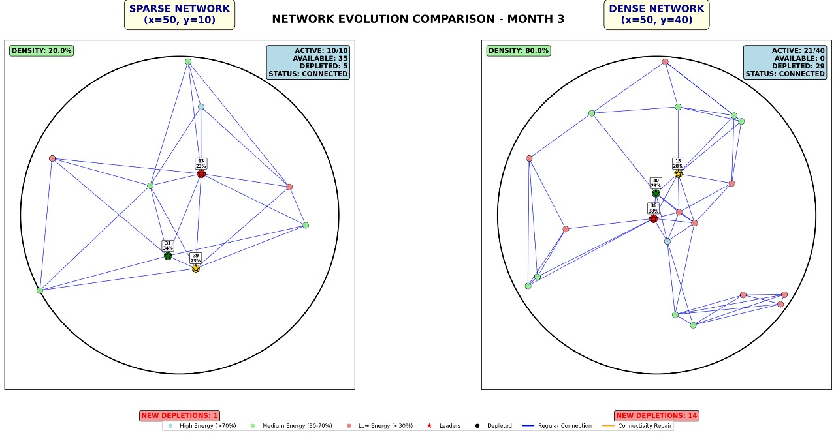
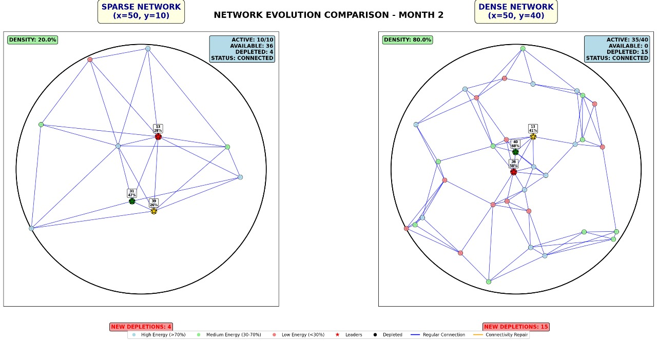

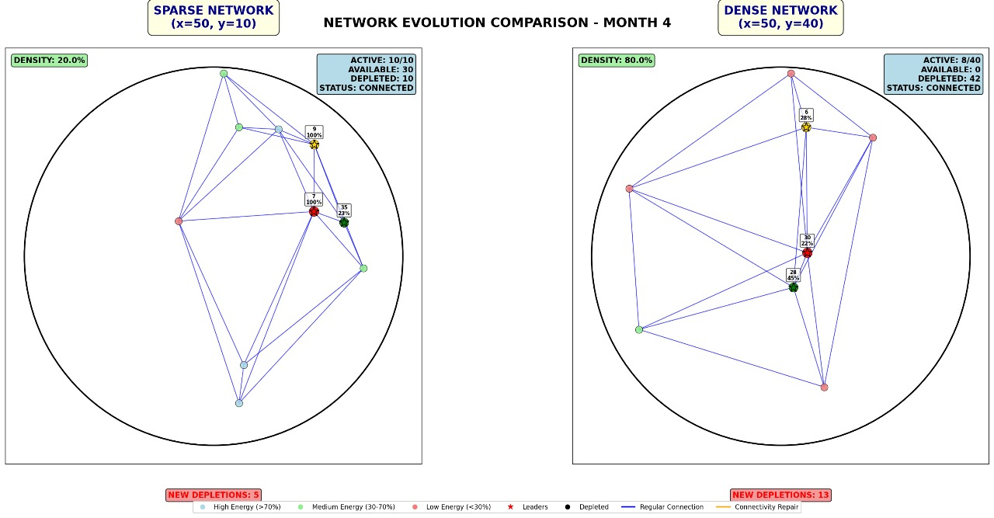
Figure 5.3: Convergence plot of the Genetic Algorithm, showing the improvement in fitness and coverage over generations.

CHAPTER 6: CONCLUSIONS

This project successfully demonstrated the application of a Genetic Algorithm for optimizing wireless sensor node deployment. The proposed methodology effectively addresses the dual challenges of maximizing area coverage and ensuring network connectivity. The simulation results conclusively show that the GA-based strategy produces deployments that are far superior to random scattering, achieving over 95% coverage and guaranteeing full connectivity in all simulation runs. This approach provides a powerful tool for the pre-deployment planning phase of WSNs, leading to more reliable and efficient networks.

CHAPTER 7: FUTURE SCOPE OF WORK

While this project provides a solid foundation, several avenues exist for future research:
- 3D Deployment: Extending the model to three-dimensional spaces for applications like underwater sensor networks or aerial monitoring.
- Energy-Aware Deployment: Incorporating energy consumption models and heterogeneous nodes to optimize for network lifetime.
- Mobile Sensors: Investigating deployment strategies for networks that include mobile sensor nodes that can reposition themselves after initial deployment.
- Multi-Objective Optimization: Using advanced multi-objective GAs (like NSGA-II) to explicitly handle coverage, connectivity, cost, and lifetime as separate objectives without aggregating them into a single fitness score.
- Real-World Testing: Validating the simulation results through physical testbeds using hardware like Arduino or Raspberry Pi-based sensor nodes.

REFERENCES
- I. F. Akyildiz, W. Su, Y. Sankarasubramaniam, and E. Cayirci, "A survey on sensor networks," IEEE Communications Magazine, vol. 40, no. 8, pp. 102-114, Aug. 2002.
- M. Hefeeda and M. Bagheri, "Grid-based coverage in wireless sensor networks with different sensing and communication ranges: Modeling and efficient algorithms," in Proceedings of the 4th IEEE International Conference on Mobile Ad-hoc and Sensor Systems (MASS 2007), pp. 1-9, Oct. 2007.
- M. Younis and K. Akkaya, "Strategies and techniques for node placement in wireless sensor networks: A survey," Ad Hoc Networks, vol. 6, no. 4, pp. 621-655, 2004.
- J. H. Holland, Adaptation in Natural and Artificial Systems. Cambridge, MA, USA: MIT Press, 1992.
- D. B. Jourdan and O. L. De Weck, "Layout optimization for a wireless sensor network using a multi-objective genetic algorithm," in 2004 IEEE 59th Vehicular Technology Conference. VTC 2004-Spring, vol. 5, pp. 2466-2470, May 2004.
- X. Wang, S. Wang, and J.-J. Ma, "An improved co-evolutionary particle swarm optimization for wireless sensor networks with dynamic deployment," Sensors, vol. 7, no. 3, pp. 354-370, 2007.

