- Introduction

Disasters such as earthquakes, floods, and storms pose significant threats to human life and property. Rapid urbanization and climate change have increased the frequency and impact of such events. The aim of this project is to build a centralized, AI-powered mobile application that helps predict disasters, issue timely alerts, and provide crucial emergency features to minimize loss and optimize response.

- Objectives

- Real-time disaster prediction using AI models.
- Location-based live alerts and risk assessments.
- Live map tracking with visual overlays.
- Emergency SOS signaling.
- A centralized mobile application built using React Native.

- System Architecture

The application follows a modular architecture:
- Frontend: React Native (Expo)
- Backend: Node.js with Express
- Database: Firebase Firestore
- ML Integration: Python-based models served via FastAPI

[Mobile App UI] <--> [Node.js Backend] <--> [Firebase + ML]

- Key Features

- Live Disaster Tracking
- AI-Based Predictions (Earthquake, Flood, Storm)
- Incoming Alerts with Region Detection
- SOS Emergency Signaling
- Settings for Personalization

- Module Descriptions

  - Home Screen

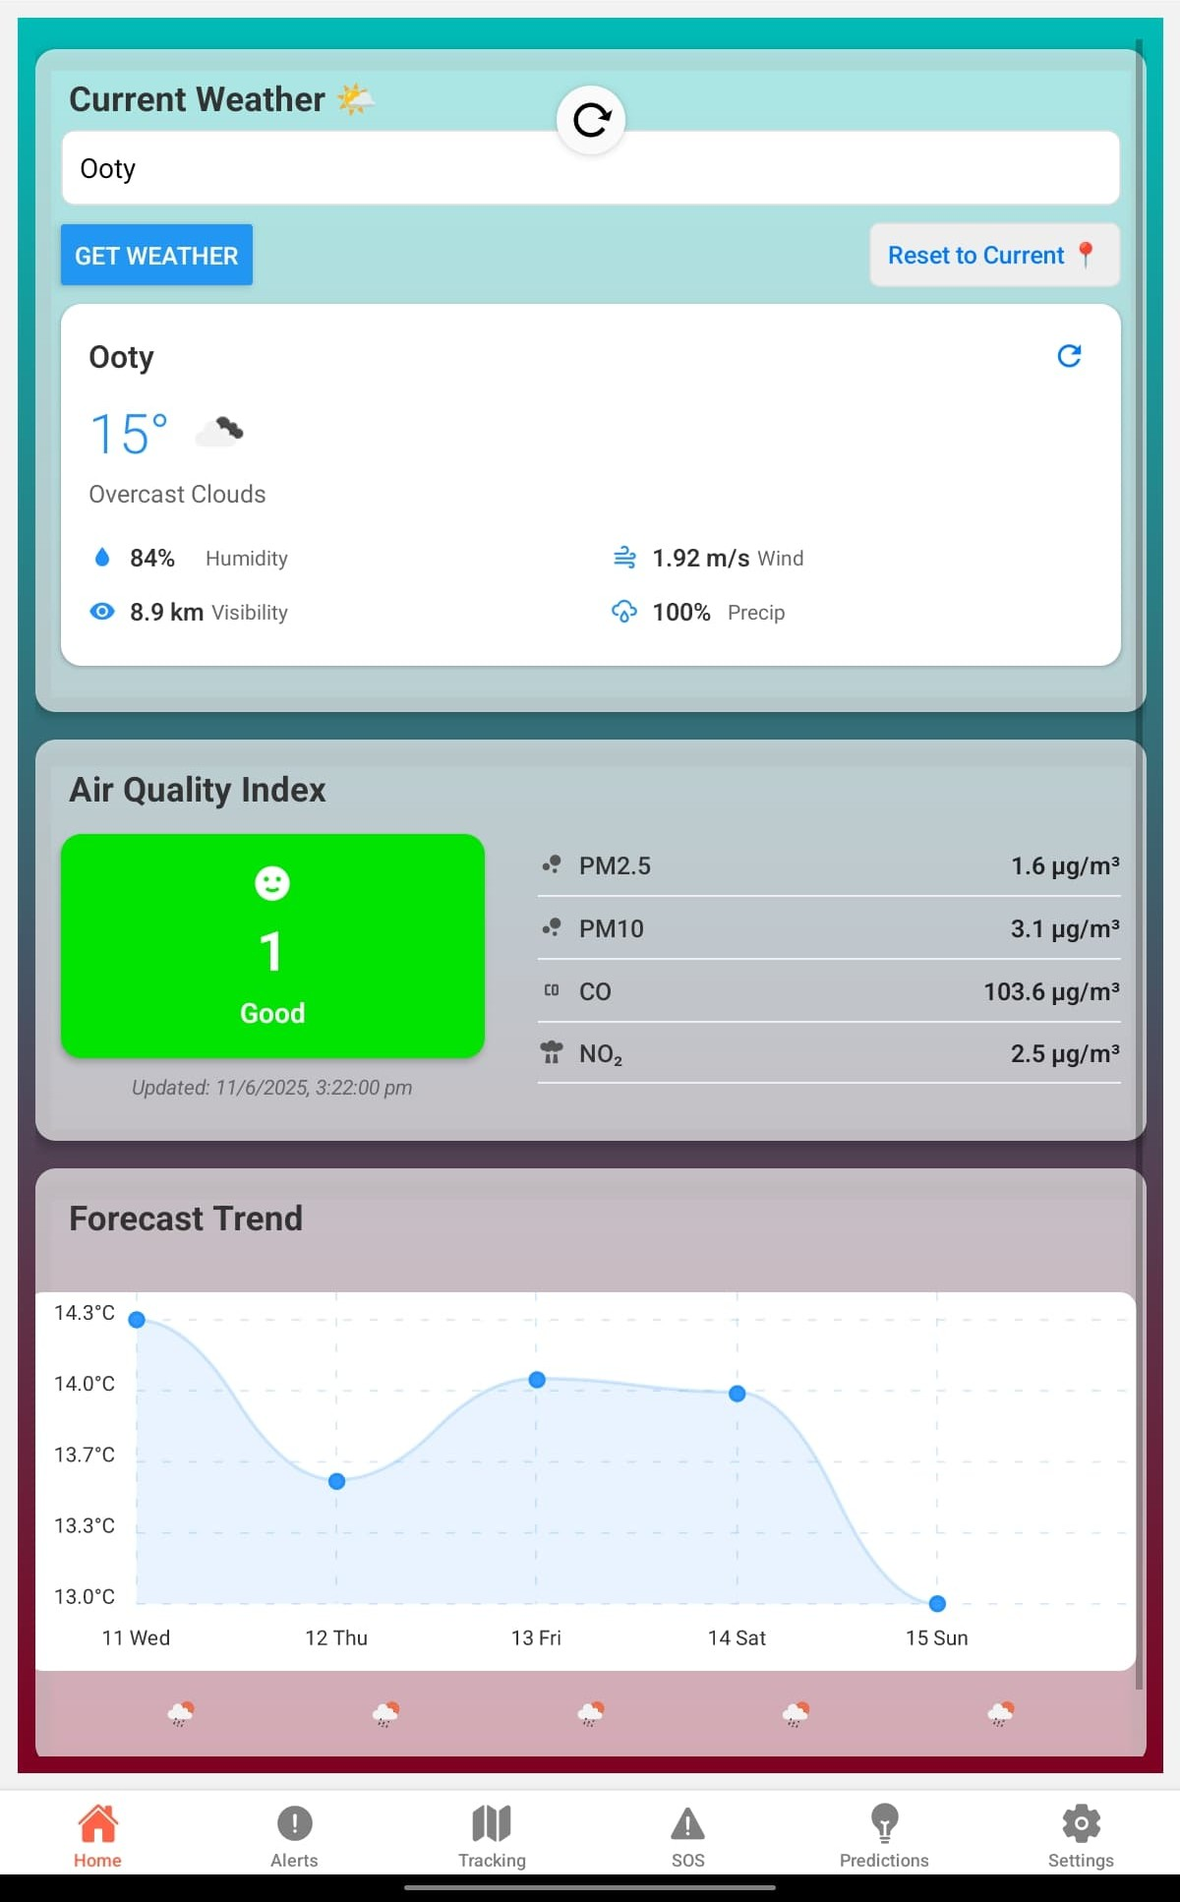

  - Earthquake Prediction

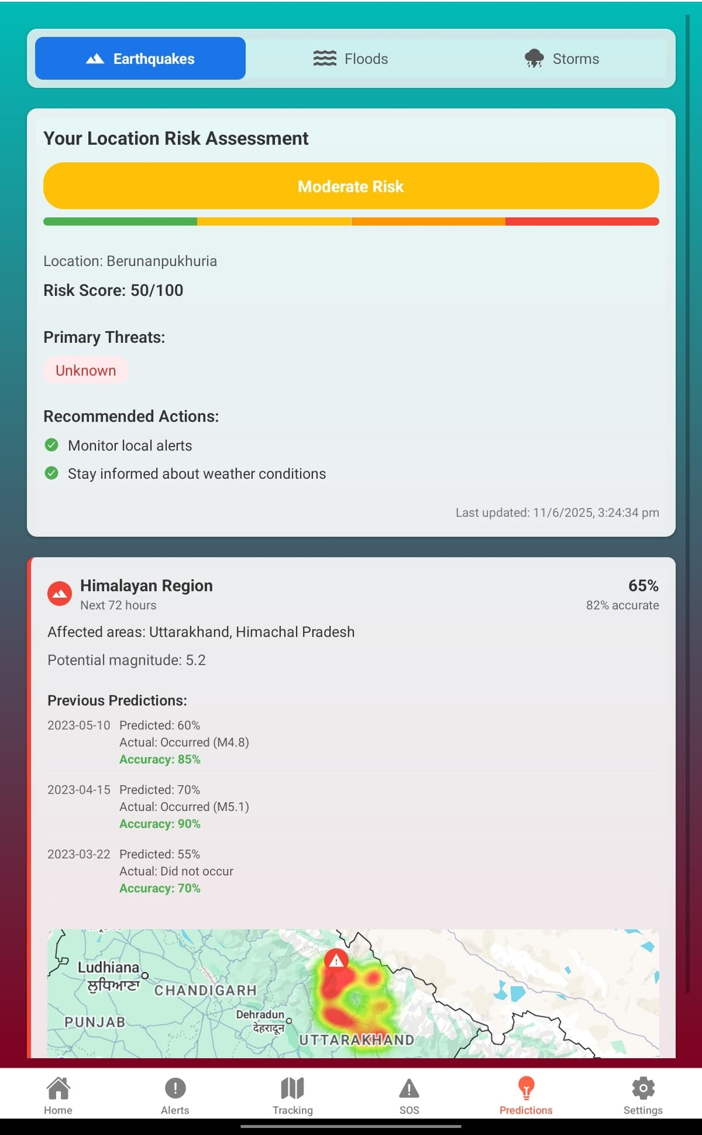

  - Flood Prediction

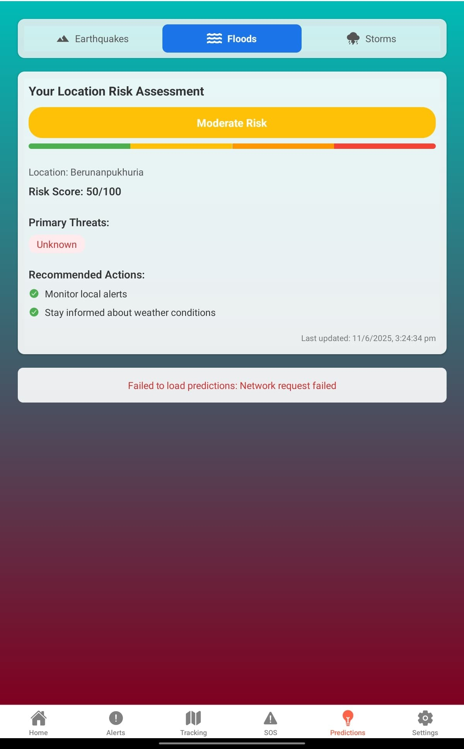

  - Storm Prediction

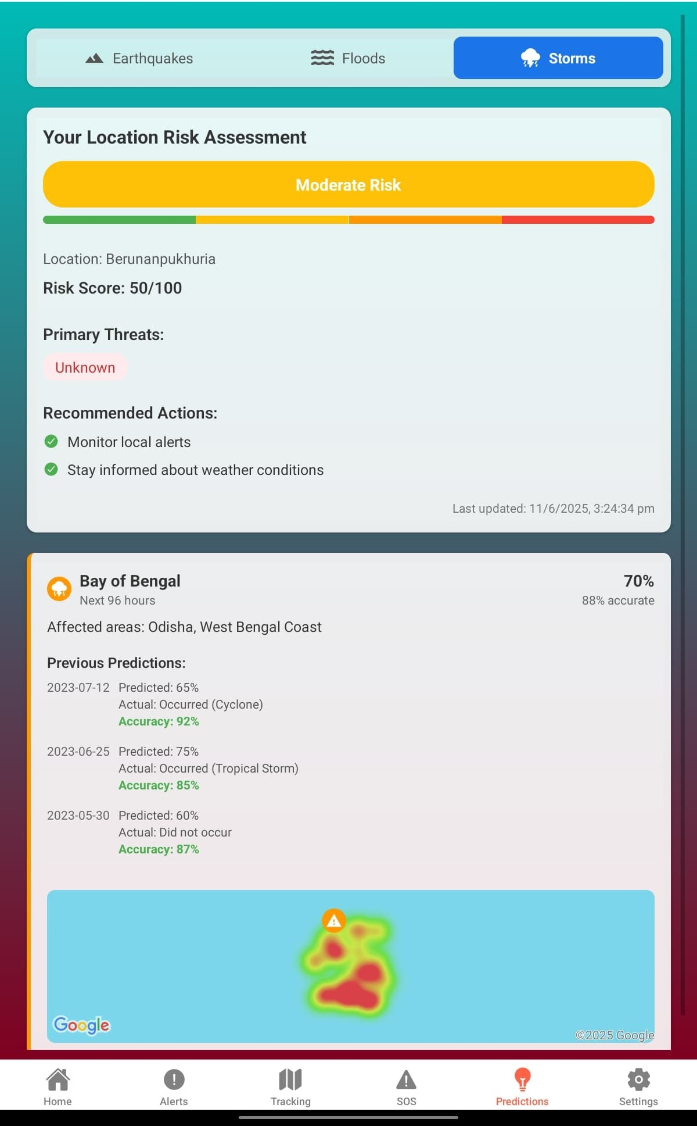

  - Tracking Screen

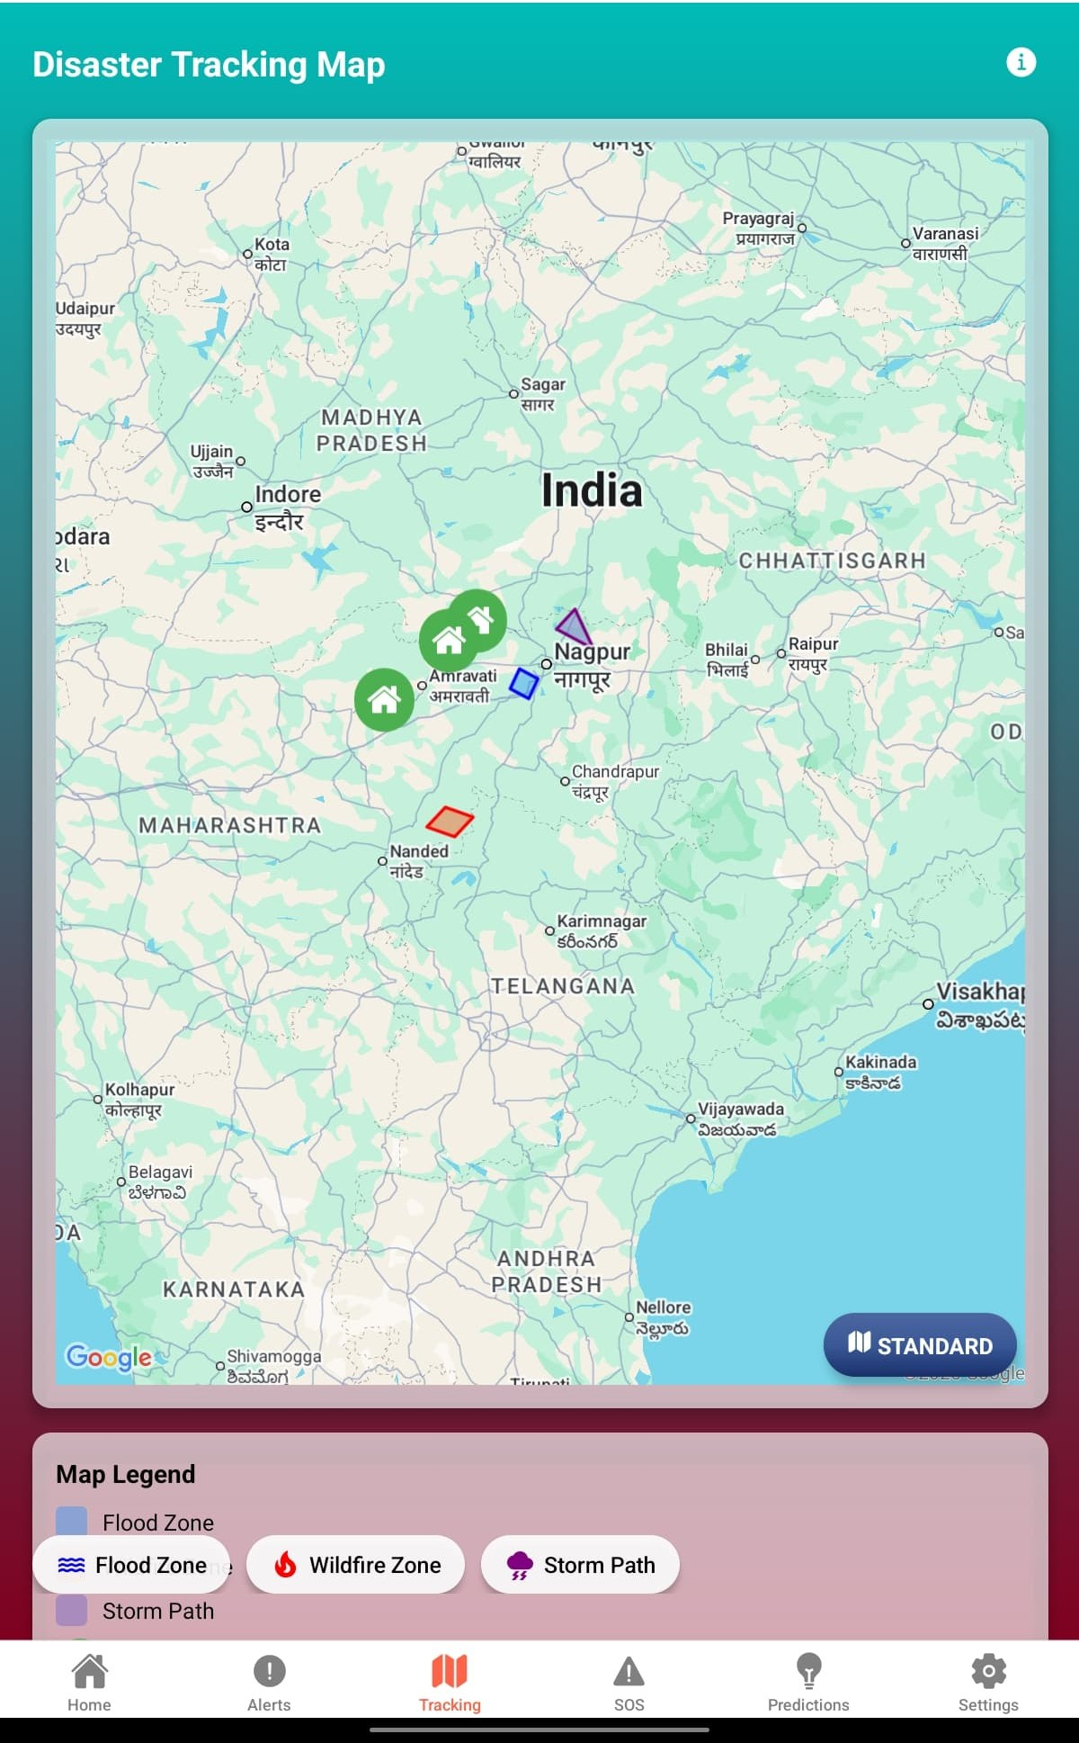

  - Incoming Alerts

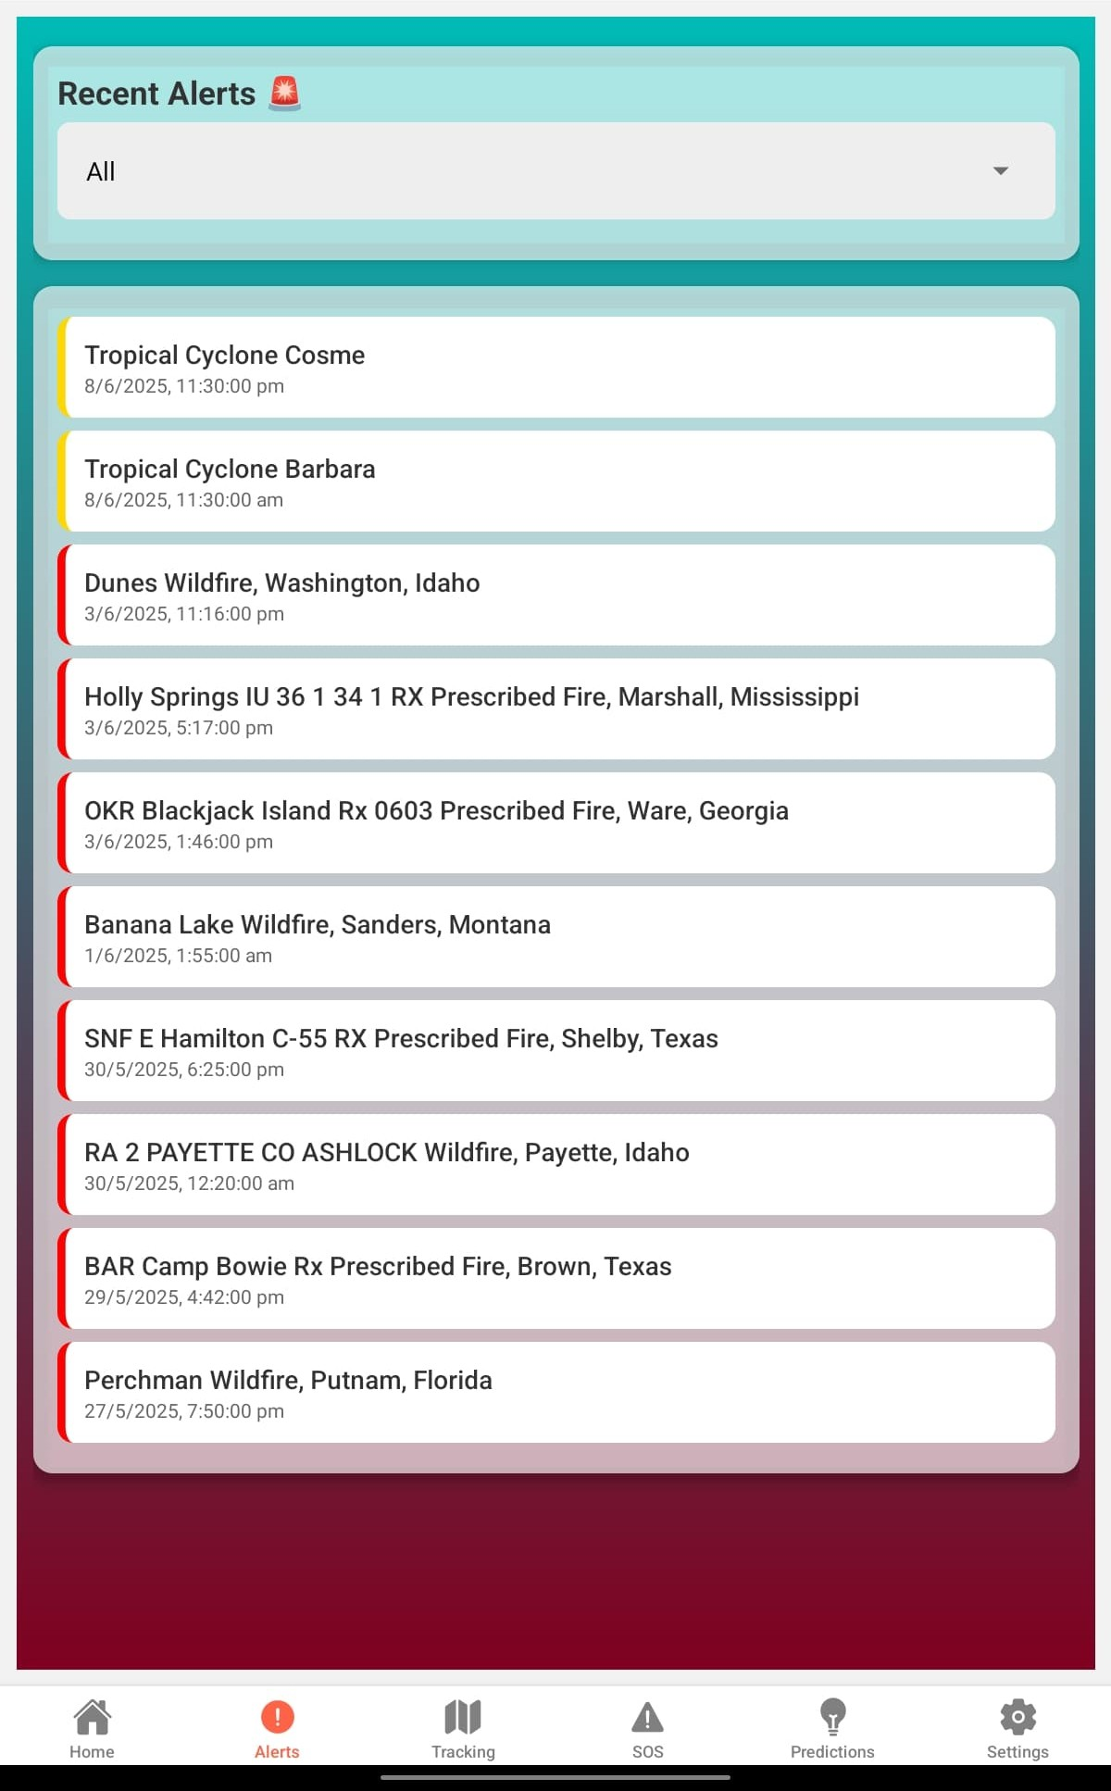

  - SOS Module

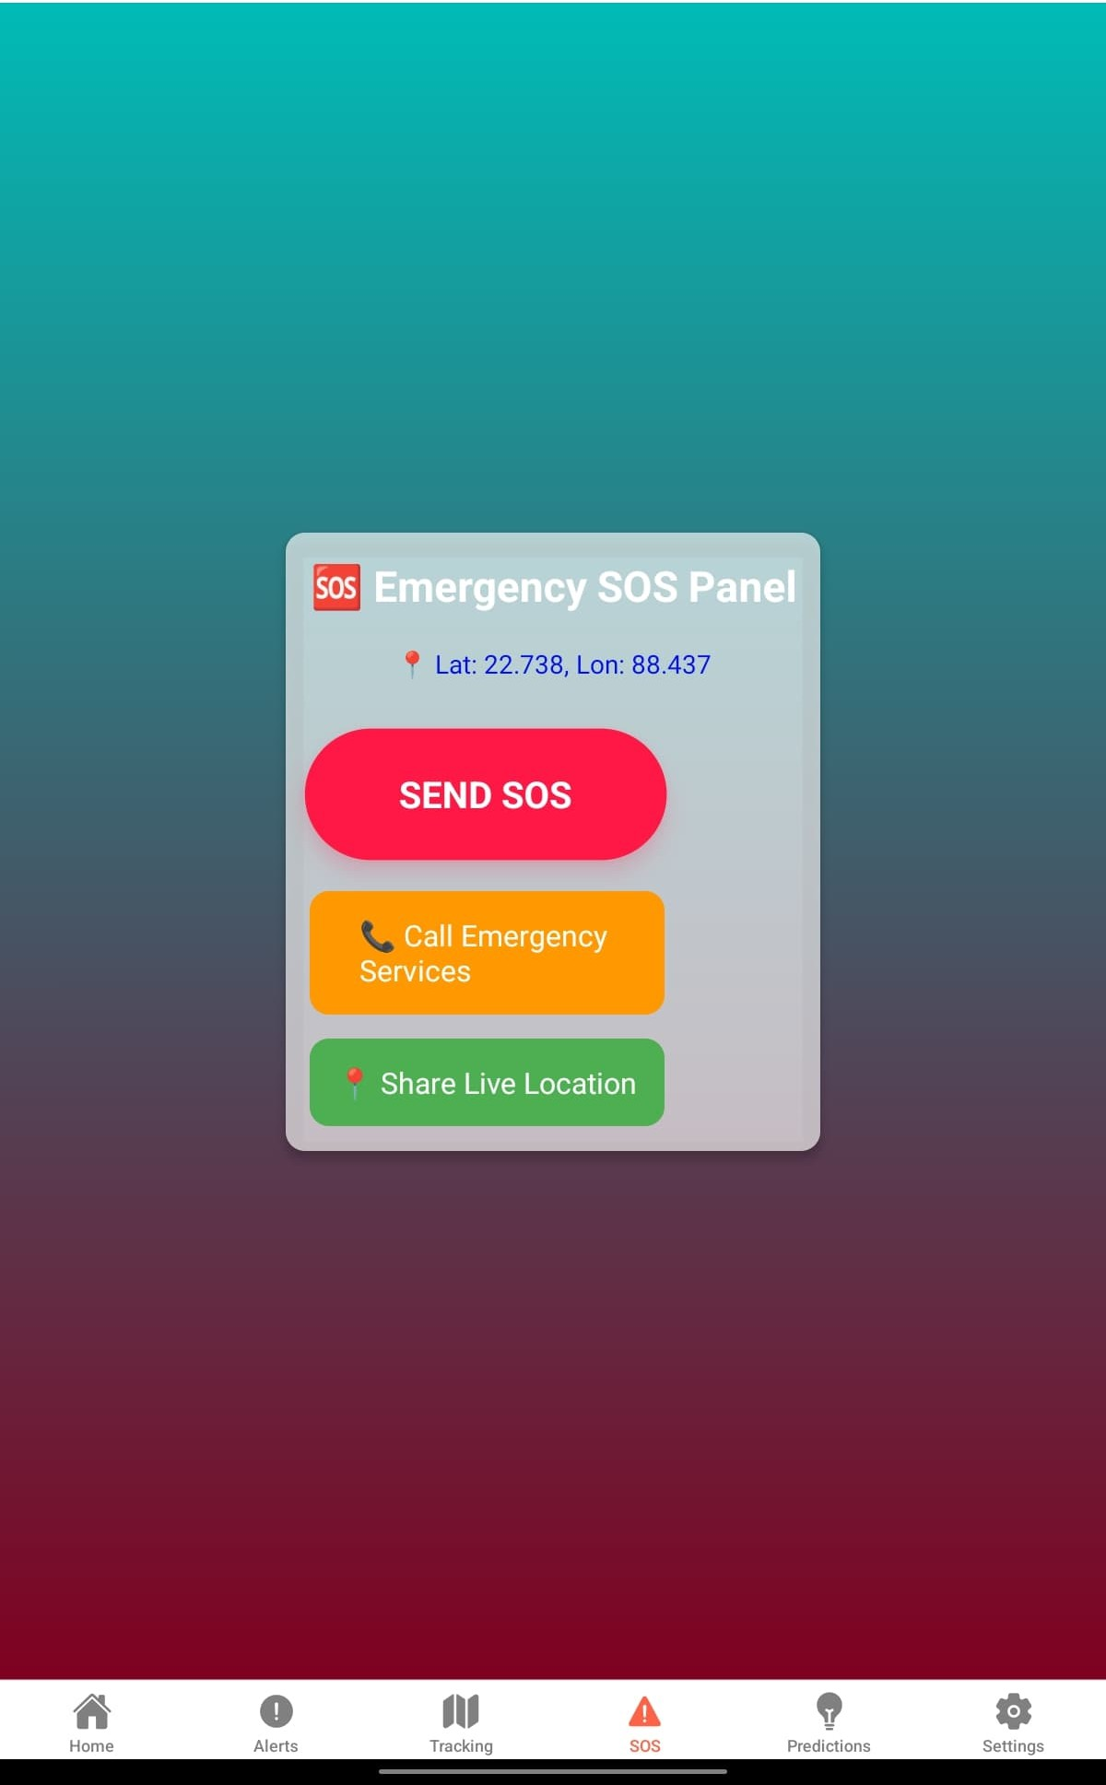

  - Settings Page

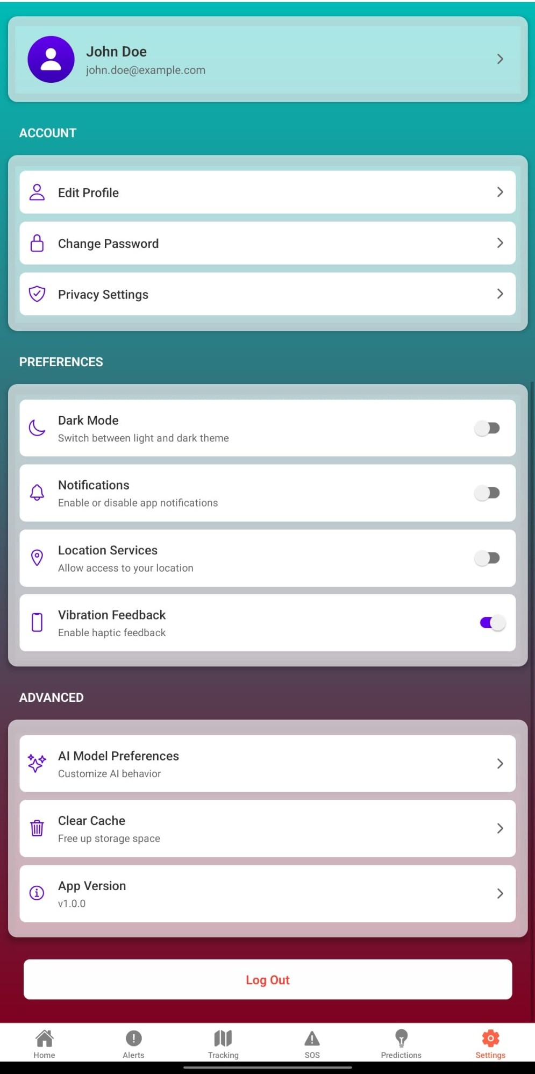

- Technology Stack

- Frontend: React Native (Expo, TypeScript)
- Navigation: React Navigation with Bottom Tabs
- Backend: Node.js with Express
- Database: Firebase Firestore
- Machine Learning: Python (TensorFlow, scikit-learn) served via FastAPI
- Bluetooth: react-native-bluetooth-classic
- Location: Expo Location API
- Maps: Google Maps SDK

- Backend and AI Integration

Each disaster type prediction is powered by a trained machine learning model that takes the latest meteorological and seismic data as input. The mobile app sends user location or manually entered region data to the FastAPI server, which returns prediction scores and risk levels.

Example API:
POST /predict_flood
{
"rainfall": 34,
"humidity": 80, "district": "Malda"
}

Response:
{
"prediction": "High Flood Risk"
}

- Challenges Faced

- Ensuring fast and lightweight performance for real-time mobile prediction.
- Handling location permissions and background services.
- Accurate disaster prediction with minimal false positives.
- Managing Firebase security rules and session management.
- APK crash resolution due to Expo-native bridge limitations (post EAS build).

- Future Enhancements

- Integration of multilingual support.
- Offline map caching and alert storage.
- Auto-notification for nearby shelters.
- ML model improvement with larger datasets.
- SMS-based fallback alerts in no-internet zones.

- Conclusion

This project serves as a proactive solution to disaster management by combining AI, geolocation, and mobile technology. It simplifies alert dissemination, enhances preparedness, and can significantly reduce disaster impact through timely predictions.

