

American International University-Bangladesh (AIUB)  
Department of Computer Science  
Faculty of Science &Technology (FST)  
Spring 2020-2021

Section: A  
Software Quality and Testing

**<Find Nearby Doctor>**

A Report submitted

By

|  |  |  |
| --- | --- | --- |
| SN | Student Name | Student ID |
| 1 | Saikat Baul | 18-36193-1 |
| 2 | Sumaiya Rahman Eva | 18-36531-1 |
| 3 | Sakimul Karim Adan | 18-36622-1 |
| 4 | Nujat Tasnim | 18-37490-1 |

Under the supervision of

Abhijit Bhowmik

Associate Professor

Faculty of Science & Technology

American International University-Bangladesh

Software Test Plan

for

< Find Nearby Doctor >

Version 1.0 approved

Prepared by < Saikat Baul, Sumaiya Rahman Eva, Sakimul Karim, and Nujat Tasnim >

< American International University-Bangladesh >

<29/04/2021>

Table of Contents

Revision History 4

1. Test Plan Identifier: FND01.3 4

2. References 4

3. Introduction 4

3.1 Background to the Problem 4

3.2 Solution to the Problem 4

3.2.1 Available solution 4

3.2.2 Our Solution 5

4. Requirement Specification 5

4.1 System Features 5

4.1.1 Users 5

4.1.2 Features 5

4.2 System Quality Attributes 6

4.3 System Interface 6

4.4 Project Requirements 8

4.4.1 Effort Estimation 8

4.4.2 Time Estimation 8

4.4.3 Cost Estimation 8

4.4.4 Budget 9

5. Features not to be Tested 9

6. Testing Approach 9

6.1 Testing Levels 9

6.2 Test Tools 10

6.3 Meetings 10

7. Test Cases/Test Items 10

8. Item Pass/Fail Criteria 16

9. TEST DELIVERABLES 16

10. Staffing and Training Needs 16

11. Responsibilities 17

12. Testing Schedule 17

12.1 Work Breakdown Structure 17

12.2 Schedule 18

13. Planning Risks and Contingencies 18

14. Approvals 19

# 

# Revision History

|  |  |  |  |
| --- | --- | --- | --- |
| Revision | Date | Updated by | Update Comments |
| 0.1 | 2021.04.17 | Nujat Tasnim | First Draft |
| 0.2 | 2021.04.19 | Sumaiya Rahman Eva | Second Draft |
| 0.3 | 2021.04.20 | Saikat Baul | Third Draft |
| 0.4 | 2021.04.17 | Sakimul Karim Adan | Fifth Draft |
| 0.5 | 2021.04.19 | Saikat Baul | Sixth Draft |
| 0.6 | 2021.04.20 | Sakimul Karim Adan | Last Draft |
|  |  |  |  |
|  |  |  |  |

# Test Plan Identifier: FND01.3

# References

* Project Plan
* Test plan template IEEE-829
* Requirement's specifications Document

# Introduction

## Background to the Problem

Finding a good qualified and reliable Doctor for such a patient who is new in his area is an exceedingly difficult & hassling task. Sometimes people move from one place to another place and it becomes a hassling task for them to find a specialized doctor nearby. Moreover, which doctor is specialized in which department, how to get their appointments in time, doctor’s visit details- these things become difficult for a patient.

## Solution to the Problem

### Available solution

* Find doctors manually.
* Find doctor’s chamber and book appointment manually.
* Pay visiting fees manually.

### Our Solution

* We will build a platform where user/patient can search specialized doctors according to disease and patient’s nearby location. This software will solve the above mentioned problem where patients need to find doctors manually. Doctors and patients- both sides will be benefited as it will save their time and make their work easier and more efficient.
* In our proposed solution patient can make a choice among the doctor’s list according to chamber location and visiting fees. Patients can search specialized doctors according to disease and patient’s nearby location. They can book appointment through online (mobile app/website). They can also pay visiting fees through online.
* There is no such existing software solution with above mentioned features where a patient who doesn’t know in his/her area which doctor is specialized and how to get appointment timely. So we will work as a media here between patients and doctors to get or give service, find doctors in the patient’s location.

# Requirement Specification

## System Features

### Users

* Doctors
* Patient
* Admin

### Features

* Users can login in the system.
* Admin can create, retrieve, update, and delete in the system.
* Admin can track location to see the doctor’s updates.
* Admin can create accounts for doctors and patient.
* Patient/user can search doctors list according to their disease and nearby location, book appointment, can pay visiting fees and give ratings according to service.
* Doctors can fix their visiting hour, visiting fees, can check appointment list, chamber location and can receive payment.

**Priority Level:** High

**Precondition:** user have valid user id and password

## System Quality Attributes

* **Reliability:** Measure if the software is reliable enough to sustain in any condition. Should give consistently correct results. Software reliability is measured in terms of working of the project under different working environments and different conditions.
* **Maintainability**: Different versions of the software should be easy to maintain. For development it should be easy to add code to the existing system, and should be easy to upgrade for new features and modern technologies from time to time. Maintenance should be cost-effective and easy. The system is easy to maintain and correcting defects or making a change in the software.
* **Usability:** This can be measured in terms of ease of use. The application should be user-friendly. Should be easy to learn. Navigation should be simple. The system must be: Easy to use for input preparation, operation, and interpretation of the output. Provide consistent user interface standards or conventions with our other frequently used systems. Easy for new or infrequent users to learn to use the system.
* **Portability:** This can be measured in terms of Costing issues related to porting, technical issues related to porting, Behavioral issues related to porting.
* **Correctness:** The application should be correct in terms of its functionality, calculations used internally and the navigation should be correct. This means the application should adhere to functional requirements.
* **Efficiency:** Major system quality attribute. Measured in terms of time required to complete any task given to the system. If the system is not efficient then it cannot be used in real-time applications.
* **Integrity or Security:** Integrity comes with security. System integrity or security should be sufficient to prevent unauthorized access to system functions, preventing information loss, ensure that the software is protected from virus infection, and protecting the privacy of data entered the system.
* **Testability:** The system should be easy to test and find defects. If required it should be easy to divide into different modules for testing.
* **Flexibility:** Should be flexible enough to modify. Adaptable to other products with which it needs interaction. Should be easy to interface with other standard 3rd party components.
* **Reusability:** Software reuse is a good cost-efficient and time-saving development way. Different code libraries classes should be generic enough to use easily in different application modules. Dividing application into different modules so that modules can be reused across the application.

Applying above quality attributes standards we can determine whether the system meets the requirements of quality or not.

## System Interface

In this system a patient can search nearby doctors. He/she needs to login to the system first. The system will verify the login. If login is wrong the system will display login error. To search a doctor, patient must input by location and department. The system will highlight the doctor list according to their search in a priority order according to doctor's location distance, rating, fees. The patient can select any doctor for consulting from the list. Patient can rate doctor services and pay the bill after the booking. He/she can pay the bill in two ways, using bkash or using card. The patient can also view his/her booking history. Doctor also have to login before using this system. Doctor can update chamber location, modify consulting time, update fees and request to cancel the appointment if necessary. The doctor can also view the patient book list. Admin can verify any doctor or patient account. Admin can also ban/delete any account if necessary. Admin will also approve the cancellation of appointment request if any doctor request.

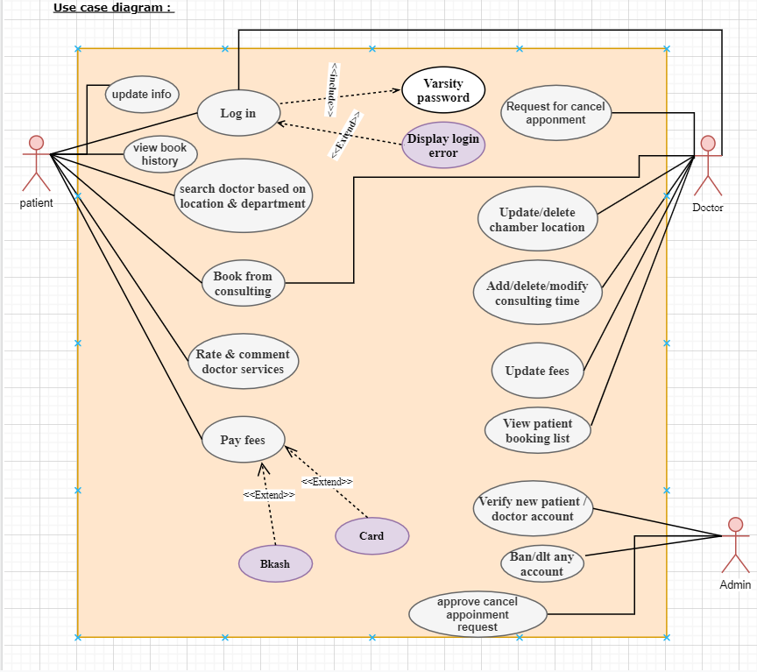

Figure : Use Case Diagram

## Project Requirements

### Effort Estimation

Effort allocation using 40-20-40 rule:

* “Front end” activities (40-50%)
* Construction activities (15-20%)
* Testing and installation (30-40%)

### Time Estimation

In our project we used COCOMO model. COCOMO is one of the most generally used software estimation models in the world. COCOMO predicts the efforts and schedule of a software product based on the size of the software.

As our software project is an organic software project so,

Coefficient = 2.4

Project complexity(P) = 1.05

SLOC dependent coefficient(T) = 0.38

Source lines or code (SLOC) = 9000

Effort = PM = Coefficient < Effort Factor > * (SLOC/1000) ^P

=2.4*(9000/1000) ^1.05

=24.11

Development time = DM = 2.50*(PM)^T

=2.50*(24.11) ^0.38

= 8.38

Required number of people = ST

= PM/DM

=24.11/8.74

=2.9

≅ 3

Here,

* PM: person-months needed for project (labor working hours).
* DM: duration time in months for project (week days).
* ST: average staffing necessary.

### Cost Estimation

From time estimation we can assume we need 4.5 months to complete this software development.

Resource cost (per month) = ৳ 70,000

Employee’s Salary (per month) = ৳ 1,10,000

Testing and maintenance = ৳ 30,000

Total cost in 4.5 months = (৳ 70,000 + ৳ 1,10,000 + ৳ 30,000) * 4.5 = ৳ 9,45,000

### Budget

Total budget = Total cost in 4.5 months+ profit

= 9,45,000 + 2,00,000

= ৳ 1,145,000

# Features not to be Tested

The list of all the features that are not planned for testing will be listed out.

Example:

* Out of scope features.
* Minimal risk features.
* Future functionality.
* Specific the reason these features will not be tested.
* Not to include these features for software release time.

# Testing Approach

## Testing Levels

The testing for finding nearby doctor project will consist of Unit, Integration, System and Acceptance test levels. It is hoped that there will be at least one full time independent test person for system and integration testing. However, with the budget constraints and time line established, most testing will be done by the test manager with the development team’s participation.

UNIT Testing will be done by the developers (programmers) and will be approved by the development team leader. Proof of unit testing (test case list, sample output, data printouts, defect information) must be provided by the programmer to the team leader before unit testing will be accepted and passed on to the test person. All unit test information will also be provided to the test person. Tools will be used for unit testing.

INTEGRATION Testing will be performed by developers (programmers) or by the independent test engineer. Gray box testing technique will be used for testing more than one component of the program or a subprogram. Gray box testing basically combination of Black and White box testing. However, if any defect arises during the integration testing, it will be forwarded to the developers (programmers) directly for debugging. There may be scope for non-informal meeting called walkthrough between dedicated test engineer and the programmer about defects.

SYSTEM Testing will be totally done by dedicated test engineer with the supervision of development team leader and test manager (Test Lead). System testing will follow White Box testing. Here the whole integrated program will be checked. System will be given some input and the test engineer will check the output. If the system is able to deliver the expected output then it will be considered as passed. If test engineer accepts all major component as correct then the test lead will declare the system to be ready for the next formal testing which is Acceptance testing.

ACCEPTANCE Testing will be performed by the actual end users with the assistance of the test manager and development team leader. Programs will enter into Acceptance test after all critical and major defects have been corrected. A program may have one major defect as long as it does not impede testing of the program (I.E. there is a work around for the error). Prior to final completion of acceptance testing all open critical and major defects MUST be corrected and verified by the Customer test representative.

## Test Tools

For the testing the system we have used tools listed below:

* **Tessy** for automated testing
* **Load Ninja** for load testing
* **WebLoad** for load testing of the website
* **PICT** ( Pairwise Independent Combinatorial Testing) for test case generation
* **CPPUnit** for unit testing.

## Meetings

The test team will meet once every two weeks to evaluate progress to date and to identify error trends and problems as early as possible. The test team leader will meet with development and the project manager once every two weeks as well. These two meetings will be scheduled on different weeks. Additional meetings can be called as required for emergency situations.

# Test Cases/Test Items

|  |  |  |  |  |  |
| --- | --- | --- | --- | --- | --- |
| **Project Name:** Find Nearby Doctor | | | **Test Designed by:** Nujat Tasnim | | |
| **Test Case ID:** FR_1 | | | **Test Designed date:** 21.04.2021 | | |
| **Test Priority (Low, Medium, High):** High | | | **Test Executed by:** Sumaiya Rahman Eva | | |
| **Module Name:** Sign up session | | | **Test Execution date:** 22.04.2021 | | |
| **Test Title:** Sign up successfully with username and password | | | | | |
| **Description:** Test the website signup page. | | | | | |
| **Precondition:** user must enter a password of at least 8 characters.  **Dependencies:** None | | | | | |
| **Test Steps** | **Test Data** | **Expected Results** | | **Actual Results** | **Status (Pass/Fail)** |
| **1.**Go to signup page  **2.** Click Sign up  **3.** Enter username & password  **4.**Click Submit button | Username: Nujat11  Password: 1234 | User should successfully sign up into the application. | | As Expected, | Pass |
| **Post Condition:** User is successfully signed up into the website. Details of the user are stored into the database. | | | | | |

|  |  |  |  |  |  |
| --- | --- | --- | --- | --- | --- |
| **Project Name:** Find Nearby Doctor | | | **Test Designed by:** Nujat Tasnim | | |
| **Test Case ID:** FR_4 | | | **Test Designed date:** 21.04.2021 | | |
| **Test Priority (Low, Medium, High):** High | | | **Test Executed by:** Sumaiya Rahman Eva | | |
| **Module Name:** Account confirmation | | | **Test Execution date:** 22.04.2021 | | |
| **Test Title:** Admin confirming users successfully | | | | | |
| **Description:** test if the admin can successfully confirm users and upload their information into the database. | | | | | |
| **Precondition:** users will fill up every required information before doing registration.  **Dependencies:** None | | | | | |
| **Test Steps** | **Test Data** | **Expected Results** | | **Actual Results** | **Status (Pass/Fail)** |
| **1.**Go to admin’s account  **2.**View registration request  **3.**Click confirm button  **4.**Check database |  | User should be confirmed and user’s information should be inserted into the database | | As Expected, | Pass |
| **Post Condition:** Admin will check if the user is already registered or not. If not registered than information will insert into database, if already registered there will be a mail sent to the user. | | | | | |

|  |  |  |  |  |  |
| --- | --- | --- | --- | --- | --- |
| **Project Name:** Find Nearby Doctor | | | **Test Designed by:**  Nujat Tasnim | | |
| **Test Case ID:** FR_5 | | | **Test Designed date:** 21.04.2021 | | |
| **Test Priority (Low, Medium, High):** High | | | **Test Executed by:** Sakimul Karim Adan | | |
| **Module Name:**  Login Session | | | **Test Execution date:** 22.04.2021 | | |
| **Test Title:**  verify login with valid username and password | | | | | |
| **Description:**  Test website login page | | | | | |
| **Precondition:**  User must have valid username and password  **Dependencies:** None | | | | | |
| **Test Steps** | **Test Data** | **Expected Results** | | **Actual Results** | **Status (Pass/Fail)** |
| **1.** Go to the website  **2.** Enter username  **3.** Enter password  **4.** Click submit | Username: Nujat11  Password: 1234 | User should login into the application | | As Expected, | Pass |
| **Post Condition:**  User is validated with database and successfully login to account. The account session details are logged in the database. | | | | | |

|  |  |  |  |  |  |
| --- | --- | --- | --- | --- | --- |
| **Project Name:** Find Nearby Doctor | | | **Test Designed by:** Nujat Tasnim | | |
| **Test Case ID:** FR_7 | | | **Test Designed date:** 21.04.2021 | | |
| **Test Priority (Low, Medium, High):** High | | | **Test Executed by:** Sakimul Karim Adan | | |
| **Module Name:** Create accounts | | | **Test Execution date:** 22.04.2021 | | |
| **Test Title:** Create accounts for doctors and patients. | | | | | |
| **Description:**  test if the admin can create accounts for doctors and patients. | | | | | |
| **Precondition:**  User must have sign up first with valid user name and password.  **Dependencies:** None | | | | | |
| **Test Steps** | **Test Data** | **Expected Results** | | **Actual Results** | **Status (Pass/Fail)** |
| **1.** Go to create account  **2.** Edit the particular text fields,  **3.** Click the create button. | Username: Nujat11  Email: [st@gmail.com](mailto:st@gmail.com)  Address: 12/1 Dhaka. | Admin should create account into the application | | As Expected, | Pass |
| **Post Condition:**  Account is created successfully by admin. The account details are saved into the database. | | | | | |

|  |  |  |  |  |  |
| --- | --- | --- | --- | --- | --- |
| **Project Name:** Find Nearby Doctor | | | **Test Designed by:** Nujat Tasnim | | |
| **Test Case ID:** FR_10 | | | **Test Designed date:** 21.04.2021 | | |
| **Test Priority (Low, Medium, High):** High | | | **Test Executed by:** Saikat Baul | | |
| **Module Name:**  update information | | | **Test Execution date:** 22.04.2021 | | |
| **Test Title:** edit or change information as per wish. | | | | | |
| **Description:**  test if the user can change any information in order to update his/her profile. | | | | | |
| **Precondition:**  An existing user has to enter his/her current password correctly.  **Dependencies:** None | | | | | |
| **Test Steps** | **Test Data** | **Expected Results** | | **Actual Results** | **Status (Pass/Fail)** |
| **1.** Go to update profile,  **2.** Edit the particular text fields,  **3.** Click the update button. | Name: Sadia  Email: [st@gmail.com](mailto:st@gmail.com)  Address: 12/1 Dhaka.  Current Password: 1234  New Password: 12345 | User information updated successfully. | | As Expected, | Pass |
| **Post Condition:**  Confirmation messages will be displayed before performing any update operation. | | | | | |

|  |  |  |  |  |  |
| --- | --- | --- | --- | --- | --- |
| **Project Name:** Find Nearby Doctor | | | **Test Designed by:** Nujat Tasnim | | |
| **Test Case ID:** FR_12 | | | **Test Designed date:** 21.04.2021 | | |
| **Test Priority (Low, Medium, High):** High | | | **Test Executed by:** Saikat Baul | | |
| **Module Name:**  update information | | | **Test Execution date:** 22.04.2021 | | |
| **Test Title:** update chamber location, modify consulting time, update fees and request to cancel the appointment | | | | | |
| **Description:**  test if the doctor can modify his account. | | | | | |
| **Precondition:** Doctor must have account with valid user name and password.  **Dependencies:** None | | | | | |
| **Test Steps** | **Test Data** | **Expected Results** | | **Actual Results** | **Status (Pass/Fail)** |
| **1.** Go to update profile,  **2.** Edit the particular text fields,  **3.** Click the update button. | Username: Dr. Salma Khatun  Email: [salma@gmail.com](mailto:salma@gmail.com)  Address: 15/1 Dhaka.  Time: 5:00pm-9:00pm | Doctor information updated successfully. | | As Expected, | Pass |
| **Post Condition:**  Confirmation messages will be displayed before performing any update operation. | | | | | |

|  |  |  |  |  |  |
| --- | --- | --- | --- | --- | --- |
| **Project Name:** Find Nearby Doctor | | | **Test Designed by:** Nujat Tasnim | | |
| **Test Case ID:** FR_14 | | | **Test Designed date:** 21.04.2021 | | |
| **Test Priority (Low, Medium, High):** High | | | **Test Executed by:** Saikat Baul | | |
| **Module Name:** search operation | | | **Test Execution date:** 22.04.2021 | | |
| **Test Title:** proper outcome of search operation. | | | | | |
| **Description:** Verify that filtering works correctly on the search result page. | | | | | |
| **Precondition:**  a user should enter queries in the search box.  **Dependencies:** None | | | | | |
| **Test Steps** | **Test Data** | **Expected Results** | | **Actual Results** | **Status (Pass/Fail)** |
| 1.Go to home page,  2.Enter category,  3.Click search button. | Doctor Name: Dr. Salma Khatun  Category: Cardiologist | Show Doctors that belong to mentioned category correctly. | | As Expected, | Pass |
| **Post Condition:** Search result will be unavailable if doctor not found under the given category. | | | | | |

# Item Pass/Fail Criteria

If the system is built according to the customer’s requirements, has minimum number of defects in all execution environment and at the same time delivered within budget and time then then the system will pass and the project will be a success. Moreover, if 97% - 98% of the test cases are passed during tasting period then a software can be acknowledged as passed. Most importantly if the customers are satisfied with the delivered product, it will also determine that the system is passed. Other than that, system will be treated as fail system.

The test process will be completed once it is ensured all the features and functionality are correctly implemented and working perfectly and providing accurate results.

# TEST DELIVERABLES

* Acceptance test plan
* System/Integration test plan
* Unit test plans/turnover documentation
* Screen prototypes
* Report mock-ups
* Defect/Incident reports and summaries
* Test logs and turnover reports

# Staffing and Training Needs

There will be at least one (1) full time tester assigned to the project for the system, integration and acceptance testing phases of the project. This will require assignment of a person part time at the beginning of the project to participate in reviews etc. and approximately 12 months into the project they would be assigned full time. If a separate test person is not available the test manager will assume this role.

In order to provide complete and proper testing the following area(s) need to be addressed in terms of training.

1. At least one developer and test team member needs to be trained.

# Responsibilities

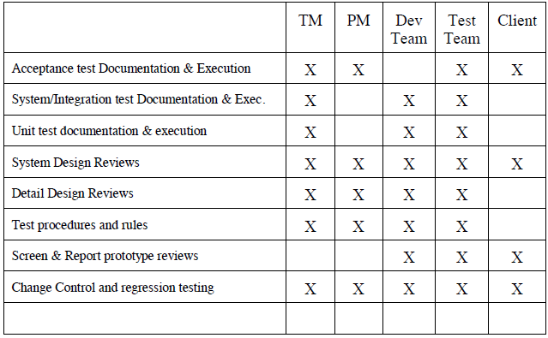

# Testing Schedule

Work Breakdown Structure and Scheduling are given below for the project.

## Work Breakdown Structure

|  |  |  |  |
| --- | --- | --- | --- |
| **Action** | **Task Name** | **Duration** | **Predecessors** |
| A | Develop Business case | 1 Week | - |
| B | Assign Project Manager | 1 Week | A |
| C | Develop Project Charter | 1 Week | B |
| D | Perform Primary Planning | 2 Week | B |
| E | Perform Support Planning | 2 Week | B |
| F | Develop Performance Plan | 2 Week | B |
| G | Assign Developers | 1 Week | B |
| H | Manage Procurements | 1 Week | G |
| I | Track and Manage Risks | 1 Week | G |
| J | Website Prototype Design | 2 Week | G |
| K | Landing Page | 1 Week | G |
| L | User Registration/Login/User type | 1 Week | G |
| M | Question Function | 2 Week | G |
| N | User Profile | 1 Week | G |
| O | Team profile | 1 Week | G |
| P | Team Room | 2 Week | G |
| Q | Design and Create Other Pages | 2 Week | P |
| R | Manage Changes | 3 Week | P |
| S | Test the system | 2 Week | P |
| T | Documentation Closeout | 1 Week | S |
| U | Transfer Project | 1 Week | T |

## Schedule

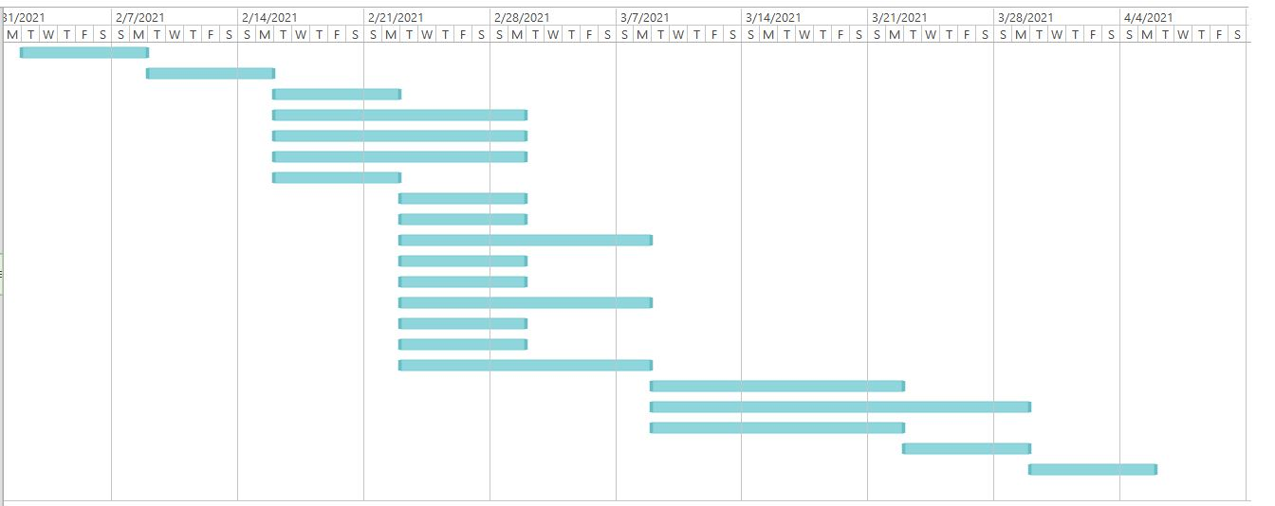

# Planning Risks and Contingencies

|  |  |  |
| --- | --- | --- |
| **Risk** | **Impact** | **Preparation** |
| **Change in requirements of clients:** Clients sometimes tend to change requirements out of nowhere. This is a huge problem and results in increase of development jobs as well as testing jobs. | High | Testing team members with knowledge of programming can start working to help developers. |
| **Budget issues:** Due to lack of resources or time, resources were hired that increases cost. The planning did not work as it was supposed to do. Third party involvement increases cost as a result overall budget increase. | High | Manage client about increase in payment. In case of system testing, use clients and get the works done. |
| **Inappropriate requirements understanding of the testing team lead:** As a result, the objection is totally blur. | Medium | Manage two or three testing team members while discussing about the requirements specifications. |
| **Staff Shortage:** Incomplete works that results in delay of submission. | Medium | Use clients for testing wherever it is possible to ensure their satisfaction is met or not.  Hire resources based on the project’s progress. |
| **Lack of testing tools:** Advanced testing tools makes testing easier, less time consumption. | Medium | Talk with PM to arrange testing tools to make testing more efficient. |

# Approvals

|  |  |
| --- | --- |
| **Designation - Name** | **Sign** |
| Project Sponsor - BRTC (representative) |  |
| Project Manager - Sumaiya Rahman Eva |  |
| Test Manager - Nujat Tasnim |  |
| Development Team Leader - Sakimul Karim Adan |  |
| Test Team Leader - Nujat Tasnim |  |
| Independent Test Engineer - Saikat Baul |  |