 

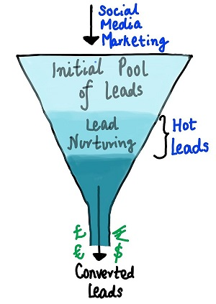

**Lead Conversion Process - Demonstrated as a funnel**

1. Which are the top three variables in your model which contribute most towards the probability of a lead getting converted?

Ans:

1. Total Time Spent on Website
2. Lead Origin_Lead Add Form
3. Lead Source_Direct Traffic

These are the top three variables in our model, which contribute most towards the

Probability of a lead getting converted.

1. What are the top 3 categorical/dummy variables in the model which should be focused the most on in order to increase the probability of lead conversion?

Ans:

1. Lead Origin_Lead Add Form
2. Tags_Will revert after reading the email
3. Last Activity_SMS Sent

These are the top 3 categorical/dummy variables in the model which should be focused the most on in order to increase the probability of lead conversion.

1. X Education has a period of 2 months every year during which they hire some interns. The sales team, in particular, has around 10 interns allotted to them. So during this phase, they wish to make the lead conversion more aggressive. So they want almost all of the potential leads (i.e. the customers who have been predicted as 1 by the model) to be converted and hence, want to make phone calls to as much of such people as possible. Suggest a good strategy they should employ at this stage.

Ans:

X Education needs to follow the below strategy:

1. For this problem we can choose a low Cut-Off point of 0.3, which gives a good result for accuracy, sensitivity and specificity.
2. Though, the precision is less; but as this cut-off includes more people that can be called for conversion and since we have a large team we can take follow up for maximum people.
3. ‘Reach out to larger audience and Focus on potential one’
4. Advertise their course offline and online every means possible
5. Collect the data of those customers who visited X-education offline Outlet and Online portals.
6. Feed this collected data as input and fetch the details of the customers who are predicted as hot leads.
7. Reach out to these customers by every possible means and present your course offer in such way which make them convince to purchase the course
8. Discount on offered course would be good in that time to get more customers.
9. Similarly, at times, the company reaches its target for a quarter before the deadline. During this time, the company wants the sales team to focus on some new work as well. So during this time, the company’s aim is to not make phone calls unless it’s extremely necessary, i.e. they want to minimize the rate of useless phone calls. Suggest a strategy they should employ at this stage.

Ans:

At this cool down time X-education needs to use below strategy:

1. ‘Focus on Small but potential audience’.
2. Follow the strategy same as above but the only difference is reach out those customers who are having high chances of buying the courses among the potential leads.
3. Choose people who has probability between 0.39 and 0.6 because these are the people who has significant chances of conversion but need follow up. So, these people need more follow up to make it convert as compared to people who has high probability. Since we need to make limited calls in order to support the deals, we can call only those people whose probability is wavering close to cut-off.