**Exercise: Displaying Images in your app**

**Overview**

So far you have learned how to display images in React Native with the **Image** component, as well as how to style images. Remember that **Image** is a core component that accepts locally stored image files in addition to online image files and can take many styling props.

In this exercise, you will display and style images within the Little Lemon app.

**Scenario**

Your next duty is to add a unique **Little Lemon logo** to the Welcome screen.

Below you’ll find the logo you will need to add, in the form of a PNG file.



**Starter Code:**

The starter code can be downloaded from the zipped folder below:

[Displaying-Images-Starter-Code (2)](https://d3c33hcgiwev3.cloudfront.net/4qNXQxQUTxKmjvmlBT-DfQ_9c279dc86b6c4f2a852f954295628af1_Displaying-Images-Starter-Code-2-.zip?Expires=1714262400&Signature=LgdP~CJP4lUx72bUbj1OAklTcdNBAyojFr29lZ3iEsETHst7OKX2WNMaqNztLCBDGWAEg2zokn1RbzAgUfyALbdIuvN6dyw-cMnLPinXEjzIg46rI2JQBEuJD0HCkIjn2D55nQ2N3uJfbKtNJFzosnt2MuZSFU~yEdCXv75Tem4_&Key-Pair-Id=APKAJLTNE6QMUY6HBC5A" \t "_blank)

[ZIP File](https://d3c33hcgiwev3.cloudfront.net/4qNXQxQUTxKmjvmlBT-DfQ_9c279dc86b6c4f2a852f954295628af1_Displaying-Images-Starter-Code-2-.zip?Expires=1714262400&Signature=LgdP~CJP4lUx72bUbj1OAklTcdNBAyojFr29lZ3iEsETHst7OKX2WNMaqNztLCBDGWAEg2zokn1RbzAgUfyALbdIuvN6dyw-cMnLPinXEjzIg46rI2JQBEuJD0HCkIjn2D55nQ2N3uJfbKtNJFzosnt2MuZSFU~yEdCXv75Tem4_&Key-Pair-Id=APKAJLTNE6QMUY6HBC5A" \t "_blank)

You will add the **Image** component to the **Welcome** Screen to render the **Little Lemon logo**.

The image below is an example of how your app should look after you complete this exercise:

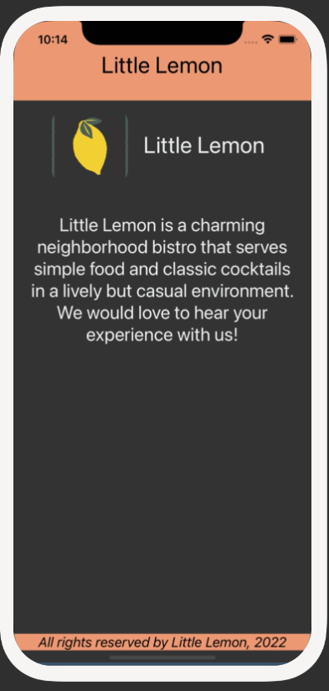

Colors that you will use:

***#EE9972, #*EDEFEE, *black and white.***

**Instructions**

**Step 1: Import the Little Lemon logo**

Your first step is to import the Little Lemon logo image into your project. To make sure that you have it available, right-click on the Little Lemon logo image in **Scenario** and then click on **Save image as...** to save it to your local drive as a **.png** file. Create an image folder in your project and then add the **logo.png** file to it.

You can name it as follows with the following folder structure within the root folder of your project:

**img/logo.png**

**Step 2: Configure the image component within the Welcome Screen**

Your next step is to configure the **Image** component within the welcome screen. It should display the Little Lemon logo that you just imported on the screen. Import the **Image** component within your Welcome screen to start using it.

**Step 3: Style the component**

In this step, you will style the logo image and the welcome heading, to match the screenshots. Make sure to provide meaningful names for all your styles.

**Hint**: You can set the image’s **height**, **width** and **borderRadius** styles to match the screenshots.

**Conclusion**

By completing this exercise, you will demonstrate your understanding and ability to configure and utilize the **Image** component to display images within your React Native app.

Mark as completed

Like

Dislike

Report an issue