**Exercise: Moving between screens**

**Overview**

In a previous exercise, you set up React Navigation in your app and used the Stack Navigator to establish routes between two screens.

However, the user currently cannot move from one screen to another. So, in this exercise, you will implement the ability to move between screens in the Little Lemon app.

**Scenario**

Previously, you wrote the code for setting up navigation routes in the Stack Navigator. To continue, you will expand this code to allow movement between the login screen and the welcome screen. To be more specific, your task is to implement a feature that takes the user to the welcome screen when they press the login button.

A back button will be automatically available on the welcome screen, and you need to validate it if it takes you back to the login screen as expected.

**Starter Code**

For the starter code for this exercise, use the code of the [**Solution: Set up Routes**](https://www.coursera.org/learn/react-native-course/supplement/uSz6z/solution-set-up-routes)**.**

Below you’ll find screenshots from the emulator which demonstrate the expected output after you complete this exercise.

The initial screen should be the **Login** screen**,** and then clicking on the login button should take you to the **Welcome** screen.

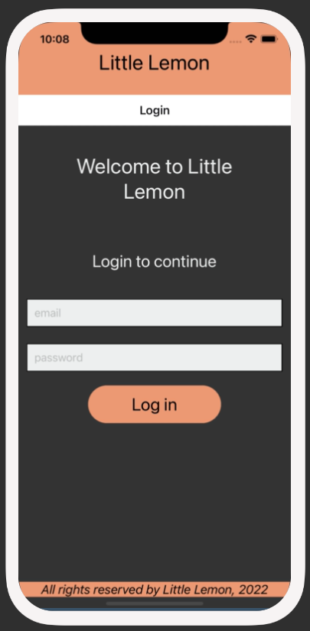

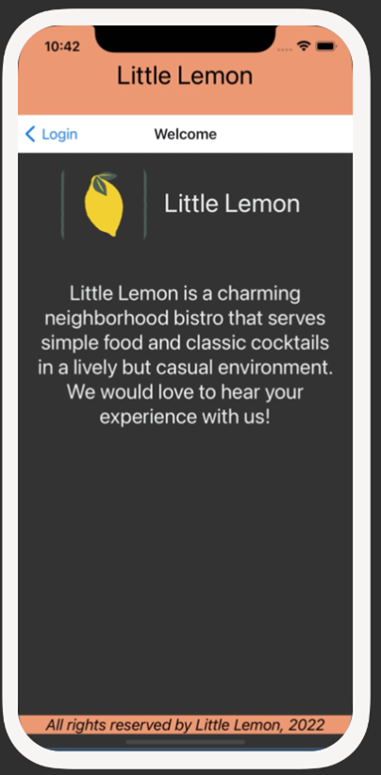

**Instructions**

**Step 1: Configure the Login button to move from the Login screen to the Welcome screen**

First, you will set the Login button to move the user from the Login screen to the **Welcome** screen. When the user presses the Login button they can move to the **Welcome** screen.

**Step 2: Verify built-in back button works**

You will notice that when you move to the **Welcome** screen from the **Login** screen, there will be a back button on the top left corner of the screen. You need to verify that clicking on it takes you back to the **Login** screen. This is an in-built feature and requires no additional code. If the back button does not appear or does not work correctly, review your code and revise it as needed.

**Conclusion**

By completing this exercise, you will demonstrate your understanding and ability to move between screens using the Stack Navigator within your mobile app.