**Solution: Build a scrollable component**

**Overview**

In this reading, you will review the solution code for the exercise.

The code block below outlines the outcome of the exercise in its entirety.

***WelcomeScreen.js***

1

2

3

4

5

6

7

8

9

10

11

12

13

14

15

16

17

18

19

20

21

22

23

24

25

26

27

28

29

30

import * as React from 'react';

import { ScrollView, Text } from 'react-native';

export default function WelcomeScreen() {

  return (

    <ScrollView indicatorStyle={"white"} style={{ flex: 1 }}>

      <Text

        style={{

          padding: 40,

          fontSize: 50,

          color: '#EDEFEE',

          textAlign: 'center',

        }}>

        Welcome to Little Lemon

      </Text>

      <Text

        style={{

          fontSize: 38,

          padding: 20,

          marginVertical: 8,

          color: '#EDEFEE',

          textAlign: 'center',

        }}>

        Little Lemon is a charming neighborhood bistro that serves simple food

        and classic cocktails in a lively but casual environment. We would love

        to hear more about your experience with us!

      </Text>

    </ScrollView>

  );

}

***App.js***

1

2

3

4

5

6

7

8

9

10

11

12

13

14

15

16

17

18

19

20

21

22

23

24

import * as React from 'react';

import { View, Text } from 'react-native';

import LittleLemonHeader from './components/LittleLemonHeader';

import LittleLemonFooter from './components/LittleLemonFooter';

import WelcomeScreen from "./WelcomeScreen";

export default function App() {

  return (

    <>

      <View

        style={{

          flex: 1,

          backgroundColor: '#495E57',

        }}>

        <LittleLemonHeader />

        <WelcomeScreen />

      </View>

      <View style={{ backgroundColor: '#495E57' }}>

        <LittleLemonFooter />

      </View>

    </>

  );

}

The font size on the Welcome screen is fairly large and needs to be scrollable. The code above produces the following output on the emulator with a scrollable screen:

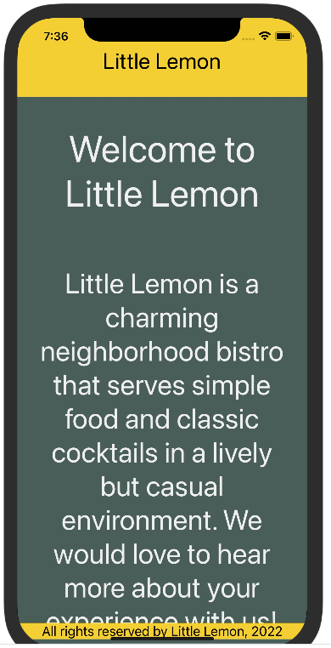

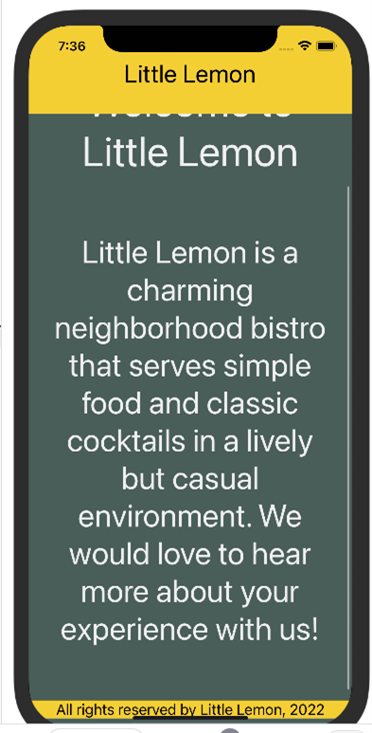

**Procedure**

Next, review the breakdown of the individual steps below.

**Step 1: Enhance Welcome Screen to be Scrollable**

Modify the Welcome Screen to use **ScrollView** component instead of the **View** component for the parent view.

1

2

3

4

5

6

7

8

9

10

11

12

13

14

15

16

17

18

19

20

21

22

23

24

25

26

27

export default function WelcomeScreen() {

  return (

    <ScrollView style={{ flex: 1 }}>

      <Text

        style={{

          padding: 40,

          fontSize: 50,

          color: '#EDEFEE',

          textAlign: 'center',

        }}>

        Welcome to Little Lemon

      </Text>

      <Text

        style={{

          fontSize: 38,

          padding: 20,

          marginVertical: 8,

          color: '#EDEFEE',

          textAlign: 'center',

        }}>

        Little Lemon is a charming neighborhood bistro that serves simple food

        and classic cocktails in a lively but casual environment. We would love

        to hear more about your experience with us!

      </Text>

    </ScrollView>

  );

}

**Step 2: Ensure that the scroll indicator is white in color**

Pass the prop **indicatorStyle** to the **ScrollView** component and give it the value **white**. This will ensure that the scroll indicator is white in color.

1

2

3

    <ScrollView indicatorStyle={"white"} style={{ flex: 1 }}>

    ...