**Solution: Create a TextInput Component**

**Overview**

In this reading, you will review the solution code for the exercise.

The code block below outlines the outcome of the exercise in its entirety.

***WelcomeScreen.js***

1

2

3

4

5

6

7

8

9

10

11

12

13

14

15

16

17

18

19

20

21

22

23

24

25

26

27

28

29

30

31

32

33

34

35

36

37

38

39

40

import React, { useState } from 'react';

import { ScrollView, Text, StyleSheet, TextInput } from 'react-native';

export default function WelcomeScreen() {

  const [firstName, onChangeFirstName] = useState('');

  return (

    <ScrollView style={styles.container}>

      <Text style={styles.headerText}>Welcome to Little Lemon</Text>

      <Text style={styles.regularText}>

        Little Lemon is a charming neighborhood bistro that serves simple food

        and classic cocktails in a lively but casual environment. We would love

        to hear more about your experience with us!

      </Text>

      <TextInput

        style={styles.inputBox}

        value={firstName}

        onChangeText={onChangeFirstName}

        placeholder={'First Name'}

      />

    </ScrollView>

  );

}

const styles = StyleSheet.create({

  container: {

    flex: 1,

  },

  headerText: {

    padding: 40,

    fontSize: 30,

    color: '#EDEFEE',

    textAlign: 'center',

  },

  regularText: {

    fontSize: 24,

    padding: 20,

    marginVertical: 8,

    color: '#EDEFEE',

    textAlign: 'center',

  },

The code above will produce the following output on the emulator:

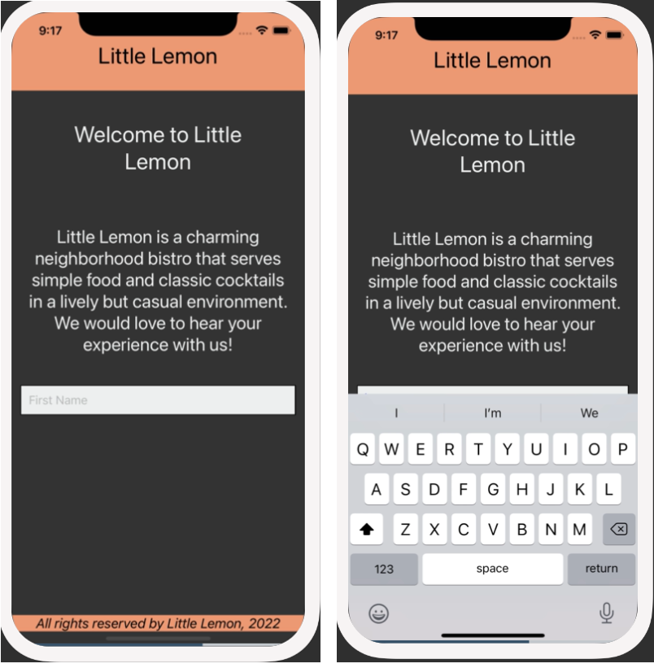

**Procedure**

Next, review the breakdown of the individual steps below.

**Step 1: Configure TextInput component on the Welcome Screen.**

On the Welcome Screen, configure the **TextInput** component to accept user’s input.

First, import **TextInput** from React Native:

1

import { ScrollView, Text, StyleSheet, TextInput } from 'react-native';

Then, configure the **TextInput** component*:*

1

2

3

4

5

<TextInput

     value={firstName}

     onChangeText={onChangeFirstName}

     placeholder={'First Name'}

  />

**Step 2: Store user input within TextInput as local state**

In this step, make sure to import the **useState** hook from React and create a local state for storing the user’s name that is being entered in the text input box.

1

2

3

import React, { useState } from 'react';

const [firstName, onChangeFirstName] = useState('');

**Step 3: Style the component**

Once you have coded a working component, it is time to style it. In this step, you will style the **TextInput** component to match the screenshots above.

20

21

22

23

24

25

26

27

28

29

30

31

32

33

34

35

36

37

38

39

40

41

42

43

44

45

46

47

48

49

  );

}

const styles = StyleSheet.create({

  container: {

    flex: 1,

  },

  headerText: {

    padding: 40,

    fontSize: 30,

    color: '#EDEFEE',

    textAlign: 'center',

  },

  regularText: {

    fontSize: 24,

    padding: 20,

    marginVertical: 8,

    color: '#EDEFEE',

    textAlign: 'center',

  },

  inputBox: {

    height: 40,

    margin: 12,

    borderWidth: 1,

    padding: 10,

    fontSize: 16,

    borderColor: 'EDEFEE',

    backgroundColor: '#EDEFEE',

  },

});

Mark as completed

Like

Dislike

Report an issue