A comparison of simulated quantum and classical classification heads on frozen ResNet50 features for PatchCamelyon
Saikat Das
Department of Computer Science and Engineering
Ahsanullah University of Science and Technology, Dhaka, Bangladesh
Corresponding author: Saikat Das
Email: saikatdasmain47@gmail.com
Running title Quantum and classical heads on frozen ResNet50 features

Abstract
Hybrid quantum classical image classifiers require controls that distinguish the contribution of a quantum circuit from that of the underlying image representation. We evaluated whether a small simulated quantum classifier improved patch level metastatic tissue classification under a fixed eight component representation and a shared neural training schedule. An ImageNet pretrained ResNet50 encoder was frozen, and its 2,048-dimensional features were reduced to eight training fitted principal components. We compared standard and arctangent input multilayer perceptrons, two layer rotation circuits with and without controlled NOT gates, and a classical reference selected using slide separated training folds. Final neural heads were fitted using three initialization seeds and all 262,144 official training patches. Models and analysis settings were locked before scoring the 32,768-patch official test set. Uncertainty was estimated using 20,000 paired whole slide bootstrap resamples across 129 test slides. Mean test area under the receiver operating characteristic curve was 0.8657 for the controlled NOT circuit and 0.8776 for the selected Fourier Nyström reference, a difference of −0.01191 (conditional 95% interval −0.02359 to −0.00038). The controlled NOT versus no controlled NOT difference was −0.00848. Its interval after adjustment for multiple comparisons included zero. A post hoc slide jackknife sensitivity test for the primary comparison gave p=0.0526, showing that exclusion of zero depended on the uncertainty method. These results provide no evidence of a quantum head improvement in the evaluated configuration. The eight components retained 58.80% of training feature variance. Conclusions concern this compressed representation, one dataset and exact classical simulation.

Introduction
PatchCamelyon (PCam) provides small tissue images for testing models that detect metastatic tissue [1,2]. Its fixed training, validation and test partitions allow studies to use a common benchmark. A positive label means tumor is present in the central 32 by 32 pixels [2]. Patch performance does not establish performance for whole slides or patients.
A pretrained image encoder can provide features for a smaller classifier. ResNet introduced residual connections for image recognition [3]. Work on feature transfer showed that transfer depends on the source task and network layer [4]. Mari et al. extended transfer learning to models that place a quantum circuit after a pretrained classical network [5]. This approach makes small circuit experiments possible without encoding every image pixel into qubits. It also raises a direct question. Does the circuit improve predictions once the image features are fixed?
Reviews of quantum learning describe both possible uses and limits in training and evaluation [6,7]. Circuit output depends on how data enter the circuit [8]. Some circuit families also have very small gradients, although this cannot be assumed for every small model [9]. Classical models can remain competitive even on some tasks designed around quantum features [10]. Broad benchmark results further show why useful classical controls and circuits without entangling gates should be tested [11]. These findings motivate a controlled comparison rather than an assumed quantum benefit.
The evaluation also needs to separate model selection from final testing [12]. Patches from one slide can be related, so uncertainty should account for slide groups [13]. Here we compare four small heads and a classical reference on the same eight features from a frozen ResNet50. We retain the official training rows, choose the reference within training data and lock the fitted models before test scoring. Our contribution is the resulting comparison of input mapping and CNOT gates, with paired slide uncertainty, separate seed variation and saved predictions. In this pathology setting, many patches share a slide. We therefore examine whether apparent head differences remain meaningful after pairing uncertainty by slide. The question concerns an eight component constraint and a shared schedule.

Related work
Mari et al. established the use of pretrained classical features with a small trainable quantum head [5]. This is the starting point of our study, not a new architecture. Work on data encoding further links circuit outputs to Fourier functions of the inputs [8]. This gives a reason to include a classical trigonometric reference alongside neural controls. It does not imply that our reference can reproduce every circuit function.
Two studies are particularly close to the pathology task. Goyal et al. studied quantum edge and frequency preprocessing with image classifiers and fusion on a modified PCam dataset [14]. Their intervention changes image processing. Baral et al. studied classical and hybrid classifiers under adversarial attacks [15]. They used a balanced subset of 20,000 PCam images and an 80:20 split. They also included a classical bottleneck model and evaluated their selected hybrid model with three random seeds. Classical controls and repeated seeds therefore already exist in this literature. Our experiment instead holds the frozen representation fixed and uses the official partitions for a direct comparison of classifier heads.
Bowles et al. compared quantum and classical models across benchmark tasks and examined circuits without entanglement [11]. Their results support checking whether a circuit component adds value. Huang et al. showed that access to data can allow classical learners to compete even in some settings built around quantum problems [10]. Neither paper predicts the result of our PCam experiment. Singh et al. studied MedMNIST with classical training and real device inference [16]. Goyal et al. later proposed configurable quantum edge processing for histopathology and evaluated circuits on real processors [17]. This June 2026 preprint studies image preprocessing and hardware behavior. Our head comparison uses exact simulation.
These studies address related but different questions. Their reported accuracies cannot be ranked against our AUROC without matching data, splits and evaluation rules. We add a focused PCam result using shared features, the full official training partition, a reference chosen within training data and uncertainty paired by slide. This study connects head comparisons to slide dependence, shared schedule effects and exact image overlap in an official pathology benchmark. It does not introduce a new architecture or claim the first quantum PCam classifier.

Materials and methods

Study design and executed scope
This computer study used existing public images. The effective final scope was one frozen ResNet50 encoder, eight transformed features, four neural heads and seeds 101, 202 and 303. A documented resource driven amendment reduced an earlier plan containing additional backbones, dimensions, seeds and controls before reported official test scoring. Historical source configurations retain that larger plan. The executed SCOPE.json and final specifications define the reported experiment. The test lock is an internal timestamped artifact lock, not external preregistration. Development results were available before final test evaluation. No test driven model winner was selected. Fig 1 summarizes the executed study workflow.

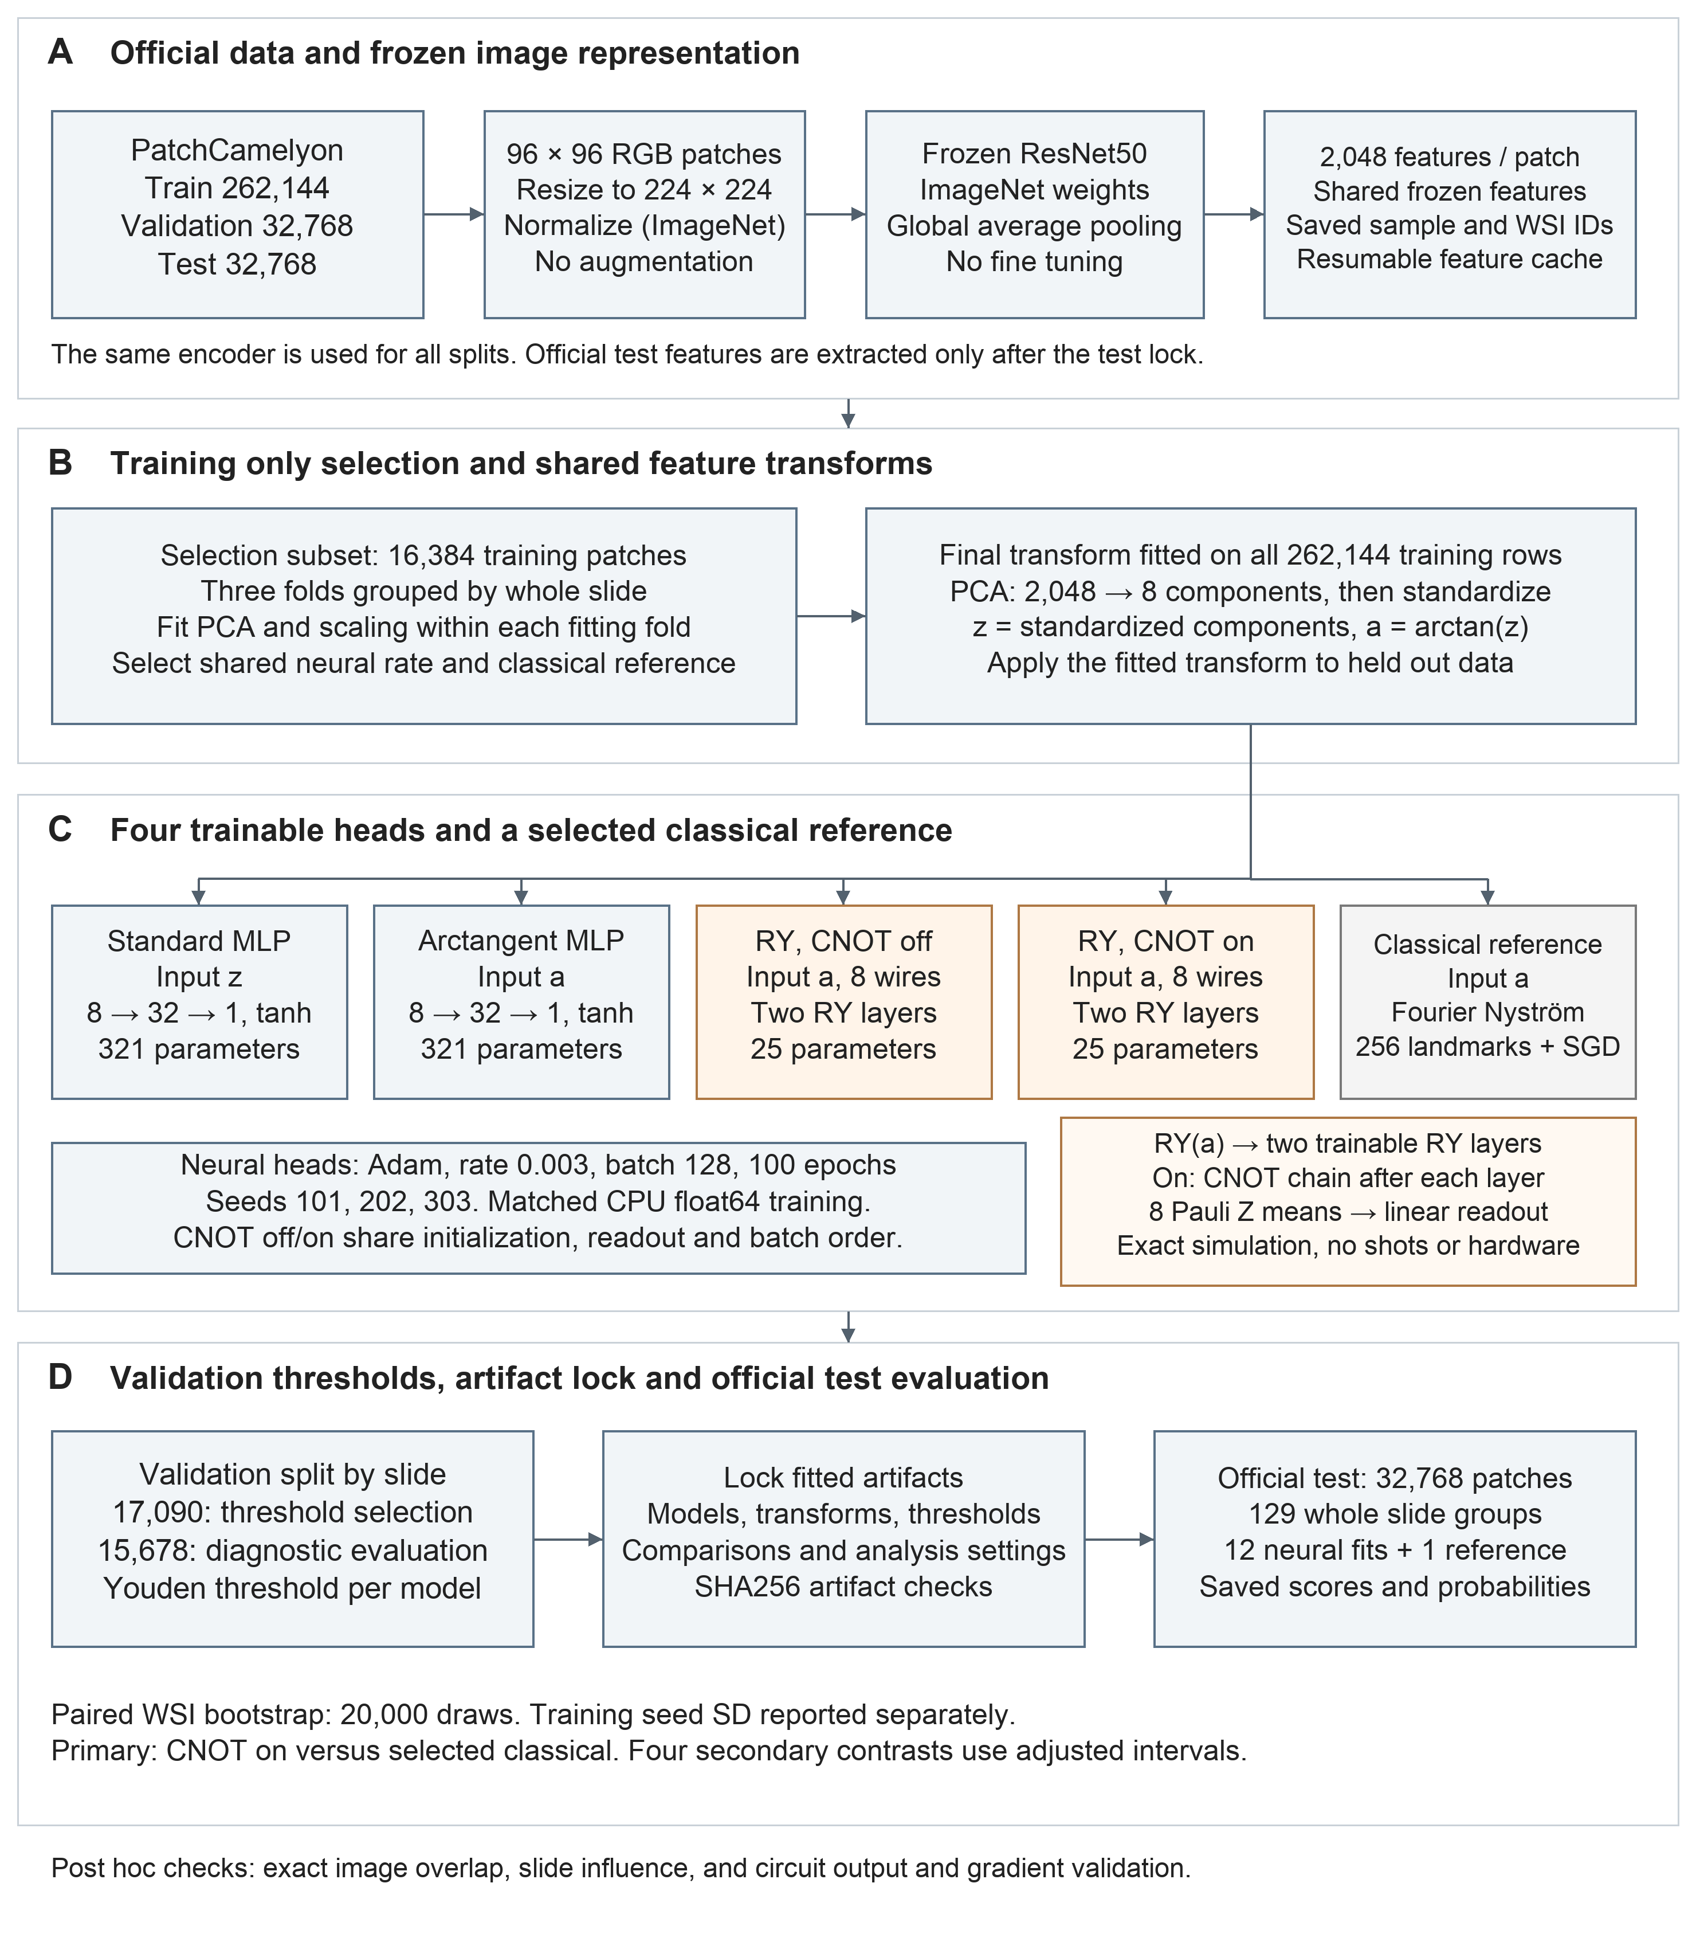
Fig 1. Executed study methodology. (A) Official PatchCamelyon splits and shared frozen ResNet50 feature extraction. (B) Training only grouped model selection and training fitted PCA and scaling. The final shared representation contains eight components. (C) Four neural heads and a training selected Fourier Nystrom reference. Neural fits use three seeds and a shared optimization schedule. CNOT off and on circuits share initial rotations and readout values. Circuits are classically simulated without shots or quantum hardware. (D) Validation threshold selection, fitted artifact lock, official test scoring and paired whole slide uncertainty analysis. Post hoc checks are identified separately.

Dataset and split handling
We used the official training, validation and test partitions and retained their repeated rows (Table 1). Images were 96 by 96 RGB patches. A positive PCam label indicates at least one tumor pixel in the central 32 by 32 region [1,2]. Whole slide identifiers did not overlap between partitions. A post hoc audit hashed every original patch and checked raw label order against the saved manifests. There were 220,025 unique training images, 28,108 unique validation images and 29,383 unique test images. No exact images were shared between training and validation or between validation and test. Training and test shared 33 image hashes, involving 35 training rows and 34 test rows. We retained the locked full test analysis and added a separate descriptive sensitivity excluding those 34 test rows. This does not establish absence of near duplicates or patient overlap.
Table 1. Official dataset partitions. Counts are rows and distinct WSI identifiers, not patients.
Split | Patches | Negative | Positive | WSIs
train | 262144 | 131072 | 131072 | 216
valid | 32768 | 16399 | 16369 | 54
test | 32768 | 16391 | 16377 | 129

Training only selection used a fixed, label stratified 16,384-row subset. Three StratifiedGroupKFold partitions used WSI groups, with sample and fold seeds 71911 and 71912. Validation slides were divided using seed 71914 into 27 threshold selection slides (17,090 patches) and 27 diagnostic slides (15,678 patches). Reported development metrics use the diagnostic half. The entire official test partition was scored after lock. Dataset size was determined by the benchmark, not a prospective power calculation. No retrospective power claim is made.

Frozen representation and transformations
The encoder was the pinned ImageNet ResNet50 variant resnet50.tv_in1k, with 23,508,032 frozen parameters and a saved weight state checksum. Images were resized directly to 224×224 with bilinear antialiased interpolation, converted to tensors and normalized using means (0.485, 0.456, 0.406) and standard deviations (0.229, 0.224, 0.225). No random augmentation, crop, stain normalization or encoder fine tuning was used. Global average pooled outputs had 2,048 dimensions. Feature chunks and per image identifiers were shared across heads.
For each training fold, randomized principal component analysis [18] with eight components, 24 oversamples, seven power iterations and seed 71911 was fitted exclusively to that fold's fitting rows. Each principal component was standardized using fitting row statistics. The final transform was refitted on all official training rows. Held out data were transformed without refitting. The standard MLP received z. The arctangent MLP and both RY circuits received a=arctan(z), component by component, without an extra scaling factor. Eight components were a resource constraint that allowed the declared circuit comparison. They were not chosen because eight was proven sufficient. The saved final PCA retained 58.8005% of training feature variance. The three fitting fold transforms retained 58.9259%, 58.7760% and 58.7407% (S3 Table). Explained variance does not measure retained information about the tissue label. A full feature classical baseline was not part of the locked experiment, so the predictive cost of compression remains unknown.

Neural models and circuit ablation
Both perceptrons used an 8→32→1 architecture with a hyperbolic tangent hidden activation and affine output, totaling 321 trainable parameters. They differed only in standard versus arctangent input mapping. Circuits encoded each component with an RY rotation from the all zero state, followed by two trainable RY layers. The CNOT on model applied an ordered nearest neighbor chain, wires 0→1 through 6→7, after each trainable layer. CNOT off omitted those gates. Eight Pauli Z expectation values fed an affine scalar readout. Each circuit had 16 rotation parameters and nine readout parameters, totaling 25. Off/on models shared initial rotation and readout values for a given seed. The comparison isolates these gates within the declared circuit and optimizer. It does not measure entanglement itself or match capacity to the perceptron.
The simulator represented an exact real 256-amplitude statevector in PyTorch float64. There were no finite shots, device noise, quantum hardware measurements or stochastic shot effects. With no CNOT gates, successive rotations on a wire combine, making this control a classically evaluable trigonometric model. It is therefore a structural circuit ablation. With CNOT off, the logit is b+sum over j of w_j cos(a_j+theta_1j+theta_2j).
After test inspection, a separate NumPy implementation constructed full Kronecker rotation matrices and computational basis CNOT matrices. Across four and eight wires, both gate settings and six cases per setting, expectations agreed within 1.23e-15. PyTorch gradients for all input angles and rotation weights agreed with central finite differences of the matrix reference within 1.89e-9, using step 1e-6. Wire zero was the most significant bit. CNOT control and target order were checked explicitly. The gate free cosine expression agreed within 8.89e-16. These checks validate the retained circuit function. They are not an external replication or quantum device test. Full checks and tolerances are in Supplementary methods and S6 Table.

Analytical computational complexity
For batch size B, q wires and L layers, this statevector implementation uses O(B·2^q) state storage and O(B·L·q·2^q) gate operations per forward pass, with additional automatic differentiation storage during training. At q=8 it tracks 256 real amplitudes per patch. An 8→32→1 MLP instead has O(B·q·32) leading dense layer work. These are implementation level scaling descriptions, not measured FLOP counts. The gate free RY function could be evaluated directly with O(B·q) trigonometric operations. The present off implementation retains the common statevector path. Its two rotation weights on each wire enter only through their sum, so nominal parameter count does not imply independently identifiable capacity. Neither parameter count nor simulation time establishes quantum advantage.

Optimization and training only selection
All neural heads used the same training loop, binary cross entropy with logits, Adam [19] (betas 0.9 and 0.999, epsilon 10^−8, zero weight decay), batch size 128 and 100 epochs. All neural head fits used CPU float64 with two PyTorch threads. A common learning rate of 0.003 was selected from 0.001, 0.003 and 0.01 by averaging fold AUROCs across the four heads. This experiment compares a shared schedule. It does not compare the best schedule for each architecture. Deterministic epoch permutations used seed + 10,000×epoch, with epoch indexed from zero. Final runs each performed 204,800 updates. There was no validation based early stopping or best epoch selection. Rotation weights began as independent normal values with mean zero and SD 0.1. Circuit readout weights and bias used the PyTorch Linear uniform range from minus 1/sqrt(8) to plus 1/sqrt(8). MLP layers used the same Linear rule with the appropriate input width. The CV initialization seed was 71911. Final seeds were 101, 202 and 303. CNOT pairs shared initial values. S4 Table and the accompanying CSV give all existing head and learning rate fold results. Parameter initialization rules and reconstructed values are supplied with the code, with their reconstruction runtime identified.
Fourteen nonneural classical candidates comprised six logistic regressions, three ExtraTrees variants, three histogram gradient boosting variants and two Fourier Nyström variants. Standard and arctangent MLPs at the selected common learning rate also entered the classical reference selection pool. The winning reference was chosen by mean training fold AUROC, with a deterministic tie rule. Its training fold mean AUROC was 0.884710. It used the arctangent mapping, 256 training sampled Nyström landmarks [20] and the kernel K(a,b)=∏_j{[1+cos(a_j−b_j)]/2} over eight coordinates. Eigenvalues were floored at 10^−12. An SGD logistic classifier used alpha 0.0001, maximum 1,000 iterations, tolerance 10^−4 and seed 71911. The reference was refitted on all training rows. Its optimization and feature map budget differ from those of neural heads.

Threshold selection and test access
Each final model's probability threshold maximized Youden's index [21] on threshold selection slides. Ties used proximity to 0.5, then the smaller threshold. This procedure selects an operating threshold. It is not probabilistic calibration. No Platt or isotonic calibration was fitted. Diagnostic validation rows did not determine these thresholds. Final models, transforms, selection, validation outputs and scientific code were checksummed before test scoring.
Saved checkpoints allowed interrupted runs to continue. Recovery details and numerical replay checks are in Supplementary methods. The internal lock protected fitted models, transforms, selection and thresholds before test scoring. It does not establish independent replication.

Use of artificial intelligence tools
OpenAI Codex assisted with language editing, manuscript organization, code development and debugging, and analysis and figure scripts. File hashes, metric recomputation and circuit validation were used to check outputs. The author is responsible for the work.

Outcomes and statistical analysis
The primary outcome was the difference between mean per seed test AUROC of CNOT on and the training selected classical reference. This is the mean of seed specific AUROCs, not the AUROC of an averaged score ensemble. Secondary contrasts were CNOT on minus off, CNOT on minus arctangent MLP, CNOT on minus standard MLP, and arctangent minus standard MLP. ROC and precision recall plots describe performance across thresholds [22]. Average precision summarized the ranking of predicted scores. Brier score and log loss evaluated predicted probabilities. Accuracy, sensitivity, specificity, precision and F1 used thresholds fixed on the threshold selection validation slides.
Within slide dependence motivates cluster aware ROC inference [13]. We do not claim to implement the specific estimator in that reference. Bootstrap resampling follows the general approach of Efron [23], with slides as the resampling units here. The locked analysis used 20,000 paired WSI bootstrap replicates (seed 71913). Each replicate resampled 129 slides with replacement and included all patches with their slide's multiplicity. Identical resampling weights were applied to every model and seed. AUROC was patch weighted within each resample, rather than an unweighted mean of slide specific AUROCs. Percentile intervals used the 2.5th and 97.5th percentiles for the primary contrast. Four secondary comparisons used Bonferroni percentile limits at 0.625% and 99.375%, giving nominal family wise 95% coverage. Training seed sample SD was reported separately. These intervals condition on the fitted models, training data, selection and three retained seeds. They do not include variability from retraining on new data or establish patient independence.
For post hoc sensitivity, we deleted each WSI in turn, recomputed model AUROCs and estimated the contrast standard error as sqrt[(G−1)/G Σ(θ_(−g)−mean θ_(−g))²], G=129. We used approximate two sided t tests with 128 degrees of freedom and Holm correction [24] across the four secondary sensitivity tests. This jackknife approximation was not the locked primary test. We did not run patch independent DeLong, patch level McNemar or t tests treating three seeds as independent patient samples. No equivalence margin or smallest important effect was specified. All inferential results are interpreted without post hoc power claims.
Analyses used the saved Python 3.13/PyTorch 2.11/scikit learn 1.6.1/SciPy 1.16.3/NumPy 2.1.3 environment for the experiment. Manuscript reanalysis software versions are recorded separately. Scikit learn provides the classical analysis tools [25]. Sources and exact configuration hashes accompany predictions. No rows were excluded as outliers from the locked test analysis. The exact overlap exclusion and slide influence checks were later descriptive analyses. Overlap between individual model intervals does not test a paired model difference. Inconclusive secondary contrasts do not establish equivalence.

Results

Integrity and completeness
A separate analysis script in the same project recomputed all 13 test AUROC and average precision values from saved predictions. It also reconstructed the five nominal contrast intervals using the saved 20,000 bootstrap arrays. A direct weighted AUROC calculation from original scores matched the first 32 saved draws per model. The full resampling procedure was not independently repeated. These are computational consistency checks by the same workflow, not validation by another researcher. The retained circuit passed the separate matrix and gradient tests described above. File integrity counts and checks are in Supplementary methods.

Test discrimination and operating characteristics
The selected classical reference achieved AUROC 0.8776. Neural mean AUROCs ranged from 0.8657 for CNOT on to 0.8765 for the standard MLP (Table 2). Seed variability and conditional test set uncertainty describe different sources of variation and are displayed separately. Table 2 reports mean performance across seeds. It does not describe a pooled ensemble. S1 Table gives operating metrics and S2 Table gives exact confusion counts. Figs 2 and 3 show the ROC and precision recall curves.
Table 2. Official test discrimination and probability error. AUROC is the mean across fixed neural seeds. SD describes seed variation. Conditional 95% intervals use paired WSI bootstrap draws averaged across retained seeds. The selected classical model is one fit. AP is average precision. Threshold dependent metrics are reported in S1 Table.
Model | Fits | AUROC  Mean (seed SD) | AUROC  95% CI | AP | Brier
Standard MLP | 3 | 0.8765 (0.0016) | 0.8458 to 0.9055 | 0.8784 | 0.1523
Arctangent MLP | 3 | 0.8729 (0.0015) | 0.8407 to 0.9032 | 0.8751 | 0.1524
RY CNOT off | 3 | 0.8742 (0.0012) | 0.8453 to 0.9004 | 0.8671 | 0.1463
RY CNOT on | 3 | 0.8657 (0.0020) | 0.8342 to 0.8946 | 0.8649 | 0.1502
Selected classical | 1 | 0.8776 | 0.8486 to 0.9046 | 0.8743 | 0.1459

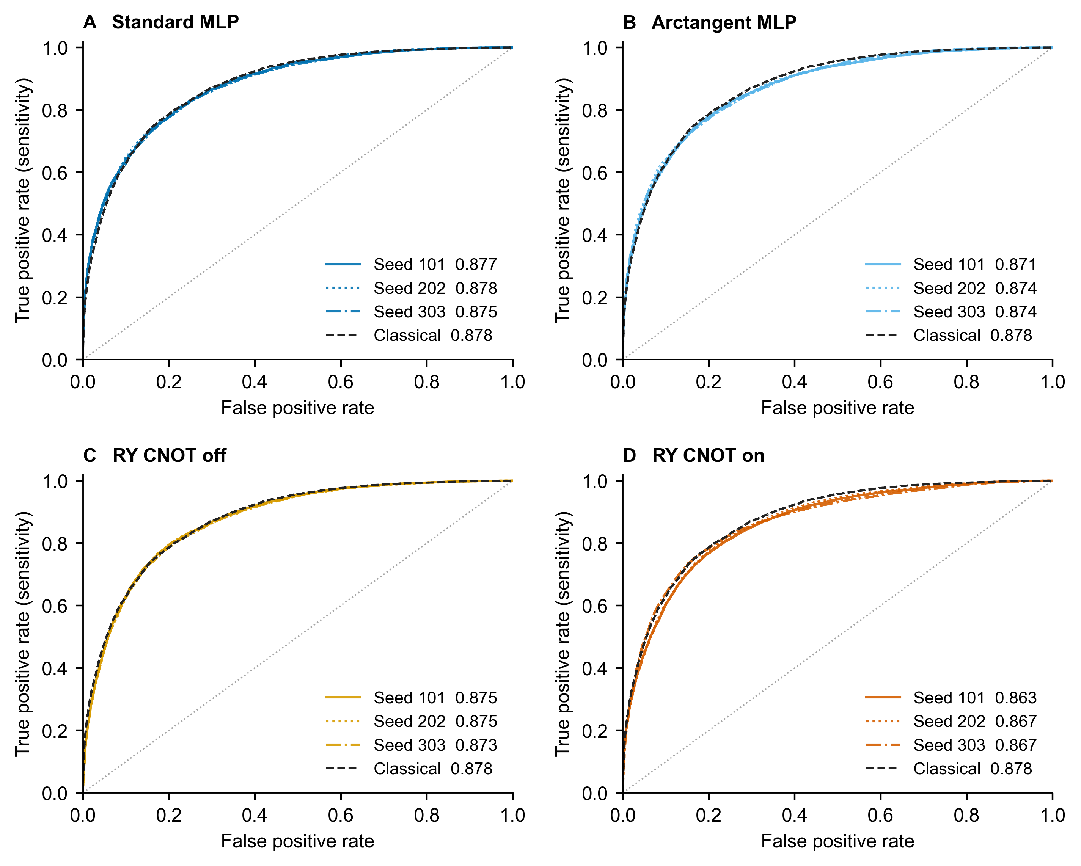
Fig 2. Test ROC curves. Each panel compares one neural head at seeds 101, 202 and 303 with the same selected classical reference. Legend values are AUROC. False positive rate is FP divided by all negative patches. True positive rate is TP divided by all positive patches. The dotted diagonal shows equal true and false positive rates. All curves use the same 32,768 test patches. No smoothing or uncertainty bands are applied.

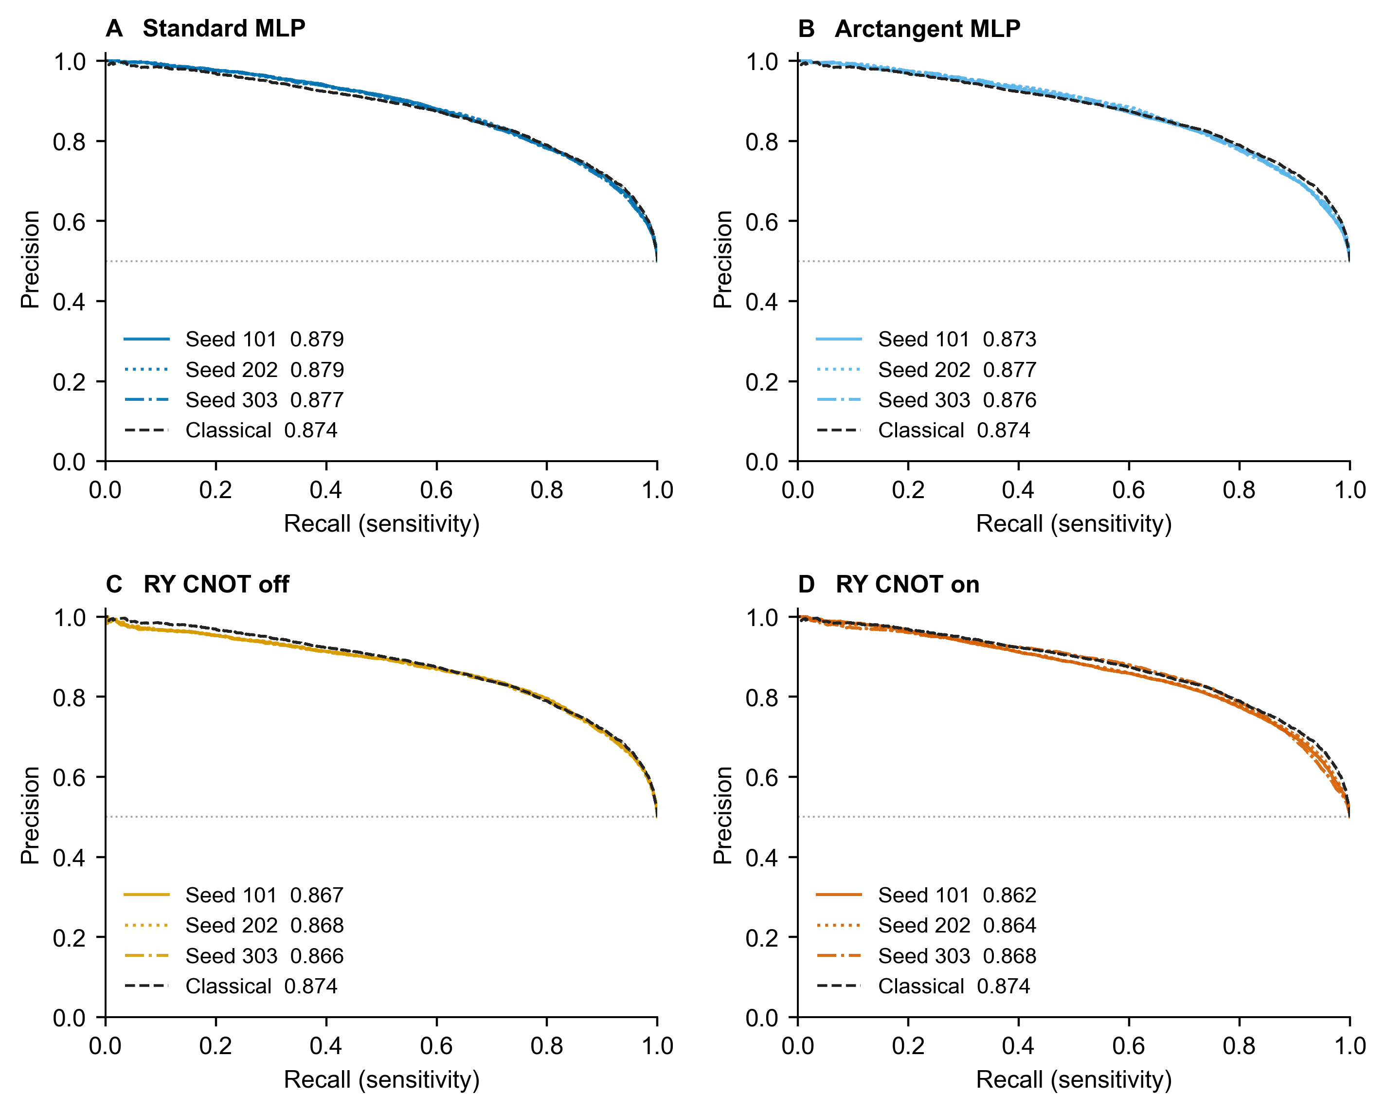
Fig 3. Test precision recall curves. Panels and seed styles match Fig 2. Legend values are average precision. Recall is TP divided by all positive patches. Precision is TP divided by all predicted positive patches. The dotted horizontal line marks test prevalence, 16,377/32,768 or 0.4998. Small changes near low recall reflect individual score ranks. The conventional endpoint at recall zero has precision one. Curves are empirical steps without smoothing or uncertainty bands.

Primary comparison and ablations
The primary AUROC difference was −0.011911 (95% conditional percentile interval −0.023594 to −0.000379). Thus the locked bootstrap comparison favored the classical reference, but its upper limit lay close to zero. Post hoc jackknife sensitivity gave t=-1.956, p=0.0526. Exact computed values are in Table 4. The estimated difference favored the classical reference. Exclusion of zero depended on the uncertainty procedure. These procedures need not agree near zero. We interpret the effect and its uncertainty without treating a p value threshold as a separate scientific conclusion.
The CNOT on/off difference was −0.008475. Its nominal interval excluded zero, but the four comparison adjusted interval included zero (Table 3 and Fig 4). The other adjusted secondary intervals also included zero. Removing CNOT gates did not provide a family adjusted conclusive gain. Equally, the results do not support adding them in this configuration. Differences between MLP mappings are not evidence that dimensional compression itself is harmless, because a full dimensional control was not executed in the final scope.
Table 3. Locked AUROC contrasts. Differences are AUROC units. Four secondary intervals are Bonferroni adjusted, not unadjusted significance claims.
Contrast | AUROC difference | Nominal 95% CI | Family adjusted 95% CI
CNOT on minus classical | -0.011911 | [-0.023594, -0.000379] | Primary comparison
CNOT on minus CNOT off | -0.008475 | [-0.016990, -0.000628] | [-0.019470, 0.001427]
CNOT on minus atan MLP | -0.007233 | [-0.025644, 0.014327] | [-0.029973, 0.022183]
CNOT on minus standard MLP | -0.010747 | [-0.028909, 0.010240] | [-0.033098, 0.017242]
Atan minus standard MLP | -0.003514 | [-0.006798, -0.000352] | [-0.007650, 0.000600]

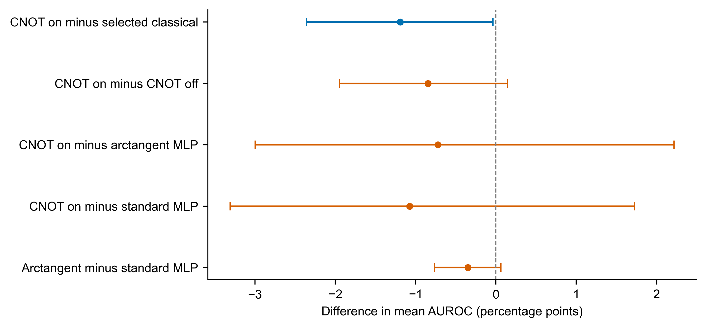
Fig 4. Paired differences in mean test AUROC. The blue primary contrast uses a nominal 95% WSI bootstrap interval. Orange secondary contrasts use Bonferroni adjusted intervals for a four comparison family. All intervals condition on the fitted models and retained seeds. The vertical dashed line marks zero. Values are percentage points.
Table 4. Post hoc WSI jackknife sensitivity tests
Contrast | SE | t  (df 128) | Two sided p | Holm p
CNOT on minus classical | 0.00609 | -1.956 | 0.0526 | NA
CNOT on minus CNOT off | 0.00427 | -1.985 | 0.0492 | 0.1554
CNOT on minus atan MLP | 0.01071 | -0.675 | 0.5008 | 0.6066
CNOT on minus standard MLP | 0.01040 | -1.033 | 0.3033 | 0.6066
Atan minus standard MLP | 0.00168 | -2.087 | 0.0389 | 0.1554

Sensitivity tests were added after inspection of test results. Holm adjustment applies to the four secondary contrasts only. The primary locked inference remains the paired WSI percentile bootstrap.

Training diagnostics and elapsed time
Mean neural training compute times were 268.65 seconds for standard MLP, 266.63 seconds for arctangent MLP, 5,447.13 seconds for CNOT off and 7,374.70 seconds for CNOT on. The descriptive CNOT on/standard MLP ratio was approximately 27.45. The classical reference fit took 31.57 seconds, including its feature map fit, and is not on the same timing boundary. Neural timers include mini batch indexing, forward/backward passes and optimizer updates, and exclude setup, epoch order generation, diagnostics, checkpoint writes and frozen feature extraction. Runs span Colab sessions and some checkpoints contain multiple runtime segments. These times characterize observed classical execution, not standardized hardware speed comparisons or quantum hardware cost.
Training diagnostic losses used the first 1,024 training rows. Before test access, a fit was blocked if its epoch 81 loss minus epoch 100 loss exceeded 0.02. All twelve fits passed this rule. Fig 5 shows the saved training traces and observed neural compute times. A small recent decline does not prove convergence. Circuit losses remained higher than MLP losses. The traces cannot separate limited capacity from unsuitable optimization. The existing CV grid also shows that 0.001 gave the highest mean fold AUROC for both MLPs, whereas 0.01 did so for both circuits (S4 Table). The common selected rate remained 0.003. No new schedule was selected from test results. Full traces, update counts and measured timing are retained in the analysis files.
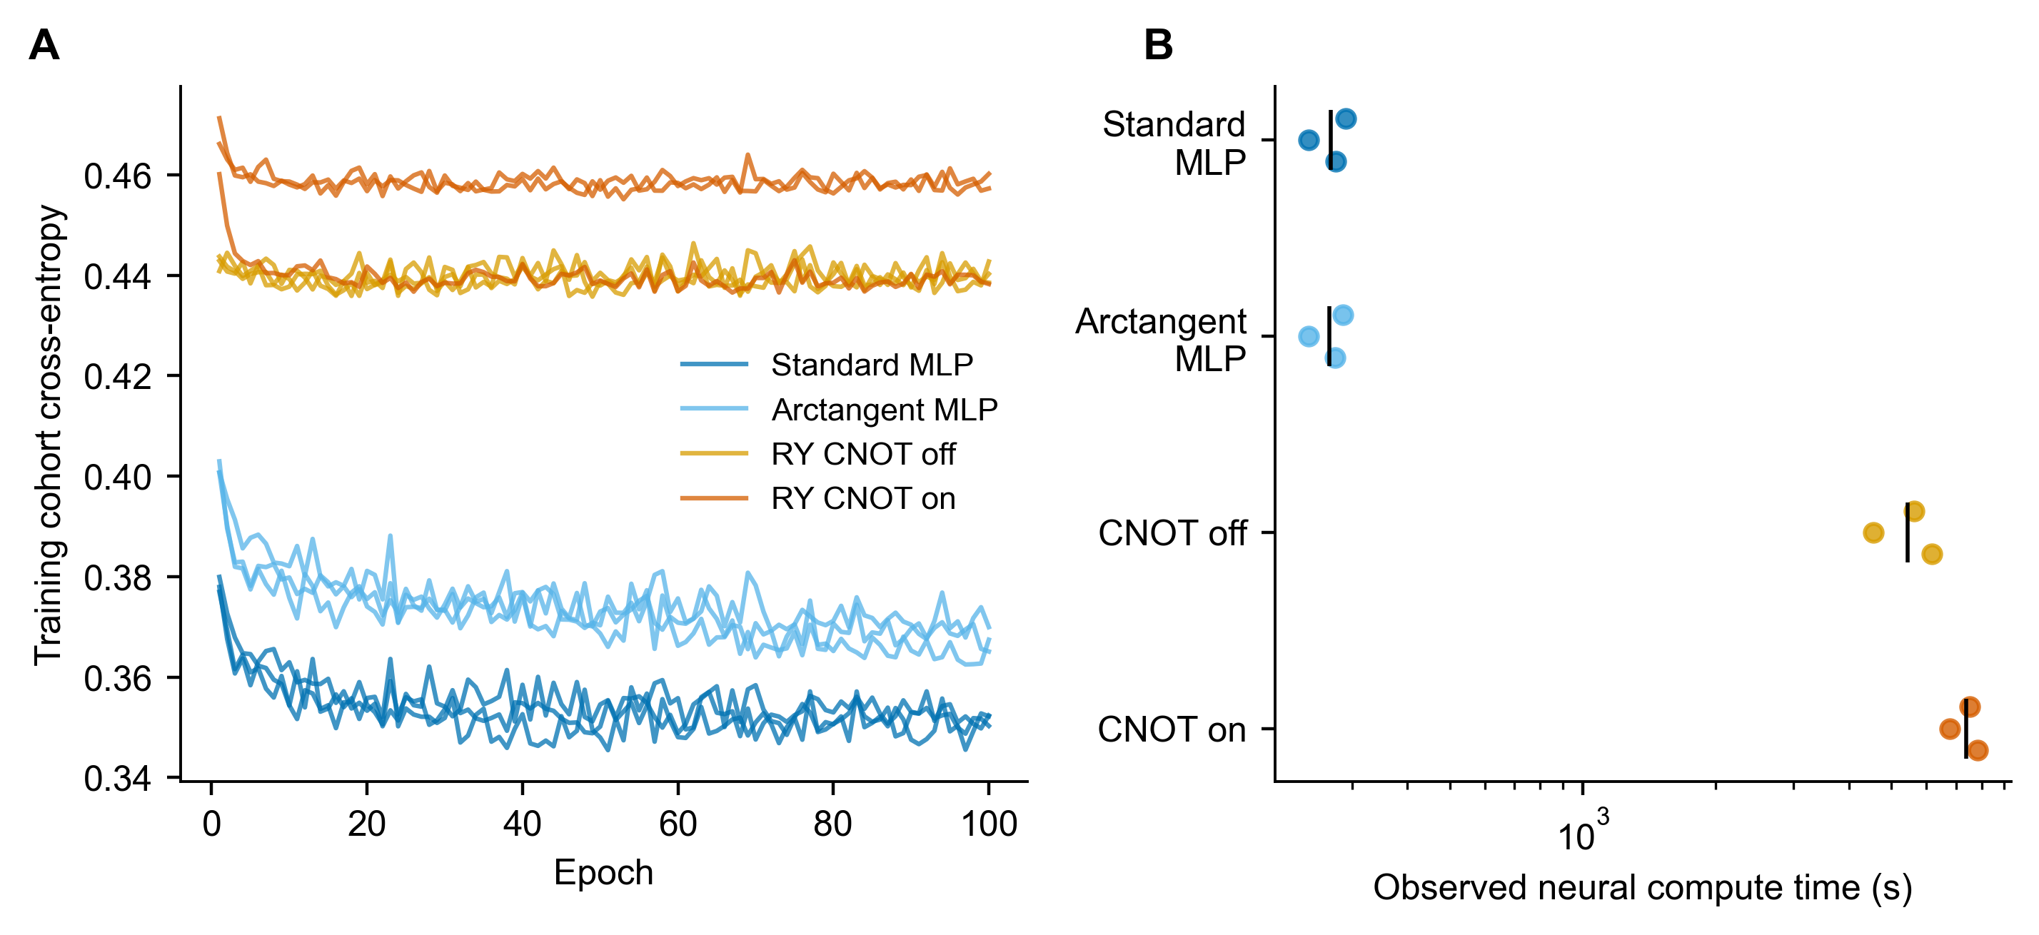
Fig 5. Training diagnostics and observed compute time. (A) Cross entropy on a fixed 1,024-row training cohort. (B) Individual seed neural compute times. Black ticks denote means. Time uses a log scale. Session differences limit hardware comparisons. Timer boundaries are specified in Methods.

Image overlap and slide influence
The exact audit found 3,385 repeated test rows beyond the first occurrence of each image. The 34 test rows whose hashes also occurred in training contained 33 positive labels and one negative label. Excluding these rows left 32,734 test patches. The mean CNOT on AUROC was then 0.865606 and the classical AUROC was 0.877485. Their difference was minus 0.011879, compared with minus 0.011911 in the locked analysis. This post hoc point estimate does not add an interval or replace the original analysis.
Test slides contributed between 98 and 716 patches, with median 140 and quartiles 120 and 387. The largest slide contributed 2.19% of test rows and the largest five contributed 10.31%. Removing one slide at a time gave primary differences from minus 0.015786 to minus 0.009775. The largest change arose on removing camelyon16_test_099, which contributed 677 patches. All leave one slide point estimates favored the classical reference. These descriptive checks do not quantify patient independence or remove all sources of bias. Counts and influence values are supplied in S5 and S7 Tables.

Discussion
Within this fixed representation and optimization schedule, a simulated entangling head did not improve discrimination over the selected classical reference. The primary point estimate was negative, consistent with the broader benchmarking concern that a quantum component should be justified against classical alternatives [11]. The intervals concern these retained fitted models and seeds. They do not measure variation from repeating the full training and selection process. No clinically important margin was defined. The point estimate favored the classical reference, while exclusion of zero depended on the uncertainty procedure.
The off/on intervention changes CNOT connectivity while retaining initialization, readout size, optimizer, batch order and update count. Its adjusted interval includes zero, so the study does not establish a general causal penalty from entanglement. A shared schedule improves control over computational treatment but may disadvantage a model whose optimal schedule differs. The selected classical pool also has different optimization budgets. These features define the experiment and should not be concealed as fully equal hyperparameter optimization.
The study differs from quantum image preprocessing on a modified PCam subset [14]. Here the image representation is held fixed, whereas preprocessing studies alter the information reaching the image model. Reported accuracies from such work are contextual evidence, not a head to head SOTA comparison. The present experiment cannot claim a new best PCam classifier. Its empirical value is the controlled intervention, official row coverage, cluster aware paired uncertainty and reusable prediction evidence. The setting adds two practical lessons. Shared image features do not remove dependence among patches from one slide. Official split names also do not guarantee that every image is pixel distinct across training and test. In this case, excluding the identified overlap changed the point difference little, while the shared schedule and eight component constraint still limit what can be concluded about model capability.
Limitations include one dataset and one frozen ImageNet representation, severe eight component compression, three neural seeds, unequal parameter counts between MLP and circuit heads, no independent external cohort, no patient identifiers, repeated native patches, the observed exact train and test overlap, no exhaustive near duplicate audit and approximate conditional WSI inference. The seed SD does not capture training set or selection uncertainty. Exact noiseless simulation cannot predict finite shot or noisy hardware behavior. Resource driven scope changes and recovery history must be disclosed. The work evaluates patch classification, not slide diagnosis, patient prognosis, clinical deployment or quantum speedup.

Conclusions
For official PatchCamelyon patches represented by eight training transformed frozen ResNet50 features, the tested simulated CNOT on head showed no demonstrated benefit over a training selected classical reference. Its mean test AUROC was lower. Exclusion of zero depended on the uncertainty procedure. The post hoc exact overlap exclusion left a similar point difference. Adjusted circuit and mapping ablations were inconclusive. The results support reporting a bounded controlled evaluation rather than a quantum advantage claim.

Data and code availability
Original PCam data are available at https://github.com/basveeling/pcam#download and the maintainers' mirror at https://zenodo.org/records/2546921 [2]. Study code and derived evidence are prepared for release at https://github.com/saikatdas47/PCam-Quantum-Git. The release includes sources, configurations, split and slide IDs, fitted transforms and models, predictions, bootstrap arrays, analysis scripts, figures, tables, environment records and checksums. Upload is pending. Raw images are obtained separately from PCam maintainers. Complete frozen feature arrays must be regenerated for new training.

Declarations
Funding: The author received no specific funding for this work.
Competing interests: The author declares no competing interests.
Author contributions: Saikat Das: Conceptualization, methodology, software, validation, formal analysis, investigation, resources, data curation, visualization, project administration, writing of the original draft, and review and editing of the manuscript.
Ethics approval and consent to participate: Not applicable. This secondary analysis used publicly available PCam images and metadata. No participants were recruited and no new human tissue was collected. No new ethics approval was obtained.

References
1. Veeling BS, Linmans J, Winkens J, Cohen T, Welling M. Rotation equivariant CNNs for digital pathology. Medical Image Computing and Computer Assisted Intervention. MICCAI 2018. LNCS 11071. pp. 210–218. doi:10.1007/978-3-030-00934-2_24.
2. Veeling BS and PCam contributors. PatchCamelyon dataset repository. https://github.com/basveeling/pcam. Accessed 24 October 2026.
3. He K, Zhang X, Ren S, Sun J. Deep residual learning for image recognition. Proceedings of the IEEE Conference on Computer Vision and Pattern Recognition. 2016. pp. 770–778. https://openaccess.thecvf.com/content_cvpr_2016/html/He_Deep_Residual_Learning_CVPR_2016_paper.html.
4. Yosinski J, Clune J, Bengio Y, Lipson H. How transferable are features in deep neural networks? Advances in Neural Information Processing Systems. 2014. https://arxiv.org/abs/1411.1792.
5. Mari A, Bromley TR, Izaac J, Schuld M, Killoran N. Transfer learning in hybrid classical-quantum neural networks. Quantum. 2020;4:340. doi:10.22331/q-2020-10-09-340.
6. Cerezo M, Arrasmith A, Babbush R, Benjamin SC, Endo S, Fujii K, et al. Variational quantum algorithms. Nature Reviews Physics. 2021;3:625–644. doi:10.1038/s42254-021-00348-9.
7. Cerezo M, Verdon G, Huang HY, Cincio L, Coles PJ. Challenges and opportunities in quantum machine learning. Nature Computational Science. 2022;2:567–576. doi:10.1038/s43588-022-00311-3.
8. Schuld M, Sweke R, Meyer JJ. Effect of data encoding on the expressive power of variational quantum-machine-learning models. Physical Review A. 2021;103:032430. doi:10.1103/PhysRevA.103.032430.
9. McClean JR, Boixo S, Smelyanskiy VN, Babbush R, Neven H. Barren plateaus in quantum neural network training landscapes. Nature Communications. 2018;9:4812. doi:10.1038/s41467-018-07090-4.
10. Huang HY, Broughton M, Mohseni M, Babbush R, Boixo S, Neven H, et al. Power of data in quantum machine learning. Nature Communications. 2021;12:2631. doi:10.1038/s41467-021-22539-9.
11. Bowles J, Ahmed S, Schuld M. Better than classical? The subtle art of benchmarking quantum machine learning models. arXiv:2403.07059v2. 2024. https://arxiv.org/abs/2403.07059.
12. Cawley GC, Talbot NLC. On Over-fitting in Model Selection and Subsequent Selection Bias in Performance Evaluation. Journal of Machine Learning Research. 2010;11:2079–2107. https://www.jmlr.org/papers/v11/cawley10a.html.
13. Obuchowski NA. Nonparametric analysis of clustered ROC curve data. Biometrics. 1997;53(2):567–578. doi:10.2307/2533958.
14. Goyal N, Uehara G, Spanias A. Quantum-enhanced cancer detection for histopathologic images. IEEE International Conference on Image Processing. 2025. pp. 1342–1347. doi:10.1109/ICIP55913.2025.11084595.
15. Baral B, Bhalgamiya B, Majumder R, Dutta Roy D, Dutta Roy T. Adversarial attacks on hybrid classical-quantum deep learning models for histopathological cancer detection. APL Machine Learning. 2025;3:036106. doi:10.1063/5.0270673.
16. Singh G, Jin H, Merz KM Jr. Benchmarking MedMNIST dataset on real quantum hardware. Scientific Reports. 2026;16:9017. doi:10.1038/s41598-026-35605-3.
17. Goyal N, Uehara G, Spanias A. Configurable Algorithms for Histopathologic Cancer Detection on Quantum Hardware. arXiv:2606.21752v1. 2026. Preprint. https://arxiv.org/abs/2606.21752.
18. Jolliffe IT, Cadima J. Principal component analysis: a review and recent developments. Philosophical Transactions of the Royal Society A. 2016;374:20150202. doi:10.1098/rsta.2015.0202.
19. Kingma DP, Ba J. Adam: A Method for Stochastic Optimization. ICLR. 2015. https://arxiv.org/abs/1412.6980.
20. Williams CKI, Seeger M. Using the Nyström Method to Speed Up Kernel Machines. Advances in Neural Information Processing Systems 13. 2001. pp. 682–688. https://proceedings.neurips.cc/paper/2000/file/19de10adbaa1b2ee13f77f679fa1483a-Paper.pdf.
21. Youden WJ. Index for rating diagnostic tests. Cancer. 1950;3(1):32–35. https://pubmed.ncbi.nlm.nih.gov/15405679/.
22. Saito T, Rehmsmeier M. The Precision-Recall Plot Is More Informative than the ROC Plot When Evaluating Binary Classifiers on Imbalanced Datasets. PLOS ONE. 2015;10(3):e0118432. doi:10.1371/journal.pone.0118432.
23. Efron B. Bootstrap Methods: Another Look at the Jackknife. Annals of Statistics. 1979;7(1):1–26. doi:10.1214/aos/1176344552.
24. Holm S. A Simple Sequentially Rejective Multiple Test Procedure. Scandinavian Journal of Statistics. 1979;6(2):65–70. https://www.jstor.org/stable/4615733.
25. Pedregosa F, Varoquaux G, Gramfort A, Michel V, Thirion B, Grisel O, et al. Scikit-learn: Machine Learning in Python. Journal of Machine Learning Research. 2011;12:2825–2830. https://www.jmlr.org/papers/v12/pedregosa11a.html.

Supporting information
S1 Table. Official test operating characteristics and log loss
Model | Accuracy | Sensitivity | Specificity | Precision | F1 | Log loss
Standard MLP | 0.7860 | 0.7227 | 0.8493 | 0.8276 | 0.7714 | 0.4724
Arctangent MLP | 0.7853 | 0.7286 | 0.8420 | 0.8220 | 0.7722 | 0.4732
RY CNOT off | 0.7938 | 0.7637 | 0.8238 | 0.8125 | 0.7873 | 0.4506
RY CNOT on | 0.7865 | 0.7504 | 0.8225 | 0.8086 | 0.7784 | 0.4623
Selected classical | 0.7928 | 0.7699 | 0.8158 | 0.8068 | 0.7879 | 0.4471

Accuracy, sensitivity, specificity, precision and F1 use validation fixed thresholds. Neural values are arithmetic means of three seed specific metrics. Log loss uses predicted probabilities without thresholding. Class specific denominators are 16,377 positive and 16,391 negative test patches.
S2 Table. Per model confusion counts and selected thresholds
Model and seed | TN | FP | FN | TP | Threshold
Atan MLP 101 | 13526 | 2865 | 4062 | 12315 | 0.422852
Atan MLP 202 | 13772 | 2619 | 4387 | 11990 | 0.448878
Atan MLP 303 | 14106 | 2285 | 4884 | 11493 | 0.515854
Standard MLP 101 | 13639 | 2752 | 4175 | 12202 | 0.407081
Standard MLP 202 | 13981 | 2410 | 4520 | 11857 | 0.475657
Standard MLP 303 | 14141 | 2250 | 4927 | 11450 | 0.507723
CNOT off 101 | 13552 | 2839 | 3873 | 12504 | 0.451625
CNOT off 202 | 13354 | 3037 | 3640 | 12737 | 0.464389
CNOT off 303 | 13604 | 2787 | 4095 | 12282 | 0.475452
CNOT on 101 | 13512 | 2879 | 4268 | 12109 | 0.472891
CNOT on 202 | 13367 | 3024 | 4028 | 12349 | 0.495876
CNOT on 303 | 13566 | 2825 | 3968 | 12409 | 0.482663
Selected classical | 13371 | 3020 | 3769 | 12608 | 0.438553

All counts refer to the same 32,768 official test patches. Positive means tumor in the central 32 by 32 pixels. Decisions use probability greater than or equal to the saved threshold.

Supplementary methods

Implementation validation
Validation was added after the official test results were inspected. It checks the retained circuit code without fitting parameters. A separate NumPy implementation builds full Kronecker RY matrices and explicit basis permutation CNOT matrices. It begins in the zero state, applies angle encoding, then two rotation layers with the declared ordered chains. Wire zero is the most significant bit. There are six forward cases for each wire count and gate setting, including zero angles and pi over two angles. All input and rotation coordinates are checked by central finite differences with step 1e-6. Forward tolerance is 1e-12 and gradient tolerance is 1e-8. Basis maps establish adjacent control and target direction. The cosine expression separately checks the gate free outputs. This provides a different mathematical implementation within the same project, not an external replication.

Consistency and numerical recovery
All 1,207 exported manifest entries matched SHA256 and byte count. All 654 locked artifacts matched their stored hashes. Thirteen fitted model records, twelve 100 epoch neural traces and 26 held out prediction files were present. Metric recomputation used a separate analysis script in the same workflow. The five nominal intervals were reconstructed from saved bootstrap arrays. The first 32 saved draws for each model were checked by direct weighted AUROC calculation. The full 20,000 resampling procedure was not repeated by the reanalysis.
Saved feature chunks and epoch checkpoints allowed continuation across sessions. Python patch versions and CPU or CUDA wheel variants were recorded. Predictions could differ slightly on replay. A tolerance of 1e-12 was used, while protected saved predictions and thresholds remained authoritative. Threshold crossings were accepted only inside this tolerance band. These checks concern numerical consistency. They do not make raw image replication or independent investigator claims.

Initialization and optimization reporting
The circuit initialization uses normal rotation weights with SD 0.1 and PyTorch Linear readout initialization. MLP weights and biases use the Linear uniform initialization rule for each layer input width. The selection seed is 71911 and final seeds are 101, 202 and 303. Off circuit parameters are copied from the paired on circuit. Reconstructed parameter CSV files are marked as current runtime reconstructions. Original initial tensors were not separately archived, so bitwise equality of reconstructed initial draws across library versions is not asserted. All 78 existing training fold scores and the full classical candidate grid are provided as machine readable files. There was one CV initialization seed, so the folds do not estimate initialization variation.

Eight component and dataset audits
Explained variance values were read from the stored PCA objects. No transform was fitted again. These objects were created with scikit learn 1.6.1 and read with local 1.7.2 for this reporting task. The version warnings are recorded. The audit reads numeric attributes and does not make transformed predictions under the changed version. Exact image checks hash C order uint8 RGB pixel bytes. All original label arrays were compared with saved manifests. The local train image hashes reproduce the original saved train hashes, but the missing original training gzip still limits compressed file provenance. The test image hashes are newly computed. Exact overlap exclusion and slide influence are descriptive checks added after test inspection.

S3 Table. Training fitted PCA explained variance
Transform | Fitting rows | Components | Variance retained
final | 262144 | 8 | 58.8005%
cv0 | 10696 | 8 | 58.9259%
cv1 | 11016 | 8 | 58.7760%
cv2 | 11056 | 8 | 58.7407%

Individual component values are supplied in PCA_explained_variance.csv. Variance retention does not establish retention of label information.
S4 Table. Existing learning rate selection results
Head | Rate | Fold 1 | Fold 2 | Fold 3 | Mean
Standard MLP | 0.001 | 0.8839 | 0.8937 | 0.8851 | 0.8876
Standard MLP | 0.003 | 0.8794 | 0.8869 | 0.8866 | 0.8843
Standard MLP | 0.01 | 0.8758 | 0.8839 | 0.8830 | 0.8809
Arctangent MLP | 0.001 | 0.8772 | 0.8944 | 0.8881 | 0.8866
Arctangent MLP | 0.003 | 0.8765 | 0.8884 | 0.8892 | 0.8847
Arctangent MLP | 0.01 | 0.8721 | 0.8819 | 0.8871 | 0.8804
RY CNOT off | 0.001 | 0.8536 | 0.8829 | 0.8742 | 0.8702
RY CNOT off | 0.003 | 0.8551 | 0.8840 | 0.8748 | 0.8713
RY CNOT off | 0.01 | 0.8559 | 0.8837 | 0.8772 | 0.8722
RY CNOT on | 0.001 | 0.8288 | 0.8605 | 0.8415 | 0.8436
RY CNOT on | 0.003 | 0.8321 | 0.8648 | 0.8722 | 0.8564
RY CNOT on | 0.01 | 0.8374 | 0.8675 | 0.8733 | 0.8594

All rows use training folds and initialization seed 71911. The original rule selected rate 0.003 by averaging across all heads and folds. The grid was not used to change the test model. Complete unrounded scores for all 78 fold jobs accompany the paper.

S5 Table. Patch counts across slides
Partition | Slides | Minimum | Median | Maximum | Largest five
train | 216 | 537 | 697.5 | 3800 | 6.69%
valid | 54 | 259 | 345.0 | 1728 | 21.33%
test | 129 | 98 | 140.0 | 716 | 10.31%

Counts refer to original rows. The last column is the fraction of rows contributed by the five largest slides. All slide counts are supplied in patches_per_slide.csv.
S6 Table. Circuit numerical validation
Wires | CNOT | Cases | Maximum output error | Maximum gradient error
4 | Off | 6 | 6.66e-16 | 8.27e-10
4 | On | 6 | 8.88e-16 | 5.83e-10
8 | Off | 6 | 1.22e-15 | 1.89e-09
8 | On | 6 | 6.66e-16 | 1.59e-09

Errors are absolute. The independent dense matrix reference supplies the expected outputs and finite difference objective. Local NumPy 1.26.4 and PyTorch 2.14.1 were used. This is post hoc implementation validation.
S7 Table. Largest changes in the primary point difference after removing one slide
Slide | Patches | Difference without slide | Change from full
Test 099 | 677 | -0.015786 | -0.003875
Test 051 | 570 | -0.009775 | 0.002136
Test 108 | 469 | -0.010272 | 0.001639
Test 066 | 716 | -0.013370 | -0.001458
Test 079 | 678 | -0.013197 | -0.001286

These are the five largest absolute changes. The full point difference is minus 0.011911. All 129 leave one slide differences remain negative. No slide was removed from the locked analysis.

