VFCPL MARINE ENERGY PLATFORM — VFCPL-MEP-001
IMMERSION-COOLED BATTERY ENERGY STORAGE SYSTEM (BESS)
Cooling System Design, Control Logic & Performance Validation
Technical Submission in Support of IRS Type Approval

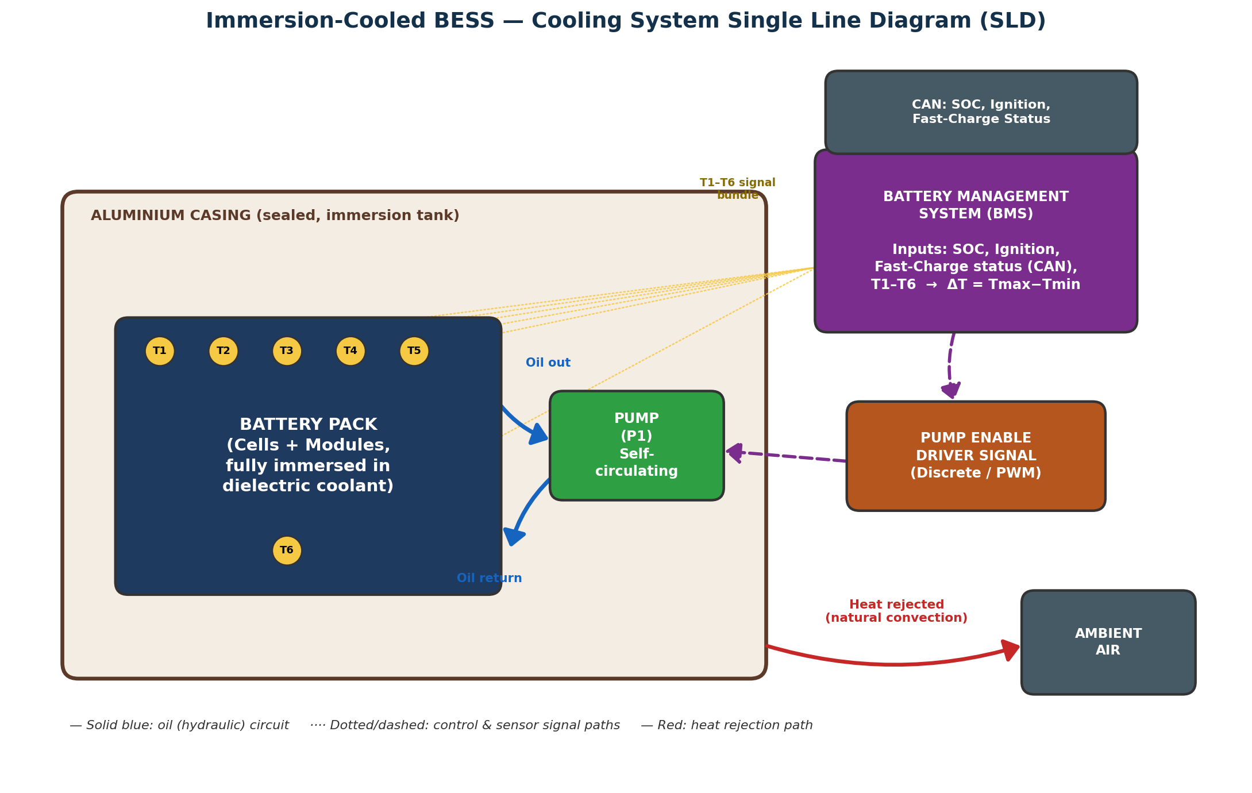

Applicant / System Integrator | VFCPL (Vayusakti Future Construct Pvt. Ltd.)
Platform Reference | VFCPL-MEP-001
Approval Authority | Indian Register of Shipping (IRS)
Governing Documents | IRS Classification Note on Approval of Lithium-ion Battery Systems (CN Rev.1); IRS Guidelines on Battery Powered Vessels (GL Rev.2)
Document Type | Cooling System Technical Submission (Design, Control Logic & Test Data)
Revision | A — Issued for Review
Date | 12 September 2026
Classification | Company Confidential — For IRS Submission Use

Table of Contents

1. Purpose & Scope
This document presents the cooling system design, Battery Management System (BMS) pump control logic, dielectric coolant fluid technical properties, and performance validation data for the immersion-cooled Battery Energy Storage System (BESS) proposed for installation aboard the VFCPL-MEP-001 marine platform.
It is submitted by VFCPL, as system integrator and sole applicant, in support of type approval and vessel installation approval by the Indian Register of Shipping (IRS), under the IRS Classification Note on Approval of Lithium-ion Battery Systems (CN Rev.1, March 2026) and the IRS Guidelines on Battery Powered Vessels (GL Rev.2, March 2026).
The scope of this submission covers:
- Cooling system architecture and Single Line Diagram (SLD) — hydraulic and control signal paths.
- BMS-executed pump activation logic, including the governing Boolean conditions and full truth table.
- Technical characterisation of the dielectric immersion coolant fluid, including fire-safety, dielectric, and environmental properties.
- Bench thermal-cycle validation data (rest / discharge / rest / charge / rest) demonstrating in-service ΔT behaviour against the BMS control thresholds.
- Cycle-life capacity retention (State-of-Health) data across 818 charge/discharge cycles.
- An analysis of why the full-immersion architecture achieves optimum thermal uniformity and supports the cell's designed cycle life.
- A compliance cross-reference against the applicable standards framework.
This submission is intended to be read together with the compliance tracker workbook and requirement matrix already exchanged with IRS as part of the overall CPSS/BESS type-approval dossier for VFCPL-MEP-001.

2. Cooling System Description

2.1 Architecture Overview
The BESS battery pack is cooled by a closed-loop, self-circulating dielectric coolant system. The dielectric fluid is the sole coolant medium within the pack: there is no separate coolant reservoir and no external heat exchanger in the circuit. A single self-circulating pump (P1) continuously recirculates the coolant through the pack's immersion channel and directly back to the pump, redistributing heat within the pack to equalise cell temperatures rather than rejecting heat to an external loop.
Because the coolant is also the dielectric medium in which the cells are immersed, the fluid performs two simultaneous functions: (i) electrical insulation between live cell surfaces and the earthed casing, and (ii) thermal transport from the cell surface to the casing wall. This is the defining characteristic of the full-immersion cooling architecture, as distinct from cold-plate or air-cooled designs.

2.2 Monitoring & Control Inputs
The BMS continuously monitors:
- State of Charge (SOC)
- Ignition status
- Fast-charge status, received via CAN bus from the DC charger / on-board charger
- Pack temperature via six thermistors (T1–T6), from which ΔT = Tmax − Tmin is derived in real time
Based on these inputs, the BMS issues a discrete/PWM pump-enable signal to the pump driver, which energises Pump P1. The complete signal and hydraulic architecture is shown in the Single Line Diagram (Figure 1).

2.3 Heat Rejection Path
With no external heat exchanger in the circuit, the pack rejects heat entirely through its own casing, along the following path:
Cell → Coolant (convection) → Coolant circulation (pack-wide homogenisation) → Coolant → Casing wall (conduction) → Casing → Ambient air (natural convection)
This heat-rejection path, combined with the ΔT-based control logic described in Section 4, is the primary means by which the system constrains intra-pack thermal gradients during both drive and fast-charge operating modes.

3. Cooling System — Single Line Diagram (SLD)
Figure 1 shows the cooling system SLD: the hydraulic circuit (solid blue), the BMS control and sensor signal paths (dashed / dotted), and the casing heat-rejection path (red). Six thermistors (T1–T6) are positioned on the pack — five near the corners/edges and one centrally located — feeding the ΔT computation in the BMS.
Figure 1 — Immersion-cooled BESS cooling system SLD: hydraulic circuit, BMS control/sensor signal paths, and casing-to-ambient heat rejection path.

3.1 Key Design Features Evident in the SLD
- Single closed hydraulic loop — pack immersion channel → pump → pack immersion channel — with no external heat exchanger or reservoir.
- Thermistor bundle (T1–T6) feeds the BMS continuously; the BMS computes ΔT and issues the pump-enable signal independently of the hydraulic circuit.
- CAN-bus inputs (SOC, ignition, fast-charge status) are combined with the thermal signal at the BMS before the pump-enable decision is issued.
- The only path for heat to leave the system is via the sealed aluminium casing to ambient air — a design point directly relevant to fire and thermal-runaway propagation assessment under the IRS framework.

4. BMS Pump Activation Logic
The cooling pump is switched ON whenever either of two conditions is satisfied. This section defines both conditions, their combined Boolean structure, and the full truth table executed by the BMS.

4.1 Condition A — Fast Charging
- Fast charging is active, AND
- SOC ≥ 10%
When Condition A is met, the pump is latched ON for the entire fast-charge session — it does not cycle off between charge pulses. It turns off once fast charging ends or SOC drops below the 10% threshold, whichever occurs first.

4.2 Condition B — Thermal Delta During Drive
- A minimum temperature differential ΔT ≥ 4°C exists within the pack (Tmax − Tmin across monitored cells), AND
- Ignition is ON, AND
- SOC ≥ 10%
When Condition B is met, the pump switches ON, and switches OFF as soon as any one of the three sub-conditions is no longer satisfied.

4.3 Combined Logic
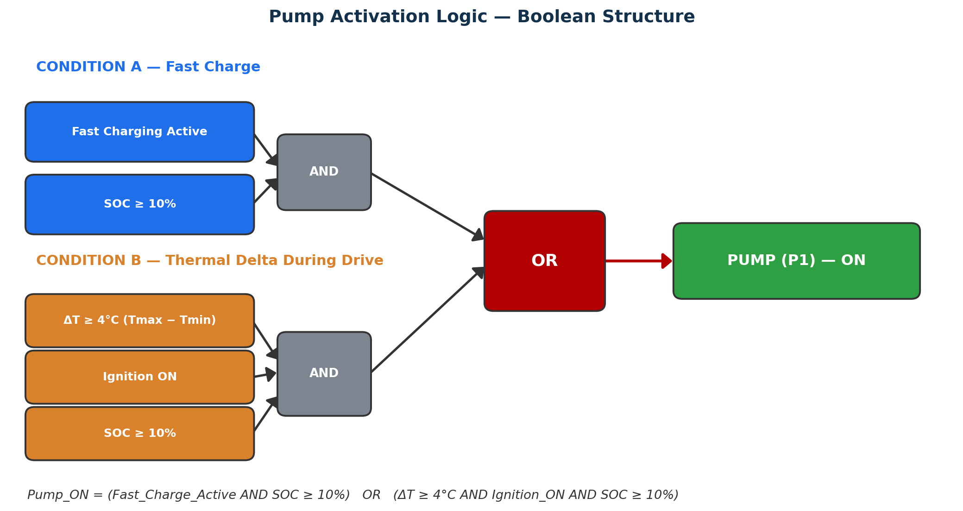
Figure 2 — Pump control logic: Condition A and Condition B combine through an OR function to generate the pump-enable output.

4.4 Truth Table
Fast Charge Active | ΔT ≥ 4°C | Ignition ON | SOC ≥ 10% | Pump State | Governing Condition
TRUE | — | — | TRUE | ON | Condition A (fast charge)
TRUE | — | — | FALSE | OFF | SOC below threshold
FALSE | TRUE | TRUE | TRUE | ON | Condition B (ΔT + ignition)
FALSE | TRUE | TRUE | FALSE | OFF | SOC below threshold
FALSE | TRUE | FALSE | TRUE | OFF | Ignition not ON
FALSE | FALSE | TRUE | TRUE | OFF | ΔT below threshold
FALSE | FALSE | FALSE | FALSE | OFF | No condition met

5. Dielectric Immersion Coolant Fluid — Technical Properties
The coolant fluid is a synthetic organic ester dielectric fluid, formulated to meet IEC 61099:2010 and the equivalent Indian Standard IS 16081:2013 for unused synthetic organic esters for electrical purposes. It is classified as a K-class (less-flammable) insulating liquid, and is the sole coolant and dielectric medium in the immersion-cooled battery pack described in Sections 2–4.

5.1 Fire Safety Performance
- Flash point 290°C / fire point 316°C — versus a typical mineral-oil flash point of ~140–160°C — meeting K-class classification.
- Net Calorific Value of approximately 31.6–32.6 MJ/kg, within the K-class fire-severity threshold, limiting fire severity in the event of a casing breach.
- Certified under UL 340 and FM Approval (Class 6933) frameworks (Section 5.4), supporting reduced separation-distance and fire-protection design margins, subject to confirmation by the authority having jurisdiction.

5.2 Typical Technical Properties
Property | Test Method | Unit | Typical Value | IEC 61099 / IS 16081 Limit
Appearance | Visual | - | Clear, pale yellow liquid | Clear
Colour | IEC 61099 / ISO 2049 | - | < 1 | < 1
Density at 20°C | IEC 61099 / ISO 12185 | kg/m³ | 963.5 | ≤ 1000
Viscosity at 40°C | ASTM D 7042 | mm²/s | 30.0 | max. 35
Viscosity at −20°C | ASTM D 7042 | mm²/s | 1446 | max. 3000
Viscosity at 100°C | ASTM D 7042 | mm²/s | 5.38 | max. 15
Pour Point | IEC 61099 / ISO 3016 | °C | −57 to −63 | max. −40
Flash Point | IEC 61099 / ISO 2592 | °C | 290 | min. 250
Fire Point | IEC 61099 / ISO 2592 | °C | 316 | min. 300
Neutralisation Value | IEC 62021-3 | mg KOH/g | < 0.01 | ≤ 0.03
Water Content | IEC 60814 | mg H2O/kg | 3 | ≤ 200
Breakdown Voltage | IEC 60156 | kV | 73 | > 45
Dielectric Dissipation Factor (90°C) | IEC 60247 | - | 0.006 | ≤ 0.03
DC Resistivity at 90°C | IEC 60247 | GΩ·m | 15 | min. 2
Corrosive Sulfur | IEC 62535 | - | Non-corrosive | Negative
Oxidation Stability 164h – Total Acidity | IEC 61125 | mg KOH/g | 0.10 | max. 0.3
Oxidation Stability 164h – Sludge | IEC 61125 | % | < 0.01 | max. 0.01
PCB Content | IEC 61619 | mg/kg | Not detectable | Not detectable
DBDS Content | IEC 62697-1 | mg/kg | Not detectable | Not detectable
Net Calorific Value | ASTM D 240 | MJ/kg | 31.6 – 32.6 | K-class (fire point ≥ 300°C)

5.3 Environmental and Aquatic Safety Data
Environmental Test | Method | Result | Ref.
Ready Biodegradability | OECD 301B | 92.91% biodegradation by Day 28 (reference: rapeseed oil, 100%) — meets 60% ready-biodegradability threshold | Appx. H
Acute Aquatic Toxicity – Daphnia magna | OECD 202 | 24h EC50 > 100 mg/L; 48h EC50 > 100 mg/L — no immobilisation observed up to 100 mg/L | Appx. J
Freshwater Algae Growth Inhibition | OECD 201 | No adverse effect threshold reached in the tested range | Appx. I
Acute Aquatic Toxicity – Fish | OECD 203 | No adverse effect threshold reached in the tested range | Appx. K

5.4 Certifications, Approvals & Supporting Test Reports
Certification / Test Report | Scope | Date / Reference | Appx.
UL 340 (6th Ed.) | Dielectric Mediums (EOUV) | 04-Apr-2024 | Appx. B
FM Approval, Class 6933 | Property loss prevention / fire performance | 08-Mar-2024 | Appx. C
ATEX Ex II 3G Ex II B T4 | Zone 2 explosive-atmosphere use | Valid 30-Jun-2025 to 29-Jun-2035 | —
IEC 61099:2010 / IS 16081:2013 Type Test | Independent laboratory type testing (Siemens Energy) | 04-Jul-2023 | Appx. A
Net Calorific Value Test Report | Independent laboratory test (Intertek India) | See report | Appx. D
EN 45545 Fire Behaviour Test Report | Independent laboratory test (Ignito Labs) | 22-Dec-2023 | Appx. E
ERDA Test Report — Transol Synth 100 | Independent property verification (ERDA, Vadodara) | See report | Appx. F
ERDA Crystallization Report | Low-temperature crystallization behaviour (ERDA) | RP-2425-005920 | Appx. G

Full batch-specific properties are subject to confirmation against the current Certificate of Analysis and Safety Data Sheet (SDS) at the time of formal submission; the values above are typical properties compiled from independent laboratory test reports and certification bodies.

5.5 Index of Supporting Test Reports
The independent laboratory test reports and certification documents underlying Sections 5.1–5.4 are reproduced in full in the Appendices, indexed below.
Appx. | Report Title | Issuing Laboratory / Body | Page
A | IEC 61099 / IS 16081 Independent Type Test Report | Siemens Energy Global GmbH & Co. KG | 15
B | UL 340 Certificate of Compliance | UL Solutions | 18
C | FM Approval — Certificate of Compliance (Class 6933) | FM Approvals | 21
D | Net Calorific Value Test Report | Intertek India Pvt. Ltd. | 23
E | Fire Behaviour Test Report (EN 45545) | Ignito Labs Pvt. Ltd. | 26
F | ERDA Test Report — Transol Synth 100 | ERDA, Vadodara | 30
G | Crystallization Report (RP-2425-005920) | ERDA, Vadodara | 35
H | Biodegradability Test Report (OECD 301B) | Intertek India Pvt. Ltd. | 39
I | Freshwater Algae Growth Inhibition Report (OECD 201) | Intertek India Pvt. Ltd. | 47
J | Daphnia sp. Immobilisation Report (OECD 202) | Intertek India Pvt. Ltd. | 54
K | Fish Acute Toxicity Report (OECD 203) | Intertek India Pvt. Ltd. | 64

6. Thermal Performance Validation
Bench thermal-cycle testing was conducted at 28°C ambient across a full operational sequence — rest, discharge, rest, charge, rest — with all six pack thermistors (T1–T6) and battery ambient (T_Amb) logged continuously. This section presents the measured thermal response and cross-references it against the ΔT ≥ 4°C pump-activation threshold defined in Section 4.
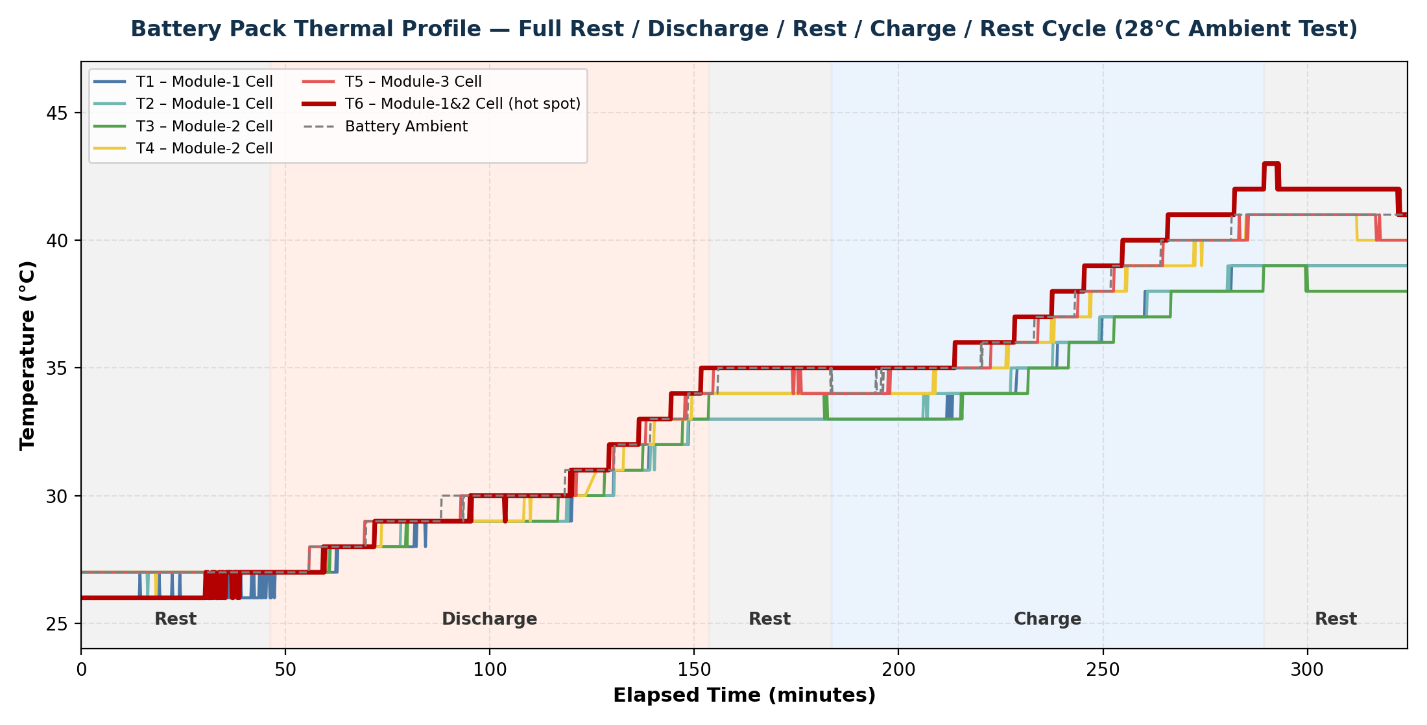
Figure 3 — Measured pack temperature profile across the full rest / discharge / rest / charge / rest test sequence (28°C ambient). Shaded bands mark each operating phase.

6.1 Phase-wise Temperature Change Summary
Phase | Time Window | Duration (min) | Temperature Change Range (°C) | Observation
Rest (initial) | 15:27 – 16:14 | 46 | 0 to +1 | Baseline, thermal equilibrium with 28°C ambient
Discharge | 16:14 – 18:01 | 107 | +6 to +8 | Steady rise; T6 (hot spot) shows largest gain
Rest (post-discharge) | 18:01 – 18:31 | 30 | −1 to 0 | Near-flat; slight inter-cell equalisation
Charge | 18:31 – 20:17 | 106 | +6 to +7 | Comparable rise profile to discharge; T6 again highest
Rest (final) | 20:17 – 20:52 | 35 | −2 to 0 | Slight cooling / equalisation toward test end

6.2 Correlation with Pump Activation Threshold
The peak instantaneous intra-pack differential recorded across the six BMS-monitored cell thermistors (T1–T6) during the test was ΔT = 4°C, occurring during the charge phase and again during the post-charge rest phase — precisely at the ΔT ≥ 4°C threshold that triggers Condition B of the pump control logic. During both the discharge and charge phases, the module 1/2 cell location (T6) consistently ran hottest, while the module-1 cell locations (T1/T2) ran coolest, confirming that meaningful intra-pack gradients develop during active operation and that the BMS ΔT threshold is set at the level these gradients actually reach — i.e., the control logic is positioned to engage under real operating conditions rather than only in edge cases.
The overall absolute temperature range recorded across the six pack thermistors and battery ambient during the full test was 26°C to 43°C — consistent with the heat-rejection path described in Section 2.3, where the coolant homogenises pack temperature ahead of conduction through the casing wall.

7. Cycle-Life Capacity Retention (State of Health)
Charge/discharge capacity and State-of-Health (SOH) were tracked over 818 recorded cycles to characterise long-term capacity fade under repeated cycling — a key input to the battery system's service-life and end-of-life safety margin assessment.
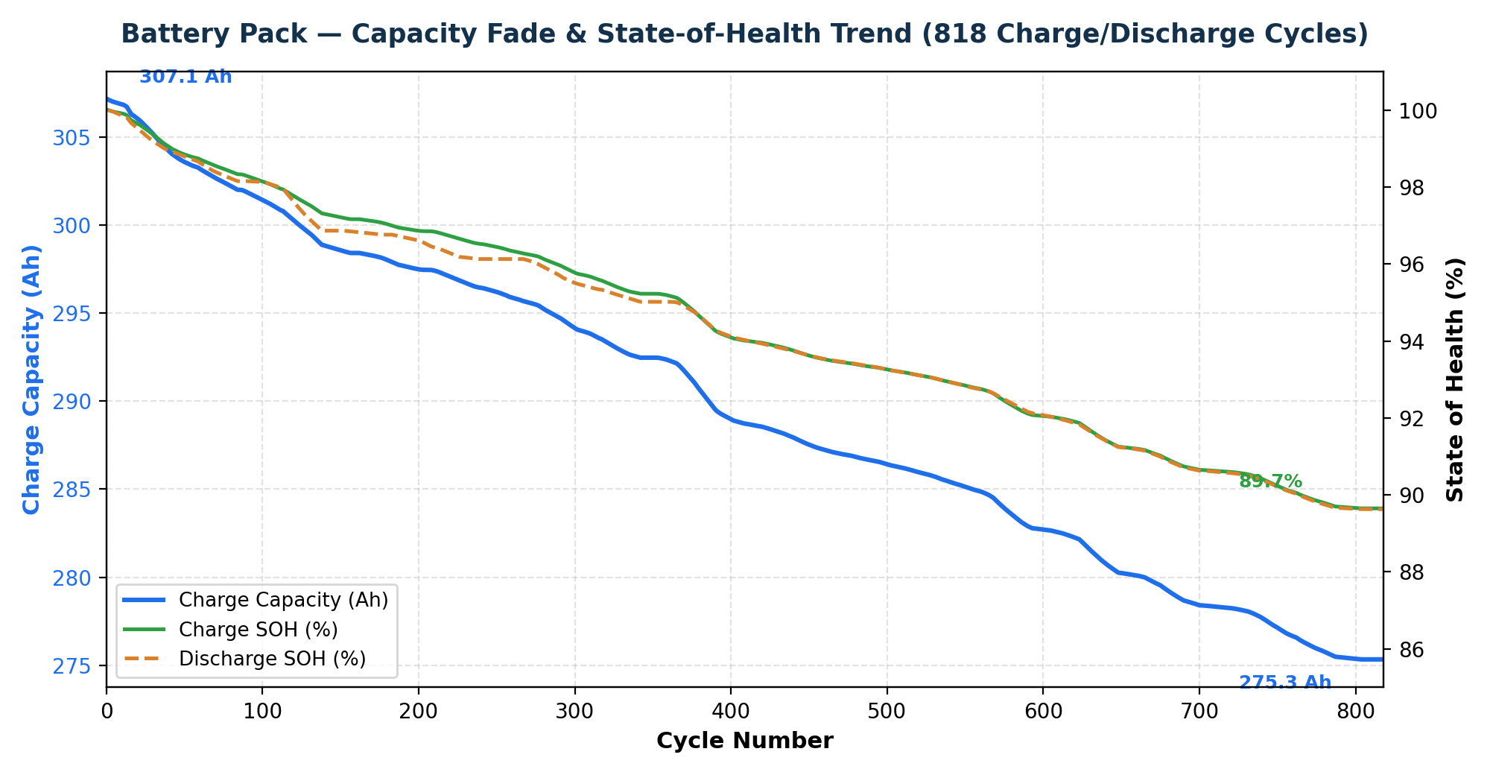
Figure 4 — Charge capacity and SOH trend over 818 charge/discharge cycles.

7.1 Summary — Cycle 1 vs. Cycle 818
Parameter | Cycle 1 | Cycle 818 | Change
Charge Capacity (Ah) | 307.12 | 275.33 | −10.35%
Charge SOH (%) | 100.00 | 89.65 | −10.35 pp
Discharge SOH (%) | 99.99 | 89.63 | −10.36 pp
Cell SOH (%) | 100.00 | 93.81 | −6.19 pp

Capacity fade follows a steady, near-linear trend over the recorded cycle range with no step changes or anomalous discontinuities, indicating stable, predictable degradation behaviour under the tested cycling regime rather than an incipient fault condition. The “Cell SOH” metric (tracking the least-healthy monitored cell) fades more slowly than pack-level Chg/Dch SOH over the recorded range, which is expected where pack-level capacity is constrained by more than one cell's balance state.

8. Immersion Cooling Performance — Achieving Optimum Thermal Uniformity and Full Design-Life Cycling for Lithium-ion Cells
This section draws together the SLD/control-logic design (Sections 2–4), the coolant properties (Section 5), and the measured test data (Sections 6–7) to demonstrate why the full-immersion cooling architecture achieves the thermal uniformity and controlled cycling environment that lithium-ion cells require to reach their intended service life.

8.1 Direct-Contact Immersion Removes the Weak Links in Conventional Cooling
In a cold-plate design, heat must conduct from the cell body, across a contact interface (and any thermal-interface material), to a single cooled face — cells or regions farther from that face run measurably hotter. In an air-cooled design, the working fluid itself (air) has a heat-transfer coefficient roughly an order of magnitude lower than a liquid, and airflow shadowing readily creates hot pockets. Full immersion removes both weak links at once: the dielectric coolant is in direct contact with the entire wetted cell surface, so heat is drawn from the whole cell body rather than one face, and the fluid's own circulation (Section 2) continuously redistributes that heat across the pack.

8.2 What the Measured Data Confirms
- Even under the most thermally demanding phases (discharge and charge), the peak instantaneous intra-pack differential across the six BMS-monitored cell thermistors (T1–T6) was ΔT = 4°C (Section 6), remaining tightly bounded throughout the full duty cycle and confirming the coolant is effectively homogenising heat across the pack.
- The BMS ΔT ≥ 4°C trigger (Section 4) is closely matched to the peak gradient observed in bench testing, engaging pump circulation exactly when a meaningful intra-pack gradient emerges — demonstrating that the immersion architecture, together with the control logic, actively bounds the thermal envelope across the full drive and fast-charge duty cycle.
- No hot-spot thermistor location exceeded the pack's overall 26–43°C operating band recorded across the full rest/discharge/rest/charge/rest sequence — well inside the safe operating window for the cell chemistry.

8.3 Qualitative Comparison Against Alternative Cooling Architectures
The comparison below is a general, qualitative characterisation of cooling-architecture behaviour for context; it is not a side-by-side test result — only the immersion-cooled configuration in Sections 6–7 has been bench-validated for this system.
Cooling Architecture | Contact Mode | Typical Cell-to-Cell ΔT Tendency | Hot-Spot / Fire-Path Risk | Heat-Extraction Effectiveness
Full Immersion (this system) | Fluid wets entire cell surface directly | Low — measured max ΔT = 4°C across monitored cell thermistors | Low — no dry contact points; fluid also suppresses/delays thermal-runaway propagation | High — fluid draws heat from the whole cell body, not one face
Cold Plate (typical) | Contact at one face only; conduction through interface/TIM | Moderate — conduction path length and TIM quality govern gradient | Moderate — cells farthest from plate run hotter | Moderate — heat must first conduct to the contact face
Forced/Natural Air (typical) | Convective contact only, indirect | High — air has far lower heat capacity/conductivity than liquid | Higher — airflow shadowing creates hot pockets | Lower — weakest heat-transfer coefficient of the three

8.4 Cycle-Life Outcome Consistent With the Desired Service Life
Over the 818 recorded cycles (Section 7), charge capacity fell 10.35% and Charge SOH fell from 100% to 89.65% — a steady, near-linear trend with no step changes or accelerated-fade signatures that would indicate thermally-driven degradation. On a simple linear extrapolation of this observed rate (i.e. assuming no change in fade behaviour beyond the tested range), the pack would be projected to remain above an 80% SOH end-of-life threshold for approximately 1,580 cycles — well beyond the 818 cycles actually exercised.
This projection is indicative only: real cells typically show a more concave (accelerating) fade curve approaching end-of-life rather than a straight line, so it should be treated as an order-of-magnitude indication rather than a guaranteed cycle count, pending extended cycling to validate the true end-of-life knee point. Within the tested range, however, the data shows no evidence that the immersion-cooled thermal environment is accelerating degradation — which is the relevant conclusion for this submission: the cooling architecture is not the limiting factor on cycle life.

8.5 Summary Position
Taken together, Sections 6–8 show that the full-immersion architecture keeps intra-pack thermal gradients small and actively bounded, keeps the coolant/casing/ambient heat-rejection path (Section 2.3) effective across the full duty cycle, and is consistent with — rather than a constraint on — the cell's designed cycle life. This is the basis on which VFCPL considers the cooling architecture to deliver the level of thermal control a lithium-ion marine BESS requires to reach its intended operational life.

9. Compliance Cross-Reference
The table below maps the technical content of this submission against the applicable standards framework already established for the VFCPL-MEP-001 type-approval programme. It is intended as a navigation aid alongside the full compliance tracker workbook and requirement matrix submitted separately; it does not restate every individual clause.
Compliance Area | Governing Standard(s) | Cross-Reference in This Document / Programme
Battery system safety (cell/system electrical & environmental tests) | IEC 62619, IEC 62620 | Referenced in the wider CPSS compliance tracker (Batteries / BMS sheets); cycle-life data in Section 7 supports capacity/SOH-related test items
Hazardous-area / ignition-source rating | IEC 60079 (Ex equipment, Zone 2) | Coolant ATEX rating (Section 5.4) is directly relevant where the immersion tank interfaces with a classified space
Insulating liquid — synthetic ester | IEC 61099:2010 / IS 16081:2013 | Section 5.2 — full typical-properties table against IEC 61099/IS 16081 limits
Marine equipment qualification (shock, vibration, EMC, climatic, salt mist, inclination, etc.) | IACS UR E10 (Rev.10, Aug 2024) | Addressed in the parallel IACS UR E10 test matrix prepared for the battery/BMS system; coolant compatibility test programme referenced separately
Fire safety / less-flammable liquid provisions | FSS Code, SOLAS II-2 (as referenced in IRS Guidelines) | Section 5.1 — K-class fire performance data (flash/fire point, calorific value, UL 340 / FM 6933)
Battery space / vessel installation requirements | IRS Guidelines on Battery Powered Vessels (GL Rev.2) | Addressed in the Battery Space / Vessel Installation sheet of the compliance tracker; cooling architecture (Section 2–4) is the primary technical input

10. Conclusion & Recommendation
The immersion-cooled BESS cooling system described in this submission uses a single-loop, self-circulating dielectric coolant architecture with a clearly defined, dual-condition BMS pump control logic (Section 4). Bench validation data demonstrates:
- Intra-pack thermal gradients of up to 4°C develop under real discharge/charge operation — precisely the level at which the ΔT ≥ 4°C pump-activation threshold is designed to respond, confirming the control logic is correctly scoped to actual operating conditions.
- The coolant fluid meets IEC 61099:2010 / IS 16081:2013 K-class insulating-liquid requirements, with fire, dielectric, and environmental performance suitable for a sealed marine immersion application.
- Capacity retention over 818 cycles shows stable, predictable fade behaviour with no anomalous degradation, supporting the assumed service-life and safety margins used elsewhere in the CPSS type-approval dossier.
- The direct-contact immersion architecture (Section 8) achieves the thermal uniformity and bounded ΔT envelope that lithium-ion cells require to reach their intended cycle life, with no evidence in the tested range that the cooling environment is a limiting factor on degradation.
On this basis, VFCPL respectfully submits that the cooling system design, control logic, and supporting performance data presented in this document are suitable for IRS review as part of the type-approval and vessel installation approval process for VFCPL-MEP-001, and requests IRS's review and comments.

This document should be read together with:
- The CPSS compliance tracker workbook (Batteries, BMS, Cooling System, Battery Space/Vessel Installation, Documentation, Tests & Certification sheets)
- The requirement matrix with responsibility (P/S) markers across the programme parties
- The IACS UR E10 test matrix prepared for the battery/BMS system
- Supplier no-objection letters, submitted separately as attachments per standard programme correspondence practice

Appendices — Supporting Test Reports & Certifications
The following pages reproduce, in full, the independent laboratory test reports and certification documents underlying the technical data presented in Section 5. These are provided as supporting evidence for IRS review; the index and page references are given in Section 5.5 of the main report.

Appendix A — IEC 61099 / IS 16081 Independent Type Test Report

Source Document | Siemens Energy Global GmbH & Co. KG — Test Report ML138-23 (04-Jul-2023)
Standard / Test Method | IEC 61099:2010 / IS 16081:2013 — full property panel
Relevance to This Submission | Independent verification of the typical properties table in Section 5.2
The pages of the original report follow, reproduced in full.

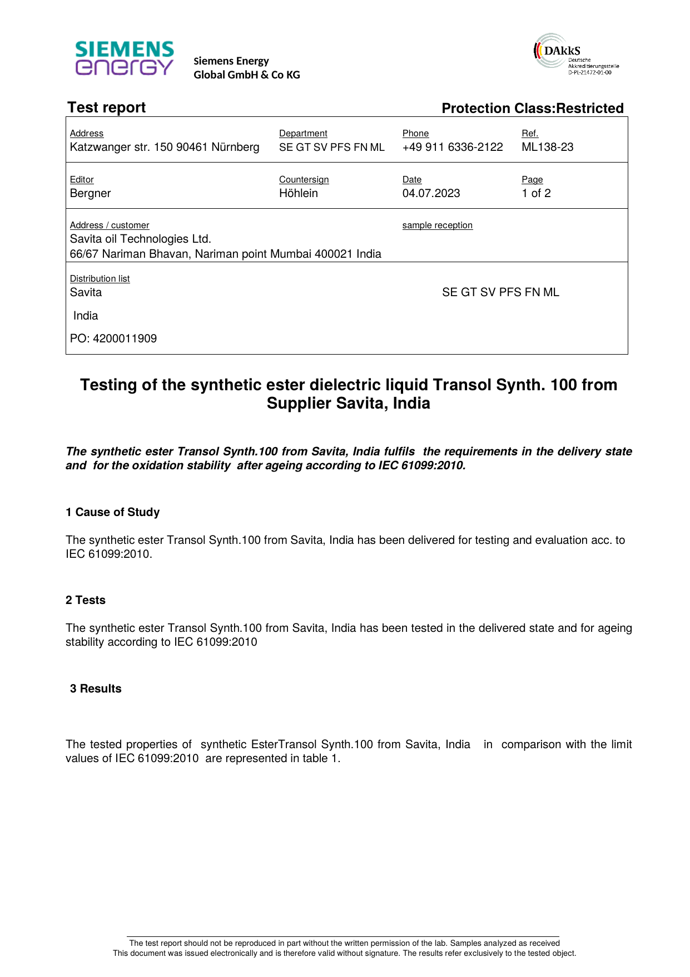

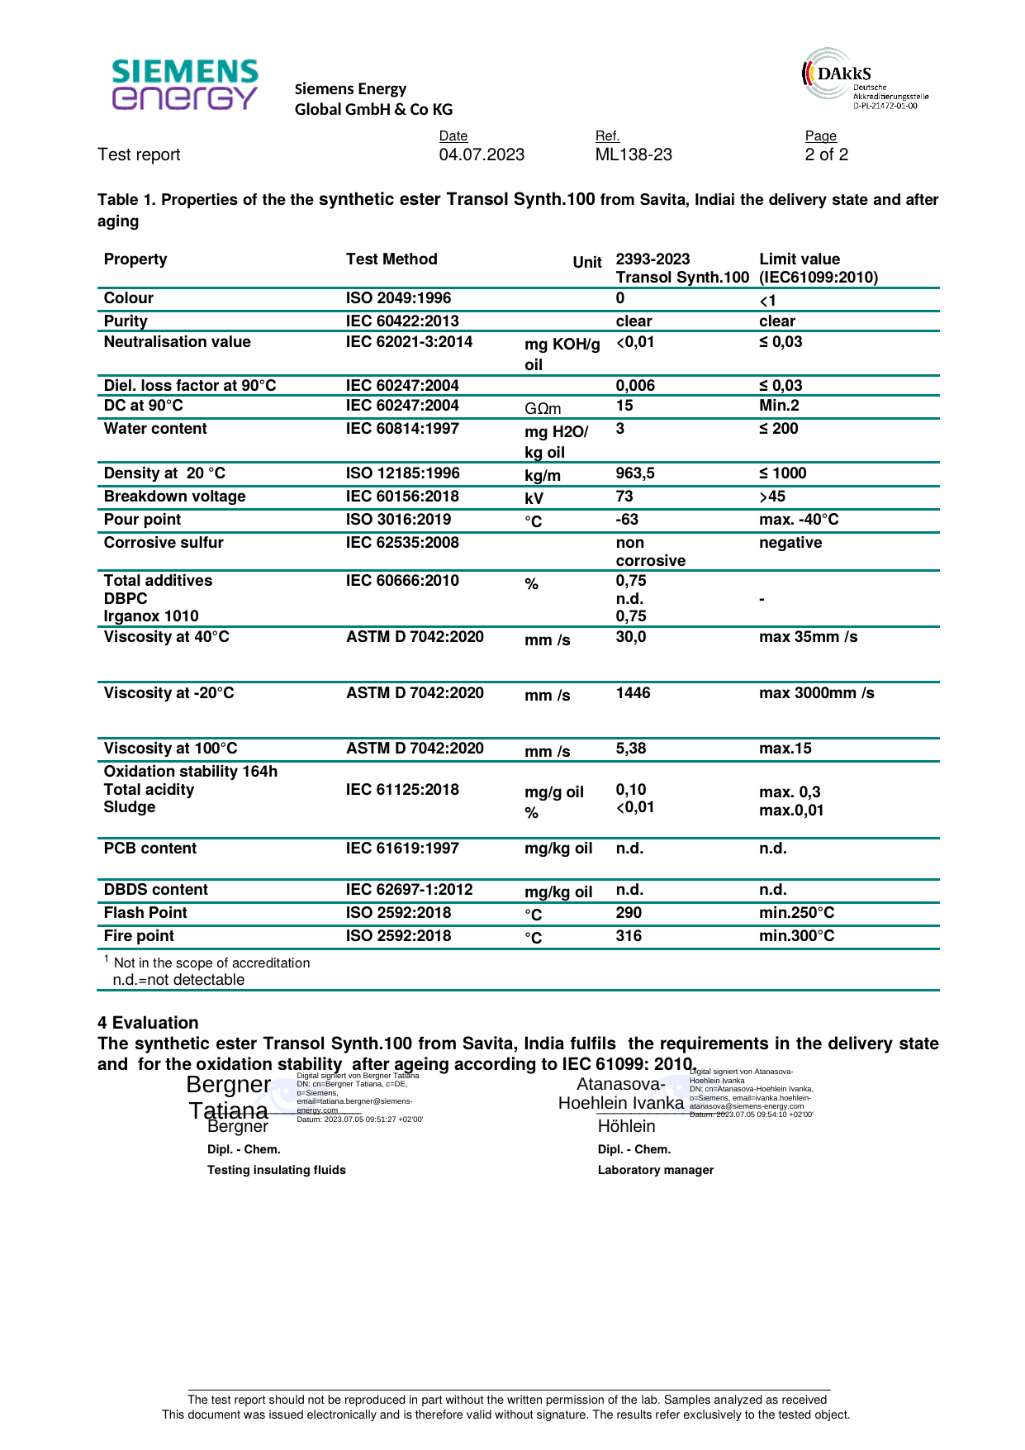

Appendix B — UL 340 Certificate of Compliance

Source Document | UL Solutions — Certificate UL-US-2409672-0
Standard / Test Method | UL 340 (6th Ed.) — Dielectric Mediums (EOUV)
Relevance to This Submission | Supports the fire-safety certification referenced in Sections 5.1 and 5.4
The pages of the original report follow, reproduced in full.

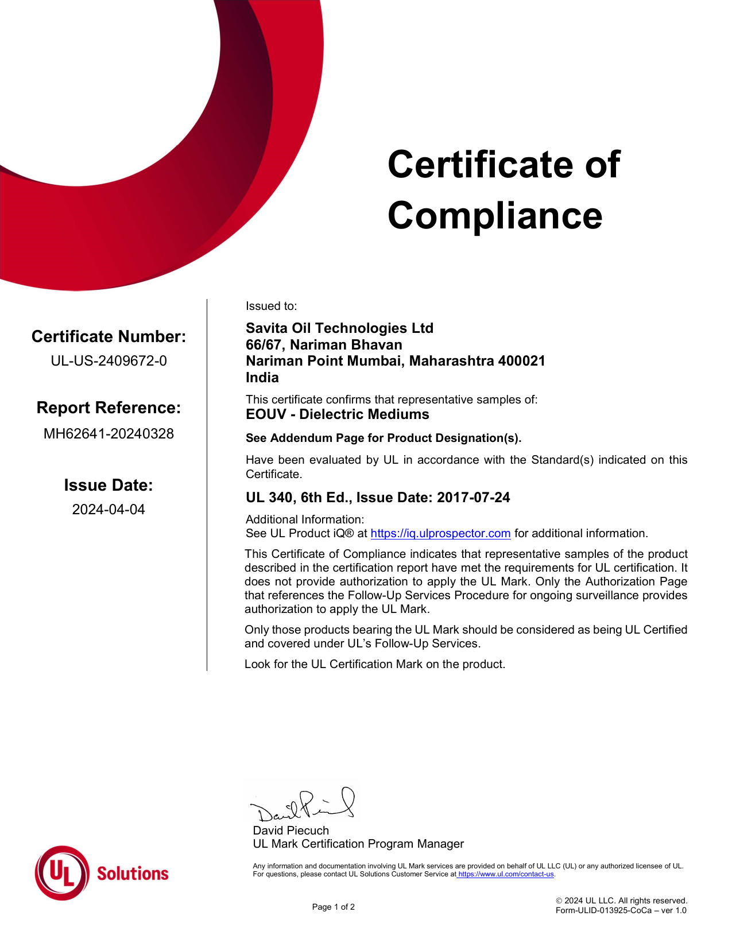

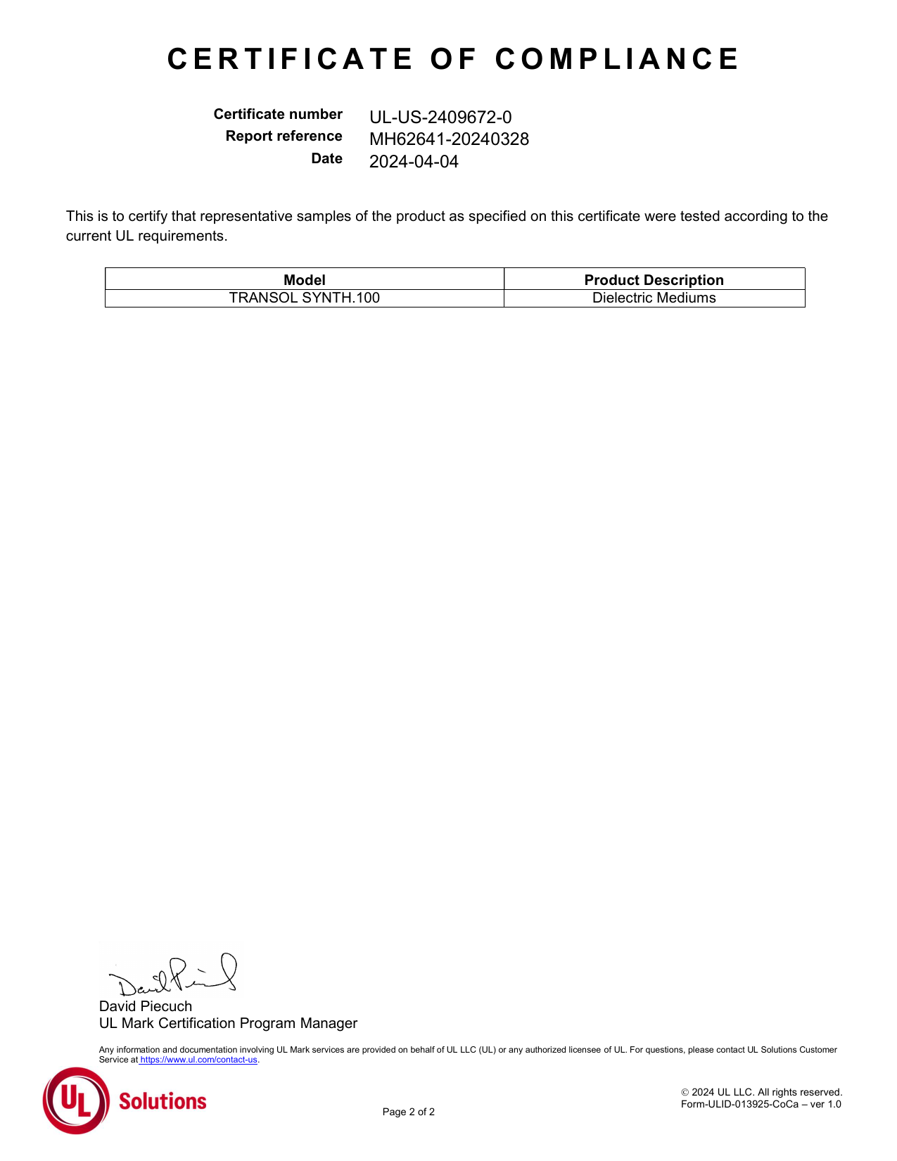

Appendix C — FM Approval — Certificate of Compliance

Source Document | FM Approvals — Approval Identification PR465843 (08-Mar-2024)
Standard / Test Method | FM Approval Standard, Class 6933
Relevance to This Submission | Supports the fire-safety certification referenced in Sections 5.1 and 5.4
The pages of the original report follow, reproduced in full.

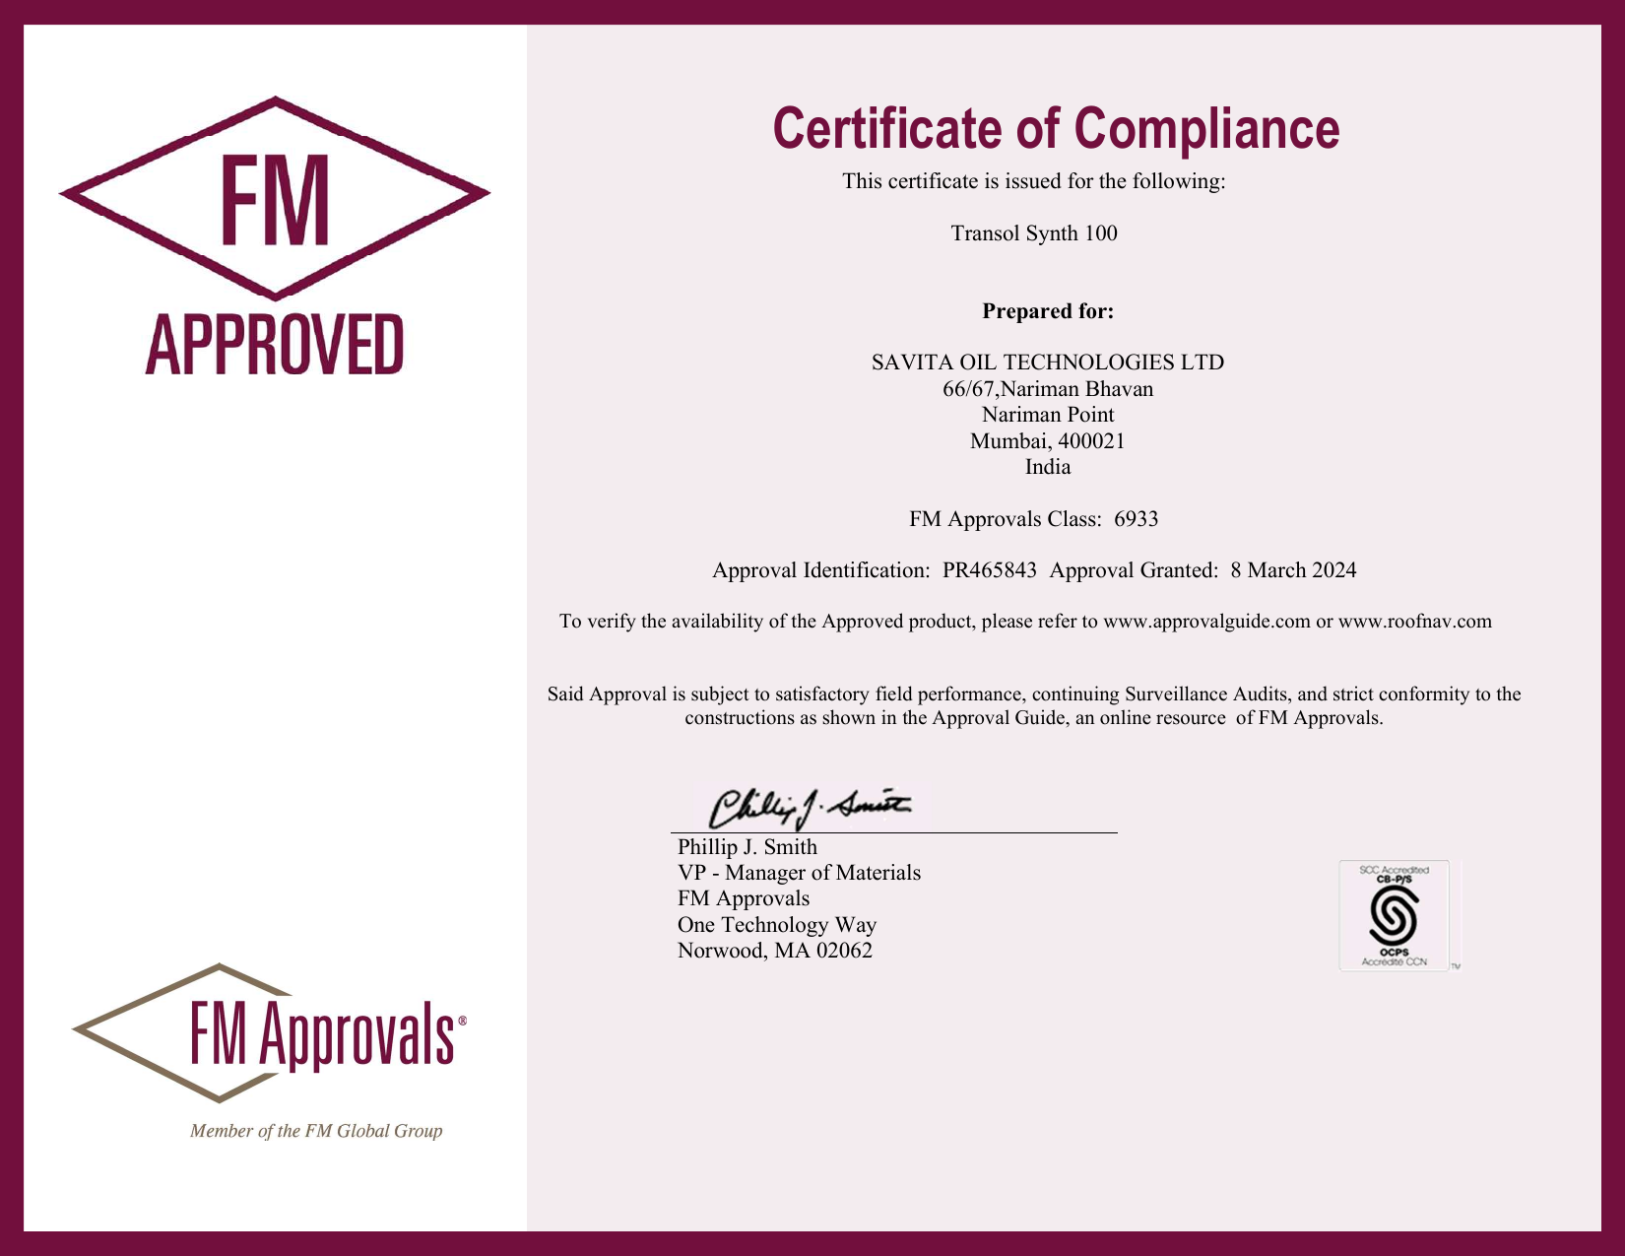

Appendix D — Net Calorific Value Test Report

Source Document | Intertek India Private Limited
Standard / Test Method | ASTM D 240
Relevance to This Submission | Supports the Net Calorific Value figure quoted in Sections 5.1 and 5.2
The pages of the original report follow, reproduced in full.

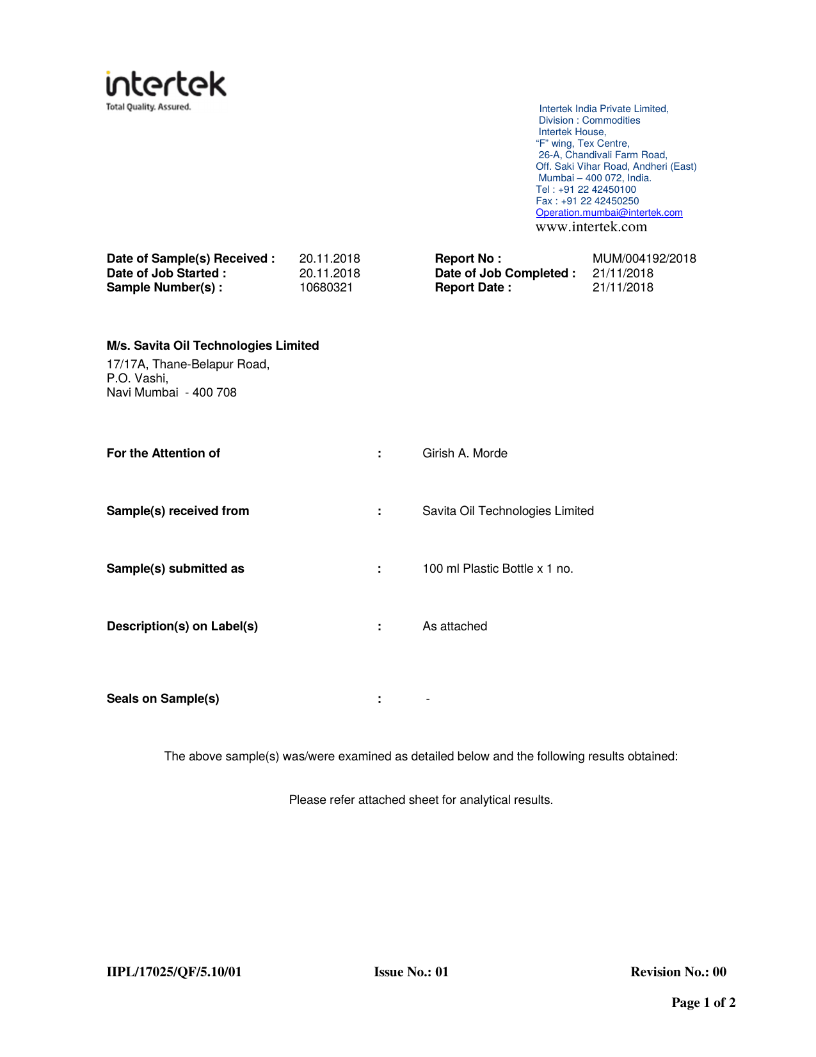

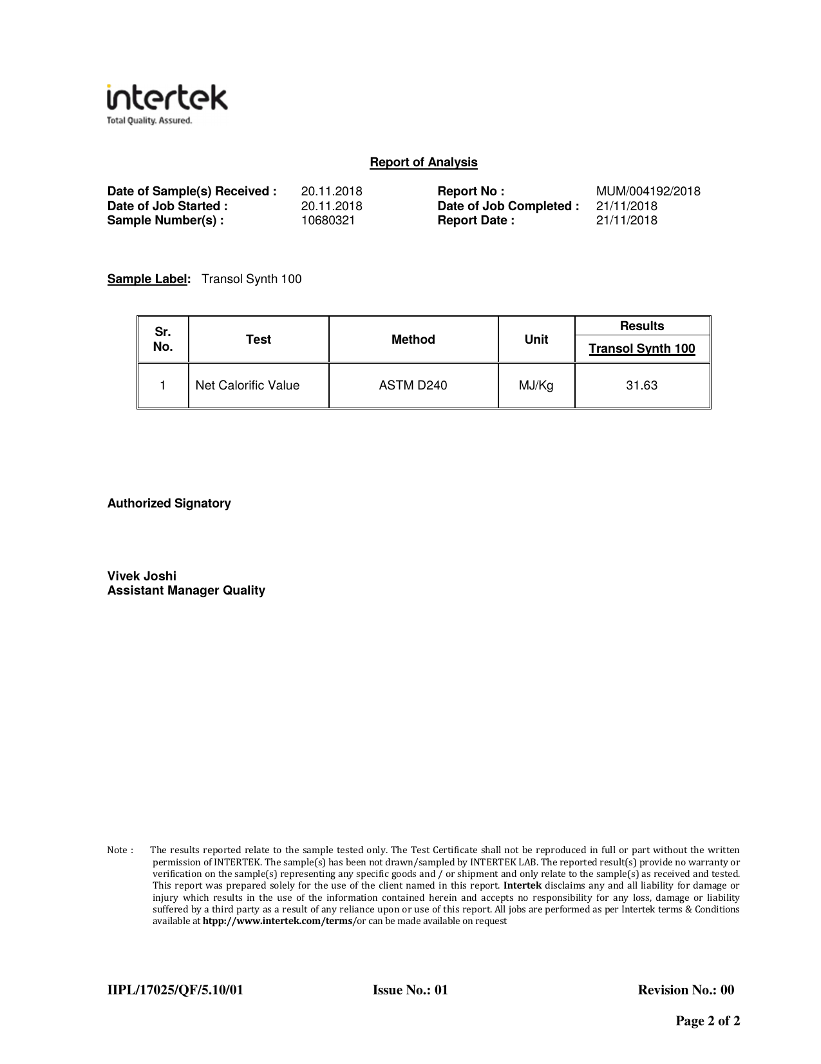

Appendix E — Fire Behaviour Test Report (EN 45545)

Source Document | Ignito Labs Private Limited — Test Report I231211009-1 (22-Dec-2023)
Standard / Test Method | EN 45545 (railway fire behaviour test series)
Relevance to This Submission | Supplementary fire-behaviour characterisation beyond the marine/K-class data in Section 5.1
The pages of the original report follow, reproduced in full.

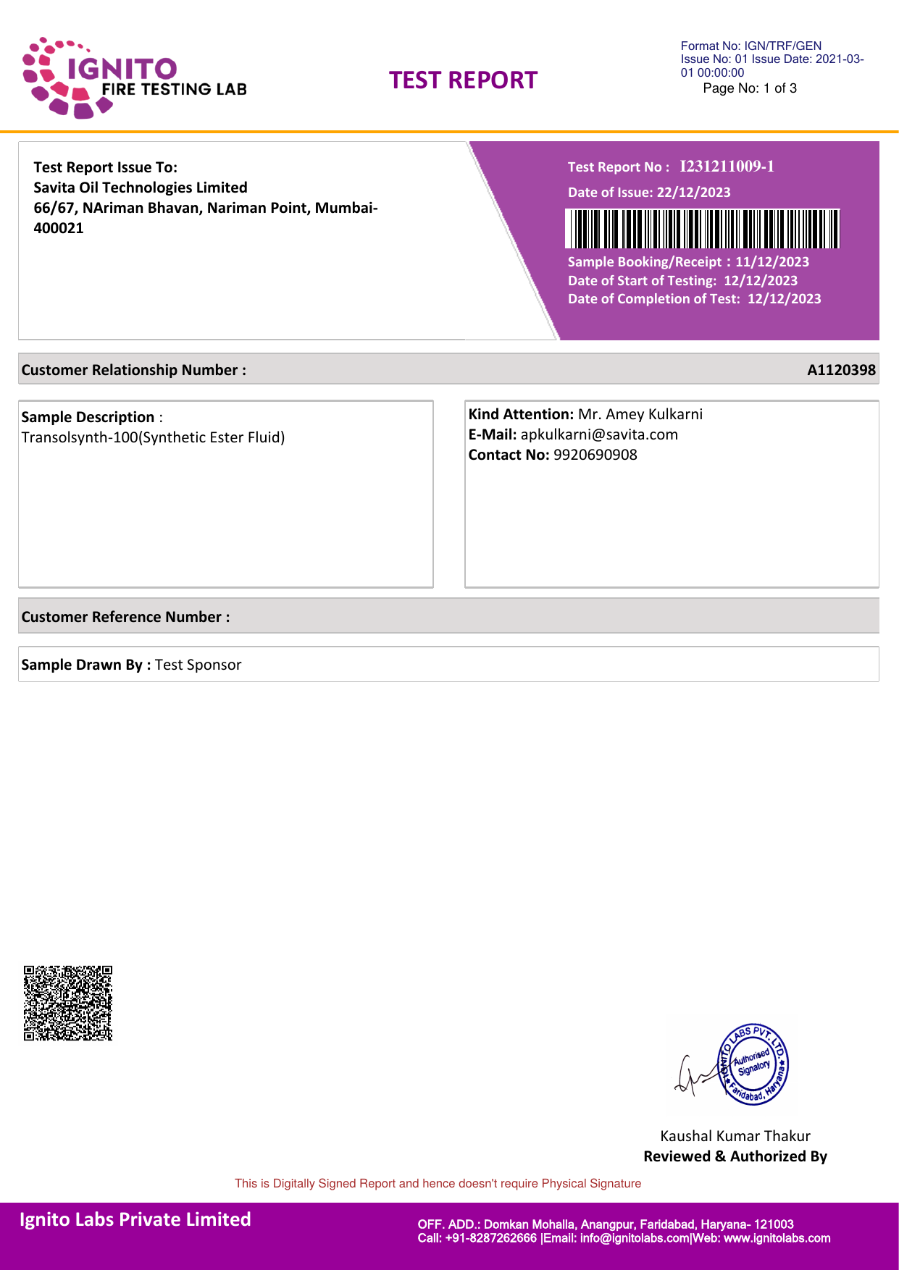

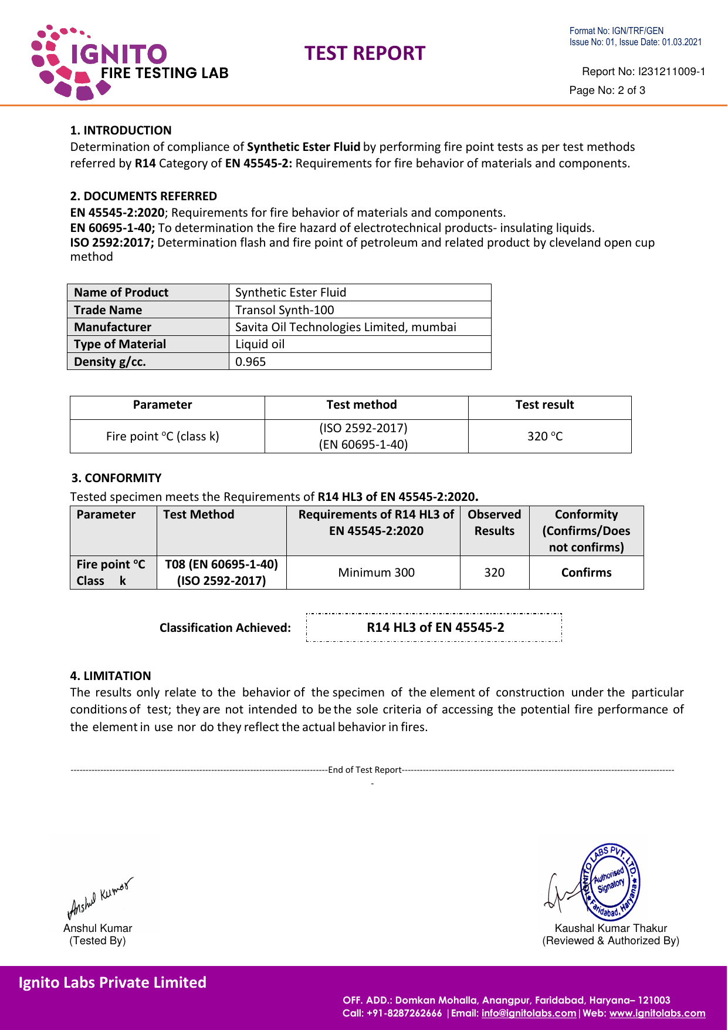

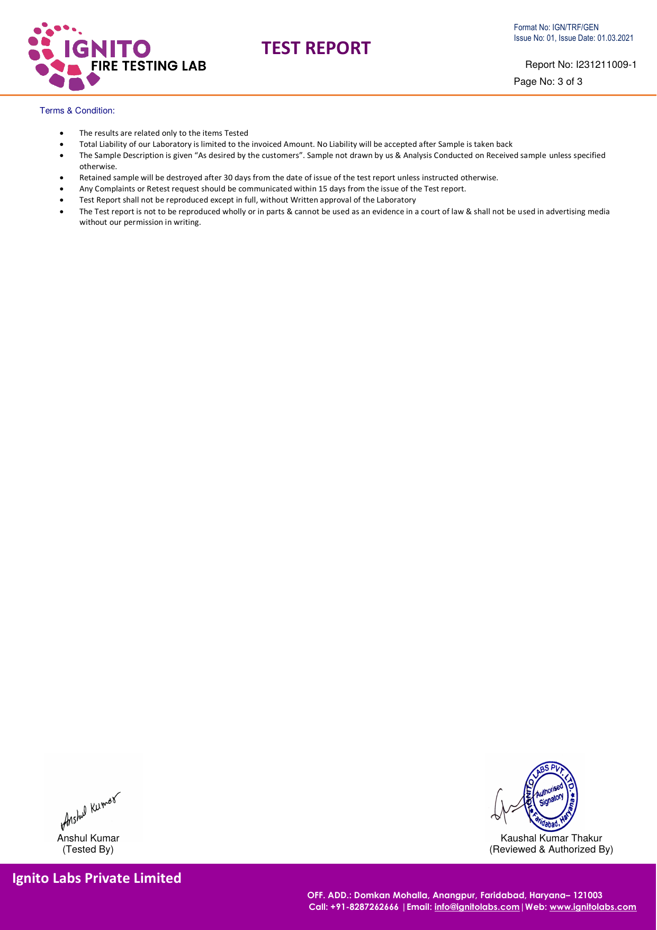

Appendix F — ERDA Test Report — Transol Synth 100

Source Document | Electrical Research and Development Association (ERDA), Vadodara
Standard / Test Method | IEC 61099 / IS 16081 property verification
Relevance to This Submission | Independent property verification supporting Section 5.2
The pages of the original report follow, reproduced in full.

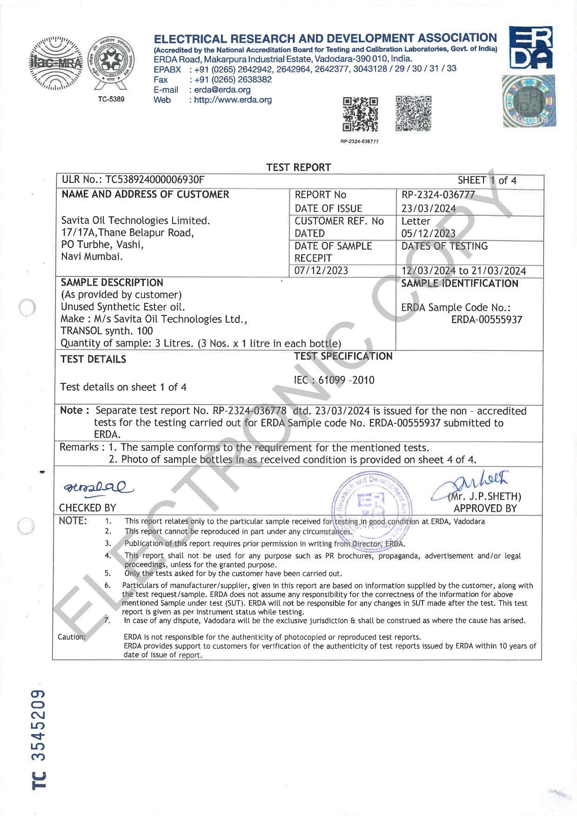

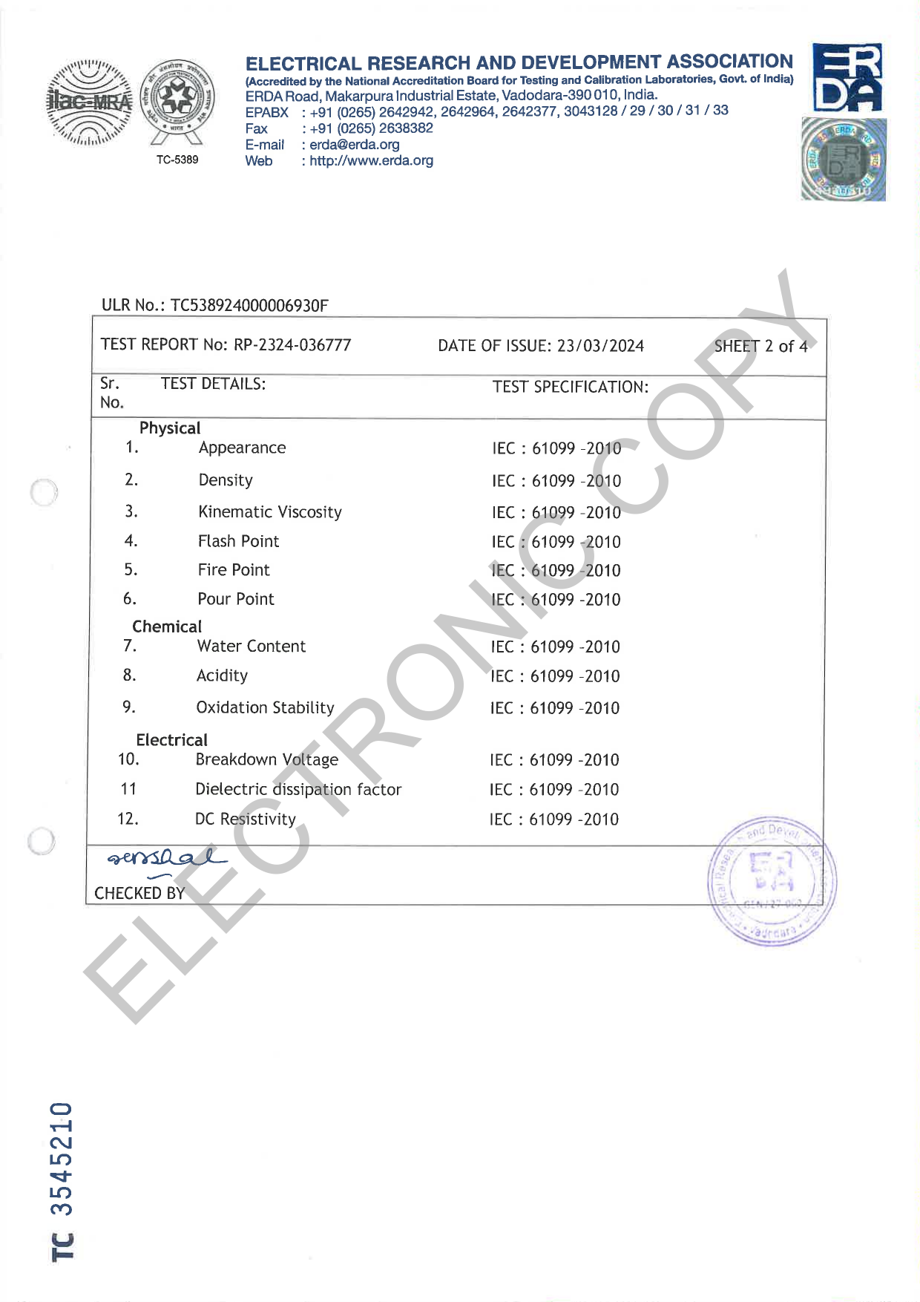

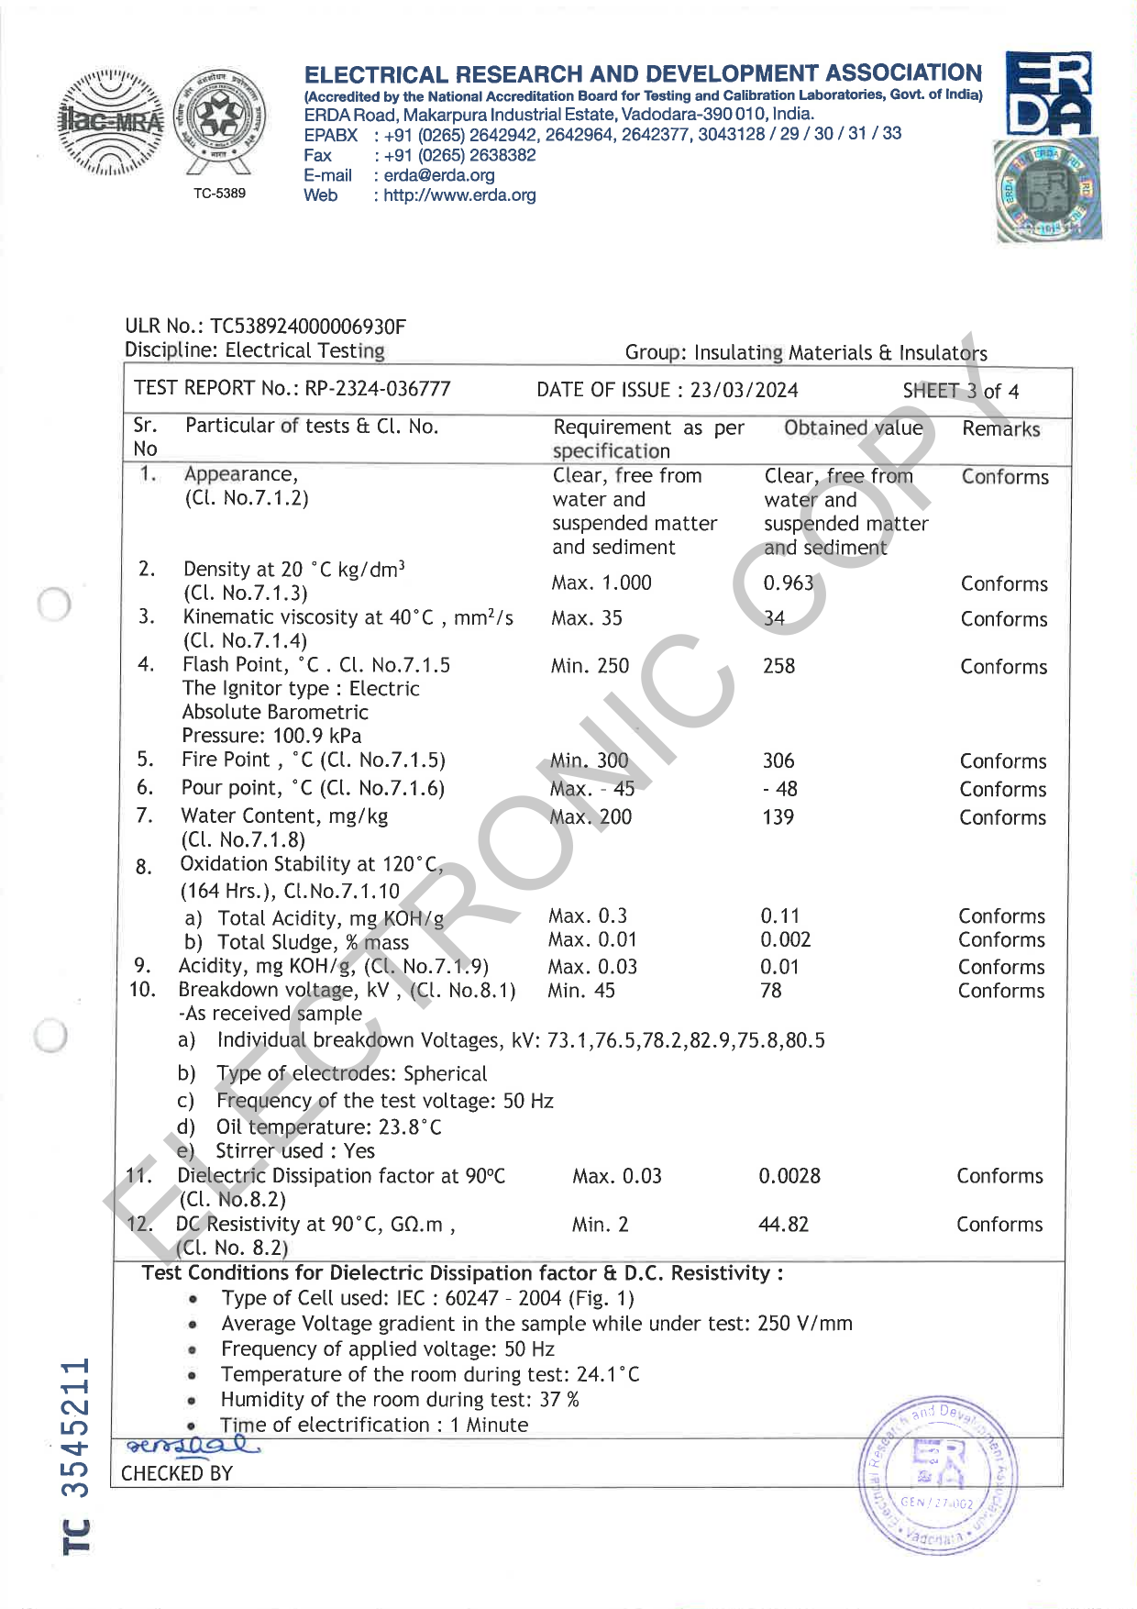

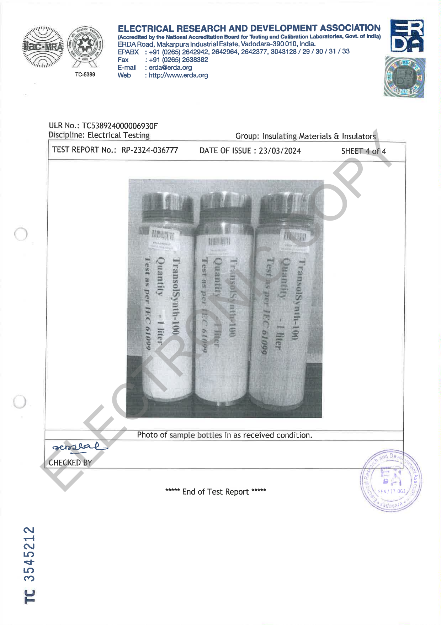

Appendix G — Crystallization Report

Source Document | Electrical Research and Development Association (ERDA) — Report RP-2425-005920
Standard / Test Method | Low-temperature crystallization behaviour
Relevance to This Submission | Supports the pour-point / low-temperature performance data in Section 5.2
The pages of the original report follow, reproduced in full.

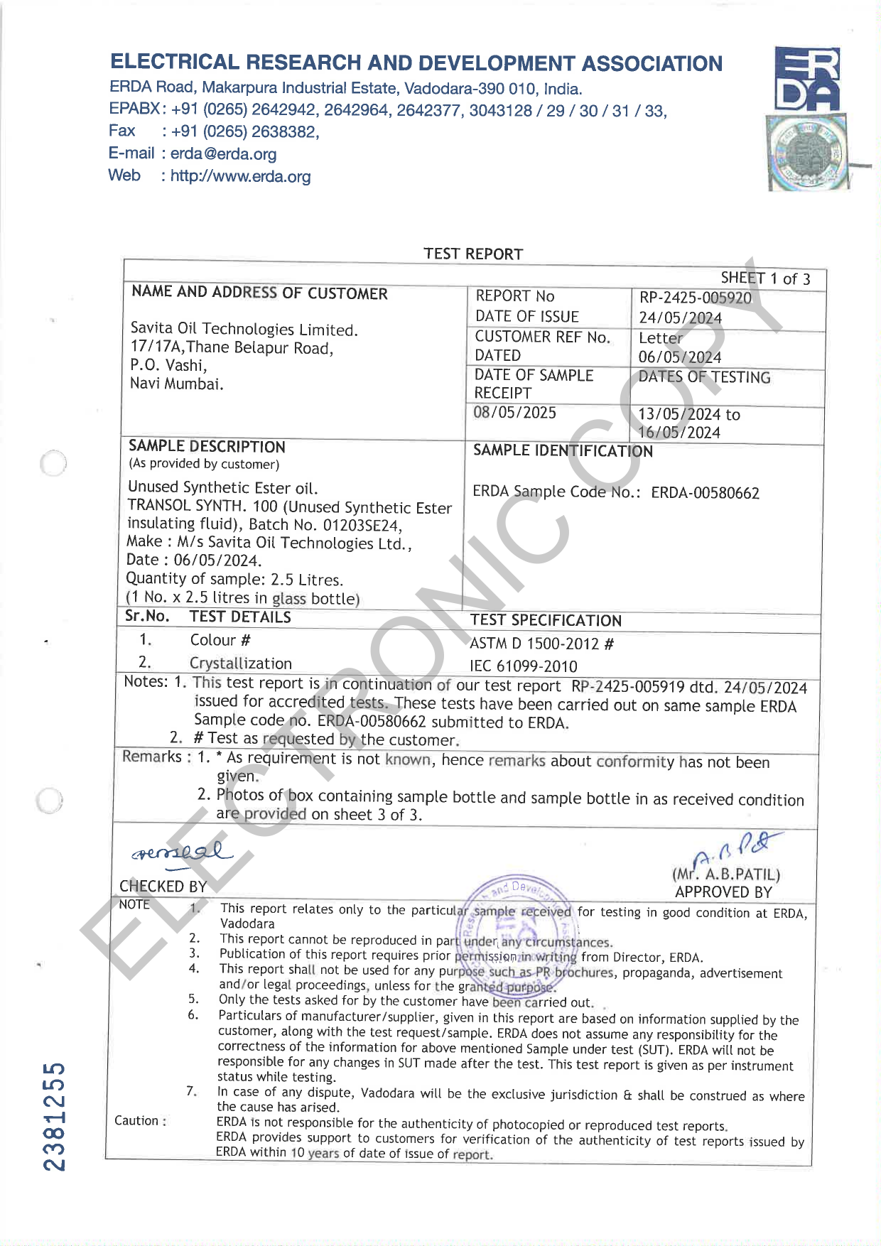

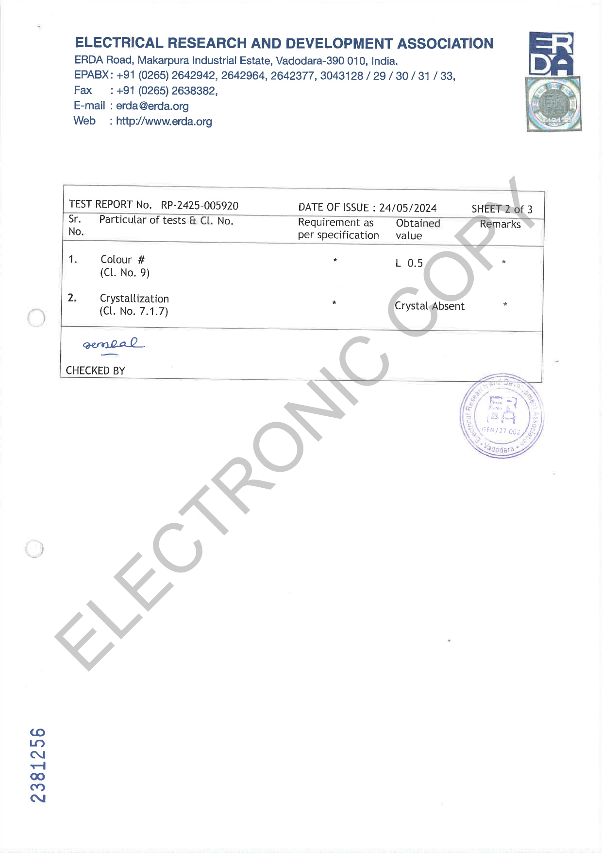

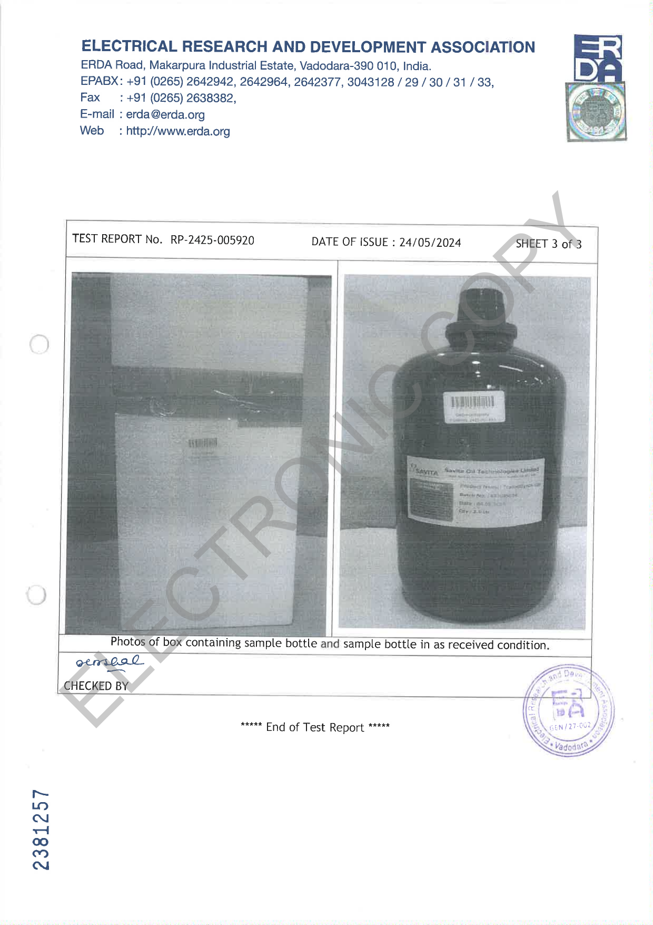

Appendix H — Biodegradability Test Report (OECD 301B)

Source Document | Intertek India Private Limited — Report MUM/000752/2022
Standard / Test Method | OECD 301B (modified) — Ready Biodegradability
Relevance to This Submission | Supports the environmental data in Section 5.3
The pages of the original report follow, reproduced in full.

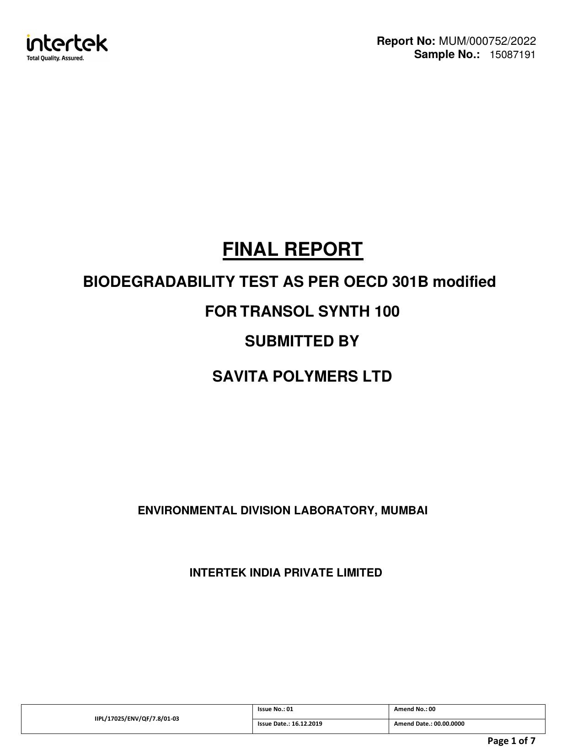

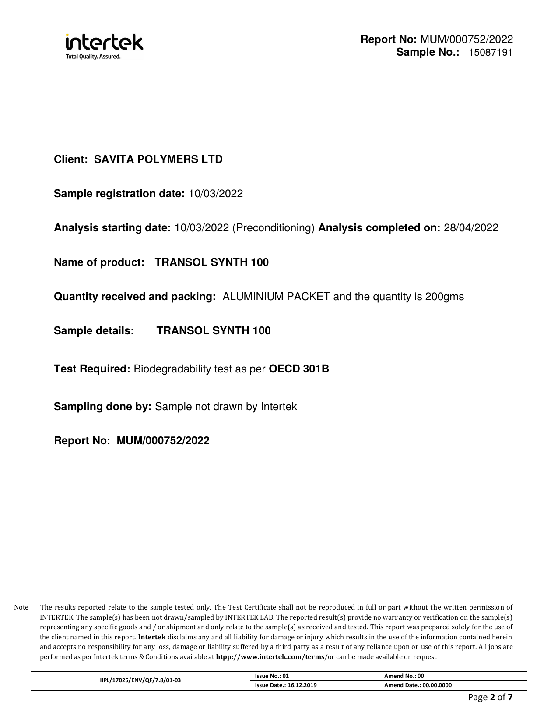

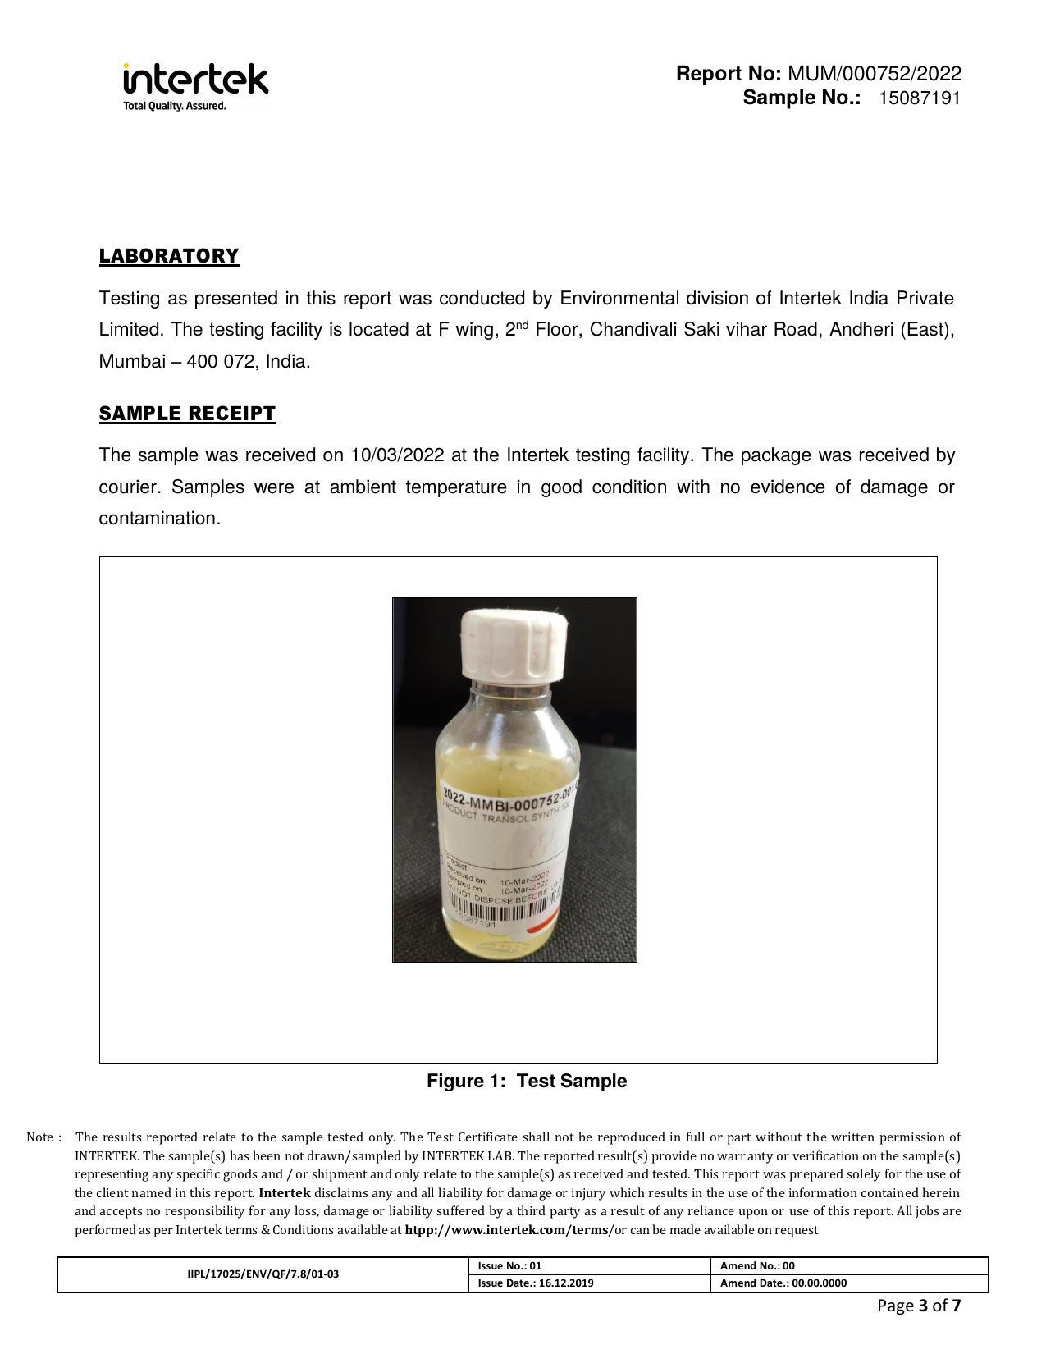

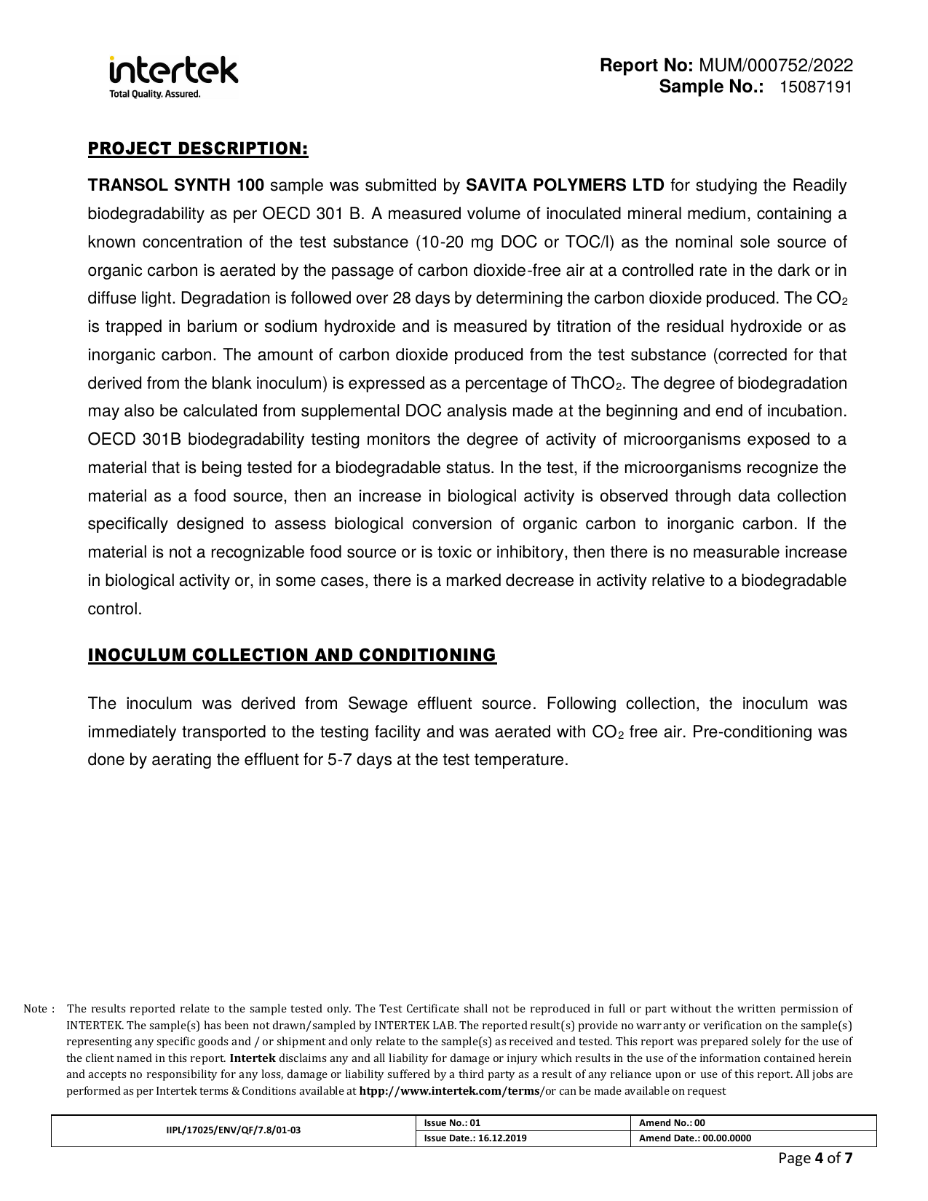

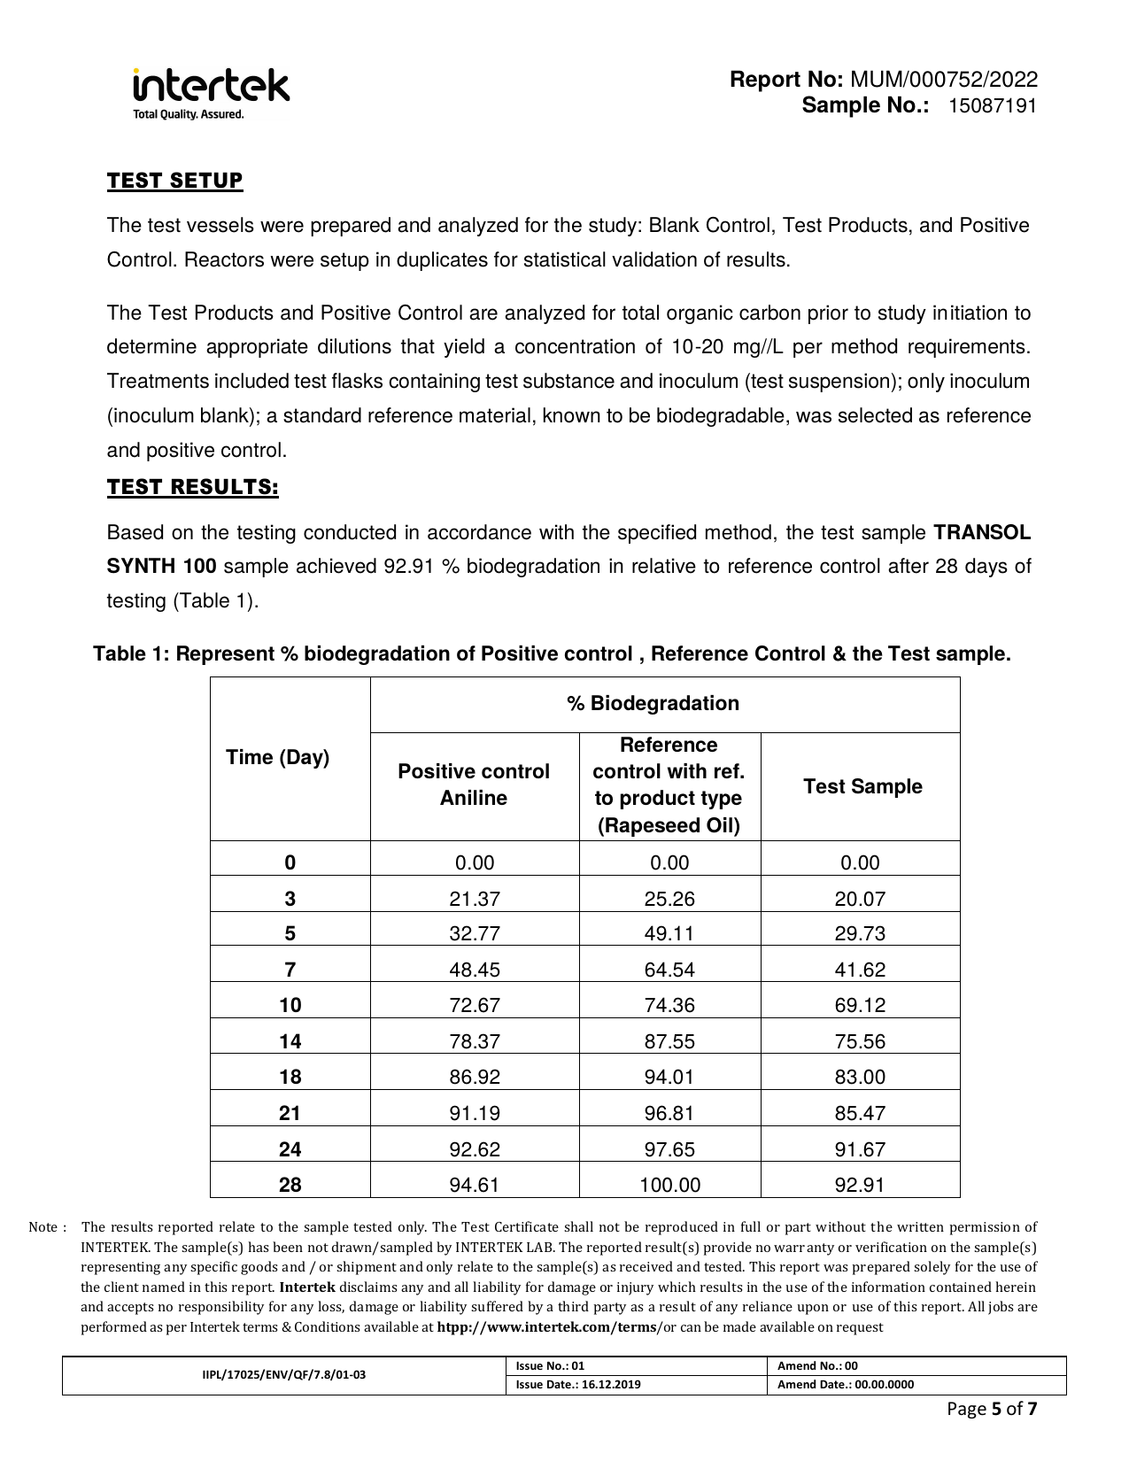

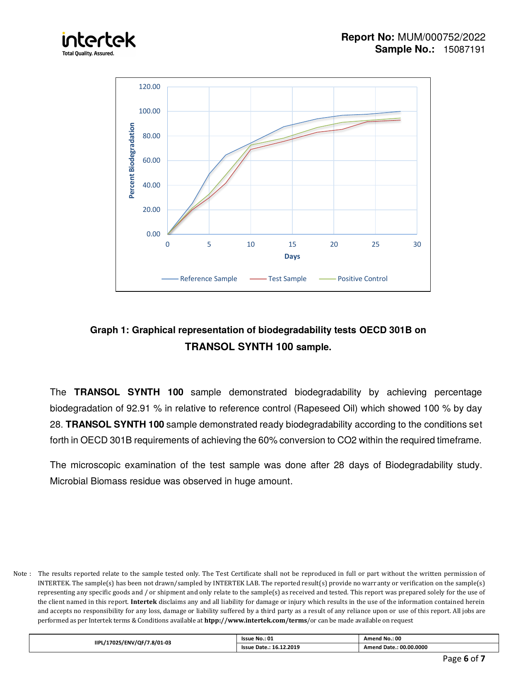

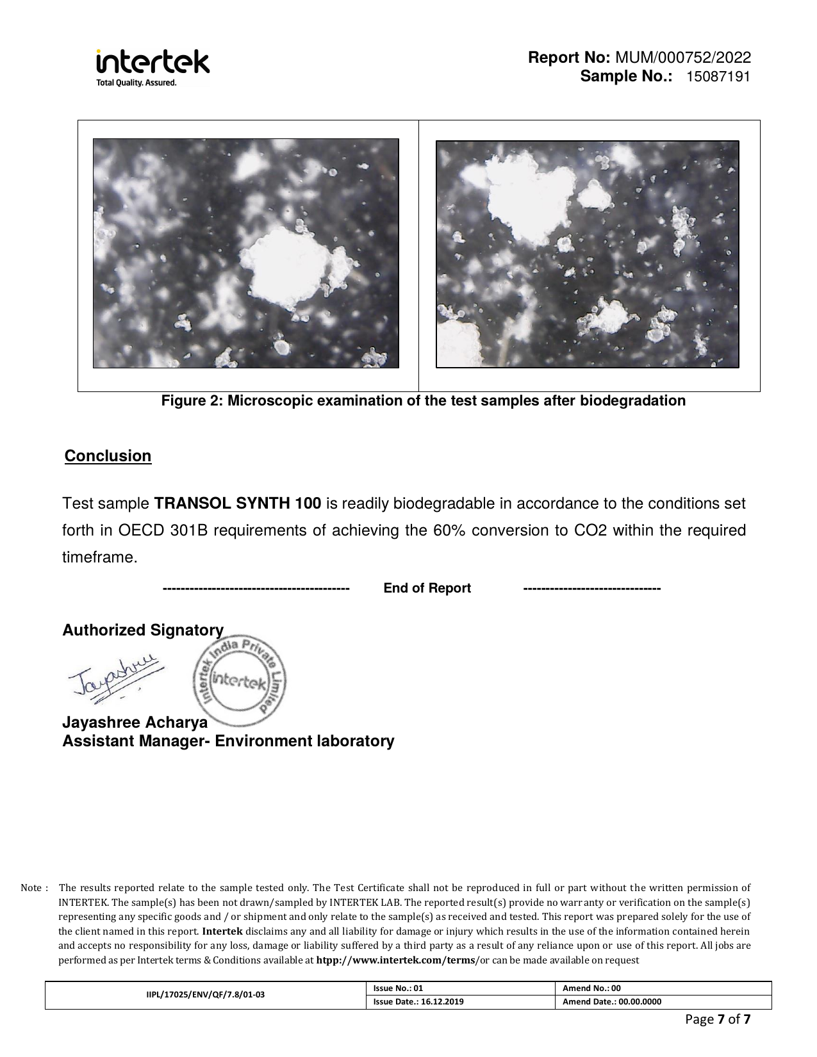

Appendix I — Freshwater Algae Growth Inhibition Test Report (OECD 201)

Source Document | Intertek India Private Limited — Report No. 002378
Standard / Test Method | OECD 201
Relevance to This Submission | Supports the environmental data in Section 5.3
The pages of the original report follow, reproduced in full.

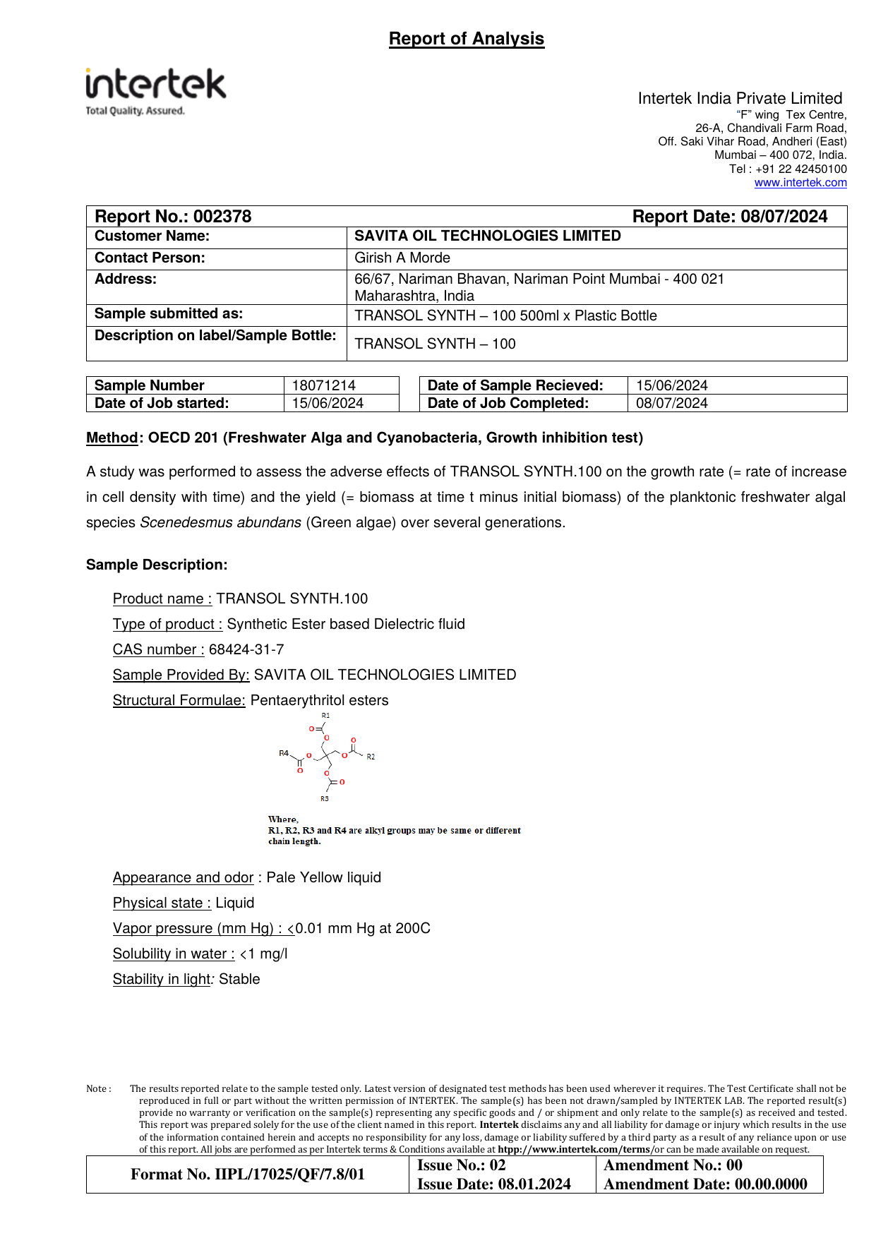

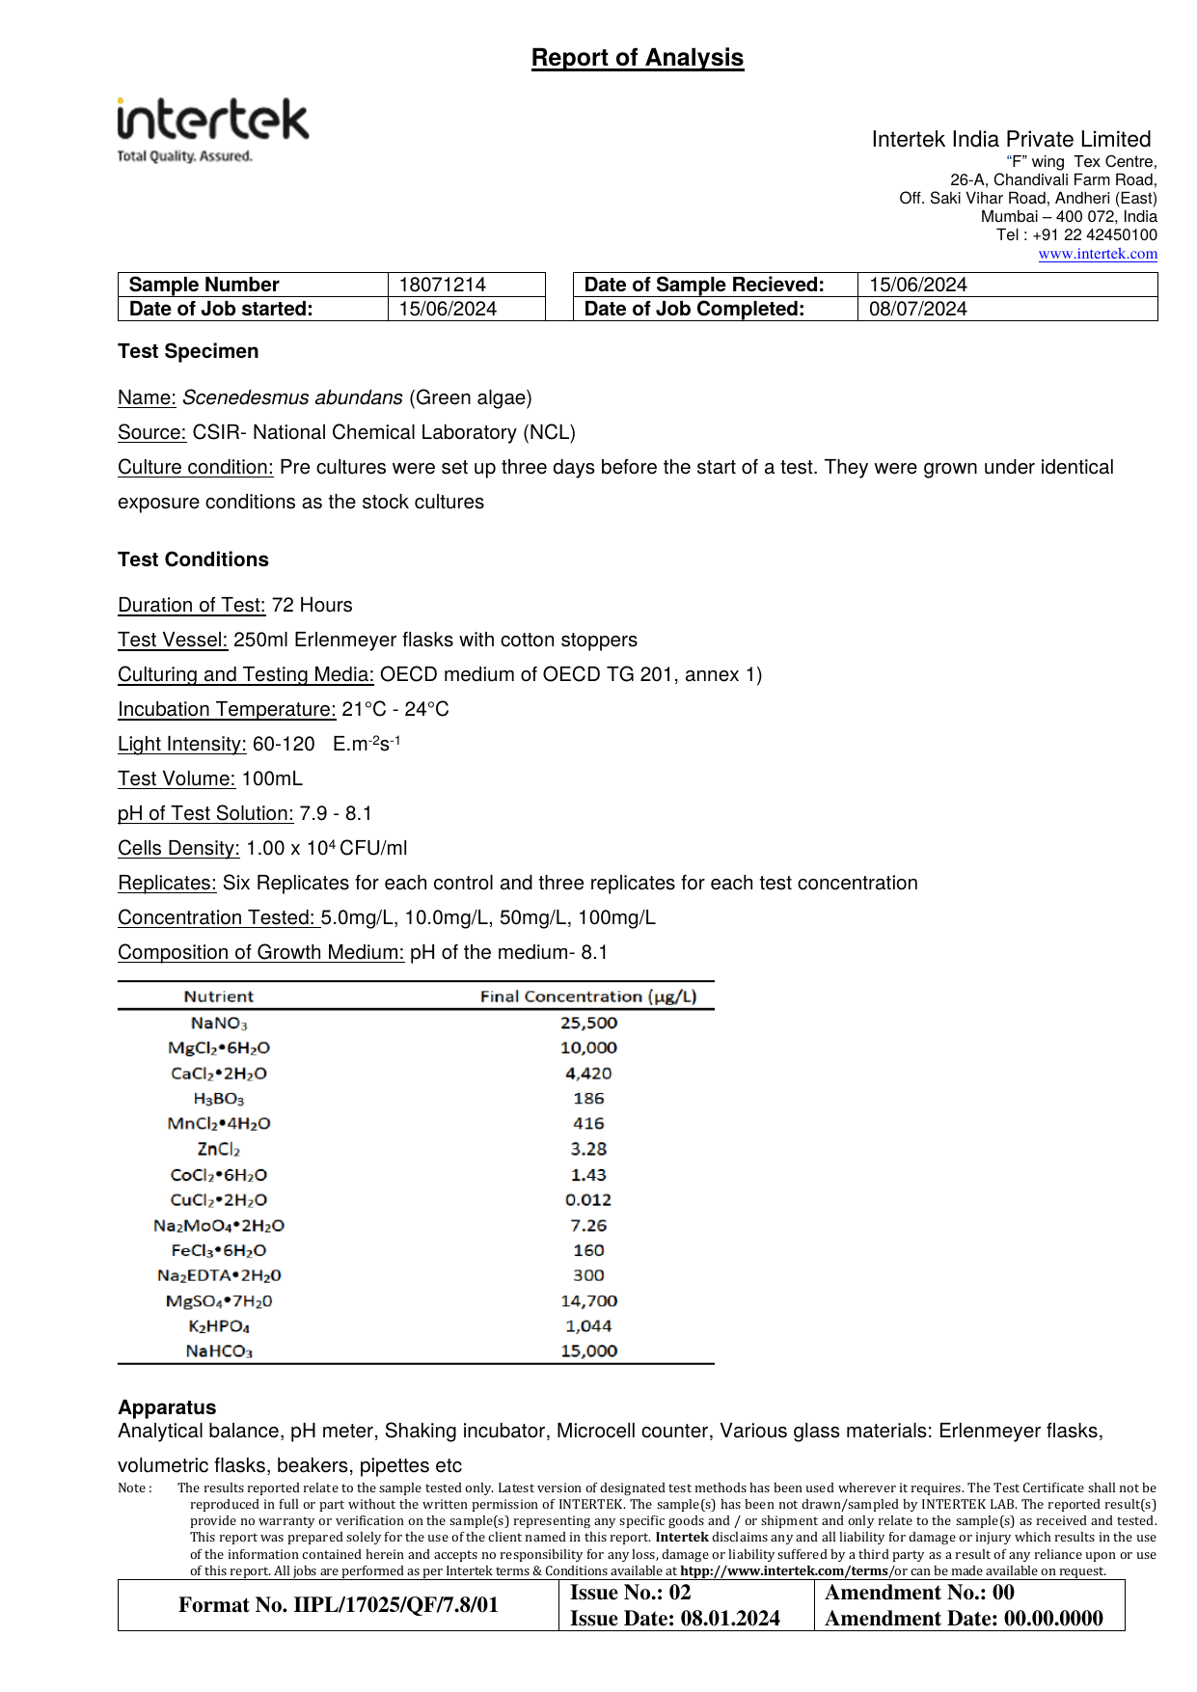

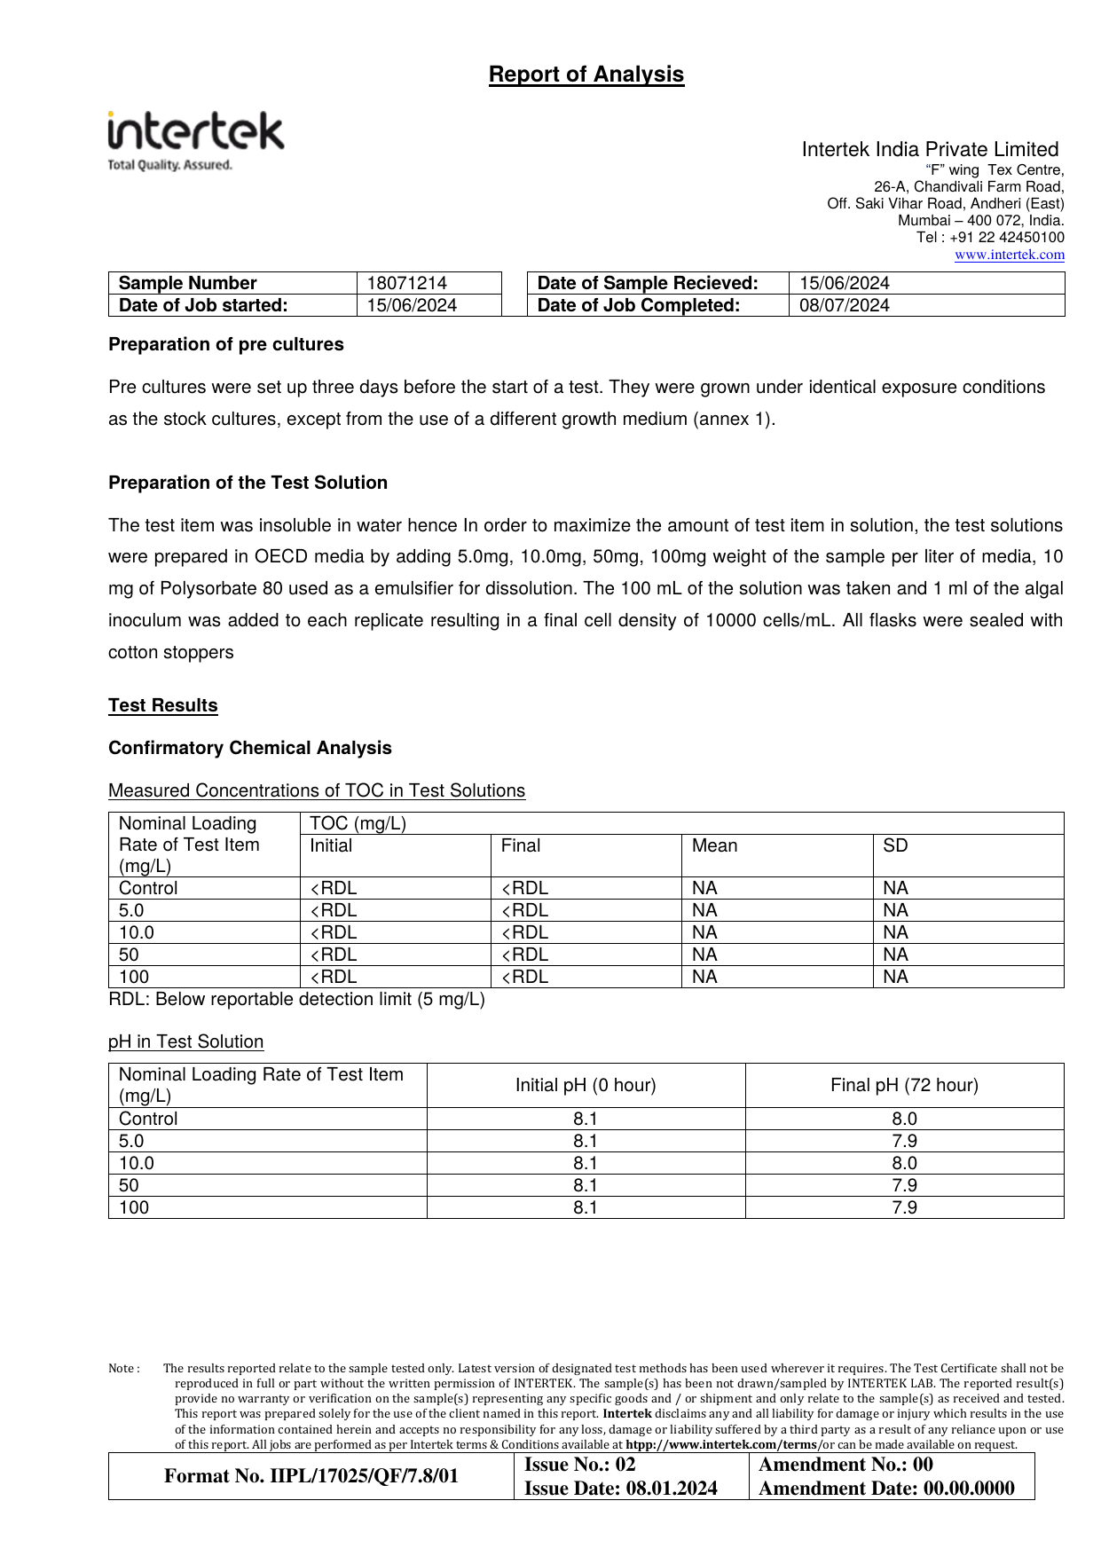

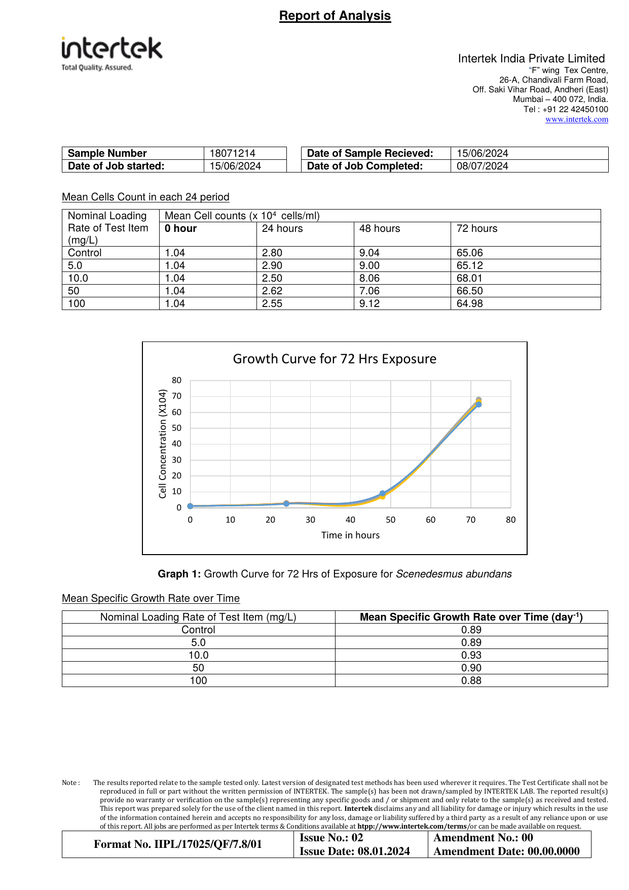

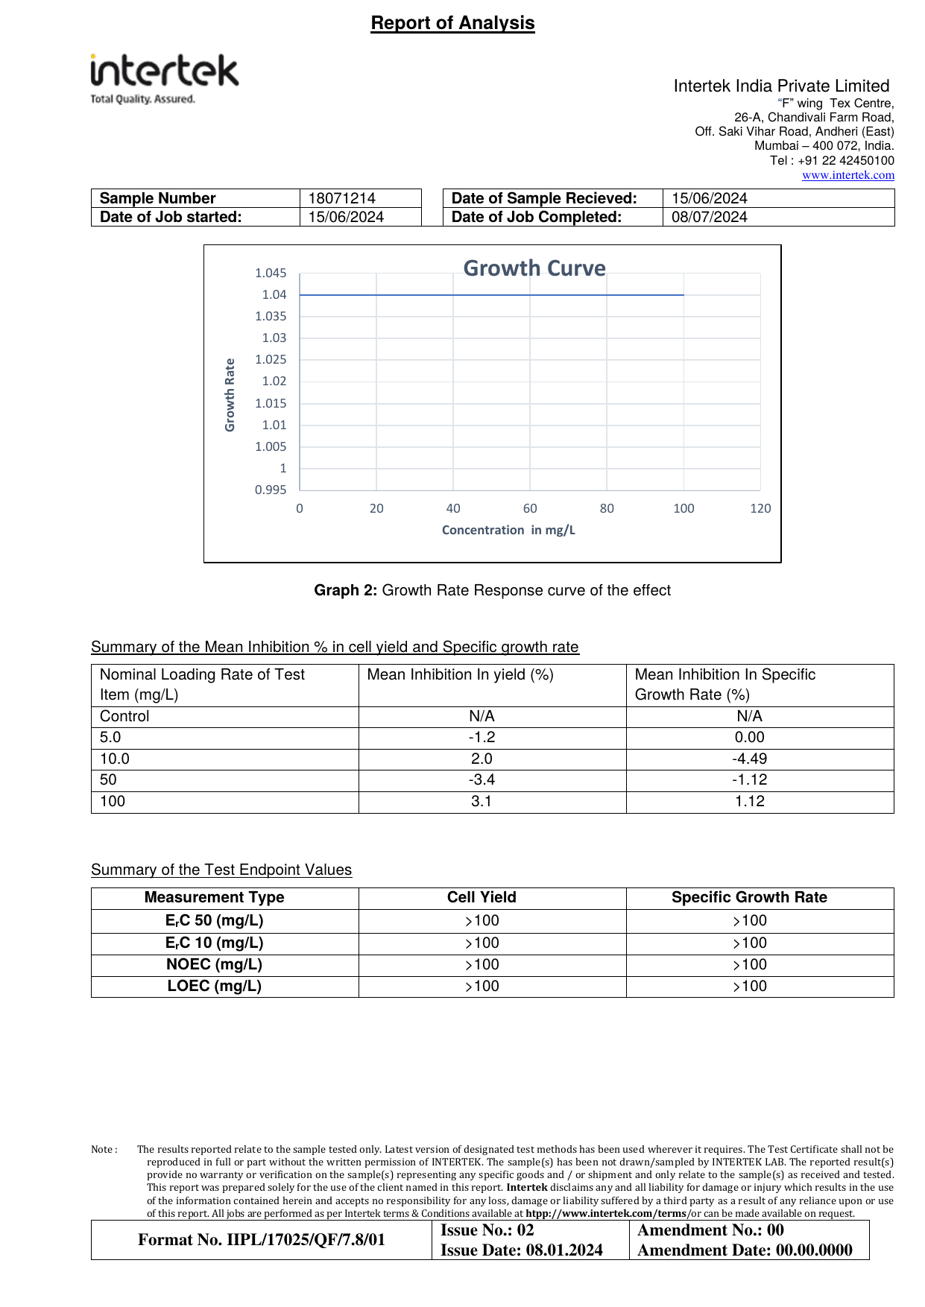

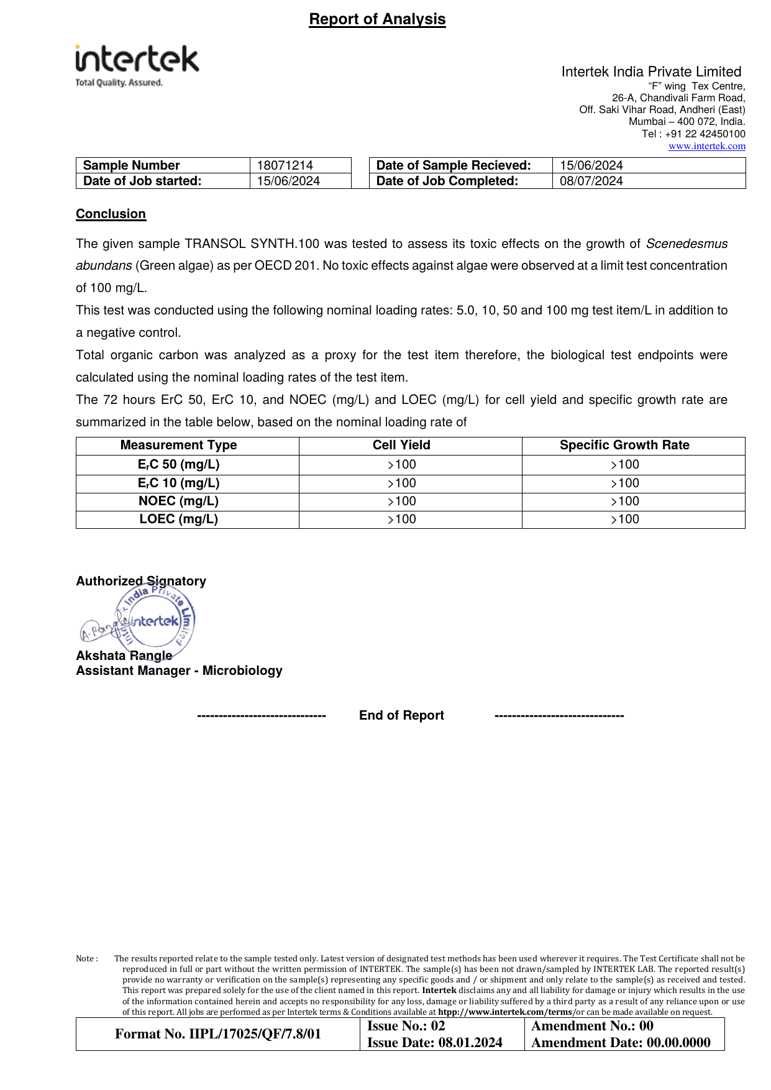

Appendix J — Daphnia sp. Immobilisation Test Report (OECD 202)

Source Document | Intertek India Private Limited — Report No. 002379R
Standard / Test Method | OECD 202
Relevance to This Submission | Supports the environmental data in Section 5.3
The pages of the original report follow, reproduced in full.

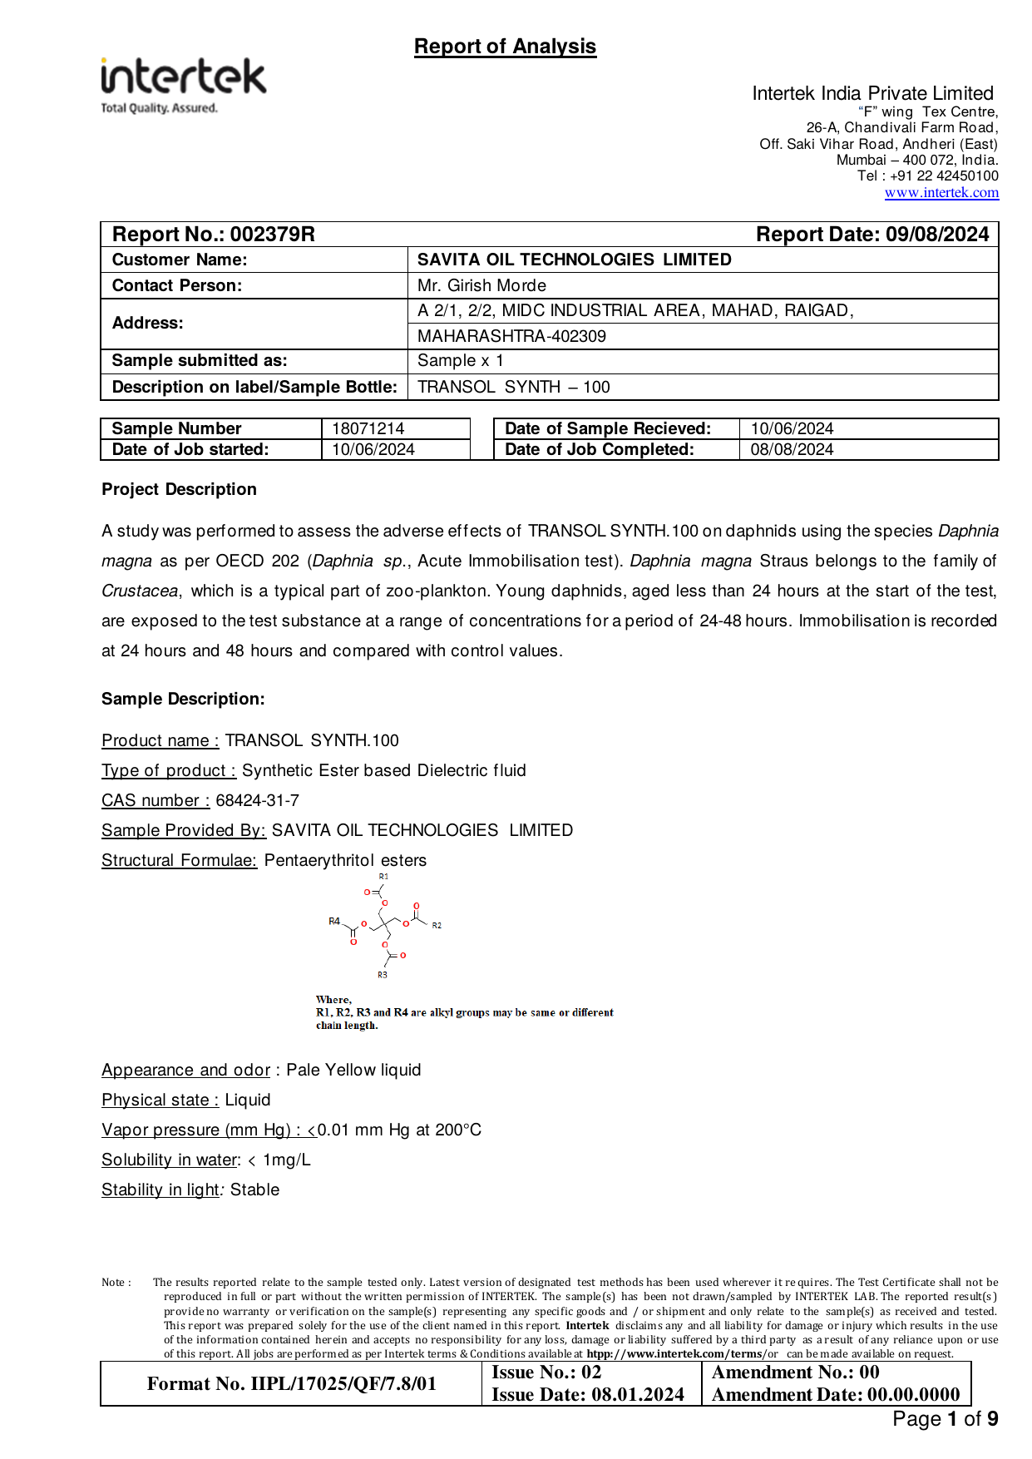

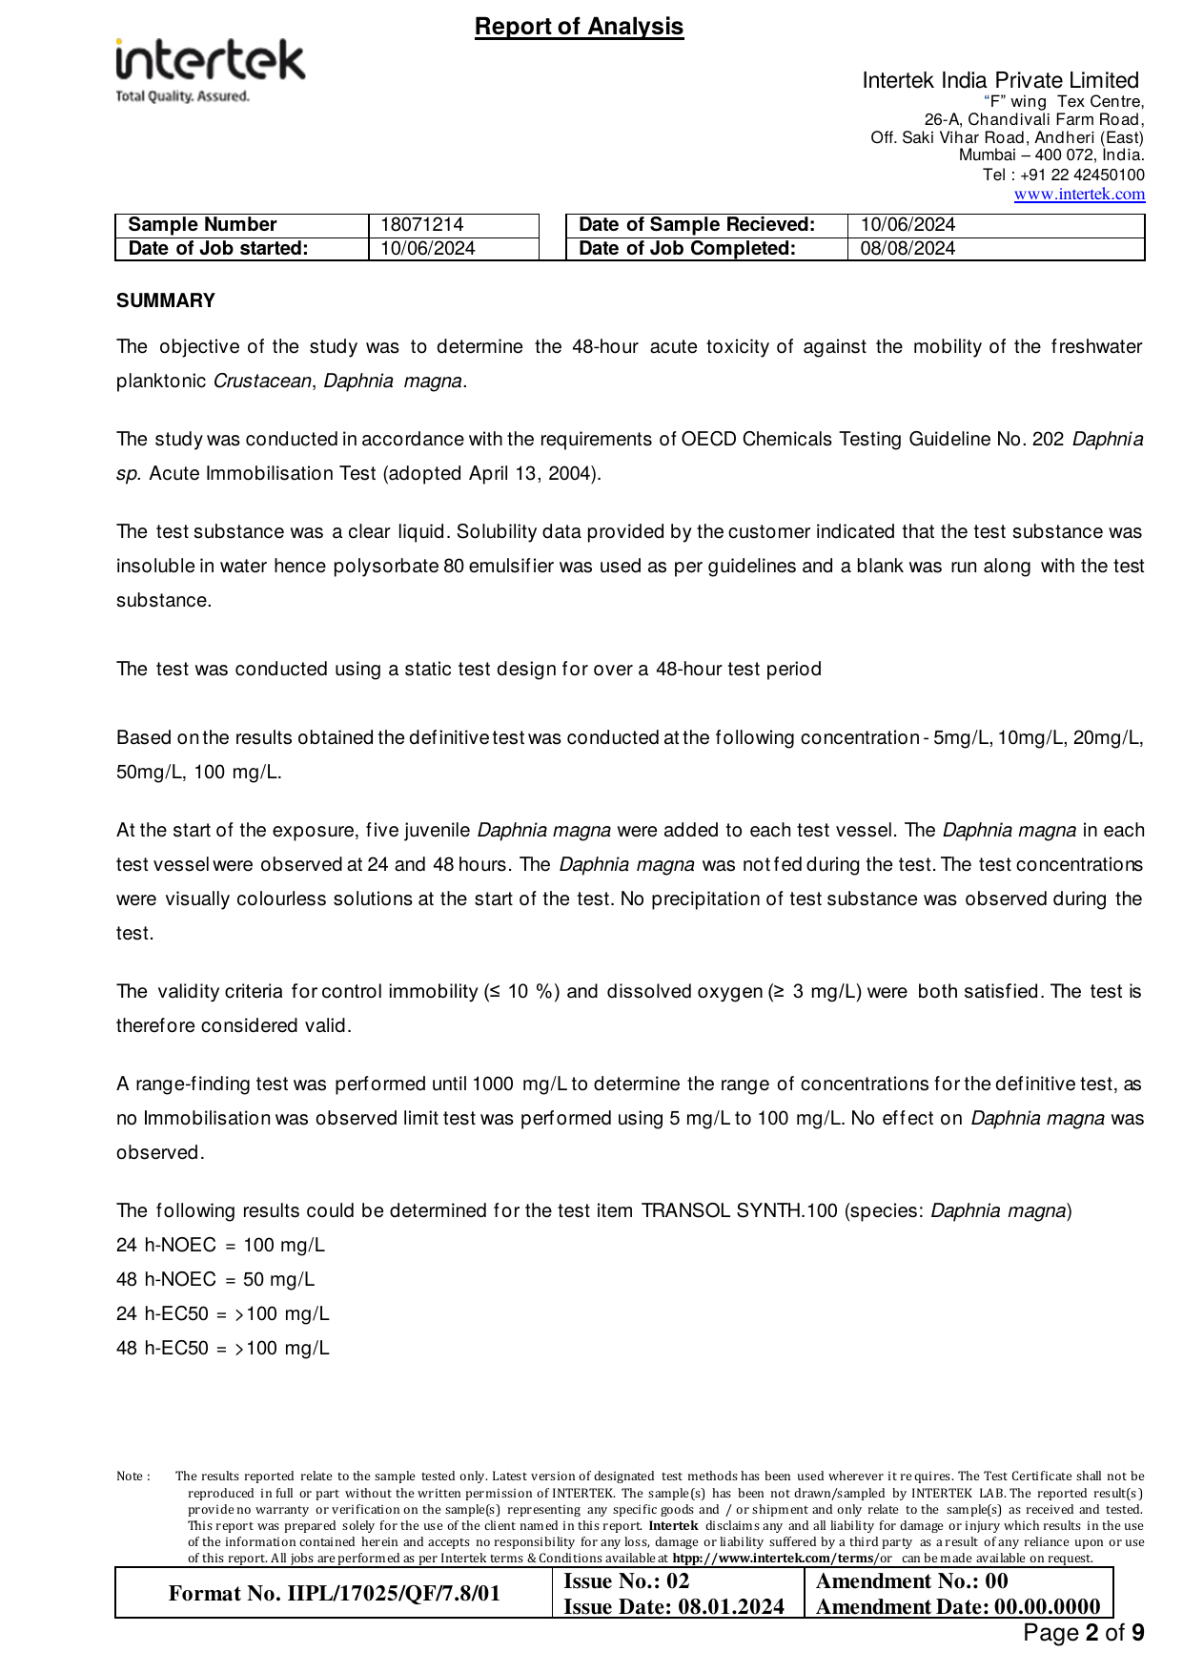

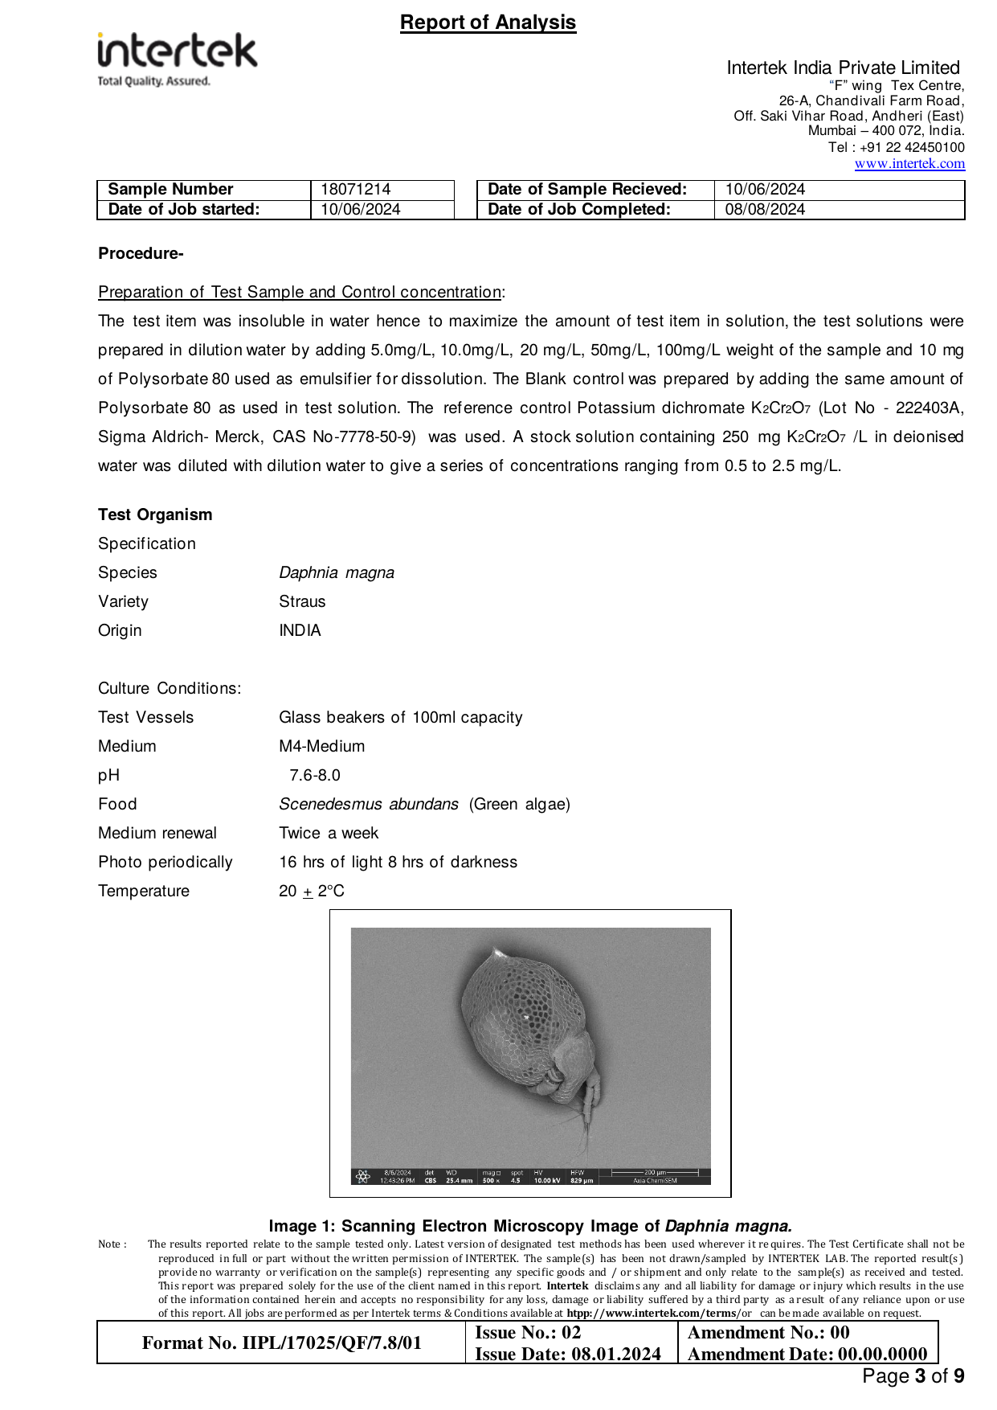

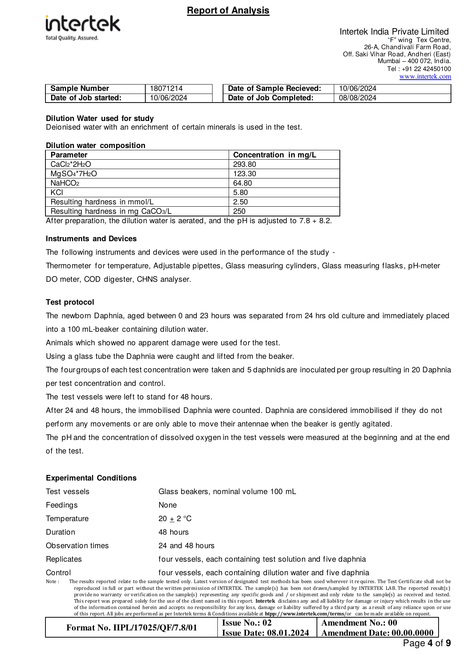

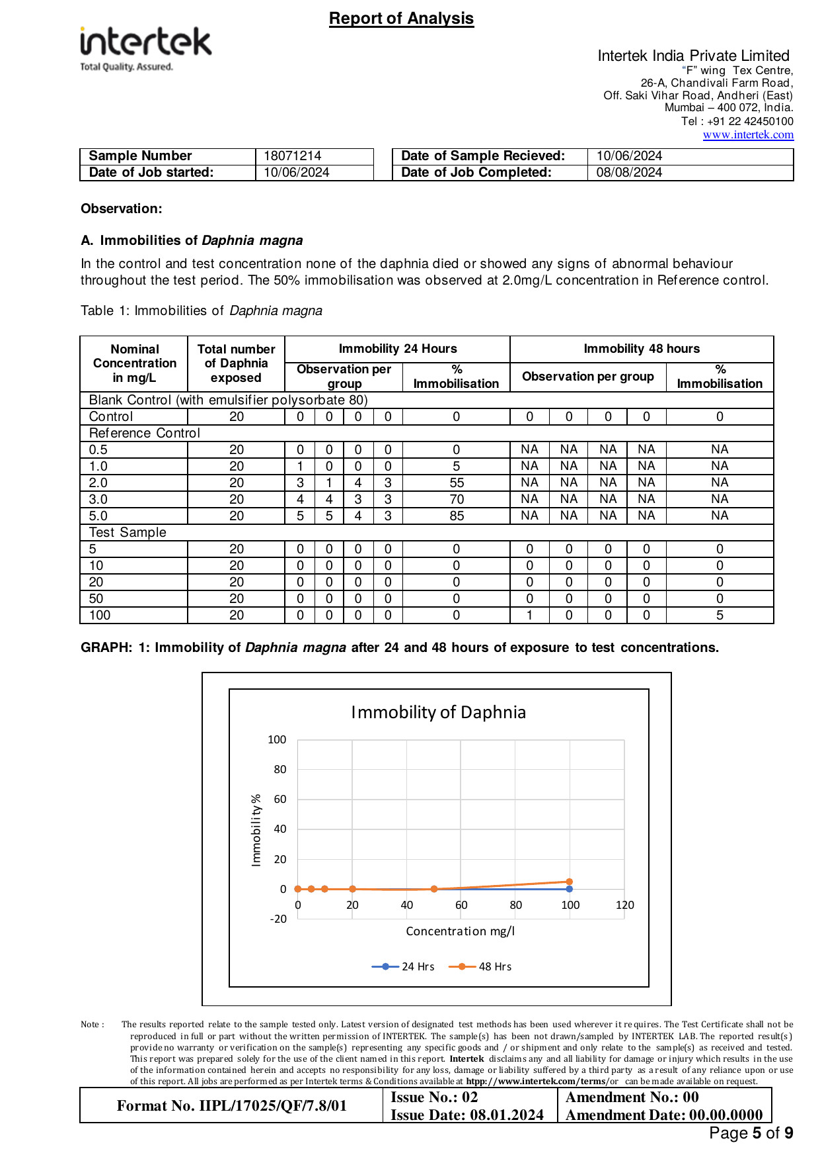

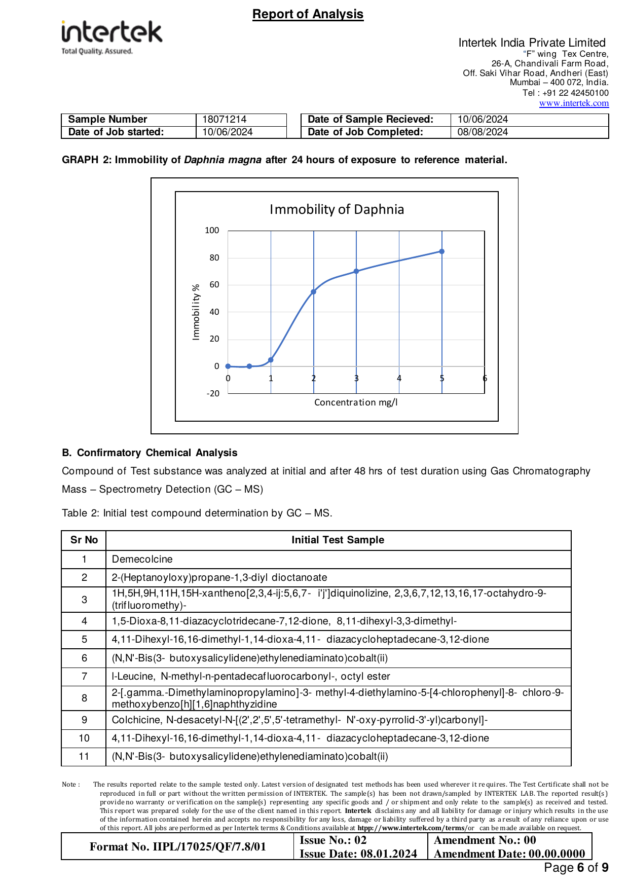

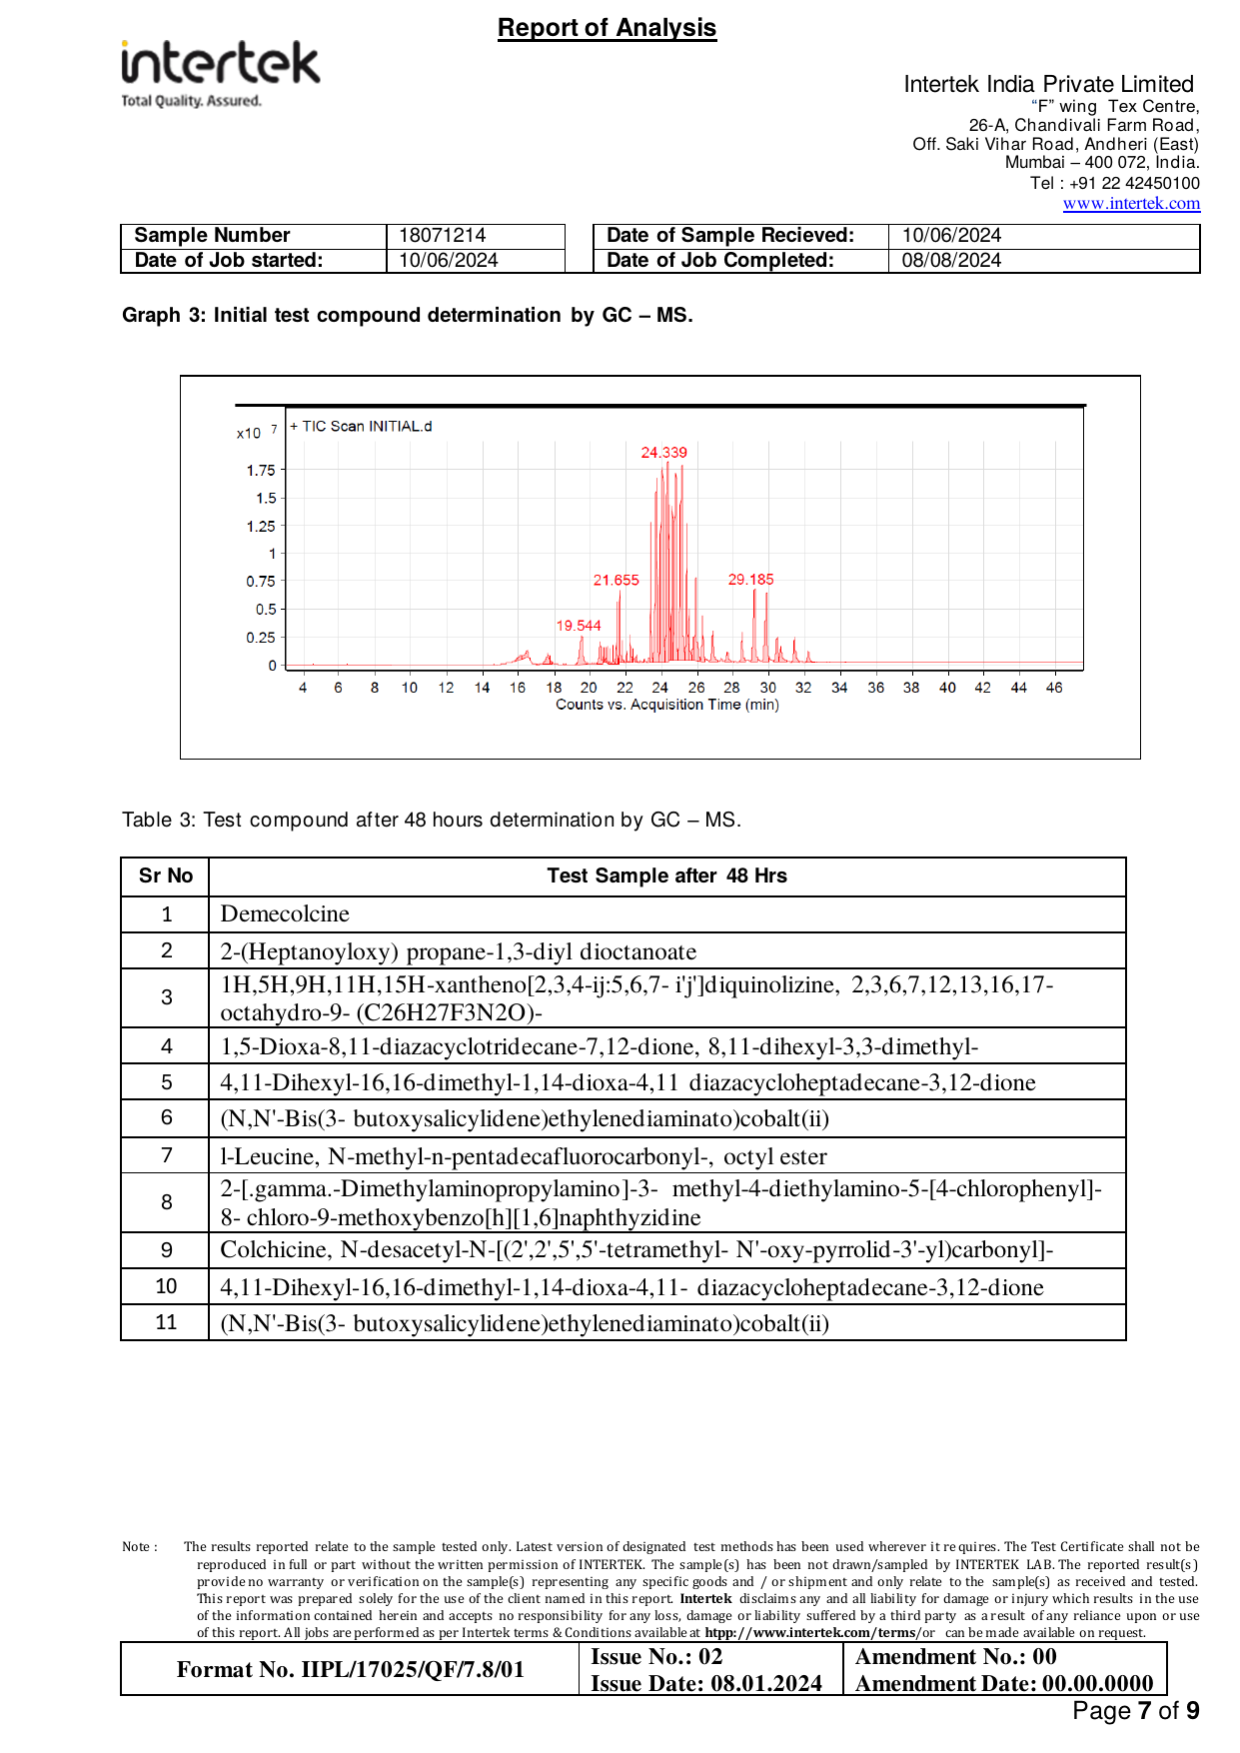

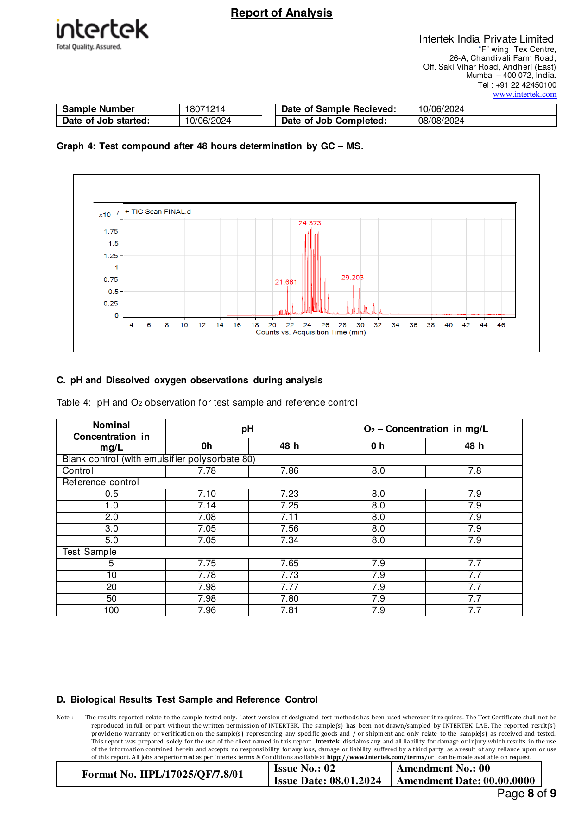

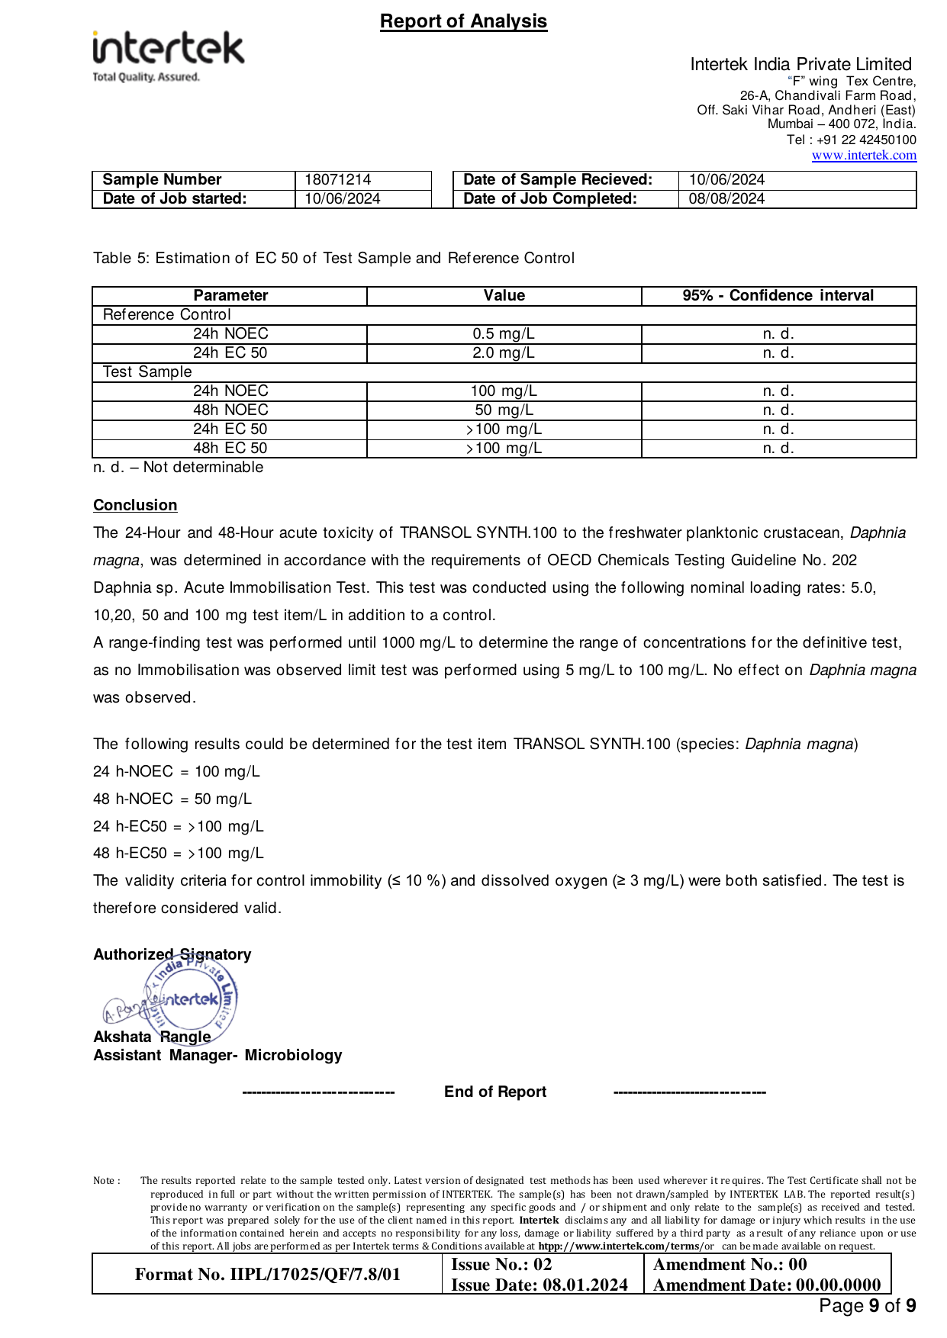

Appendix K — Fish Acute Toxicity Test Report (OECD 203)

Source Document | Intertek India Private Limited
Standard / Test Method | OECD 203
Relevance to This Submission | Supports the environmental data in Section 5.3
The pages of the original report follow, reproduced in full.

