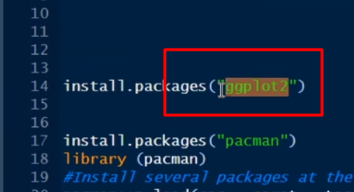

R e string always inverted commay thakbe. Aita akta package aikhane ggplot2.

Numeric char inverted comma lage na.