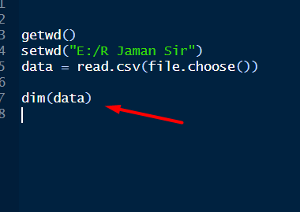

Je file import korsi, oitar koto row column ache ta dekha jabe aitay.

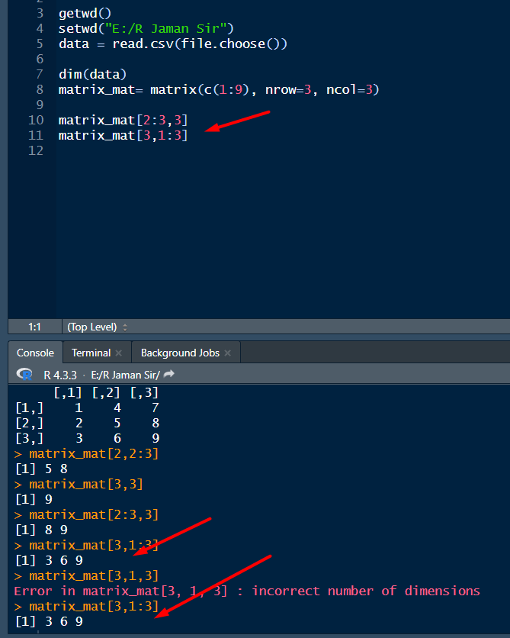

Aita mane hocche 1st e row. So 2 r 3 row er 3rd column. Then 2nd ta hocche 3rd row er 1 theke 3 column.

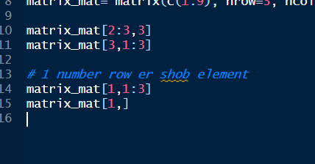

Column e faka rakhle bujhe nibe je aikhaner shob column er man chaitese.

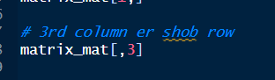

Same system

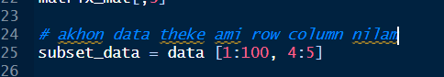

Aivabe akta nirdishto portion niye kaj kora jay. pran er master file er example.



Aita mane 2000 theke 2020 row nibe, shob column rekhe dibe.

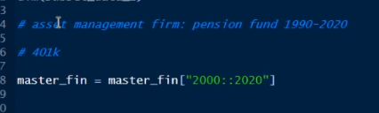

Mone koro 1990-2020 data ache. tokhon aita hbe.

double colon naki date er jonno use kora hoise.

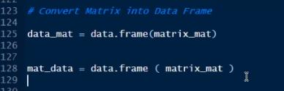

R shobshomoy data frame niye kaj kore.

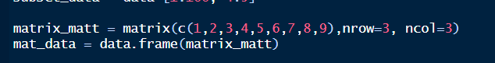

Aita example

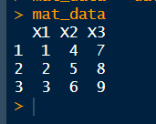

Output aita

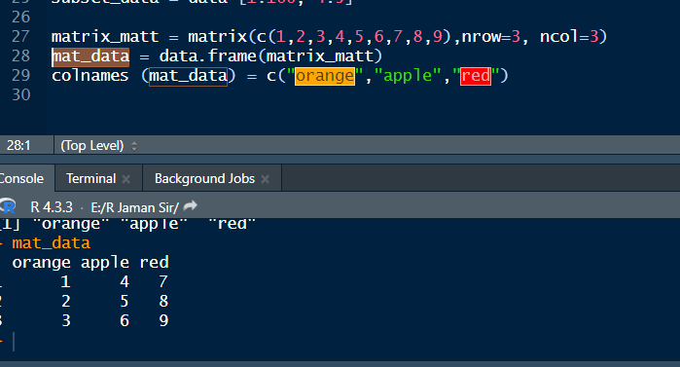

Column name gula change korlam

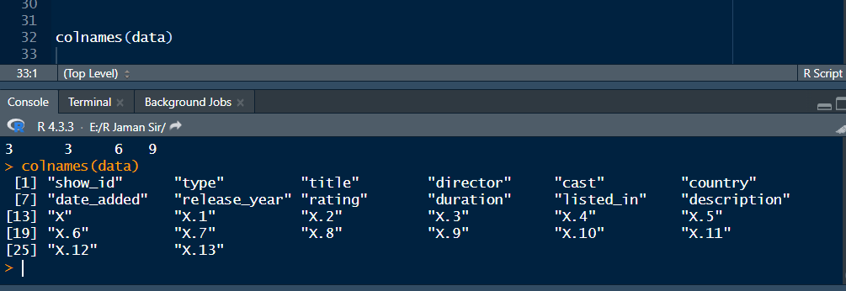

Aita mane amr import kora csv te koyta column ache with their names

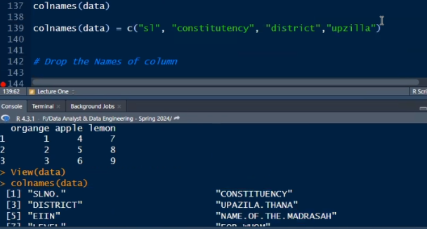

Aitar dara column gular name change kora jabe

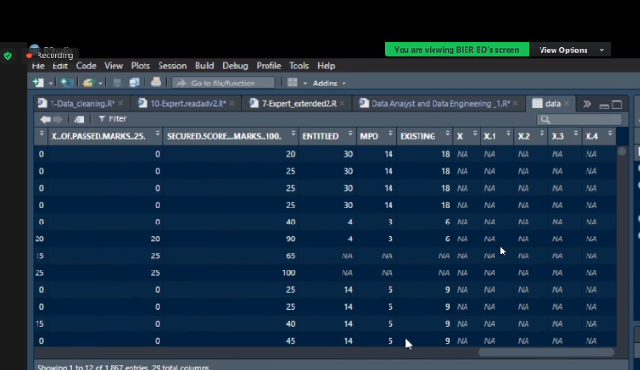

Amr import kora file e amon kichu thakle oita delete kora lagbe.

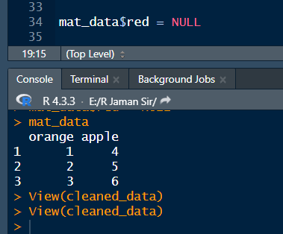

Dekho, ami red delete kore disi.

$ sign dilei oitar column gula dekhabe.

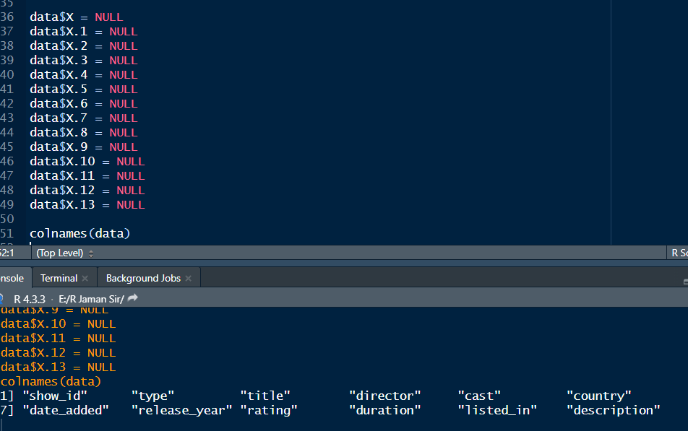

Aije delete korlam, delete kore abr colnames diye check o korlam.

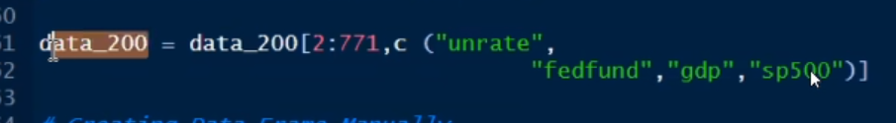

Aita mane 2 theke 771 row porjonto select kore oitar just ai 4 ta column select koro.

Akhon manually employee info niye akta data frame banabo

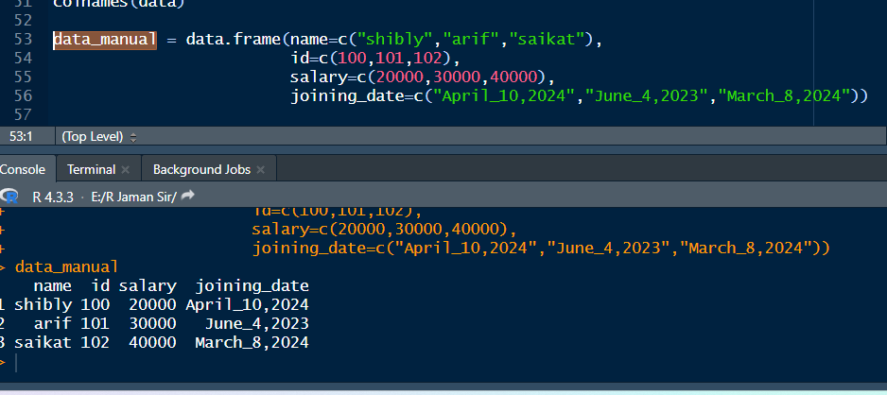

Aije

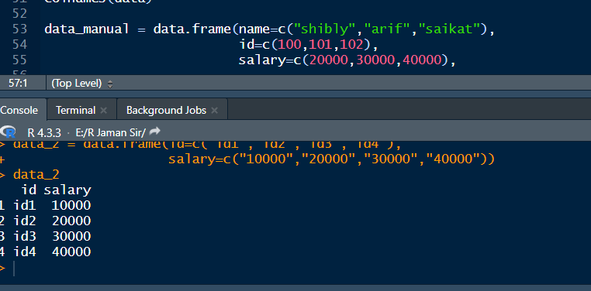

Arekta korlam

Akhon mone koro ai data 2 te akta column add korbo.

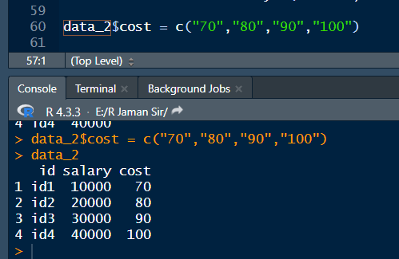

Aivabe add korbo new column.

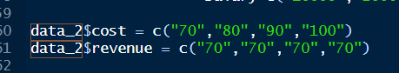

Revenue o add korlam.

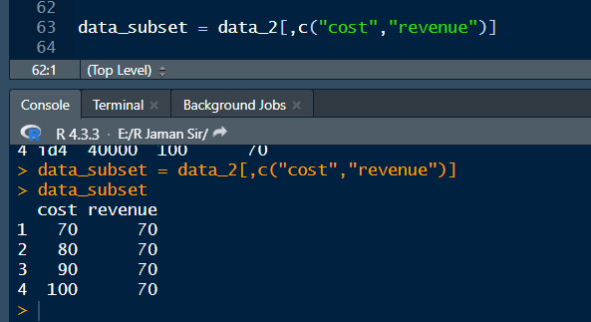

Aita korlam je oi data_2 theke shob row and just cost and revenue select korlam.

Subset korar jonno amon third bracket dite hoy.

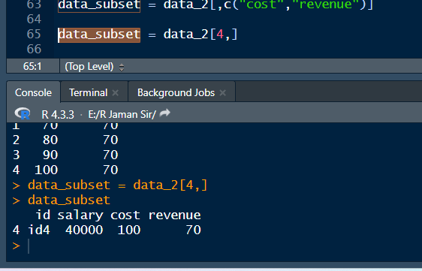

Aikhane korlam je 4 number row er shob column.

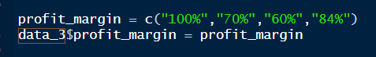

Aikahne profit_margin name e arekta open korlam column. Aivabeo column open kore then add kora jay.

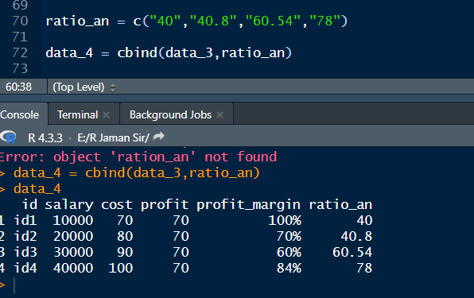

Aivabeo add kora jay cbind diye.

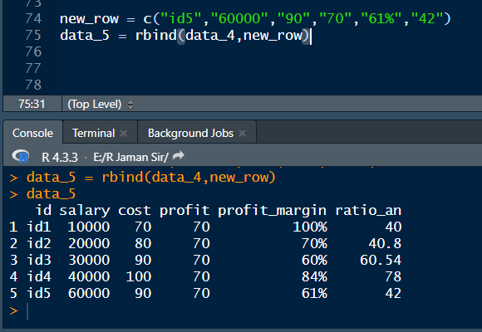

Aikhane row add korlam

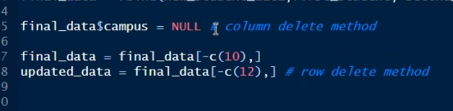

Column and Row delete method aita