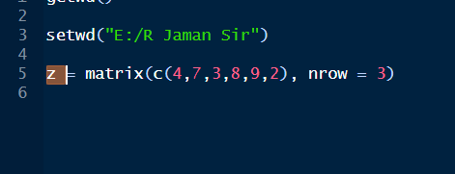

Akta matrix korlam. Dekho aikhane ncol charai hoye gese bcoz of multiple.

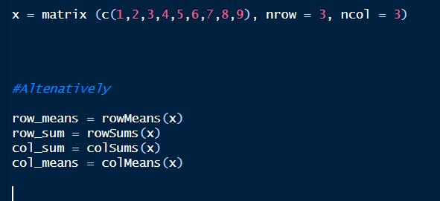

Aita akta way sum mean ber korar

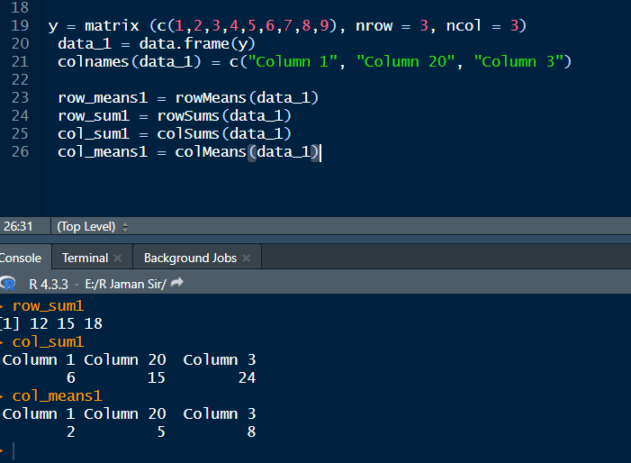

Aita arekta way

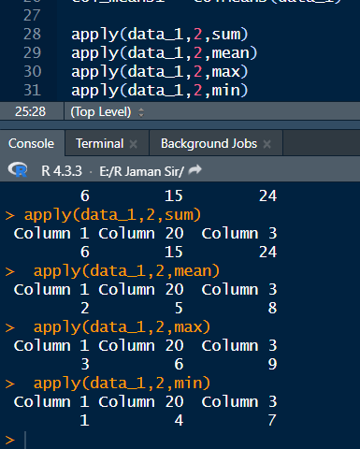

Aita hocche apply function. Aita aro powerful. Aikhane apply e 1 dile row er hisab hbe, 2 dile column er hbe.

Ai 2 system er dfrnc hocche ager tay max min nai. Akhon max minimum number o pawa jabe.

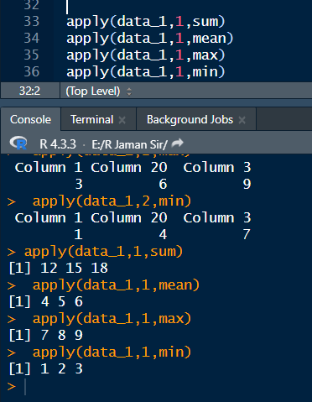

This is for row

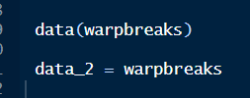

Warpbreaks R er built in data. Aita ami load korlam, then data_2 te save korlam.

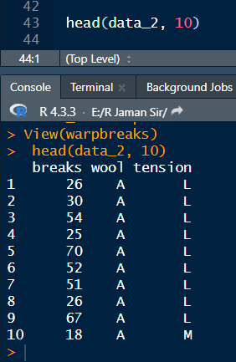

Ami head diye ai datar 10 ta row dekhlam akhon. Mane idea nilam.

Aikhane dekho a onekbar, L onekbar. Ami unique gula dekhbo.

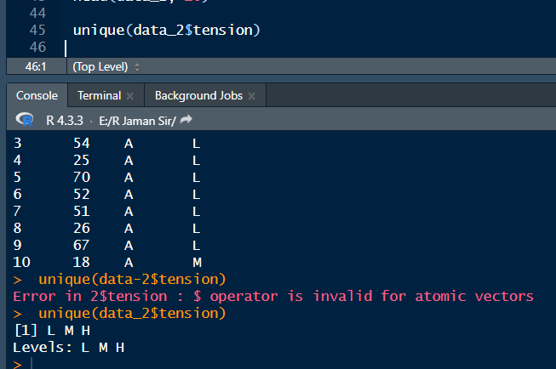

Dekho, amk dekhaya dise unique nam gula data_2 er tension column e.

Group sum apply korar time e tapply use kora hoy. jemon aikhane uporer pic e L er under e onekgula number ache. M er under e ache. H er under e o ache. ami ai jinishgular separate sum mean ber korbo. Tokhon tapply lagbe amr. Excel e aita sumif. R e tapply.

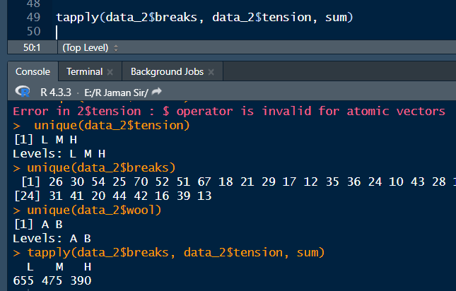

Dekho, shob category sum ber hoise. Data2 breaks disi, coz age numeric ta thakbe.

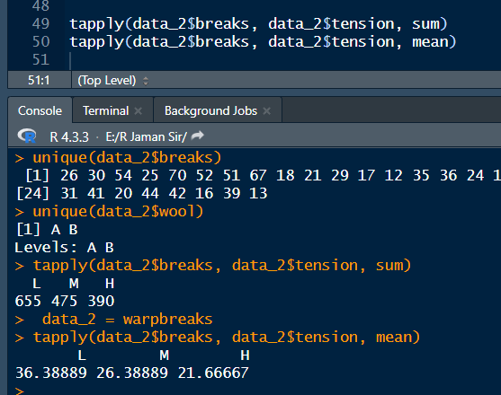

Aije mean korlam

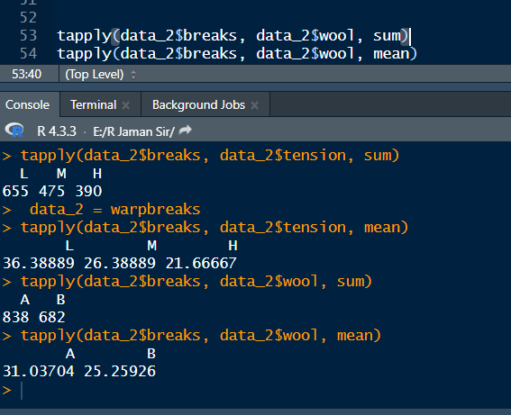

Aibar wool diye ber korlam

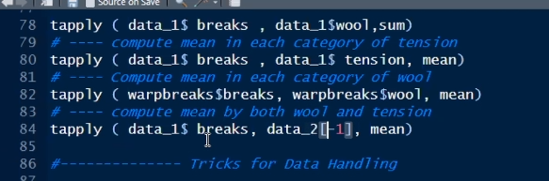

Sir e dekho 3 number line e ki korse. Hisab same e. 4 number ta bhul. Oita ami ditesi akhon thik kore.

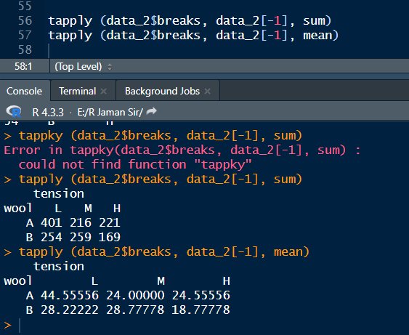

Aije korlam. Aitar mane hocche break e number ache, ami oi number gula niye hisab korobo. Kintu tmk she break column bad diye baki 2 ta column er je mutual bepar ache, oigula niye research koro.

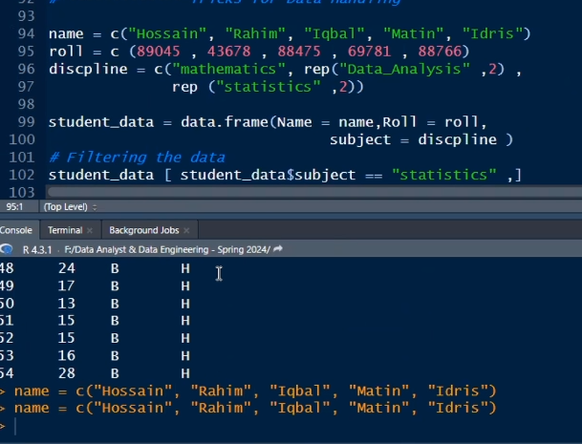

Aita sir er. Aikhane 1st 2 line namer akta column create korsi. Then roll er column o create korlam.

Aikhane disciplinr mane k kon department e ache. hossaim math e, then rep dilam, jar mane eker odhik manush kono course a ache. so nam ache r 4 ta after Hossain. So Rahim r Iqbal jabe data analysis e, matin r idris jabe stats e. then student data data frame e nibo.

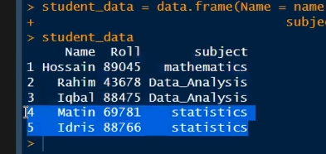

Dataframe ta amon hbe dekhte. To mone koro ami chai statistics jara pore, tader ante.

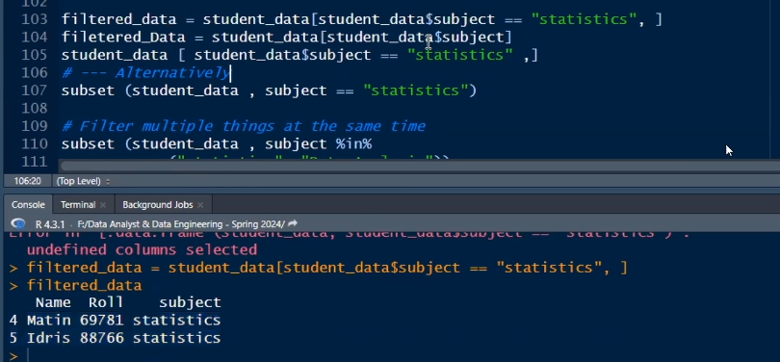

1st line Aitar mane hocche ami student data er subject column theke jara statistics nise, tader ber korbo.

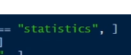

Aitar mane hocche statistics row er shob column.



Aitao same jinish.

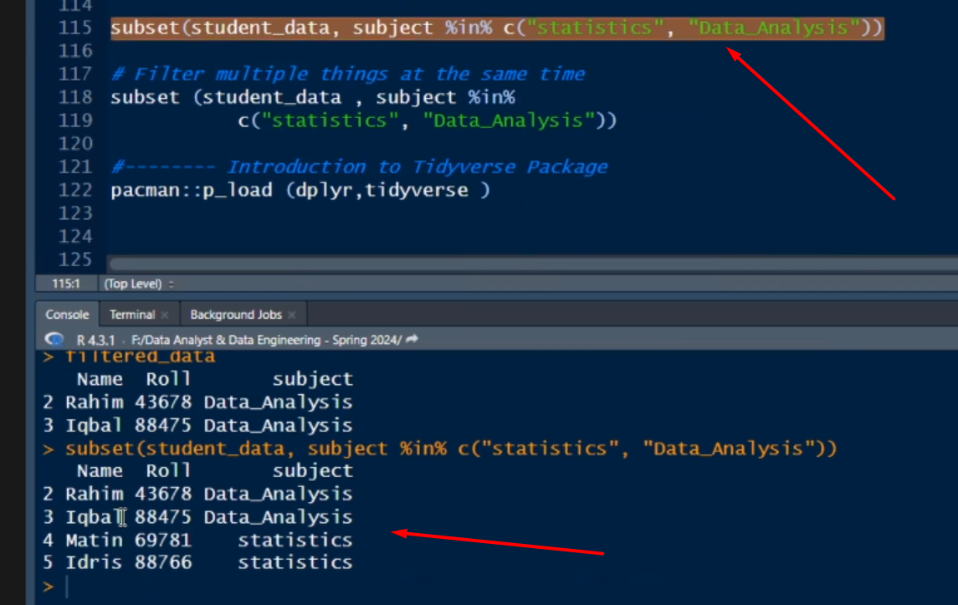

Ai line diye statistics and data analysis der multiple filter korlam.

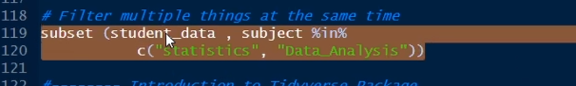

Aita diye single filtering o kora jay. tokhon just akta kete dibo.

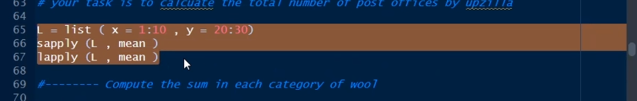

Aita home task.