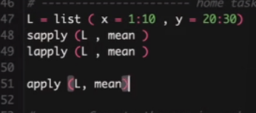

Aita just list er jonno kaj kore, matrix er jonno kaj kore na.

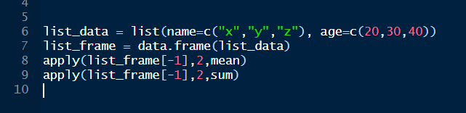

Aivabe list koreo kaj kora jay matrix kora chara.

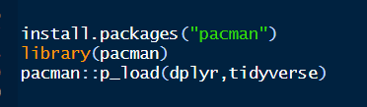

To ajker class er jonno aituku korlam.

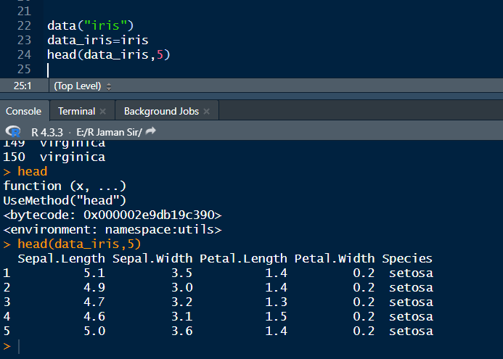

To dekho aj new in built data iris niye kaj korbo. Aita load kore save kore then aitar 5 ta row dekhtesi head function e.

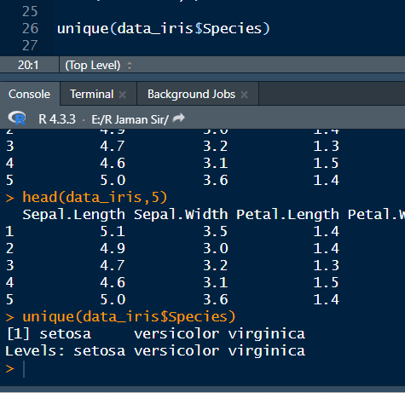

Unique diye dekhlam ki ki common species ache.

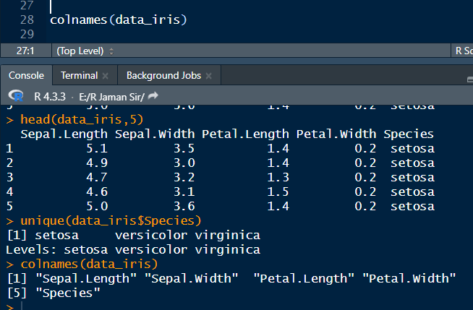

Aita diye ki ki column ache ta dekhlam

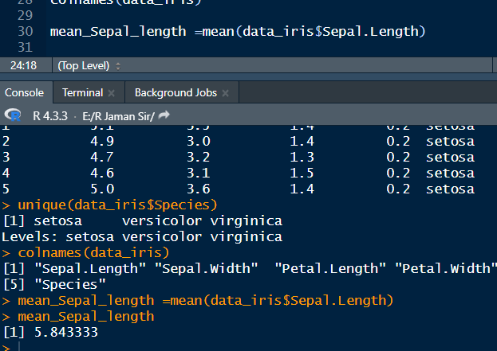

Aije mean ber korlam sepal length er

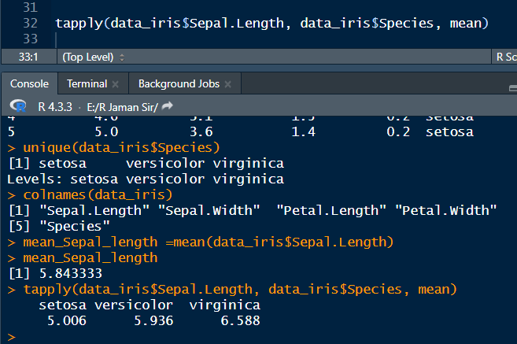

Aita korlam group mean

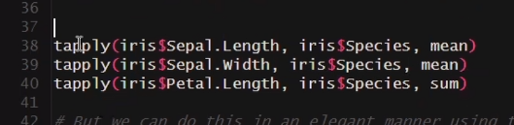

Aivabe aigulao ami ber korte pari. Aigula kintu old fashioned method. Ai kajgula tidyverse diyeo kora jay khub shundorvabe.

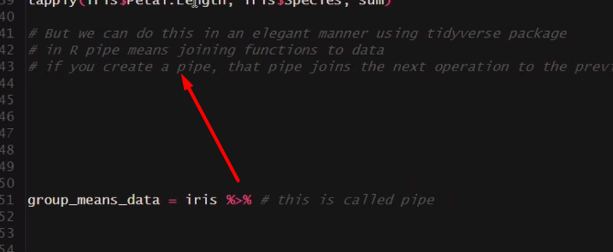

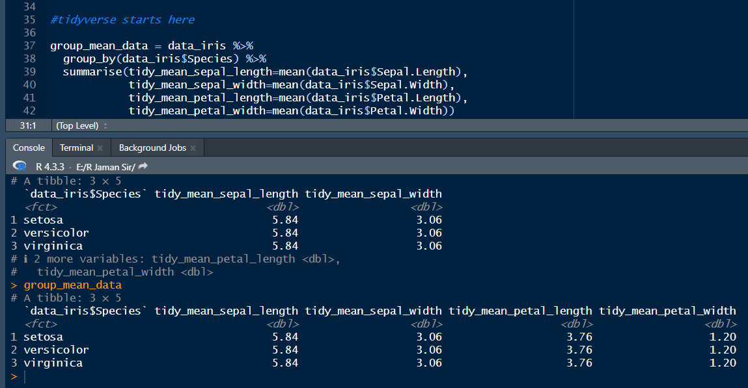

Aita diye group mean ber korlam tidyverse diye.

Variance hocche risk

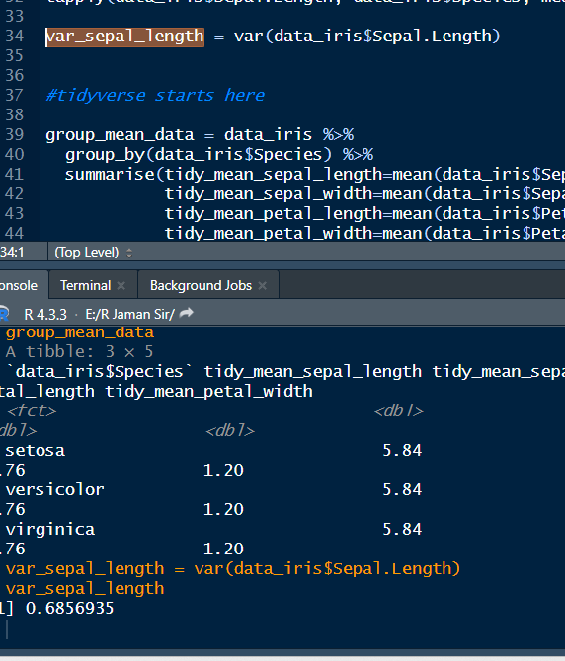

Aije variance ber korlam.

Variance joto kom, toto risk kom.

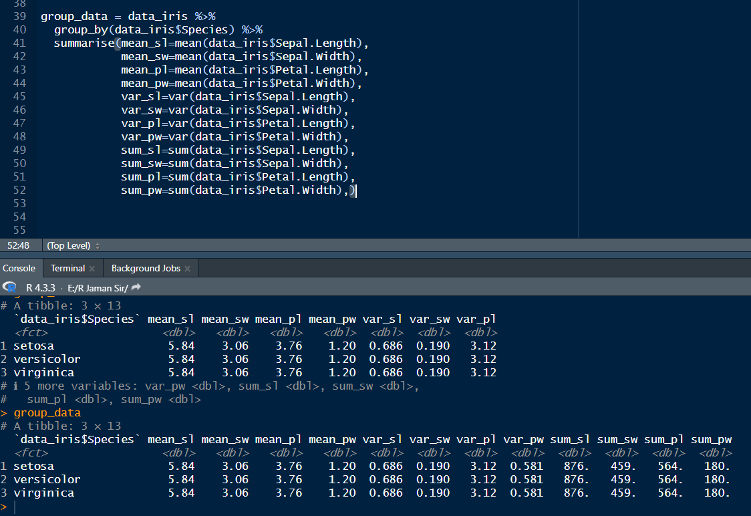

Aivabe shob ekotre korlam.

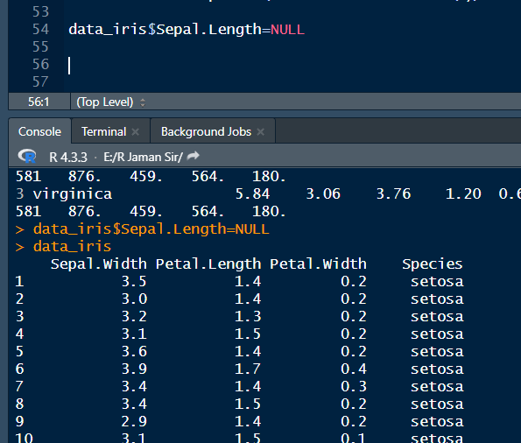

Aikhane dekho ami akta column delete kore dilam

But aivabe somossha hocche, aivabe permanently delete hoye jay. tahole amk abr notun kore iris data load kora lagbe.

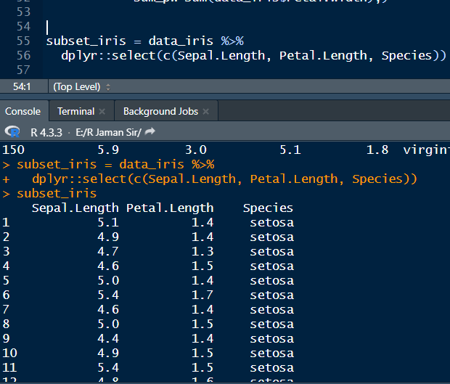

So alternatively aita korle alada akta subset banaise. Just ja ja disi ta ta e dekhabe.

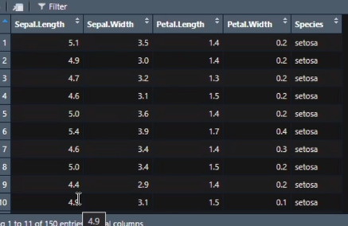

Akhon filter korbo. Mone koro ami bolbo je sepal length e just 5 er upore ja ache, ta select koro.

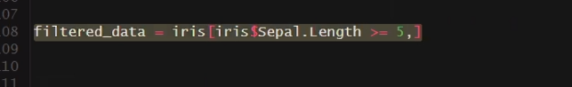

Aita mane 5 or 5 er upore ja ache. aita ager method.

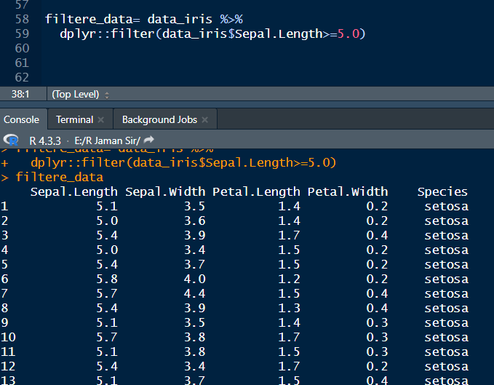

Aije filter korlam.

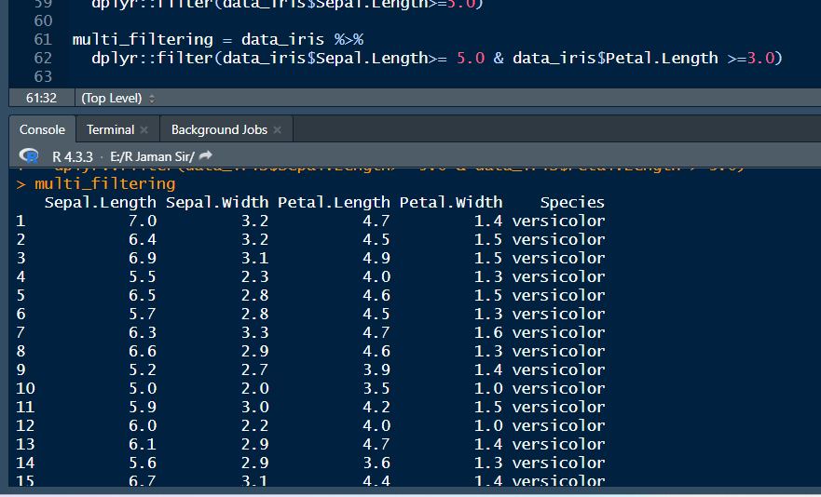

Aivabe ,multi filter korlam.

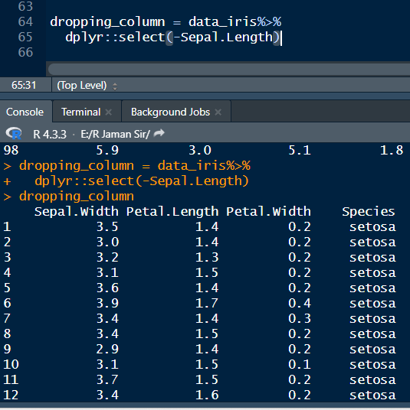

Aita mane akta column drop korlam. Aitao permanent deletion.

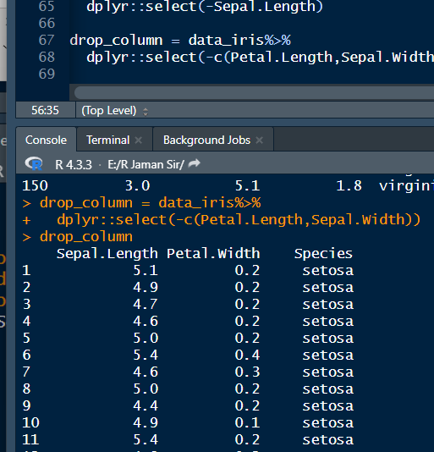

Dekho, aikhane multi column drop korlam. But atay sepal length abr fire asche.

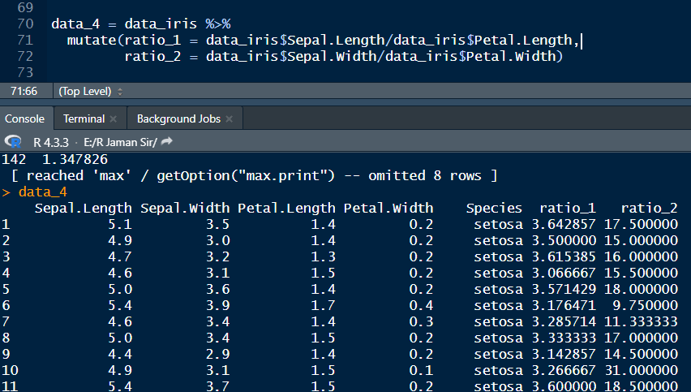

Aita ratio korlam.

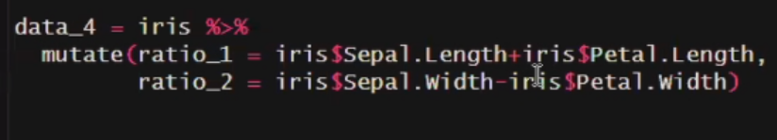

Aikahne amon jog biyog o korte parbo.

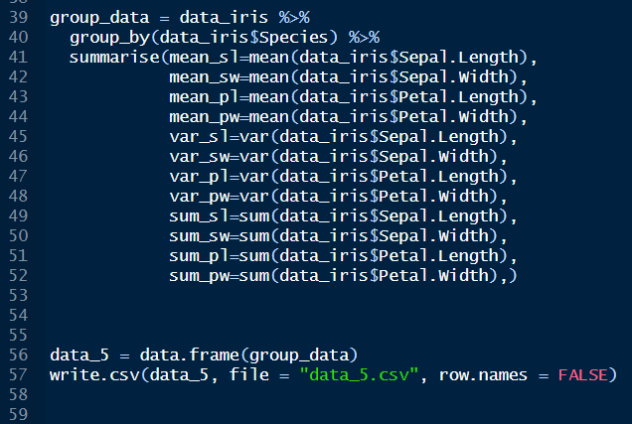

Aivabe ami kintu csv file o create kore felsi.

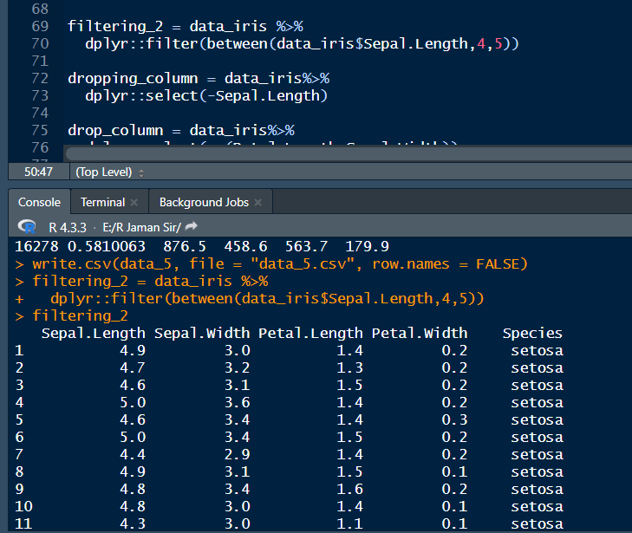

Aikhane dekho aitar mane ami 4 and 5 value er majher data gula nitesi.